Figure S1 The trend changes in the burden of COPD diseases attributed to occupational PGFs by sex in BRICS countries from 1990 to 2021 (A. DALYs; B. Deaths; C. YLDs; D. YLLs).
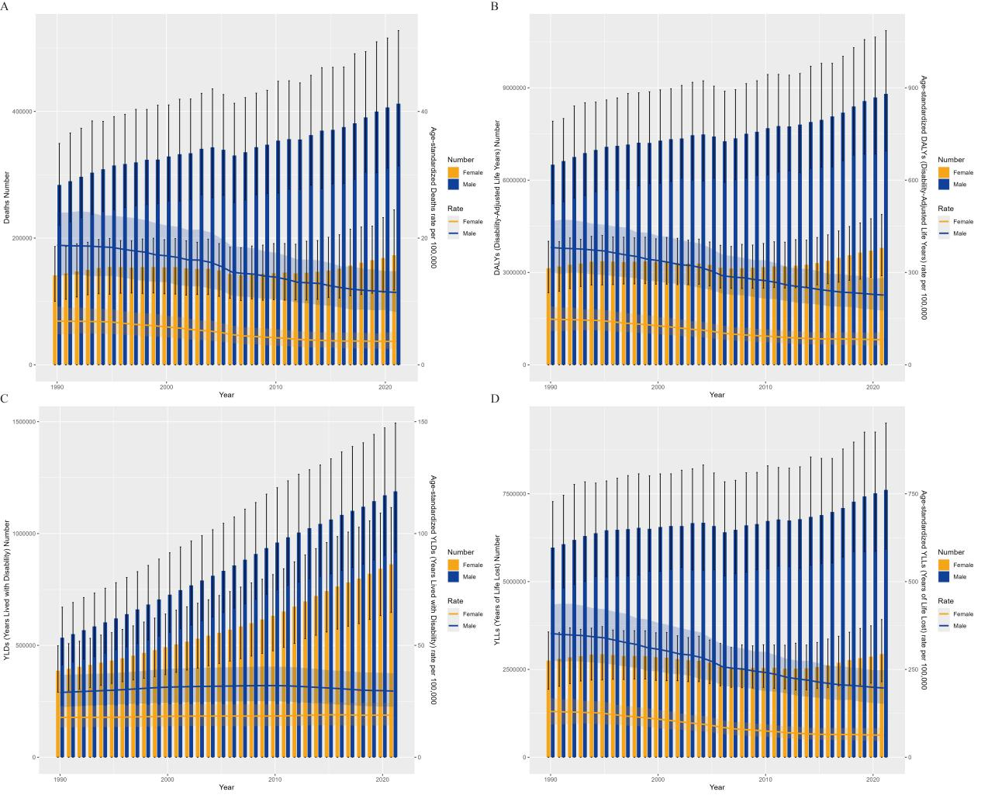

Figure S2 Distribution of COPD burden attributable to occupational PGFs by sex and age group in BRICS countries in 2021(A. DALYs; B. Deaths; C. YLDs; D. YLLs).
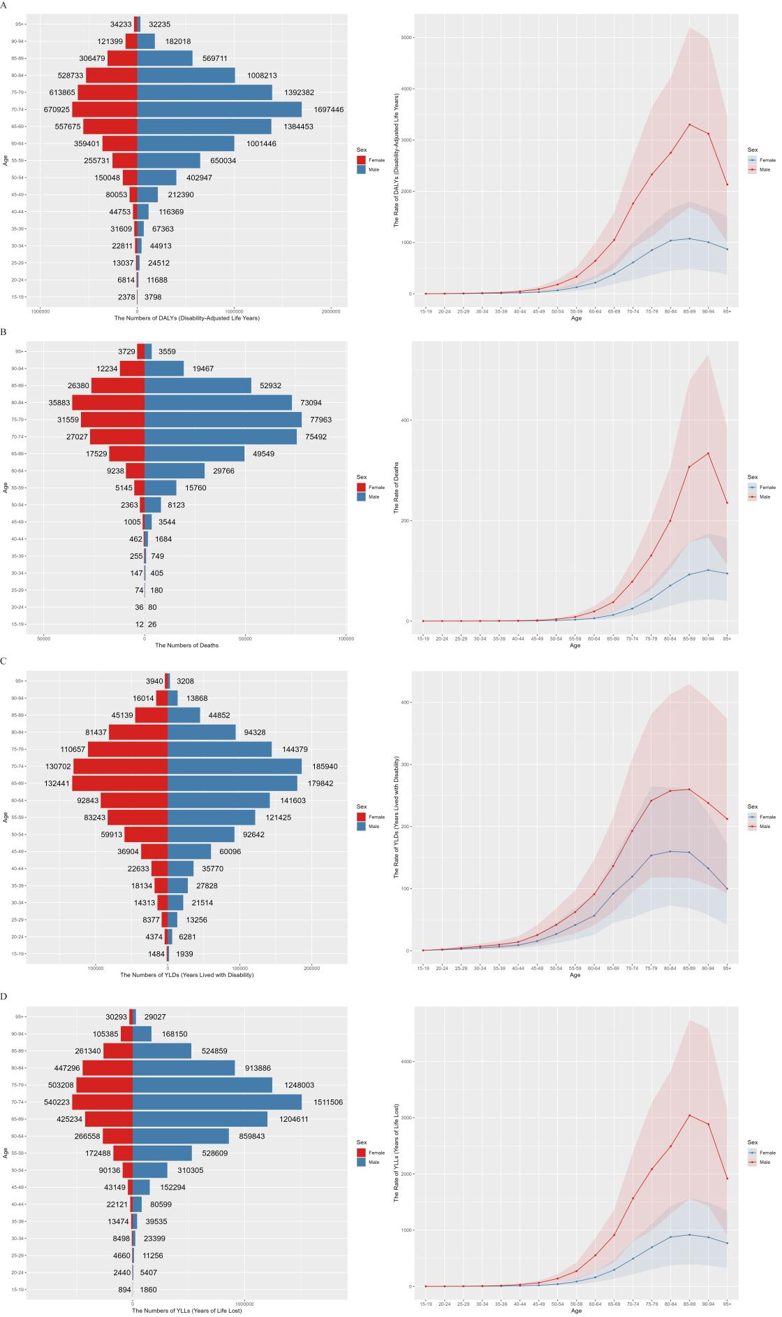

Figure S3. Trends in ASRs of occupational COPD burden among 19 comparator countries, 1990–2021; (A) DALYs; (B) Deaths; (C) YLLs; (D) YLDs.
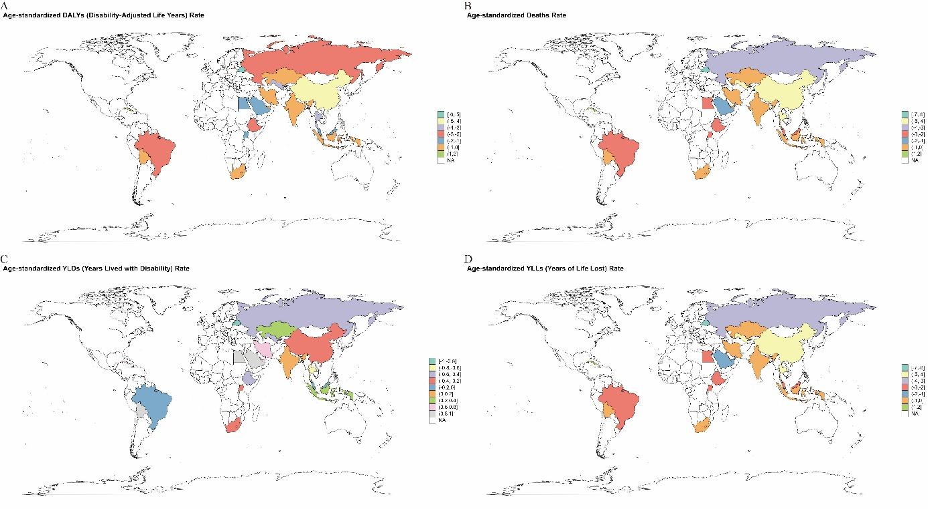

Figure S4. Age-standardized rates of COPD burden attributable to occupational PGFs in 19 comparator countries, 2021. Bar plots depict rates per 100,000 population for (A) DALYs, (B) deaths, (C) YLLs, and (D) YLDs. 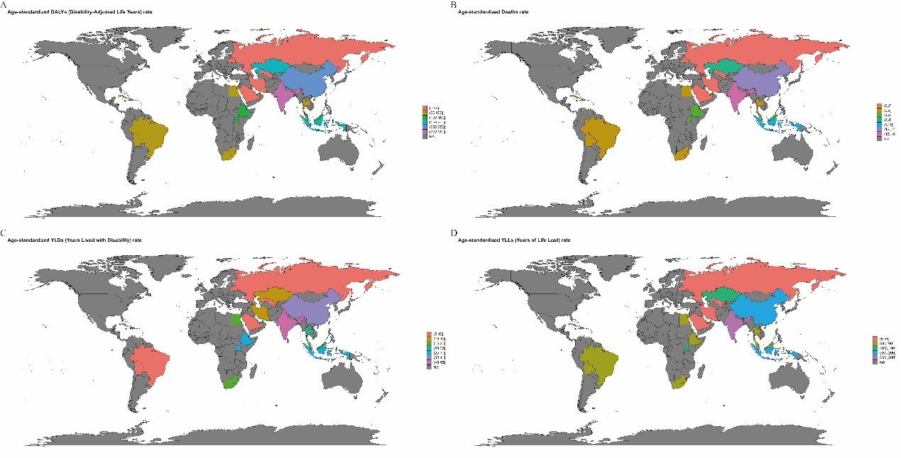

Figure S5. Absolute counts of COPD burden attributable to occupational PGFs in 19 comparator countries, 1990–2021. Time trends in absolute numbers are shown for (A) DALYs, (B) deaths, (C) YLLs, and (D) YLDs.
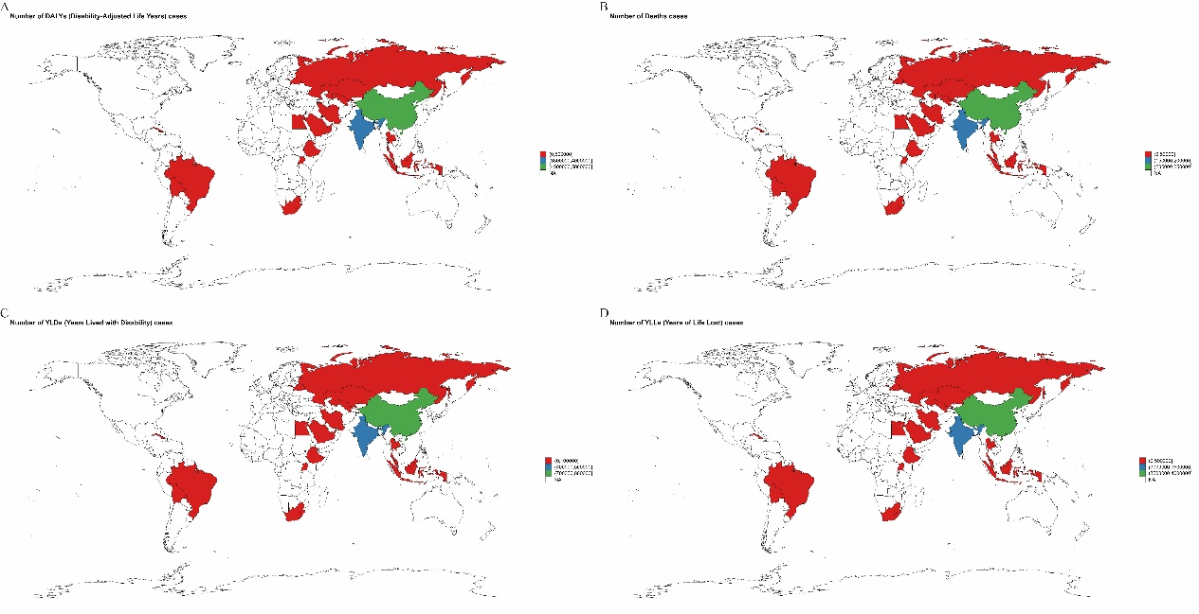

Figure S6. Percentage change in absolute counts of COPD burden attributable to occupational PGFs in 19 comparator countries, 1990–2021. Percentage changes relative to 1990 values are illustrated for (A) deaths, (B) YLLs, (C) DALYs, and (D) YLDs.

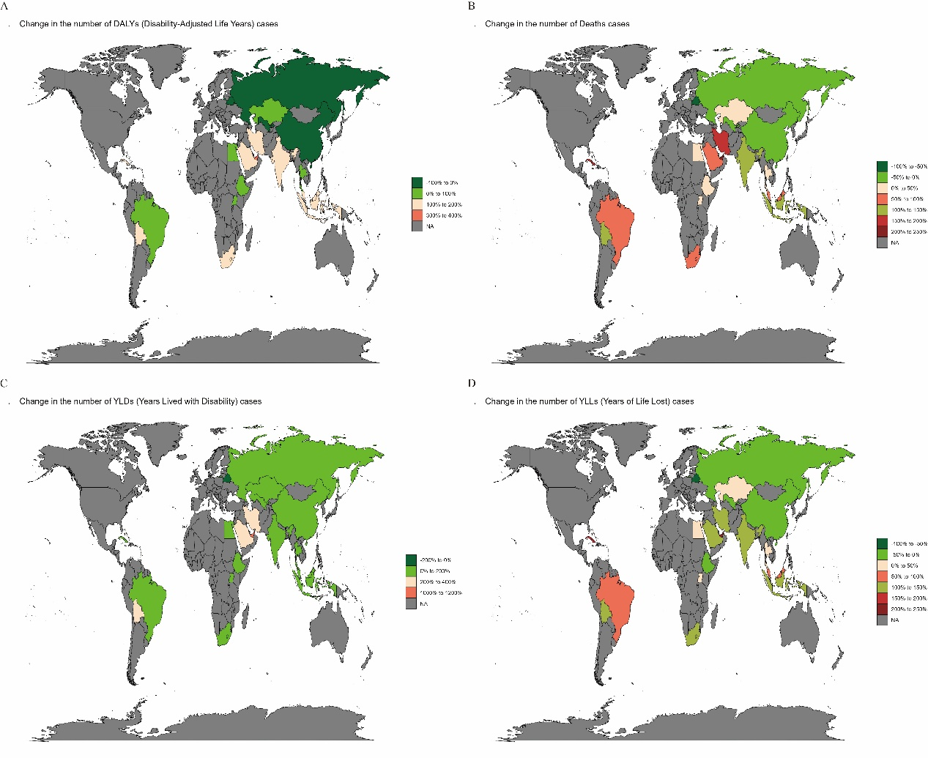

Figure S7 Sex-stratified decomposition analysis of COPD burden attributable to occupational PGFs in BRICS countries, 1990-2021. Contributions of population growth, population aging, and epidemiological changes to (A) DALYs, (B) deaths,
(C) YLDs, and (D) YLLs.