Appendix A: Statistical distributions of service times in each service point

Table S1 Statistical distributions of service times in each service point (Unit: minutes).
Process | Statistical distribution
Contact Public Relations | 0.12 + 1.18 * BETA (1.88, 1.9)
Inquire about Medical History | TRIA (0.5,1.2,1.5)
Register New Patients | TRIA (1,1.84,7)
Measure Blood Pressure and Heart Rate | 0.45+LOGN (0.743,0.459)
Measure Weight and Height | TRIA (0,0.25,1.18)
Consult Endocrinologist* | DISC (see in supplementary material)
Consult Cardiologist* | DISC (see in supplementary material)
Consult Respiratory Specialist | 0.999 + WEIB (9.36, 1.59)
Consult Urologist and Kidney Disease Specialist | 1 + GAMM (2.44, 2.92)
Consult Neurologist and Brain Specialist | LOGN (9.31, 6.38)
Blood Sampling | 2 + LOGN (4.28, 3.29)
Receive Appointment Slips | 0.12 + ERLA (0.108, 4)
Make Payment | TRIA (1.12, 1.69, 3.86)
Receive Medications | TRIA (0, 2.21, 8)
Await Blood Sugar Test Results** | 60
Await Thyroid Test Results** | 120
Await Blood Lipid Test Results** | 60
Await Urine Test Results** | 30
Note: *the complete statistical distribution is too long to be inserted in this paper; **Constant value

Appendix B: Simulation model of the MED OPD clinic at the Thai hospital case study.

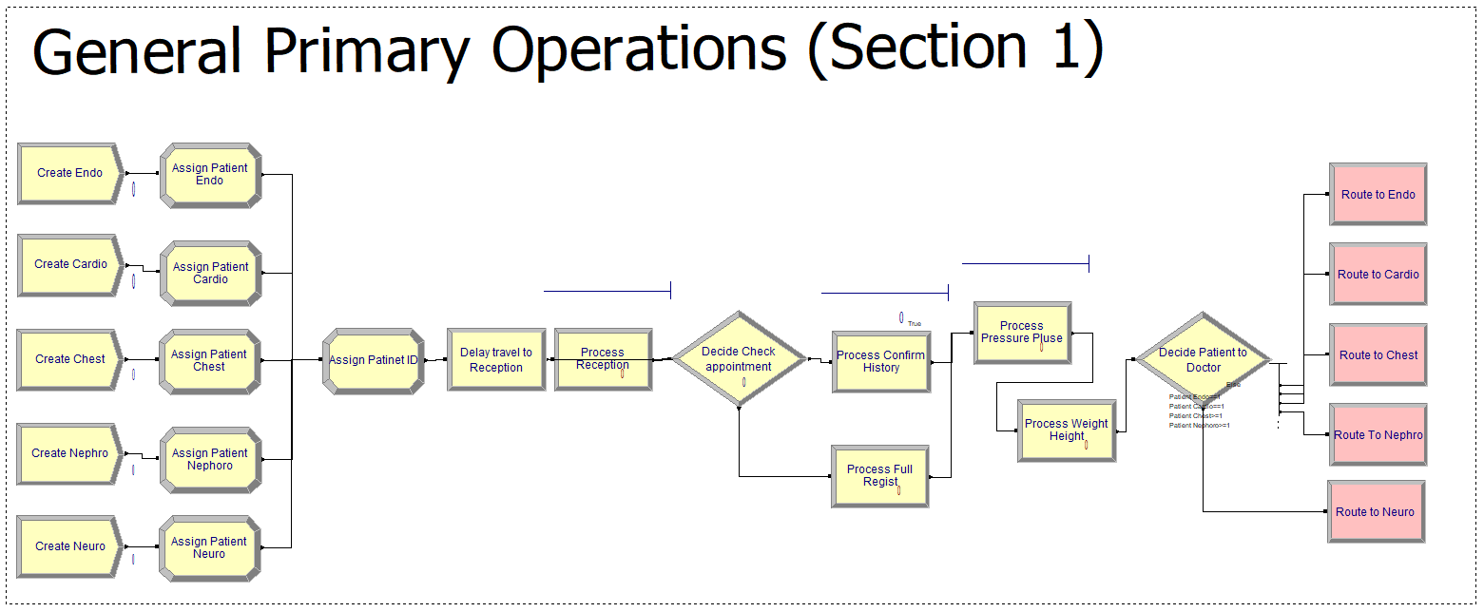
Figure S1 General primary operations (Section 1)
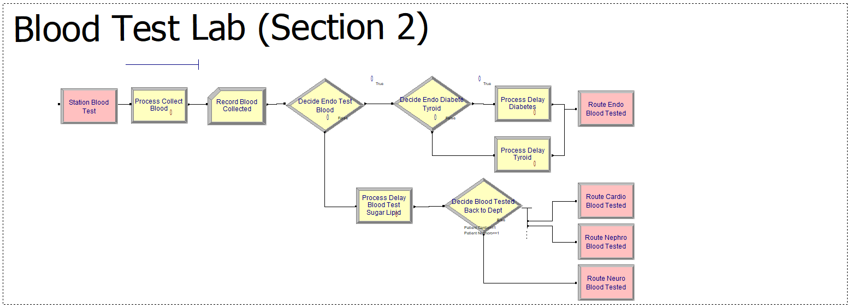
Figure S2 Blood Test Lab (Section 2)

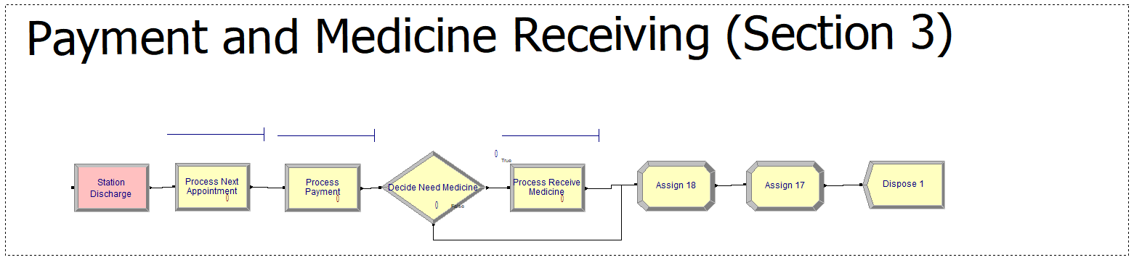
Figure S3 Payment and Medicine Receiving (Section 3)
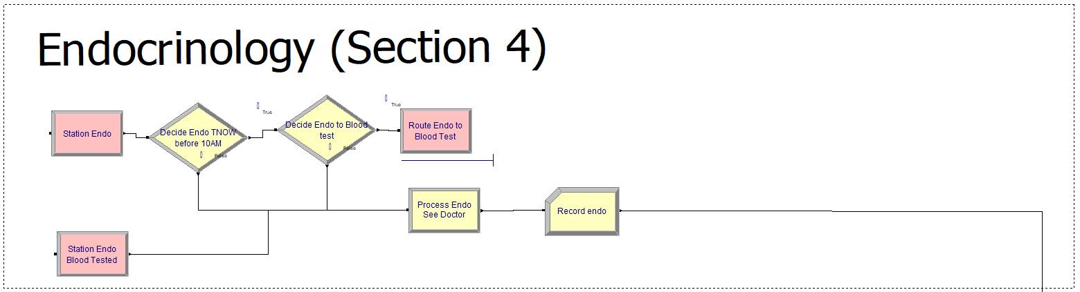
Figure S4 Endocrinology (Section 4)

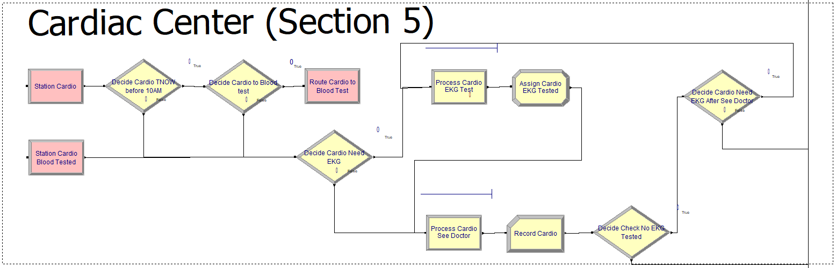
Figure S5 Cardiac Center (Section 5)
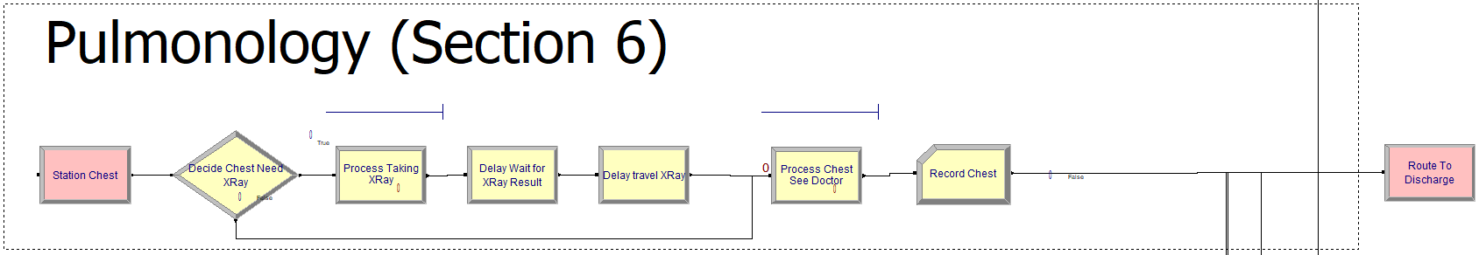
Figure S6 Pulmonology (Section 6)

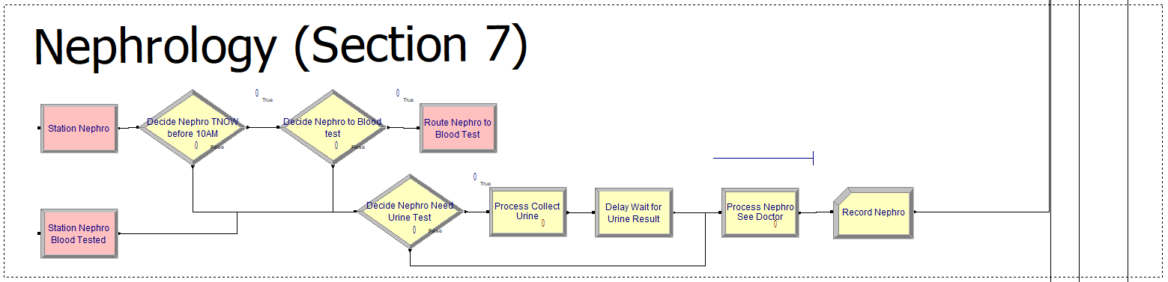
Figure S7 Nephrology (Section 7)

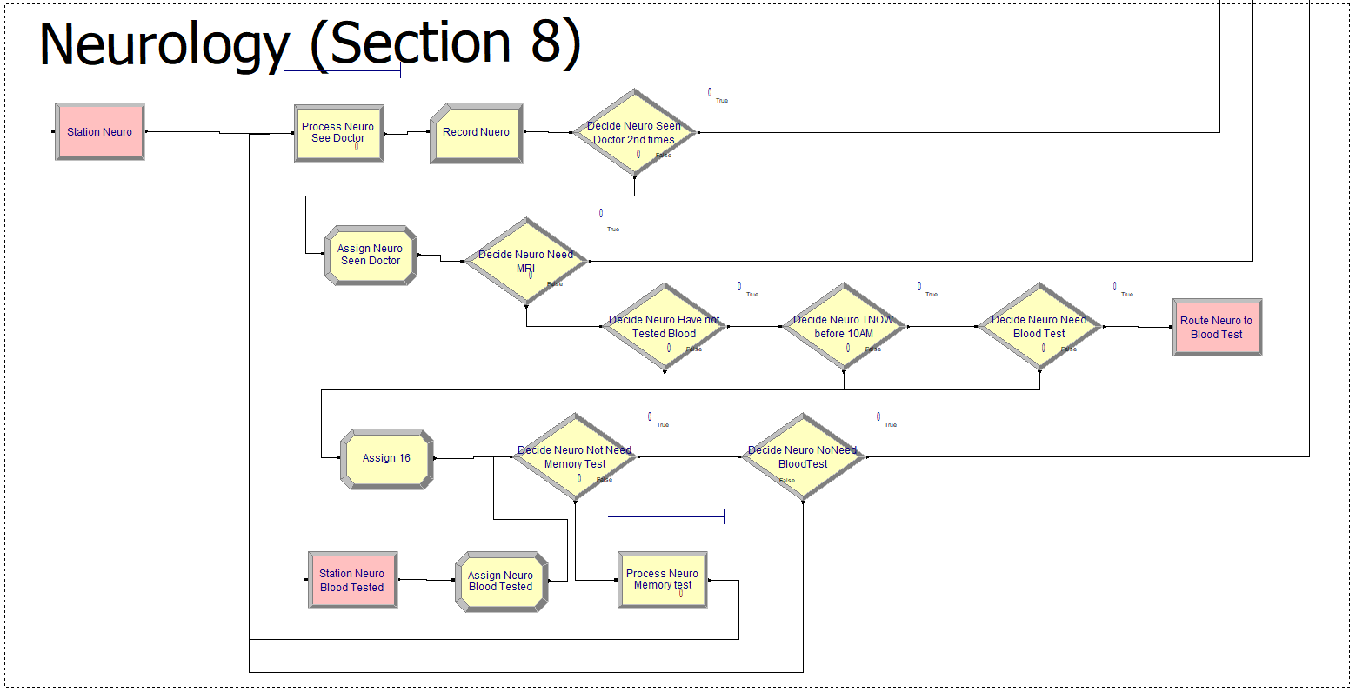
Figure S8 Neurology (Section 8)

Appendix C: Strengthening the Reporting of Empirical Simulation Studies (STRESS)

Discrete-event simulation guidelines STRESS-DES

Section/Subsection | Item | Details
- Objectives
Purpose of the model | 1.1 | The purpose of the simulation model in this study was to evaluate and optimize outpatient service efficiency at the MED clinic of a Thai public hospital. The model was designed to analyse patient flow, resource allocation, and operational bottlenecks to identify areas for improvement. Specifically, the objectives included reducing patient Length of Stay (LOS), minimizing waiting times, and improving resource utilization through scenario-based analysis and experimentation with resource configurations.
Model Outputs | 1.2 | The model outputs include the following quantitative performance measures:  - Mean Length of Stay (LOS): Calculated as the total time a patient spends in the system, including waiting, diagnostic, and treatment times.  - Waiting Times: Measured as the time patients spend in queues at different service points.  - Queue Lengths: Average and maximum queue lengths at critical service points, such as doctor consultations and diagnostics.
Experimentation Aims | 1.3 | The simulation model was used for experimentation with the following aims:  a.) Scenario-Based Analysis  - Baseline (Current Allocation): Represents the current operational state of the clinic.  - Increased Patient Proportions: Examines the impact of a 20% increase in specific patient categories, such as endocrinology and neurology, on LOS and resource utilization.  - Improved Resource Allocation: Adjusts the number of doctors based on identified bottlenecks.  - Pre-Appointment Blood Testing: Introduces pre-appointment diagnostics for 20% of patients to reduce overall LOS.  - Redistributed Patient Arrival Patterns: Redistributes 20% of morning arrivals to the afternoon.  b.) Design of Experiments  The Design of Experiments (DOE) was conducted using a 2-level factorial design with five independent variables:  - Patient arrival patterns  - Doctor availability  - Doctor delays in commencing work  - Pre-appointment blood testing  - Patient category proportions  c.) Simulation Optimization  Objective: To minimize LOS.  Parameters: Five independent variables in b)  Algorithm: Response Optimizer in Minitab was employed to identify the optimal combination of parameter levels. The optimizer uses desirability functions to maximize efficiency and minimize LOS.
- Logic
Base model overview diagram | 2.1 | Presented in Figure 1
Base model logic | 2.2 | Upon entering the system, patients initiate contact with the patient administration department to confirm their appointment and complete the registration process. New patients may be asked to provide essential medical history details, including verification of treatment eligibility for insurance coverage. Following this, patients undergo vital signs assessment, weight measurement, and blood pressure checks to establish baseline data. If patients have scheduled examinations such as blood tests, urine tests, or electrocardiograms are required, patients are directed to the respective procedures. After these examinations, patients join the queue alongside those without appointments to await the doctor's consultation. Following the medical diagnosis, patients proceed to the payment process, where they settle fees for examinations, procedures, and medications in a single transaction. Once payment is completed, patients can collect their prescribed medications from the hospital's pharmacy department. For those requiring follow-up appointments, staff members issue appointment slips after payment. Upon completing this process, their treatment for the day is considered finished, and they are free to leave the system.
Scenario logic | 2.3 | The scenarios differ from the base model as follows:  - Patient Arrival Patterns (Scenario A): Adjusts the proportion of morning arrivals from 55% to 35%, redistributing 20% of patients to the afternoon session.  - Doctor Availability (Scenario B): Introduces improved resource allocation at identified bottleneck points (e.g., increased doctor availability in endocrinology and neurology clinics).  - Doctor Delays (Scenario C): Compares scenarios of on-time doctor availability (8:00 AM and 1:00 PM start) versus delays (8:30 AM and 1:30 PM start).  - Pre-Appointment Blood Testing (Scenario D): Introduces pre-appointment testing for 20% of non-urgent patients.  - Patient Category Proportions (Scenario E): Adjusts patient proportions based on projected demographic trends, such as increased proportions in endocrinology and neurology.
Algorithms | 2.4 | Patient arrivals are modeled using a nonstationary Poisson process, where arrival rates vary across time slots. Within each slot, arrivals follow a Poisson process, and inter-arrival times are generated using an exponential distribution.
Components | 2.5 | 2.5.1 Entities | Patients: Represented as entities with attributes such as arrival time, patient categories, and diagnostic requirements.
Components | 2.5 | 2.5.2 Activities | Registration: Patients confirm appointments and complete administrative tasks.  Vital Signs Assessment: Routine checks like blood pressure and temperature are performed.  Weight and Height Measurement: Patients' weight and height are recorded.  Patient History: Medical history and symptoms are collected.  Diagnostics: Patients requiring tests are routed to diagnostic facilities.  Consultation: Patients queue to see a doctor for diagnosis and treatment.  Payment: Patients settle fees at the payment section.  Medication Collection: Prescribed medicines are collected from the pharmacy.
Components | 2.5 | 2.5.3 Resources | Doctors: Serve as resources in consultation activities.  Diagnostic Equipment: Includes machines for blood tests, X-rays, etc.  Administrative Staff: Operate in registration and payment sections.
Components | 2.5 | 2.5.4 Queues | Queue Discipline: FIFO is used for all queues. No reneging or balking occurs.
Components | 2.5 | 2.5.5 Entry/Exit Points | Entry Points: Patients arrive via the main entrance and proceed to registration. Arrival patterns mimic a Poisson process.  Exit Points: Patients exit after completing payment or medication collection.
- Data
Data sources | 3.1 | Interviews with Stakeholders: Information was collected from hospital staff, including doctors, nurses, and administrative personnel, to understand workflow processes and validate simulation logic.  Routinely Collected Data: Patient entry and exit timestamps, consultation durations, diagnostic test times, and resource availability data were obtained from the hospital's IT department, covering December 2021 to March 2022.  Prospectively Collected Samples: Direct observations were conducted to measure service times at stations lacking historical data, such as diagnostic test.
Pre-processing | 3.2 | Missing Data: Patients with incomplete records were excluded from the analysis to maintain data integrity.  Outlier Removal: Extreme values for consultation durations (e.g., >3 SD from the mean) were excluded to ensure realistic simulation scenarios.  Categorization: Patient data was categorized by clinic type and service pathway to align with input requirements for the simulation model.
Input parameters | 3.3 | These data were then analysed using the Input Analyzer tool in Arena software. To fit distributions for datasets, we applied the chi-square test at a significance level (α) of 0.05 for datasets containing 50 or more values, as recommended by Russell (2022). For datasets with fewer than 50 values, we used the Kolmogorov-Smirnov test. This approach, supported by Arena simulation software, ensures accurate probability distribution representations for real-world service times in our model.  The results of the data fitting are presented as follows:  Contact Public Relations: 0.12 + 1.18 * BETA (1.88, 1.9)  Inquire about Medical History: TRIA (0.5,1.2,1.5)  Register New Patients: TRIA (1,1.84,7)  Measure Blood Pressure and Heart Rate (V/S): 0.45+LOGN (0.743,0.459)  Measure Weight and Height: TRIA (0,0.25,1.18)  Consult Endocrinologist: DISC (0.000,0.000,0.135,3.133,0.351,6.267, 0.600,9.400,0.763,12.533,0.864,15.667,0.927,18.800,0.959,21.933, 0.977,25.067,0.985,28.200,0.989,31.333,0.991,34.467,0.995,37.600, 0.995,40.733,0.995,43.867,0.995,47.000,0.997,50.133,0.997,53.267, 0.998,56.400,0.998,59.533,0.999,62.667,0.999,65.800,0.999,68.933,0.999,72.067,0.999,75.200,0.999,78.333,0.999,81.467,0.999,84.600,0.999,87.733,0.999,90.867,1,94.000) (as presented in Figure S9.)  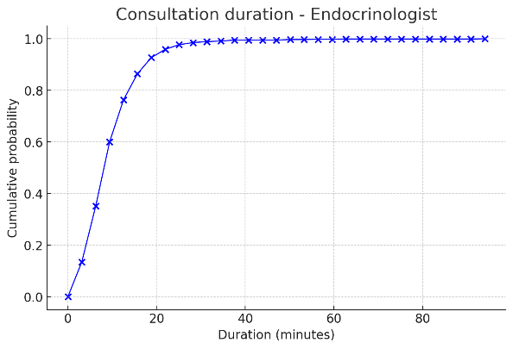  Figure S9. Cumulative distribution function graph for endocrinologist consultation duration.  Consult Cardiologist: DISC (0.000,0.000,0.054,1.500,0.170,3.000,0.283, 4.500,0.461,6.000, 0.611,7.500,0.704,9.000,0.759,10.500,0.796,12.000, 0.845,13.500,0.892,15.000 0.914,16.500,0.929,18.000,0.953,19.500, 0.963,21.000,0.975,22.500,0.990,24.000,0.998,25.500,0.998,27.000, 0.998,28.500,1.0,30.000) (as presented in Figure S10.)  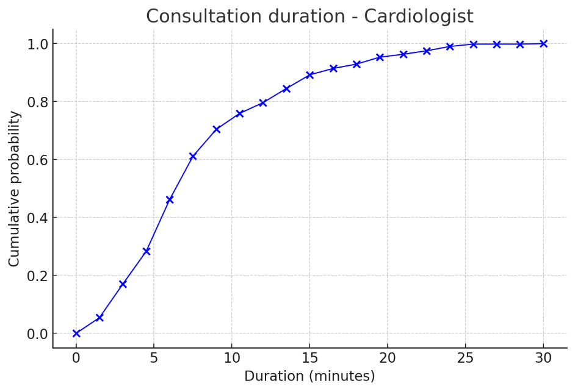  Figure S10. Cumulative distribution function graph for cardiologist consultation duration.  Consult Respiratory Specialist: 0.999 + WEIB (9.36, 1.59)  Consult Urologist and Kidney Disease Specialist: 1 + GAMM (2.44, 2.92)  Consult Neurologist and Brain Specialist: LOGN (9.31, 6.38)  Blood Sampling: 2 + LOGN (4.28, 3.29)  Receive Appointment Slips: 0.12 + ERLA (0.108, 4)  Make Payment: TRIA (1.12, 1.69, 3.86)  Receive Medications: TRIA (0, 2.21, 8)  Await Blood Sugar Test Results: Constant (60)  Await Thyroid Test Results: Constant (120)  Await Blood Lipid Test Results: Constant (60)  Await Urine Test Results: Constant (30)
Assumptions | 3.4 | Unavailable Data: For stations without available data, constant service times were assumed to ensure model consistency.  Routing Logic: Patients were modelled to complete all required processes sequentially, without skipping steps, unless specified (e.g., pre-appointment diagnostics).  Unchanging Workflows: The current workflow was maintained unchanged, except for adjustments introduced in experimental scenarios.  Exclusion of Emergency Cases: Emergency cases were not included in this study.
- Experimentation
Initialisation | 4.1 | System Type: The modelled system is a terminating system, as it evaluates a fixed operational period.  Warm-up Period: A warm-up period was not required as the model focuses on discrete operational periods without dependency on prior states.  Stopping Condition: The simulation runs terminate after a fixed period of 7 days, reflecting a week of hospital operations.  Initial Conditions: No pre-loaded queues or activities were initialized. The starting conditions assume an empty system at the beginning of each day, ensuring consistency across runs. These initializations were deterministic to maintain uniformity across replications.
Run length | 4.2 | Each simulation run represents 7 days (98 hours), capturing weekly operational patterns. The time unit used in the simulation is minutes.
Estimation approach | 4.3 | Each scenario was replicated 16 times. This number was determined using Equation (1) to ensure a desired a 2% error from the point estimator (based on decision makers), meeting statistical confidence requirements.  $n≅n_{0}\frac{h_{0}^{2}}{h^{2}}$ (1)  where $n:$the number of replications,  $n_{0}:$the number of initial replications  $h_{0}:$the half-width obtained from the initial set of replications  $h:$the desired half-width from decision makers.  Pisuchpen, R., & Chansangar, W. (2014). Modifying production line for productivity improvement: A Case Study of Vision Lens Factory. Songklanakarin Journal of Science & Technology, 36(3).
- Implementation
Software or programming language | 5.1 | The simulation was developed using Arena Simulation Software, Version 14.
Random sampling | 5.2 | All sampling uses the function in Arena Simulation Software, Version 14.
Model execution | 5.3 | Event Processing Mechanism: Process-interaction approach is utilized within the Arena environment, where entities interact with resources through predefined processes and activity blocks.  Priority Rules: First-In-First-Out (FIFO) discipline was applied in all queues.  Computing Approach: The model runs on a single-core execution process. Parallel or distributed simulation mechanisms were not utilized in this study.
System Specification | 5.4 | The simulation model was executed on a laptop with the following hardware specifications: an Intel(R) Core(TM) i7-1065G7 CPU running at 1.30GHz (up to 1.50GHz) and 16.0 GB of installed RAM (15.8 GB usable). The system operated on a 64-bit Windows operating system with an x64-based processor.
- Code Access
Computer Model Sharing Statement | 6.1 | The simulation model described in this study is not openly accessible due to restrictions imposed by the hospital associated with the research. However, readers interested in obtaining the model, along with details regarding the simulation software and any other associated tools required to reproduce the results, can request access by contacting corresponding author.

Reference format based on the guidelines from: Thomas Monks, Christine S. M. Currie, Bhakti Stephan Onggo, Stewart Robinson, Martin Kunc, and Simon J. E. Taylor (2019). "Strengthening the reporting of empirical simulation studies: Introducing the STRESS guidelines," Journal of Simulation, 13(1), 55-67. DOI: https://doi.org/10.1080/17477778.2018.1442155

Appendix D: The current and improved medical resource allocation each clinic

Table S2 Current vs. improved allocation of medical resources in the endocrinology clinic
 | Current |  |  |  |  |  |  |  |  | Improvement
Time | Mon | Tue | Wed | Thu | Fri | Sat | Sun |  |  | Mon | Tue | Wed | Thu | Fri | Sat | Sun
06:00-06:30 | 0 | 0 | 0 | 0 | 0 | 0 | 0 |  |  | 0 | 0 | 0 | 0 | 0 | 0 | 0
06:30-07:00 | 0 | 0 | 0 | 0 | 0 | 0 | 0 |  |  | 0 | 0 | 0 | 0 | 0 | 0 | 0
07:00-07:30 | 0 | 0 | 0 | 0 | 0 | 0 | 0 |  |  | 0 | 0 | 0 | 0 | 0 | 0 | 0
07:30-08:00 | 0 | 0 | 0 | 0 | 0 | 0 | 1 |  |  | 0 | 0 | 0 | 0 | 0 | 0 | 1
08:00-08:30 | 0 | 1 | 0 | 0 | 0 | 0 | 1 |  |  | 0 | 1 | 0 | 0 | 0 | 0 | 1
08:30-09:00 | 0 | 1 | 0 | 0 | 0 | 0 | 1 |  |  | 0 | 1 | 0 | 0 | 0 | 0 | 1
09:00-09:30 | 2 | 3 | 1 | 2 | 0 | 2 | 3 |  |  | 2 | 3 | 1 | 2 | 0 | 2 | 3
09:30-10:00 | 2 | 3 | 1 | 2 | 1 | 2 | 4 |  |  | 2 | 3 | 1 | 2 | 1 | 2 | 4
10:00-10:30 | 2 | 3 | 1 | 2 | 1 | 2 | 4 |  |  | 2 | 3 | 1 | 2 | 1 | 2 | 4
10:30-11:00 | 2 | 3 | 1 | 2 | 1 | 2 | 4 |  |  | 2 | 3 | 1 | 2 | 1 | 2 | 4
11:00-11:30 | 2 | 3 | 1 | 2 | 1 | 2 | 4 |  |  | 2 | 3 | 1 | 2 | 1 | 2 | 4
11:30-12:00 | 2 | 3 | 1 | 2 | 1 | 2 | 3 |  |  | 2 | 3 | 1 | 2 | 1 | 2 | 3
12:00-12:30 | 2 | 1 | 1 | 0 | 1 | 2 | 2 |  |  | 2 | 1 | 1 | 0 | 1 | 2 | 2
12:30-13:00 | 0 | 0 | 1 | 0 | 1 | 2 | 1 |  |  | 0 | 0 | 1 | 0 | 1 | 2 | 1
13:00-13:30 | 0 | 0 | 1 | 0 | 1 | 2 | 1 |  |  | 0 | 0 | 1 | 0 | 1 | 2 | 1
13:30-14:00 | 2 | 2 | 1 | 3 | 1 | 2 | 1 |  |  | 2 | 2 | 1 | 4 | 1 | 2 | 1
14:00-14:30 | 2 | 2 | 1 | 3 | 1 | 1 | 1 |  |  | 2 | 2 | 1 | 4 | 1 | 2 | 1
14:30-15:00 | 2 | 2 | 1 | 3 | 1 | 1 | 1 |  |  | 2 | 2 | 1 | 4 | 1 | 2 | 1
15:00-15:30 | 2 | 2 | 1 | 3 | 1 | 1 | 1 |  |  | 2 | 2 | 1 | 4 | 1 | 2 | 1
15:30-16:00 | 2 | 2 | 1 | 3 | 1 | 0 | 0 |  |  | 2 | 2 | 1 | 4 | 1 | 0 | 0
16:00-16:30 | 2 | 0 | 1 | 0 | 0 | 0 | 0 |  |  | 2 | 0 | 1 | 0 | 0 | 0 | 0
16:30-17:00 | 0 | 0 | 1 | 0 | 0 | 0 | 0 |  |  | 0 | 0 | 1 | 0 | 0 | 0 | 0
17:00-17:30 | 0 | 1 | 1 | 1 | 0 | 0 | 0 |  |  | 0 | 1 | 1 | 1 | 0 | 0 | 0
17:30-18:00 | 0 | 1 | 0 | 1 | 0 | 0 | 0 |  |  | 0 | 1 | 0 | 1 | 0 | 0 | 0
18:00-18:30 | 0 | 1 | 0 | 0 | 0 | 0 | 0 |  |  | 0 | 1 | 0 | 0 | 0 | 0 | 0
18:30-19:00 | 0 | 1 | 0 | 0 | 0 | 1 | 0 |  |  | 0 | 1 | 0 | 0 | 0 | 1 | 0
19:00-19:30 | 0 | 1 | 0 | 0 | 0 | 0 | 0 |  |  | 0 | 1 | 0 | 0 | 0 | 0 | 0
19:30-20:00 | 0 | 0 | 0 | 0 | 0 | 0 | 0 |  |  | 0 | 0 | 0 | 0 | 0 | 0 | 0
FTE | 26 | 36 | 17 | 29 | 13 | 24 | 33 | 178 |  | 26 | 36 | 17 | 34 | 13 | 27 | 33 | 186

Table S3 Current vs. improved allocation of medical resources in the cardiac clinic
 | Current |  |  |  |  |  |  |  |  | Improvement
Time | Mon | Tue | Wed | Thu | Fri | Sat | Sun |  |  | Mon | Tue | Wed | Thu | Fri | Sat | Sun
06:00-06:30 | 0 | 0 | 0 | 0 | 0 | 0 | 0 |  |  | 0 | 0 | 0 | 0 | 0 | 0 | 0
06:30-07:00 | 0 | 0 | 0 | 0 | 0 | 0 | 0 |  |  | 0 | 0 | 0 | 0 | 0 | 0 | 0
07:00-07:30 | 0 | 0 | 0 | 0 | 0 | 0 | 0 |  |  | 0 | 0 | 0 | 0 | 0 | 0 | 0
07:30-08:00 | 0 | 0 | 0 | 0 | 0 | 0 | 0 |  |  | 0 | 0 | 0 | 0 | 0 | 0 | 0
08:00-08:30 | 0 | 0 | 0 | 0 | 0 | 0 | 0 |  |  | 0 | 0 | 0 | 0 | 0 | 0 | 0
08:30-09:00 | 0 | 0 | 0 | 0 | 0 | 0 | 0 |  |  | 0 | 0 | 0 | 0 | 0 | 0 | 0
09:00-09:30 | 0 | 0 | 0 | 1 | 1 | 0 | 0 |  |  | 0 | 0 | 0 | 1 | 1 | 0 | 1
09:30-10:00 | 1 | 2 | 1 | 2 | 2 | 0 | 0 |  |  | 1 | 2 | 1 | 2 | 2 | 0 | 1
10:00-10:30 | 1 | 2 | 1 | 2 | 2 | 0 | 0 |  |  | 1 | 2 | 1 | 2 | 2 | 0 | 1
10:30-11:00 | 1 | 2 | 1 | 2 | 2 | 0 | 0 |  |  | 1 | 2 | 1 | 2 | 2 | 0 | 1
11:00-11:30 | 0 | 2 | 1 | 1 | 1 | 0 | 0 |  |  | 0 | 2 | 1 | 1 | 1 | 0 | 1
11:30-12:00 | 0 | 1 | 1 | 1 | 1 | 0 | 0 |  |  | 0 | 1 | 1 | 1 | 1 | 0 | 1
12:00-12:30 | 1 | 1 | 1 | 0 | 1 | 0 | 0 |  |  | 1 | 1 | 1 | 0 | 1 | 0 | 0
12:30-13:00 | 1 | 0 | 0 | 0 | 0 | 0 | 0 |  |  | 1 | 0 | 0 | 0 | 0 | 0 | 0
13:00-13:30 | 1 | 0 | 0 | 0 | 0 | 0 | 0 |  |  | 1 | 0 | 0 | 0 | 0 | 0 | 0
13:30-14:00 | 1 | 0 | 0 | 0 | 0 | 0 | 0 |  |  | 1 | 0 | 0 | 0 | 0 | 0 | 0
14:00-14:30 | 1 | 0 | 0 | 0 | 0 | 0 | 0 |  |  | 1 | 0 | 0 | 0 | 0 | 0 | 0
14:30-15:00 | 0 | 0 | 0 | 0 | 0 | 0 | 0 |  |  | 0 | 0 | 0 | 0 | 0 | 0 | 0
15:00-15:30 | 0 | 0 | 0 | 0 | 0 | 0 | 0 |  |  | 0 | 0 | 0 | 0 | 0 | 0 | 0
15:30-16:00 | 0 | 0 | 0 | 0 | 0 | 0 | 0 |  |  | 0 | 0 | 0 | 0 | 0 | 0 | 0
16:00-16:30 | 0 | 0 | 0 | 0 | 0 | 0 | 0 |  |  | 0 | 0 | 0 | 0 | 0 | 0 | 0
16:30-17:00 | 0 | 0 | 0 | 0 | 0 | 0 | 0 |  |  | 0 | 0 | 0 | 0 | 0 | 0 | 0
17:00-17:30 | 0 | 1 | 0 | 0 | 0 | 0 | 1 |  |  | 0 | 1 | 0 | 0 | 0 | 0 | 1
17:30-18:00 | 0 | 1 | 0 | 0 | 0 | 0 | 1 |  |  | 0 | 1 | 0 | 0 | 0 | 0 | 1
18:00-18:30 | 0 | 1 | 0 | 0 | 0 | 0 | 1 |  |  | 0 | 1 | 0 | 0 | 0 | 0 | 1
18:30-19:00 | 0 | 1 | 0 | 0 | 0 | 0 | 1 |  |  | 0 | 1 | 0 | 0 | 0 | 0 | 1
19:00-19:30 | 0 | 1 | 0 | 0 | 0 | 0 | 1 |  |  | 0 | 1 | 0 | 0 | 0 | 0 | 1
19:30-20:00 | 0 | 0 | 0 | 0 | 0 | 0 | 0 |  |  | 0 | 0 | 0 | 0 | 0 | 0 | 0
FTE | 8 | 15 | 6 | 9 | 10 | 0 | 5 | 53 |  | 8 | 15 | 6 | 9 | 10 | 0 | 11 | 59

Table S4 Current vs. improved allocation of medical resources in the pulmonology clinic
 | Current |  |  |  |  |  |  |  |  | Improvement
Time | Mon | Tue | Wed | Thu | Fri | Sat | Sun |  |  | Mon | Tue | Wed | Thu | Fri | Sat | Sun
06:00-06:30 | 0 | 0 | 0 | 0 | 0 | 0 | 0 |  |  | 0 | 0 | 0 | 0 | 0 | 0 | 0
06:30-07:00 | 0 | 0 | 0 | 0 | 0 | 0 | 0 |  |  | 0 | 0 | 0 | 0 | 0 | 0 | 0
07:00-07:30 | 0 | 0 | 0 | 0 | 0 | 0 | 0 |  |  | 0 | 0 | 0 | 0 | 0 | 0 | 0
07:30-08:00 | 0 | 0 | 0 | 0 | 0 | 0 | 0 |  |  | 0 | 0 | 0 | 0 | 0 | 0 | 0
08:00-08:30 | 0 | 0 | 0 | 0 | 0 | 0 | 0 |  |  | 0 | 0 | 0 | 0 | 0 | 0 | 0
08:30-09:00 | 0 | 0 | 0 | 0 | 0 | 0 | 0 |  |  | 0 | 0 | 0 | 0 | 0 | 0 | 0
09:00-09:30 | 0 | 0 | 0 | 0 | 0 | 0 | 1 |  |  | 0 | 0 | 0 | 0 | 0 | 0 | 1
09:30-10:00 | 0 | 0 | 0 | 0 | 0 | 0 | 1 |  |  | 0 | 0 | 0 | 0 | 0 | 0 | 1
10:00-10:30 | 0 | 0 | 0 | 0 | 0 | 0 | 1 |  |  | 0 | 0 | 0 | 0 | 0 | 0 | 1
10:30-11:00 | 0 | 0 | 1 | 0 | 1 | 1 | 1 |  |  | 0 | 0 | 2 | 0 | 1 | 2 | 1
11:00-11:30 | 0 | 0 | 1 | 0 | 1 | 1 | 1 |  |  | 0 | 0 | 2 | 0 | 1 | 2 | 1
11:30-12:00 | 0 | 0 | 1 | 0 | 1 | 1 | 0 |  |  | 0 | 0 | 2 | 0 | 1 | 2 | 0
12:00-12:30 | 0 | 0 | 1 | 0 | 1 | 1 | 0 |  |  | 0 | 0 | 2 | 0 | 1 | 2 | 0
12:30-13:00 | 0 | 0 | 0 | 0 | 1 | 2 | 0 |  |  | 0 | 0 | 0 | 0 | 1 | 2 | 0
13:00-13:30 | 1 | 1 | 0 | 1 | 1 | 1 | 0 |  |  | 1 | 1 | 0 | 1 | 1 | 1 | 0
13:30-14:00 | 1 | 1 | 0 | 1 | 0 | 0 | 1 |  |  | 1 | 1 | 0 | 1 | 0 | 0 | 1
14:00-14:30 | 1 | 1 | 0 | 1 | 0 | 0 | 1 |  |  | 1 | 1 | 0 | 1 | 0 | 0 | 1
14:30-15:00 | 1 | 1 | 0 | 1 | 0 | 0 | 1 |  |  | 1 | 1 | 0 | 1 | 0 | 0 | 1
15:00-15:30 | 0 | 0 | 0 | 0 | 0 | 0 | 1 |  |  | 0 | 0 | 0 | 0 | 0 | 0 | 1
15:30-16:00 | 0 | 0 | 0 | 0 | 0 | 0 | 1 |  |  | 0 | 0 | 0 | 0 | 0 | 0 | 1
16:00-16:30 | 0 | 0 | 0 | 0 | 0 | 0 | 0 |  |  | 0 | 0 | 0 | 0 | 0 | 0 | 0
16:30-17:00 | 0 | 0 | 0 | 0 | 0 | 0 | 0 |  |  | 0 | 0 | 0 | 0 | 0 | 0 | 0
17:00-17:30 | 1 | 0 | 0 | 0 | 0 | 0 | 0 |  |  | 1 | 0 | 0 | 0 | 0 | 0 | 0
17:30-18:00 | 1 | 0 | 0 | 0 | 1 | 0 | 0 |  |  | 1 | 0 | 0 | 0 | 1 | 0 | 0
18:00-18:30 | 1 | 1 | 0 | 0 | 1 | 0 | 0 |  |  | 1 | 1 | 0 | 0 | 1 | 0 | 0
18:30-19:00 | 0 | 1 | 0 | 0 | 0 | 0 | 0 |  |  | 0 | 1 | 0 | 0 | 0 | 0 | 0
19:00-19:30 | 0 | 1 | 0 | 0 | 0 | 0 | 0 |  |  | 0 | 1 | 0 | 0 | 0 | 0 | 0
19:30-20:00 | 0 | 1 | 0 | 0 | 0 | 0 | 0 |  |  | 0 | 1 | 0 | 0 | 0 | 0 | 0
FTE | 7 | 8 | 4 | 4 | 8 | 7 | 10 | 48 |  | 7 | 8 | 8 | 4 | 8 | 11 | 10 | 56

Table S5 Current vs. improved allocation of medical resources in the nephrology clinic
 | Current |  |  |  |  |  |  |  |  | Improvement
Time | Mon | Tue | Wed | Thu | Fri | Sat | Sun |  |  | Mon | Tue | Wed | Thu | Fri | Sat | Sun
06:00-06:30 | 0 | 0 | 0 | 0 | 0 | 0 | 0 |  |  | 0 | 0 | 0 | 0 | 0 | 0 | 0
06:30-07:00 | 0 | 0 | 0 | 0 | 0 | 0 | 0 |  |  | 0 | 0 | 0 | 0 | 0 | 0 | 0
07:00-07:30 | 0 | 0 | 0 | 0 | 0 | 0 | 0 |  |  | 0 | 0 | 0 | 0 | 0 | 0 | 0
07:30-08:00 | 0 | 0 | 0 | 0 | 0 | 0 | 0 |  |  | 0 | 0 | 0 | 0 | 0 | 0 | 0
08:00-08:30 | 0 | 0 | 0 | 0 | 0 | 0 | 0 |  |  | 0 | 0 | 0 | 0 | 0 | 0 | 0
08:30-09:00 | 0 | 0 | 0 | 0 | 0 | 0 | 0 |  |  | 0 | 0 | 0 | 0 | 0 | 0 | 0
09:00-09:30 | 0 | 0 | 0 | 0 | 0 | 1 | 0 |  |  | 0 | 0 | 0 | 0 | 0 | 1 | 0
09:30-10:00 | 0 | 0 | 0 | 0 | 0 | 1 | 0 |  |  | 0 | 0 | 0 | 0 | 0 | 1 | 0
10:00-10:30 | 0 | 0 | 0 | 1 | 1 | 1 | 0 |  |  | 0 | 0 | 0 | 1 | 1 | 1 | 0
10:30-11:00 | 0 | 0 | 0 | 1 | 1 | 1 | 0 |  |  | 0 | 0 | 0 | 1 | 1 | 1 | 0
11:00-11:30 | 0 | 0 | 0 | 1 | 1 | 1 | 0 |  |  | 0 | 0 | 0 | 1 | 1 | 1 | 0
11:30-12:00 | 0 | 0 | 0 | 1 | 1 | 1 | 0 |  |  | 0 | 0 | 0 | 1 | 1 | 1 | 0
12:00-12:30 | 0 | 0 | 0 | 1 | 1 | 1 | 0 |  |  | 0 | 0 | 0 | 1 | 1 | 1 | 0
12:30-13:00 | 0 | 0 | 0 | 1 | 1 | 0 | 0 |  |  | 0 | 0 | 0 | 1 | 1 | 0 | 0
13:00-13:30 | 0 | 0 | 0 | 0 | 0 | 0 | 0 |  |  | 0 | 0 | 0 | 0 | 0 | 0 | 0
13:30-14:00 | 1 | 1 | 1 | 0 | 1 | 0 | 1 |  |  | 1 | 2 | 1 | 0 | 1 | 0 | 2
14:00-14:30 | 1 | 1 | 1 | 0 | 1 | 0 | 2 |  |  | 1 | 2 | 1 | 0 | 1 | 0 | 2
14:30-15:00 | 1 | 1 | 1 | 1 | 0 | 0 | 2 |  |  | 1 | 2 | 1 | 1 | 0 | 0 | 2
15:00-15:30 | 1 | 1 | 1 | 0 | 0 | 0 | 1 |  |  | 1 | 2 | 1 | 0 | 0 | 0 | 1
15:30-16:00 | 0 | 1 | 1 | 0 | 0 | 0 | 1 |  |  | 0 | 2 | 1 | 0 | 0 | 0 | 1
16:00-16:30 | 0 | 1 | 1 | 0 | 0 | 0 | 1 |  |  | 0 | 2 | 1 | 0 | 0 | 0 | 1
16:30-17:00 | 0 | 1 | 0 | 0 | 0 | 0 | 1 |  |  | 0 | 2 | 0 | 0 | 0 | 0 | 1
17:00-17:30 | 0 | 0 | 0 | 0 | 0 | 0 | 0 |  |  | 0 | 0 | 0 | 0 | 0 | 0 | 0
17:30-18:00 | 0 | 0 | 0 | 0 | 0 | 0 | 0 |  |  | 0 | 0 | 0 | 0 | 0 | 0 | 0
18:00-18:30 | 0 | 0 | 0 | 0 | 0 | 0 | 0 |  |  | 0 | 0 | 0 | 0 | 0 | 0 | 0
18:30-19:00 | 0 | 0 | 0 | 0 | 0 | 0 | 0 |  |  | 0 | 0 | 0 | 0 | 0 | 0 | 0
19:00-19:30 | 0 | 0 | 0 | 0 | 0 | 0 | 0 |  |  | 0 | 0 | 0 | 0 | 0 | 0 | 0
19:30-20:00 | 0 | 0 | 0 | 0 | 0 | 0 | 0 |  |  | 0 | 0 | 0 | 0 | 0 | 0 | 0
FTE | 4 | 7 | 6 | 7 | 8 | 7 | 9 | 48 |  | 4 | 14 | 6 | 7 | 8 | 7 | 10 | 56

Table S6 Current vs. improved allocation of medical resources in the neurology clinic
 | Current |  |  |  |  |  |  |  |  | Improvement
Time | Mon | Tue | Wed | Thu | Fri | Sat | Sun |  |  | Mon | Tue | Wed | Thu | Fri | Sat | Sun
06:00-06:30 | 0 | 0 | 0 | 0 | 0 | 0 | 0 |  |  | 0 | 0 | 0 | 0 | 0 | 0 | 0
06:30-07:00 | 0 | 0 | 0 | 0 | 0 | 0 | 0 |  |  | 0 | 0 | 0 | 0 | 0 | 0 | 0
07:00-07:30 | 0 | 0 | 0 | 0 | 0 | 0 | 0 |  |  | 0 | 0 | 0 | 0 | 0 | 0 | 0
07:30-08:00 | 0 | 0 | 0 | 0 | 0 | 0 | 0 |  |  | 0 | 0 | 0 | 0 | 0 | 0 | 0
08:00-08:30 | 0 | 0 | 0 | 0 | 0 | 0 | 0 |  |  | 0 | 0 | 0 | 0 | 0 | 0 | 0
08:30-09:00 | 0 | 0 | 0 | 0 | 0 | 0 | 2 |  |  | 0 | 0 | 0 | 0 | 0 | 0 | 3
09:00-09:30 | 0 | 0 | 0 | 0 | 0 | 2 | 2 |  |  | 0 | 0 | 0 | 0 | 0 | 3 | 3
09:30-10:00 | 0 | 0 | 0 | 0 | 0 | 2 | 3 |  |  | 0 | 0 | 0 | 0 | 0 | 3 | 3
10:00-10:30 | 2 | 1 | 2 | 0 | 1 | 2 | 3 |  |  | 2 | 1 | 2 | 0 | 1 | 3 | 3
10:30-11:00 | 2 | 1 | 2 | 0 | 1 | 2 | 3 |  |  | 2 | 1 | 2 | 0 | 1 | 3 | 3
11:00-11:30 | 2 | 1 | 2 | 0 | 1 | 1 | 3 |  |  | 2 | 1 | 2 | 0 | 1 | 1 | 3
11:30-12:00 | 2 | 1 | 2 | 1 | 2 | 1 | 2 |  |  | 2 | 1 | 2 | 1 | 2 | 1 | 2
12:00-12:30 | 2 | 1 | 2 | 1 | 2 | 1 | 2 |  |  | 2 | 1 | 2 | 1 | 2 | 1 | 2
12:30-13:00 | 1 | 1 | 1 | 2 | 1 | 1 | 2 |  |  | 1 | 1 | 1 | 3 | 1 | 1 | 2
13:00-13:30 | 1 | 1 | 1 | 3 | 1 | 2 | 1 |  |  | 1 | 1 | 1 | 3 | 1 | 2 | 1
13:30-14:00 | 1 | 1 | 1 | 3 | 1 | 2 | 1 |  |  | 1 | 1 | 1 | 3 | 1 | 2 | 1
14:00-14:30 | 1 | 1 | 1 | 2 | 1 | 2 | 1 |  |  | 1 | 1 | 1 | 2 | 1 | 2 | 1
14:30-15:00 | 1 | 1 | 0 | 2 | 1 | 2 | 0 |  |  | 1 | 1 | 0 | 2 | 1 | 2 | 0
15:00-15:30 | 0 | 1 | 0 | 0 | 1 | 2 | 0 |  |  | 0 | 1 | 0 | 0 | 1 | 2 | 0
15:30-16:00 | 0 | 1 | 0 | 0 | 1 | 2 | 0 |  |  | 0 | 1 | 0 | 0 | 1 | 2 | 0
16:00-16:30 | 0 | 0 | 0 | 0 | 0 | 0 | 0 |  |  | 0 | 0 | 0 | 0 | 0 | 0 | 0
16:30-17:00 | 0 | 0 | 0 | 0 | 0 | 0 | 0 |  |  | 0 | 0 | 0 | 0 | 0 | 0 | 0
17:00-17:30 | 0 | 0 | 0 | 0 | 0 | 0 | 0 |  |  | 0 | 0 | 0 | 0 | 0 | 0 | 0
17:30-18:00 | 0 | 0 | 0 | 0 | 0 | 0 | 0 |  |  | 0 | 0 | 0 | 0 | 0 | 0 | 0
18:00-18:30 | 0 | 0 | 0 | 0 | 0 | 0 | 0 |  |  | 0 | 0 | 0 | 0 | 0 | 0 | 0
18:30-19:00 | 0 | 0 | 0 | 0 | 0 | 0 | 0 |  |  | 0 | 0 | 0 | 0 | 0 | 0 | 0
19:00-19:30 | 0 | 0 | 0 | 0 | 0 | 0 | 0 |  |  | 0 | 0 | 0 | 0 | 0 | 0 | 0
19:30-20:00 | 0 | 0 | 0 | 0 | 0 | 0 | 0 |  |  | 0 | 0 | 0 | 0 | 0 | 0 | 0
FTE | 15 | 12 | 14 | 14 | 14 | 24 | 25 | 118 |  | 15 | 12 | 14 | 15 | 14 | 28 | 27 | 125

Appendix E: Group comparison

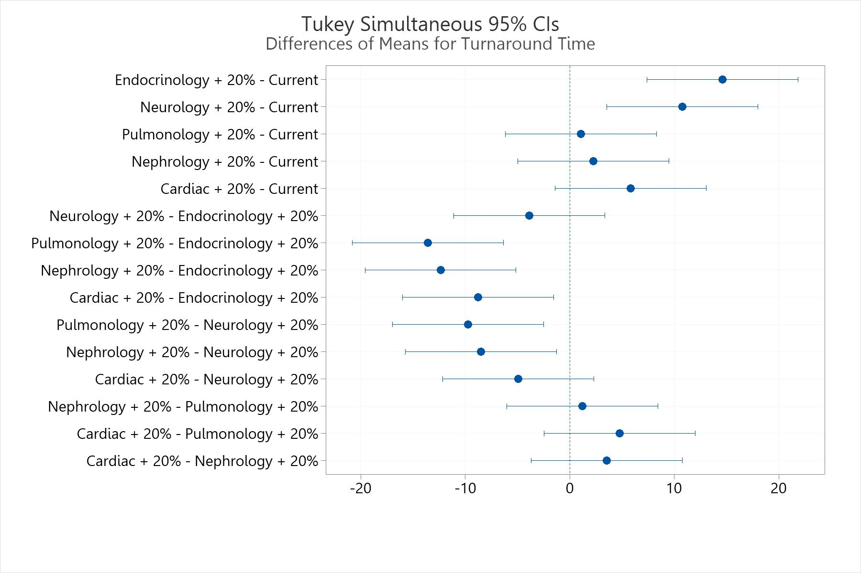
Figure S11 Group comparison using Tukey simultaneous 95% CI.

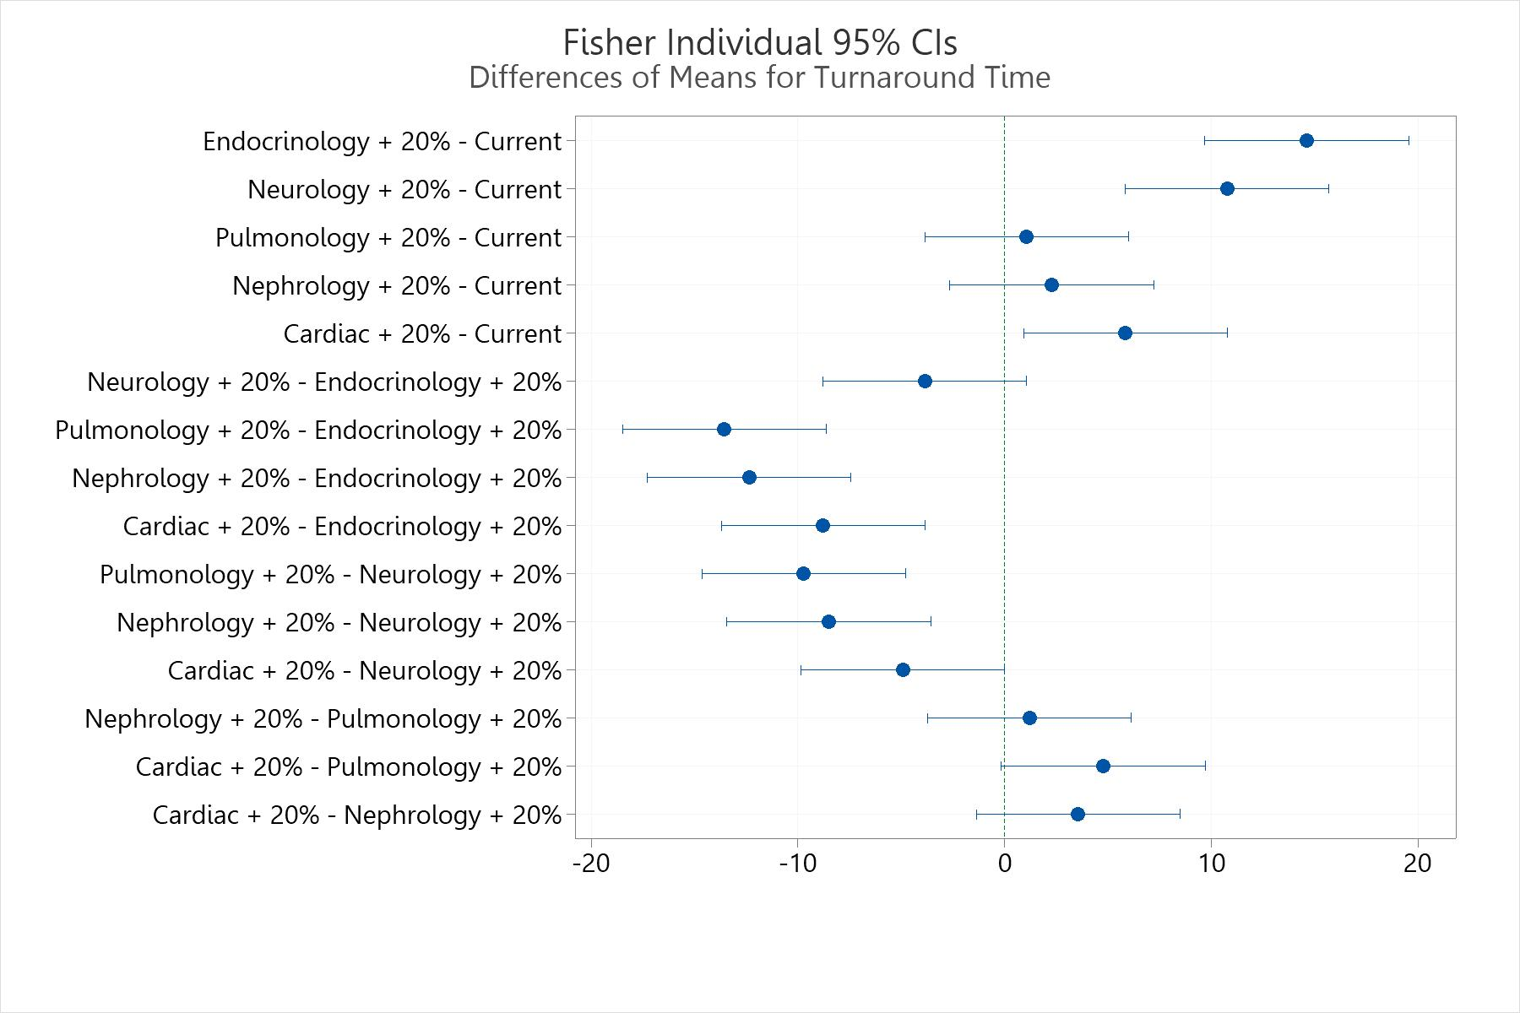
Figure S12 Group comparison using Fisher individual 95% CI.

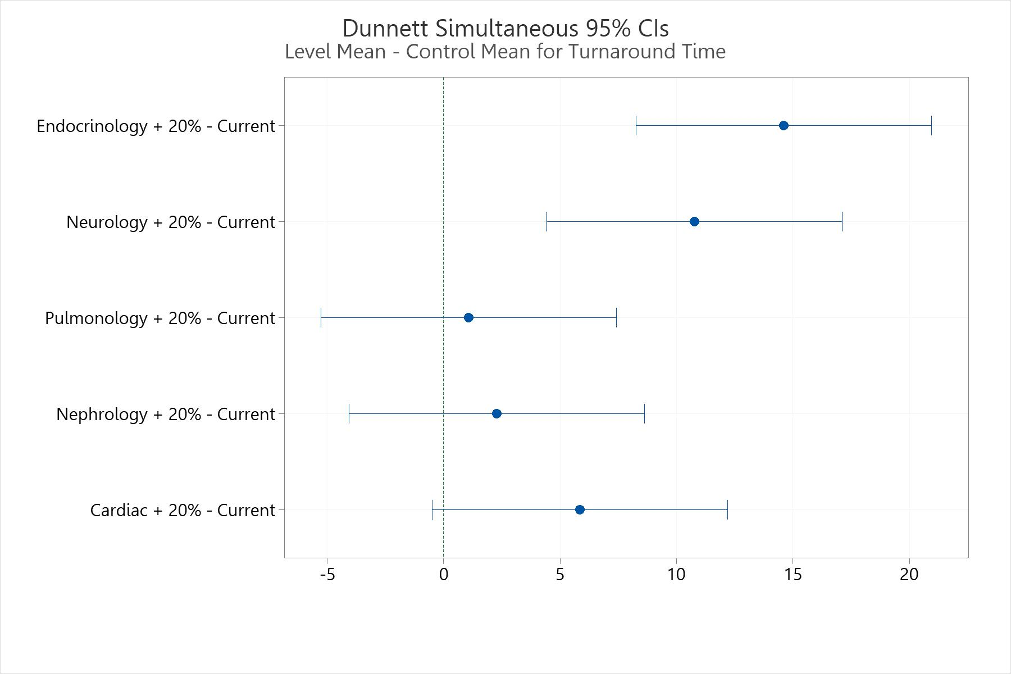
Figure S13 Group comparison using Dunnett simultaneous 95% CI.

