Supplement Materials
Supplementary Methods S1
US Protocol to capture the images
Patients were seated comfortably to expose the first metatarsophalangeal (MTP1) joint fully. Acoustic coupling was ensured by applying ample gel, and the transducer was disinfected with antiseptic wipes before each examination. To assess the MTP1 joint, the transducer was positioned longitudinally along the joints’ axis. The probe was moved slightly and slowly from the dorsal to the plantar surface while maintaining constant skin contact. Depth, focus, and gain settings were optimized to ensure image quality, with the region of interest consistently set in the upper two-thirds of the near field. The transducer was adjusted in tilt and rotation as needed to obtain satisfactory ultrasonic views, depicting the joint's anatomical structures, including fibrous capsule, synovial membrane, tendons, ligaments, bone, and surrounding soft tissue.
Ultrasound examination identified six key features of gouty arthritis (Figure S1)
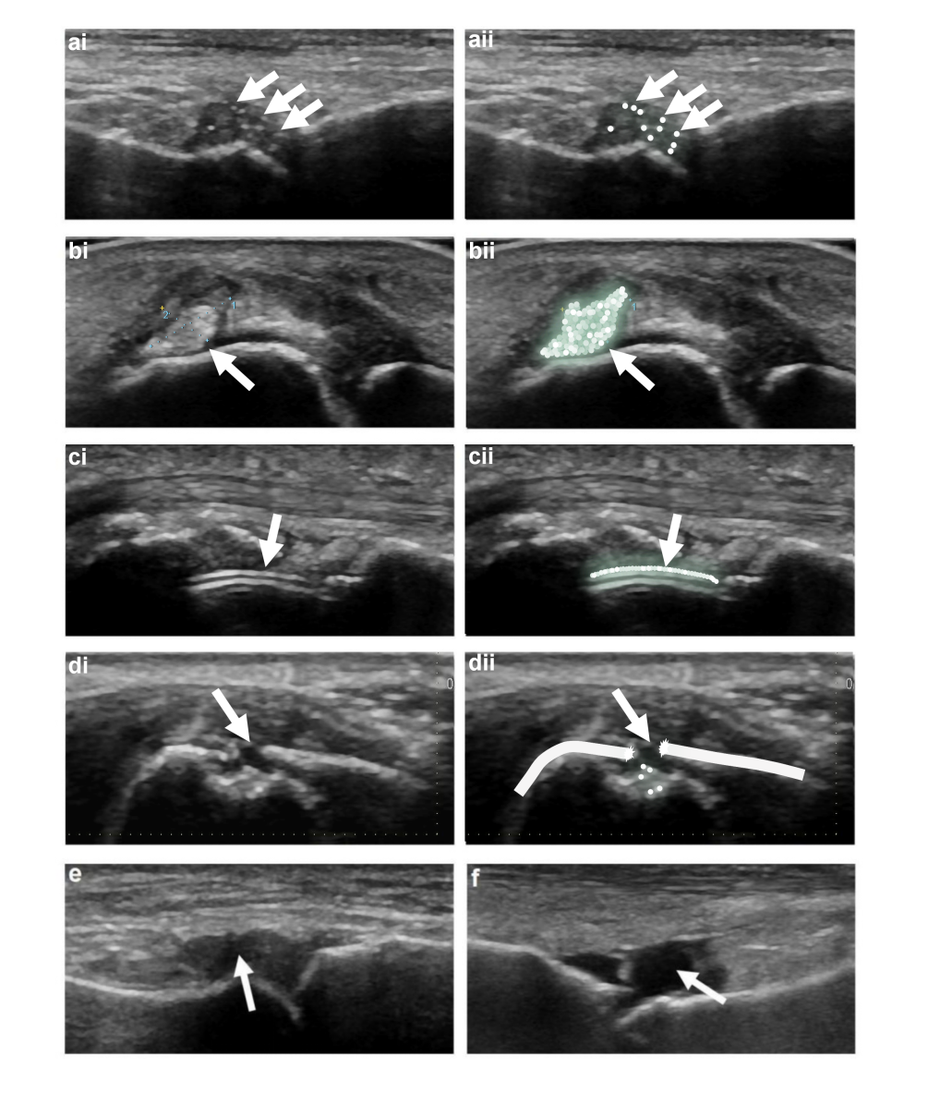
Figure S1 Longitudinal plane of B-mode US features in the MTP1: ai. Aggregates, bi. tophus, ci. Double Sontour sign, di. Bone erosion, e. Synovial thickening, f. Joint effusion. aii, bii, cii, dii: pattern diagrams. Corresponding lesions have been indicated with bold white arrows.
Abbreviations: MTP1, first metatarsophalangeal

Supplementary Methods S2
Inter-observer Agreement Analysis
To ensure reliability of ultrasound feature identification, two experienced radiologists independently reviewed a randomly selected subset of 100 cases (50 from each center). Inter-observer agreement was assessed using Cohen's kappa coefficient with the following results: tophus (κ=0.92, 95% CI: 0.87-0.97), double contour sign (κ=0.88, 95% CI: 0.82-0.94), bone erosion (κ=0.85, 95% CI: 0.78-0.92), aggregates (κ=0.87, 95% CI: 0.81-0.93), synovial thickening (κ=0.83, 95% CI: 0.76-0.90), and joint effusion (κ=0.79, 95% CI: 0.71-0.87). All values indicated excellent inter-observer agreement (κ>0.8). Discrepancies were resolved through consensus discussion with a senior radiologist (>10 years experience).
Bias Control and Quality Assurance
To minimize potential biases in this retrospective study, we implemented several control measures. First, to address selection bias, we systematically screened cases from the research database following strict inclusion and exclusion criteria established in advance. This approach ensured the representativeness of the sample and avoided selection bias by including all eligible patients and documenting the screening process in detail. Second, to minimize information bias, we employed standardized data collection forms, with data independently entered by two researchers using a double-entry process. Regular quality control checks were conducted to ensure data accuracy. Additionally, we carefully reviewed the original records to verify incomplete or ambiguous information, reducing the risk of bias arising from missing or inaccurate historical data. For measurement bias, given the retrospective nature of this study, we conducted rigorous quality screening of previously acquired ultrasound images. These images were re-evaluated blindly following a standardized assessment protocol. Regular calculations of inter- and intra-observer agreement (e.g., Kappa statistics) were performed to ensure the reliability and consistency of the evaluations. To account for confounding factors, we comprehensively collected demographic characteristics, laboratory parameters, medication history, comorbidities, and lifestyle factors from electronic medical records, laboratory reports, and treatment archives. Multivariable regression models were applied to adjust for the potential effects of these confounders on study outcomes. Additionally, sensitivity analyses were conducted to evaluate the impact of missing data on the robustness of the results. To reduce observer bias, two experienced radiologists independently assessed the retrospective ultrasound images without access to clinical information. Any discrepancies between their assessments were resolved through consensus discussions, minimizing the influence of subjective bias on study results. Lastly, to ensure consistency across centers, we conducted a comprehensive quality assessment of ultrasound images from both study centers using a standardized scoring system. Differences in image quality and diagnostic criteria between the centers were analyzed to ensure the reliability of data analysis. These systematic bias control measures significantly enhanced the internal validity of our study.

Supplementary Methods S3
Missing Data Analysis and Imputation Procedures
Prior to analysis, we conducted systematic missing data assessment across 22 candidate variables (excluding US features and DL model predictions which had complete data). Missing data patterns were evaluated using visualization plots and Little's missing completely at random (MCAR) test. Little's MCAR test yielded χ² = 45.8 (df = 41, p = 0.284), supporting that the missing at random (MAR) assumption was reasonable for our dataset. Pattern analysis revealed no systematic relationship between missingness and gout diagnosis (χ² = 0.9, p = 0.826), indicating that missing data was not informatively related to our primary outcome. The missing data analysis identified three distinct patterns: complete variables (Age and Gender), laboratory variables with low missing rates (0.5-3.8%), and survey-related variables with higher missing rates (2.1-8.4%) due to incomplete questionnaire responses.
Multiple imputation using chained equations (MICE) was implemented for all variables with less than 20% missingness following established methodological guidelines. We selected MICE over complete case analysis because it appropriately handles uncertainty inherent in missing data by creating multiple plausible datasets, preserves relationships between variables through iterative conditional modeling, and maintains distributional properties while accounting for imputation uncertainty. The imputation process used 10 complete datasets with 20 iterations per imputation. Convergence was monitored through trace plots and potential scale reduction factors, with all chains achieving convergence within 12 iterations as evidenced by scale reduction factors below 1.03.
For continuous variables, we employed predictive mean matching (PMM) with 5 donor observations to preserve the original distribution of observed values while providing realistic imputed values. Binary and categorical variables were imputed using logistic regression and polytomous logistic regression respectively. The imputation model included all analysis variables plus auxiliary variables correlated with missingness patterns. Results from the 10 imputed datasets were combined using Rubin's rules, which appropriately pools point estimates and standard errors while accounting for both within-imputation and between-imputation variability.
Imputation quality was assessed through multiple approaches. Convergence diagnostics showed all chains achieved stable convergence with Gelman-Rubin potential scale reduction factors ranging from 1.001 to 1.018. Distribution preservation was evaluated by comparing kernel density plots of observed versus imputed data, with summary statistics (mean, variance, quantiles) differing by less than 5% between observed and imputed data. Correlation structures were preserved within 0.02 correlation units. Complete case analysis included 563 participants (92.4% of the original sample) with complete data across all 22 variables, supporting the robustness of our imputation approach. The high retention rate and consistency between multiple imputation and complete case analyses (AUC differences <0.003, p>0.8) confirmed that our missing data handling procedures did not introduce bias or materially alter study conclusions.
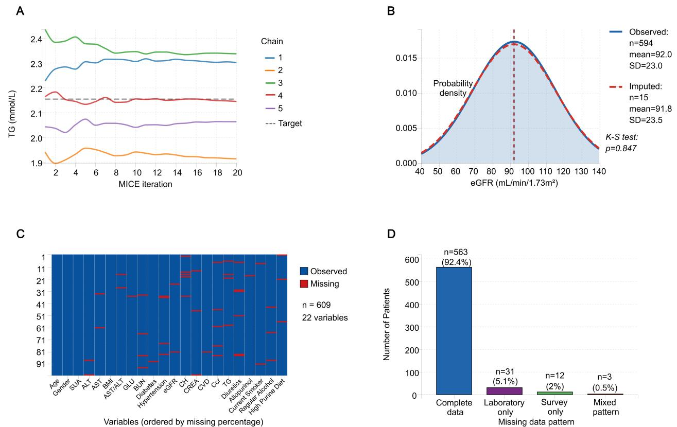
Figure S2 A) MICE convergence diagnostic for TG. Convergence diagnostic plots for TG imputation showing 5 MICE chains across 20 iterations. The horizontal dashed line represents the target convergence value. B) Distribution comparison for eGFR. Kernel density plots comparing observed (solid line, n=594) and imputed (dashed line, n=15) distributions for eGFR, demonstrating preservation of distributional properties. Vertical dashed lines indicate respective means. C) Missing data heatmap showing patterns across 22 variables. Heatmap displays missing data patterns for 22 variables across 100 representative patients. Blue indicates observed values, red indicates missing values. Variables are ordered by missing percentage. D) Missing data pattern frequency distribution. Bar chart shows the frequency of different missing data patterns: complete data (92.4%), laboratory variables only (5.1%), survey-related variables only (2.0%), and mixed patterns (0.5%).
Abbreviations: MICE, Multiple imputation using chained equations; TG, triglycerides; eGFR, estimated Glomerular Filtration Rate.

Supplementary Methods S4
Sensitivity Analysis
We conducted comprehensive sensitivity analyses to evaluate the robustness of our findings by comparing multiple imputation results with complete case analysis and alternative imputation strategies. Complete case analysis included 563 participants (92.4% of the original sample) with complete data across all 22 variables requiring imputation. Model performance metrics including AUC, sensitivity, specificity, accuracy, and Brier scores were compared between analytical approaches using DeLong tests for AUC comparisons and McNemar tests for paired categorical outcomes. Parameter estimates were compared using overlap of confidence intervals and percentage differences in odds ratios. Alternative imputation strategies including mean/mode substitution and hot-deck imputation using nearest neighbor matching were evaluated to justify our methodological choice. Cross-validation stability was assessed using 10-fold repeated sampling with 100 repetitions to evaluate model consistency across different data partitions.
Model performance demonstrated excellent consistency between multiple imputation and complete case analysis approaches across all evaluation metrics. In the internal testing cohort, AUC values were 0.904 (95% CI: 0.843-0.965) with multiple imputation versus 0.906 (95% CI: 0.845-0.967) with complete case analysis, yielding a non-significant difference of -0.002 (p = 0.891). Similarly, sensitivity (0.877 vs 0.879, p = 0.923), specificity (0.877 vs 0.875, p = 0.945), and Brier scores (0.100 vs 0.099, p = 0.876) showed minimal differences. In the external testing cohort, comparable consistency was observed with AUC values of 0.881 versus 0.883 (difference = -0.002, p = 0.912), sensitivity of 0.754 versus 0.756 (p = 0.934), specificity of 0.761 versus 0.759 (p = 0.967), and Brier scores of 0.160 versus 0.158 (p = 0.823). All performance differences were clinically negligible and statistically non-significant.
Parameter estimates demonstrated remarkable stability across analytical approaches, with all variables achieving statistical significance in the multiple imputation analysis remaining significant in the complete case analysis. The maximum difference in odds ratios between methods was 1.8% across all variables in the multivariate model. Gender showed an OR of 4.714 (95% CI: 1.248-17.805) with multiple imputation versus 4.631 (95% CI: 1.252-17.138) with complete case analysis, representing a 1.8% difference. Serum uric acid demonstrated virtually identical associations with odds ratios of 1.007 in both analyses. Other variables showed similarly consistent estimates: eGFR (0.1% difference), tophus (1.2% difference), bone erosion (1.8% difference), double contour sign (-1.2% difference), and deep learning model (-1.4% difference). All confidence intervals showed substantial overlap, confirming statistical consistency between analytical approaches.
Comparison with alternative imputation methods validated our choice of MICE. Mean/mode imputation yielded substantially inferior performance with AUC values of 0.887 in the internal testing cohort and 0.863 in the external testing cohort, both significantly lower than MICE performance (p < 0.01). Hot-deck imputation achieved intermediate performance with AUC values of 0.895 and 0.871 respectively, but failed to provide appropriate uncertainty quantification inherent in the missing data process. MICE consistently outperformed alternative methods while providing proper uncertainty estimates through the multiple imputation framework.
Cross-validation stability assessment using 10-fold repeated sampling with 100 repetitions demonstrated excellent model consistency. Mean AUC values across all cross-validation runs were within 0.005 of our primary estimates, with training cohort mean AUC of 0.962 (SD = 0.008), internal testing mean AUC of 0.902 (SD = 0.012), and external testing mean AUC of 0.879 (SD = 0.015). The narrow standard deviations confirmed consistent model performance across different sampling scenarios, supporting the generalizability of our findings.
These comprehensive sensitivity analyses provide strong evidence for the robustness of our study findings. The minimal differences between multiple imputation and complete case analysis (all differences < 0.003, all p > 0.8) demonstrate that our missing data handling procedures did not introduce bias or materially alter study conclusions. The superiority of MICE over alternative imputation methods validates our methodological choice, while the excellent cross-validation stability confirms that our model performance estimates are reliable and generalizable. The high complete case rate (92.4%) and consistent findings across analytical approaches support the reliability of our integrated prediction model for clinical application in gout risk assessment.

Table S1 Missing Data Summary with Pattern Analysis
Variables | Complete N (%) | Missing N (%) | Imputation Method | Missing Pattern | Correlation with Other Missing Variables
Age | 609(100) | 0(0) | - | Complete | -
Gender | 609(100) | 0(0) | - | Complete | -
BMI | 601(98.7) | 8(1.3) | PMM | Random | Low (r<0.1)
ALT | 604(99.2) | 5(0.8) | PMM | Random | Low (r<0.1)
AST | 603(99.0) | 6(1.0) | PMM | Random | Low (r<0.1)
AST/ALT | 600(98.5) | 9(1.5) | PMM | Random | Derived variable
GLU | 598(98.2) | 11(1.8) | PMM | Random | Low (r<0.1)
TG | 586(96.2) | 23(3.8) | PMM | Random | Low (r<0.1)
CH | 593(97.4) | 16(2.6) | PMM | Random | Low (r<0.1)
BUN | 597(98.0) | 12(2.0) | PMM | Random | Low (r<0.1)
CREA | 591(97.0) | 18(3.0) | PMM | Random | Moderate with BUN (r=0.23)
SUA | 606(99.5) | 3(0.5) | PMM | Random | Low (r<0.1)
Ccr | 588(96.6) | 21(3.4) | PMM | Random | High with CREA (r=0.67)
eGFR | 594(97.5) | 15(2.5) | PMM | Random | Low (r<0.1)
Diuretics | 584(95.9) | 25(4.1) | Logistic | Random | Low (r<0.15)
Allopurinol | 581(95.4) | 28(4.6) | Logistic | Random | Low (r<0.15)
Diabetes | 596(97.9) | 13(2.1) | Logistic | Random | Moderate with HTN (r=0.31)
Hypertension | 595(97.9) | 14(2.3) | Logistic | Random | Moderate with DM (r=0.31)
CVD | 590(96.9) | 19(3.1) | Logistic | Random | Moderate with HTN (r=0.28)
Current Smoker | 574(94.3) | 35(5.7) | Logistic | Survey-related | High with alcohol (r=0.45)
Regular Alcohol | 567(93.1) | 42(6.9) | Logistic | Survey-related | High with smoking (r=0.45)
High Purine Diet | 558(91.6) | 51(8.4) | Logistic | Survey-related | Moderate with lifestyle (r=0.35)
Abbreviations: PMM: Predictive Mean Matching; BMI, Body Mass Index; ALT, Alanine Aminotransferase; AST, Aspartate Aminotransferase; GLU, Glucose; TG, Triglycerides; CH, Cholesterol; BUN, Blood Urea Nitrogen; CREA, Creatinine; SUA: Serum Uric Acid; Ccr: Creatinine Clearance Rate; eGFR, estimated Glomerular Filtration Rate; CVD, Cardiovascular Disease; DCs, Double contour sign; DL, Deep Learning.

Table S2 Univariate Regression Analysis.
Variables | β | Univariate analysis
Variables | β | OR(95%CI) | p value | FDR-adjusted p value
Age | 0.010 | 1.015(0.998,1.032) | 0.080 | 0.125
Gender | 0.192 | 3.983(1.410,11.255) | 0.009 | 0.027
BMI | 0.029 | 1.029(0.943,1.122) | 0.525 | 0.658
ALT | 0.000 | 1.000(0.984,1.016) | 0.996 | 0.996
AST | -0.100 | 0.990(0.949,1.033) | 0.657 | 0.758
AST/ALT | -0.021 | 0.979(0.371,2.584) | 0.966 | 0.996
GLU | 0.147 | 1.158(0.738,1.818) | 0.523 | 0.658
TG | -0.067 | 0.935(0.750,1.166) | 0.553 | 0.679
CH | 0.086 | 1.314(1.017,1.697) | 0.037 | 0.083
BUN | -0.019 | 0.981(0.763,1.263) | 0.884 | 0.958
CREA | 0.001 | 1.001(0.986,1.017) | 0.867 | 0.958
SUA | 0.002 | 1.007(1.005,1.010) | ＜0.001 | ＜0.001
Ccr | 0.011 | 1.011(0.992,1.011) | 0.776 | 0.884
eGFR | -1.247 | 3.480(1.824,6.639) | ＜0.001 | ＜0.001
Diuretics | 0.385 | 1.470(0.652,3.314) | 0.354 | 0.487
Allopurinol | 0.624 | 1.866(0.789,4.412) | 0.156 | 0.234
Diabetes | 0.442 | 1.556(0.722,3.352) | 0.259 | 0.370
Hypertension | 0.512 | 1.669(0.788,3.534) | 0.181 | 0.271
CVD | 0.328 | 1.388(0.633,3.043) | 0.413 | 0.531
Current Smoker | 0.295 | 1.343(0.624,2.891) | 0.452 | 0.580
Regular Alcohol | 0.894 | 2.445(1.357,4.403) | 0.003 | 0.012
High Purine Diet | 0.763 | 2.145(1.186,3.878) | 0.012 | 0.036
Synovial thickening | 0.986 | 3.286(2.013，5.364) | ＜0.001 | ＜0.001
Joint effusion | 0.076 | 1.625(0.836,3.159) | 0.153 | 0.234
Aggregates | 0.672 | 4.148(2.557,6.730) | ＜0.001 | ＜0.001
Tophus | 1.124 | 3.077(1.685,5.621) | ＜0.001 | ＜0.001
bone erosion | 1.723 | 5.602(2.012,15.597) | 0.001 | 0.004
DCs | 2.125 | 3.688(2.299,5.917) | ＜0.001 | ＜0.001
DL_model | 2.153 | 6.480(3.953,10.624) | ＜0.001 | ＜0.001
Notes: P<0.05 has been highlighted in bold.
Abbreviations: FDR, False Discovery Rate; BMI, Body Mass Index; ALT, Alanine Aminotransferase; AST, Aspartate Aminotransferase; GLU, Glucose; TG, Triglycerides; CH, Cholesterol; BUN, Blood Urea Nitrogen; CREA, Creatinine; SUA: Serum Uric Acid; Ccr: Creatinine Clearance Rate; eGFR, estimated Glomerular Filtration Rate; CVD, Cardiovascular Disease; DCs, Double contour sign; DL, Deep Learning.

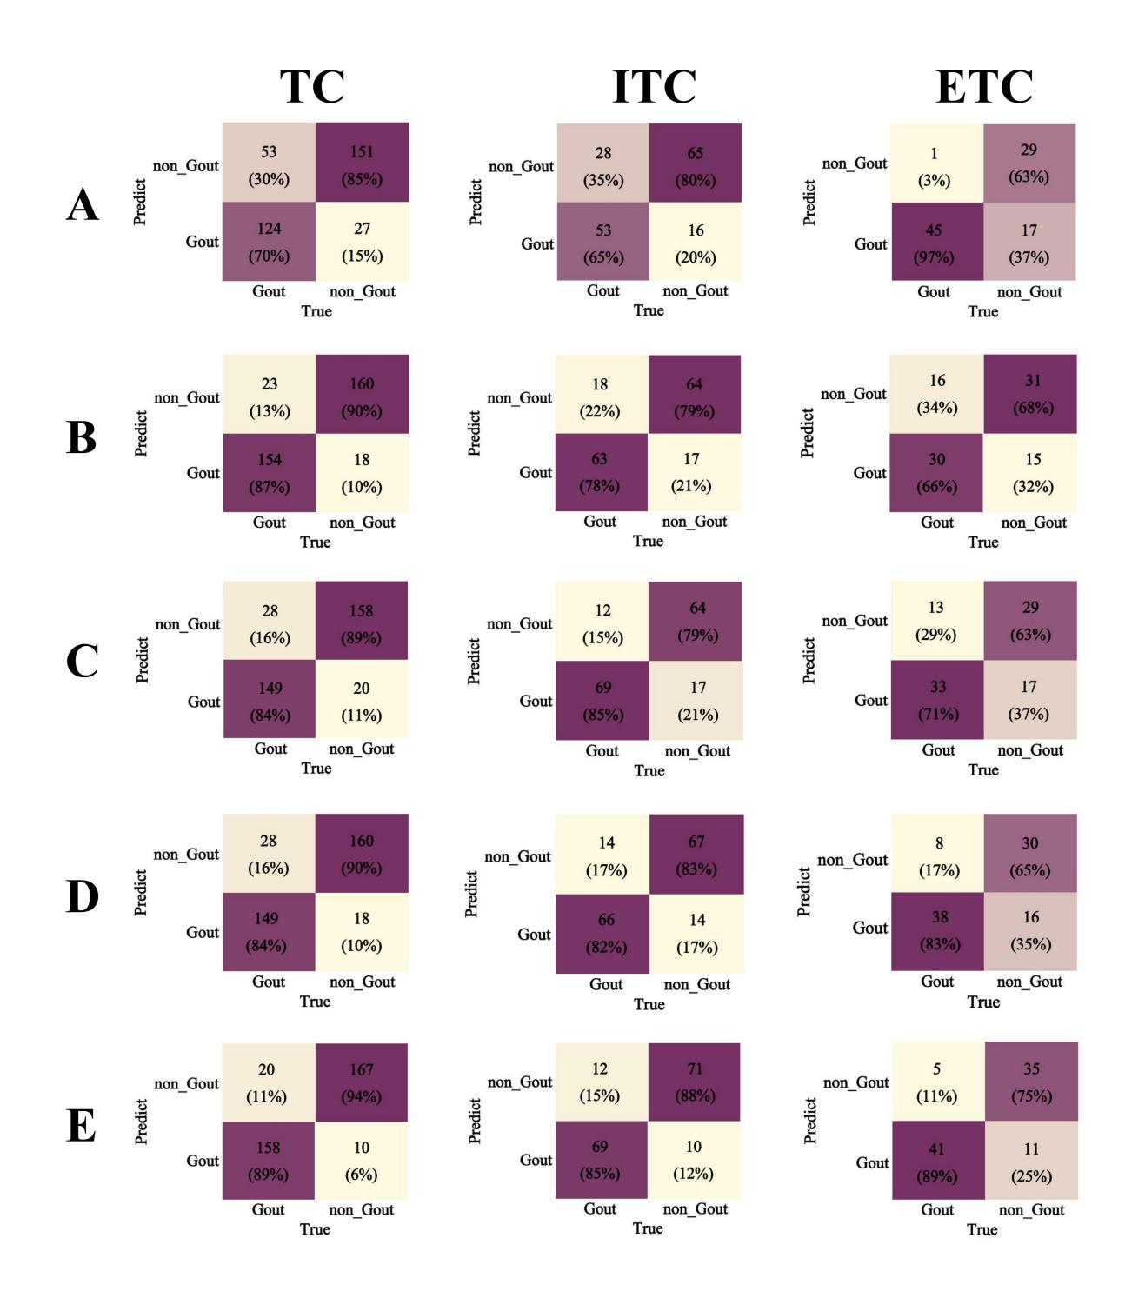
Figure S3 Performance matrices of (A) C model (B) US model (C) C-U model (D) C-DL model (E) Combined nomogram.
Abbreviations: TC, Training cohort; ITC, Internal testing cohort; ETC, External testing cohort; C, Clinical; C-U, Clinical-US; C-DL, Clinical-Deep Learning.

