Supplement
Table S1. Primers for amplification and SNaPshot® analysis
Gene | SNP | Primer sequence (5’-3’)
CYP2C9*2 | rs1799853 | F: CAGGAAGAGATTGAACGTGTGAT
CYP2C9*2 | rs1799853 | R: GGAGAAACAAACTTACCTTGGGA
CYP2C9*2 | rs1799853 | SNaPshot: GTGCACGAGGTCCAGAGATAC
CYP2C9*2 | rs1799853 | F: GTCAGCTTCCTCTTTCTTGCC
CYP2C9*2 | rs1799853 | R: CACCCCTGAAATGTTTCCAA
CYP2C9*2 | rs1799853 | SNaPshot: GGGAAGAGGAGCATTGAGGAC
CYP2C9*8 | rs1057910 | F: GTCAGCTTCCTCTTTCTTGCC
CYP2C9*8 | rs1057910 | R: CACCCCTGAAATGTTTCCAA
CYP2C9*8 | rs1057910 | SNaPshot: CTCAACTCCTCCACAAGGCAG
CYP2C9*29 | rs182132442 | F: GAATTCACTGTAATCAAATATGCTGG
CYP2C9*29 | rs182132442 | R: CATATCTCAGGGTTGTGCTTGTC
CYP2C9*29 | rs182132442 | SNaPshot: TCCTAGGAAAAGCACAACCAA
ABCB1 | rs1045642 | F: ATCGTGTCCCAGGAGCCCAT
ABCB1 | rs1045642 | R: GCTCCCAGGCTGTTTATTTGA
ABCB1 | rs1045642 | SNaPshot: CCTCCTTTGCTGCCCTCAC
PXR | rs1523127 | F: TGCTTGGTGGTAAGTTCTTTGC
PXR | rs1523127 | R: GCCTTTACTTCAGTGGGAATCTC
PXR | rs1523127 | SNaPshot: GAATAAGCTAATACTCCTGTCCTGAA
PXR | rs3814055 | F: AGGGCTGGATTAAAGCATGTACT
PXR | rs3814055 | R: CAAGCCTCTGGCAACAGTAAAG
PXR | rs3814055 | SNaPshot: TTTTTGGCAATCCCAGGTT
POR | rs1135612 | F: AGGGCTGGATTAAAGCATGTACT
POR | rs1135612 | R: CAAGCCTCTGGCAACAGTAAAG
POR | rs1135612 | SNaPshot: TTTTTGGCAATCCCAGGTT
POR | rs1135612 | F: CGGTGGTTGTGGAGTACGAG
POR | rs1135612 | R: GATGAAGCCTATGAAGGGTGC
POR | rs1135612 | SNaPshot: CCGCCGTTCTCCCCG
POR | rs1057868 | F: ACATGGTCTCGCTCTGTTGC
POR | rs1057868 | R: GGTGTTGTTCCATAAGGGTGAG
POR | rs1057868 | SNaPshot: AGCCTTGCAAAGTTCTGAGATC
UGT1A9 | rs28898617 | F: TGAAGAAAGCAAATGTAGCAGG
UGT1A9 | rs28898617 | R: ACCAACACCTTTCCACTCTCAG
UGT1A9 | rs28898617 | SNaPshot: AGCCACGGCAGGGGAACC
ABCB1 | rs4148738 | F: GAAAGACCAGGGAAGAGGAAAT
ABCB1 | rs4148738 | R: ATGGGGACTAAGAAGAATGGAAG
ABCB1 | rs4148738 | SNaPshot: GCTGACCTGTTTTTGGCTGAC
Note: * represents a specific allele or genetic variant of that gene.
Abbreviations: SNP, single nucleotide polymorphism; F, forward; R, reverse;
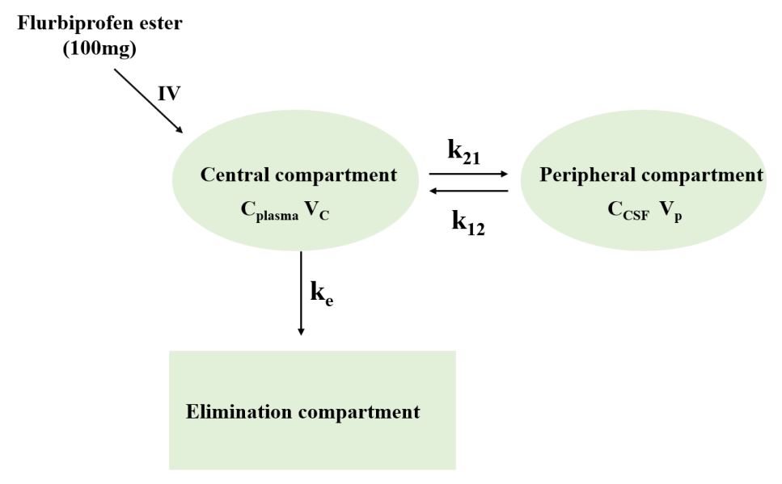
Figure S1. Schematic diagram of the two-compartment model of flurbiprofen.
k₁₂: distribution rate from central to peripheral; k₂₁: distribution rate from peripheral to central; k_{e}: Elimination rate (metabolism/excretion). IV, Intravenous Injection. C_{plasma}, concentration in the plasma; V_{c}, apparent volume of distribution in the plasma; C_{CSF}, concentration in the cerebrospinal fluid; V_{CSF}, apparent volume of distribution in the cerebrospinal fluid.

