Supporting Information
Multimodal Imaging-Guided Tumor Microenvironment-Responsive Nanoplatform for Synergistic Therapy of Pancreatic Cancer
Na Li^{1, 2*}; Haifeng Hu^{2*}; Yuqi Li³ Silong Li³; Guangyue Shi¹; Xiaoyang Yu¹; Liguo Hao¹

¹Department of Molecular Imaging, School of Medical Technology, Qiqihar Medical University, Qiqihar, Heilongjiang, 161006, People’s Republic of China; ²Department of Imaging Medicine and Nuclear Medicine, School of Clinical Medicine, Jiamusi University, Jiamusi, Heilongjiang, 154002，People’s Republic of China; ³Medical Imaging, School of Medical Technology, Qiqihar Medical University, Qiqihar, Heilongjiang, 161006, People’s Republic of China.

*These authors contributed equally to this work.

Correspondence: Liguo Hao, Department of Molecular Imaging, School of Medical Technology, Qiqihar Medical University, No. 333, Bukui North Street, Jianhua District, Qiqihar City, Heilongjiang Province, 161006, People’s Republic of China, Email haoliguo@qmu.edu.cn.

Figure S1 XRD patterns of HM NPs.

Figure S2 Raman mapping of HM NPs.

Figure S3 (a) UV absorption spectrum of ICG; (b) UV absorption spectrum of DOX; (c) Standard curve of DOX; (d) Standard curve of ICG.

Figure S4 Temperature changes of Free ICG in 5 hot and cold cycling cycles.

Figure S5 Photothermal Conversion Efficiency of HMP-ICG&DOX NPs.

Figure S6 Photothermal Conversion Efficiency of Free ICG.

Figure S7 In vivo distribution of manganese within 24 h following injection of HMP-ICG&DOX NPs.

Figure S8 Quantification of MR signal intensity in tumour tissue of nude mice within 12 h following injection of HMP-ICG&DOX NPs.

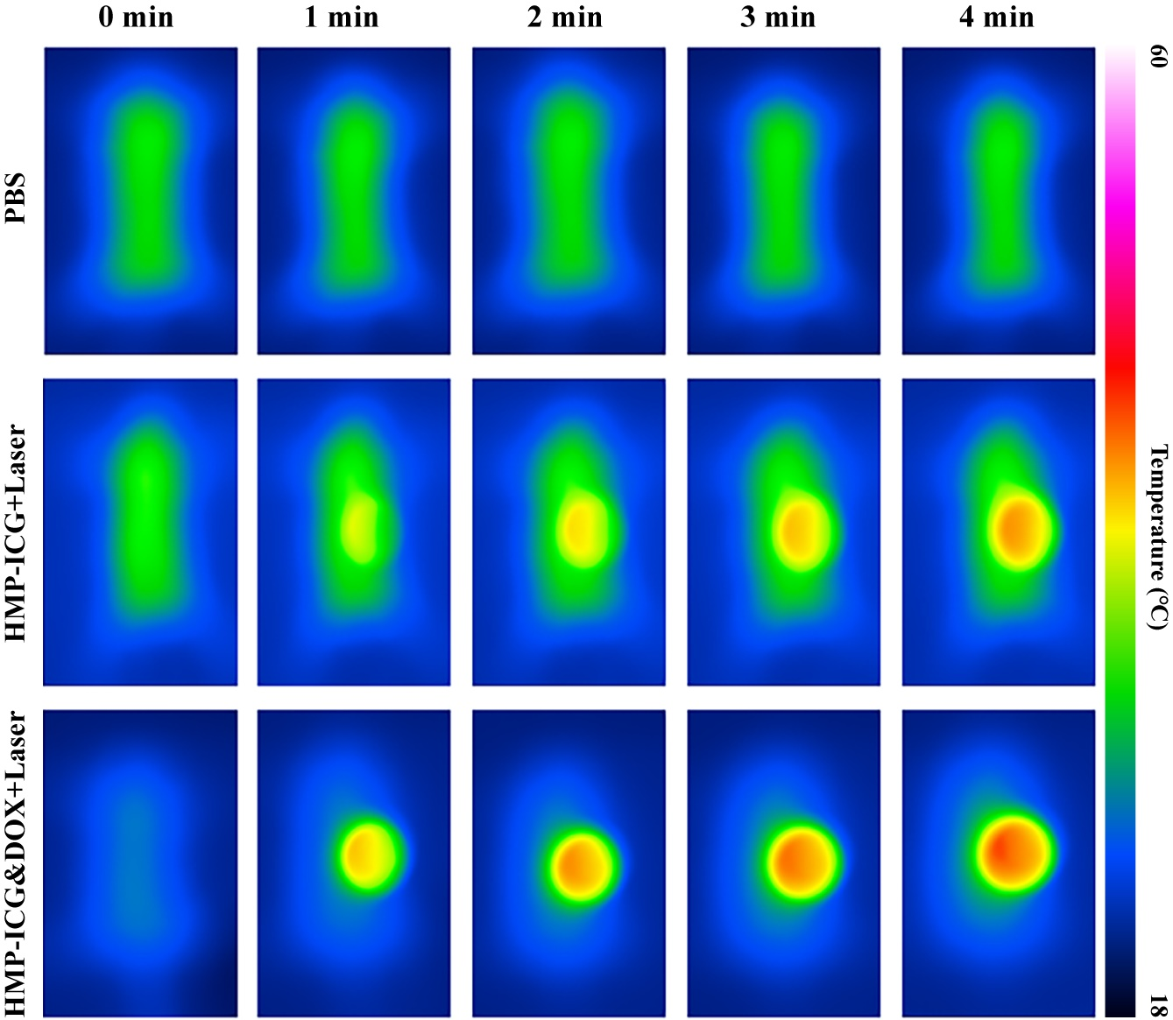
Figure S9 Infrared thermal imaging in nude mice.

