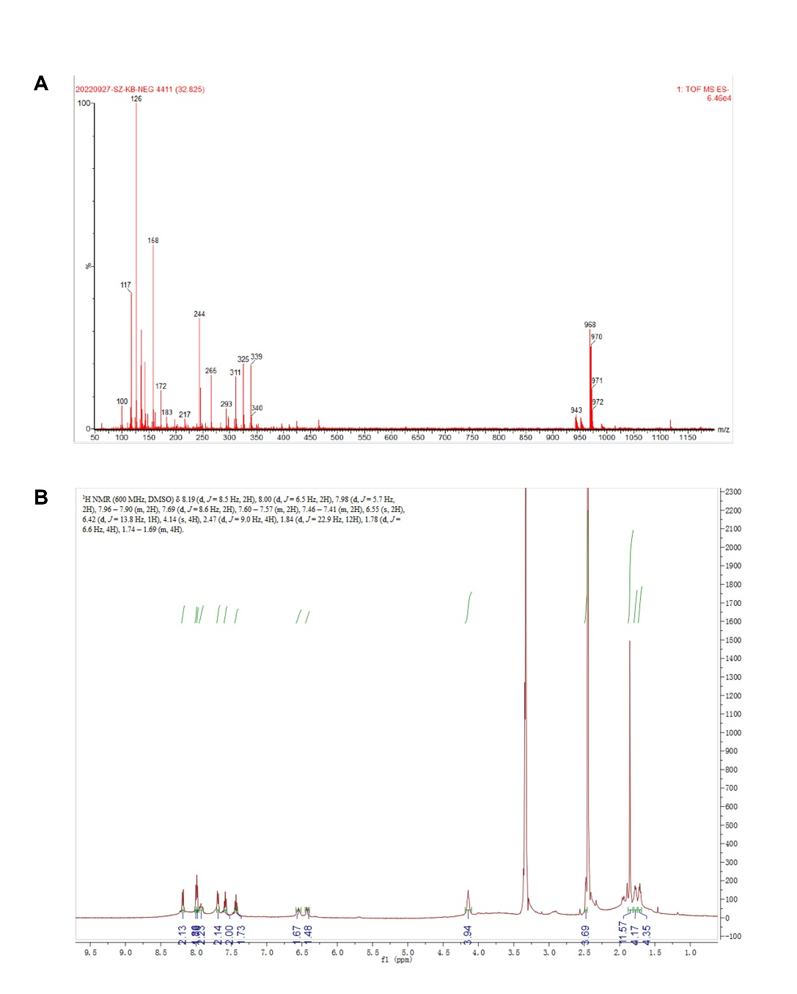
Figure S1. Characterization of the conjugate (ICG-CDDP) by mass spectrometry (A) and ¹H-NMR (B).

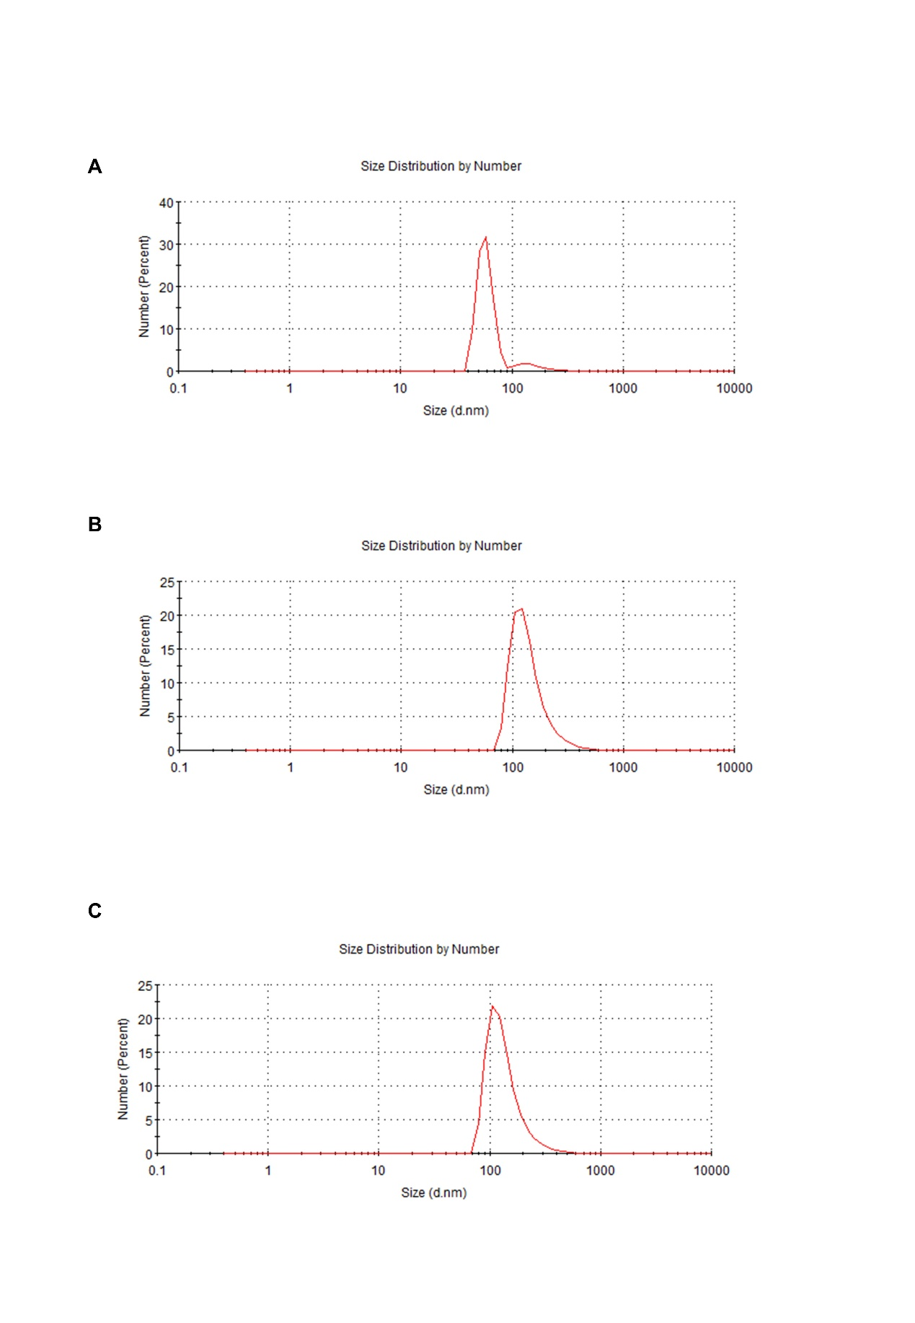
Figure S2. Size distributions of MSN-NH₂ (A), HMs (B), and ICG-CDDP@HMs (C).

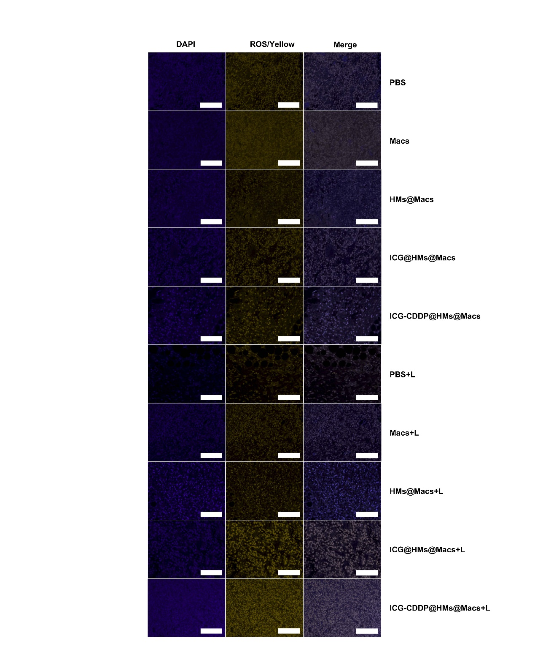
Figure S3. Microscopy images of DHE (yellow)-stained tumor tissues from mice that received different treatments. The nuclei were stained with DAPI (blue). Scale bar, 100 μm.

