Supplementary Figure 1 The enriched gene pathways of fibroblasts
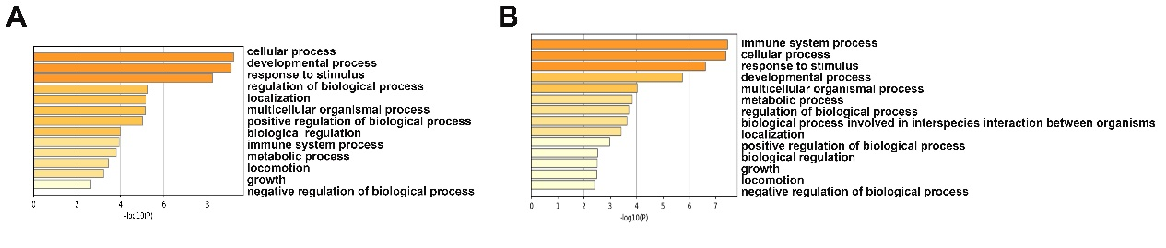
(A). The enriched gene pathways of LUM+ FAP cells. (B). The enriched gene pathways of FBN1+ FAP cells.

Supplementary Figure 2 SASP Levels Correlate with Immune Infiltration in Sarcopenic Muscle
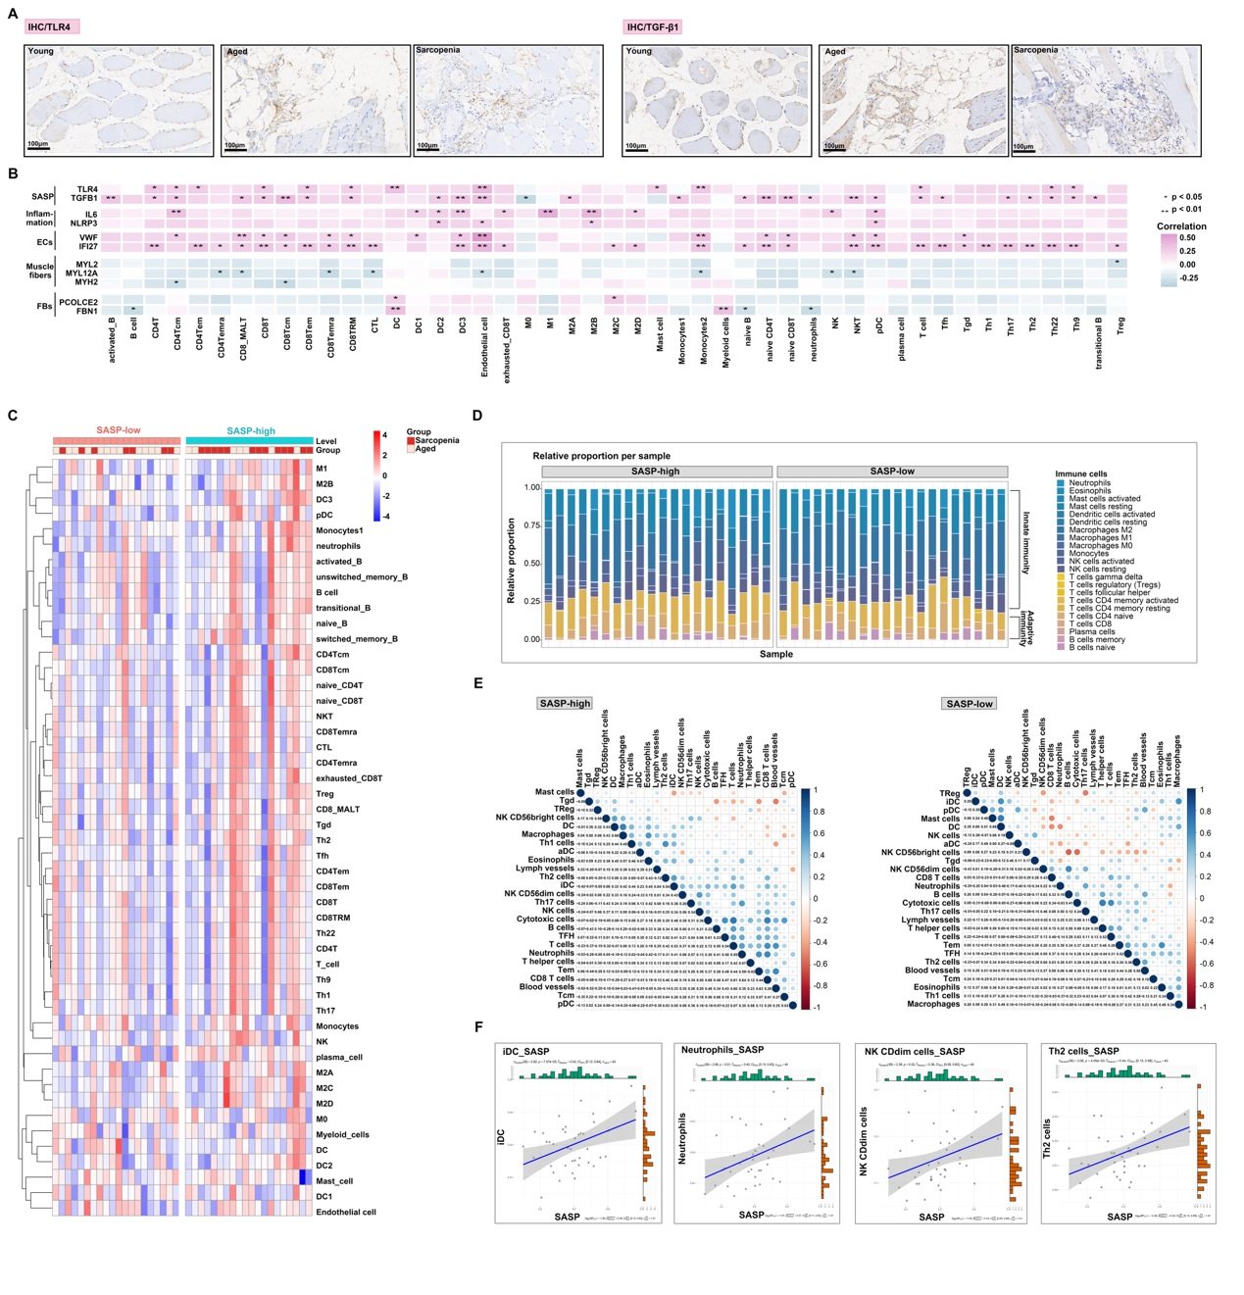
(A) Immunohistochemical staining for TLR4 and TGF-β1 expression in aged, young, and sarcopenia groups. (B) Correlations between SASP, inflammatory genes, endothelial cells, muscle fibers, and fibroblasts (columns) and SASP-related genes (rows). (C) Heatmap illustrating the expression levels of immune cells in SASP-low and SASP-high groups. (D) Stacked bar plots depicting the relative proportions of immune cells in SASP-low and SASP-high groups. (E) Correlation analysis of different immune cells in SASP-low and SASP-high groups. (F) Relationship between immune cells (iDC, neutrophils, NK CDdim cells, and Th2 cells) and SASP. *P < 0.05; **P < 0.01.

