Supplementary Table 1. Patient Characteristics and Disease Stage-Specific Clinical Features
No. | Sex | ANCA§ | Asthma |  |  |  | L-EGPA |  |  |  |  |  | S-EGPA |  |  |  | Organ involvement
No. | Sex | ANCA§ | Age | Peripheral blood EOS (%) | Induced sputum EOS (%) | FEV1%pred |  | Age |  | Peripheral blood EOS (%) | Induced sputum EOS (%) | FEV1%pred | Age | Peripheral blood EOS (%) | Induced sputum EOS (%) | FEV1%pred | Organ involvement
1 | M | NEG | 46 | 4.2 | 14.5 | 78.1 | 50 |  | 11.8 |  | 37.5 | 71.2 | 51 | 13.5 | 23.0 | 68.8 | Lung, upper airway, heart
2 | F | NEG | 44 | 10.8 | 15.6 | 83.2 | 50 |  | 15.3 |  | 55.3 | 89.7 | 51 | 17.5 | 35.0 | 96.9 | Lung, upper airway, skin
3 | F | NEG | 31 | 3.5 | 11.5 | 72.3 | 50 |  | 13.1 |  | 73.5 | 74.0 | 53 | 19.8 | 63.0 | 78.1 | Lung, upper airway, skin
4 | M | NEG | 28 | 18.9 | 31.0 | 84.6 | 34 |  | 23.5 |  | 89.0 | 81.1 | 36 | 28.9 | 43.0 | 79.6 | Lung, upper airway, skin
5 | M | NEG | 49 | 0.3 | 21.5 | 38.0 | 59 |  | 10.2 |  | 66.0 | 41.7 | 61 | 24.2 | 41.5 | 51.5 | Lung, upper airway, skin, gastrointestinal tract, peripheral nerve
6 | M | NEG | 60 | 0.3 | 3.5 | 55.9 | 63 |  | 12.2 |  | 91.5 | 58.9 | 63 | 14.8 | 9.0 | 61.3 | Lung, upper airway, skin
7 | F | NEG | 60 | 9.3 | 6.0 | 79.1 | 60 |  | 16.5 |  | 48.0 | 81.3 | 61 | 18.0 | 32.0 | 83.4 | Lung, upper airway, gastrointestinal tract
8 | M | NEG | 55 | 5.8 | 36.7 | 78.9 | 60 |  | 10.9 |  | 86.8 | 79.6 | 62 | 12.7 | 14.3 | 89.2 | Lung, upper airway, heart
9 | M | POS | 38 | 5.3 | 1.5 | 71.4 | 56 |  | 12.8 |  | 47.0 | 80.7 | 59 | 16.1 | 44.5 | 64.7 | Lung, upper airway, gastrointestinal tract, skin
10 | M | NEG | 27 | 4.3 | 6.0 | 78.3 | 38 |  | 13.7 |  | 75.0 | 81.4 | 39 | 26.5 | 46.0 | 86.3 | Lung, upper airway, skin
11 | F | NEG | 46 | 0.1 | 6.0 | 69.3 | 48 |  | 49.2 |  | 44.5 | 71.1 | 57 | 56.1 | 34.0 | 76.8 | Lung, upper airway, gastrointestinal tract, skin
12 | M | NEG | 20 | 2.5 | 2.5 | 88.0 | 21 |  | 7.1 |  | 60.5 | 79.4 | 22 | 7.5 | 21.0 | 93.9 | Lung, upper airway, gastrointestinal tract, skin
13 | F | NEG | 60 | 12.1 | 10.5 | 31.5 | 69 |  | 16.8 |  | 70.5 | 24.9 | 72 | 20.2 | 38.5 | 40.9 | Lung, upper airway, gastrointestinal tract
Table legend: M, male; F, female; NEG, negative; POS, positive; EOS, eosinophils. § Each patient underwent ANCA testing at least once during the L-EGPA stage and at least once during the S-EGPA stage. ANCA was considered negative only if all tests performed in both stages were negative.

Asthma diagnosis
 | 1 | 2 | 3 | 4 | 5 | 6 | 7 | 8 | 9 | 10 | 11 | 12 | 13
Wheeze, shortness of breath, chest tightness and/or cough | Yes | Yes | Yes | Yes | Yes | Yes | Yes | Yes | Yes | Yes | Yes | Yes | Yes
Positive bronchodilator responsiveness (reversibility) test with spirometry (or PEF) | NA | No | No | Yes | Yes | Yes | NA | Yes | No | No | NA | Yes | NA
Excessive variability in twice-daily PEF over 2 weeks | NA | NA | NA | NA | NA | NA | NA | NA | NA | NA | NA | NA | NA
Increase in lung function after 4 weeks of treatment | Yes | Yes | Yes | Yes | Yes | Yes | Yes | Yes | Yes | Yes | Yes | Yes | Yes
Positive bronchial challenge test | No | NA | NA | Yes | NA | NA | Yes | NA | NA | Yes | Yes | NA | Yes
L-EGPA classification
 | 1 | 2 | 3 | 4 | 5 | 6 | 7 | 8 | 9 | 10 | 11 | 12 | 13
History of asthma | Yes | Yes | Yes | Yes | Yes | Yes | Yes | Yes | Yes | Yes | Yes | Yes | Yes
Eosinophils >10% of the total white blood cell count | Yes | Yes | Yes | Yes | Yes | Yes | Yes | Yes | Yes | Yes | Yes | No | Yes
Mononeuropathy or polyneuropathy | No | No | No | No | No | No | No | No | No | No | No | No | No
Pulmonary infiltrates | Yes | Yes | Yes | Yes | Yes | Yes | Yes | Yes | Yes | Yes | Yes | Yes | Yes
Paranasal sinus abnormality | Yes | Yes | Yes | Yes | Yes | Yes | Yes | Yes | Yes | Yes | Yes | Yes | Yes
Histopathology showing eosinophil degranulation | Yes | Yes | Yes | Yes | NA | Yes | NA | Yes | Yes | Yes | Yes | Yes | Yes
Supplementary Table 2. Patient characteristics at diagnosis
Table legend: PEF, peak expiratory flow; NA, not available.

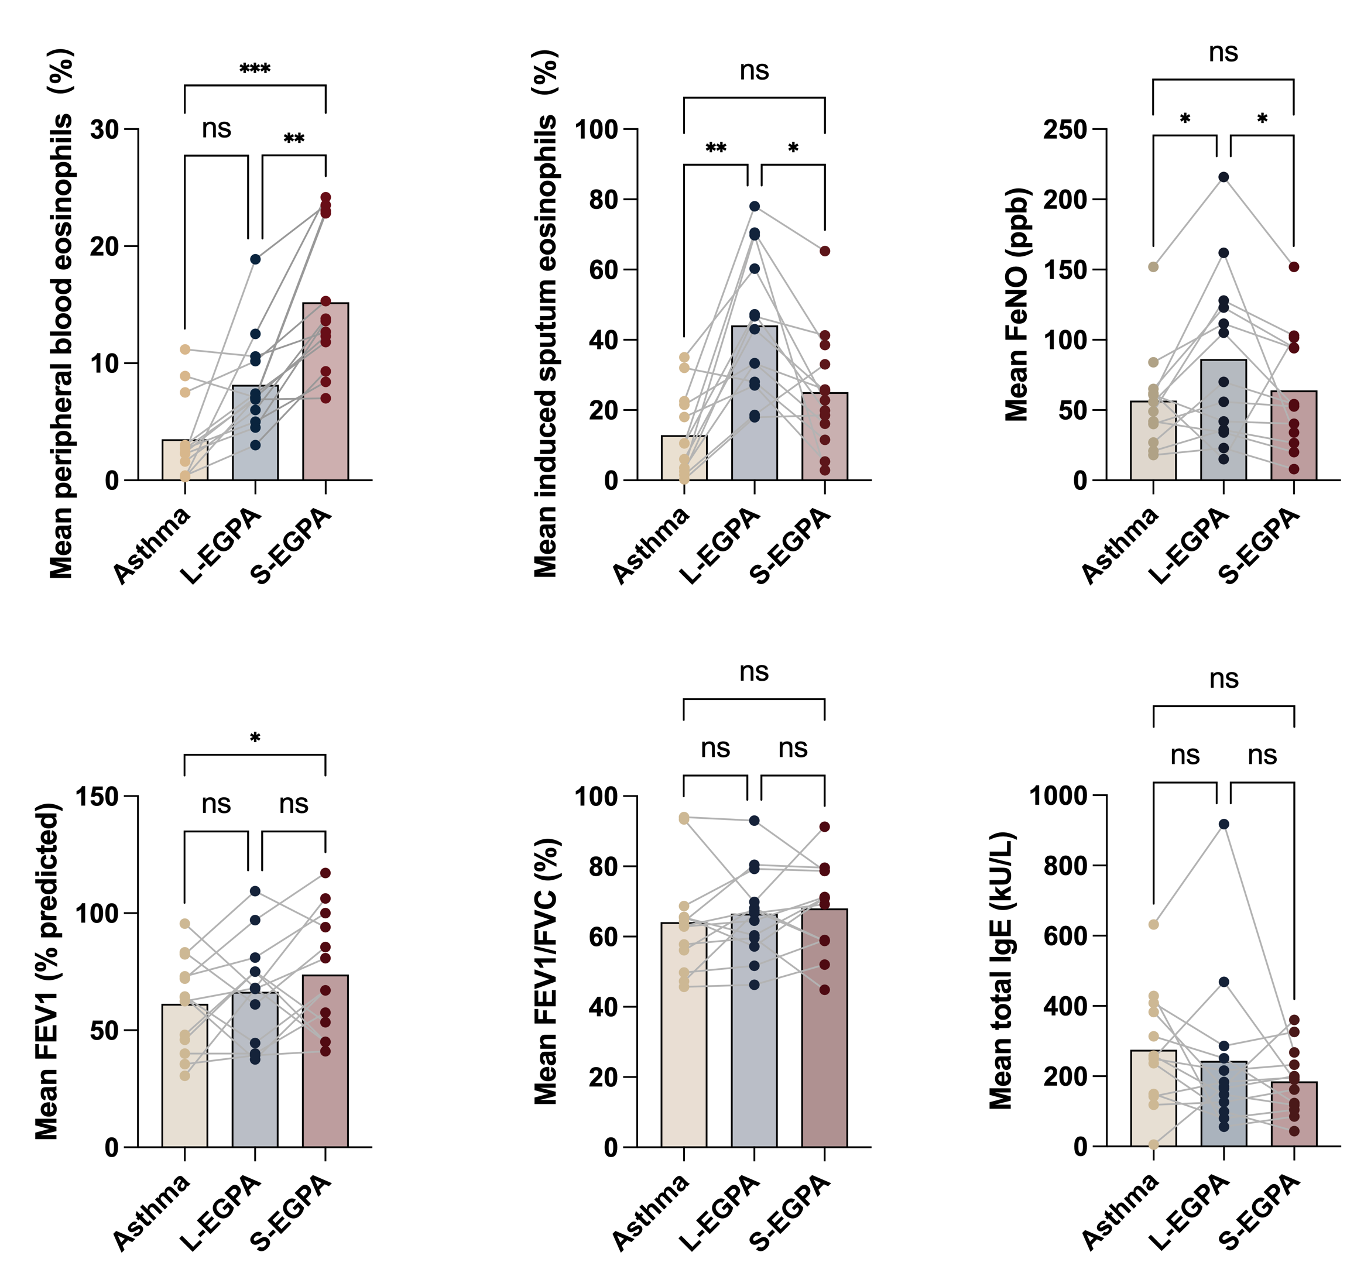
Supplementary Figure 1. Analysis of Key Indicator Means Across Disease Stages
Figure legend: Means analysis of peripheral blood eosinophils (%), induced sputum eosinophils (%), FeNO, percent predicted FEV₁, FEV₁/FVC ratio, and total IgE. Significance is indicated as: ns, not significant; *p.adj < 0.05; **p.adj < 0.01; ***p.adj < 0.001. Sample size: N=13
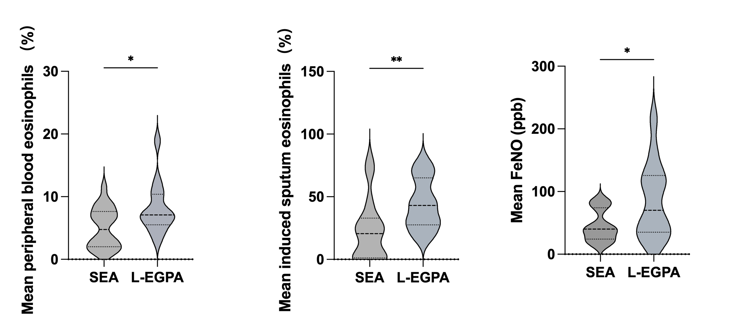
Supplementary Figure 2. Comparison of Mean Eosinophilic Inflammatory Markers Between Severe Eosinophilic Asthma and L-EGPA
Figure legend: Comparison of eosinophilic inflammatory indicators between severe eosinophilic asthma and L-EGPA. SEA: severe eosinophilic asthma. Significance is indicated as: *p < 0.05; **p < 0.01. SEA sample size: N=27, all with disease duration >6 years and not progressed to EGPA; L-EGPA sample size: N=13.
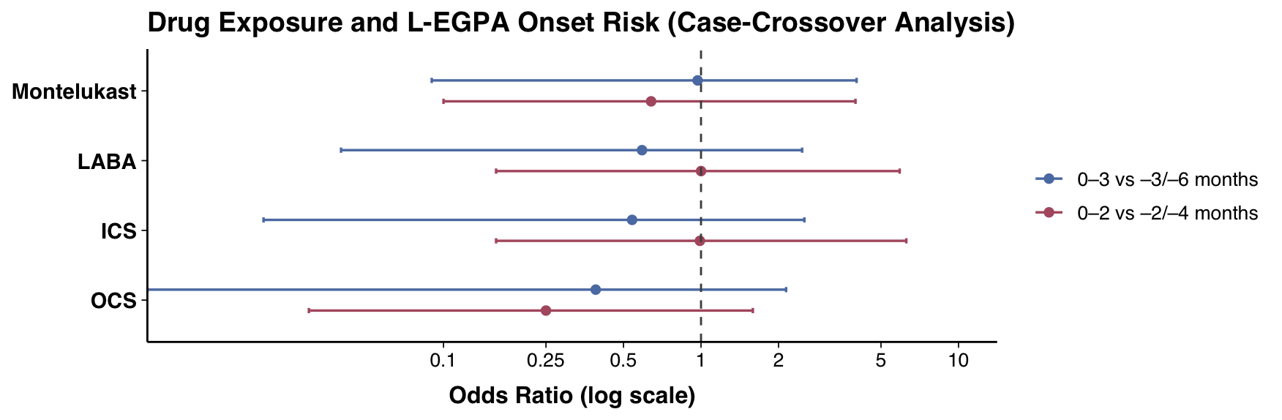Supplementary Figure 3. Pharmacological factors potentially associated with the onset of EGPA
Figure legend: LABA, Long-Acting Beta-Agonist; ICS, Inhaled Corticosteroid; OCS, Oral Corticosteroid.

