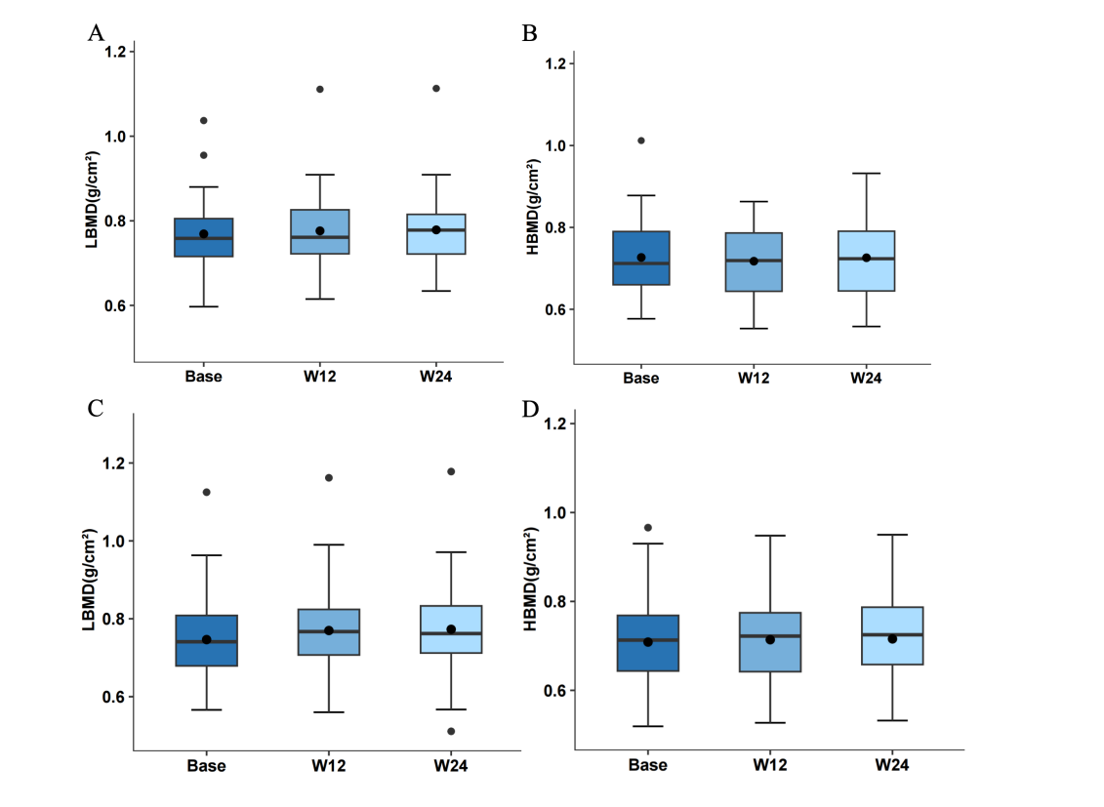
Fig S1. The value in lumbar BMD (LBMD) and hip BMD (HBMD)
(A-B The values of LBMD and HBMD in the minodronate group. C-D The values of LBMD and HBMD in the alendronate group.).
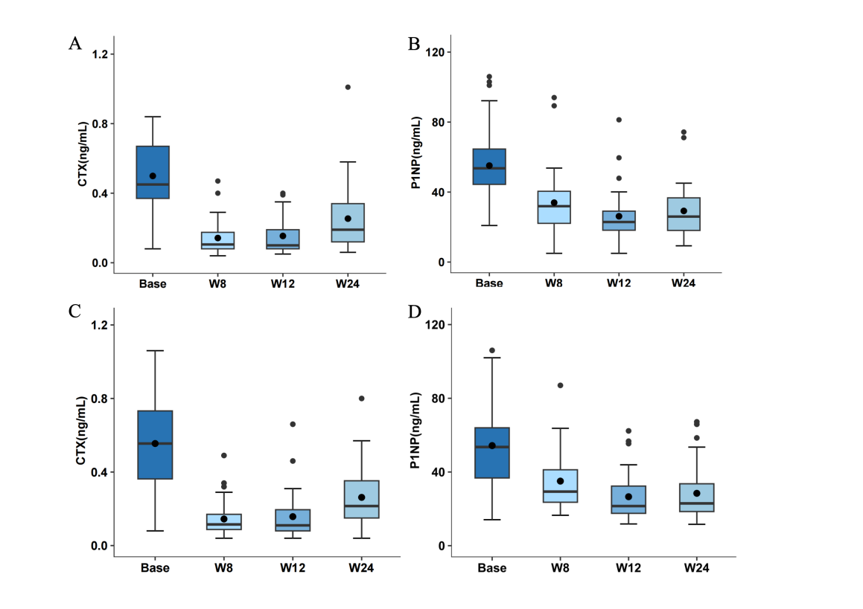
Fig S2. The level in CTX and P1NP after treatment
(A-B The concentration of CTX and P1NP in the minodronate group. C-D The concentration of CTX and P1NP in the alendronate group.).
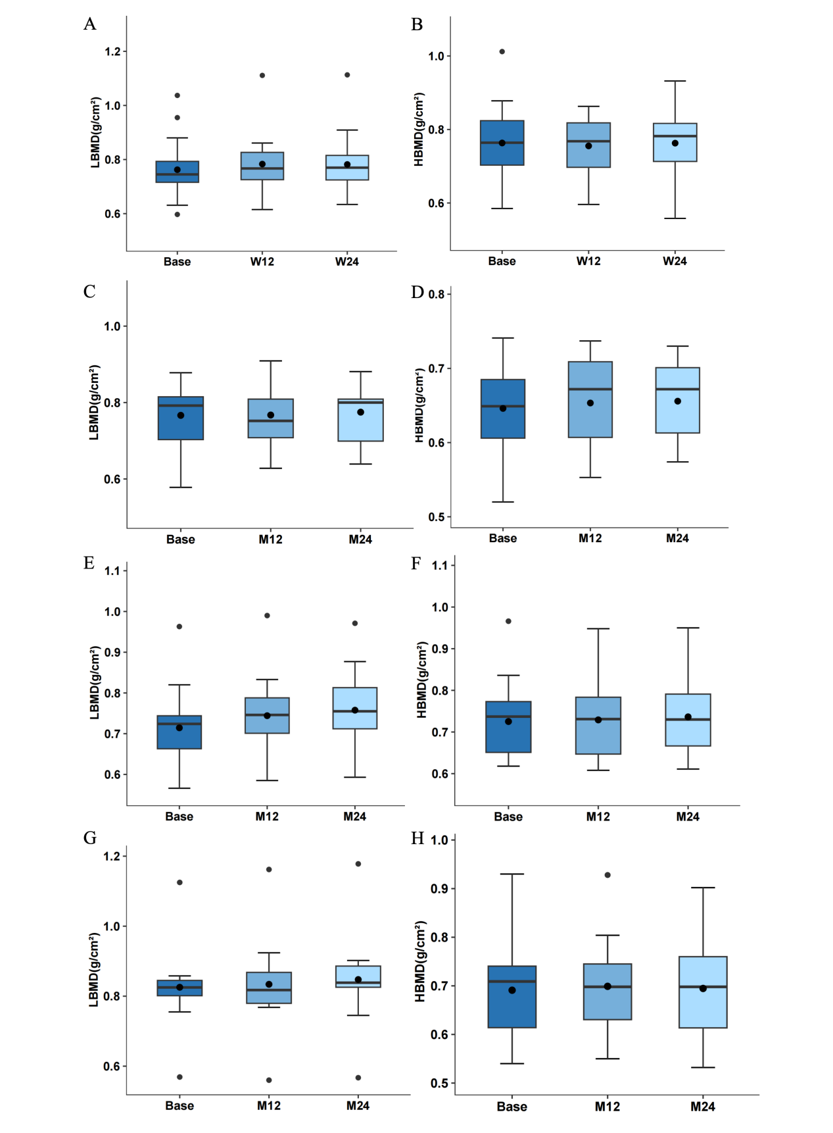
Fig S3. Effects of age on lumbar BMD (LBMD) and hip BMD (HBMD)
- B The values of LBMD and HBMD in the senior minodronate group. C-D The values of LBMD and HBMD in the older minodronate group. E-F The values of LBMD and HBMD in the senior alendronate group. G-H The values of LBMD and HBMD in the older alendronate group. ).

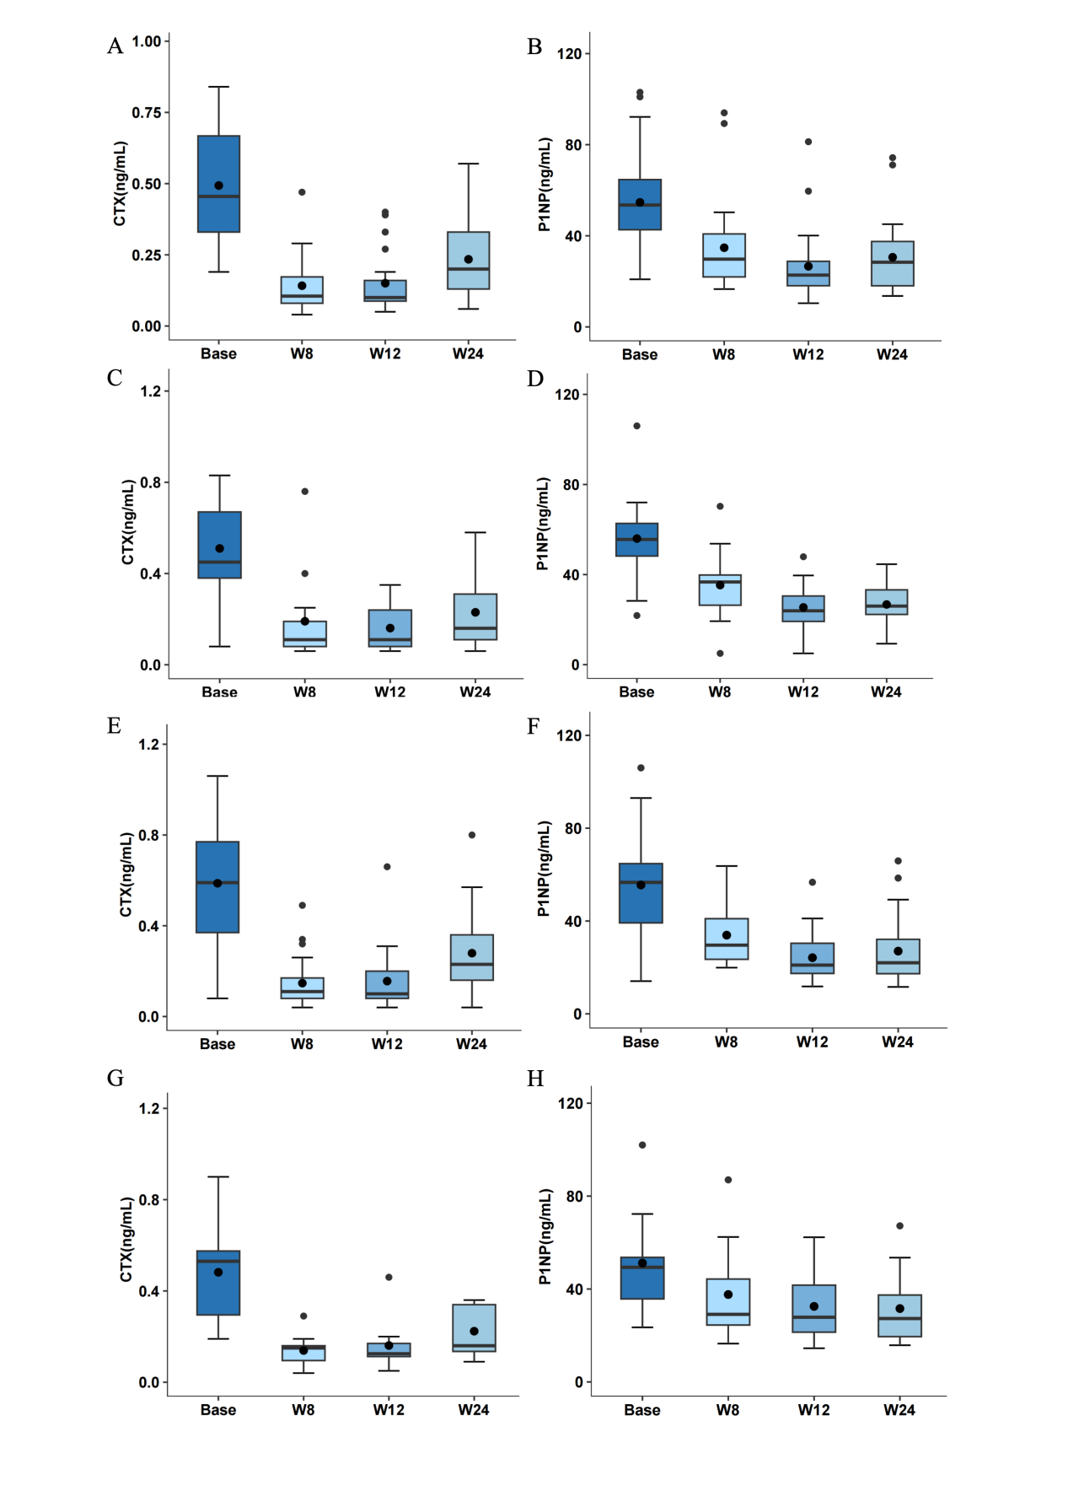
Fig S4. Effects of age on CTX and P1NP
(A-B The concentration of CTX and P1NP in the senior minodronate group. C-D The concentration of CTX and P1NP in the older minodronate group. E-F The concentration of CTX and P1NP in the senior alendronate group. G-H The concentration of CTX and P1NP in the older alendronate group. ).
Table S1 Baseline Characteristics of patients of different ages
 | Minodronate |  | Alendronate
 | < 75 year | ≥ 75 year | < 75 year | ≥ 75 year
N | 24（64.84） | 13（35.14） | 25（67.57） | 12（32.43）
Age (years) | 61.42±5.11 | 75.85±1.14 | 62.38±5.42 | 76.82±1.66
Time since menopause (years) | 49.21±2.60 | 50.77±7.76 | 48.81±5.39 | 50.46±3.72
Body mass index (kg/m² ) | 24.77±3.11 | 25.51±2.20 | 24.52±2.70 | 25.16±3.12
VAS score [back pain] (mm) | 36.63±7.57 | 40.77±9.54 | 40.38±5.99 | 44.00±9.66
Creatinine (umol/L) | 66.75±9.16 | 73.93±7.36 | 66.42±10.08 | 68.82±8.75
Bone mineral density (g/cm²)
Lumbar spine | 0.76±0.10 | 0.77±0.09 | 0.72±0.08 | 0.79±0.10
Total hip | 0.75±0.13 | 0.66±0.65 | 0.70±0.11 | 0.69±0.11
Bone turnover markers
Serum OC (ng/mL) | 20.38±6.49 | 23.85±8.45 | 20.46±7.77 | 20.45±11.45
Serum P1NP (ng/mL) | 56.48±21.99 | 55.98±20.75 | 55.52±21.39 | 58.90±33.50
Serum CTX (ng/mL) | 0.49±0.19 | 0.51±0.21 | 0.61±0.30 | 0.48±0.22
Ca (mmol/L) | 2.46±0.07 | 2.46±0.09 | 2.44±0.05 | 2.43±0.06
P (mmol/L) | 1.26±0.17 | 1.21±0.17 | 1.23±0.12 | 1.23±0.16

Table S2 The changes in the VAS scores of the two groups

 | Baseline | 1 weeks | 2 weeks | 3 weeks | 4 weeks | 5 weeks | 6 weeks | 7 weeks | 8 weeks | 9 weeks | 10 weeks | 11weeks
Min
VAS | 38.65±7.79 | 38.65±7.79 | 36.89±7.68 | 36.43±7.42 | 35.03±7.69 | 34.05±7.58 | 33.05±7.41 | 32.00±7.55 | 30.84±7.41 | 29.89±7.56 | 28.11±7.49 | 27.57±7.69
P |  | 1 | 0.32 | 0.21 | 0.041 | 0.01 | 0.002 | <0.001 | <0.001 | <0.001 | <0.001 | <0.001
Reduce |  |  | 1.76±0.83 | 2.21±0.95 | 3.62±1.14 | 4.59±1.14 | 5.59±1.61 | 6.65±1.64 | 7.81±1.56 | 8.76±1.44 | 10.54±1.69 | 11.08±1.52
Aln
VAS | 42.03±8.78 | 41.97±8.80 | 40.65±8.54 | 39.51±8.59 | 38.73±8.67 | 37.76±8.56 | 36.7±8.45 | 35.86±8.58 | 34.97±8.64 | 34.19±8.52 | 32.95±8.83 | 32.16±8.73
P |  | 0.979 | 0.493 | 0.212 | 0.101 | 0.034 | 0.008 | 0.002 | <0.001 | <0.001 | <0.001 | <0.001
Reduce |  | 0.05±0.33 | 1.38±1.14 | 2.51±1.12 | 3.30±1.37 | 4.27±1.22 | 5.32±1.45 | 6.16±1.32 | 7.05±1.27 | 7.84±1.44 | 9.08±1.50 | 9.86±1.29
P(M:A) |  | 0.043 | 0.002 | 0.594 | 0.351 | 0.63 | 0.764 | 0.841 | 0.437 | 0.738 | 0.277 | 0.237

Table S3 The changes of LBMD, HBMD, CTX and P1NP from baseline in the minodronate and alendronate group

CTX | W8 | W12 | W24
Min（%） | 66.43±22.32 | 64.88±26.59 | 46.14±34.69
Aln（%） | 67.28±29.89 | 63.09±42.39 | 41.25±61.11
p | 0.581 | 0.447 | 0.568

P1NP | W8 | W12 | W24
Min（%） | 36.21±20.76 | 50.35±20.87 | 44.82±20.62
Aln（%） | 33.35±29.65 | 46.04±33.88 | 44.11±31.30
p | 0.835 | 0.240 | 0.228

LBMD | W12 | W24
Min（%） | 2.02±7.16 | 2.42±7.54
Aln（%） | 3.13±4.23 | 4.84±3.88
p | 0.158 | 0.103

HBMD | W12 | W24
Min（%） | 1.03±6.24 | 1.58±7.01
Aln（%） | 0.81±3.27 | 3.13±14.44
p | 0.078 | 0.621

