Supplementary Material
Is sham acupuncture equally effective for primary insomnia?
A Bayesian network meta-analysis
Table S1. PRISMA 2020 checklist
Table S2. Detailed search strategy in each database.
Table S3. Excluded studies, with reasons.
Table S4. Characteristics of the studies included.
Table S5. Details of Acupuncture Treatment Method.
Table S6. Sensitivity analysis for PSQI at treatment endpoint.
Table S7. Sensitivity analysis for PSQI at the follow-up visit.
Table S8. Network meta-regression beta estimates for PSQI at treatment endpoint.
Table S9. Network meta-regression beta estimates for PSQI at the follow-up visit.
Table S10. The quality of evidence for PSQI at treatment endpoint.
Table S11. The quality of evidence for TST at treatment endpoint.
Table S12. The quality of evidence for WASO at treatment endpoint.
Table S13. The quality of evidence for SE at treatment endpoint.
Table S14. The quality of evidence for PSQI at the follow-up visit.
Figure S1. Risk of bias summary for all included studies
Figure S2. Funnel plot for PSQI at treatment endpoint.
Figure S3. Network plot and league table for PSQI at the follow-up visit.
Figure S4. Funnel plot for PSQI at the follow-up visit.
Figure S5. SUCRA plot for PSQI at the follow-up visit.
Figure S6. Network plot and league table for TST at treatment endpoint.
Figure S7. Funnel plot for TST at treatment endpoint.
Figure S8. SUCRA plot for TST at treatment endpoint.
Figure S9. Network plot and league table for SE at treatment endpoint.
Figure S10. Funnel plot for SE at treatment endpoint.
Figure S11. SUCRA plot for SE at treatment endpoint.
Figure S12. Network plot and league table for WASO at treatment endpoint.
Figure S13. Funnel plot for WASO at treatment endpoint.
Figure S14. SUCRA plot for WASO at treatment endpoint.

Table S1. PRISMA 2020 checklist
Section and Topic | Item | Checklist item | Location where item is reported
TITLE
Title | 1 | Identify the report as a systematic review. | P1
ABSTRACT
Abstract | 2 | See the PRISMA 2020 for Abstracts checklist. | P2-3
INTRODUCTION
Rationale | 3 | Describe the rationale for the review in the context of existing knowledge. | P3-5
Objectives | 4 | Provide an explicit statement of the objective(s) or question(s) the review addresses. | P5-6
METHODS
Eligibility criteria | 5 | Specify the inclusion and exclusion criteria for the review and how studies were grouped for the syntheses. | P7-9
Information sources | 6 | Specify all databases, registers, websites, organisations, reference lists and other sources searched or consulted to identify studies. Specify the date when each source was last searched or consulted. | P6
Search strategy | 7 | Present the full search strategies for all databases, registers and websites, including any filters and limits used. | P7, Table S2
Selection process | 8 | Specify the methods used to decide whether a study met the inclusion criteria of the review, including how many reviewers screened each record and each report retrieved, whether they worked independently, and if applicable, details of automation tools used in the process. | P9-10
Data collection process | 9 | Specify the methods used to collect data from reports, including how many reviewers collected data from each report, whether they worked independently, any processes for obtaining or confirming data from study investigators, and if applicable, details of automation tools used in the process. | P9-10
Data items | 10a | List and define all outcomes for which data were sought. Specify whether all results that were compatible with each outcome domain in each study were sought (e.g. for all measures, time points, analyses), and if not, the methods used to decide which results to collect. | P9-10
Data items | 10b | List and define all other variables for which data were sought (e.g. participant and intervention characteristics, funding sources). Describe any assumptions made about any missing or unclear information. | P9-10
Study risk of bias assessment | 11 | Specify the methods used to assess risk of bias in the included studies, including details of the tool(s) used, how many reviewers assessed each study and whether they worked independently, and if applicable, details of automation tools used in the process. | P9
Effect measures | 12 | Specify for each outcome the effect measure(s) (e.g. risk ratio, mean difference) used in the synthesis or presentation of results. | P10
Synthesis methods | 13a | Describe the processes used to decide which studies were eligible for each synthesis (e.g. tabulating the study intervention characteristics and comparing against the planned groups for each synthesis (item #5)). | P7
Synthesis methods | 13b | Describe any methods required to prepare the data for presentation or synthesis, such as handling of missing summary statistics, or data conversions. | P10-11
Synthesis methods | 13c | Describe any methods used to tabulate or visually display results of individual studies and syntheses. | P10-11
Synthesis methods | 13d | Describe any methods used to synthesize results and provide a rationale for the choice(s). If meta-analysis was performed, describe the model(s), method(s) to identify the presence and extent of statistical heterogeneity, and software package(s) used. | P10-11
Synthesis methods | 13e | Describe any methods used to explore possible causes of heterogeneity among study results (e.g. subgroup analysis, meta-regression). | P11
Synthesis methods | 13f | Describe any sensitivity analyses conducted to assess robustness of the synthesized results. | P11
Reporting bias assessment | 14 | Describe any methods used to assess risk of bias due to missing results in a synthesis (arising from reporting biases). | P11
Certainty assessment | 15 | Describe any methods used to assess certainty (or confidence) in the body of evidence for an outcome. | P12
RESULTS
Study selection | 16a | Describe the results of the search and selection process, from the number of records identified in the search to the number of studies included in the review, ideally using a flow diagram. | P12, Figure 1
Study selection | 16b | Cite studies that might appear to meet the inclusion criteria, but which were excluded, and explain why they were excluded. | P12, Table S3
Study characteristics | 17 | Cite each included study and present its characteristics. | P13, Table S4 and S5
Risk of bias in studies | 18 | Present assessments of risk of bias for each included study. | P13-14, Figure 2, Figure S1
Results of individual studies | 19 | For all outcomes, present, for each study: (a) summary statistics for each group (where appropriate) and (b) an effect estimate and its precision (e.g. confidence/credible interval), ideally using structured tables or plots. | P14-17, Figure 3-4, Figure S3, S5, S6, S8, S9, S11, S12, S14
Results of syntheses | 20a | For each synthesis, briefly summarise the characteristics and risk of bias among contributing studies. | P13-14
Results of syntheses | 20b | Present results of all statistical syntheses conducted. If meta-analysis was done, present for each the summary estimate and its precision (e.g. confidence/credible interval) and measures of statistical heterogeneity. If comparing groups, describe the direction of the effect. | P14-17, Figure 3-4, Figure S3, S5, S6, S8, S9, S11, S12, S14
Results of syntheses | 20c | Present results of all investigations of possible causes of heterogeneity among study results. | P17, Table S8 and S9
Results of syntheses | 20d | Present results of all sensitivity analyses conducted to assess the robustness of the synthesized results. | P14-15, Table S6 and S7
Reporting biases | 21 | Present assessments of risk of bias due to missing results (arising from reporting biases) for each synthesis assessed. | P14-17, Figure S2, S4, S7, S10, S13
Certainty of evidence | 22 | Present assessments of certainty (or confidence) in the body of evidence for each outcome assessed. | P17-18, Table S10-14
DISCUSSION
Discussion | 23a | Provide a general interpretation of the results in the context of other evidence. | P18-25
Discussion | 23b | Discuss any limitations of the evidence included in the review. | P25-27
Discussion | 23c | Discuss any limitations of the review processes used. | P26-27
Discussion | 23d | Discuss implications of the results for practice, policy, and future research. | P27-28
OTHER INFORMATION
Registration and protocol | 24a | Provide registration information for the review, including register name and registration number, or state that the review was not registered. | P2, P6
Registration and protocol | 24b | Indicate where the review protocol can be accessed, or state that a protocol was not prepared. | P6
Registration and protocol | 24c | Describe and explain any amendments to information provided at registration or in the protocol. | N/A
Support | 25 | Describe sources of financial or non-financial support for the review, and the role of the funders or sponsors in the review. | P29
Competing interests | 26 | Declare any competing interests of review authors. | P29
Availability of data, code and other materials | 27 | Report which of the following are publicly available and where they can be found: template data collection forms; data extracted from included studies; data used for all analyses; analytic code; any other materials used in the review. | P30

Table S2. Detailed search strategy in each database.
Pubmed |  | Result
#1 | Sleep Initiation and Maintenance Disorders[Mesh] | 19671
#2 | "Sleep Initiation and Maintenance Disorders"[Title/Abstract] OR "agrypnia"[Title/Abstract] OR "Awakening, Early"[Title/Abstract] OR "Chronic Insomnia"[Title/Abstract] OR "DIMS (Disorders of Initiating and Maintaining Sleep)"[Title/Abstract] OR "disorder of sleep initiation and maintenance"[Title/Abstract] OR "Disorders of Initiating and Maintaining Sleep"[Title/Abstract] OR "disorders of sleep initiation and maintenance"[Title/Abstract] OR "Dysfunction*, Sleep Initiation"[Title/Abstract] OR "Early Awakening"[Title/Abstract] OR "hyposomnia*"[Title/Abstract] OR "Insomnia Disorder*"[Title/Abstract] OR "Insomnia*"[Title/Abstract] OR "Insomnia, Chronic"[Title/Abstract] OR "Insomnia, Nonorganic"[Title/Abstract] OR "Insomnia, Primary"[Title/Abstract] OR "Insomnia, Psychophysiological"[Title/Abstract] OR "Insomnia, Rebound"[Title/Abstract] OR "Insomnia, Transient"[Title/Abstract] OR "Nonorganic Insomnia"[Title/Abstract] OR "Primary Insomnia"[Title/Abstract] OR "Psychophysiological Insomnia"[Title/Abstract] OR "Rebound Insomnia"[Title/Abstract] OR "sleep initiation and maintenance disorder*"[Title/Abstract] OR "Sleep Initiation Dysfunction*"[Title/Abstract] OR "sleep initiation/maintenance disorder"[Title/Abstract] OR "Sleeplessness"[Title/Abstract] OR "Transient Insomnia"[Title/Abstract] | 35151
#3 | "Acupuncture"[Mesh] | 2103
#4 | "Acupuncture"[Title/Abstract] OR "Pharmacopuncture"[Title/Abstract] OR "acupuncture therapy"[Title/Abstract] OR "shonishin"[Title/Abstract] | 30027
#5 | "Randomized Controlled Trial" [Publication Type] | 629947
#6 | "randomized controlled trial"[Title/Abstract] OR "controlled clinical trial"[Title/Abstract] OR "randomized"[Title/Abstract] OR "randomised"[Title/Abstract] OR "placebo"[Title/Abstract] OR "randomly"[Title/Abstract] OR "trial"[Title/Abstract] OR "groups"[Title/Abstract] NOT "animals"[Title/Abstract] | 3809444
#7 | (#1 OR #2) AND (#3 OR #4) AND (#5 OR #6) | 402
Embase
#1 | 'insomnia'/exp OR 'insomnia' | 107199
#2 | 'sleep initiation and maintenance disorders':ti,ab,kw OR 'agrypnia':ti,ab,kw OR 'awakening, early':ti,ab,kw OR 'chronic insomnia':ti,ab,kw OR 'dims (disorders of initiating and maintaining sleep)':ti,ab,kw OR 'disorder of sleep initiation and maintenance':ti,ab,kw OR 'disorders of initiating and maintaining sleep':ti,ab,kw OR 'disorders of sleep initiation and maintenance':ti,ab,kw OR 'dysfunction*, sleep initiation':ti,ab,kw OR 'early awakening':ti,ab,kw OR 'hyposomnia*':ti,ab,kw OR 'insomnia disorder*':ti,ab,kw OR 'insomnia*':ti,ab,kw OR 'insomnia, chronic':ti,ab,kw OR 'insomnia, nonorganic':ti,ab,kw OR 'insomnia, primary':ti,ab,kw OR 'insomnia, psychophysiological':ti,ab,kw OR 'insomnia, rebound':ti,ab,kw OR 'insomnia, transient':ti,ab,kw OR 'nonorganic insomnia':ti,ab,kw OR 'primary insomnia':ti,ab,kw OR 'psychophysiological insomnia':ti,ab,kw OR 'rebound insomnia':ti,ab,kw OR 'sleep initiation and maintenance disorder*':ti,ab,kw OR 'sleep initiation dysfunction*':ti,ab,kw OR 'sleep initiation maintenance disorder':ti,ab,kw OR 'sleeplessness':ti,ab,kw OR 'transient insomnia':ti,ab,kw | 58481
#3 | 'acupuncture'/exp OR 'acupuncture' | 75321
#4 | 'acupuncture':ti,ab,kw OR 'pharmacopuncture':ti,ab,kw OR 'acupuncture therapy':ti,ab,kw OR 'shonishin':ti,ab,kw | 42696
#5 | 'randomized controlled trial'/exp OR 'randomized controlled trial' | 1162653
#6 | ('randomized controlled trial':ti,ab,kw OR 'controlled clinical trial':ti,ab,kw OR 'randomized':ti,ab,kw OR 'randomised':ti,ab,kw OR 'placebo':ti,ab,kw OR 'randomly':ti,ab,kw OR 'trial':ti,ab,kw OR 'groups':ti,ab,kw) NOT 'animals':ti,ab,kw | 5351818
#7 | (#1 OR #2) AND (#3 OR #4) AND (#5 OR #6) | 1044
Cochrane library
#1 | MeSH descriptor: [Sleep Initiation and Maintenance Disorders] explode all trees | 3911
#2 | ('Sleep Initiation and Maintenance Disorders' OR 'agrypnia' OR 'Awakening, Early' OR 'Chronic Insomnia' OR 'DIMS (Disorders of Initiating and Maintaining Sleep)' OR 'disorder of sleep initiation and maintenance' OR 'Disorders of Initiating and Maintaining Sleep' OR 'disorders of sleep initiation and maintenance' OR 'Dysfunction*, Sleep Initiation' OR 'Early Awakening' OR 'hyposomnia*' OR 'Insomnia Disorder*' OR 'Insomnia*' OR 'Insomnia, Chronic' OR 'Insomnia, Nonorganic' OR 'Insomnia, Primary' OR 'Insomnia, Psychophysiological' OR 'Insomnia, Rebound' OR 'Insomnia, Transient' OR 'Nonorganic Insomnia' OR 'Primary Insomnia' OR 'Psychophysiological Insomnia' OR 'Rebound Insomnia' OR 'sleep initiation and maintenance disorder*' OR 'Sleep Initiation Dysfunction*' OR 'sleep initiation maintenance disorder' OR 'Sleeplessness' OR 'Transient Insomnia'):ti,ab,kw | 17023
#3 | MeSH descriptor: [Acupuncture] explode all trees | 225
#4 | ('Acupuncture' OR 'Pharmacopuncture' OR 'acupuncture therapy' OR 'shonishin'):ti,ab,kw | 21110
#5 | MeSH descriptor: [Randomized Controlled Trial] explode all trees | 37
#6 | ('randomized controlled trial' OR 'controlled clinical trial' OR 'randomized' OR 'randomised' OR 'placebo' OR 'randomly' OR 'trial' OR 'groups' NOT 'animals'):ti,ab,kw | 1655716
#7 | (#1 OR #2) AND (#3 OR #4) AND (#5 OR #6) | 641
Web of science
#1 | TS=("Sleep Initiation and Maintenance Disorders" OR "agrypnia" OR "Awakening, Early" OR "Chronic Insomnia" OR "DIMS (Disorders of Initiating and Maintaining Sleep)" OR "disorder of sleep initiation and maintenance" OR "Disorders of Initiating and Maintaining Sleep" OR "disorders of sleep initiation and maintenance" OR "Dysfunction*, Sleep Initiation" OR "Early Awakening" OR "hyposomnia*" OR "Insomnia Disorder*" OR "Insomnia*" OR "Insomnia, Chronic" OR "Insomnia, Nonorganic" OR "Insomnia, Primary" OR "Insomnia, Psychophysiological" OR "Insomnia, Rebound" OR "Insomnia, Transient" OR "Nonorganic Insomnia" OR "Primary Insomnia" OR "Psychophysiological Insomnia" OR "Rebound Insomnia" OR "sleep initiation and maintenance disorder*" OR "Sleep Initiation Dysfunction*" OR "sleep initiation/maintenance disorder" OR "Sleeplessness" OR "Transient Insomnia") and Preprint Citation Index (Exclude – Database) | 88631
#2 | TS=("Acupuncture" OR "Pharmacopuncture" OR "acupuncture therapy" OR "shonishin") and Preprint Citation Index (Exclude – Database) | 99200
#3 | TS=("randomized controlled trial" OR "controlled clinical trial" OR "randomized" OR "randomised" OR "placebo" OR "randomly" OR "trial" OR "groups" NOT "animals") and Preprint Citation Index (Exclude – Database) | 8241053
#4 | #1 AND #2 AND #3 and Preprint Citation Index (Exclude – Database) | 888
Sinomed
#1 | (("随机对照"[常用字段:智能] OR "随机对照试验"[常用字段:智能] OR "随机对照研究"[常用字段:智能] OR "随机对照临床研究"[常用字段:智能] OR "随机对照临床试验"[常用字段:智能] OR "随机对照试验(rct)"[常用字段:智能]) OR ("随机对照试验(主题)"[不加权:扩展])) AND (("针灸"[常用字段:智能] OR "针灸治疗"[常用字段:智能] OR "针灸疗法"[常用字段:智能] OR "常规针灸"[常用字段:智能] OR "单纯针灸"[常用字段:智能]) OR "单纯针灸治疗"[常用字段:智能] OR ("针灸疗法"[不加权:扩展])) AND (("反跳性失眠症"[常用字段:智能] OR "睡眠起始功能障碍"[常用字段:智能] OR "失眠"[常用字段:智能] OR "失眠症"[常用字段:智能] OR "慢性失眠"[常用字段:智能] OR "早醒"[常用字段:智能] OR "非器质性失眠症"[常用字段:智能] OR "原发性失眠"[常用字段:智能] OR "入睡和睡眠失调"[常用字段:智能] OR "DIMS"[常用字段:智能] OR "心理生理性失眠"[常用字段:智能] OR "暂时性失眠"[不加权:扩展])) | 3354
CNKI
#1 | SU=(反跳性失眠症 + 睡眠起始功能障碍 + 失眠 + 失眠症 + 慢性失眠 + 早醒 + 非器质性失眠症 + 原发性失眠 + 入睡和睡眠失调 + DIMS + 心理生理性失眠 + 暂时性失眠) AND SU=(针灸 + 针灸治疗 +针灸疗法 + 常规针灸 + 单纯针灸 + 单纯针灸治疗) AND SU=(随机对照 + 随机对照试验 + 随机对照研究 + 随机对照试验(rct) + 随机对照临床研究 + 随机对照临床试验) | 167
WanFang
#1 | 主题:("反跳性失眠症"OR"睡眠起始功能障碍"OR"失眠"OR"失眠症"OR"慢性失眠"OR"早醒"OR"非器质性失眠症"OR"原发性失眠"OR"入睡和睡眠失调"OR"DIMS"OR"心理生理性失眠"OR"暂时性失眠") and 主题:("针灸"OR"针灸治疗 +针灸疗法"OR"常规针灸"OR"单纯针灸"OR"单纯针灸治疗") and 主题:("随机对照"OR"随机对照试验"OR"随机对照研究"OR"随机对照试验(rct)"OR"随机对照临床研究"OR"随机对照临床试验") | 290
Search date: December 26, 2024.
Update date: April 23, 2025.
To avoid overlooking relevant literature, we checked the reference lists of systematic reviews published in the last two years and performed manual searches to identify additional relevant studies.

Table S3. Excluded studies, with reasons.
ID | Title of the excluded study | Summary reasons | Specific reasons
1¹ | Chung, K.F., et al., Acupuncture with or without combined auricular acupuncture for insomnia: a randomised, waitlist-controlled trial. Acupuncture in medicine : journal of the British Medical Acupuncture Society, 2018. 36(1): p. 2-13. | Wrong intervention | Continuous use of hypnotic drugs during the study
2² | Yeung, W.F., et al., Electroacupuncture for tapering off long-term benzodiazepine use: A randomized controlled trial. Journal of Psychiatric Research, 2019. 109: p. 59-67. | Wrong intervention | Continuous use of hypnotic drugs during the study
3³ | Lu, Y., et al., Acupuncture Treatment for Insomnia and its Effect on Serum TNF-α, IL-6, and IL-1β levels. Acupuncture and Electro-Therapeutics Research, 2022. 47(2): p. 183-194. | Wrong intervention | Continuous use of hypnotic drugs during the study
4⁴ | Wang, C., et al., Impact of Acupuncture on Sleep and Comorbid Symptoms for Chronic Insomnia: A Randomized Clinical Trial. Nat Sci Sleep, 2021. 13: p. 1807-1822. | Wrong intervention | Continuous use of hypnotic drugs during the study
5⁵ | Guo, J., et al., Efficacy of acupuncture for primary insomnia: a randomized controlled clinical trial. Evid Based Complement Alternat Med, 2013. 2013: p. 163850. | Wrong intervention | Continuous use of hypnotic drugs during the study
6⁶ | Saletu-Zyhlarz, G.M., et al., Acute and chronic effects of electroacupuncture in primary insomnia: placebo-controlled clinical, polysomnographic, EEG topographic/tomographic and psychometric studies. Clinical EEG and neuroscience, 2020. 51(3): p. NP21‐NP22. | Wrong study design | Non-randomized controlled trial
7⁷ | Lee, S.I., et al., Analysis of Quantitative Electroencephalography (QEEG) Following Acupuncture Treatment in Patients with Insomnia: Z Scored Absolute Power and sLORETA. The Korean Society of Oriental Neuropsychiatry, 2016. 27(3): p. 169-184 | Wrong study design | Non-randomized controlled trial
8⁸ | Quan, Z., et al., Cerebral fMRI in observation on the therapeutic mechanism of electro-acupuncture on Shenmen and Sanyinjiao for insomnia. Chinese Jorunal of Interventional Imaging and Therapy, 2011. 8(3): p. 204-207 | Wrong study design | Non-randomized controlled trial
9⁹ | Chang, J.S., H.P. Liu, and W.Y. Lin, Acupuncture at SP6 Point in Lower Extremities Improved Patients' Insomnia, Which Was Also Shown Through Ryodoraku Electrical Measurements. Acupunct Electrother Res, 2016. 41(2): p. 79-93. | Lack of data | No assessment of subjective sleep quality or objective sleep parameters
10¹⁰ | Minghui, G., et al., The effect of regulating and tranquilising acupuncture on the quality of life of patients with primary insomnia. Journal of Sichuan of Traditional Chinese Medicine, 2016(5) | Lack of data | No assessment of subjective sleep quality or objective sleep parameters

Table S4. Characteristics of the studies included.
Author | Country | Year | Sample size | Age  (Year) | Woman/Man | Insomnia duration (Year) | Diagnostic system | Intervention | Treatment duration | Time points included in the analysis | Outcomes of interest
Xi ¹¹ | China | 2020 | EG:29  CG: 30 | EG:  43.2±13.2  CG:  42±13.8 | EG: 18/11  CG: 17/13 | EG:  3.52±3.41  CG:  3.72±3.25 | ICSD-3 | EG: AT  (Electroacupuncture)  CG: SA  (Superficial needling) | 4 wks | 4 wks | PSQI
Yeung ¹² | China | 2009 | EG: 30  CG: 30 | EG:  48.3±9.5  CG:  47.8±8.6 | EG: 22/8  CG: 24/6 | EG:  7.7±8.1  CG:  10.8±16.7 | DSM-IV | EG: AT  (Electroacupuncture)  CG: NISA  (Streitberger sham device) | 3 wks | 4 wks | PSQI  TST  (min)  WASO (min)  SE (%)
Bo ¹³ | China | 2018 | EG: 36  CG: 36 | EG:  45±18  CG:  44±21 | EG: 12/24  CG: 25/11 | EG:  1.6±1.4  CG:  1.7±1.3 | China Insomnia Diagnosis and Treatment Guidelines for Adults 2012 | EG: AT  (Manual Acupuncture)  CG: NISA  (Unidentified sham device) | 4 wks | 4 wks  8 wks  (4-week follow-up) | PSQI
Yin ¹⁴ | China | 2017 | EG: 36  CG: 36 | EG:  39.7±12.9  CG:  37.3±15.1 | EG: 19/17  CG: 21/15 | NR | DSM-IV | EG: AT  (Manual Acupuncture)  CG: NISA  (Unidentified sham device) | 4 wks | 4 wks  8 wks  (4-week follow-up) | TST  (min)  SE  (%)
Ma ¹⁵ | China | 2022 | EG: 11  CG: 16 | EG:  57.18±10.34  CG:  57.50±4.60 | EG: 8/3  CG: 12/4 | EG:  14.3±15.9  CG:  9.1±8.8 | ICSD-3 | EG: AT  (Manual Acupuncture)  CG: SA  (Superficial needling) | 6 wks | 6 wks | PSQI  TST  (min)
Lai ¹⁶ | China | 2024 | EG: 36  CG: 36 | EG:  39.42±2.53  CG:  40.06±2.14 | EG: 17/19  CG: 16/20 | NR | NR | EG: AT  (Manual Acupuncture)  CG: SA  (Superficial needling) | 6 wks | 6 wks | PSQI
Zhang ¹⁷ | China | 2019 | EG: 32  CG: 32 | EG:  39.0±1.7  CG:  41.0±13.5 | EG: 25/7  CG: 20/12 | EG:  1.56±0.51  CG:  1.73±0.43 | ICSD-3 | EG: AT  (Manual Acupuncture)  CG: SA  (Superficial needling) | 4 wks | 4 wks | PSQI
Zhao ¹⁸ | China | 2019 | EG: 32  CG: 32 | EG:  36.94±10.22  CG:  39.31±10.88 | EG: 19/13  CG: 17/15 | EG:  0.39±0.11  CG:  0.33±0.13 | ICSD-3 | EG: AT  (Manual Acupuncture)  CG: NISA  (Streitberger sham device) | 8 wks | 8 wks | PSQI
Lee ¹⁹ | Korea | 2020 | EG: 49  CG1: 52  CG2: 49 | EG:  51.78±8.86  CG1:  52±8.91  CG2:  52±8.77 | EG: 40/9  CG1: 43/9  CG2: 30/19 | EG:  6.36±6.62  CG1:  6.03±5.61  CG2:  6.85±7.65 | DSM-V | EG: AT  (Electroacupuncture)  CG1: NISA  (Park sham device)  CG2: NAT | 4 wks | 4 wks  8 wks  (4-week follow-up) | PSQI
Li ²⁰ | China | 2017 | EG: 30  CG: 27 | EG:  47±0.50  CG:  48±1 | EG: 27/3  CG: 21/6 | EG:  8.81±7.94  CG:  8.75±7.17 | DSM-IV | EG: AT  (Manual Acupuncture)  CG: SA  (Superficial needling) | 4 wks | 4 wks  8 wks  (4-week follow-up) | PSQI
Zhang ²¹ | China | 2020 | EG: 48  CG: 48 | EG:  36.6±14.4  CG:  39.2±13.8 | EG: 26/22  CG: 27/21 | EG:  1.72±1.58  CG:  1.8±1.41 | DSM-IV | EG: AT  (Manual Acupuncture)  CG: NISA  (Park sham device) | 2 wks | 2 wks  6 wks  (4-week follow-up) | PSQI
Li ²² | China | 2021 | EG: 29  CG: 28 | EG:  44.4±12.6  CG:  44.5±11.1 | EG: 17/12  CG: 15/13 | EG:  4.7±4  CG:  4.8±3.6 | ICSD-3 | EG: AT (Electroacupuncture)  CG: SA  (Superficial needling) | 4 wks | 4 wks | PSQI
Jiang ²³ | China | 2024 | EG: 30  CG: 30 | EG:  36.67±2.13  CG:  37.5±1.8 | EG: 21/9  CG: 19/11 | EG:  4.54±4.41  CG:  4.64±5.22 | DSM-V | EG: AT  (Manual Acupuncture)  CG: SA  (Superficial needling) | 4 wks | 4 wks | PSQI  TST  (min)  WASO (min)  SE  (%)
Wang ²⁴ | China | 2021 | EG: 30  CG: 29 | EG:  69±4  CG:  69±5 | EG: 17/13  CG: 18/11 | EG:  1.66±0.5  CG:  1.64±0.48 | ICSD-3 | EG: AT  (Electroacupuncture)  CG: SA  (Superficial needling) | 4 wks | 4 wks | PSQI
Xi ²⁵ | China | 2021 | EG: 29  CG: 29 | EG:  44±12  CG:  41±12 | EG: 17/12  CG: 16/13 | EG:  6.6±4.4  CG:  5.7±4.7 | ICSD-3 | EG: AT (Electroacupuncture)  CG: SA  (Superficial needling) | 4 wks | 4 wks | PSQI
Yeung ²⁶ | China | 2021 | EG: 70  CG: 70 | EG:  42.2±12.8  CG:  42.0±13.3 | EG: 56/14  CG: 56/14 | EG:  5.0±5.8  CG:  5.5±6.4 | DSM-IV | EG: AT  (Electroacupuncture)  CG: NISA  (Streitberger sham device) | 4 wks | 5 wks  9 wks  (4-week follow-up) | TST  (min)  WASO (min)  SE  (%)
Zhao ²⁷ | China | 2021 | EG: 29  CG: 27 | EG:  47.17±14.08  CG:  45.59±12.65 | EG: 16/13  CG: 17/10 | EG:  2.71±3.22  CG:  2.9±3.55 | ICSD-3 | EG: AT  (Electroacupuncture)  CG: SA  (Superficial needling) | 4 wks | 4 wks  8 wks  (4-week follow-up) | PSQI
Huo ²⁸ | China | 2023 | EG: 30  CG: 30 | EG:  48±9  CG:  46±8 | EG: 16/14  CG: 14/16 | EG:  3.07±1.95  CG:  2.64±2.34 | DSM-IV | EG: AT  (Manual Acupuncture)  CG: SA  (Superficial needling) | 4 wks | 4 wks  8 wks  (4-week follow-up) | PSQI
Zhang ²⁹ | China | 2023 | EG: 44  CG: 46 | EG:  38.09±13.33  CG:  39.41±13.93 | EG: 28/16  CG: 30/16 | NR | DSM-V | EG: AT  (Manual Acupuncture)  CG: NISA  (Park sham device) | 2 wks | 2 wks  6 wks  (4-week follow-up) | PSQI
Zhao ³⁰ | China | 2018 | EG: 30  CG: 30 | EG:  36.8±10.7  CG:  38.4±10.8 | EG: 18/12  CG: 16/14 | EG:  0.38±0.1  CG:  0.39±0.11 | DSM-V; ICSD-3 | EG: AT  (Manual Acupuncture)  CG: NISA  (Streitberger sham device) | 8 wks | 8 wks | PSQI
Wu ³¹ | China | 2021 | EG: 34  CG: 32 | EG:  47±13.59  CG:  46.22±11.91 | EG: 19/15  CG: 21/11 | EG:  3.1±4.23  CG:  2.8±3.32 | ICSD-3 | EG: AT (Electroacupuncture)  CG: SA  (Superficial needling) | 4 wks | 4 wks  8 wks  (4-week follow-up) | PSQI
Jing ³² | China | 2017 | EG: 30  CG: 30 | EG:  47.75±3.71  CG:  48.31±3.14 | EG: 27/3  CG: 23/7 | EG:  0.69±0.2  CG:  0.65±0.13 | DSM-IV | EG: AT  (Manual Acupuncture)  CG: SA  (Superficial needling) | 4 wks | 4 wks  8 wks  (4-week follow-up) | PSQI
Zhang ³³ | China | 2024 | EG: 23  CG: 22 | EG:  35.66±15.01  CG:  39±15.85 | EG: 15/8  CG: 13/0 | EG:  5.08±7.11  CG:  4.41±6.78 | DSM-V | EG: AT  (Manual Acupuncture)  CG: SA  (Superficial needling) | 4 wks | 4 wks | PSQI
Cui ³⁴ | China | 2021 | EG: 20  CG: 18 | EG:  52.09±14.96  CG:  45.45±23.33 | EG: 15/5  CG: 14/4 | NR | ICSD-3 | EG: AT  (Manual Acupuncture)  CG: SA  (Superficial needling) | 2 wks | 2 wks | PSQI
Guo ³⁵ | China | 2019 | EG: 60  CG: 60 | EG:  46.17±3.71  CG:  48.67±3.14 | EG: 49/11  CG: 45/15 | EG:  4.95±2.4  CG:  5.3±1.6 | DSM-V | EG: AT  (Manual Acupuncture)  CG: SA  (Superficial needling) | 4 wks | 4 wks  8 wks  (4-week follow-up) | PSQI
Zhang ³⁶ | China | 2024 | EG: 51  CG: 53 | EG:  52±11.86  CG:  55.79±12.72 | EG: 40/11  CG: 43/10 | EG:  6.58±6.44  CG:  6.62±7.32 | ICSD-3 | EG: AT  (Manual Acupuncture)  CG: SA  (Superficial needling) | 4 wks | 4 wks | PSQI
Zhang ³⁷ | China | 2020 | EG: 30  CG: 30 | NR | NR | NR | CCMD-3 | EG: AT  (Manual Acupuncture)  CG: NISA  (Park sham device) | 2 wks | 2 wks  6 wks  (4-week follow-up) | PSQI
Xu ³⁸ | China | 2014 | EG: 32  CG: 16 | EG:  47.63±12.57  CG:  47.25±10.02 | EG: 23/9  CG: 12/4 | EG:  0.51±0.64  CG:  0.57±0.45 | CCMD-2R | EG: AT (Electroacupuncture)  CG: NAT | 6 wks | 6 wks | PSQI
Xu ³⁹ | China | 2022 | EG: 29  CG: 28 | EG:  67±3  CG:  67±3 | EG: 21/8  CG: 18/10 | NR | ICSD-3 | EG: AT (Electroacupuncture)  CG: SA  (Superficial needling) | 4 wks | 4 wks | PSQI
Zhu ⁴⁰ | China | 2024 | EG: 50  CG: 50 | EG:  44.17±3.31  CG:  46.65±3.24 | EG: 39/11  CG: 35/15 | EG:  4.55±1.84  CG:  5.07±1.17 | DSM-V | EG: AT  (Manual Acupuncture)  CG: SA  (Superficial needling) | 4 wks | 4 wks  8 wks  (4-week follow-up) | PSQI
Liu ⁴¹ | China | 2021 | EG: 29  CG: 27 | EG:  47.17±14.08  CG:  45.59±12.65 | EG: 16/13  CG: 17/10 | EG:  0.23±0.27  CG:  0.24±0.3 | ICSD-3 | EG: AT (Electroacupuncture)  CG: SA  (Superficial needling) | 4 wks | 4 wks | PSQI
Chen ⁴² | China | 2023 | EG: 26  CG: 24 | EG:  31.5±18  CG:  40±20 | EG: 18/8  CG: 14/10 | NR | DSM-V | EG: AT  (Manual Acupuncture)  CG: SA  (Superficial needling) | 4 wks | 4 wks | PSQI  TST  (min)
Wang ⁴³ | China | 2020 | EG: 43  CG: 43 | EG:  51.45±12.1  CG:  51.1±11.6 | EG: 34/9  CG: 36/7 | NR | NR | EG: AT (Electroacupuncture)  CG: SA  (Superficial needling) | 5 wks | 5 wks | PSQI  TST  (min)  WASO (min)  SE  (%)
EG, Experimental Group; CG, Control Group; NR, Not Reported; AT, Acupuncture Therapy; SA, Superficial Acupuncture; NISA, Non-Invasive Sham Acupuncture; NAT, Non-acupuncture Therapy; PSQI, Pittsburgh Sleep Quality Index; TST, Total Sleep Time; SOL, Sleep Onset Latency; WASO, wake after sleep onset; SE, Sleep Efficiency; DSM-V, Diagnostic and Statistical Manual of Mental Disorders (Fifth Edition); DSM-IV, Diagnostic and Statistical Manual of Mental Disorders (Fourth Edition); ICSD-3, International classification of sleep disorders (Third Edition); CCMD-3, Chinese Classification of Mental Disorders (Third Edition); CCMD-2R, Chinese Classification and Diagnostic Criteria of Mental Disorders (2nd Edition, Revised).

Table S5. Details of Acupuncture Treatment Method.
Study ID | Treatment points | Depth of  insertion | Needle stimulation | Needle retention time | Needle type | Number of treatment session | Frequency | Other interventions in all groups | Study setting
Xi¹¹ 2020 | EG:  GV20, GV24, EX-HN3, HT7(bilateral), SP6(bilateral)  CG:  LI10(bilateral), ST32(bilateral), BL58(bilateral) | EG:  5-10mm  CG:  1-2mm | EG:  De qi  2Hz continuous wave electrical stimulation  CG:  Superficial needle insertion with immediate cessation  No electrical stimulation | 30 min | EG:  0.30mm × 40mm  CG:  0.30mm × 40mm | 12 | 3 times a week for 4 weeks | Sleep Health Education | Nanjing University of Chinese Medicine affiliated Hospital acupuncture rehabilitation department insomnia clinic
Yeung¹² 2009 | EG:  EX-HN3, GV20, HT7(bilateral), EX-HN1(bilateral), EX-HN22  CG:  EX-HN3, GV20, HT7(bilateral), EX-HN1(bilateral), EX-HN22 | NR | EG:  De qi  4Hz square wave electrical stimulation  CG:  Non-penetrating skin stimulation  No electrical stimulation | 30 min | EG:  0.25mm × 25mm (head acupoints)  0.20mm × 25mm (ears’ acupoints)  CG:  Streitberger sham device | 9 | 3 times a week for 3 weeks | NR | NR
Dong¹³ 2018 | EG:  EX-HN3, GV20, GV14  CG:  1cm next to EX-HN3, GV20, GV14 | NR | EG:  De qi  CG:  Non-penetrating skin stimulation | 30 min | EG:  0.3mm × 40mm  CG:  0.4mm × 50mm | 12 | 3 times a week for 4 weeks | NR | Department of Acupuncture, Shanghai Hospital of Traditional Chinese Medicine
Yin¹⁴ 2017 | EG:  GV20, GV24, EX-HN3, EX-HN22(bilateral), HT7(bilateral), SP6(bilateral)  CG:  GV20, GV24, EX-HN3, EX-HN22(bilateral), HT7(bilateral), SP6(bilateral) | EG:  16.7mm  (GV20, GV24, EX-HN3, EX-HN22, HT7)  33.3-50mm  (SP6)  CG:  0mm | EG:  De qi  CG:  Non-penetrating skin stimulation | 30 min | EG:  0.3mm × 25mm  (GV20, EX-HN3)  0.3mm × 40mm  (GV24, EX-HN22, HT7, SP6)  CG: Unidentified sham device | 12 | 3 times a week for 4 weeks | NR | Shanghai Hospital of Traditional Chinese Medicine
Ma¹⁵ 2022 | EG:  EX-HN1, GV24, GV20  CG:  1cm next to EX-HN1, GV24, GV20 | EG:  12.5-20mm  CG:  2-5mm | EG:  De qi  CG:  Superficial needle insertion with immediate cessation | 20 min | EG:  0.3mm × 25mm  CG:  0.3mm × 25mm | 18 | 3 times a week for 6 weeks | Sleep Health Education | Department of Encephalopathy and acupuncture, Dong fang Hospital, Beijing University of Chinese Medicine
Lai¹⁶ 2024 | EG:  SP6, PC6, EX-HN3, GB13(bilateral), GV20, GV24  CG:  1cm next to SP6, PC6, EX-HN3, GB13(bilateral), GV20, GV24 | EG:  10-20mm  CG:  1-2mm | EG:  De qi  CG:  Superficial needle insertion with immediate cessation | 30 min | EG:  0.3mm × 25mm  CG:  0.3mm × 25mm | 21 | 7 times every 2 weeks for 6 weeks | NR | Affiliated Hospital of Guilin Medical College
Zhang¹⁷ 2019 | EG:  CV12, CV13, CV14, CV6, ST36(bilateral), PC6(bilateral), ST25(bilateral)  CG:  LI10(bilateral), TE4(bilateral), GB31(bilateral), ST32(bilateral), ST34(bilateral) | EG: NR  CG: 1-2mm | EG:  De qi  CG:  Superficial needle insertion with immediate cessation | 30 min | EG:  0.3mm × 25mm  0.3mm × 40mm  CG:  0.3mm × 25mm  0.3mm × 40mm | 12 | 3 times a week for 4 weeks | NR | Department of acupuncture and moxibustion, Beijing Hospital of Traditional Chinese Medicine, Capital Medical University
Zhao¹⁸ 2019 | EG:  GV24, GB13, EX-HN1, GV11, HT7(bilateral)  CG:  GV24, GB13, EX-HN1, GV11, HT7(bilateral) | EG:  10-30mm  CG:  0mm | EG:  De qi  CG:  Non-penetrating skin stimulation | 30 min | EG:  0.3mm × 25mm  (GV24, GB13, EX-HN1, GV11)  CG:  Streitberger sham device | 24 | 3 times a week for 8 weeks | NR | Shanghai Municipal Hospital of TCM affiliated to Shanghai TCM University
Lee¹⁹ 2020 | EG:  GV20, EX-HN3, HT7(bilateral), PC6(bilateral), BL63(bilateral), KI4(bilateral)  CG1:  Non-acupoints  CG2:  Usual care | EG:  5-20mm  CG1:  0mm | EG:  De qi  4Hz continuous wave electrical stimulation  CG1:  Non-penetrating skin stimulation  No electrical stimulation | 30 min | EG:  0.25mm × 40mm  CG1:  Park sham device | 10 | 2-3 times a week for 4 weeks | Sleep Hygiene Education | Daejeon Korean Medicine Hospital of Daejeon University;  Dunsan Korean Medicine Hospital of Daejeon University;  Dongeui University Korean Medical Hospital;  Semyung University Korean Medicine Hospital
Li²⁰ 2017 | EG:  DU20, DU24, EX-HN1, GB13, SP6(bilateral), PC6(bilateral), HT7(bilateral)  CG:  LI14, LI10, TE4, TE5, GB31, ST32, ST34 | EG: NR  CG: 1-2mm | EG:  De qi  CG:  Superficial needle insertion with immediate cessation | 30 min | NR | 12 | 3 times a week for 4 weeks | NR | Department of acupuncture and moxibustion, Beijing Hospital of Traditional Chinese Medicine, Capital Medical University
Zhang²¹ 2020 | EG:  bilateral EX-HN22, PC6, HT7, LI4, ST36, KI6, HT7, LR3  CG:  bilateral EX-HN22, PC6, HT7, LI4, ST36, KI6, HT7, LR3 | EG:  10-20mm  CG:  0mm | EG:  De qi  CG:  Non-penetrating skin stimulation | 30 min | EG:  0.3mm × 25mm  0.3mm × 40mm  CG1:  Park sham device | 10 | 5 times a week for 2 weeks | NR | Department of Acupuncture and moxibustion, Sichuan Hospital of Traditional Chinese Medicine
Li²² 2021 | EG:  GV20, GV24, EX-HN3, HT7(bilateral), SP6(bilateral)  CG:  bilateral LI10, ST32, BL58 | EG:  10-15mm  CG:  2-3mm | EG:  De qi  2Hz continuous wave electrical stimulation  CG:  Superficial needle insertion with immediate cessation  No electrical stimulation | 30 min | EG:  0.3mm × 40mm  CG:  0.3mm × 40mm | 12 | 3 times a week for 4 weeks | Sleep Hygiene Education | Department of acupuncture and moxibustion, Affiliated Hospital of Nanjing University of Chinese Medicine
Jiang²³ 2024 | EG:  GV20, GV24, EX-HN1, HT7(bilateral), GB13(bilateral), PC6(bilateral), SP6(bilateral)  CG:  bilateral BIAO, LI10, GB31, ST32, ST34 | EG: 3-5mm  CG: 1-2mm | EG:  De qi  CG:  Superficial needle insertion with immediate cessation | 30 min | EG:  0.25mm × 25mm  CG:  0.25mm × 25mm | 12 | 3 times a week for 4 weeks | NR | outpatient acupuncture clinics of Beijing Hospital of Traditional Chinese Medicine, Capital Medical University (Beijing TCM Hospital)
Wang²⁴ 2021 | EG:  GV20, EX-HN3, HT7, SP6, BL15, BL23  CG:  GV20, EX-HN3, HT7, SP6, BL15, BL23 | EG:  10-20mm  CG:  2-3mm | EG:  De qi  2Hz discontinuous wave electrical stimulation  CG:  Superficial needle insertion with immediate cessation  No electrical stimulation | 30 min | EG:  0.3mm × 40mm  CG:  0.3mm × 40mm | 12 | 3 times a week for 4 weeks | Sleep Health Education | Insomnia clinic, Affiliated Hospital of Nanjing University of Chinese Medicine
Xi²⁵ 2021 | EG:  GV20, GV24, EX-HN3, HT7, SP6  CG:  LI10, ST32, BL58 | EG:  5-10mm  CG:  1-2mm | EG:  De qi  2Hz continuous wave electrical stimulation  CG:  Superficial needle insertion with immediate cessation  No electrical stimulation | 30 min | EG:  0.3mm × 40mm  CG:  0.3mm × 25mm | 12 | 3 times a week for 4 weeks | Sleep Health Education | Insomnia clinic, Affiliated Hospital of Nanjing University of Chinese Medicine
Yeung²⁶ 2021 | EG:  TF4(bilateral), ST8(bilateral), EX-HN1(bilateral), EX-HN3, GV20,  alternative SP6, PC6, HT7, EX-HN5, GV24, EX-HN22, GB8, LR3, GB15  CG:  1cm next to TF4(bilateral), ST8(bilateral), EX-HN1(bilateral), EX-HN3, GV20 | NR | EG:  De qi  4Hz continuous wave electrical stimulation  CG:  Non-penetrating skin stimulation  No electrical stimulation | 30 min | EG:  0.25mm × 30mm  CG:  Streitberger sham device | 8 | twice a week for 4 weeks | NR | Treatment room of the  School of Nursing at the Hong Kong Polytechnic University
Zhao²⁷ 2021 | EG:  GV20, EX-HN3, HT7(bilateral), SP6(bilateral)  CG:  bilateral LI15, LI14, ST32, BL58 | EG:  5-10mm  (GV20, EX-HN3)  10-15mm  (HT7, SP6)  CG:  1-2mm | EG:  De qi  2Hz continuous wave electrical stimulation  CG:  Superficial needle insertion with immediate cessation  No electrical stimulation | 30 min | NR | 12 | 3 times a week for 4 weeks | NR | Jiangsu Province Hospital of Traditional Chinese Medicine insomnia clinic
Huo²⁸ 2023 | EG:  GV20, GV24, EX-HN1, SP6(bilateral), PC6(bilateral), HT7(bilateral), GB13(bilateral)  CG:  Non-acupoints | EG:  10-20mm  (GV20, GV24, EX-HN1, SP6)  10-30mm  (PC6, HT7, GB13)  CG:  2-3mm | EG:  De qi  CG:  Superficial needle insertion with immediate cessation | 30 min | EG:  0.25mm × 40mm  CG:  0.25mm × 25mm | 12 | 3 times a week for 4 weeks | NR | Insomnia clinic, Acupuncture Center, Beijing Hospital of Traditional Chinese Medicine, Capital Medical University
Zhang²⁹ 2023 | EG:  bilateral EX-HN22, PC6, HT7, LI4, ST36, KI6, BL62, LR3  CG:  bilateral EX-HN22, PC6, HT7, LI4, ST36, KI6, BL62, LR3 | EG:  5-8mm  (EX-HN22, PC6, LI4)  3-5mm  (HT7, LR3)  2-5mm  (KI6, BL62)  10-13mm (ST36)  CG:  0mm | EG:  De qi  CG:  Non-penetrating skin stimulation | 30 min | EG:  0.3mm × 25mm  0.3mm × 40mm  CG:  Park sham device | 10 | 5 times a week for 2 weeks | NR | Department of Acupuncture and moxibustion, Sichuan Hospital of Traditional Chinese Medicine
Zhao³⁰ 2018 | EG:  EX-HN1, GV24, GV20, GB13, KI3, HT7  CG:  EX-HN1, GV24, GV20, GB13, KI3, HT7 | EG:  10-30mm  CG:  0mm | EG:  De qi  CG:  Non-penetrating skin stimulation | 30 min | EG:  0.25mm × 25mm  CG:  Streitberger sham device | 24 | 3 times a week for 8 weeks | NR | Shanghai Hospital of Traditional Chinese Medicine affiliated to Shanghai University of Traditional Chinese Medicine
Wu³¹ 2021 | EG:  GV20, EX-HN3, HT7, SP6, BL13, BL15, BL18, BL20, BL23  CG:  Non-acupoints | EG:  5-10mm  (GV20, EX-HN3)  10-15mm  (BL13, BL15, BL18, BL20, BL23)  15mm  (HT7, SP6)  CG:  1-2mm | EG:  De qi  2Hz discontinuous wave electrical stimulation  CG:  Superficial needle insertion with immediate cessation  No electrical stimulation | 30 min | NR | 12 | 3 times a week for 4 weeks | Sleep Hygiene Education | Outpatient Department of Acupuncture Rehabilitation, Affiliated Hospital of Nanjing University of Chinese Medicine
Guo³² 2017 | EG:  GV20, GV24, EX-HN1, GB13, HT7(bilateral), PC6(bilateral), SP6(bilateral)  CG:  LI14, LI10, TE4, TE5, GB31, ST32, ST34 | EG: NR  CG: 1-2mm | EG:  De qi  CG:  Superficial needle insertion with immediate cessation | 30 min | EG:  0.32mm × 40mm  CG:  0.32mm × 40mm | 12 | 3 times a week for 4 weeks | NR | Beijing Hospital of Traditional Chinese Medicine, Capital Medical University
Song³³ 2024 | EG:  GV20, GV24, GB13, EX-HN1, SP6, PC6, HT7  CG:  2cm next to LI14, LI10, TE4, TE5, GB31, ST32, ST34 | EG: NR  CG: 1-2mm | EG:  De qi  CG:  Superficial needle insertion with immediate cessation | 30 min | EG:  0.3mm × 25mm  (GV20, GV24, GB13, EX-HN1)  0.3mm × 40mm  (SP6, PC6, HT7)  CG:  0.3mm × 25mm  (GV20, GV24, GB13, EX-HN1)  0.3mm × 40mm  (SP6, PC6, HT7) | 12 | 3 times a week for 4 weeks | NR | Beijing Hospital of Traditional Chinese Medicine affiliated to Capital Medical University acupuncture insomnia specialist outpatient
Cui³⁴ 2021 | EG:  GV20, GV24, EX-HN1, GB13, HT7(bilateral), PC6(bilateral), SP6(bilateral)  CG:  2cm next to GV20, GV24, EX-HN1, GB13, HT7(bilateral), PC6(bilateral), SP6(bilateral) | EG: NR  CG: 1-2mm | EG:  De qi  CG:  Superficial needle insertion with immediate cessation | 30 min | NR | 6 | 3 times a week for 2 weeks | NR | Beijing Hospital of Traditional Chinese Medicine, Capital Medical University
Guo³⁵ 2019 | EG:  GV20, GV24, GB13, EX-HN1, SP6, PC6, HT7  CG:  LI14, LI10, TE4, TE5, GB31, ST32, ST34 | EG: NR  CG: 1-2mm | EG:  De qi  CG:  Superficial needle insertion with immediate cessation | 30 min | EG:  0.3mm × 25mm  (GV20, GV24, GB13, EX-HN1)  0.3mm × 40mm  (SP6, PC6, HT7)  CG:  0.3mm × 25mm  (GV20, GV24, GB13, EX-HN1)  0.3mm × 40mm  (SP6, PC6, HT7) | 12 | 3 times a week for 4 weeks | NR | Insomnia clinic, Acupuncture Center, Beijing Hospital of Traditional Chinese Medicine, Capital Medical University
Zhang³⁶ 2024 | EG:  GV20, bilateral BL15, BL20, HT7, KI6, BL62, EX-HN22, SP6, ST36  CG:  1cm next to GV20, bilateral BL15, BL20, HT7, KI6, BL62, EX-HN22, SP6, ST36 | EG:  5mm(GV20)  10mm  (BL15, BL20)  20mm  (HT7, KI6, BL62, EX-HN22, SP6, ST36)  CG: 1mm | EG:  De qi  CG:  Superficial needle insertion with immediate cessation | 30 min | EG:  0.32mm × 25mm  CG:  0.32mm × 25mm | 14 | Every other day for 4 weeks | NR | Beijing Hospital of Traditional Chinese Medicine, Capital Medical University
Leixiao Zhang³⁷ 2020 | EG:  HT7, EX-HN22, KI6, BL62, PC6, LI4, LR3  CG:  HT7, EX-HN22, KI6, BL62, PC6, LI4, LR3 | EG: NR  CG: 0mm | EG:  De qi  CG:  Non-penetrating skin stimulation | 30 min | EG:  NR  CG:  Park sham device | 10 | 5 times a week for 2 weeks | NR | Outpatient Department of acupuncture and moxibustion, the Third Affiliated Hospital of Chengdu University of Chinese Medicine
Xu^{38,39} 2014 | EG:  GV20, GV24, SP6, HT7, EX-HN22, KI3, ST36, LR3  CG:  Waiting list | EG:  20mm  (GV20, GV24, EX-HN22) | EG:  De qi  2Hz discontinuous wave electrical stimulation | 30 min | EG:  0.3mm × 25mm  (GV20, GV24, EX-HN22)  0.3mm × 40mm  (SP6, HT7, KI3, ST36, LR3) | 18 | 3 times a week for 6 weeks | Sleep Hygiene Education | Shanghai Hospital of Traditional Chinese Medicine acupuncture outpatient department
Xu 2022 | EG:  GV20, GV24, EX-HN3, HT7, SP6  CG:  GV20, GV24, EX-HN3, HT7, SP6 | EG:  10-20mm  CG:  2-3mm | EG:  De qi  2Hz discontinuous wave electrical stimulation(GV20, EX-HN3)  CG:  Superficial needle insertion with immediate cessation  No electrical stimulation | 30 min | EG:  0.3mm × 40mm  CG:  0.3mm × 40mm | 12 | 3 times a week for 4 weeks | Sleep Health Education | Nanjing University of Traditional Chinese Medicine Affiliated Hospital and Yueyahu Community Health Service Center insomnia clinic
Zhu⁴⁰ 2024 | EG:  GV20, GV24, GB13, EX-HN1, SP6, PC6, HT7  CG:  LI14, LI10, TE4, TE5, GB31, ST32, ST34 | EG:  25mm(SP6)  10mm  (HT7, PC6)  NR  (GV20, GV24, GB13, EX-HN1)  CG:  1-2mm | EG:  De qi  CG:  Superficial needle insertion with immediate cessation | 30 min | EG:  0.3mm × 40mm  (SP6, HT7, PC6)  0.3mm × 25mm  (GV20, GV24, GB13, EX-HN1)  CG:  0.3mm × 40mm  0.3mm × 25mm | 12 | 3 times a week for 4 weeks | Sleep Hygiene Education | Insomnia clinic, Department of acupuncture and moxibustion, Beijing Hospital of Traditional Chinese Medicine, Capital Medical University
Liu⁴¹ 2021 | EG:  GV20, GV29, HT7(bilateral), SP6(bilateral)  CG:  LI15(bilateral), LI14(bilateral), ST32(bilateral) | EG:  10mm  (GV20, GV29, HT7)  15mm(SP6)  CG:  1-2mm | EG:  De qi  2Hz dilatational  wave electrical stimulation  CG:  Superficial needle insertion with immediate cessation  No electrical stimulation | 30 min | EG:  0.3mm × 25mm  CG:  0.3mm × 25mm | 12 | 3 times a week for 4 weeks | NR | Department of Acupuncture and Moxibustion, Department of Neurology, Affiliated Hospital of Nanjing University of Chinese Medicine
Chen⁴² 2023 | EG:  GV20, GV24, EX-HN1, GB13, HT7(bilateral), PC6(bilateral), SP6(bilateral)  CG:  bilateral LI14, LI10, TE4, TE5, GB31, ST34, ST32 | EG:  10mm  (GV20, GV29, EX-HN1, GB13, SP6)  5mm  (HT7, PC6)  CG:NR | EG:  De qi  CG:  Superficial needle insertion with immediate cessation | 30 min | NR | 12 | 3 times a week for 4 weeks | NR | Department of Acupuncture and Moxibustion, Beijing Hospital of Traditional Chinese Medicine Affiliated to Capital Medical University
Wang⁴³ 2020 | EG:  GV-20, HT-7(bilateral), SP-6(bilateral)  CG:  Non-acupoints | EG:  5-8mm (GV20)  10mm  (HT-7, SP-6)  CG:NR | EG:  De qi  4Hz square wave electrical stimulation  CG:  Superficial needle insertion with immediate cessation  No electrical stimulation | 30 min | 0.35mm × 25mm | 25 | 5 times a week for 5 weeks | NR | outpatient clinics in the Neurological Department of China-Japan Union Hospital of Jilin University and Changchun University of Chinese Medicine
EG, experimental group; CG, control group; NR, Not Reported

Table S6. Sensitivity analysis for PSQI at treatment endpoint.
 | AT vs SA | AT vs SC | AT vs NISA | SA vs NAT | SA vs NISA | NAT vs NISA
Before | -3.66  (-4.48, -2.84) | -4.08  (-6.72, -1.44) | -4.35  (-5.67, -3) | -0.42  (-3.19, 2.33) | -0.69  (-2.24, 0.89) | -0.27  (-3.01, 2.52)
After | -3.58  (-4.54, -2.62) | -4.35  (-7.95, -0.74) | -4.36  (-5.81, -2.89) | -0.76  (-4.5, 2.96) | -0.77  (-2.52, 0.98) | -0.01  (-3.61, 3.62)
The results are presented as the mean difference (95% confidence interval); The values in bold text indicate statistical significance; AT, Acupuncture Therapy; SA, Superficial Acupuncture; NISA, Non-Invasive Sham Acupuncture; NAT, Non-acupuncture Therapy.

Table S7. Sensitivity analysis for PSQI at the follow-up visit.
 | AT vs SA | AT vs NAT | AT vs NISA | SA vs NAT | SA vs NISA | NAT vs NISA
Before | -4.21  (-6.14, -2.3) | -4.96  (-9.46, -0.45) | -5.44  (-7.63, -3.15) | -0.75  (-5.64, 4.14) | -1.22  (-4.13, 1.78) | -0.47  (-4.95, 4.08)
After | -4.04  (-7.11, -0.95) | -4.97  (-10.42, 0.48) | -5.42  (-8.1, -2.66) | -0.93  (-7.21, 5.31) | -1.38  (-5.46, 2.74) | -0.45  (-5.87, 5.04)
The results are presented as the mean difference (95% confidence interval); The values in bold text indicate statistical significance; AT, Acupuncture Therapy; SA, Superficial Acupuncture; NISA, Non-Invasive Sham Acupuncture; NAT, Non-acupuncture Therapy.

Table S8. Network meta-regression beta estimates for PSQI at treatment endpoint.
Covariate | AT vs SA | AT vs NAT | AT vs NISA | SA vs NAT | SA vs NISA | NISA vs NAT
Year | 0.81  (-1.27, 2.89) | -0.73  (-4.93, 3.58) | -2.51  (-4.4, 0.57) | -1.7  (-6.27, 2.9) | -3.44  (-6.29, 0.54) | 1.91  (-2.52, 6.49)
Sample size | -0.56  (-2.23, 1.11) | -0.51  (-5.52, 4.37) | -0.11  (-3.29, 3.15) | 0.07  (-5.14, 5.21) | 0.45  (-3.13, 4.08) | -0.43  (-5.93, 4.89)
Treatment sessions | 1.39  (-0.6, 3.34) | 0.69  (-4.11, 5.6) | -0.67  (-2.67, 1.35) | -0.78  (-5.86, 4.31) | -2.13  (-4.97, 0.67) | 1.42  (-3.59, 6.52)
Data are presented as beta (95% CI); The value in bold text denotes a 95% probability that there is evidence of effect modification based on the specified covariate; AT, Acupuncture Therapy; SA, Superficial Acupuncture; NISA, Non-Invasive Sham Acupuncture; NAT, Non-acupuncture Therapy.

Table S9. Network meta-regression beta estimates for PSQI at the follow-up visit.
Covariate | AT vs SA | AT vs NAT | AT vs NISA | SA vs NAT | SA vs NISA | NISA vs NAT
Year | -0.56  (-4.07, 2.87) | -0.76  (-9.91, 8.45) | -0.89  (-6.25, 4.4) | -0.2  (-9.73, 9.19) | -0.32  (-6.44, 5.72) | 0.41  (-9.63, 10.32)
Sample size | 0.54  (-3.28, 4.27) | 0.69  (-9.49, 9.79) | 1.25  (-3.64, 6.21) | 0.24  (-10.14, 9.58) | 0.67  (-5.44, 6.58) | -0.89  (-11.91, 8.82)
Treatment sessions | 2.39  (-15.6, 30.02) | 0.75  (-9.64, 12.02) | 1.12  (-4.43, 6.41) | -6.56  (-68.39, 36.02) | -2.08  (-56.99, 49.15) | -0.55  (-11.21, 10.46)
Data are presented as beta (95% CI); The value in bold text denotes a 95% probability that there is evidence of effect modification based on the specified covariate; AT, Acupuncture Therapy; SA, Superficial Acupuncture; NISA, Non-Invasive Sham Acupuncture; NAT, Non-acupuncture Therapy.

Table S10. The quality of evidence for PSQI at treatment endpoint.
Comparison |  | Direct evidence | Indirect evidence | Network meta-analysis
AT | SA | High | High | High
AT | NISA | High | High | High
AT | NAT | Moderate  Risk of bias(-1) | Moderate  Risk of bias(-1) | Moderate  Risk of bias(-1)
SA | NISA | - | High | Moderate  Imprecision(-1)
SA | NAT | - | Moderate  Risk of bias(-1) | Low  Risk of bias(-1)  Imprecision(-1)
NISA | NAT | Low  Imprecision(-1)  Risk of bias(-1) | Moderate  Risk of bias(-1) | Low  Risk of bias(-1)  Imprecision(-1)
AT, Acupuncture Therapy; SA, Superficial Acupuncture; NISA, Non-Invasive Sham Acupuncture; NAT, Non-acupuncture Therapy.

Table S11. The quality of evidence for TST at treatment endpoint.
Comparison |  | Direct evidence | Indirect evidence | Network meta-analysis
AT | SA | Moderate  Imprecision(-1) | Moderate  Imprecision(-1) | Moderate  Imprecision(-1)
AT | NISA | Moderate  Imprecision(-1) | Moderate  Imprecision(-1) | Moderate  Imprecision(-1)
SA | NISA | - | Moderate  Imprecision(-1) | Low  Imprecision(-1)  Imprecision(-1)
AT, Acupuncture Therapy; SA, Superficial Acupuncture; NISA, Non-Invasive Sham Acupuncture.

Table S12. The quality of evidence for WASO at treatment endpoint.
Comparison |  | Direct evidence | Indirect evidence | Network meta-analysis
AT | SA | Moderate  Imprecision(-1) | Moderate  Imprecision(-1) | Moderate  Imprecision(-1)
AT | NISA | Moderate  Imprecision(-1) | Moderate  Imprecision(-1) | Moderate  Imprecision(-1)
SA | NISA | - | Moderate  Imprecision(-1) | Low  Imprecision(-1)  Imprecision(-1)
AT, Acupuncture Therapy; SA, Superficial Acupuncture; NISA, Non-Invasive Sham Acupuncture.

Table S13. The quality of evidence for SE at treatment endpoint.
Comparison |  | Direct evidence | Indirect evidence | Network meta-analysis
AT | SA | Low  Reporting bias(-1)  Imprecision(-1) | Low  Reporting bias(-1)  Imprecision(-1) | Low  Reporting bias(-1)  Imprecision(-1)
AT | NISA | Low  Reporting bias(-1)  Imprecision(-1) | Low  Reporting bias(-1)  Imprecision(-1) | Low  Reporting bias(-1)  Imprecision(-1)
SA | NISA | - | Low  Reporting bias(-1)  Imprecision(-1) | Very Low  Reporting bias(-1)  Imprecision(-1)  Imprecision(-1)
AT, Acupuncture Therapy; SA, Superficial Acupuncture; NISA, Non-Invasive Sham Acupuncture.

Table S14. The quality of evidence for PSQI at the follow-up visit.
Comparison |  | Direct evidence | Indirect evidence | Network meta-analysis
AT | SA | Low  Risk of bias(-1)  Reporting bias(-1) | Low  Risk of bias(-1)  Reporting bias(-1) | Low  Risk of bias(-1)  Reporting bias(-1)
AT | NISA | Moderate  Reporting bias(-1) | Moderate  Reporting bias(-1) | Moderate  Reporting bias(-1)
AT | SC | Low  Risk of bias(-1)  Reporting bias(-1) | Low  Risk of bias(-1)  Reporting bias(-1) | Low  Risk of bias(-1)  Reporting bias(-1)
SA | NISA | - | Low  Risk of bias(-1)  Reporting bias(-1) | Very Low  Risk of bias(-1)  Reporting bias(-1)  Imprecision(-1)
SA | SC | - | Low  Risk of bias(-1)  Reporting bias(-1) | Very Low  Risk of bias(-1)  Reporting bias(-1)  Imprecision(-1)
NISA | SC | Very Low  Risk of bias(-1)  Reporting bias(-1)  Imprecision(-1) | Low  Risk of bias(-1)  Reporting bias(-1) | Very Low  Risk of bias(-1)  Reporting bias(-1)  Imprecision(-1)
AT, Acupuncture Therapy; SA, Superficial Acupuncture; NISA, Non-Invasive Sham Acupuncture; NAT, Non-acupuncture Therapy.

Figure S1. Risk of bias summary for all included studies
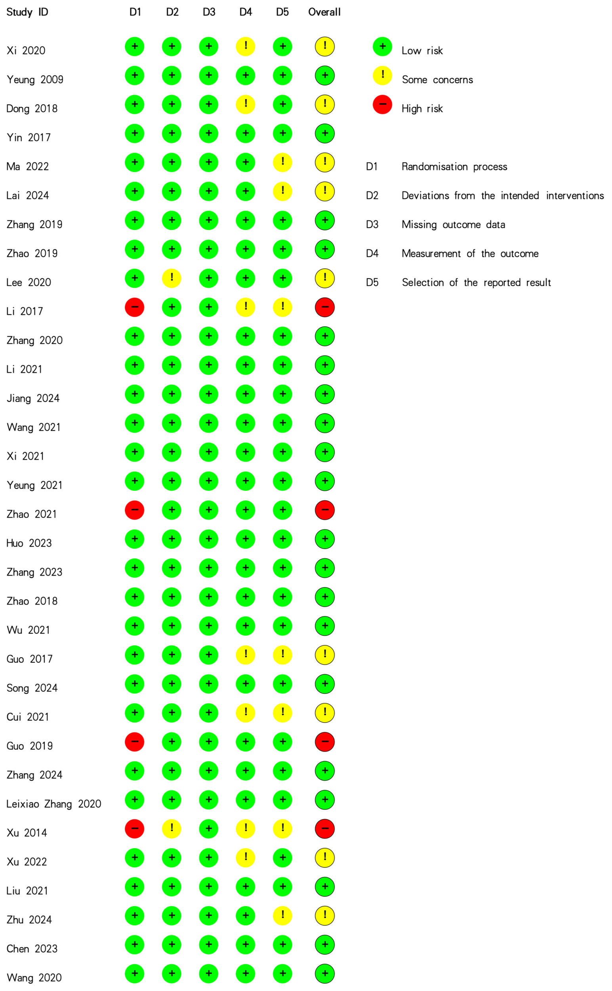
Notes: ROB figure adapted from Higgins JP, Altman DG, Gøtzsche PC, Jüni P, Moher D, Oxman AD, Savovic J, Schulz KF, Weeks L, Sterne JA; Cochrane Bias Methods Group; Cochrane Statistical Methods Group. The Cochrane Collaboration's tool for assessing risk of bias in randomised trials. BMJ. 2011 Oct 18;343:d5928.⁴⁴
Figure S2. Funnel plot for PSQI at treatment endpoint.
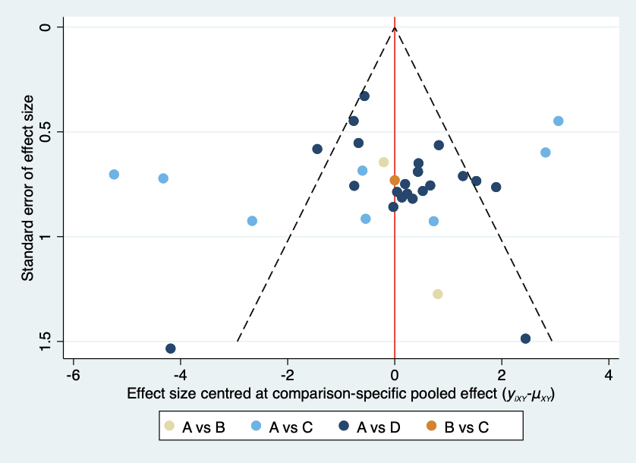
A, Acupuncture Therapy; B, Non-acupuncture Therapy; C, Non-Invasive Sham Acupuncture; D, Superficial Acupuncture.

Figure S3. Network plot and league table for PSQI at the follow-up visit.
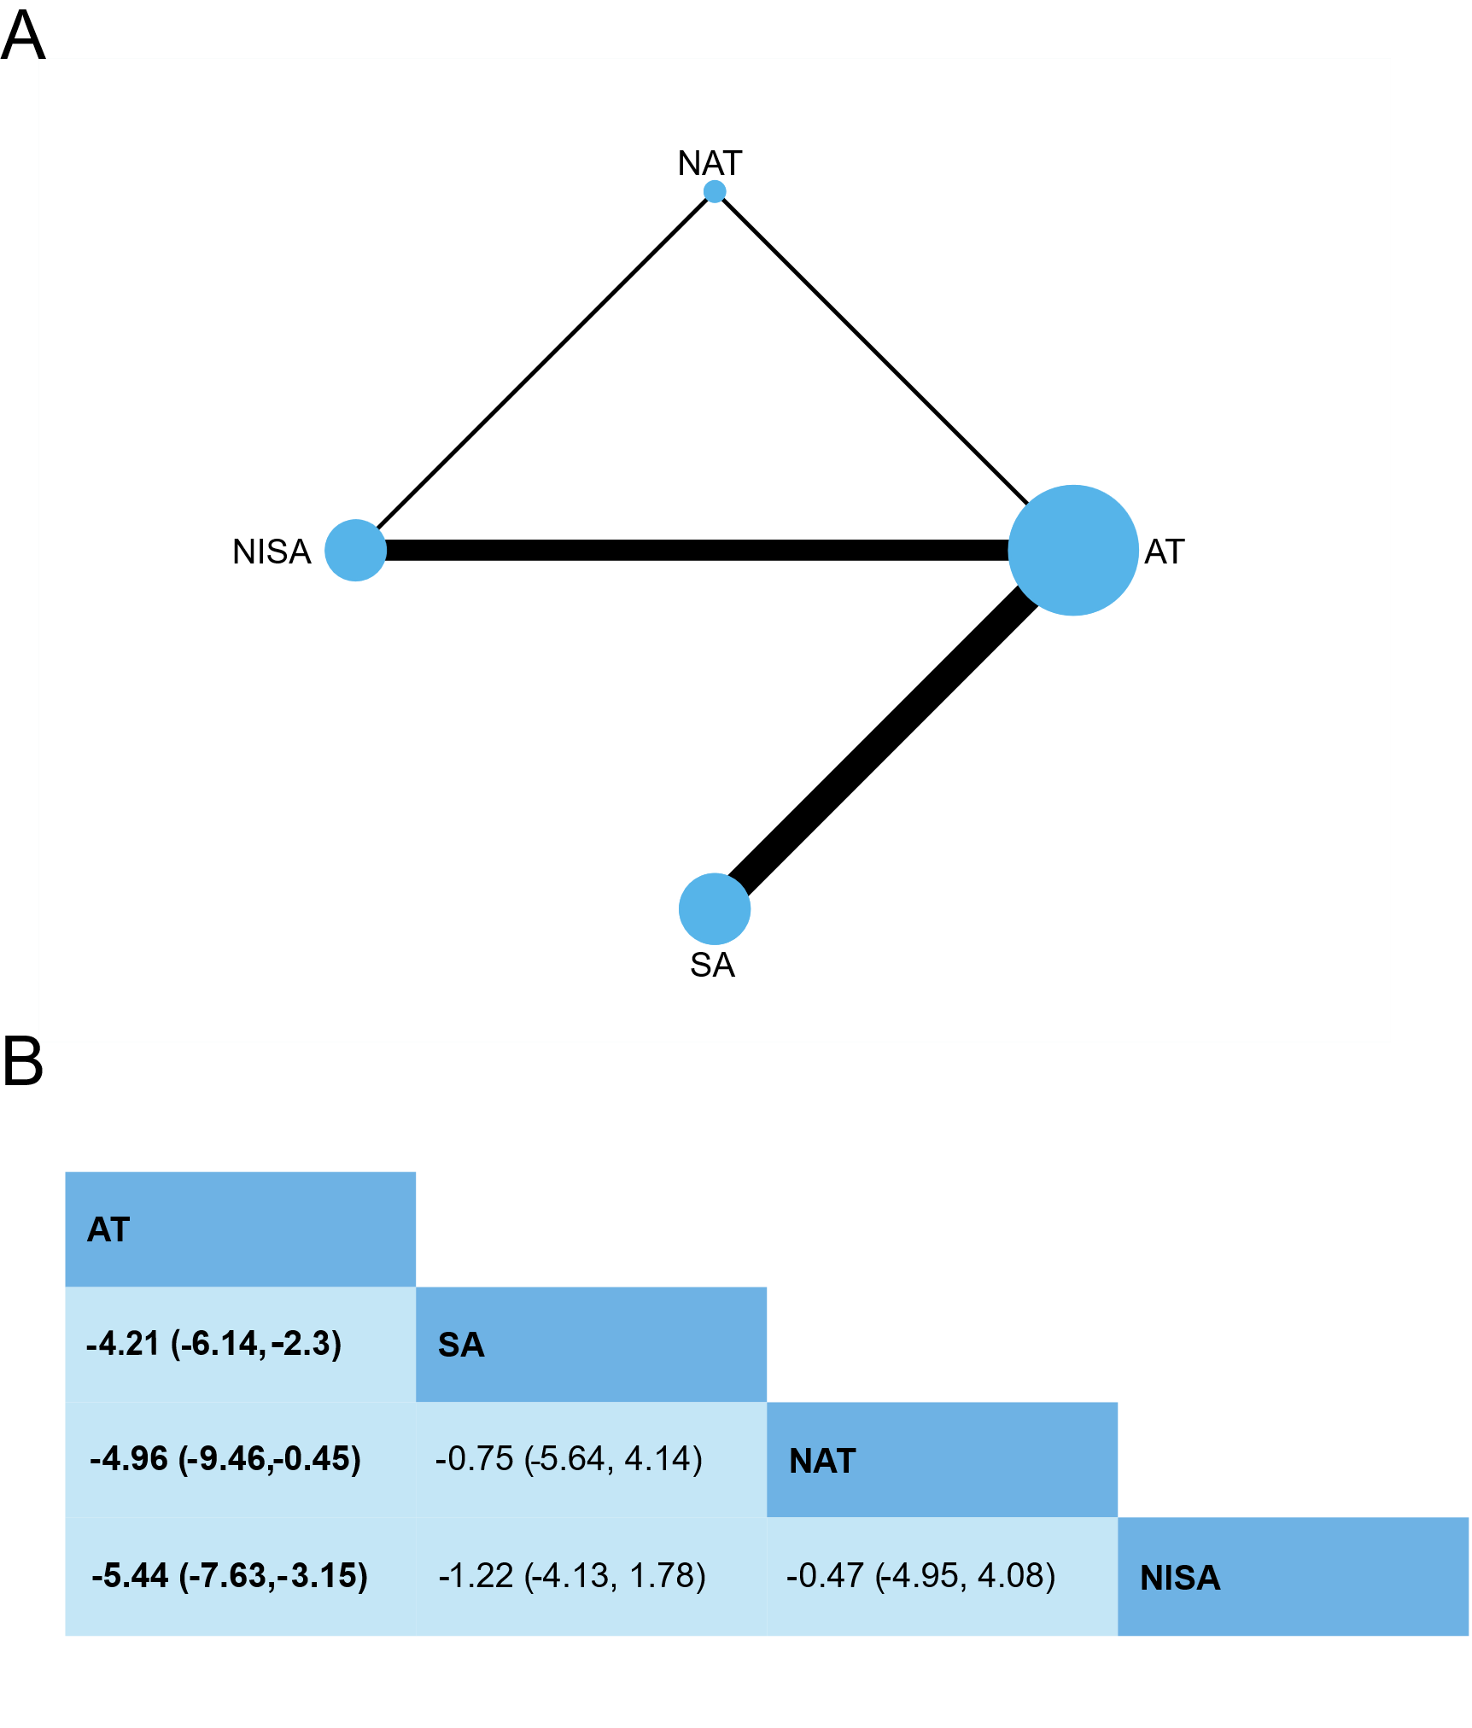
(A) Network plot for PSQI at the follow-up visit.
Node (circle) sizes indicate the number of studies, and edge (line) widths represent the number of direct comparisons. AT, Acupuncture Therapy; SA, Superficial Acupuncture; NISA, Non-Invasive Sham Acupuncture; NAT, Non-acupuncture Therapy.
(B) League table for PSQI at the follow-up visit.
Estimates are presented as mean difference (MD) and 95% credible intervals (CI). Comparisons between treatments should be read from left to right. The estimate of intervention effectiveness is located at the intersection of the column-defining intervention and the row-defining intervention. Significant results are presented in bold.

Figure S4. Funnel plot for PSQI at the follow-up visit.
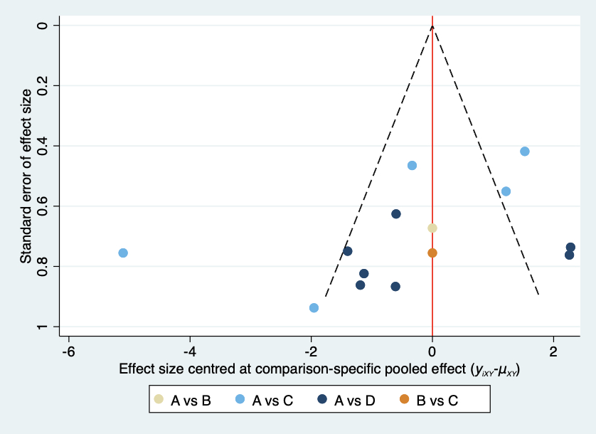
A, Acupuncture Therapy; B, Non-acupuncture Therapy; C, Non-Invasive Sham Acupuncture; D, Superficial Acupuncture.

Figure S5. SUCRA plot for PSQI at the follow-up visit.
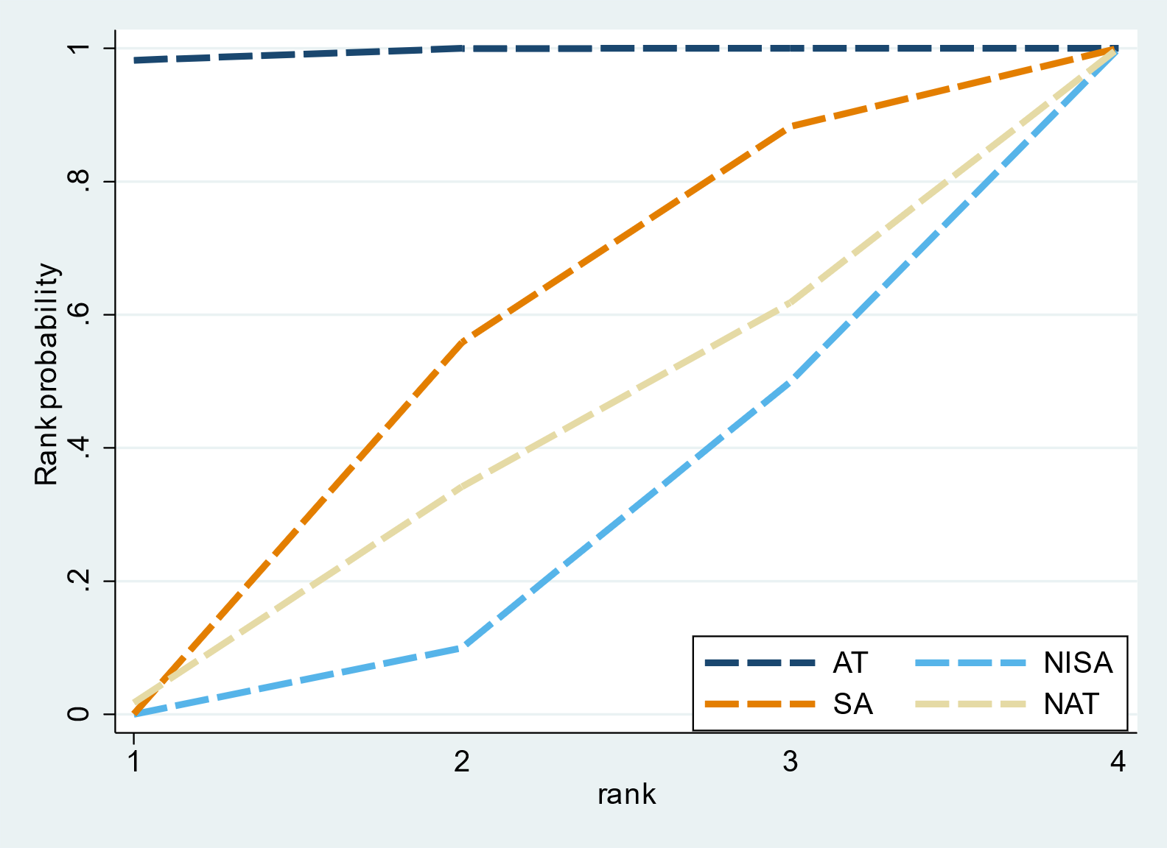
AT, Acupuncture Therapy; SA, Superficial Acupuncture; NISA, Non-Invasive Sham Acupuncture; NAT, Non-acupuncture Therapy.
*SUCRA is a numeric presentation of the overall ranking and presents a single number associated with each treatment. SUCRA values range from 0 to 1. The higher the SUCRA value, and the closer to 1, the higher the likelihood that a therapy is in the top rank or one of the top ranks; the closer to 0 the SUCRA value, the more likely that a therapy is in the bottom rank, or one of the bottom ranks.

Figure S6. Network plot and league table for TST at treatment endpoint.
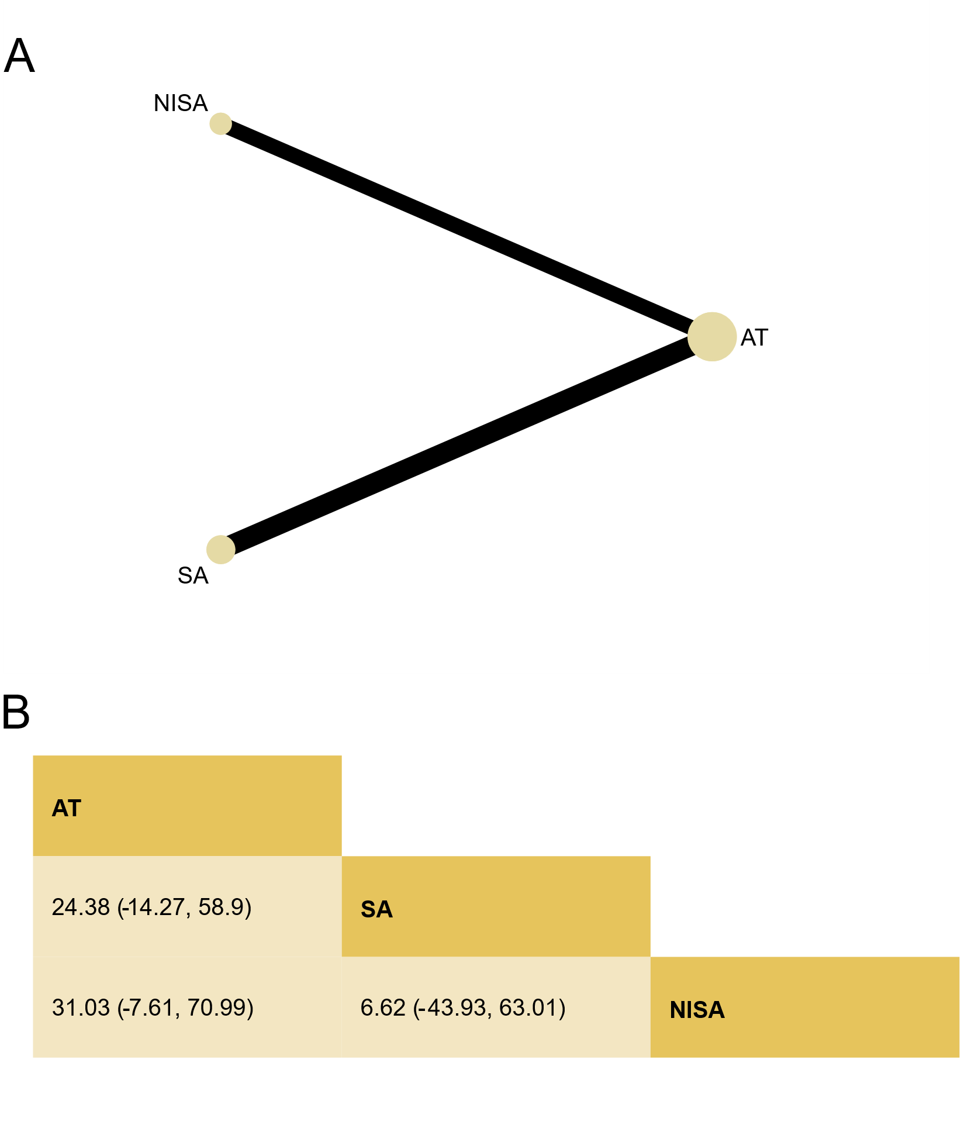
(A) Network plot for TST at treatment endpoint.
Node (circle) sizes indicate the number of studies, and edge (line) widths represent the number of direct comparisons. AT, Acupuncture Therapy; SA, Superficial Acupuncture; NISA, Non-Invasive Sham Acupuncture.
(B) League table for TST at treatment endpoint.
Estimates are presented as mean difference (MD) and 95% credible intervals (CI). Comparisons between treatments should be read from left to right. The estimate of intervention effectiveness is located at the intersection of the column-defining intervention and the row-defining intervention. Significant results are presented in bold.

Figure S7. Funnel plot for TST at treatment endpoint.
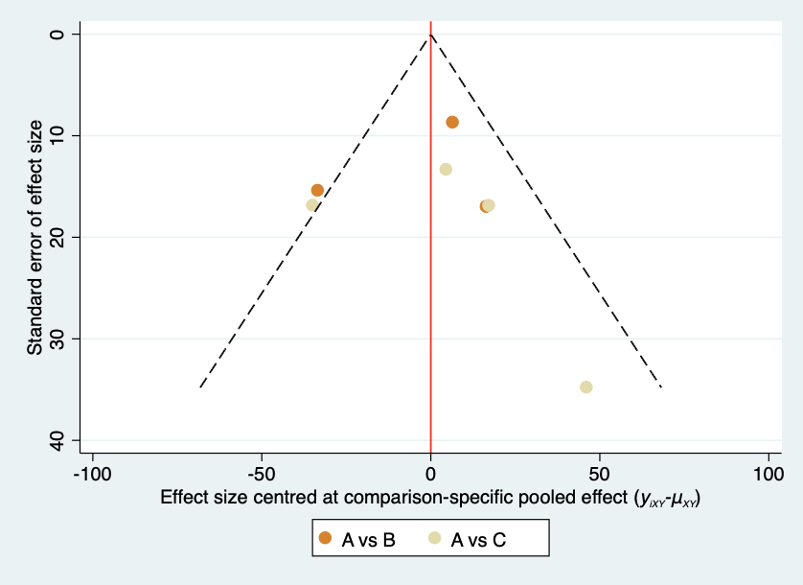
A, Acupuncture Therapy; B, Non-Invasive Sham Acupuncture; C, Superficial Acupuncture.

Figure S8. SUCRA plot for TST at treatment endpoint.
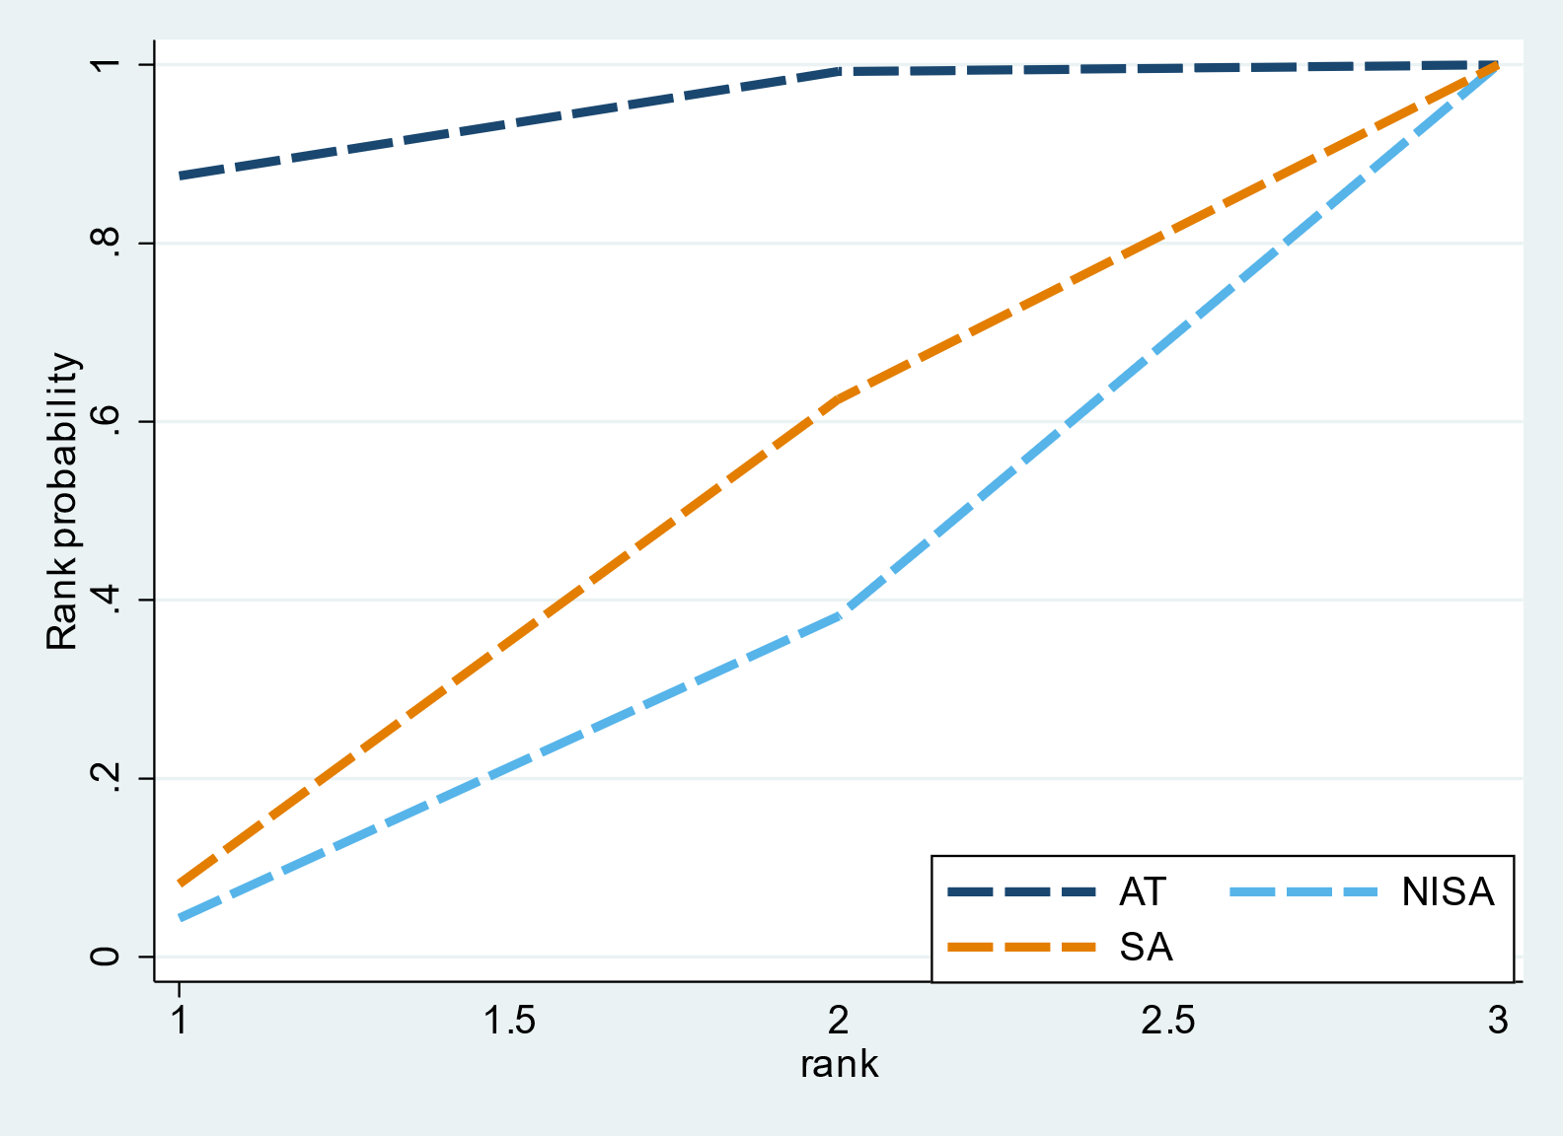
AT, Acupuncture Therapy; SA, Superficial Acupuncture; NISA, Non-Invasive Sham Acupuncture.
*SUCRA is a numeric presentation of the overall ranking and presents a single number associated with each treatment. SUCRA values range from 0 to 1. The higher the SUCRA value, and the closer to 1, the higher the likelihood that a therapy is in the top rank or one of the top ranks; the closer to 0 the SUCRA value, the more likely that a therapy is in the bottom rank, or one of the bottom ranks.

Figure S9. Network plot and league table for SE at treatment endpoint.
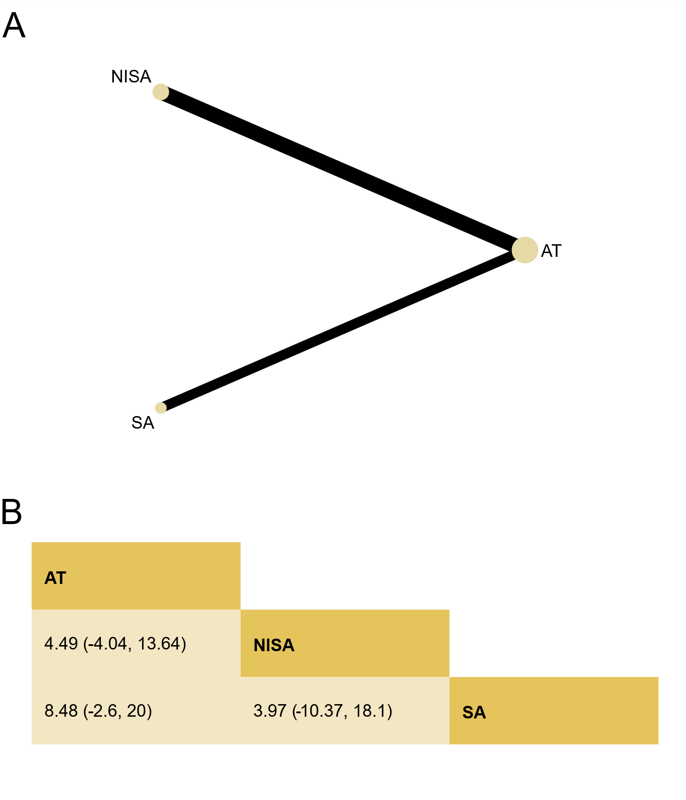
(A) Network plot for SE at treatment endpoint.
Node (circle) sizes indicate the number of studies, and edge (line) widths represent the number of direct comparisons. AT, Acupuncture Therapy; SA, Superficial Acupuncture; NISA, Non-Invasive Sham Acupuncture.
(B) League table for SE at treatment endpoint.
Estimates are presented as mean difference (MD) and 95% credible intervals (CI). Comparisons between treatments should be read from left to right. The estimate of intervention effectiveness is located at the intersection of the column-defining intervention and the row-defining intervention. Significant results are presented in bold.

Figure S10. Funnel plot for SE at treatment endpoint.
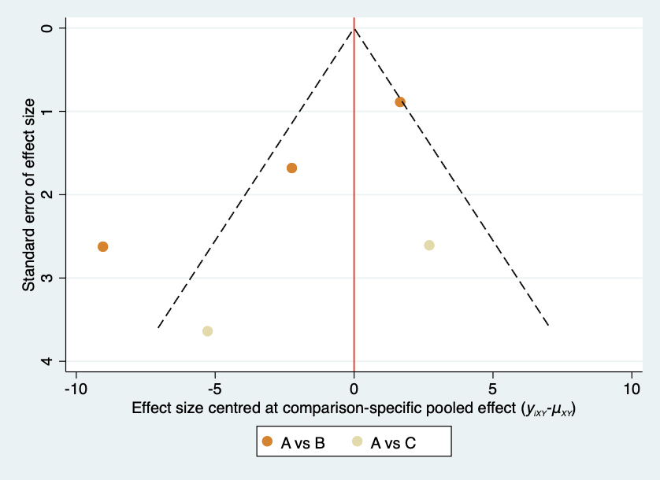
A, Acupuncture Therapy; B, Non-Invasive Sham Acupuncture; C, Superficial Acupuncture.

Figure S11. SUCRA plot for SE at treatment endpoint.
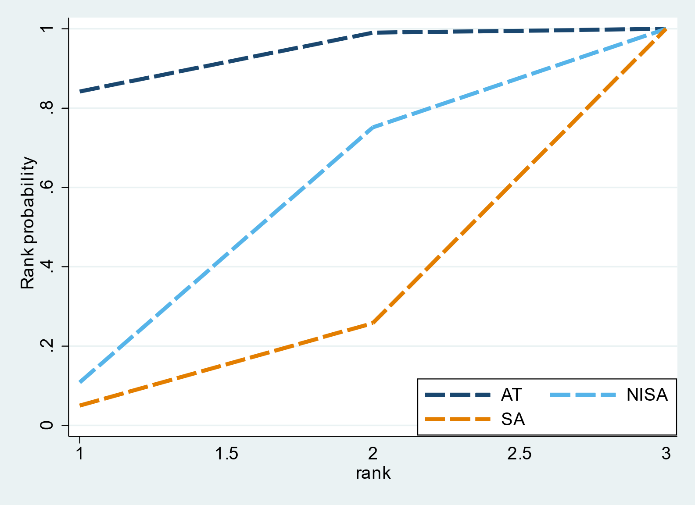
AT, Acupuncture Therapy; SA, Superficial Acupuncture; NISA, Non-Invasive Sham Acupuncture.
*SUCRA is a numeric presentation of the overall ranking and presents a single number associated with each treatment. SUCRA values range from 0 to 1. The higher the SUCRA value, and the closer to 1, the higher the likelihood that a therapy is in the top rank or one of the top ranks; the closer to 0 the SUCRA value, the more likely that a therapy is in the bottom rank, or one of the bottom ranks.

Figure S12. Network plot and league table for WASO at treatment endpoint.
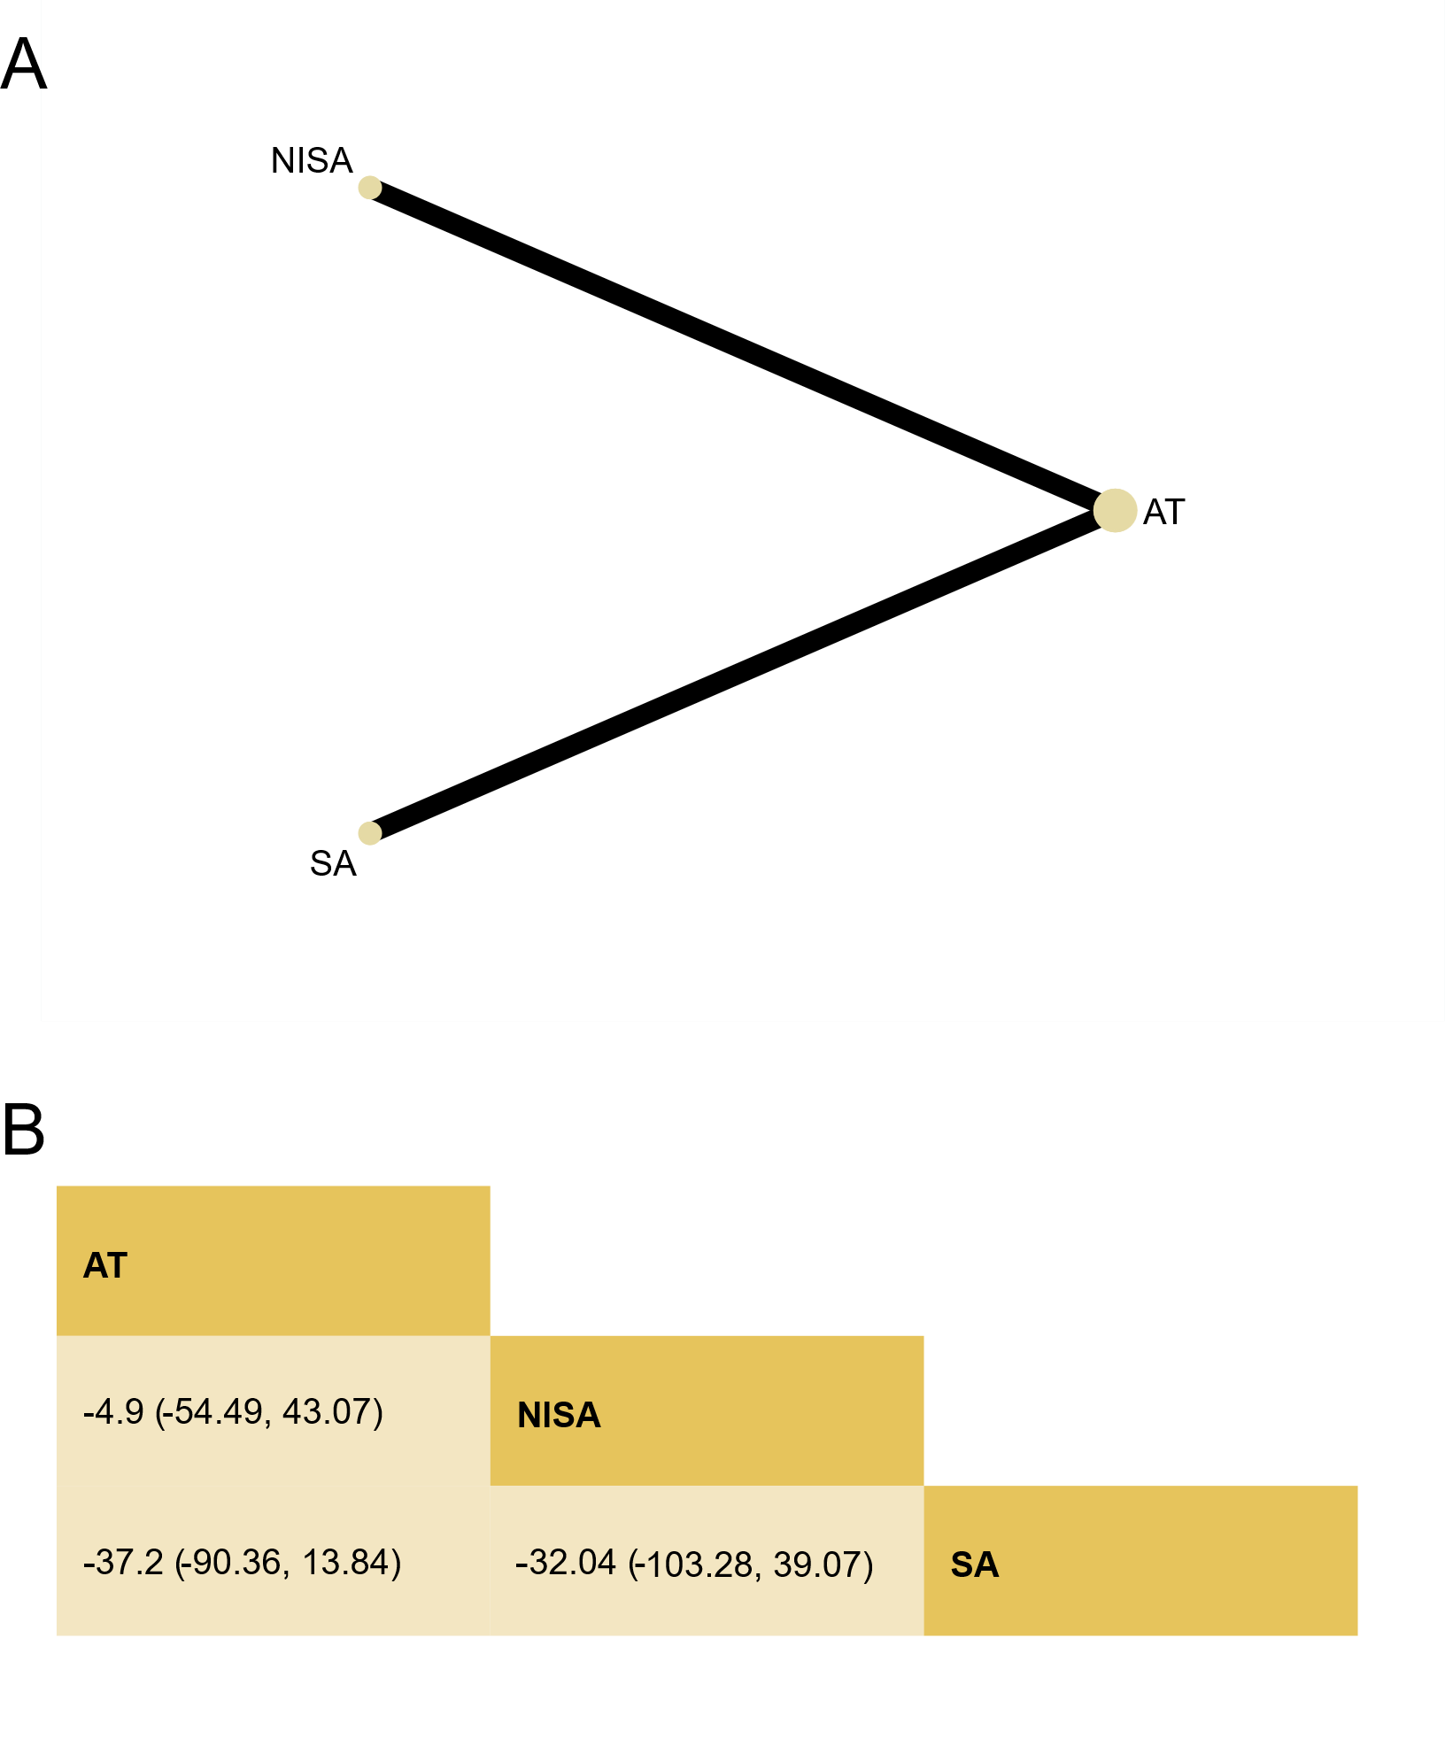
(A) Network plot for WASO at treatment endpoint.
Node (circle) sizes indicate the number of studies, and edge (line) widths represent the number of direct comparisons. AT, Acupuncture Therapy; SA, Superficial Acupuncture; NISA, Non-Invasive Sham Acupuncture.
(B) League table for WASO at treatment endpoint.
Estimates are presented as mean difference (MD) and 95% credible intervals (CI). Comparisons between treatments should be read from left to right. The estimate of intervention effectiveness is located at the intersection of the column-defining intervention and the row-defining intervention. Significant results are presented in bold.

Figure S13. Funnel plot for WASO at treatment endpoint.
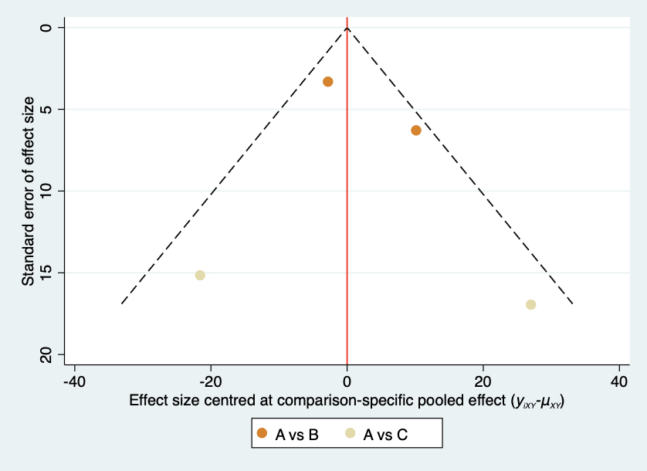
A, Acupuncture Therapy; B, Non-Invasive Sham Acupuncture; C, Superficial Acupuncture.

Figure S14. SUCRA plot for WASO at treatment endpoint.
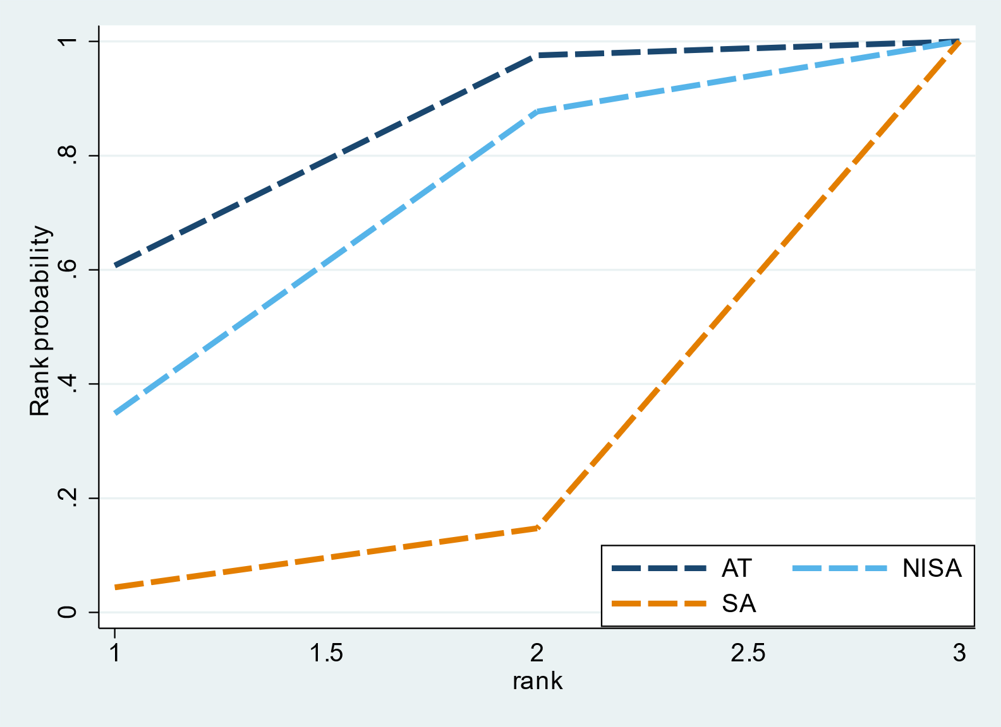
AT, Acupuncture Therapy; SA, Superficial Acupuncture; NISA, Non-Invasive Sham Acupuncture.
*SUCRA is a numeric presentation of the overall ranking and presents a single number associated with each treatment. SUCRA values range from 0 to 1. The higher the SUCRA value, and the closer to 1, the higher the likelihood that a therapy is in the top rank or one of the top ranks; the closer to 0 the SUCRA value, the more likely that a therapy is in the bottom rank, or one of the bottom ranks.

References
1. Chung KF, Yeung WF, Yu BYM, et al. Acupuncture with or without combined auricular acupuncture for insomnia: a randomised, waitlist-controlled trial. Article. Acupuncture in medicine : journal of the British Medical Acupuncture Society. 2018;36(1):2-13. doi:10.1136/acupmed-2017-011371
2. Yeung WF, Chung KF, Zhang ZJ, et al. Electroacupuncture for tapering off long-term benzodiazepine use: A randomized controlled trial. Article. Journal of Psychiatric Research. 2019;109:59-67. doi:10.1016/j.jpsychires.2018.11.015
3. Lu Y, Lai C, Lu P, Peng Y, Bao Z, Luo H. Acupuncture Treatment for Insomnia and its Effect on Serum TNF-α, IL-6, and IL-1β levels. Article. Acupuncture and Electro-Therapeutics Research. 2022;47(2):183-194. doi:10.3727/036012921X16287835103453
4. Wang C, Xu WL, Li GW, et al. Impact of Acupuncture on Sleep and Comorbid Symptoms for Chronic Insomnia: A Randomized Clinical Trial. Nat Sci Sleep. 2021;13:1807-1822. doi:10.2147/nss.S326762
5. Guo J, Wang LP, Liu CZ, et al. Efficacy of acupuncture for primary insomnia: a randomized controlled clinical trial. Evid Based Complement Alternat Med. 2013;2013:163850. doi:10.1155/2013/163850
6. Saletu-Zyhlarz GM, Meng A, Anderer P, et al. Acute and chronic effects of electroacupuncture in primary insomnia: placebo-controlled clinical, polysomnographic, EEG topographic/tomographic and psychometric studies. Journal article; Conference proceeding. Clinical EEG and neuroscience. 2020;51(3):NP21‐NP22. doi:10.1177/1550059415622686
7. Lee SI, Hwa LJ, Moon K, et al. Analysis of Quantitative Electroencephalography (QEEG) Following Acupuncture Treatment in Patients with Insomnia: Z Scored Absolute Power and sLORETA. research-article. The Korean Society of Oriental Neuropsychiatry. 2016 2016;27(3):169-184.
8. Quan Z, Dayan Y, Xiao CUI, Kanrong Y, Jie LI, Canghuan Z. Cerebral fMRI in observation on the therapeutic mechanism of electro-acupuncture on Shenmen and Sanyinjiao for insomnia. Chinese Jorunal of Interventional Imaging and Therapy. 2011 2011;8(3):204-207. 1672-8475(2011)8:3<204:Nfgcdz>2.0.Tx;2-2.
9. Chang JS, Liu HP, Lin WY. Acupuncture at SP6 Point in Lower Extremities Improved Patients' Insomnia, Which Was Also Shown Through Ryodoraku Electrical Measurements. Acupunct Electrother Res. 2016;41(2):79-93. doi:10.3727/036012916x14666839504550
10. Minghui G, Aixia L, Ping Y, et al. The effect of regulating and tranquilising acupuncture on the quality of life of patients with primary insomnia. Journal of Sichuan of Traditional Chinese Medicine. 2016;(5)2017450031.
11. Xi HQ, Wu WZ, Liu CY, Wang XQ, Li JH. Effect of Tongdu Tiaoshen needling in treatment of chronic insomnia by regulating the hypothalamic-pituitary-adrenal axis. Acupuncture research. 2020;45(7):552-556. doi:10.13702/j.1000-0607.190791
12. Yeung WF, Chung KF, Zhang SP, Yap TG, Law ACK. Electroacupuncture for primary insomnia: A randomized controlled trial. Article. Sleep. 2009;32(8):1039-1047. doi:10.1093/sleep/32.8.1039
13. Dong B, Chen ZQ, Jie MA. Clinical Curative Observation of Applying Acupuncture at Yintang (EX-HN3),Baihui (Du20) and Dazhui (Du14) with Periosteal Puncture Method in the Treatment of Primary Insomnia. Journal of Sichuan of Traditional Chinese Medicine. 2018;
14. Yin X, Gou M, Xu J, et al. Efficacy and safety of acupuncture treatment on primary insomnia: a randomized controlled trial. Journal article. Sleep medicine. 2017;37:193‐200. doi:10.1016/j.sleep.2017.02.012
15. Ma Y, Pang R, Teng R, Song J, Shi Y, Wu X. Effect of scalp acupuncture on sleep quality in patients with chronic insomnia. Journal of Changchun University of Chinese Medicine. 2022;38(12)2023119740. doi:10.13463/j.cnki.cczyy.2022.12.014
16. Lai CH. Clinical Research on the Treatment of Paradoxical Insomnia with Acupuncture for Regulating the Mind and Inducing Sleep. Inner Mongolia Journal of Traditional Chinese Medicine. 2024;43(4)2024314461. doi:10.16040/j.cnki.cn15-1101.2024.04.063
17. Zhang F, Tang Q, Guo J, et al. Effects of "Old Ten Needles" Acupoints Group on Sleep Quality and Excessive Arousal in Patients with Chronic Insomnia. Effects of "Old Ten Needles" Acupoints Group on Sleep Quality and Excessive Arousal in Patients with Chronic Insomnia. Journal of Traditional Chinese Medicine. 2019 2019;60(8):671-674. 1001-1668(2019)60:8<671:Lszzxd>2.0.Tx;2-a. doi:10.13288/j.11-2166/r.2019.08.010
18. Zhao FY, Xu H, Hong YF, et al. Attention network function of insomniacs improved by manual acupuncture: Evidence from Attention Network Task. Article. World Journal of Acupuncture - Moxibustion. 2019;29(2):91-96. doi:10.1016/j.wjam.2019.05.006
19. Lee B, Kim BK, Kim HJ, et al. Efficacy and Safety of Electroacupuncture for Insomnia Disorder: A Multicenter, Randomized, Assessor-Blinded, Controlled Trial. Nature and Science of Sleep. 2020 2020;12:1145-1159. doi:10.2147/nss.S281231
20. Li HQ, Zou YH, Guo J, Wei J, Cao KG. 30 cases of primary insomnia treated by ‘Zhou's method of regulating the spirit and acupuncture’. Global Traditional Chinese Medicine. 2017;10(7)2017522119. doi:10.3969/j.issn.1674-749.2017.07.033
21. Zhang L, Tang Y, Hui R, et al. The effects of active acupuncture and placebo acupuncture on insomnia patients: a randomized controlled trial. Journal article. Psychology, health & medicine. 2020;25(10):1201‐1215. doi:10.1080/13548506.2020.1738015
22. Li JH, Wu WZ, Liu CY, et al. Effect of Tiaoshen needling on plasma melatonin and cortisol in patients with chronic insomnia. Randomized Controlled Trial. Acupuncture research. 2021-Aug-25 2021;46(8):690-4. doi:10.13702/j.1000-0607.201009
23. Jiang TF, Chen ZY, Liu J, et al. Acupuncture modulates emotional network resting-state functional connectivity in patients with insomnia disorder: a randomized controlled trial and fMRI study. BMC Complement Med Ther. Aug 21 2024;24(1):311. doi:10.1186/s12906-024-04612-0
24. Wang XQ, Qin S, Wu WZ, et al. Effect of electroacupuncture on serum melatonin and dopamine in aged insomnia. Journal article. Chinese acupuncture & moxibustion. 2021;41(5):501‐504. doi:10.13703/j.0255-2930.20200404-k0001
25. Xi HQ, Wu WZ, Liu CY, et al. Effect of acupuncture at Tiaoshen acupoints on hyperarousal state in chronic insomnia. Randomized Controlled Trial. Acupuncture Research. 2021-Mar-12 2021;41(3):263-7. doi:10.13703/j.0255-2930.20200303-k0004
26. Yeung WF, Yu BY, Yuen JW, et al. Semi-Individualized Acupuncture for Insomnia Disorder and Oxidative Stress: A Randomized, Double-Blind, Sham-Controlled Trial. Nat Sci Sleep. 2021;13:1195-1207. doi:10.2147/nss.S318874
27. Zhao Y, Wu W, Wang X, Xu Y, Jiang Y, Liu C. To Observe the Effect of Tiaoshen Acupuncture on Hyperarousal in Patients with Chronic Insomnia. Modernization of Traditional Chinese Medicine and Materia Medica-World Science and Technology. 2021;23(07):2538-2543. doi:10.11842/wst.20200704001
28. Huo YS, Chen ZY, Yin XJ, et al. Tiaoshen acupuncture for primary insomnia: a pilot randomized controlled trial. Randomized Controlled Trial; English Abstract;. Chinese acupuncture & moxibustion. 2023-Sep-12 2023;43(9):1008-13. doi:10.13703/j.0255-2930.20221120-0001
29. Zhang L, Deng Y, Hui R, et al. The effects of acupuncture on clinical efficacy and steady-state visual evoked potentials in insomnia patients with emotional disorders: A randomized single-blind sham-controlled trial. Article. Frontiers in Neurology. 2023;13doi:10.3389/fneur.2022.1053642
30. Zhao FY, Zhang ZY, Xia XJ, et al. Memory response to manual acupuncture in chronic insomniacs: evidence from event-related potentials. Journal of Acupuncture and Tuina Science. 2018;16(6):382-388. doi:10.1007/s11726-018-1078-3
31. Wu WZ, Zhao YN, Liu CY, et al. Effects of electroacupuncture on sleep quality, daytime fatigue and serum cortisol in chronic insomnia. Effects of electroacupuncture on sleep quality,daytime fatigue and serum cortisol in chronic insomnia. China Journal of Traditional Chinese Medicine and Pharmacy. 2021;36(9)2021544137.
32. Guo J, Tang CY, Wang LP. Effect of Tiaoshen Acupuncture Therapy on Sleep Quality and Hyperarousal State in Primary Insomnia. Journal of Clinical Acupuncture and Moxibustion. 2017;
33. Song ZX, Jiang TF, Yin XZ, Zhu LY, Guo J. A Study on Central Mechanism of Tiaoshen Acupuncture Treatment for Early Awakening Insomnia Based on fMRI Low-Frequency Amplitude Ratio Analysis. Journal of Clinical Acupuncture and Moxibustion. 2024;doi:10.19917/j.cnki.1005-0779.024147
34. Cui YX, Ao YT, Sun JQ. Metabonomics Study on Acupuncture Improving Primary Insomnia. Clinical Journal of Traditional Chinese Medicine. 2021;33(8)2021512126. doi:10.16448/j.cjtcm.2021.0847
35. Guo J, Hu J, Zhang F, et al. Clinical study of the effect of acupuncture with the method of regulating the spirit on the rate of heart rate variability in primary insomnia. Global Traditional Chinese Medicine. 2019;12(12)2020368089. doi:10.3969/j.issn.1674-1749.2019.12.024
36. Zhang X, Zhang Y, Liu L, Guo J, Zhang F. Acupuncture for regulating hyperarousal state in chronic insomnia with deficiency of heart and spleen:a clinical trial study. Beijing Journal of Traditional Chinese Medicine. 2024;43(7)2024434082. doi:10.16025/j.1674-1307.2024.07.007
37. Zhang LX, Hui R, Tang Y, et al. Effects of acupuncture on insomnia with depression. Effects of acupuncture on insomnia with depression. China Journal of Traditional Chinese Medicine and Pharmacy. 2020;35(8)2020707159.
38. Xu S, Sun Y, Wang S, Wu J, Yin P. Clinical observation on the treatment of primary insomnia mainly by electroacupuncture on Baihui Shenting. Journal of Sichuan of Traditional Chinese Medicine. 2014;32(5)2014516312.
39. Xu X, Wang X, Wu W, et al. Effects of Electroacupuncture on Sleep Quality and Serum Melatonin in Elderly Insomnia Patients. Effects of Electroacupuncture on Sleep Quality and Serum Melatonin in Elderly Insomnia Patients. Shanghai Journal of Acupuncture and Moxibustion. 2022;41(1)2022158412. doi:10.13460/j.issn.1005-0957.2022.01.0001
40. Zhu L, Chen K, Jiang T, Chen Z, Wang G, Guo J. Clinical Study of Spirit-Regulating Acupuncture Improving Sleep Latency and Hyperarousal of Patients with CID. Clinical Study of Spirit-Regulating Acupuncture Improving Sleep Latency and Hyperarousal of Patients with CID. Journal of Clinical Acupuncture and Moxibustion. 2024;40(9)2024488395. doi:10.19917/j.cnki.1005-0779.024167
41. Liu C, Zhao Y, Qin S, Wang X, Jiang Y, Wu W. Randomized controlled trial of acupuncture for anxiety and depression in patients with chronic insomnia. Ann Transl Med. Sep 2021;9(18):1426. doi:10.21037/atm-21-3845
42. Chen Z, Jiang T, Yin X, Li B, Tan Z, Guo J. The increased functional connectivity between the locus coeruleus and supramarginal gyrus in insomnia disorder with acupuncture modulation. Front Neurosci. 2023;17:1131916. doi:10.3389/fnins.2023.1131916
43. Wang YK, Li T, Ha LJ, et al. Effectiveness and cerebral responses of multi-points acupuncture for primary insomnia: a preliminary randomized clinical trial and fMRI study. BMC Complement Med Ther. Aug 17 2020;20(1):254. doi:10.1186/s12906-020-02969-6
44. Higgins JP, Altman DG, Gøtzsche PC, Jüni P, Moher D, Oxman AD, Savovic J, Schulz KF, Weeks L, Sterne JA; Cochrane Bias Methods Group; Cochrane Statistical Methods Group. The Cochrane Collaboration's tool for assessing risk of bias in randomised trials. BMJ. 2011 Oct 18;343:d5928.

