Supplementary data

Manuscript ID number: 541042
Title of paper: Royal jelly extracellular vesicles enhance diabetic wound healing via inflammation modulation, fibroblast migration, and angiogenesis
Yen-Yu Tsai ¹ , Long-Sen Chang ¹ , Chun-Wen Lan ^{1,2,3} ,Ying-Jung Chen ^{4,5,6,*}, Jen-Hao Yang ^{1,*}
¹ Institute of Biomedical Sciences, National Sun Yat-Sen University, Kaohsiung, Taiwan
² SCT-BioMed Co., Ltd., Kaohsiung, Taiwan
³ Department of Medical Education and Research, Kaohsiung Veterans General Hospital, Kaohsiung, Taiwan
⁴ Department of Fragrance and Cosmetic Science, Kaohsiung Medical University, Kaohsiung, Taiwan
⁵ Drug Development and Value Creation Research Center, Kaohsiung Medical University, Kaohsiung, Taiwan
⁶ Department of Medical Research, Kaohsiung Medical University Hospital, Kaohsiung, Taiwan

ORCiD:
Y.-Y.T. 0000-0003-0715-5227
L.-S.C. 0000-0002-3204-5137
Y.-J.C. 0000-0001-8562-1268
J.-H.Y. 0009-0004-4320-0843
C.-W.L. 0000-0001-5042-685X

Supplementary Figure 1

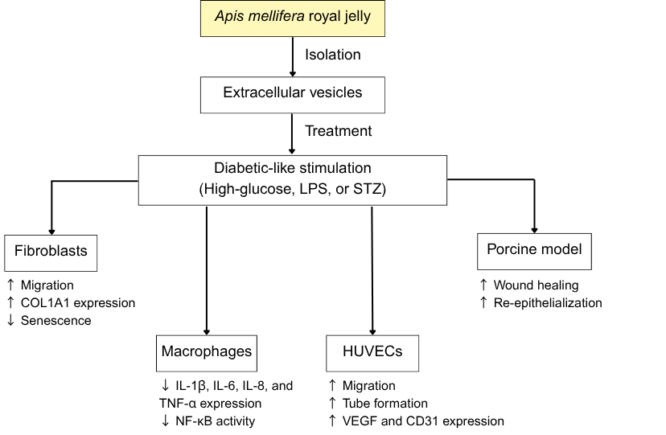
Supplementary Figure 1. Mechanistic diagram summarizing the effect of RJEVs on diabetic wound healing. This diagram shows the diabetic-like wound healing mechanism of RJEVs in vitro and in vivo. In vitro functions include (1) decreased senescence, accelerated migration, and increased COL1A1 expression in high-glucose-stimulated fibroblasts, (2) decreased cytokine expression (IL-1β, IL-6, IL-8, and TNF-α) and NF-κB activity in LPS-induced RAW-BlueTM and THP-1, (3) enhanced migration, tube formation, and VEGF and CD31 protein expression in high-glucose-stimulated HUVECs. In vivo findings include accelerated wound healing in STZ-induced porcine models by enhancing re-epithelialization.

Supplementary Figure 2

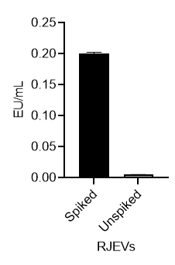
Supplementary Figure 2. Endotoxin levels of unspiked and spiked RJEVs (20 μg/mL). Endotoxin levels were assessed by the ToxinSensorTM Endotoxin Detection System kit and quantified. Spiked samples = RJEVs + Standard, to detect endotoxin interference (false negative results); unspiked samples = RJEVs. Calculated spike recovery was 78%, which is within the acceptable range (50 - 200 %). Recovery % = [(Spiked result - Unspiked result) / Spike added] x 100. n = 8.
Supplementary Figure 3

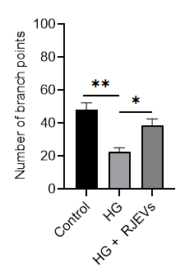
Supplementary Figure 3. Number of branch points of HG-stimulated and RJEVs treated HUVECs. HUVECs were treated with 20 μg/mL RJEVs in the presence of absence of HG stimulation. Data are shown as mean ± SD of three independent biological replicates. n = 3. *p < 0.05, **p < 0.01; HG samples are compared to control and HG + RJEVs samples are compared to HG samples.

Supplementary Figure 4

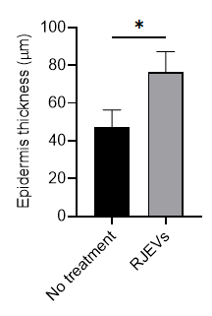

Supplementary Figure 4. Epidermal thickness of expanded skin in diabetic porcine. Epidermal thickness qualification of “no treatment” and “RJEVs” sample groups. Data are shown as mean ± SD of four independent biological replicates. n = 4. *p < 0.05; RJEVs group is compared to the no treatment group.

