Supplementary Information
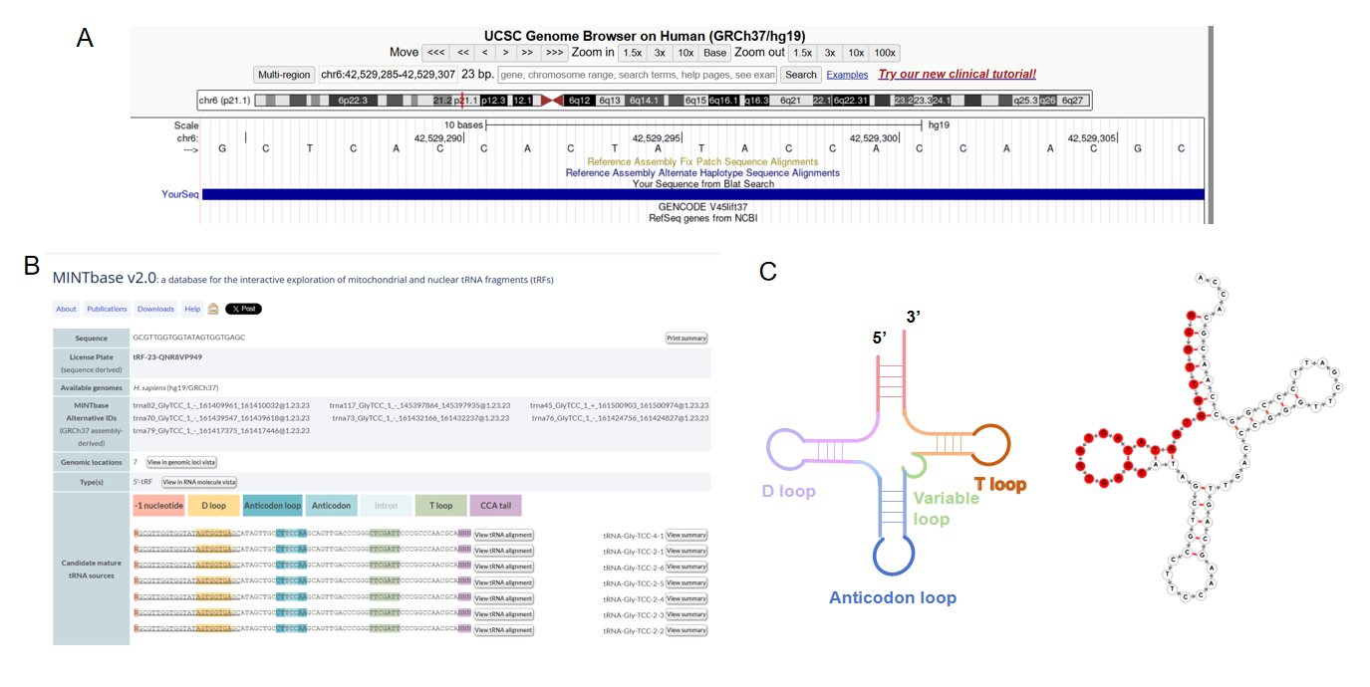
Supplementary Figure 1 tRF5-23-GlyTCC-2 Identified as an i-tRF.
(A) tRF5-23-GlyTCC-2 is located on chromosome 6, with coordinates 42,529,286–42,529,308, spanning a length of 23 base pairs (bp).
(B) Classification of tRF5-23-GlyTCC-2 as an i-tRF, with a sequence length of 23 nucleotides (5'-GCGTTGGTGGTATAGTGGTGAGC-3'), according to MINTbase v2.0.
(C) On the left is a simplified schematic diagram of a general tRNA structure, and on the right is the structural representation of tRF5-23-GlyTCC-2 retrieved from the tsRFun database (the bases highlighted in red in the figure legend correspond to the sequence of tRF5-23-GlyTCC-2).

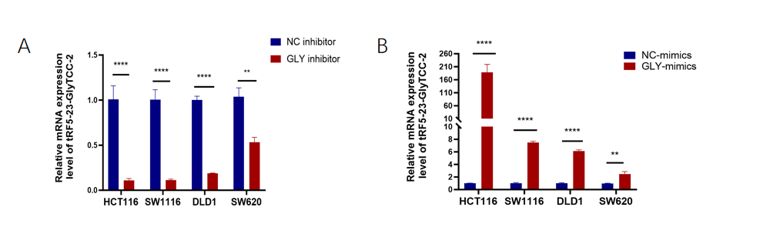
Supplementary Figure 2 The transfection efficiencies of tRF5-23-GlyTCC-2.

(A) The transfection efficiencies of tRF5-23-GlyTCC-2 inhibitor was measured by qRT-PCR.

(B) the transfection efficiencies of tRF5-23-GlyTCC-2 mimics was measured by qRT-PCR.

