Supplementary
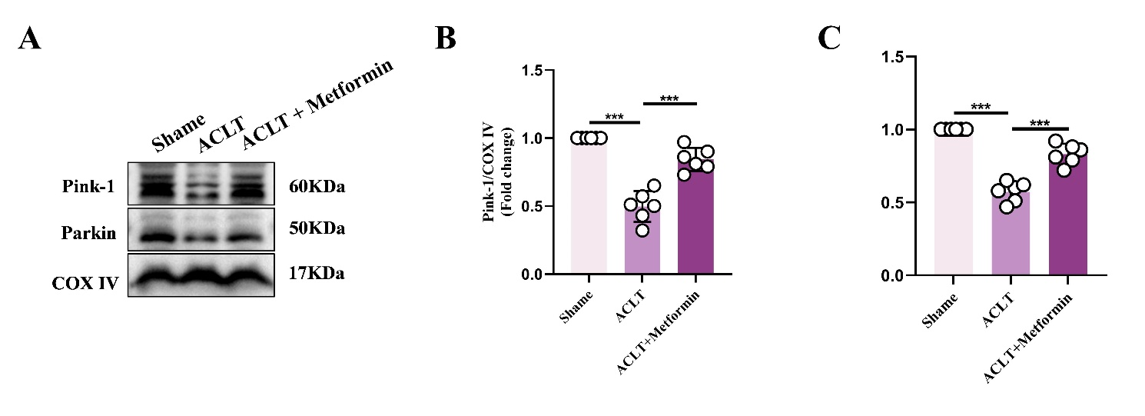
Figure S1. Primary mouse articular chondrocytes were isolated from Sham, ACLT, and ACLT + Metformin groups, and mitophagy-related proteins were evaluated by western blot.
(A) Western blot analysis of PINK1, Parkin, and COX IV protein expression levels in chondrocytes from each group.
(B, C) Densitometric quantification of the PINK1/COX IV ratio (B) and Parkin/COX IV ratio (C).
Statistical analysis was performed using one-way ANOVA followed by Tukey’s post-hoc multiple comparisons test: ns, P > 0.05; * P < 0.05; ** P < 0.01; *** P < 0.001. Data are presented as mean ± SD from at least six independent experiments.

Figure S2. Quantitative analysis of EdU-positive (green) cell proportions following EdU staining across treatment groups. Statistical analysis was performed using one-way ANOVA followed by Tukey’s post-hoc multiple comparisons test: ns, P > 0.05; * P < 0.05; ** P < 0.01; *** P < 0.001. The data represent the mean ± SD from at three independent experiments.

