Supplementary Information 1: The effects of allicin on the liver and kidneys of rats
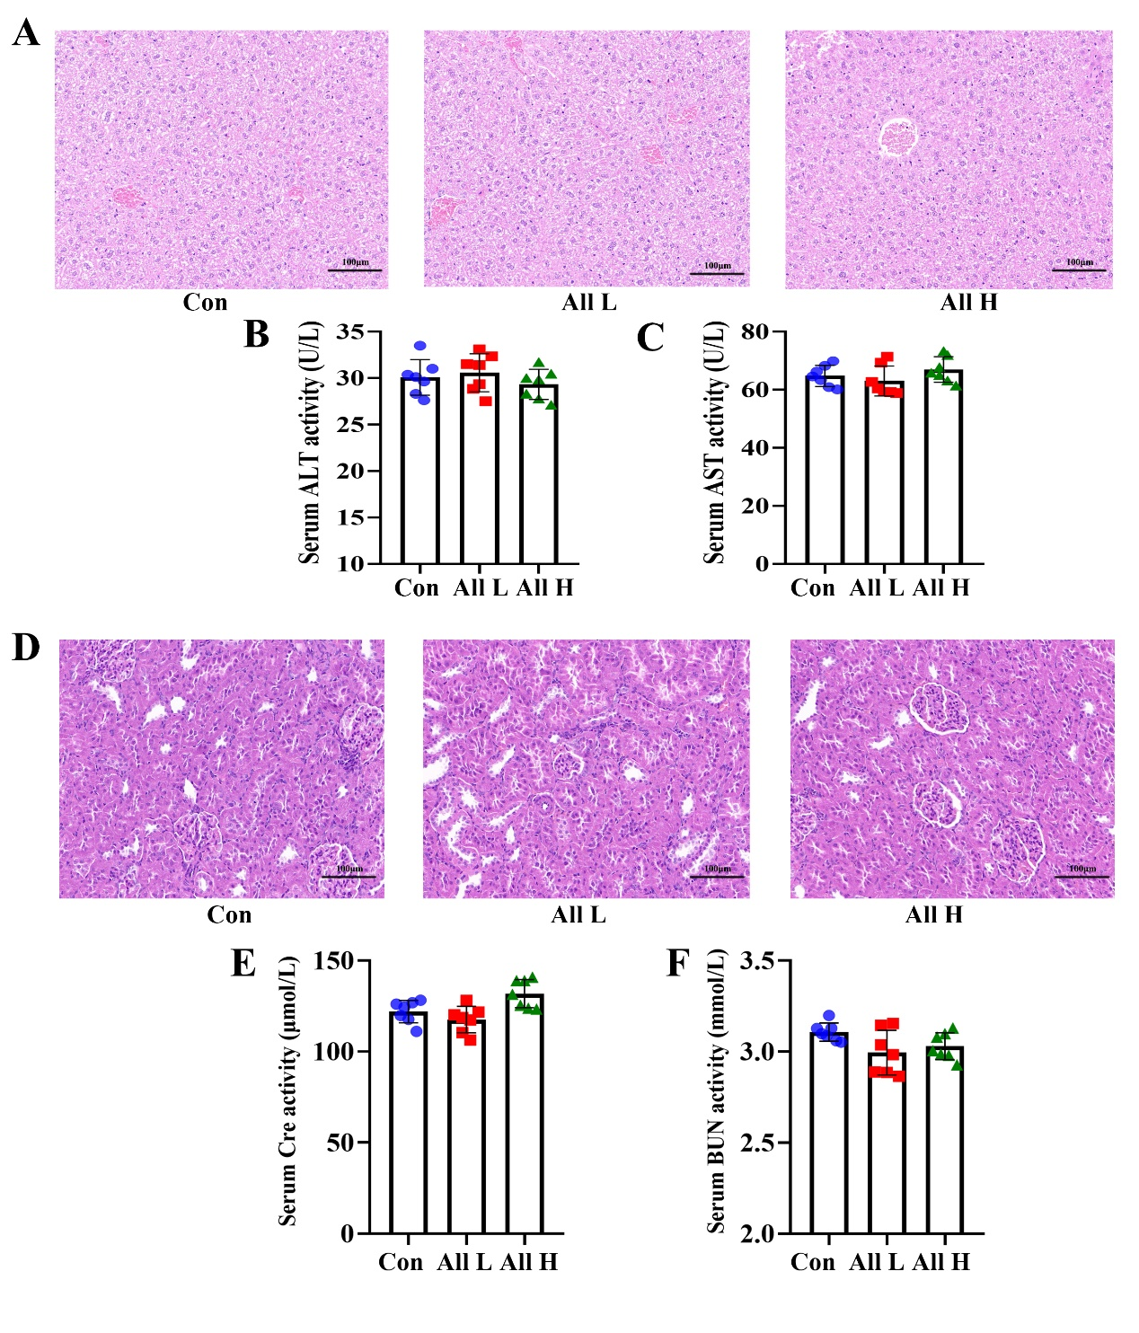
We preliminarily studied the effects of different doses of allicin on the liver and kidneys of rats. The experimental period was 7 days. The allicin dose was 15 mg/kg in the low-dose group and 30 mg/kg in the high-dose group. At the end of the experiment, blood, liver and kidney tissues of rats in each group were taken to evaluate the safety of allicin on the liver and kidneys. The results showed that compared with the Con group, the liver tissue structure of rats in the All H and All L groups was intact, the cells were neatly arranged, and there was no inflammatory cell infiltration or edema (Figure S1 A). And there was no significant difference in the expression of serum ALT and AST among the groups of rats (Figure S1 BC). The kidney tissue structure of rats in the All H and All L groups was clear, with normal glomeruli and renal tubules, and no inflammatory cell infiltration or pathological injury (Figure S1 D). The results of serum renal function index showed that there were no significant differences in the expressions of BUN and Cre in the serum of each group of rats (Figure S1 EF). This part indicates that allicin at doses of 15mg/kg and 30mg/kg did not cause pathological damage to the liver and kidneys of rats.

Figure S1: Effects of different doses of allicin on the liver and kidney of rat. (A) HE pathological section of liver tissue of rat. (B) The activity of ALT in the serum. (C) The activity of AST in the serum. (D) HE pathological section of kidney tissue of rat. (E) The activity of Cre in the serum. (F) The activity of BUN in the serum. Data are expressed as mean ± SEM for 7 rats in each group.

