Supplemental material
Supplemental Material 1 HypoPT-SD Measure
Item | Response Scale
1. How would you rate any muscle cramps you experienced during the past 24 hours? | 5-point ordinal response scale:  - 0 = none  - 1 = mild  - 2 = moderate  - 3 = severe  - 4 = very severe
2. How would you rate any tingling you experienced during the past 24 hours?
3. How would you rate any numbness you experienced during the past 24 hours?
4. How would you rate any muscle spasms or twitching you experienced during the past 24 hours?
5. How would you rate any feelings of heaviness you experienced in your arms or legs during the past 24 hours?
6. How would you rate any physical fatigue you experienced during the past 24 hours?
7. How would you rate any slowed or confused thinking, sometimes called brain fog, you experienced during the past 24 hours?
8. How would you rate any anxiety you felt during the past 24 hours?
9. How would you rate any sadness or depression you felt during the past 24 hours?
10. How did your hypoparathyroidism impact your sleep last night? | 3-point ordinal response scale:  - 0 = not at all  - 1 = somewhat  - 2 = very much
11. How did your hypoparathyroidism impact your ability to exercise in the past 24 hours?
12. How did your hypoparathyroidism impact your ability to complete your work (for example, at school, at home or at a job) in the past 24 hours?
13. How did your hypoparathyroidism impact your relationships with your family members in the past 24 hours?

Notes: The Hypoparathyroidism Symptom Diary (HypoPT-SD) response scales in Supplemental Material 1 are reprinted with permission of Shire Human Genetic Therapies, Inc. © 2016 Shire Human Genetic Therapies, Inc. All rights reserved.
Abbreviations: HypoPT-SD, Hypoparathyroidism Symptom Diary.

Supplemental Material 2 Institutional Review Boards and Independent Ethics Committees
Schulman Associates IRB Inc, Cincinnati, US; University of Chicago Institutional Review Board, Chicago, US; Mayo Clinic Institutional Review, Rochester, US; Western Institutional Review Board, Puyallup, US;CHOP IRB, Philadelphia, US; Advarra IRB, Columbia, US; Health Research Ethics Authority, St Johns, Canada; CHU de Québec – Université Laval, Quebec, Canada; Commissie Medische Ethiek UZ KU, Leuven, Belgium; De Videnskabsetiske Komitéer for Region Midtjylland, Viborg, Denmark’ CPP Sud-Mediterranée 1, Marsielle, France; Ethikkommission der Medizinischen Fakultät Carl-Gustav-Cams der TU, Dresden, Germany; Comitato Etico di Area Vasta Centro, Ufficio di Segreteria, via Largo, Firenza, Italy; Comitato Etico di Area Vasta Centro, Ufficio di Segreteria, Azienda Ospedaliero-Universitaria Careggi Largo, Firenza, Italy; Comitato Etico Milano Area B c/o, Milan, Italy; Comitato Etico Universita Campus, Rome, Italy; REK Sør-Øst, Osla, Norway; Stichting Beoordeling Ethiek, Assen, Netherlands; CEIC- Fundacion Jimenez Diaz, Madrid, Spain; Etikprövningsmyndigheten, Uppsala, Sweden; East of England - Cambridge South Research Ethics Committee, Nottingham, UK; CEIC - Comissão de Ética para a Investigação Clinica, Lisbon, Portugal

Supplemental Material 3 HypoPT-SD Item Scores Descriptive Statistics
Item | n | Mean (SD) | Median | 25th, 75th Percentile | Min, Max | Floor/Ceilingª | Missing (%)^{b}
Baseline
Item 1. Muscle cramps | 92 | 2.2 (0.8) | 2.1 | 1.7, 2.9 | 0.1, 4.0 | 0.0/1.1 | 1 (1.1)
Item 2. Tingling | 92 | 2.3 (0.8) | 2.3 | 1.8, 2.9 | 0.5, 4.0 | 0.0/2.2 | 1 (1.1)
Item 3. Numbness | 92 | 2.2 (0.8) | 2.1 | 1.9, 2.8 | 0.4, 4.0 | 0.0/1.1 | 1 (1.1)
Item 4. Muscle spasms or twitching | 92 | 2.3 (0.8) | 2.2 | 1.9, 2.9 | 0.0, 3.9 | 2.2/0.0 | 1 (1.1)
Item 5. Feelings of heaviness in arms or legs | 92 | 2.5 (0.9) | 2.5 | 1.9, 3.1 | 0.0, 4.0 | 3.3/6.5 | 1 (1.1)
Item 6. Physical fatigue | 92 | 2.9 (0.8) | 2.8 | 2.3, 3.6 | 1.4, 4.0 | 0.0/15.2 | 1 (1.1)
Item 7. Slowed or confused thinking | 92 | 2.4 (0.9) | 2.4 | 1.8, 3.0 | 0.0, 4.0 | 2.2/3.3 | 1 (1.1)
Item 8. Anxiety | 92 | 2.0 (1.0) | 2.1 | 1.3, 2.9 | 0.0, 4.0 | 4.3/1.1 | 1 (1.1)
Item 9. Sadness or depression | 92 | 1.9 (1.0) | 1.9 | 1.1, 2.6 | 0.0, 4.0 | 3.3/2.2 | 1 (1.1)
Item 10. Impact on sleep | 92 | 1.4 (0.5) | 1.2 | 1.0, 1.9 | 0.2, 2.0 | 0.0/21.7 | 1 (1.1)
Item 11. Impact on exercise | 92 | 1.5 (0.4) | 1.4 | 1.0, 1.9 | 0.5, 2.0 | 0.0/23.9 | 1 (1.1)
Item 12. Impact on work | 92 | 1.4 (0.5) | 1.3 | 1.0, 1.9 | 0.4, 2.0 | 0.0/22.8 | 1 (1.1)
Item 13. Impact on relationships | 92 | 1.1 (0.6) | 1.1 | 0.7, 1.6 | 0.0, 2.0 | 5.4/15.2 | 1 (1.1)
HypoPT-SD symptom subscale (items 1–7) | 92 | 2.4 (0.7) | 2.2 | 1.9, 2.9 | 1.4, 3.8 | 0.0/0.0 | 1 (1.1)
HypoPT-SD impact subscale (items 10–13) | 92 | 1.3 (0.4) | 1.3 | 1.0, 1.8 | 0.5, 2.0 | 0.0/9.8 | 1 (1.1)
Week 4
Item 1. Muscle cramps | 87 | 1.5 (1.0) | 1.4 | 0.8, 2.0 | 0.0, 4.0 | 3.4/2.3 | 6 (6.5)
Item 2. Tingling | 87 | 1.5 (0.9) | 1.5 | 0.9, 2.0 | 0.0, 4.0 | 4.6/1.1 | 6 (6.5)
Item 3. Numbness | 87 | 1.5 (1.0) | 1.4 | 0.8, 2.1 | 0.0, 4.0 | 6.9/2.3 | 6 (6.5)
Item 4. Muscle spasms or twitching | 87 | 1.5 (1.0) | 1.4 | 0.8, 2.0 | 0.0, 4.0 | 8.0/1.1 | 6 (6.5)
Item 5. Feelings of heaviness in arms or legs | 87 | 1.9 (1.0) | 1.9 | 1.1, 2.3 | 0.0, 4.0 | 4.6/3.4 | 6 (6.5)
Item 6. Physical fatigue | 87 | 2.3 (0.9) | 2.3 | 1.6, 2.9 | 0.3, 4.0 | 0.0/6.9 | 6 (6.5)
Item 7. Slowed or confused thinking | 87 | 1.7 (1.0) | 1.7 | 1.0, 2.4 | 0.0, 3.9 | 5.7/0.0 | 6 (6.5)
Item 8. Anxiety | 87 | 1.4 (1.0) | 1.1 | 0.7, 2.2 | 0.0, 3.9 | 10.3/0.0 | 6 (6.5)
Item 9. Sadness or depression | 87 | 1.3 (1.0) | 1.1 | 0.5, 2.0 | 0.0, 3.9 | 13.8/0.0 | 6 (6.5)
Item 10. Impact on sleep | 87 | 1.1 (0.5) | 1.0 | 0.8, 1.3 | 0.0, 2.0 | 1.1/11.5 | 6 (6.5)
Item 11. Impact on exercise | 87 | 1.1 (0.6) | 1.0 | 0.9, 1.6 | 0.0, 2.0 | 4.6/17.2 | 6 (6.5)
Item 12. Impact on work | 87 | 1.0 (0.6) | 1.0 | 0.6, 1.2 | 0.0, 2.0 | 6.9/11.5 | 6 (6.5)
Item 13. Impact on relationships | 87 | 0.8 (0.6) | 1.0 | 0.2, 1.0 | 0.0, 2.0 | 18.4/5.7 | 6 (6.5)
HypoPT-SD symptom subscale (items 1–7) | 87 | 1.7 (0.8) | 1.6 | 1.1, 2.2 | 0.1, 3.9 | 0.0/0.0 | 6 (6.5)
HypoPT-SD impact subscale (items 10–13) | 87 | 1.0 (0.5) | 1.0 | 0.7, 1.4 | 0.1, 2.0 | 0.0/2.3 | 6 (6.5)
Week 12
Item 1. Muscle cramps | 83 | 1.2 (1.0) | 1.0 | 0.2, 1.7 | 0.0, 4.0 | 18.1/1.2 | 10 (10.8)
Item 2. Tingling | 83 | 1.3 (0.9) | 1.1 | 0.4, 1.8 | 0.0, 4.0 | 9.6/2.4 | 10 (10.8)
Item 3. Numbness | 83 | 1.2 (1.0) | 1.1 | 0.3, 1.9 | 0.0, 4.0 | 14.5/1.2 | 10 (10.8)
Item 4. Muscle spasms or twitching | 83 | 1.2 (1.0) | 1.1 | 0.4, 1.9 | 0.0, 3.9 | 8.4/0.0 | 10 (10.8)
Item 5. Feelings of heaviness in arms or legs | 83 | 1.6 (1.1) | 1.7 | 0.8, 2.0 | 0.0, 4.0 | 8.4/3.6 | 10 (10.8)
Item 6. Physical fatigue | 83 | 2.0 (1.1) | 2.0 | 1.1, 2.6 | 0.0, 4.0 | 3.6/4.8 | 10 (10.8)
Item 7. Slowed or confused thinking | 83 | 1.5 (1.1) | 1.4 | 0.6, 2.1 | 0.0, 3.9 | 10.8/0.0 | 10 (10.8)
Item 8. Anxiety | 83 | 1.2 (1.1) | 1.0 | 0.2, 1.9 | 0.0, 3.9 | 15.7/0.0 | 10 (10.8)
Item 9. Sadness or depression | 83 | 1.1 (1.0) | 1.0 | 0.2, 1.8 | 0.0, 3.8 | 13.3/0.0 | 10 (10.8)
Item 10. Impact on sleep | 83 | 1.0 (0.6) | 1.0 | 0.8, 1.1 | 0.0, 2.0 | 4.8/13.3 | 10 (10.8)
Item 11. Impact on exercise | 83 | 1.1 (0.6) | 1.0 | 0.9, 1.6 | 0.0, 2.0 | 8.4/19.3 | 10 (10.8)
Item 12. Impact on work | 83 | 1.0 (0.6) | 1.0 | 0.4, 1.1 | 0.0, 2.0 | 14.5/12.0 | 10 (10.8)
Item 13. Impact on relationships | 83 | 0.7 (0.6) | 1.0 | 0.1, 1.0 | 0.0, 2.0 | 21.7/7.2 | 10 (10.8)
HypoPT-SD symptom subscale (items 1–7) | 83 | 1.4 (0.9) | 1.4 | 0.7, 1.8 | 0.0, 3.9 | 2.4/0.0 | 10 (10.8)
HypoPT-SD impact subscale (items 10–13) | 83 | 1.0 (0.5) | 1.0 | 0.6, 1.3 | 0.0, 2.0 | 2.4/4.8 | 10 (10.8)
EOT
Item 1. Muscle cramps | 69 | 1.1 (1.1) | 1.0 | 0.2, 1.4 | 0.0, 4.0 | 21.7/2.9 | 24 (25.8)
Item 2. Tingling | 69 | 1.1 (1.0) | 1.0 | 0.2, 1.5 | 0.0, 4.0 | 20.3/2.9 | 24 (25.8)
Item 3. Numbness | 69 | 1.1 (1.0) | 1.0 | 0.2, 1.5 | 0.0, 4.0 | 20.3/2.9 | 24 (25.8)
Item 4. Muscle spasms or twitching | 69 | 1.1 (1.1) | 1.0 | 0.1, 1.8 | 0.0, 4.0 | 18.8/1.4 | 24 (25.8)
Item 5. Feelings of heaviness in arms or legs | 69 | 1.4 (1.1) | 1.4 | 0.7, 2.0 | 0.0, 4.0 | 10.1/5.8 | 24 (25.8)
Item 6. Physical fatigue | 69 | 1.8 (1.0) | 1.9 | 1.1, 2.1 | 0.0, 4.0 | 4.3/4.3 | 24 (25.8)
Item 7. Slowed or confused thinking | 69 | 1.2 (1.0) | 1.0 | 0.6, 2.0 | 0.0, 3.8 | 14.5/0.0 | 24 (25.8)
Item 8. Anxiety | 69 | 1.0 (1.0) | 1.0 | 0.2, 1.3 | 0.0, 4.0 | 23.2/1.4 | 24 (25.8)
Item 9. Sadness or depression | 69 | 0.9 (0.9) | 1.0 | 0.1, 1.1 | 0.0, 3.8 | 23.2/0.0 | 24 (25.8)
Item 10. Impact on sleep | 69 | 0.9 (0.5) | 1.0 | 0.7, 1.1 | 0.0, 2.0 | 11.6/8.7 | 24 (25.8)
Item 11. Impact on exercise | 69 | 1.0 (0.6) | 1.0 | 0.9, 1.1 | 0.0, 2.0 | 11.6/14.5 | 24 (25.8)
Item 12. Impact on work | 69 | 0.9 (0.6) | 1.0 | 0.4, 1.0 | 0.0, 2.0 | 17.4/11.6 | 24 (25.8)
Item 13. Impact on relationships | 69 | 0.7 (0.6) | 0.9 | 0.0, 1.0 | 0.0, 2.0 | 29.0/5.8 | 24 (25.8)
HypoPT-SD symptom subscale (items 1–7) | 69 | 1.3 (0.9) | 1.2 | 0.6, 1.6 | 0.0, 3.8 | 4.3/0.0 | 24 (25.8)
HypoPT-SD impact subscale (items 10–13) | 69 | 0.9 (0.5) | 0.9 | 0.5, 1.1 | 0.0, 2.0 | 5.8/2.9 | 24 (25.8)
Change from baseline to EOT
Item 1. Muscle cramps | 68 | −1.0 (1.0) | −1.0 | −1.6, −0.3 | −4.0, 1.8 | – | 25 (26.9)
Item 2. Tingling | 68 | −1.2 (1.1) | −1.1 | −1.9, −0.6 | −3.8, 1.6 | – | 25 (26.9)
Item 3. Numbness | 68 | −1.0 (1.1) | −0.9 | −1.9, −0.1 | −3.9, 1.4 | – | 25 (26.9)
Item 4. Muscle spasms or twitching | 68 | −1.1 (1.1) | −1.0 | −1.9, −0.3 | −3.5, 1.3 | – | 25 (26.9)
Item 5. Feelings of heaviness in arms or legs | 68 | −1.1 (1.1) | −1.0 | −1.9, −0.1 | −3.9, 0.9 | – | 25 (26.9)
Item 6. Physical fatigue | 68 | −1.1 (1.1) | −1.0 | −1.9, −0.3 | −4.0, 0.9 | – | 25 (26.9)
Item 7. Slowed or confused thinking | 68 | −1.1 (0.9) | −1.0 | −1.6, −0.5 | −3.2, 1.1 | – | 25 (26.9)
Item 8. Anxiety | 68 | −1.0 (1.0) | −0.8 | −1.7, −0.2 | −3.3, 1.2 | – | 25 (26.9)
Item 9. Sadness or depression | 68 | −0.9 (1.0) | −0.6 | −1.6, −0.2 | −3.2, 1.3 | – | 25 (26.9)
Item 10. Impact on sleep | 68 | −0.5 (0.6) | −0.3 | −1.0, 0.0 | −2.0, 0.8 | – | 25 (26.9)
Item 11. Impact on exercise | 68 | −0.5 (0.6) | −0.3 | −0.9, 0.0 | −2.0, 0.6 | – | 25 (26.9)
Item 12. Impact on work | 68 | −0.5 (0.6) | −0.4 | −1.0, 0.0 | −2.0, 0.7 | – | 25 (26.9)
Item 13. Impact on relationships | 68 | −0.5 (0.6) | −0.3 | −0.9, 0.0 | −2.0, 0.9 | – | 25 (26.9)
HypoPT-SD symptom subscale (items 1–7) | 68 | −1.1 (0.9) | −0.9 | −1.6, −0.5 | −3.5, 1.2 | – | 25 (26.9)
HypoPT-SD impact subscale (items 10–13) | 68 | −0.5 (0.5) | −0.4 | −0.8, −0.1 | −2.0, 0.6 | – | 25 (26.9)

Notes: ªFloor is defined as the percentage of patients who select the lowest response option (ie, minimum score and best quality of life) and ceiling is defined as the percentage of patients who select the highest response option (ie, maximum score and worst quality of life). Floor and ceiling effects occur when 20% or more of the respondents record the minimum or maximum score possible on the scale. Items 1–9 are rated on a 5-point scale and items 10–13 are rated on a 3-point scale, where higher scores represent worse symptoms or impacts. The HypoPT-SD symptom subscale is the mean of items 1–7 and the HypoPT-SD impact subscale is the mean of items 10–13. ^{b}Missing (%) is calculated from the overall cohort (n=93).
Abbreviations: EOT, end of treatment; HypoPT-SD, Hypoparathyroidism Symptom Diary; max, maximum; min, minimum; SD, standard deviation.

Supplemental Material 4 PGI-C and PGI-S for HypoPT-SD Response Distributions
Measure and Time Point | Response Frequency (%)
PGI-C for HypoPT-SD response distribution | n | Very much improved | Much improved | Minimally improved | No change | Minimally worse | Much worse | Very much worse | Missing
Baseline | 87 | 0 (0.0) | 0 (0.0) | 0 (0.0) | 71 (81.6) | 10 (11.5) | 5 (5.7) | 1 (1.1) | 6 (6.5)
Week 12 | 64 | 3 (4.7) | 20 (31.2) | 20 (31.2) | 12 (18.8) | 5 (7.8) | 2 (3.1) | 2 (3.1) | 29 (31.2)
EOT | 62 | 7 (11.3) | 13 (21.0) | 15 (24.2) | 20 (32.3) | 2 (3.2) | 3 (4.8) | 2 (3.2) | 31 (33.3)
PGI-S for HypoPT-SD response distribution | n | No symptoms | Mild | Moderate | Severe | Very severe | Much worse | Very much worse | Missing
Baseline | 93 | 1 (1.1) | 1 (1.1) | 31 (33.3) | 37 (39.8) | 23 (24.7) | – | – | 0 (0.0)
Week 4 | 67 | 1 (1.5) | 9 (13.4) | 30 (44.8) | 20 (29.9) | 7 (10.4) | – | – | 26 (28.0)
Week 12 | 63 | 2 (3.2) | 14 (22.2) | 30 (47.6) | 11 (17.5) | 6 (9.5) | – | – | 30 (32.3)
EOT | 63 | 6 (9.5) | 12 (19.0) | 30 (47.6) | 10 (15.9) | 5 (7.9) | – | – | 30 (32.3)

Notes: All percentages calculated from the number participants with non-missing responses (eg, n=93, 67, 63 etc.), except for missing responses percentage, which is calculated from the overall cohort (n=93).
Abbreviations: EOT, end of treatment; HypoPT-SD, Hypoparathyroidism Symptom Diary; PGI-C, Patient Global Impression of Change; PGI-S, Patient Global Impression of Severity.

Supplemental Material 5 HypoPT-SD Internal Consistency at Baseline
Subscale and Item | Cronbach’s α (n=92)
HypoPT-SD symptom | 0.90
Item 1. Muscle cramps | 0.89
Item 2. Tingling | 0.88
Item 3. Numbness | 0.87
Item 4. Muscle spasms or twitching | 0.89
Item 5. Feelings of heaviness in arms or legs | 0.90
Item 6. Physical fatigue | 0.88
Item 7. Slowed or confused thinking | 0.90
HypoPT-SD impact | 0.88
Item 10. Impact on sleep | 0.88
Item 11. Impact on exercise | 0.83
Item 12. Impact on work | 0.82
Item 13. Impact on relationships | 0.87

Notes: Rows for subscales provide Cronbach’s α using all items in the subscale, whereas rows for individual items provide Cronbach’s α for the subscale with the given item removed.
Abbreviations: HypoPT-SD, Hypoparathyroidism Symptom D
Supplemental Material 6 Responsiveness Correlations
HypoPT-SD item | Correlation Coefficient (r)
HypoPT-SD item | PGI-S | PGI-C | FACIT-Fatigue | FACT-Cog impact | FACT-Cog impairments | SF-36v2 MCS | SF-36v2 PCS | WPAI:HypoPT, percent work time missed due to HypoPT | WPAI:HypoPT, percent impairment while working due to HypoPT | WPAI:HypoPT, percent overall work impairment due to HypoPT | WPAI:HypoPT, percent activity impairment due to HypoPT | EQ VAS | EQ-5D-5L mobility | EQ-5D-5L self-care | EQ-5D-5L usual activities | EQ-5D-5L pain/discomfort | EQ-5D-5L anxiety/depression
HypoPT-SD item | n=50 | n=50 | n=45 | n=45 | n=45 | n=46 | n=46 | n=17 | n=14 | n=14 | N=44 | n=45 | n=45 | n=45 | n=45 | n=45 | n=45
Item 1. Muscle cramps | 0.49 | 0.51 | −0.49 | −0.30 | −0.20 | −0.34 | −0.22 | −0.43 | −0.04 | 0.11 | 0.10 | −0.34 | 0.17 | 0.20 | 0.43 | 0.55 | 0.33
Item 2. Tingling | 0.46 | 0.61 | −0.49 | −0.35 | −0.21 | −0.36 | −0.14 | −0.25 | 0.02 | 0.10 | 0.12 | −0.35 | 0.16 | 0.16 | 0.36 | 0.56 | 0.40
Item 3. Numbness | 0.48 | 0.67 | −0.44 | −0.33 | −0.11 | −0.35 | −0.17 | −0.13 | 0.05 | 0.18 | 0.09 | −0.41 | 0.25 | 0.20 | 0.42 | 0.54 | 0.39
Item 4. Muscle spasms or twitching | 0.51 | 0.58 | −0.50 | −0.30 | −0.19 | −0.36 | −0.28 | −0.14 | −0.09 | 0.03 | 0.14 | −0.42 | 0.25 | 0.21 | 0.46 | 0.59 | 0.39
Item 5. Feelings of heaviness in arms or legs | 0.40 | 0.60 | −0.38 | −0.30 | −0.07 | −0.36 | −0.17 | 0.18 | 0.25 | 0.22 | 0.06 | −0.47 | 0.19 | 0.20 | 0.37 | 0.49 | 0.25
Item 6. Physical fatigue | 0.67 | 0.74 | −0.70 | −0.50 | −0.38 | −0.55 | −0.49 | 0.31 | 0.41 | 0.34 | 0.34 | −0.59 | 0.25 | 0.21 | 0.54 | 0.62 | 0.42
Item 7. Slowed or confused thinking | 0.56 | 0.67 | −0.60 | −0.52 | −0.41 | −0.57 | −0.33 | −0.01 | 0.46 | 0.48 | 0.27 | −0.49 | 0.21 | 0.22 | 0.46 | 0.54 | 0.51
Item 8. Anxiety | 0.58 | 0.62 | −0.66 | −0.57 | −0.46 | −0.59 | −0.40 | 0.36 | 0.30 | 0.15 | 0.36 | −0.54 | 0.34 | 0.22 | 0.57 | 0.65 | 0.58
Item 9. Sadness or depression | 0.46 | 0.46 | −0.62 | −0.46 | −0.43 | −0.62 | −0.27 | 0.21 | 0.20 | 0.03 | 0.22 | −0.49 | 0.23 | 0.17 | 0.46 | 0.57 | 0.59
Item 10. Impact on sleep | 0.58 | 0.50 | −0.59 | −0.41 | −0.38 | −0.44 | −0.43 | 0.19 | −0.15 | −0.16 | 0.28 | −0.51 | 0.30 | 0.26 | 0.45 | 0.53 | 0.42
Item 11. Impact on exercise | 0.62 | 0.58 | −0.62 | −0.55 | −0.40 | −0.44 | −0.49 | −0.15 | 0.50 | 0.45 | 0.38 | −0.53 | 0.26 | 0.19 | 0.51 | 0.60 | 0.39
Item 12. Impact on work | 0.55 | 0.51 | −0.57 | −0.47 | −0.44 | −0.40 | −0.45 | −0.02 | 0.42 | 0.46 | 0.34 | −0.44 | 0.17 | 0.16 | 0.44 | 0.52 | 0.40
Item 13. Impact on relationships | 0.48 | 0.45 | −0.58 | −0.44 | −0.45 | −0.50 | −0.35 | 0.11 | 0.42 | 0.32 | 0.29 | −0.46 | 0.19 | 0.21 | 0.42 | 0.49 | 0.44
HypoPT-SD symptom subscale | 0.58 | 0.71 | −0.58 | −0.42 | −0.25 | −0.47 | −0.29 | −0.10 | 0.17 | 0.25 | 0.18 | −0.50 | 0.24 | 0.23 | 0.49 | 0.63 | 0.43
HypoPT-SD impact subscale | 0.64 | 0.58 | −0.66 | −0.52 | −0.46 | −0.49 | −0.49 | 0.05 | 0.43 | 0.39 | 0.37 | −0.54 | 0.26 | 0.23 | 0.51 | 0.59 | 0.45

Notes: Positive changes on the HypoPT-SD items and subscales represent worsened symptoms or impacts. Positive changes on the FACIT-Fatigue, FACT-Cog, and SF-36v2 measures indicate improved functioning. For all EQ-5D-5L measures, positive changes indicate worsened problems with the symptom being assessed, whereas positive changes on the EQ VAS indicate improved health. Positive changes on the PGI-S and higher scores on the PGI-C indicate worsened symptom severity. Purple cells indicate the correlations between the symptom and impact subscales and their potential global anchors.
Abbreviations: FACT-Cog, Functional Assessment of Cancer Therapy-Cognitive Function; EQ-5D-5L, EuroQol-5 dimension 5-level; FACIT-Fatigue, Functional Assessment of Chronic Illness Therapy-Fatigue; HypoPT, hypoparathyroidism; HypoPT-SD, Hypoparathyroidism Symptom Diary; MCS, mental component summary; PCS, physical component summary; PGI-C, Patient Global Impression of Change; PGI-S, Patient Global Impression of Severity; SF-36v2, 36-item Short Form Health Survey version 2; VAS, visual analogue scale; WPAI, Work Productivity and Activity Impairment

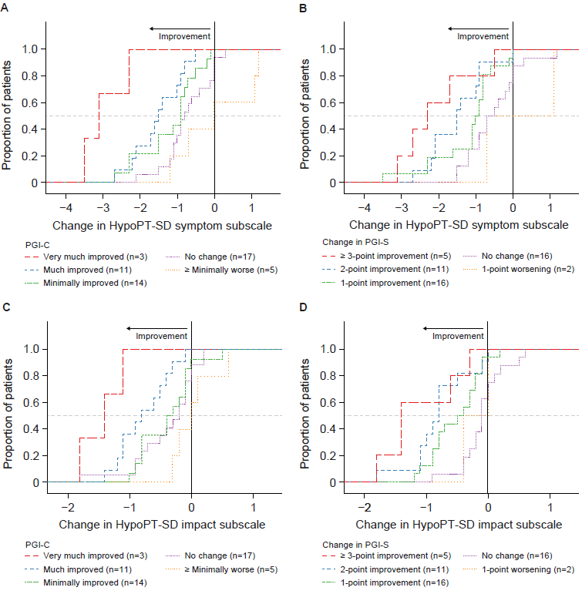

Supplemental Material 7 Cumulative distribution function of change in HypoPT-SD symptom subscale (baseline to EOT) for (A) PGI-C anchor and (B) PGI-S anchor. Cumulative distribution function of change in HypoPT-SD impact subscale (baseline to EOT) for (C) PGI-C anchor and (D) PGI-S anchor. Improvements in the HypoPT-SD symptom and impact subscales are indicated by negative score changes (reduction of symptoms), with deteriorations in the HypoPT-SD symptom and impact subscales indicated by positive score changes. Curves indicating improvement (red, blue, and green) should fall to the left of the curves indicating no change (purple) or worsening (orange).
C
Abbreviations: EOT, end of treatment; HypoPT-SD, Hypoparathyroidism Symptom Diary; PGI-C, Patient Global Impression of Change; PGI-S, Patient Global Impression of Severity.
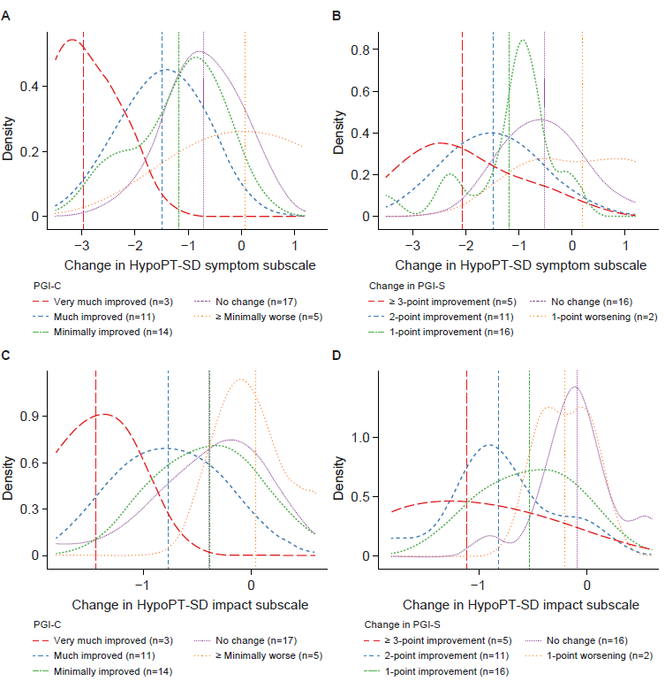
Supplemental Material 8. Probability density function of change in HypoPT-SD symptom subscale (baseline to EOT) for PGI-C anchor (A) and PGI-S anchor (B). Probability density function of change in HypoPT-SD impact subscale (baseline to EOT) for PGI-C anchor (C) and for PGI-S anchor (D).
Notes: Improvements in the HypoPT-SD symptom and impact subscales are indicated by negative score changes (reduction of symptoms), with deteriorations in the HypoPT-SD symptom and impact subscales indicated by positive score changes. Curves indicating improvement (red, blue, and green) should fall to the left of the curves indicating no change (purple) or worsening (orange).
Abbreviations: EOT, end of treatment; HypoPT-SD, Hypoparathyroidism Symptom Diary; PGI-C, Patient Global Impression of Change; PGI-S, Patient Global Impression of Severity.

