eFigure 1, Alpha diversity measured by Shannon Index across study groups (asthma vs. controls). No statistically significant differences were observed.

eFigure 2, Alpha diversity measured by Faith's Phylogenetic Diversity (PD) in asthma and control groups. No significant differences were found.

eFigure 3. Beta diversity analysis of gut microbiota using Bray-Curtis dissimilarity. The 3D visualization (Emperor plot) (A) shows clustering patterns between asthma (red) and control (green) groups. These patterns are statistically supported by PERMANOVA analysis (B), which demonstrates significant differences between the groups (p = 0.006).
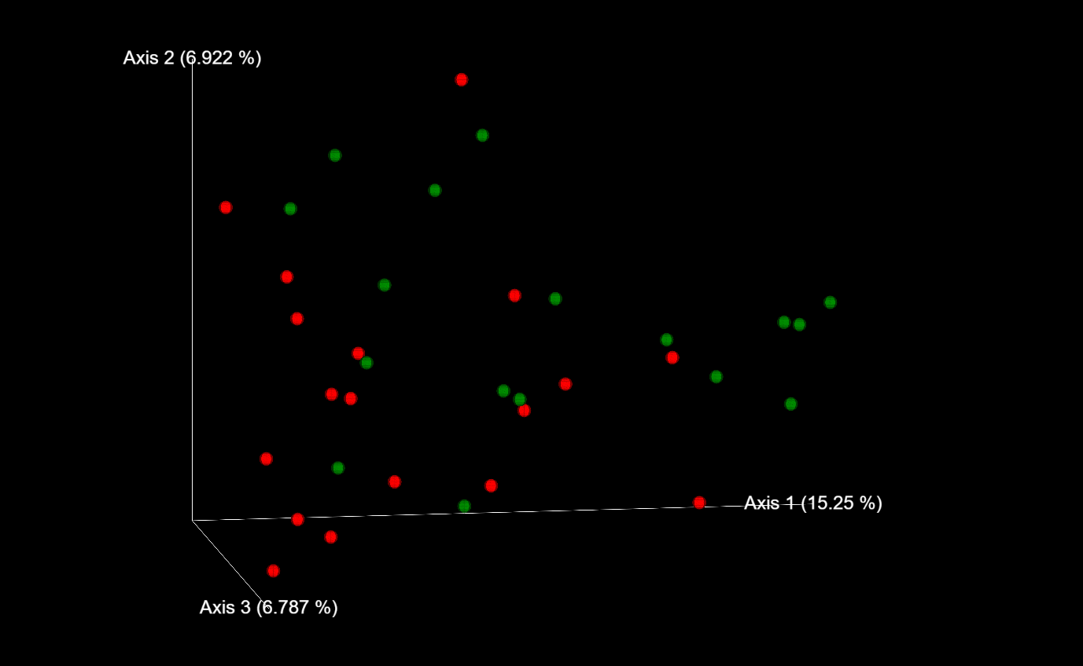
A
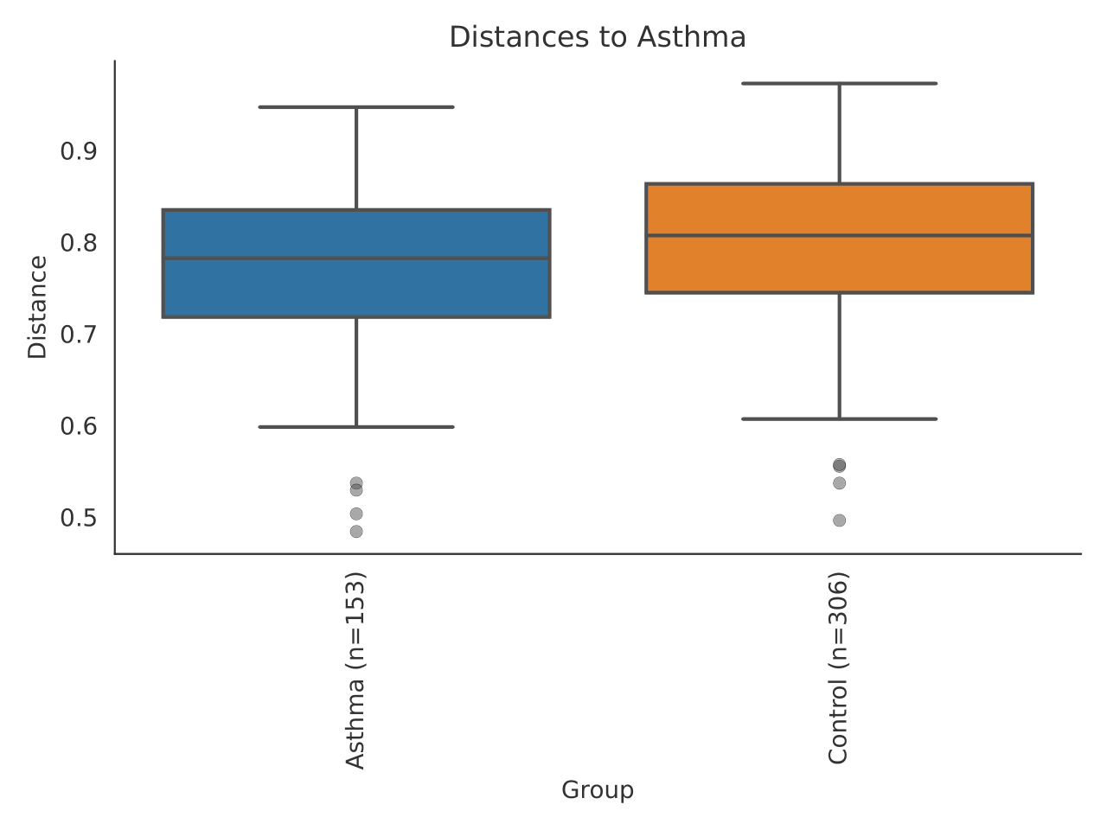
B
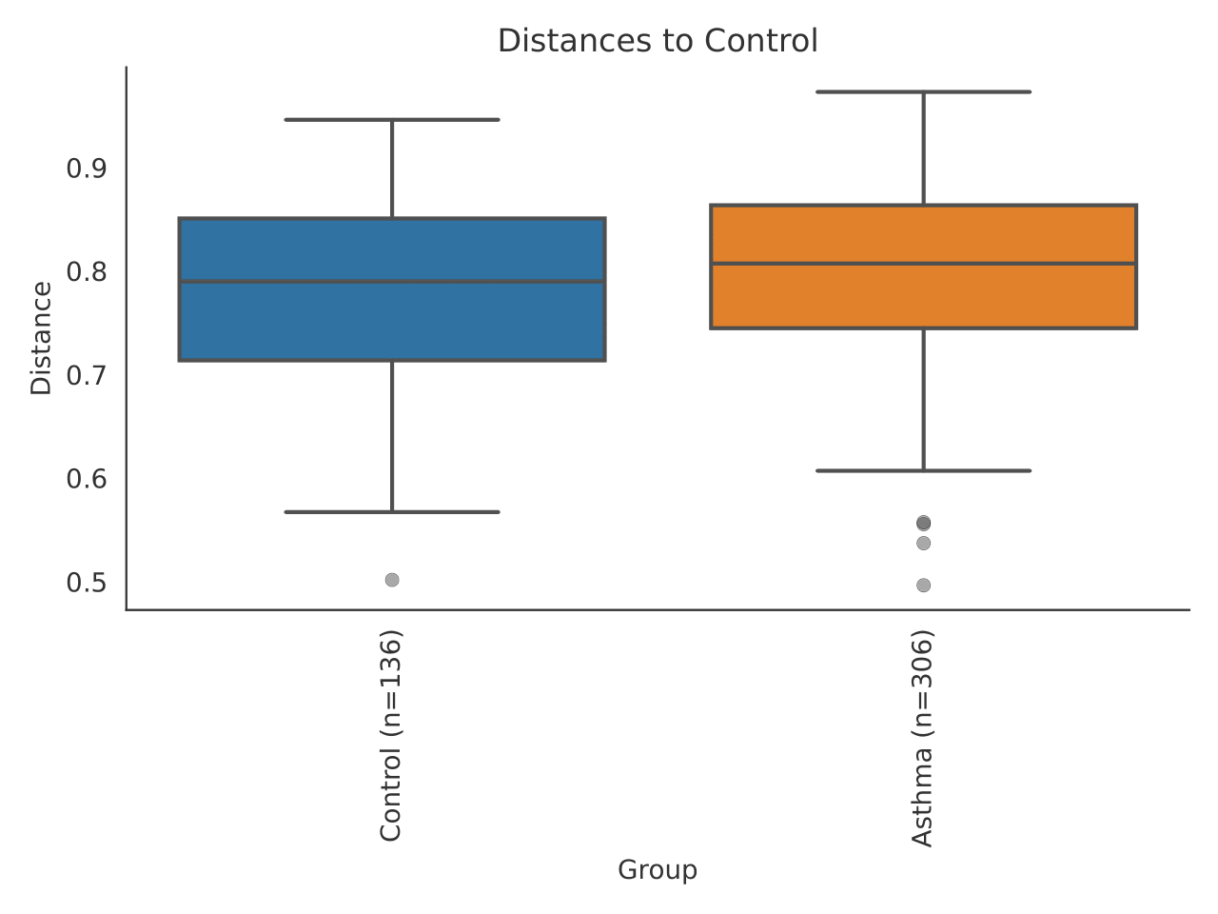

eFigure 4. Beta diversity analysis of gut microbiota using Jaccard dissimilarity. The 3D visualization (Emperor plot) (A) shows clustering patterns between asthma (red) and control (green) groups. These patterns are statistically supported by PERMANOVA analysis (B), which demonstrates significant differences between the groups (p = 0.007).
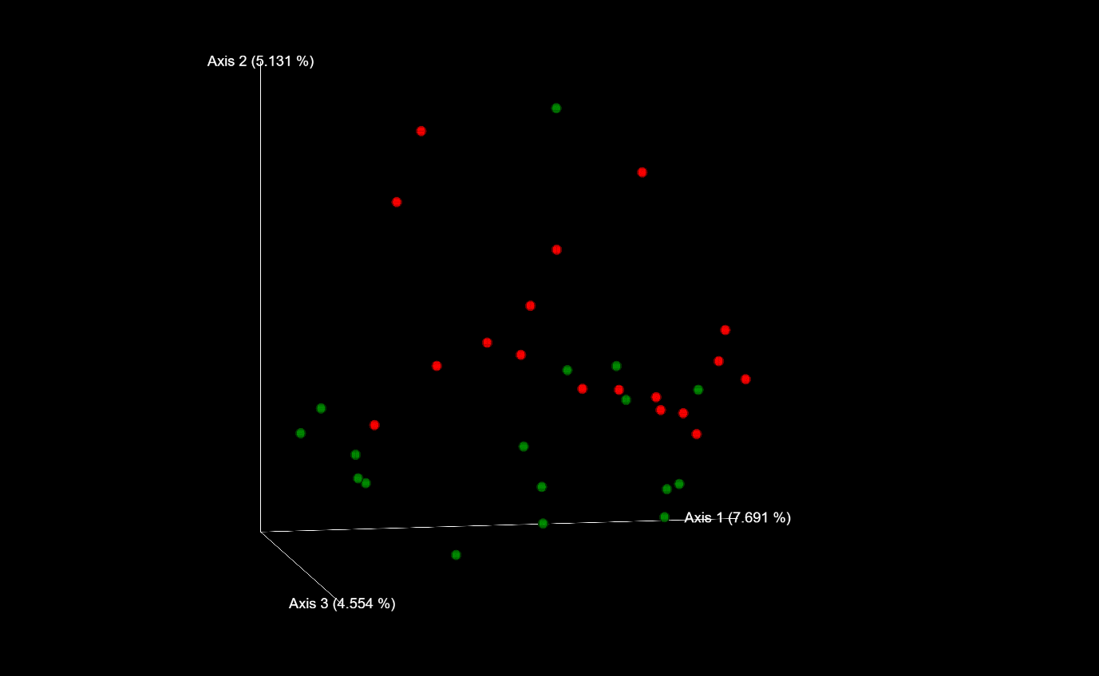
A
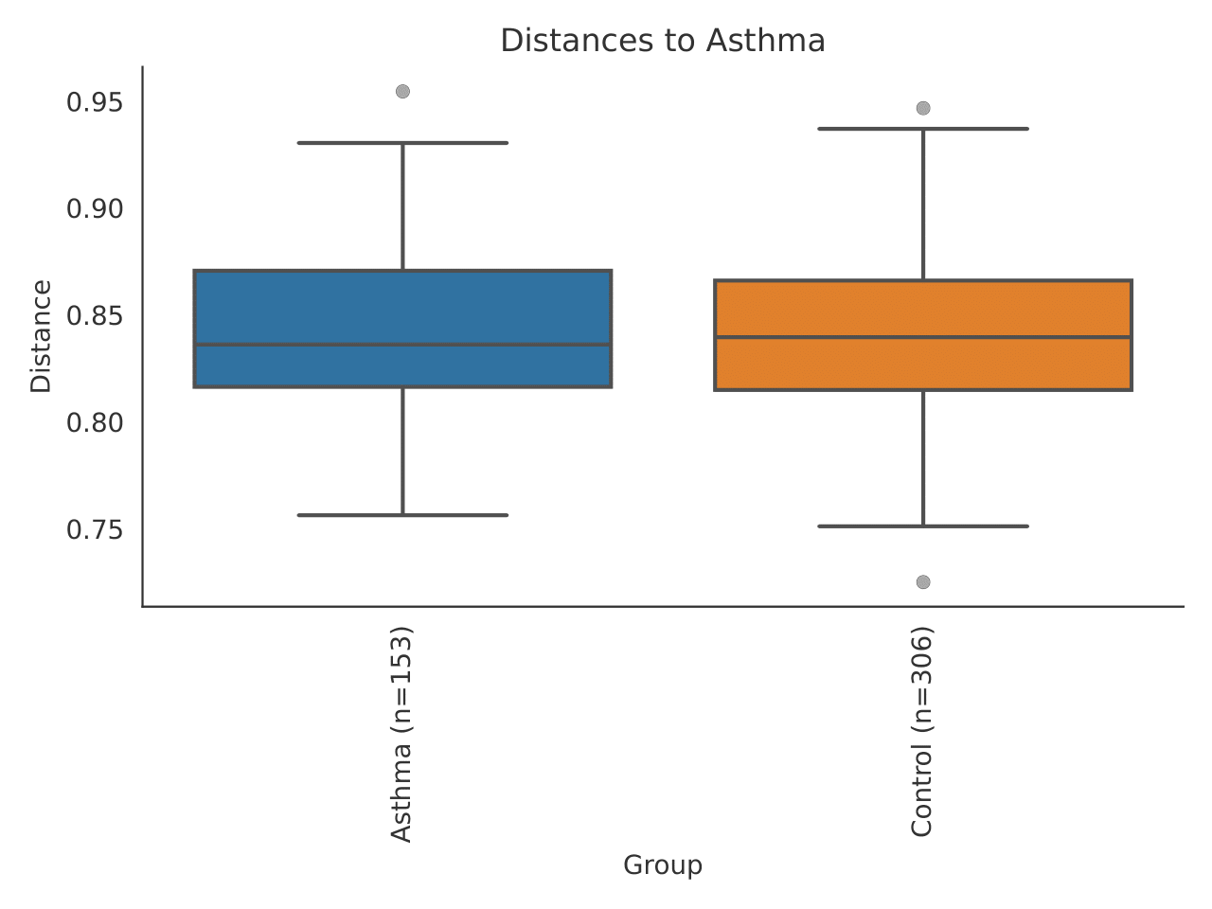
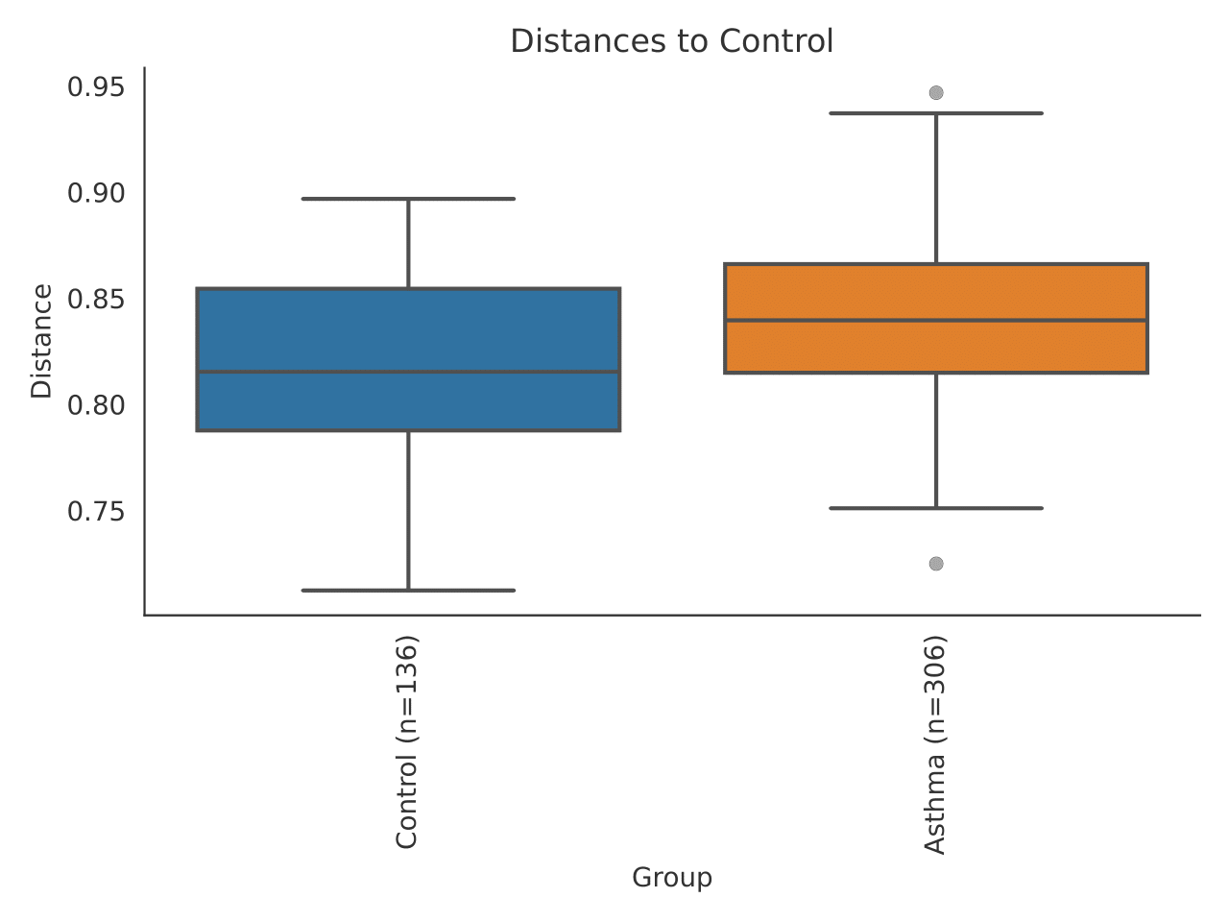
B

eTable 1. Characteristics of people participating in the first and second stages of the study

 | Asthma | Control group
Age
Min | 20,0 | 32,0
Max | 70,0 | 70,0
Median | 51,14 | 50,89
SD | 11,71 | 11,20
Gender
Female | 34 (69,4%) | 10 (55,6%)
Male | 15 (30,6%) | 8 (44,4%)
Occurrence of food allergy
Yes | 8 (16,3%) | 1 (5,6%)
No | 38 (77,6%) | 17 (94,4%)
Occurrence of food hypersensitivity
Yes | 11 (22,4%) | 1 (5,6%)
No | 35 (71,4%) | 17 (94,4%)
 | Weight
Min | 49,0 | 58,0
Max | 140,0 | 112,0
Median | 79,71 | 77,12
SD | 17,92 | 14,46
 | Height
Min | 1,53 | 1,55
Max | 1,90 | 1,87
Median | 1,67 | 1,71
SD | 0,08 | 0,09
BMI
Min | 17,87 | 19,16
Max | 40,91 | 32,03
Median | 28,45 | 26,14
SD | 5,02 | 3,35
SD standard deviation

eTable 2. Details regarding the diagnosis among the examined patients - stages I and II

Type of asthma | number of patients | %
Controlled | 20 | 40,8
Partially controlled | 9 | 18,4
Uncontrolled | 16 | 32,7
No answer | 4 | 8,2

eTable 3. Characteristics of people participating in the third stage of the study

 | Asthma | Control group
Age
Min | 33 | 32
Max | 70 | 70
Median | 50,63 | 51,06
SD | 11,49 | 11,39
Gender
Female | 11 (68,8%) | 10 (55,6%)
Male | 5 (31,3%) | 8 (44,4%)
Min | 19,72 | 19,16
Max | 40,90 | 32,03
Median | 29,05 | 26,15
SD | 5,56 | 3,35
Occurrence of food allergy
Yes | 2 (12,5%) | 1 (5,6%)
No | 14 (87,5%) | 17 (94,4%)
Occurrence of food hypersensitivity
Yes | 13 (81,3%) | 0
No | 1 (6,3%) | 18 (100%)
No answer | 2 (12,5%) | 0
SD standard deviation

eTable 4. Details regarding the diagnosis among the examined patients - stage III

Type of asthma | Number of patients | %
Well controlled | 8 | 50%
Partially controlled | 4 | 25%
Uncontrolled | 3 | 19%
No answer | 1 | 6%

eTable 5. Level of asthma control based on assessment over the last 4 weeks

Criterion | Well controlled asthma  All criteria achieved | Partially controlled asthma  1-2 of the above criteria are achieved | Uncontrolled asthma  3-4 of the above criteria are achieved
limitation of exercise tolerance | no | yes | yes
night wakings | no | yes | yes
symptoms during the day | no more than twice a week | more than twice a week | more than twice a week
the need to use SABA | no more than twice a week | more than twice a week | more than twice a week

eTable 6. Analysis of eating habits in the last 12 months in the study groups, p-value in all groups p >0,05

Products | Group | N | M | SD | Minimum | Maximum
Sweets
Sweets | Asthma | 50 | 2,51 | 0,61 | 1,43 | 4,20
Sweets | Control | 13 | 2,45 | 0,33 | 2,14 | 3,14
Dairy products
Dairy products | Asthma | 50 | 2,91 | 0,79 | 1,33 | 5,33
Dairy products | Control | 13 | 2,90 | 0,46 | 2,17 | 4,00
Cereal products
Cereal products | Asthma | 50 | 3,00 | 0,53 | 1,80 | 4,60
Cereal products | Control | 13 | 2,78 | 0,47 | 2,20 | 3,60
Fats
Fats | Asthma | 50 | 2,79 | 0,69 | 1,20 | 4,33
Fats | Control | 13 | 2,37 | 0,54 | 1,67 | 3,33
Fruits
Fruits | Asthma | 50 | 2,82 | 0,46 | 1,80 | 3,64
Fruits | Control | 13 | 2,59 | 0,38 | 2,00 | 3,27
Vegetables
Vegetables | Asthma | 50 | 3,28 | 0,53 | 2,00 | 4,73
Vegetables | Control | 13 | 3,00 | 0,44 | 2,36 | 4,00
Meat and Fish
Meat and Fish | Asthma | 50 | 2,67 | 0,55 | 1,00 | 3,75
Meat and Fish | Control | 13 | 2,55 | 0,39 | 1,88 | 3,13
Drinks
Drinks | Asthma | 50 | 1,95 | 0,49 | 1 | 3
Drinks | Control | 13 | 2,00 | 0,41 | 1 | 3
Note. N - count, M - arithmetic mean, SD - standard deviation

eTable 7. Intensification of symptoms related to the examined systems

Symptoms | M | SD | p-value (ANOVA)
Skin
Asthma | 10,39 | 6,42 | 0,000
Control | 3,22 | 5,14 | 0,000
Respiratory system
Asthma | 19.90 | 6,20 | 0,000
Control | 4,78 | 4,73 | 0,000
Gastrointestinal tract
Asthma | 13,61 | 7,47 | 0,000
Control | 6,89 | 5,37 | 0,000
Note. M - arithmetic mean, SD - standard deviation

