Table S1 : Information of included studies（n=15）
Inclusion of literature | publication date | country | study population | study methodology | phenomenon of interest | findings
Geng | 2016 | China | 15 AIDS patients | phenomenological research method | Learning what AIDS patients really experience | 6 themes：Psychological stress, Complex inner feelings, Confronting the disease, Urgent need for care organizations, Declining social participation, Financial burden
Xiao | 2023 | China | 43 patients with HIV/AIDS | phenomenological research method | Interpretation of patients' adaptation and experience of illness in daily life | 5 themes：Psychological anchoring orientation, Physical task management, Social networks and support, Employment benefits and dilemmas, Thinking about the future
Theodora | 2020 | Greece | 9 diagnosed with HIV | phenomenological research method | Identifying the social adaptation aspects and coping experiences of people living with HIV in Greece | 5 themes：Delivering bad news, Being alone, Getting the news, Getting support, Moving on with hope
Feng | 2019 | China | 14 AIDS patients | phenomenological research method | Understanding the psychological experience of older people with HIV | 4 themes：Separation anxiety from children, Fear of secondary discrimination against offspring, Feelings of lack of care, Negativism
Continuation of Table S1 : Information of included studies（n=15）
Inclusion of literature | publication date | country | study population | study methodology | phenomenon of interest | findings
Naif | 2024 | Saudi Arabia | 16 HIV patients | phenomenological research method | Get insight into the lived experience of people living with HIV | 3 main themes：Fear of the future, Feelings of despair, “Overcoming adversity”
Behzad | 2021 | Iranian | 12 AIDS patients | phenomenological research method | Explaining the lived experience of HIV-infected patients when faced with a positive diagnosis of the disease | 5 themes：Emotional shock, Fear of consequences, Guilt, Frustration, Avoidance
Zheng | 2017 | China | 9 AIDS patients | phenomenological research method | Understanding the patient's state of mental activity | 6 themes：Concealment, Doubtful denial, Fear of abandonment, Desire to be cured, Calmness and fear of disease contagion
Charles | 2017 | Canadian | 11 elderly AIDS patients | phenomenological research method | Describing the mental health experiences and experiences of older people living with HIV | 4 themes：Uncertainty, Stigma, Resilience, Coping strategies
Abdul | 2020 | Cameroon | 12 HIV-infected adolescents | phenomenological research method | Exploring the lived experiences and meanings of HIV-positive adolescents in Ghana | 7 themes：Stigmatization, Shame, Guilt, Fear of publicity, Privacy breaches, Despair, Fear of death
Continuation of Table S1 : Information of included studies（n=15）
Inclusion of literature | publication date | country | study population | study methodology | phenomenon of interest | findings
Stanley | 2024 | Kenya | 20 cases of adolescents infected with AIDS | phenomenological research method | Understanding the life experiences of adolescents and the psychosocial challenges they face | 7 themes：Living in denial, Disclosing HIV status, Adherence, Internalized stigma, Parental care, Inadequate social support, Challenging medical treatment
Petersen | 2015 | South Africa | 25 HIV-positive adolescents | phenomenological research method | Understanding the psychosocial challenges faced by HIV-positive people and the impact and experiences of coping | 6 themes：Loss of parental support, Acceptance of HIV+ status, External stigma, Discrimination, Difficulty in disclosing identity, Social coping
Naomi | 2020 | South Africa | 20 elderly people living with HIV | phenomenological research method | explored how older adults experience an AIDS diagnosis and cope | 8 themes：Fear and pain, Expectations and acceptance, Social isolation, Keys to survival, Avoiding sexual relationships, Gaining social support, Dealing with stigma, Self-disclosure
Amie | 2022 | America | 20 HIV-infected females | phenomenological research method | Exploring the social challenges faced by infected women and ways of overcoming them | 6 themes：Self-acceptance, Disclosure, Self-compassion, Social support, Willingness to survive, and Services
Continuation of Table S1 : Information of included studies（n=15）
Inclusion of literature | publication date | country | study population | study methodology | phenomenon of interest | findings
Leeann | 2016 | Canadian | 33 HIV-infected persons | phenomenological research method | Exploring the challenges of living with HIV and the experience of seeking resources for help | 4 themes：The beginnings of stigma, Tensions associated with disclosure, Seeking help from services, Moving beyond HIV stigma and discrimination
Li | 2025 | China | 30 HIV-infected patients | phenomenological research method | Exploring and analyzing the lived experience and upbringing of people living with HIV | 4 themes：Trauma and stress, Thinking and getting help, Acceptance and change, Hope and the future

Table S2: Methodological quality evaluation of included studies（n=15）
Inclusion of literature |  |  |  |  |  |  |  |  |  |  | overall assessment
Geng | Yes | Yes | Yes | Yes | Yes | Yes | Yes | Yes | Yes | Yes | A
Xiao | Unclear | Yes | Yes | Yes | Yes | Yes | Yes | Yes | Yes | Yes | B
Theodora | Yes | Yes | Yes | Yes | Yes | Yes | Yes | Yes | Yes | Yes | A
Feng | Yes | Yes | Yes | Yes | Yes | Unclear | No | Yes | Yes | Yes | B
Naif | Yes | Yes | Yes | Yes | Yes | No | Yes | Yes | Yes | Yes | B
Behzad | Yes | Yes | Yes | Yes | Yes | No | Yes | Yes | Yes | Yes | B
Zheng | Unclear | Yes | Yes | Yes | Yes | No | Yes | Yes | Yes | Yes | B
Charles | No | Yes | Yes | Yes | Yes | Yes | Yes | Yes | Yes | Yes | B
Abdul | Yes | Yes | Yes | Yes | Yes | Yes | Yes | Yes | Yes | Yes | A
Stanley | Unclear | Yes | Yes | Yes | Yes | Unclear | Yes | Yes | Yes | Yes | B
Petersen | No | Yes | Yes | Yes | Yes | No | No | Yes | Yes | Yes | B
Naomi | Yes | Yes | Yes | Yes | Yes | Yes | Yes | Yes | Yes | Yes | A
Amie | Unclear | Yes | Yes | Yes | Yes | Yes | Yes | Yes | Yes | Yes | B
Leeann | Unclear | Yes | Yes | Yes | Yes | Yes | No | Yes | Yes | Yes | B
Li | Unclear | Yes | Yes | Yes | Yes | No | Yes | Yes | Yes | Yes | B
Clarification：① Is there congruity between the stated philosophical perspective and the research methodology? ②Is there congruity between the research methodology and the research question or objectives? ③Is there congruity between the research methodology and the methods used to collect data? ④ Is there congruity between the research methodology and the representation and analysis of data? ⑤Is there congruity between the research methodology and the interpretation of results? ⑥ Is there a statement locating the researcher culturally or theoretically? ⑦Is the influence of the researcher on the research, and vice- versa, addressed? ⑧Are participants, and their voices, adequately represented? ⑨ Is the research ethical according to current criteria or, for recent studies, and is there evidence of ethical approval by an appropriate body? ⑩Do the conclusions drawn in the research report flow from the analysis, or interpretation, of the data?

Figure S1: The search strategy
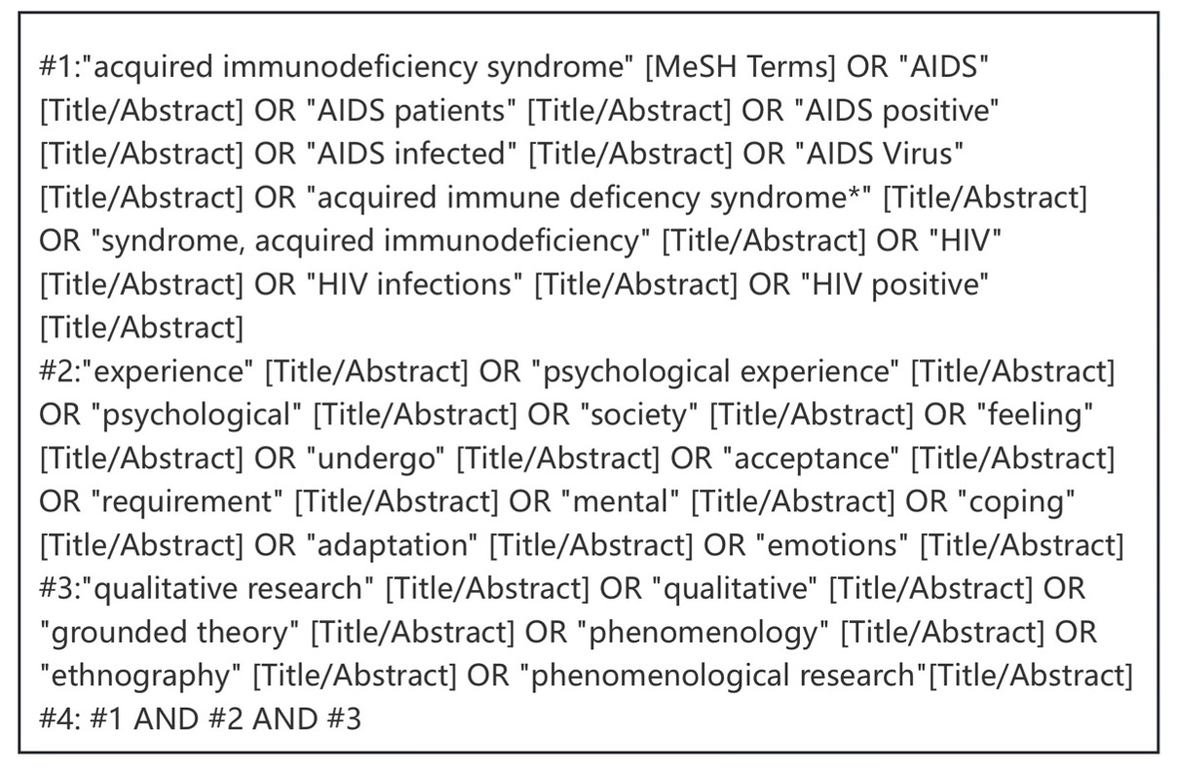

Figure S2: Literature screening process and results
