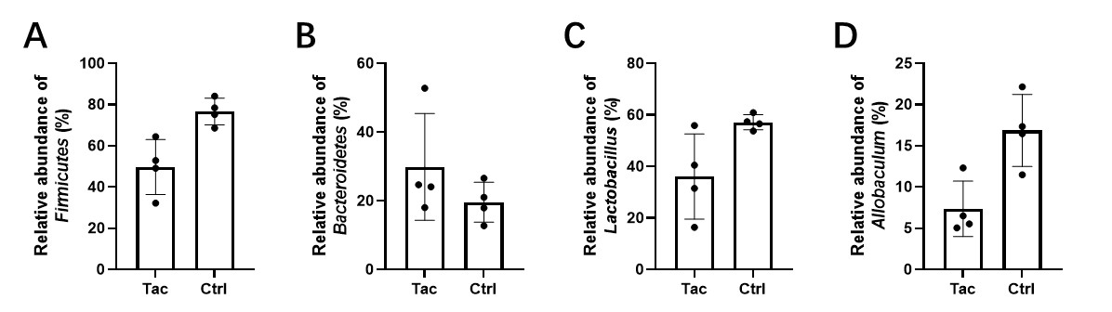
Figure S1. Relative abundance of different gut microbial taxa in Tac and Ctrl groups. (A) Relative abundance of phylum Firmicutes. (B) Relative abundance of phylum Bacteroidetes. (C) Relative abundance of genus Lactobacillus. (D) Relative abundance of genus Allobaculum. Data are presented as mean ± standard error of the mean (SEM). Ctrl, control group; Tac, tacrolimus-treated group.

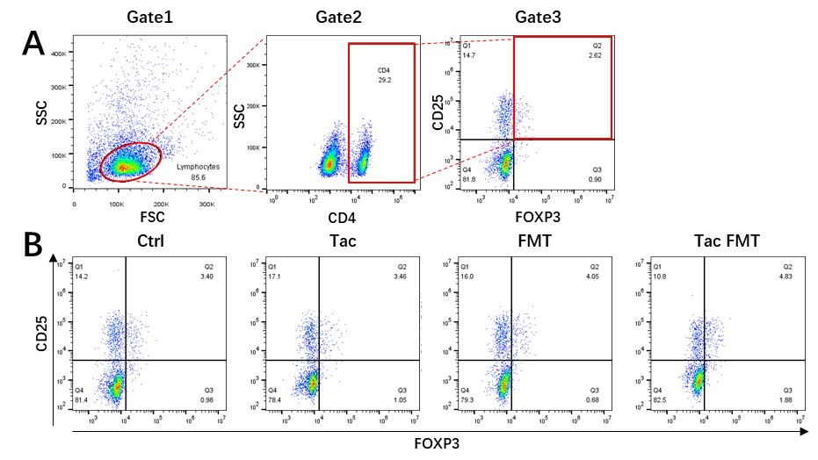
Figure S2. Flow cytometry analysis of CD4⁺CD25⁺FOXP3⁺ regulatory T cells (Tregs) in draining lymph nodes. (A) Gating strategy for identifying Tregs: Gate1 was established based on forward scatter (FSC) and side scatter (SSC) to gate lymphocytes; subsequently, Gate2 was used to select CD4⁺ cells from the gated lymphocytes; finally, Gate3 was applied to quantify CD4⁺CD25⁺FOXP3⁺ Tregs. (B) Representative flow cytometry dot plots showing CD4⁺CD25⁺FOXP3⁺ Tregs in Ctrl, Tac, FMT, and Tac FMT groups. Percentages of cells in each quadrant are indicated. Ctrl, control group; Tac, tacrolimus-treated group; FMT, the group in which the mice were administrated fecal microbiota transplantation with feces from normal saline-gavaged mice; Tac FMT, the group in which the mice were administrated fecal microbiota transplantation with feces from tacrolimus-gavaged mice.

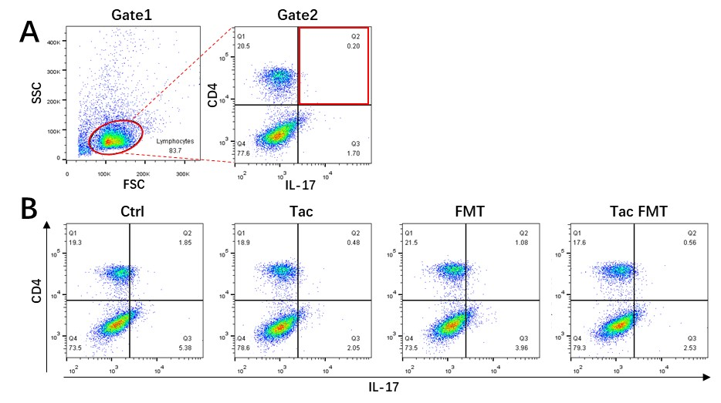
Figure S3. Flow cytometry analysis of CD4⁺IL-17⁺ T helper 17 (Th17) cells in mesenteric lymph nodes. (A) Gating strategy for identifying Th17 cells: Gate1 was established on forward scatter (FSC) and side scatter (SSC) to gate lymphocytes, followed by gating on CD4 versus IL-17 to quantify CD4⁺IL-17⁺ Th17 cells. (B) Representative flow cytometry dot plots illustrating CD4⁺IL-17⁺ Th17 cells in Ctrl, Tac, FMT, and Tac FMT groups. Percentages of cells in each quadrant are indicated. Ctrl, control group; Tac, tacrolimus-treated group; FMT, the group in which the mice were administrated fecal microbiota transplantation with feces from normal saline-gavaged mice; Tac FMT, the group in which the mice were administrated fecal microbiota transplantation with feces from tacrolimus-gavaged mice.
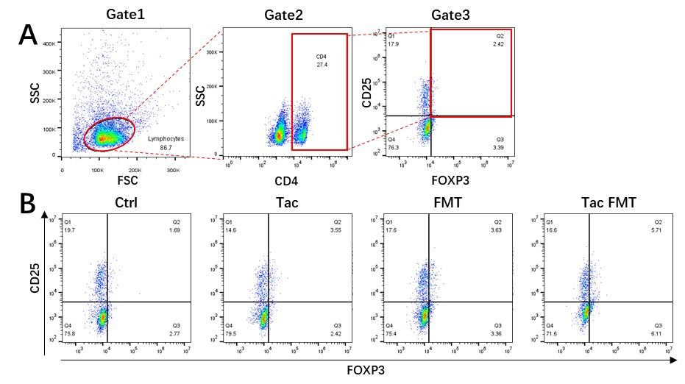
Figure S4. Flow cytometry analysis of CD4⁺CD25⁺FOXP3⁺ regulatory T cells (Tregs) in mesenteric lymph nodes. (A) Gating strategy for identifying Tregs: Gate1 was set based on forward scatter (FSC) and side scatter (SSC) to gate lymphocytes; Gate2 was then used to gate CD4⁺ cells from the lymphocyte population; Gate3 was applied to quantify CD4⁺CD25⁺FOXP3⁺ Tregs. (B) Representative flow cytometry dot plots depicting CD4⁺CD25⁺FOXP3⁺ Tregs in Ctrl, Tac, FMT, and Tac FMT groups. Percentages of cells in each quadrant are indicated. Ctrl, control group; Tac, tacrolimus-treated group; FMT, the group in which the mice were administrated fecal microbiota transplantation with feces from normal saline-gavaged mice; Tac FMT, the group in which the mice were administrated fecal microbiota transplantation with feces from tacrolimus-gavaged mice.

