Supplementary Figures

Supplemental Figure 1. The custom-made insert used to fit two phakic intraocular lenses into an eye model – a natural lens simulator and a phakic intraocular lens.

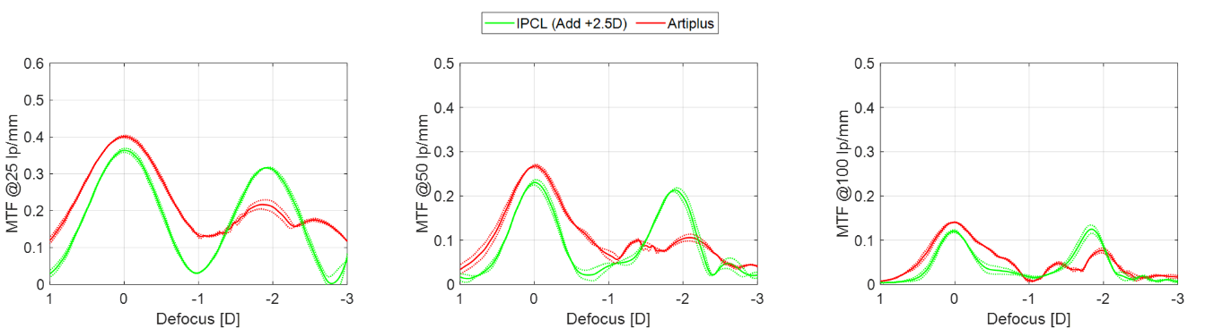
Supplemental Figure 2. The through-focus modulation transfer function curves of the tested phakic intraocular lenses for a 3mm pupil at a defocus of +1 to -3D corresponding to the spectacle plane. The dotted lines show the values of each lens separately; the solid lines refer to the average of two lenses. MTF = modulation transfer
function.

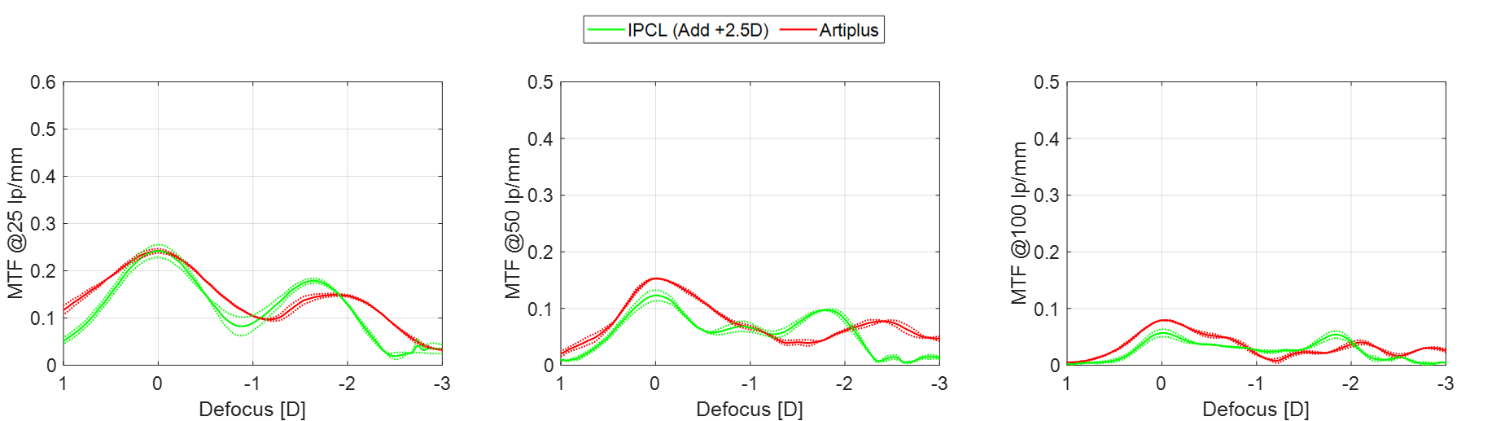
Supplemental Figure 3. The through-focus modulation transfer function curves of the tested phakic intraocular lenses for a 4.5mm pupil at a defocus of +1 to -3D corresponding to the spectacle plane. The dotted lines show the values of each lens separately; the solid lines refer to the average of two lenses. MTF = modulation transfer function.

