Material and Methods
Antibodies and dyes
The list of antibodies used for flow cytometry is summarized in Table S1. Fixable Viability Stain 700 was purchased from BD Horizon (USA). Cy5 NHS ester was purchased from Lumiprobe (USA). Lysotraker Red and DiI were purchased from Yeasen (China).
The stability of the Sq@TA/Mn@OVA nano-emulsion
The stability of the Sq@TA/Mn@OVA nano-emulsion was assessed over a 7-day period by monitoring particle size, polydispersity index (PDI), and zeta potential during storage at 4 °C or in DMEM supplemented with 10% FBS at 37 °C. Measurements were performed by dynamic light scattering (DLS) using a Malvern Nano Zetasizer (Malvern Instruments, UK).
In vitro cytotoxicity of various preparations against DC2.4 cells
The DC2.4 cells were seeded at a cell density of 5×10³/well (100 μL) on a 96-well cell culture plate at 37°C in 5% CO₂. After the cell adherence to the wall, various preparations with the OVA concentration of 25 μg/mL were added for incubation with the cell for 6 h or 24 h. The medium was then removed and washed twice with PBS. Subsequently, 100 μL of fresh medium containing 10% cell counting kit 8 (CCK-8, Yeasen, China) was added and incubated for 1.5 h. Finally, the absorbance at 450 nm was measured using a microplate reader.
Cellular internalization of various formulations in vitro
To obtain confocal scanning microscope images of cellular internalization of various formulations, DC2.4 cells were cultured on 8-well chambered cover glass (Cellvis) with 5000 cells per well, followed by 24 h incubation for attachment. Afterwards, these cells were treated with various preparations loaded with OVA (green) for 8 h, respectively. The OVA was labelled with FITC. The LysoTracker Red (red) was used to stain lysosomes. The images were obtained under a CLSM (Leica).
For flow cytometry assays, DC2.4 cells in 1 mL of culture medium were cultured in a 12-well plate. The cells were exposed to different preparations loaded with OVA (green) for 2, 4 or 8 h at 37 °C and then rinsed twice using cold PBS and collected by trypsin digestion and centrifugation. The collected cells were suspended in 100 μL PBS and immediately detected using a flow cytometry (Becton Dickinson, LSRFortessa).
Subcellular localization
The DC2.4 cells were treated with different preparations loaded with OVA (green) for 24 h, respectively. The distribution of FITC-labeled OVA and morphs of LysoTraker Red-labeled lysosome were visualized by CLSM (Leica).
Expression and purification of recombinant Pal (rPal)
The recombinant Peptidoglycan-associated lipoprotein (Pal) in A. baumannii bacteria was selected as the model antigen. The detailed expression and purification methods which have been reported previously¹.
Antigen loading and adsorption
Sq@TA/Mn emulsion was mixed with OVA-FITC at room temperature for 30 min. To examine the OVA-FITC loading efficiency, the mixture was centrifuged at 6000 × g for 10 minutes at 4 °C, resulting in two layers. The upper layer was the aggregates of emulsion droplets, and the lower layer was the dispersion phase and fluidic OVA. Thereafter, 200 μL of the lower layer liquid was transferred to a black 96-well plate. A series of FITC-labeled OVA protein solutions was prepared at 0.2, 0.1, 0.05, 0.025, 0.0125, 0.00625, 0.003125 mg/mL, and 200 μL of each OVA-FITC solution was transferred to the black 96-well plate. The fluorescence intensity of the OVA-FITC in different solutions was determined via multifunctional microplate reader at an excitation wavelength of 488 nm and an emission wavelength of 521 nm. The concentration of OVA in the lower layer was determined using a standard curve. In order to obtain the protein content adsorbed by the emulsion, the OVA content of the lower liquid was subtracted from the total OVA protein added. The loading efficiencies were calculated using the following equation: Loading efficiency = (Total OVA-FITC—OVA-FITC in the lower liquid /Total OVA-FITC × 100%).
The method for detecting the loading efficiencies for r-Pal was similar to OVA as described above.
Safety estimation of the various OVA vaccines
Female C57BL/6 mice aged six to eight weeks were treated through intramuscular injections of different preparations containing OVA (20 μg /dose of OVA) on day 0, 14, and 21. On Day 30, serum samples were collected to determine serum biochemical indices and major organs were collected. The important indicators (AST, ALT, ALP, LDH, BUN) in the serum were measured by a biochemical autoanalyzer. The primary organs of heart, liver, spleen, lung, and kidney were stained with H&E and observed by microscopy.
Measurement of immune cells in the lungs
On Day 30, the lungs of immunized mice were harvested and processed. Lung tissues were minced with scalpels and treated with DMEM medium containing 1% collagenase type I and 1% collagenase type IV for 40 min at 37 °C. Then the lung tissue suspension was passed through 70-mesh cell strainers and treated with red blood cell lysate for 5 min to obtain single-cell suspensions. The single-cell suspensions were washed once with PBS and resuspended in PBS containing 0.2% FBS. Cells were stained with fluorescently labeled antibodies for 30 min at 4 °C and samples were analyzed on a FCM instrument (Becton Dickinson, LSRFortessa). Antibodies used to detect TRMs in lung tissues are as follows: anti-CD3, anti-CD4, anti-CD8, anti-CD44, anti-CD69, anti-CD103.
Figure S1. Average size (A) and zeta-potential (B) of TA/Mn and TA/Mn@OVA measured using DLS.
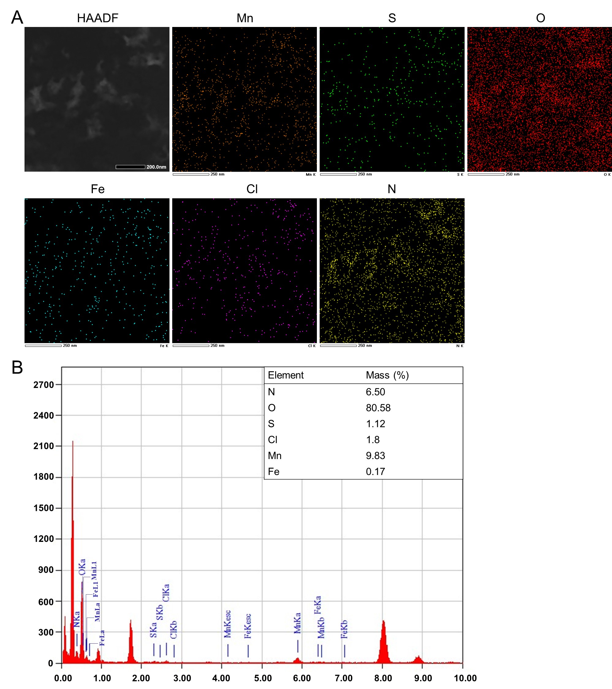
Figure S2. (A) TEM mapping images of the TA/Mn@OVA. O and Mn are represented in red and orange, respectively. Scale bar, 200 nm. (B) Element analysis of TA/Mn@OVA.
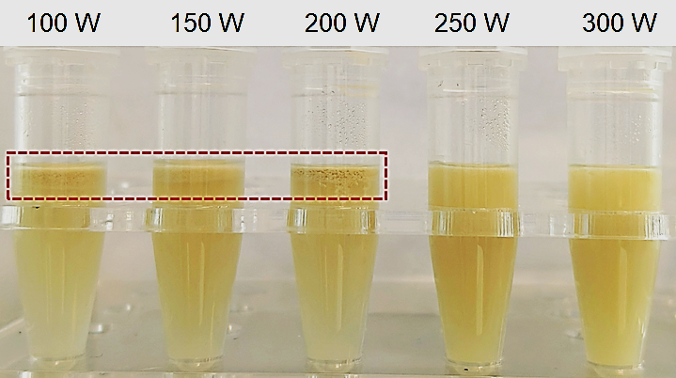
Figure S3. Photos of nano-emulsions prepared under different ultrasound power conditions; The aggregated nano-emulsions were pointed out by the red dashed line.
Figure S4. The size and polydispersity of Sq@TA/Mn assayed by DLS.
Figure S5. Average size (A) and zeta-potential (B) of Sq@TA/Mn, Sq@TA/Mn@OVA and Alum@OVA measured using DLS.
Figure S6. Particle size, polydispersity index (PDI), and zeta potential of Sq@TA/Mn@OVA during storage at 4 °C (A) or in DMEM supplemented with 10% FBS (B) at 37 °C. measured using DLS.
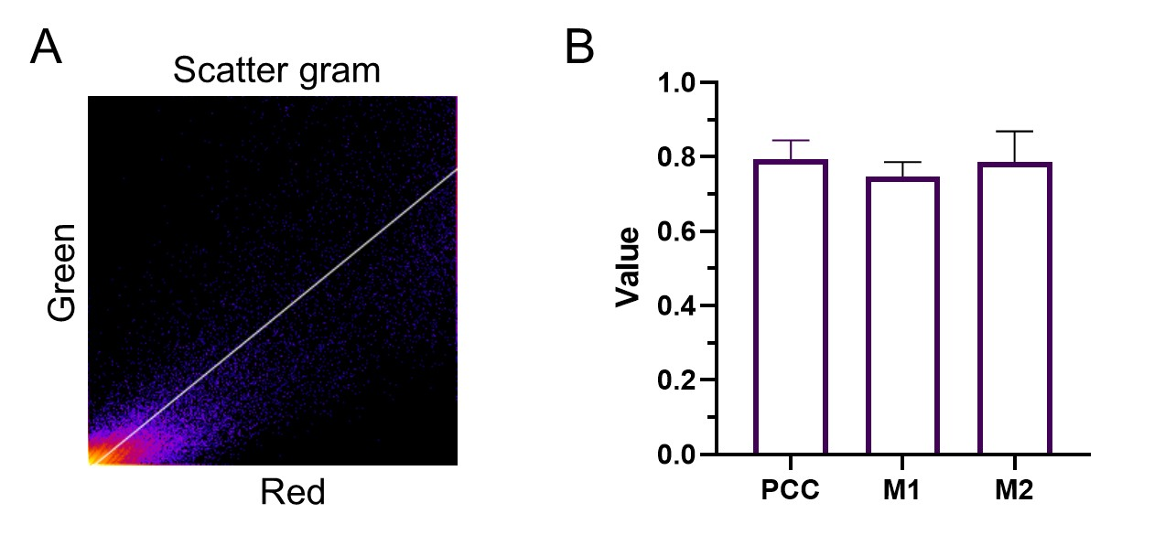
Figure S7. Co-localization of OVA-Cy5 (represented as red) with squalene/DiI (represented as green) in Sq@TA/Mn@OVA observed by STED CLSM. (A) The scatter gram for Sq@TA/Mn@OVA labeled with Cy5 and DiI were obtained using image J software. (B) Pearson’s correlation coefficient (Pcc), and Manders’ colocalization coefficient (M1 and M2).
Figure S8. Quantitative analysis of OVA accumulation in DC2.4 cells after treatment with fluidic OVA, TA/Mn@OVA and Sq@TA/Mn@OVA at an equivalent OVA dose of 20 μg/mL for 2, 4 and 8 h by flow cytometry analysis. Data were presented as mean ± SD (n = 3).
Figure S9. Body weight shifts of mice immunized with different preparations.
Figure S10. Flow cytometry gating strategy of IL-4 CD4⁺ T, IFN-γ CD4⁺ T, IL-4 CD8⁺ T, and IFN-γ CD8⁺ T cells in spleen. The FVS-700 negative cell population was defined as live cells (red text).
Figure S11. Flow cytometry raw data of IFN-γ⁺ and IL-4⁺ CD8⁺ T (A), IFN-γ⁺ and IL-4⁺ CD4⁺ T (B) cells in spleen.
Figure S12. A total of 10⁶ splenocytes/well were cultured in 96 well plate on day 30 in the presence or absence of 1 mg/mL OVA for 72 h. Culture supernatants were collected. The IL-4 (A) and IFN-γ (B) contents were tested by Elisa. Data are expressed as mean ± SD (n = 4). Statistical analysis was performed by the two-tailed, unpaired Student’s t-test, *p <0.05, **p < 0.01, ***p < 0.001.
Figure S13. Flow cytometry gating strategy of central memory (CD44⁺CD62L⁺) and effector-memory T cells (CD44⁺CD62L⁻) in spleen.
Figure S14. Gating strategy for tissue-resident memory T cells in the lungs. The FVS-700 negative cell population was defined as live cells (red text).
Supplementary tables
Table S1. Composition of various preparations
Preparations | H₂O | Tannic acid  (4 mg/mL) | MnCl₂  (36 mg/mL) | 10×HEPES（100 mM） | Squalene | Antigen  (2 mg/mL)
TA/Mn@OVA | 797.5μL | 50 μL | 2.5 μL | 100 μL | / |  | OVA  50 μL
Sq@TA/Mn @OVA | 785 μL | 50 μL | 2.5 μL | 100 μL | 12.5 μL |  | OVA  50 μL
TA/Mn@rPal | 797.5μL | 50 μL | 2.5 μL | 100 μL | / |  | rPal  50 μL
Sq@TA/Mn @rPal | 785 μL | 50 μL | 2.5 μL | 100 μL | 12.5 μL |  | rPal  50 μL
Notes: The total volume is 1000 μL.
Table S2 The list of antibodies used in this study
Antibody | Cat number | Manufacturer
PE-Cyanine7 anti-mouse CD44 | 25-0441-82 | eBioscience
BV421 Rat Anti-Mouse CD103 | 562771 | BD Horizon™
Fixable Viability Stain 700 | 564997 | BD Horizon™
FITC Rat Anti-Mouse CD4 | 553650 | BD Pharmingen™
APC/Cyanine7 anti-mouse CD3 | 100222 | Biolegend
Pacific Blue™ anti-mouse CD8a | 100728 | Biolegend
PE/Cyanine7 anti-mouse/human CD44 | 103029 | Biolegend
PE anti-mouse CD62L | 104407 | Biolegend
PerCP/Cyanine5.5 anti-mouse CD69 | 104521 | Biolegend
Brilliant Violet 510™ anti-mouse TNF-α | 506339 | Biolegend
Brilliant Violet 650™ anti-mouse IFN-γ | 505832 | Biolegend
Table S3 P values calculated between different groups
 | Groups
Days | OVA  vs TA/Mn@OVA | OVA  vs Sq@TA/Mn@OVA | TA/Mn@OVA  vs Sq@TA/Mn@OVA
14 | * | * | ns
21 | ns | ** | *
30 | ns | *** | **
42 | ns | *** | **
56 | ns | ** | **
* for p < 0.05, ** for p < 0.01 and *** for p < 0.001. ns, not significant.
References:
1. Zeng X, Wang N, Xiang C, et al. Peptidoglycan-associated lipoprotein contributes to the virulence of Acinetobacter baumannii and serves as a vaccine candidate. Genomics. 2023;115(2):110590. doi:10.1016/j.ygeno.2023.110590

