Supplementary information

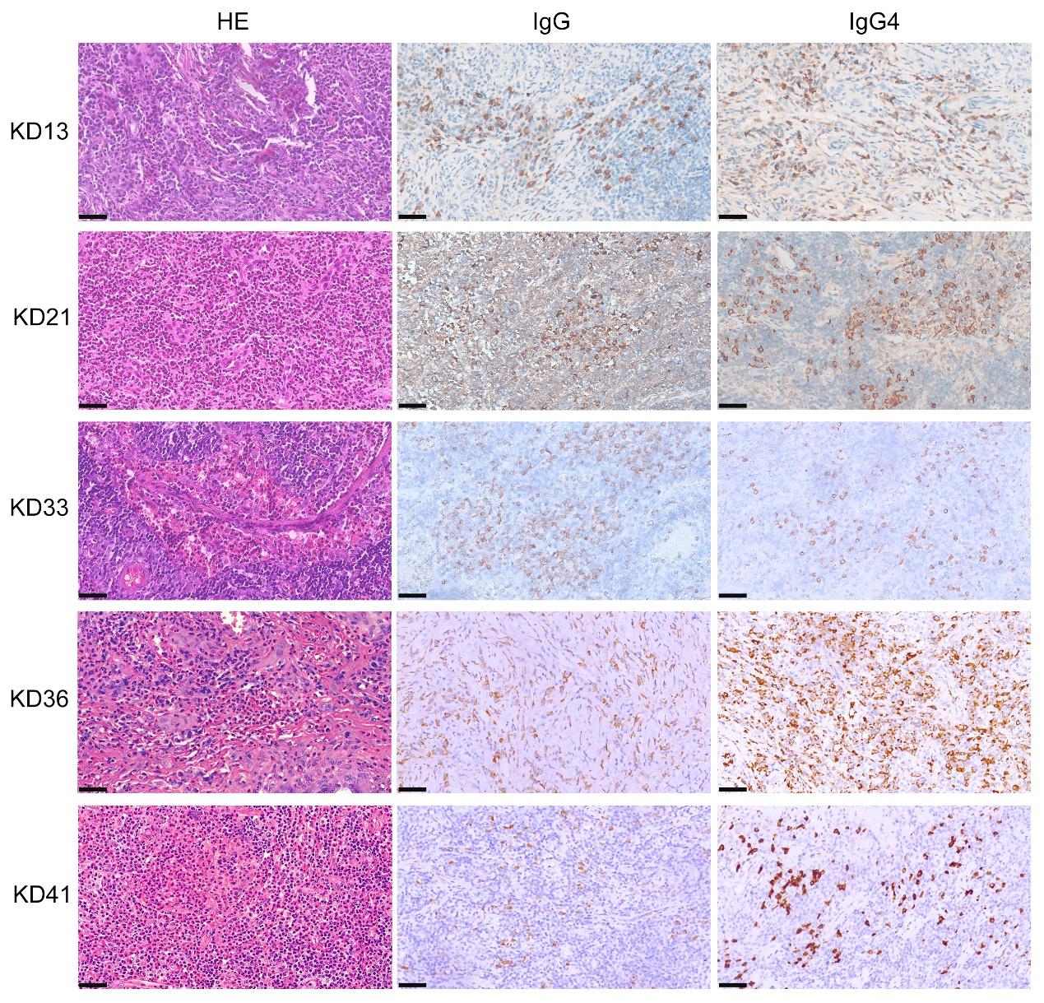
Supplementary Figure 1. Histopathological and immunohistological features of five patients of Kimura disease associated with IgG4-related disease. HE and IHC images are presented at high-power magnification (×40), with scale bars representing 50 μm in each panel.
KD13: HE staining showed lymphoid follicle formation with eosinophilic infiltration in some areas, along with small vessel proliferation. IHC revealed an IgG4 hotspot with 120/HPF and an IgG4/IgG⁺ PC ratio>40%.
KD21: HE staining demonstrated small vessel proliferation and fibroconnective tissue expansion, with marked eosinophilic infiltration. IHC revealed a dense cluster of approximately 200 IgG⁺ PC/HPF.
KD33: Hematoxylin and eosin (HE) staining revealed extensive fibroconnective tissue proliferation with storiform fibrosis and dense eosinophilic infiltration, accompanied by focal eosinophilic microabscesses. Immunohistochemistry (IHC) showed an IgG4 hotspot with 80 cells per high-power field (HPF), and an IgG4/IgG⁺ plasma cell (PC) ratio exceeding 40%.
KD36: HE staining revealed significant eosinophilic infiltration, with localized eosinophilic microabscesses. IHC showed approximately 100 IgG4⁺ PC/HPF in the affected areas, with an IgG4/IgG⁺ PC ratio>40%.
KD41: HE staining exhibited abundant eosinophilic infiltration, with eosinophilic microabscesses and small vessel proliferation. IHC analysis revealed 40-50 IgG4⁺ PC/ HPF, with an IgG4/IgG⁺ PC ratio>40%.

