Supplementary Materials

Colchicine alleviates non-atherosclerotic vascular aging by targeting endothelial dysfunction and inflammatory status

Supplementary Tables
- Table S1. Concentrations, exposure times, and experimental details for pharmacologic agents in ex vivo assays
- Table S2. Antibodies used for Western blotting
- Table S3. Cardiac function by echocardiography and pressure–volume loop
- Table S4. Pairwise group comparisons with mean differences, effect sizes, and 95% CIs

Supplementary Figures
- Figure S1. Microtubule, β-adrenergic, and NO involvement in colchicine vasodilation
- Figure S2. Representative myograph traces of colchicine-induced relaxation
- Figure S3. Maximum KCl-induced contractile responses in thoracic aortic rings
- Figure S4. End-systolic pressure and aortic diameters (PV loop and echocardiography)
- Figure S5. Western blot analysis of lung tissue (p-eNOS, iNOS, iNOS/p-eNOS ratio)
- Figure S6. Systemic cytokine levels (IL-6, MCP-1, TNF-α)

Supplementary Table S1. Concentrations, exposure times, and experimental details for colchicine and all pharmacologic agents used in ex vivo wire-myography assays
Agent | Purpose | Final Concentration | Exposure Time Before Pre-constriction | Notes
Colchicine | Test vasorelaxant response | 10⁻¹³–10⁻⁵ mol/L (acute CRC) | Cumulative additions during CRC | Clinical-range test at 7.5 nmol/L also performed
U46619 | Pre-constriction (thromboxane A₂ analog) | 30 nmol/L | Until stable contraction (~30 min) | Used for all concentration–response experiments
L-NAME | NOS inhibitor | 100 µmol/L | 15 min | Blocks nitric oxide synthase
Propranolol | Non-selective β-adrenoceptor antagonist | 1 µmol/L | 15 min
Butoxamine | Selective β₂-adrenoceptor antagonist | 1 µmol/L | 15 min
SR-59230A | Selective β₃-adrenoceptor antagonist | 1 µmol/L | 15 min
Paclitaxel | Microtubule stabilizer (tests colchicine’s microtubule mechanism) | 10 µmol/L | 15 min
TRAM-34 | Intermediate-conductance K⁺ channel blocker (EDH) | 100 nmol/L | 15 min | Used with apamin to inhibit EDH
Apamin | Small-conductance K⁺ channel blocker (EDH) | 100 nmol/L | 15 min | Used with TRAM-34 to inhibit EDH
Abbreviations: CRC, concentration–response curve; NOS, nitric oxide synthase.

Supplementary Table S2. Antibodies used for Western Blot.
Target protein | Antibody information
iNOS | 1:500, sc-650, Santa Cruz
peNOS | 1:1000, 9571, Cell Signaling
GAPDH | 1: 10000, 10494-1-AP, Proteintech

Supplementary Table S3. Cardiac function as measured by echocardiography and pressure-volume loop
Parameter | Vehicle |  |  | Colchicine
 | SMC-LM | SMC-KO | P-value* | SMC-LM | SMC-KO | P-value#
Echocardiography
HR(bpm) | 610±13.40 | 512.3±32.50 | 0.001 | 609.2±9.22 | 499.5±13.46 | 0.51
FS(%) | 50.25±0.62 | 37.80±3.01 | 0.01 | 53.64±1.69 | 35.14±2.30 | 0.49
CO(ml/min) | 15.91±0.72 | 16±0.86 | 0.94 | 22.36±1.92 | 16.82±0.99 | 0.55
Stroke volume(µl) | 26.07±0.93 | 31.47±2.34 | 0.11 | 36.69±3.06 | 33.75±1.90 | 0.46
LVEDD(mm) | 2.86±0.04 | 3.36±0.13 | 0.02 | 3.25±0.10 | 3.54±0.13 | 0.35
LVESD(mm) | 1.42±0.03 | 2.10±0.16 | 0.01 | 1.51±0.07 | 2.31±0.15 | 0.37
LV wall thickness(mm) | 1.14±0.06 | 0.93±0.03 | 0.01 | 1.07±0.06 | 0.90±0.06 | 0.71
Heart weight/Tibia length (mg/mm) | 77.39±4.91 | 64.27±3.63 | 0.05 | 80.65±4.58 | 66.93±1.60 | 0.50
LV weight/Tibia length (mg/mm) | 64.38±5.08 | 54.47±3.87 | 0.15 | 67.69±5.10 | 58.60±2.13 | 0.35
Pressure-Volume Loop
Ea(mmHg/µl) | 4.55±0.95 | 7.61±1.23 | 0.09 | 2.78±0.60 | 4.73±1.26 | 0.08
Tau(ms) | 7.11±1.14 | 8.92±0.99 | 0.09 | 6.08±0.53 | 8.14±0.69 | 0.52
Pes(mmHg) | 74.89±9.49 | 63.80±4.69 | 0.33 | 60.74±8.61 | 67.47±3.05 | 0.51
Ped(mmHg) | 4.64±1.87 | 4.13±0.34 | 0.79 | 6.90±2.95 | 4.86±1.04 | 0.59
Dp/dt max | 7413±1716 | 3606±294 | 0.07 | 5386±445 | 4285±214 | 0.09
Dp/dt min | -6789±1669 | -3727±238 | 0.11 | -4990±504 | -3825±126 | 0.69
EF (%) | 64.49±11.98 | 36.75±2.79 | 0.06 | 57.60±3.94 | 39.46±2.80 | 0.52
Stroke Volume(µl) | 20.14±4.35 | 11.01±2.48 | 0.11 | 23.96±3.56 | 20.34±4.91 | 0.18
CO(ml/min) | 10.70±2.34 | 4.32±0.73 | 0.04 | 12.88±2.09 | 9.46±2.16 | 0.1
HR(bpm) | 532.7±8.64 | 403.8±22.48 | 0.001 | 532.2±6.94 | 462.8±20.10 | 0.09
HR, Heart rate; FS, Fractional shortening; CO, Cardiac output; LVEDD, left ventricular end-diastolic diameter; LVESD, left ventricular end-systolic diameter; LV, left ventricle; Ea, effective arterial elastance; Tau, time constant of isovolumic relaxation; Pes, end-systolic pressure; Ped, end-diastolic pressure; dP/dt, left ventricular contractility during systole; EF, Ejection fraction. *p; SMC-KO (vehicle) versus SMC-LM (vehicle), and #p; SMC-KO (vehicle) versus SMC-KO (colchicine). Data are presented in mean ± SEM. . Statistical differences were analyzed by two-way ANOVA followed by Bonferroni post-hoc test.

Supplementary Table S4. Pairwise group comparisons with mean differences, effect sizes, and 95 % confidence intervals corresponding to Figures 4A–4D.
Panel A: Group differences in endothelium-dependent ACh-mediated relaxation.
(I) Group | (J) Group | Mean Difference (I–J) | Std. Error | Sig. | Lower CI | Upper CI
SMC-LM (veh) | SMC-LM (col) | -7.673 | 2.777 | .008 | -13.265 | -2.080
SMC-LM (veh) | SMC-KO (veh) | -45.140 | 2.634 | <.001 | -50.445 | -39.834
SMC-LM (veh) | SMC-KO (col) | -38.172 | 2.912 | <.001 | -44.037 | -32.306
SMC-LM (col) | SMC-LM (veh) | 7.673 | 2.777 | .008 | 2.080 | 13.265
SMC-LM (col) | SMC-KO (veh) | -37.467 | 2.634 | <.001 | -42.772 | -32.162
SMC-LM (col) | SMC-KO (col) | -30.499 | 2.912 | <.001 | -36.365 | -24.634
SMC-KO (veh) | SMC-LM (veh) | 45.140 | 2.634 | <.001 | 39.834 | 50.445
SMC-KO (veh) | SMC-LM (col) | 37.467 | 2.634 | <.001 | 32.162 | 42.772
SMC-KO (veh) | SMC-KO (col) | 6.968 | 2.777 | .016 | 1.375 | 12.560
SMC-KO (col) | SMC-LM (veh) | 38.172 | 2.912 | <.001 | 32.306 | 44.037
SMC-KO (col) | SMC-LM (col) | 30.499 | 2.912 | <.001 | 24.634 | 36.365
SMC-KO (col) | SMC-KO (veh) | -6.968 | 2.777 | .016 | -12.560 | -1.375
Panel B: Group differences in endothelium-independent SNP-mediated relaxation.
(I) Group | (J) Group | Mean Difference (I–J) | Std. Error | Sig. | Lower CI | Upper CI
SMC-LM (veh) | SMC-LM (col) | 0.000 | 5.784 | 1.000 | -11.607 | 11.607
SMC-LM (veh) | SMC-KO (veh) | -33.541 | 6.042 | <.001 | -45.665 | -21.418
SMC-LM (veh) | SMC-KO (col) | -34.960 | 5.308 | <.001 | -45.611 | -24.308
SMC-LM (col) | SMC-LM (veh) | 0.000 | 5.784 | 1.000 | -11.607 | 11.607
SMC-LM (col) | SMC-KO (veh) | -33.541 | 6.042 | <.001 | -45.665 | -21.418
SMC-LM (col) | SMC-KO (col) | -34.960 | 5.308 | <.001 | -45.611 | -24.308
SMC-KO (veh) | SMC-LM (veh) | 33.541 | 6.042 | <.001 | 21.418 | 45.665
SMC-KO (veh) | SMC-LM (col) | 33.541 | 6.042 | <.001 | 21.418 | 45.665
SMC-KO (veh) | SMC-KO (col) | -1.418 | 5.587 | .801 | -12.630 | 9.794
SMC-KO (col) | SMC-LM (veh) | 34.960 | 5.308 | <.001 | 24.308 | 45.611
SMC-KO (col) | SMC-LM (col) | 34.960 | 5.308 | <.001 | 24.308 | 45.611
SMC-KO (col) | SMC-KO (veh) | 1.418 | 5.587 | .801 | -9.794 | 12.630

Panel C: Pathway contribution to relaxation in SMC-KO mice (vehicle)
(I) Group | (J) Group | Mean Difference (I–J) | Std. Error | Sig. | Lower CI | Upper CI
KO_COL_control | L-NAME | -3.246 | 1.261 | .015 | -5.818 | -0.674
KO_COL_control | L-NAME+APA+TRAM | -3.249 | 1.144 | .008 | -5.581 | -0.916
L-NAME | KO_COL_control | 3.246 | 1.261 | .015 | 0.674 | 5.818
L-NAME | L-NAME+APA+TRAM | -0.003 | 1.339 | .998 | -2.733 | 2.727
L-NAME+APA+TRAM | KO_COL_control | 3.249 | 1.144 | .008 | 0.916 | 5.581
L-NAME+APA+TRAM | L-NAME | 0.003 | 1.339 | .998 | -2.727 | 2.733

Panel D: Pathway contribution to relaxation in SMC-KO mice (Colchicine)
(I) Group | (J) Group | Mean Difference (I–J) | Std. Error | Sig. | Lower CI | Upper CI
KO_COL_control | L-NAME | -9.712 | 1.664 | <.001 | -13.091 | -6.334
KO_COL_control | L-NAME+APA+TRAM | -11.004 | 1.664 | <.001 | -14.382 | -7.626
L-NAME | KO_COL_control | 9.712 | 1.664 | <.001 | 6.334 | 13.091
L-NAME | L-NAME+APA+TRAM | -1.292 | 1.519 | .401 | -4.376 | 1.792
L-NAME+APA+TRAM | KO_COL_control | 11.004 | 1.664 | <.001 | 7.626 | 14.382
L-NAME+APA+TRAM | L-NAME | 1.292 | 1.519 | .401 | -1.792 | 4.376

Abbreviations: SMC-LM, smooth-muscle–specific ERCC1 littermate control; SMC-KO, smooth-muscle–specific ERCC1 knockout; veh, vehicle treated; col, colchicine treated; CI, confidence interval.
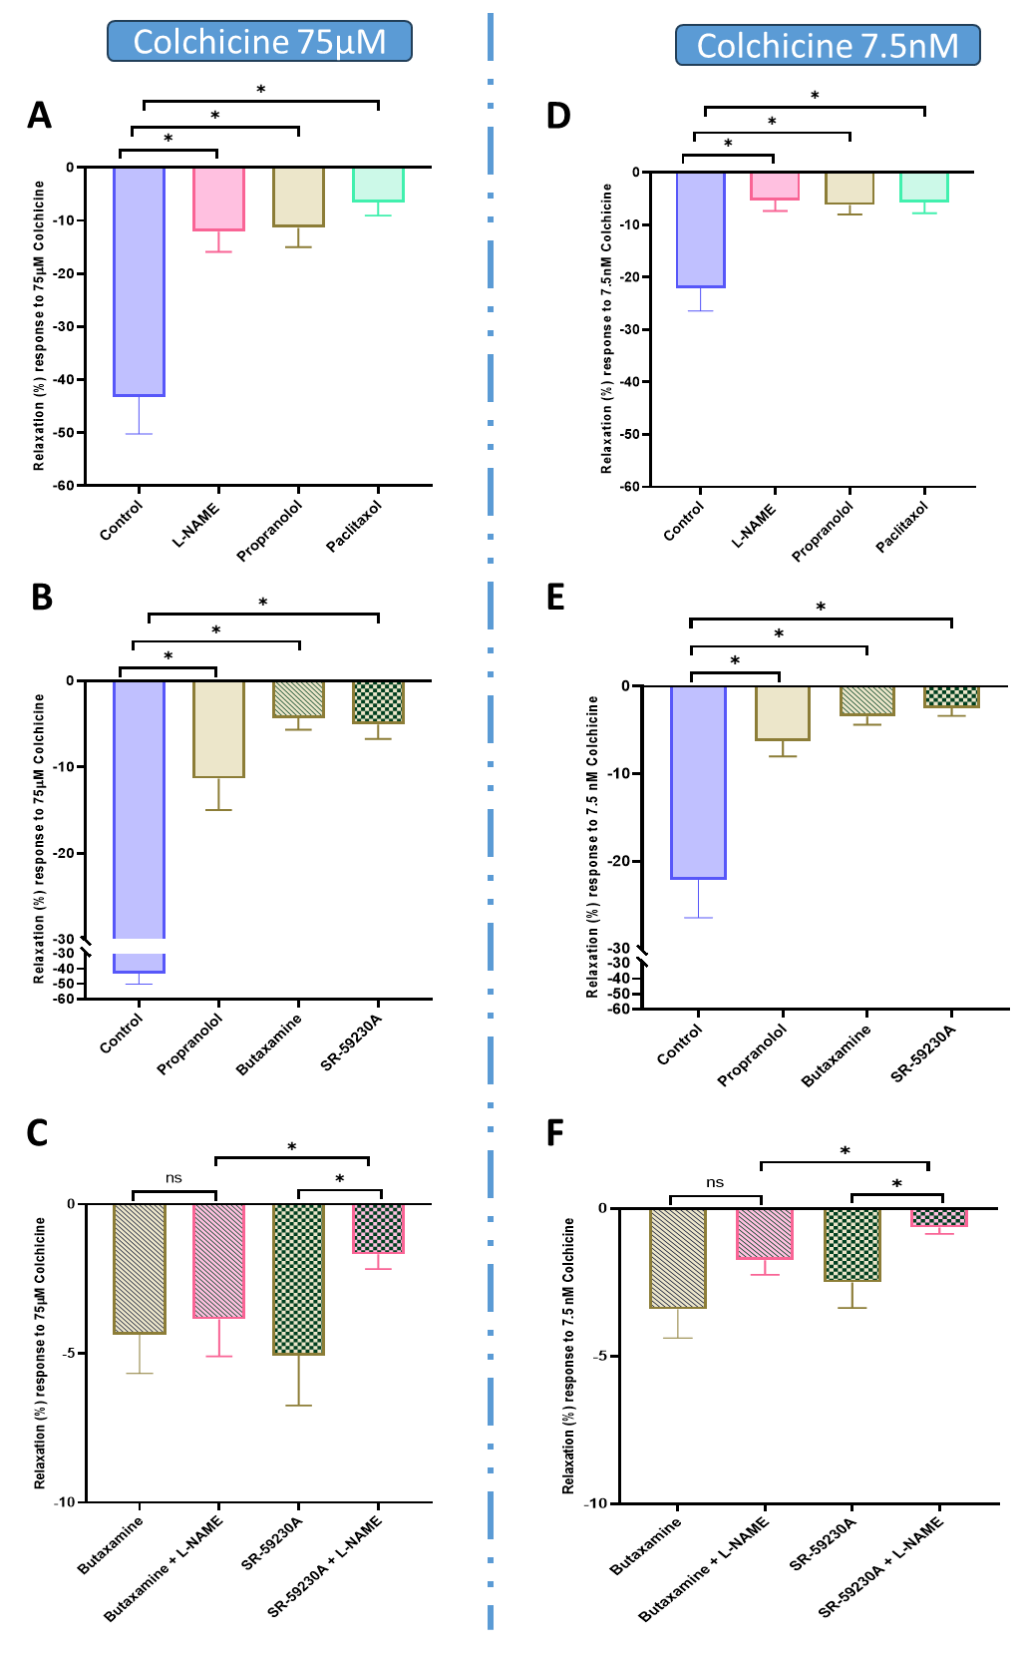
Supplementary Figure S1. Involvement of microtubules, beta-adrenergic receptors, and NO in the direct vasodilator effects of 75μM (A-C) and 7.5nM (D-F) colchicine in the mouse aorta. A,D, Effects of colchicine, in the presence of the microtubule stabilizer, paclitaxel (10 μmol/L), and (B,E) the non-selective β-antagonists propranolol (1 μmol/L), the β-2-selective antagonist butoxamine (1 μmol/L), the β-3-selective antagonist SR-59230A (1 μmol/L). C,F, effects of selective β-antagonists in presence of the NOS inhibitor L-NAME (100 μmol/L). Statistical analysis was by two-way ANOVA followed by Bonferroni post-hoc test. *; P<0.05. (N=6)

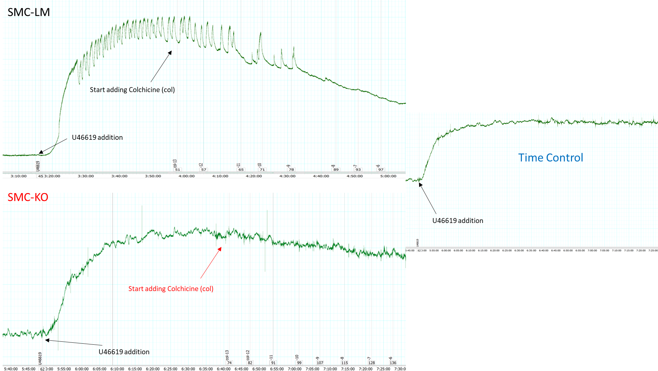
Supplementary Figure S2. Representative myograph traces showing the kinetics of colchicine-induced relaxation in SMC-LM and SMC-KO aortic rings
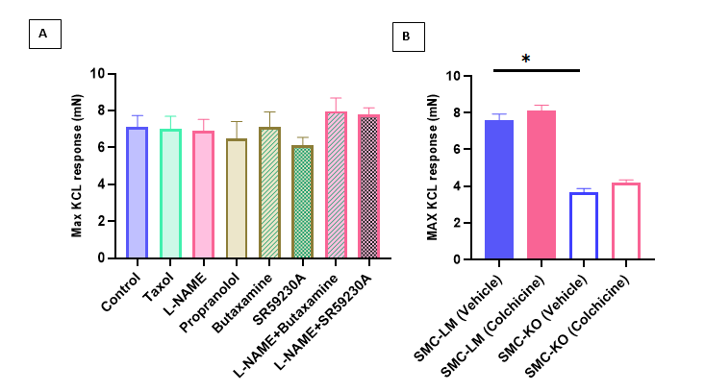
Supplementary Figure S3. (A) Maximum contractile responses to KCl (100 mmol/L) in thoracic aortic rings from SMC-LM mice (in the acute setup) were not significantly altered by colchicine-related pharmacological interventions. Pre-incubation with paclitaxel (10 µmol/L), L-NAME (100 µmol/L), propranolol (1 µmol/L), butoxamine (1 µmol/L), SR-59230A (1 µmol/L), or their combinations did not affect KCl-induced contractility, indicating that the observed differences in colchicine-mediated relaxation are not due to baseline contractile tone. Data are mean ± SEM; n=6 rings per group. (B), in the in vivo setup, we showed that maximal KCl-induced contractility was significantly reduced in SMC-KO compared to SMC-LM mice with no effect of colchicine (N=10-19 per group). Data are mean ± SEM; statistical analysis was performed using two-way ANOVA with Bonferroni post-hoc testing, * p<0.05.
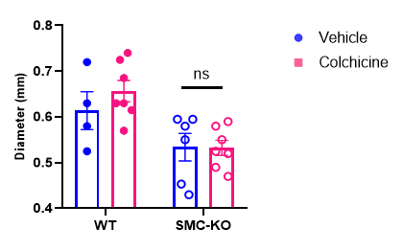

Supplementary Figure S4. (A) End-systolic pressure measured by pressure–volume loop analysis showed no difference between SMC-LM and SMC-KO mice (N = 6). (B) Abdominal aortic end-diastolic diameters, assessed by echocardiography, were not significantly different between vehicle- and colchicine-treated SMC-KO mice, indicating that reductions in pulse-wave velocity reflect structural preservation rather than baseline vasodilation. Data are mean ± SEM; statistical analysis was performed using two-way ANOVA with Bonferroni post-hoc testing.

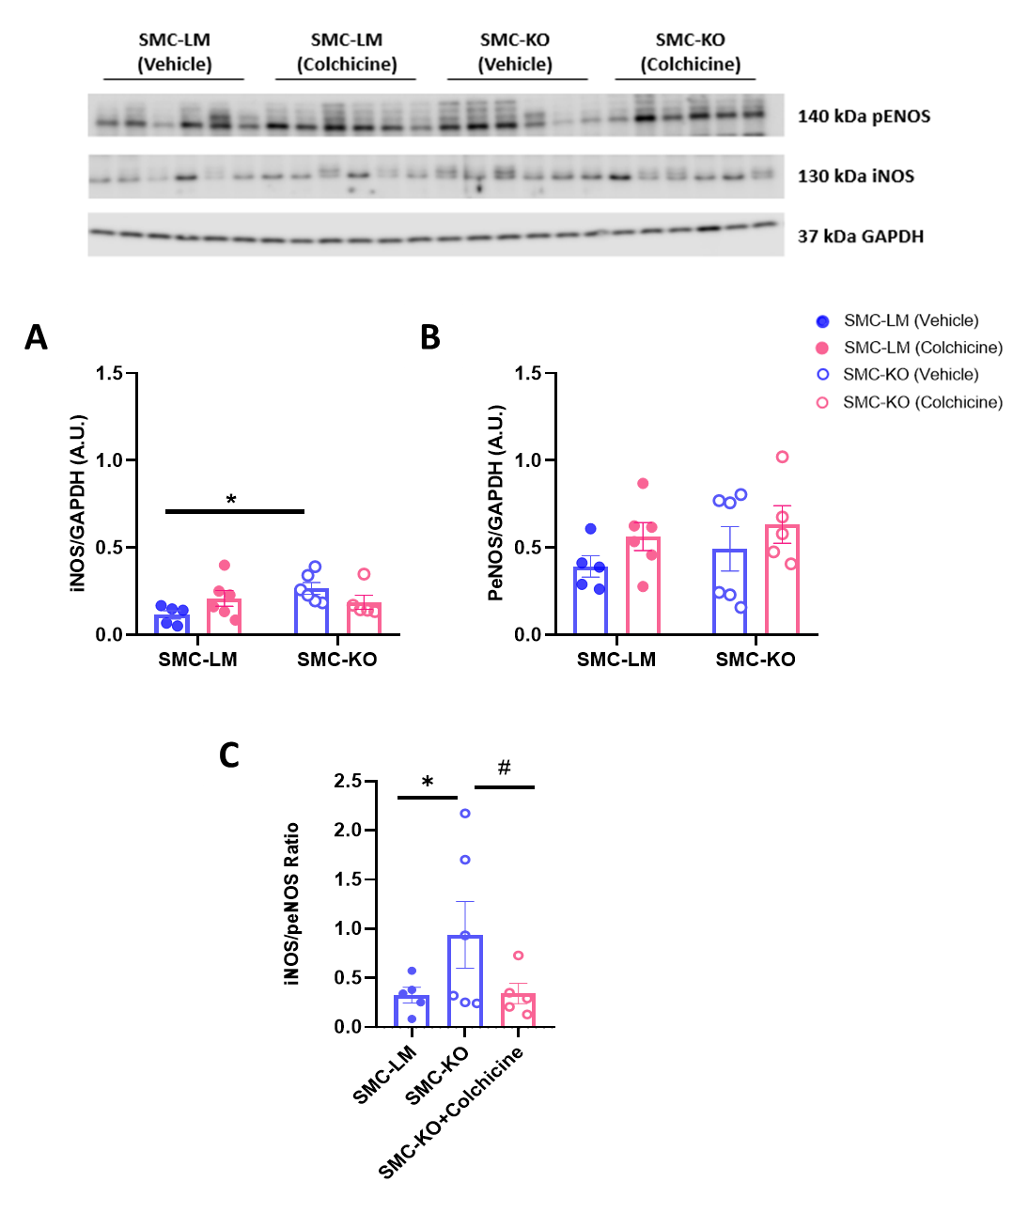
Supplementary Figure S5. Western blot analysis of lung tissue from SMC-LM and SMC-KO mice treated with vehicle or colchicine. Representative blots show phosphorylated endothelial nitric oxide synthase (p-eNOS, 140 kDa), inducible nitric oxide synthase (iNOS, 130 kDa), and GAPDH (37 kDa) as loading control. Quantification of (A) p-eNOS, (B) iNOS, and (C) the iNOS/p-eNOS ratio demonstrates that colchicine treatment lowers iNOS expression and reduces the iNOS/p-eNOS ratio in SMC-KO mice while preserving p-eNOS levels. Data are presented as mean ± SEM; N = 5-6 per group. Statistical analysis was performed using two-way ANOVA followed by Bonferroni post-hoc testing. *, #; P<0.05. N=5-6.

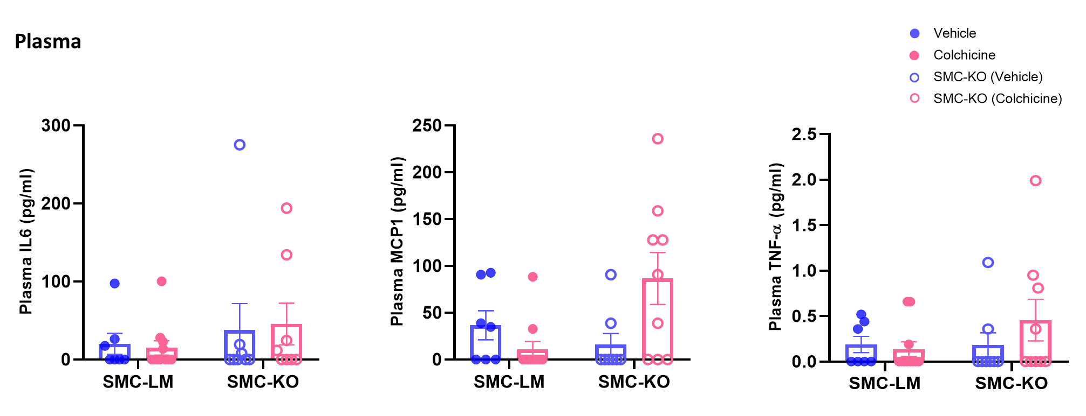

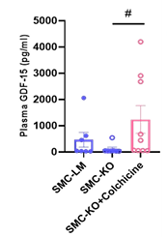
Supplementary Figure S6. SMC-KO mice show no circulating inflammatory phenotype. Statistical analysis was by two-way ANOVA followed by Bonferroni post-hoc test. #; P<0.05. N=7-9.

