Supplementary Table 1 Main themes and categories of the patient personas
 | Themes | Sub-Themes
Patient personas | Motivation | Avoid medical risks
Patient personas | Motivation | Rely on medical authority
Patient personas | Motivation | Reduce trouble
Patient personas | Motivation | Question medical authority
Patient personas | Willingness | Actively engage
Patient personas | Willingness | Passive acceptance with occasional doubts
Patient personas | Willingness | Silent or perfunctory responses
Patient personas | Willingness | Desire to assert control
Patient personas | Decision-making factors | Cognitive ability
Patient personas | Decision-making factors | Psychological trait
Patient personas | Decision-making factors | Social support
Patient personas | Decision-making balance | Rational risk-benefit assessment
Patient personas | Decision-making balance | Accept the"default option" from providers
Patient personas | Decision-making balance | Low sensitivity to medical risks
Patient personas | Decision-making balance | Overestimate personal judgment
Patient personas | Effect evaluation | Highly effective
Patient personas | Effect evaluation | Partially effective
Patient personas | Effect evaluation | Limited effect
Patient personas | Effect evaluation | Needs optimization

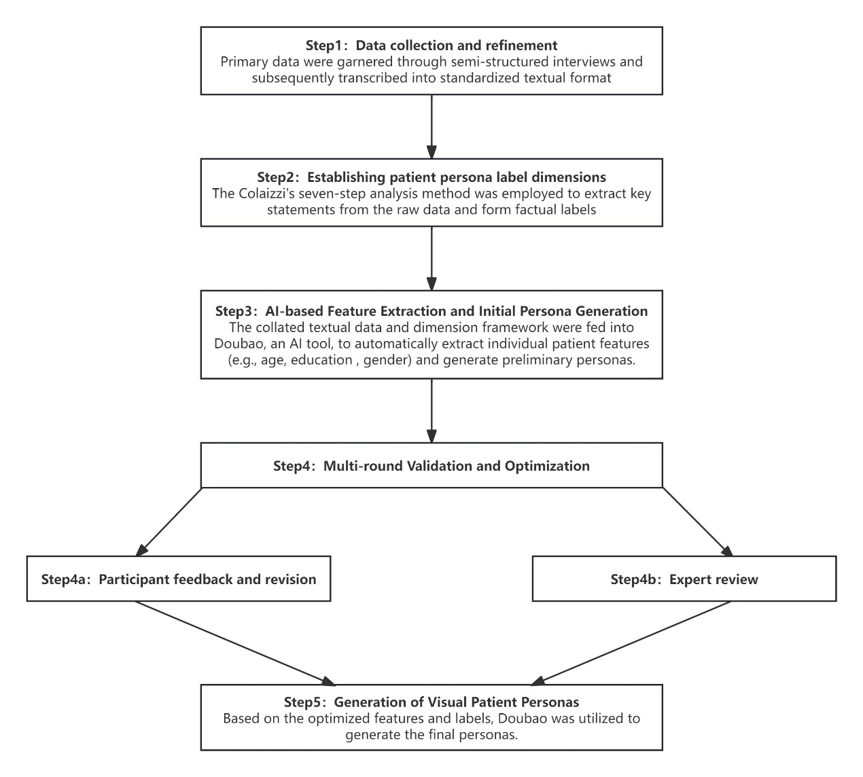
Supplementary Figure.1 An example of the process of development of the patient personas

