Supplementary material

CT image acquisition
All patients were performed abdominal CECT using a 256-detector row CT scanner (Philips iCT 256 or Revolution CT, GE Healthcare). The patient was placed in the supine position for CT scan from the diaphragmatic vault to the pubic symphysis. The scanning parameters were as follows: tube voltage was 120 kV; tube current was 160-480 mA adjusted by the automatic tube current modulation technique. After scanning, images were reconstructed using the standard reconstruction algorithm. Reconstruction matrix, 512 × 512; reconstruction thickness, 5 mm; reconstruction interval, 5 mm.
Using an Ulrich (Ulrich, Germany) high pressure syringe, the non-ionic contrast agent ioversol (350 mg I/mL) was utilized for the enhanced scanning. The injection flow rate of the contrast agent was 2.5–3.0 ml/s, and the dosage was 450 mg I/kg of body weight. Images of the arterial and portal venous phases were acquired 30, and 60 seconds, respectively, following the contrast agent administration. Images from the portal venous phase were chosen for examination since it was easier to see the necrosis there.

Image preprocessing and Feature Extraction
Anonymization was applied to the patient picture files during segmentation, and case numbers were assigned at random. The clinical information was hidden from the readers. Image preprocessing and feature extraction were performed by PyRadiomics (version 3.1.0, https://github.com/Radiomics/pyradiomics).
The voxel size of original image was resampled to 3 × 3 × 3 mm³ by nearest neighbor interpolation before features extraction, partially decreasing the diversity of data from different types of scanning equipment. The gray-level histogram's bin width was fixed at 20 in order to compute discretization of image intensities. Further, pixel intensities are normalized using the z-score.
We used 2 classes of image type: the original image type and filtered image types. For original image, the 105 extracted features can be divided into three groups: (1) 14 morphology features, (2) 18 first-order statistics features and (3) 73 texture features, including 22 gray-level co-occurrence matrix (GLCM) features, 14 gray-level dependence matrix (GLDM) features, 16 gray-level run length matrix (GLRLM) features, 16 gray level size zone matrix (GLSZM) features and 5 neighborhood gray-tone difference matrix (NGTDM) features. Filtered image types were obtained by 7 filters including exponential, gradient, laplacian of gaussian, lbp-3D, logarithm, square and square root. For each filtered image, the first order statistical and texture features were extracted (without morphology features). A total of 819 derived features were extracted for each filtered image. A total of 924 features were extracted. The above image preprocessing and radiomics feature extraction are compliant with the image biomarker standardization initiative (IBSI). Details of the features can be found in Supplementary Table 1
Table S1. Radiomic features extracted by PyRadiomics
Feature classes | Feature names
First-order Features  (N=18) | 10Percentile
First-order Features  (N=18) | 90Percentile
First-order Features  (N=18) | Energy
First-order Features  (N=18) | Entropy
First-order Features  (N=18) | InterquartileRange
First-order Features  (N=18) | Kurtosis
First-order Features  (N=18) | Maximum
First-order Features  (N=18) | Mean
First-order Features  (N=18) | MeanAbsoluteDeviation
First-order Features  (N=18) | Median
First-order Features  (N=18) | Minimum
First-order Features  (N=18) | Range
First-order Features  (N=18) | RobustMeanAbsoluteDeviation
First-order Features  (N=18) | RootMeanSquared
First-order Features  (N=18) | Skewness
First-order Features  (N=18) | TotalEnergy
First-order Features  (N=18) | Uniformity
First-order Features  (N=18) | Variance
Morphology Features  (N=14) | Elongation
Morphology Features  (N=14) | Flatness
Morphology Features  (N=14) | LeastAxisLength
Morphology Features  (N=14) | MajorAxisLength
Morphology Features  (N=14) | Maximum2DDiameterColumn
Morphology Features  (N=14) | Maximum2DDiameterRow
Morphology Features  (N=14) | Maximum2DDiameterSlice
Morphology Features  (N=14) | Maximum3DDiameter
Morphology Features  (N=14) | MeshVolume
Morphology Features  (N=14) | MinorAxisLength
Morphology Features  (N=14) | Sphericity
Morphology Features  (N=14) | SurfaceArea
Morphology Features  (N=14) | SurfaceVolumeRatio
Morphology Features  (N=14) | VoxelVolume
GLCM Texture Features  (N=22) | Autocorrelation
GLCM Texture Features  (N=22) | ClusterProminence
GLCM Texture Features  (N=22) | ClusterShade
GLCM Texture Features  (N=22) | ClusterTendency
GLCM Texture Features  (N=22) | Contrast
GLCM Texture Features  (N=22) | Correlation
GLCM Texture Features  (N=22) | DifferenceAverage
GLCM Texture Features  (N=22) | DifferenceEntropy
GLCM Texture Features  (N=22) | DifferenceVariance
GLCM Texture Features  (N=22) | Id
GLCM Texture Features  (N=22) | Idm
GLCM Texture Features  (N=22) | Idmn
GLCM Texture Features  (N=22) | Idn
GLCM Texture Features  (N=22) | Imc1
GLCM Texture Features  (N=22) | Imc2
GLCM Texture Features  (N=22) | InverseVariance
GLCM Texture Features  (N=22) | JointAverage
GLCM Texture Features  (N=22) | JointEnergy
GLCM Texture Features  (N=22) | JointEntropy
GLCM Texture Features  (N=22) | MaximumProbability
GLCM Texture Features  (N=22) | SumEntropy
GLCM Texture Features  (N=22) | SumSquares
GLDM Texture Features  (N=14) | DependenceEntropy
GLDM Texture Features  (N=14) | DependenceNonUniformity
GLDM Texture Features  (N=14) | DependenceNonUniformityNormalized
GLDM Texture Features  (N=14) | DependenceVariance
GLDM Texture Features  (N=14) | GrayLevelNonUniformity
GLDM Texture Features  (N=14) | GrayLevelVariance
GLDM Texture Features  (N=14) | HighGrayLevelEmphasis
GLDM Texture Features  (N=14) | LargeDependenceEmphasis
GLDM Texture Features  (N=14) | LargeDependenceHighGrayLevelEmphasis
GLDM Texture Features  (N=14) | LargeDependenceLowGrayLevelEmphasis
GLDM Texture Features  (N=14) | LowGrayLevelEmphasis
GLDM Texture Features  (N=14) | SmallDependenceEmphasis
GLDM Texture Features  (N=14) | SmallDependenceHighGrayLevelEmphasis
GLDM Texture Features  (N=14) | SmallDependenceLowGrayLevelEmphasis
GLRLM Texture Features  (N=16) | GrayLevelNonUniformity
GLRLM Texture Features  (N=16) | GrayLevelNonUniformityNormalized
GLRLM Texture Features  (N=16) | GrayLevelVariance
GLRLM Texture Features  (N=16) | HighGrayLevelRunEmphasis
GLRLM Texture Features  (N=16) | LongRunEmphasis
GLRLM Texture Features  (N=16) | LongRunHighGrayLevelEmphasis
GLRLM Texture Features  (N=16) | LongRunLowGrayLevelEmphasis
GLRLM Texture Features  (N=16) | LowGrayLevelRunEmphasis
GLRLM Texture Features  (N=16) | RunEntropy
GLRLM Texture Features  (N=16) | RunLengthNonUniformity
GLRLM Texture Features  (N=16) | RunLengthNonUniformityNormalized
GLRLM Texture Features  (N=16) | RunPercentage
GLRLM Texture Features  (N=16) | RunVariance
GLRLM Texture Features  (N=16) | ShortRunEmphasis
GLRLM Texture Features  (N=16) | ShortRunHighGrayLevelEmphasis
GLRLM Texture Features  (N=16) | ShortRunLowGrayLevelEmphasis
GLSZM Texture Features  (N=16) | GrayLevelNonUniformity
GLSZM Texture Features  (N=16) | GrayLevelNonUniformityNormalized
GLSZM Texture Features  (N=16) | GrayLevelVariance
GLSZM Texture Features  (N=16) | HighGrayLevelZoneEmphasis
GLSZM Texture Features  (N=16) | LargeAreaEmphasis
GLSZM Texture Features  (N=16) | LargeAreaHighGrayLevelEmphasis
GLSZM Texture Features  (N=16) | LargeAreaLowGrayLevelEmphasis
GLSZM Texture Features  (N=16) | LowGrayLevelZoneEmphasis
GLSZM Texture Features  (N=16) | SizeZoneNonUniformity
GLSZM Texture Features  (N=16) | SizeZoneNonUniformityNormalized
GLSZM Texture Features  (N=16) | SmallAreaEmphasis
GLSZM Texture Features  (N=16) | SmallAreaHighGrayLevelEmphasis
GLSZM Texture Features  (N=16) | SmallAreaLowGrayLevelEmphasis
GLSZM Texture Features  (N=16) | ZoneEntropy
GLSZM Texture Features  (N=16) | ZonePercentage
GLSZM Texture Features  (N=16) | ZoneVariance
NGTDM Texture Features  (N=5) | Busyness
NGTDM Texture Features  (N=5) | Coarseness
NGTDM Texture Features  (N=5) | Complexity
NGTDM Texture Features  (N=5) | Contrast
NGTDM Texture Features  (N=5) | Strength
Exponential (N=91)
Gradient (N=91)
Logarithm (N=91)
Square (N=91)
SquareRoot (N=91)
LBP3D (N=273) | LBP3D-k (N=91)
LBP3D (N=273) | LBP3D-m1 (N=91)
LBP3D (N=273) | LBP3D-m2 (N=91)
LoG (N=91) | log-sigma-1.0-mm (N=91)

Reproducibility analysis
To examine the reliability of the extracted radiomics features, 30 patients were randomly selected for reproducibility analysis by two abdominal imaging readers. Reader 1 performed the second segmentation and feature extraction after a one-month interval and compared the outcomes with the features the first time obtained by reader 1 for intraobserver agreement analysis. Reader 2 segmented the ROIs and extracted features separately and compared the outcomes with the features the first time obtained by reader 1 for interobserver agreement analysis. Intraclass correlation coefficient (ICC) of each radiomics features was calculated. Radiomics features with either intraobserver or interobserver ICC values < 0.75 (indicating poor reliability) were discarded in subsequent analysis.
There were 106 features with intraobserver ICC values < 0.75 and 93 features with interobserver ICC values < 0.75. A total of 196 radiomics features were eliminated due to low reliability and remaining 728 features with sufficient reproducibility were accepted for the next analysis step.
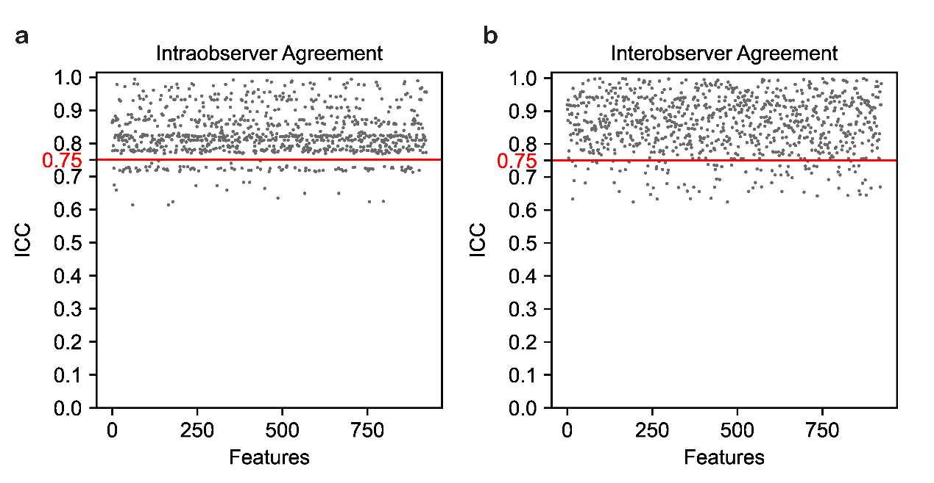
Fig. S1: Evaluation of feature reproducibility based on the interclass correlation coefficient (ICC). (a) intraobserver agreement. (b) interobserver agreement. The horizontal red cutoff line presents the ICC threshold of 0.75. Features with ICC ≥0.75 presents good agreement.

Rad score formula
The final formula of Rad score is:
rad-score = 0.661740 +0.035302 * squareroot_firstorder_Kurtosis
-0.054993 * lbp_3D_k_glszm_ZoneEntropy
+0.021500 * log_sigma_1_0_mm_3D_glcm_Idn
-0.047828 * lbp_3D_k_gldm_DependenceEntropy
+0.061973 * wavelet_HHH_glcm_Idn
+0.024363 * original_shape_Flatness
+0.031081 * squareroot_glcm_JointAverage

