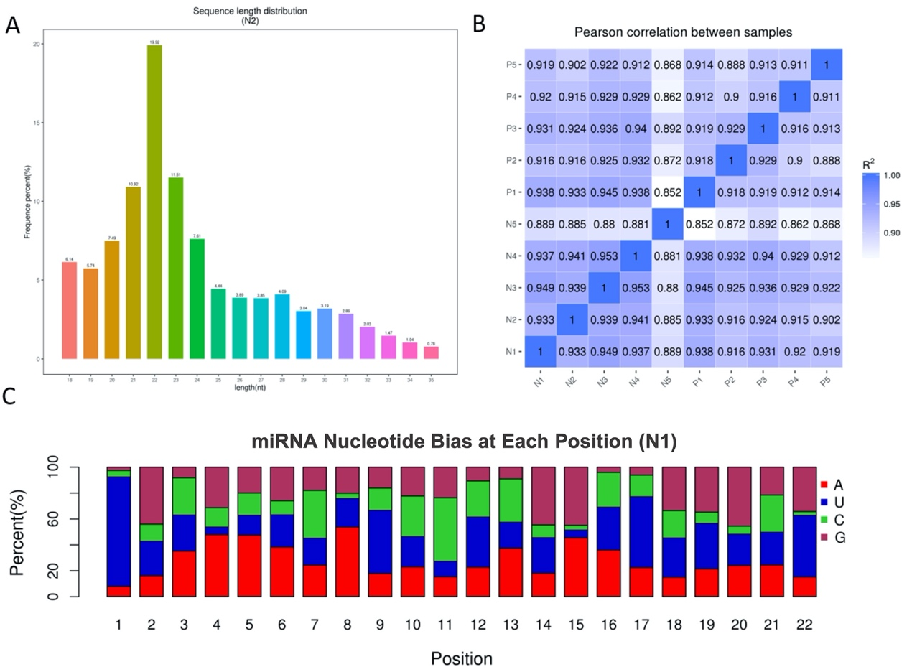

Supplementary Figure 1. Quality control of data analysis. (A) The percentages of reads with different lengths. (B) Pearson correlation analysis. (C) The percentages of the nucleotides in each position of the reads.

