Supplementary Materials for

Dissolvable microneedle administration combined with ultrasonic cavitation promotes Melanoma penetrating capability of Ce6
Binrui Shi^{1,2,3,4,7 #}
Mingjie Li^{1,2,3,4 #}
Renjie Feng^{1,2,3,4}
Guihua Wang⁵
Liyong Deng⁵
Yueyong Li⁵
Kezhen Wang^{1,2,3,6}
Meng Du^{1,2,3,7} *
Zhiyi Chen^{1,2,3,7} *
#These authors contributed equally to this work

¹ Key Laboratory of Medical Imaging Precision Theranostics and Radiation Protection, College of Hunan Province, the Affiliated Changsha Central Hospital, Hengyang Medical School, University of South China, Changsha 410004, Hunan, China.
² Institute of Medical Imaging, Hengyang Medical School, University of South China, Hengyang 421001, Hunan, China
³ Department of Medical imaging, The Affiliated Changsha Central Hospital, Hengyang Medical School, University of South China, Changsha 410004, Hunan, China
⁴ The Seventh Affiliated Hospital, Hunan Veterans Administration Hospital, Hengyang Medical School, University of South China, Changsha 410118, Hunan, China
⁵ Department of Oncology, the Affiliated Changsha Central Hospital, Hengyang Medical School, University of South China, Changsha 410004, Hunan, China.
⁶ College of Mechanical Engineering, University of South China, Changsha 410004, Hunan, China.
⁷ Institute for Future Sciences, University of South China, Changsha, Hunan, 410008, China
Corresponding Author: Meng Du, Zhiyi Chen,
Key Laboratory of Medical Imaging Precision Theranostics and Radiation Protection, College of Hunan Province, the Affiliated Changsha Central Hospital, Hengyang Medical School, University of South China, Changsha 410004, Hunan, China.

*Correspondence: Meng Du dumeng_work@126.com, Zhiyi Chen zhiyi_chen@usc.edu.cn

Supplementary Figures

Figure S1. Observation of DPP by B16F10 cells under fluorescence microscopy (Scale bar: 50 μm，blue: tumor nuclei stained with DAPI; Green: DPP
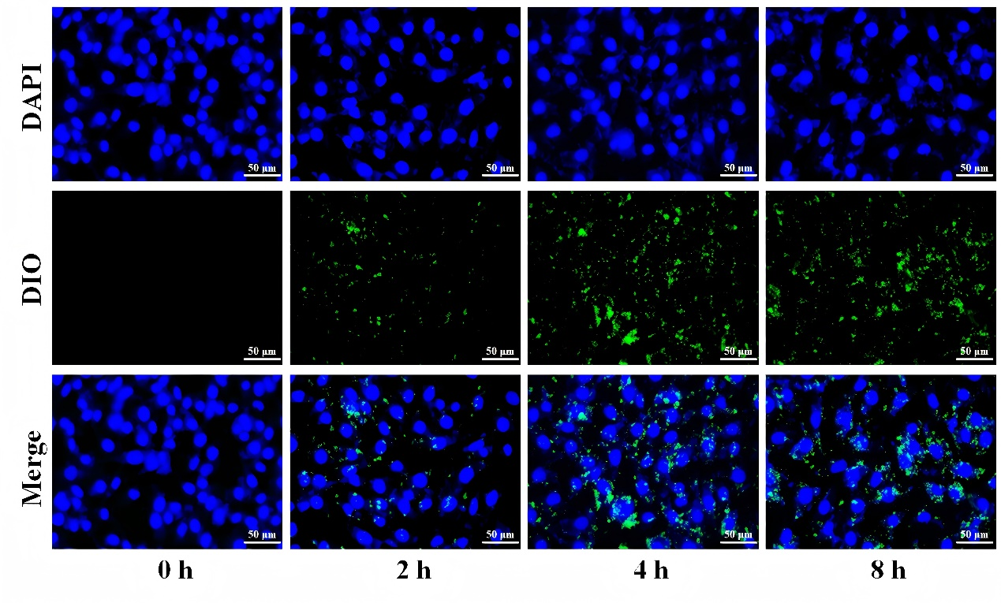

Figure S2. The relative viability of cells after co-incubation with different concentrations of CPP and B16F10 cells (with or without US irradiation)
