Supplementary material
Aleksandra Strzykalska-Augustyniak et al

Calcitriol and tacalcitol modulate Th17 differentiation through osteopontin receptors: age-dependent insights from a mouse breast cancer model
Aleksandra Strzykalska-Augustyniak, Mateusz Psurski, Honorata Zachary, Beata Filip-Psurska, Dagmara Kłopotowska, Magdalena Milczarek, Marta Świtalska, Martyna Stachowicz-Suhs, Natalia Łabędź, Aleksandra Ziemblicka, Michalina Gos, Joanna Wietrzyk

Hirszfeld Institute of Immunology and Experimental Therapy Polish Academy of Science, R. Weigla St. 12, 53-114 Wrocław, Poland.

Correspondence: Joanna Wietrzyk and Mateusz Psurski.
Hirszfeld Institute of Immunology and Experimental Therapy Polish Academy of Science, R. Weigla St. 12, 53-114 Wrocław, Poland.
Email joanna.wietrzyk@hirszfeld.pl, mateusz.psurski@hirszfeld.pl

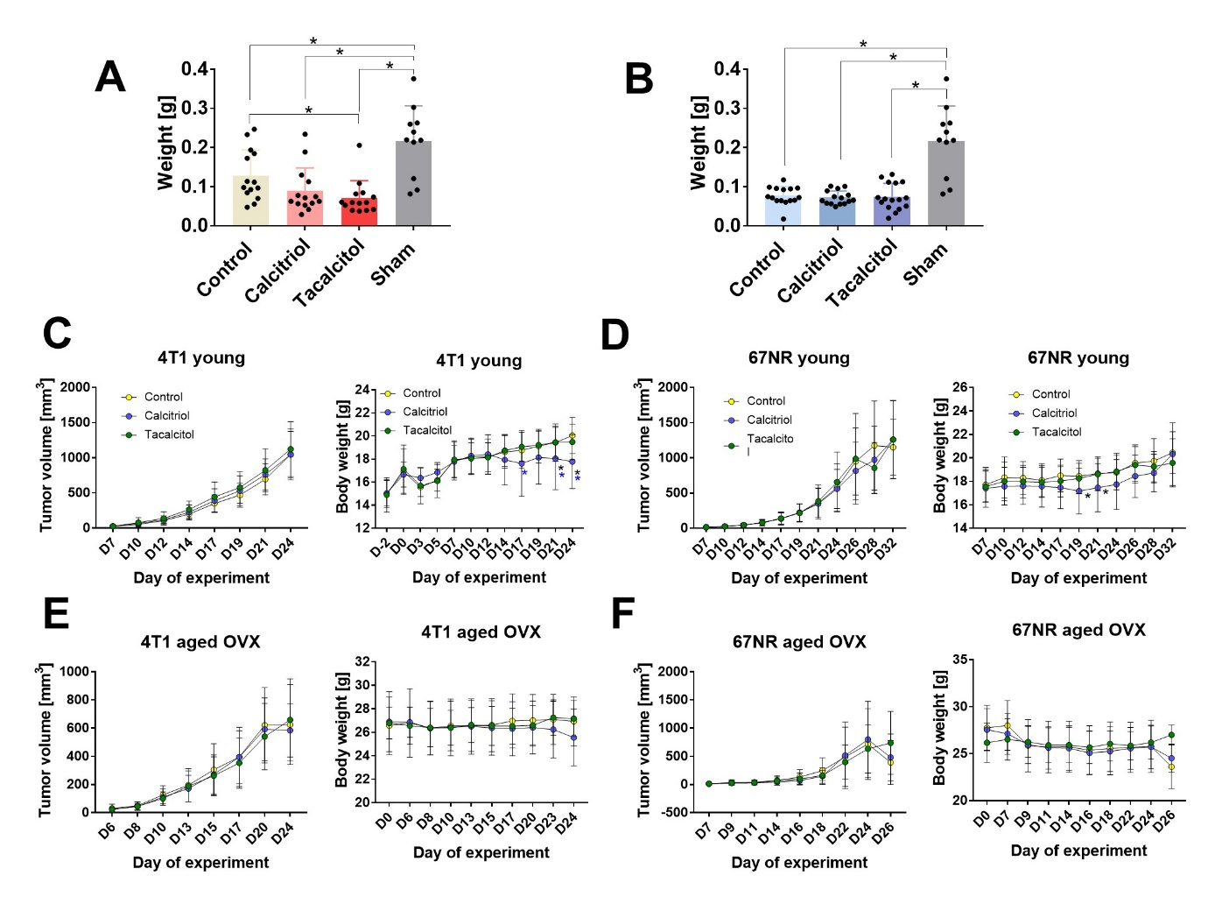
Figure S1: The weight of uterus in 4T1 (A) and 67NR (B) tumor bearing mice ovariectomized and sham-operated. Tumor growth and body weight kinetics in young (C, D) and aged ovariectomized (OVX; E, F) mice bearing 4T1 and 67NR tumors. Statistical analysis: A Holm-Sidak's, B Dunnett's, C-F Tukey's multiple comparisons tests; *p<0.05.

F G
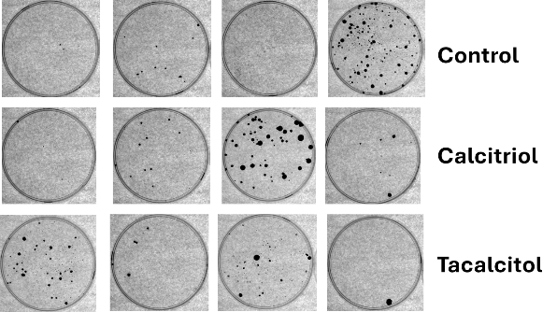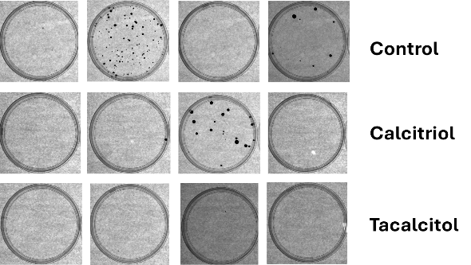
Figure S2. Metastasis of 4T1 and 67NR mouse mammary gland tumors. Surface area of 4T1 colonies cultured from A brain, B bone marrow, and C spleen harvested from 4T1 tumor bearing young and aged OVX mice. Surface area of 67NR colonies cultured from D bone marrow and E lymph nodes harvested from 67NR tumor bearing young and aged OVX mice. N=5. Representative pictures of stained colonies cultured from brains of F young and G aged 4T1 tumor bearing mice. Statistical analysis: Dunn’s multiple comparison test. Abbreviations: OVX – ovariectomized.

Table S1 Blood morphological parameters
Parameter | Group | Tumor type
Parameter | Group | N | 4T1 young | N | 4T1 aged OVX | N | 67NR young | N | 67NR aged OVX
Leukocytes [10³/µl] | Healthy** | 4 | 6.8 ± 1.2* | 15 | 14.5 ± 13.5* | 4 | 6.8 ± 1.2 | 9 | 4.7 ± 2.1*
Leukocytes [10³/µl] | Ctrl | 19 | 143.8 ± 87.4 | 20 | 181.7 ± 132.5 | 15 | 6.4 ± 2.1 | 14 | 7.9 ± 2.1
Leukocytes [10³/µl] | Cal | 20 | 212.8 ± 165.5 | 20 | 226.9 ± 136.0 | 15 | 6.6 ± 1.8 | 14 | 7.4 ± 2.0
Leukocytes [10³/µl] | Tacal | 20 | 238.7 ± 138.6* | 20 | 201.4 ± 125.4 | 14 | 4.9 ± 1.5 | 14 | 6.8 ± 1.7
Lymphocytes [10³/µl] | Healthy** | 4 | 5.7 ± 1.0* | 15 | 15.7 ± 19.7* | 4 | 5.7 ± 1.0 | 9 | 3.8 ± 1.8*
Lymphocytes [10³/µl] | Ctrl | 19 | 27.4 ± 9.9 | 20 | 29.8 ± 16.4 | 15 | 4.8 ± 1.4 | 14 | 5.5 ± 1.4
Lymphocytes [10³/µl] | Cal | 20 | 35.5 ± 23.2 | 20 | 38.7 ± 20.9 | 15 | 4.7 ± 1.1 | 14 | 5.0 ± 1.3
Lymphocytes [10³/µl] | Tacal | 20 | 43.4 ± 22.7* | 20 | 31.4 ± 12.8 | 14 | 3.9 ± 1.0 | 14 | 4.5 ± 1.1
Monocytes [10³/µl] | Healthy** | 4 | 0.4 ± 0.2* | 15 | 0.8 ± 0.6* | 4 | 0.4 ± 0.2 | 9 | 0.4 ± 0.1*
Monocytes [10³/µl] | Ctrl | 19 | 19.6 ± 9.6 | 20 | 22.2 ± 15.4 | 15 | 0.7 ± 0.3 | 14 | 0.8 ± 0.2
Monocytes [10³/µl] | Cal | 20 | 29.8 ± 19.7 | 20 | 29.6 ± 16.8 | 15 | 0.8 ± 0.3 | 14 | 0.8 ± 0.2
Monocytes [10³/µl] | Tacal | 20 | 33.6 ± 18.7* | 20 | 26.0 ± 13.5 | 14 | 0.6 ± 0.3 | 14 | 0.8 ± 0.2
Granulocytes [10³/µl] | Healthy** | 4 | 0.7 ± 0.1* | 15 | 2.1 ± 2.1* | 4 | 0.7 ± 0.1 | 9 | 0.6 ± 0.3*
Granulocytes [10³/µl] | Ctrl | 19 | 96.8 ± 71.4 | 20 | 129.7 ± 104.4 | 15 | 1.0 ± 0.6 | 14 | 1.6 ± 0.7
Granulocytes [10³/µl] | Cal | 20 | 147.6 ± 125.2 | 20 | 158.6 ± 104.6 | 15 | 1.0 ± 0.6 | 14 | 1.6 ± 0.8
Granulocytes [10³/µl] | Tacal | 20 | 161.6 ± 98.7* | 20 | 144.0 ± 101.2 | 14 | 0.6 ± 0.4* | 14 | 1.6 ± 0.8
Erythrocytes [10⁶/µl] | Healthy** | 4 | 8.7 ± 0.1 | 15 | 19.1 ± 13.4 | 4 | 8.6 ± 0.1 | 9 | 7.8 ± 0.8
Erythrocytes [10⁶/µl] | Ctrl | 19 | 10.0 ± 2.0 | 20 | 9.8 ± 2.4 | 15 | 7.9 ± 1.0 | 14 | 7.8 ± 0.8
Erythrocytes [10⁶/µl] | Cal | 20 | 10.8 ± 2.8 | 20 | 11.0 ± 1.4 | 15 | 8.4 ± 0.6 | 14 | 7.6 ± 0.8
Erythrocytes [10⁶/µl] | Tacal | 20 | 10.5 ± 2.2 | 20 | 10.8 ± 2.0 | 14 | 8.3 ± 0.7 | 14 | 7.3 ± 0.7
Hemoglobin [g/dl] | Healthy** | 4 | 16.4 ± 0.3 | 15 | 35.1 ± 23.9 | 4 | 16.4 ± 0.3* | 9 | 14.9 ± 1.4
Hemoglobin [g/dl] | Ctrl | 19 | 17.3 ± 5.9 | 20 | 19.5 ± 4.7 | 15 | 14.7 ± 1.9 | 14 | 15.0 ± 1.3
Hemoglobin [g/dl] | Cal | 20 | 19.1 ± 7.9 | 20 | 21.3 ± 2.7 | 15 | 15.4 ± 0.9 | 14 | 14.5 ± 1.6
Hemoglobin [g/dl] | Tacal | 20 | 18.1 ± 6.2 | 20 | 21.1 ± 3.7 | 14 | 15.1 ± 1.1 | 14 | 14.1 ± 1.2
Platelets [g/dl] | Healthy** | 4 | 209.0 ± 77.7* | 15 | 532.3 ± 379.6 | 4 | 209.0 ± 77.7 | 9 | 317.8 ± 122.4
Platelets [g/dl] | Ctrl | 19 | 502.5 ± 146.9 | 20 | 551.2 ± 113.0 | 15 | 295.7 ± 79.6 | 14 | 418.1 ± 115.7
Platelets [g/dl] | Cal | 20 | 544.8 ± 141.7 | 20 | 541.4 ± 161.7 | 15 | 320.3 ± 87.3 | 14 | 410.6 ± 109.1
Platelets [g/dl] | Tacal | 20 | 505.8 ± 127.2 | 20 | 581.6 ± 158.6 | 14 | 281.2 ± 84.9 | 14 | 392.2 ± 134.8
Lymphocytes [%] | Healthy** | 4 | 84.1 ± 2.6* | 15 | 79.2 ± 3.6* | 4 | 84.1 ± 2.6 | 9 | 79.0 ± 3.6*
Lymphocytes [%] | Ctrl | 19 | 22.1 ± 6.5 | 20 | 19.4 ± 7.9 | 15 | 75.9 ± 7.7 | 14 | 70.4 ± 5.5
Lymphocytes [%] | Cal | 20 | 19.4 ± 5.6 | 20 | 18.6 ± 4.5 | 15 | 73.3 ± 7.8 | 14 | 68.7 ± 5.7
Lymphocytes [%] | Tacal | 20 | 20.3 ± 7.3 | 20 | 18.1 ± 5.0 | 14 | 78.4 ± 7.5 | 14 | 66.8 ± 9.7
Monocytes [%] | Healthy** | 4 | 5.3 ± 1.1* | 15 | 8.0 ± 3.5* | 4 | 5.3 ± 1.0* | 9 | 9.2 ± 1.3
Monocytes [%] | Ctrl | 19 | 14.6 ± 3.4 | 20 | 12.9 ± 3.5 | 15 | 10.3 ± 2.4 | 14 | 9.7 ± 1.9
Monocytes [%] | Cal | 20 | 15.4 ± 3.6 | 20 | 13.7 ± 2.5 | 15 | 12.3 ± 2.7 | 14 | 10.8 ± 2.5
Monocytes [%] | Tacal | 20 | 14.6 ± 1.8 | 20 | 14.0 ± 2.7 | 14 | 11.2 ± 2.9 | 14 | 11.2 ± 2.3
Granulocytes [%] | Healthy** | 4 | 10.6 ± 2.4* | 15 | 13.4 ± 3.4* | 4 | 10.6 ± 2.4 | 9 | 12.3 ± 2.7*
Granulocytes [%] | Ctrl | 19 | 63.3 ± 8.9 | 20 | 67.7 ± 10.3 | 15 | 13.9 ± 6.4 | 14 | 19.9 ± 5.9
Granulocytes [%] | Cal | 20 | 67.0 ± 6.7 | 20 | 67.7 ± 6.6 | 15 | 14.3 ± 6.5 | 14 | 20.5 ± 6.3
Granulocytes [%] | Tacal | 20 | 67.5 ± 3.8 | 20 | 67.9 ± 7.2 | 14 | 10.5 ± 5.1 | 14 | 22.0 ± 8.8
Hematocrit [%] | Healthy** | 4 | 35.7 ± 0.6* | 9 | 122.3 ± 36.3* | 4 | 35.7 ± 0.6 | 9 | 36.5 ± 3.4
Hematocrit [%] | Ctrl | 19 | 47.9 ± 8.4 | 20 | 47.5 ± 12.2 | 15 | 35.3 ± 3.3 | 14 | 36.9 ± 2.7
Hematocrit [%] | Cal | 20 | 51.0 ± 14.1 | 20 | 52.2 ± 6.1 | 15 | 36.9 ± 3.2 | 14 | 35.6 ± 3.5
Hematocrit [%] | Tacal | 20 | 50.6 ± 10.3 | 18 | 50.6 ± 9.3 | 14 | 36.9 ± 2.7 | 14 | 34.6 ± 2.8*
Notes: statistical analysis: Dunn’s multiple comparison test; *p<0.05 as compared to Ctrl. ** healthly untreated young mice or sham operated untreated aged mice. Abbreviations: Ctrl – control, Cal – calcitriol, Tacal – tacalcitol.

Table S2 Blood biochemical parameters
Parameter | Group | Tumor type
Parameter | Group | N | 4T1 young | N | 4T1 aged OVX | N | 67NR young | N | 67NR aged OVX
Ca²⁺  [mmol/L] | Healthy** | 3 | 2.2 ± 0.1 | 5 | 2.0 ± 0.0 | 3 | 2.2 ± 0.1 | 5 | 2.0 ± 0.0
Ca²⁺  [mmol/L] | Ctrl | 5 | 2.3 ± 0.1 | 5 | 2.3 ± 0.1 | 5 | 2.2 ± 0.1 | 7 | 2.2 ± 0.0
Ca²⁺  [mmol/L] | Cal | 7 | 3.2 ± 0.4* | 5 | 3.0 ± 0.6* | 5 | 2.4 ± 0.1* | 7 | 2.1 ± 0.1
Ca²⁺  [mmol/L] | Tacal | 5 | 2.5 ± 0.1 | 5 | 2.5 ± 0.1 | 5 | 2.2 ± 0.1 | 5 | 2.3 ± 0.1
CRE  [µmol/L] | Healthy** | 3 | 4.0 ± 2.9 | 5 | 7.1 ± 2.8* | 3 | 4.0 ± 2.9 | 5 | 7.1 ± 2.8
CRE  [µmol/L] | Ctrl | 5 | 6.1 ± 1.7 | 5 | 2.4 ± 1.8 | 5 | 5.1 ± 1.8 | 7 | 7.3 ± 1.2
CRE  [µmol/L] | Cal | 8 | 6.2 ± 2.5 | 5 | 7.0 ± 2.5* | 5 | 10.7 ± 1.8* | 7 | 7.2 ± 1.9
CRE  [µmol/L] | Tacal | 5 | 4.2 ± 0.9 | 5 | 4.1 ± 1.5 | 5 | 7.3 ± 2.0 | 5 | 6.5 ± 1.1
ALT  [U/L] | Healthy** | 3 | 63.9 ± 38.2* | 5 | 30.0 ± 6.5* | 3 | 63.9 ± 38.2* | 5 | 30.0 ± 6.5
ALT  [U/L] | Ctrl | 5 | 19.8 ± 8.0 | 5 | 19.6 ± 2.1 | 5 | 26.5 ± 6.8 | 7 | 22.7 ± 4.4
ALT  [U/L] | Cal | 8 | 20.7 ± 3.2 | 5 | 23.5 ± 7.3 | 5 | 28.0 ± 4.1 | 7 | 25.3 ± 4.0
ALT  [U/L] | Tacal | 5 | 18.8 ± 2.4 | 5 | 29.3 ± 13.0 | 5 | 35.5 ± 2.6 | 5 | 22.0 ± 2.0
AST  [U/L] | Healthy** | 3 | 163.6 ± 14.8 | 5 | 110.6 ± 16.3 | 3 | 163.6 ± 14.8* | 5 | 110.6 ± 16.3*
AST  [U/L] | Ctrl | 5 | 160.4 ± 41.0 | 5 | 157.4 ± 12.6 | 5 | 128.2 ± 24.5 | 7 | 74.1 ± 5.8
AST  [U/L] | Cal | 8 | 194.1 ± 22.5 | 5 | 209.3 ± 101.2 | 5 | 129.5 ± 22.7 | 7 | 83.1 ± 15.9
AST  [U/L] | Tacal | 5 | 148.1 ± 29.5 | 5 | 166.0 ± 19.7 | 5 | 139.3 ± 12.0 | 5 | 93.7 ± 24.5
25(OH)D₃ [pg/mL] | Healthy** | 4 | 19.4 ± 3.1 | 5 | 18.5 ± 2.6 | 4 | 19.4 ± 3.1 | 5 | 18.5 ± 2.6
25(OH)D₃ [pg/mL] | Ctrl | 5 | 30.5 ± 12.9 | 5 | 24.5 ± 8.9 | 5 | 17.6 ± 4.6 | 5 | 23.8 ± 11.9
25(OH)D₃ [pg/mL] | Cal | 5 | 28.3 ± 12.7 | 5 | 16.9 ± 3.3 | 5 | 22.6 ± 3.6 | 5 | 29.0 ± 5.8
25(OH)D₃ [pg/mL] | Tacal | 5 | 25.9 ± 13.3 | 5 | 18.6 ± 1.6 | 5 | 16.8 ± 2.7 | 5 | 22.8 ± 5.6
Notes: mean ± standard deviation; statistical analysis: Dunn’s multiple comparison test; *p<0.05 as compared to Ctrl. ** healthy untreated young mice or sham operated untreated aged mice. Abbreviations: Ctrl – control, Cal – calcitriol, Tacal – tacalcitol, CRE – creatinine, ALT – alanine transaminase, AST – aspartate aminotransferase.

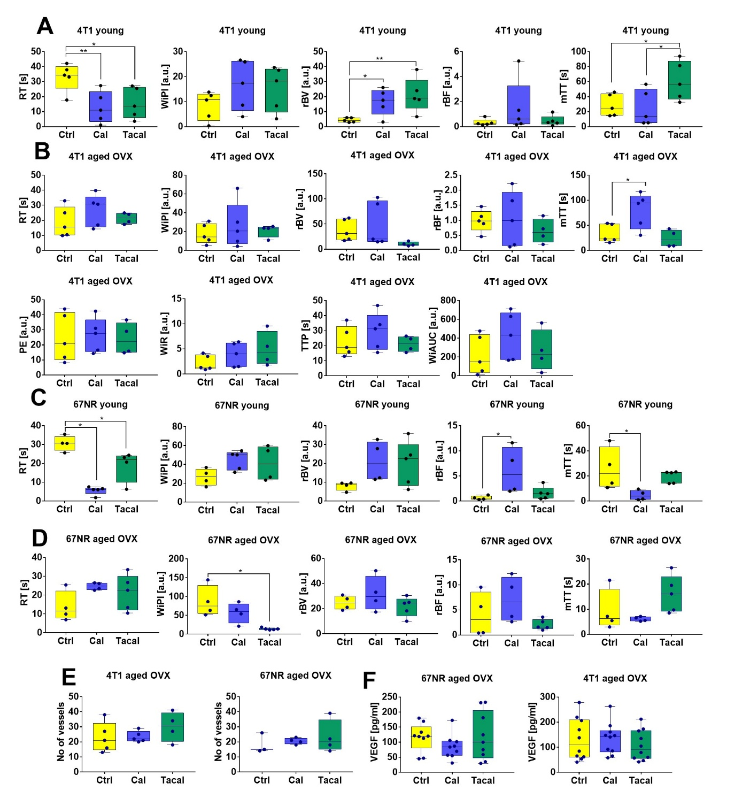Figure S3. Tumor angiogenesis parameters measured in young and aged OVX mice bearing 4T1 or 67NR mouse mammary gland cancer. A-D Ultrasound analysis of blood flow after contrast agent injection in A 4T1 bearing young mice, B 4T1 bearing aged OVX mice, C 67NR bearing young mice, and D 67NR bearing aged OVX mice. N=4-5 mice. Parameters describing blood flow in tumor tissue: PE – peak enhancement; WiR – wash-in-rate; TTP – time to peak, WiAUC – wash-in area under the curve. E Histopathological examination of tumor CD31 expression in aged OVX mice bearing 4T1 and 67NR tumors. N=4-5 mice. F Vascular endothelial growth factor (VEGF) plasma level in young mice bearing 4T1 and 67NR tumors. N=9-10 mice. Statistical analysis: A-D, F Sidak’s, E Dunnett’s multiple comparison tests; *p<0.05; **p<0.01. Abbreviations: Ctrl – control, Cal – calcitriol, Tacal – tacalcitol, PE – peak enhancement, WiR – wash-in rate, TTP – time to peak, WiAUC – wash-in area under the time-intensity curve, VEGF – vascular endothelial growth factor, OVX – ovariectomized.

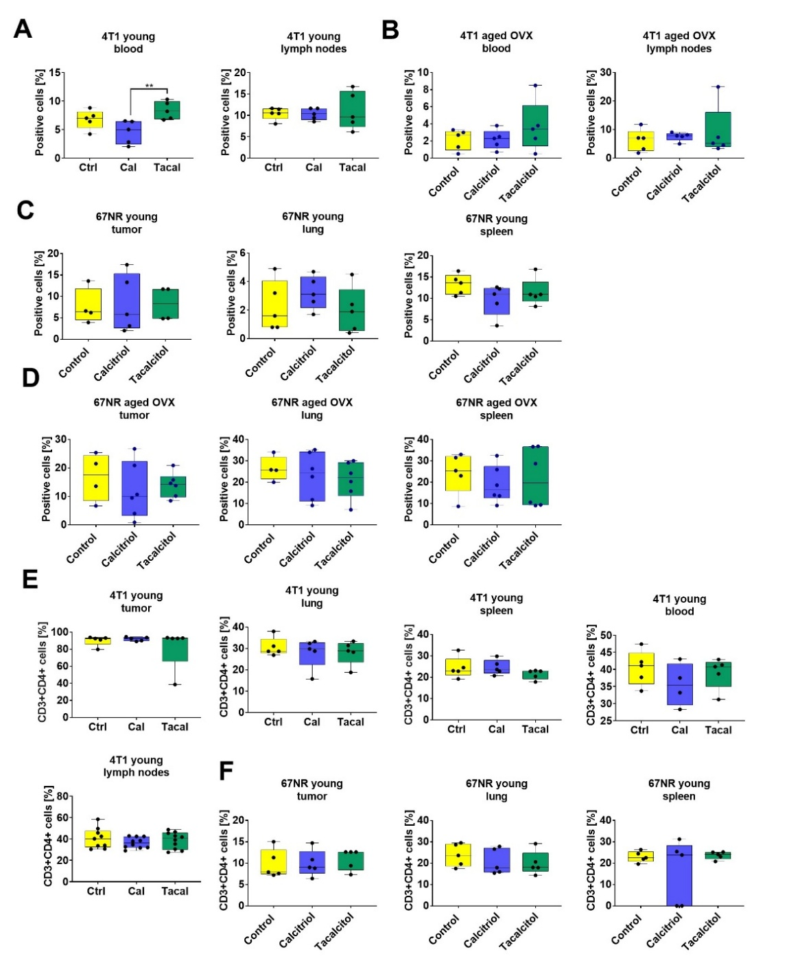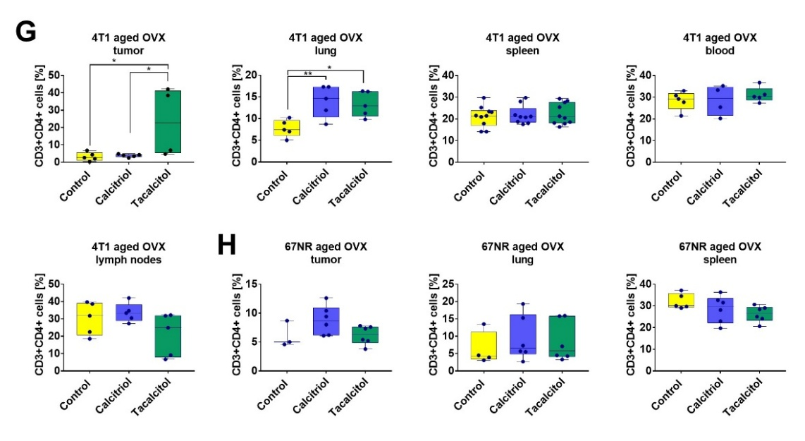
Figure S4. IL-17 expression (Th17 lymphocytes) and percentage of CD3⁺CD4⁺ lymphocytes isolated from 4T1 and 67NR tumor bearing mice treated with calcitriol and tacalcitol. Flow cytometry analysis of cells towards IL-17 expression from A young and B aged OVX mice bearing 4T1 mouse mammary gland tumors; and from C young and D aged mice bearing 67NR tumors. CD3⁺CD4⁺ lymphocytes percentage in various tissues isolated from young E 4T1 and F 67NR and from aged G 4T1 and H 67NR tumor bearing mice. N=4-5 except lymph nodes from 4T1 young mice N=9-10. Statistical analysis: B Dunnet’s or Tukey’s multiple comparison tests; *p<0.05, p**0.01. Abbreviations: Ctrl – control, Cal – calcitriol, Tacal – tacalcitol, OVX – ovariectomized.

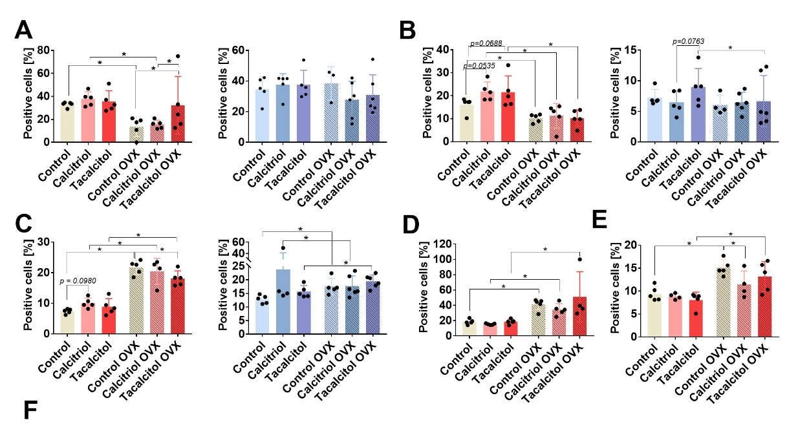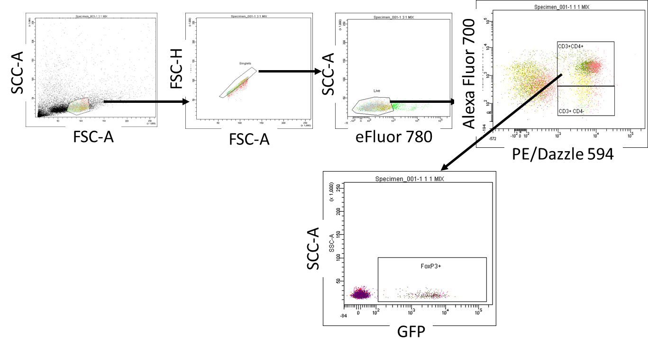
Figure S5. Treg cells in tissues from mice bearing 4T1 and 67NR tumors and treated with calcitriol or tacalcitol. Percentage of Foxp3⁺ cells (as expression of GFP) in mice bearing 4T1 (left) and 67NR (right) tumors from A tumor, B lung, and C spleen. Percentage of Foxp3⁺ cells in mice bearing 4T1 tumors from D lymph nodes and E blood. N=4-6 mice. F Gating strategy. Statistical analysis: Fisher’s LSD test; *p<0.05. Abbreviations: OVX – ovariectomized.
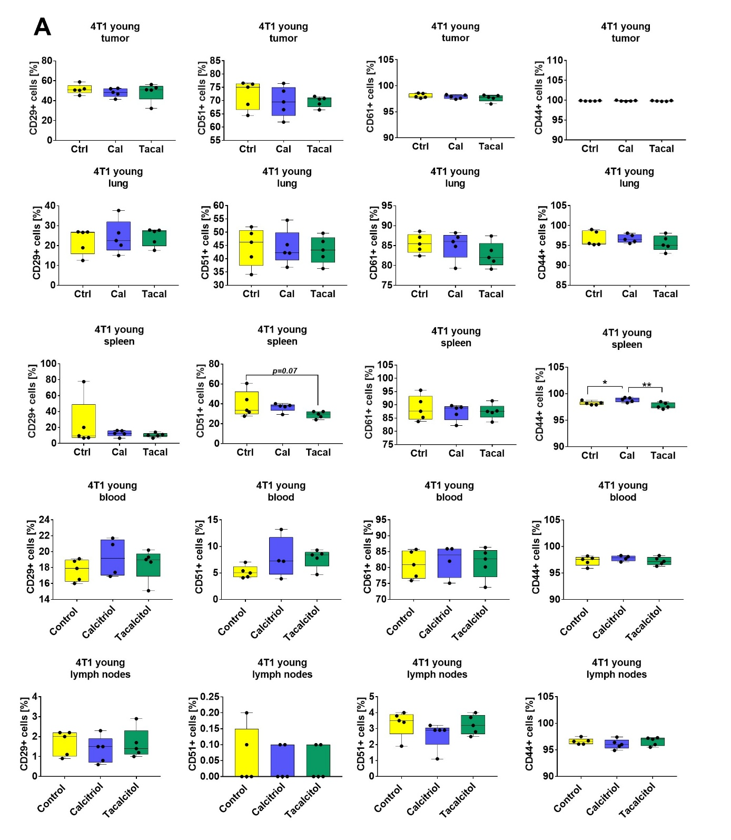
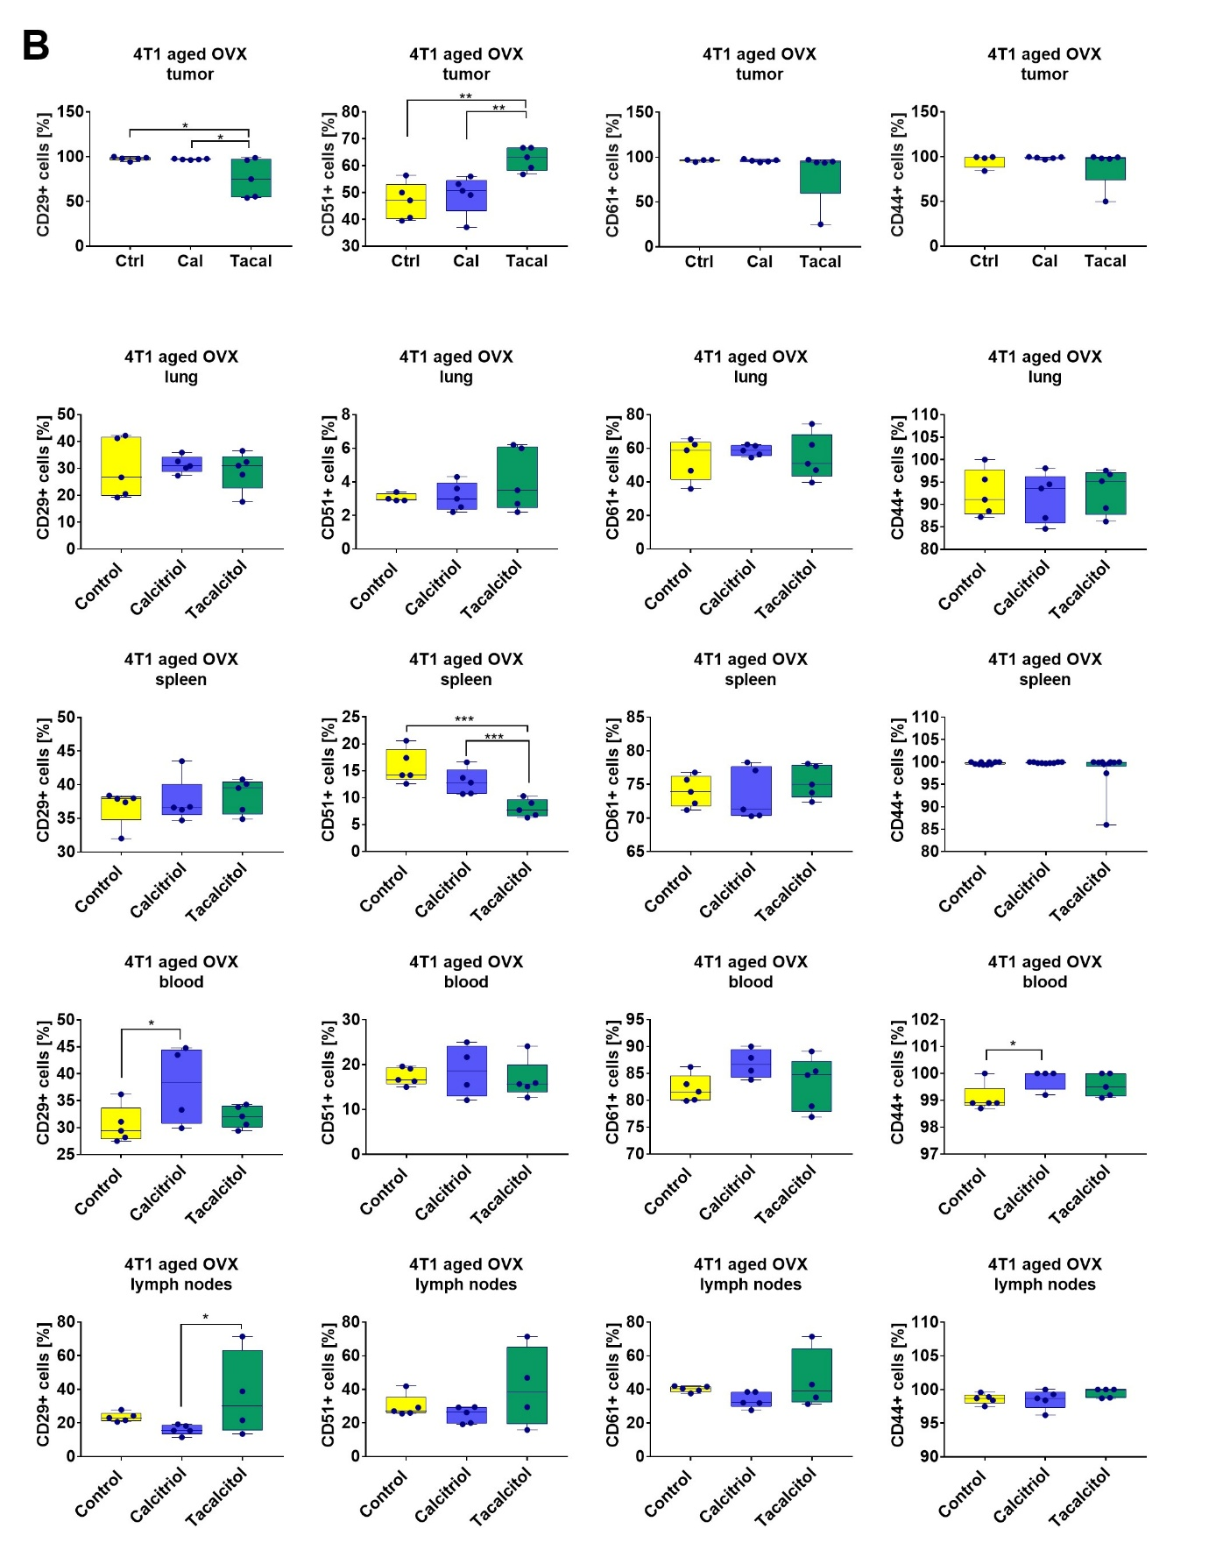
Figure S6. The percentage of CD29+, CD51+, CD61+ and CD44+ among CD3+CD4+ lymphocytes in tissues (tumor, lung, spleen, blood and lymph nodes) harvested from 4T1 tumor bearing mice. A young mice, B aged OVX mice. N=4-5. Statistical analysis: Sidak’s multiple comparison test; *p<0.05, *** p<0.01, *** p<0.001. Abbreviations: Ctrl – control, Cal – calcitriol, Tacal – tacalcitol, OVX – ovariectomized.
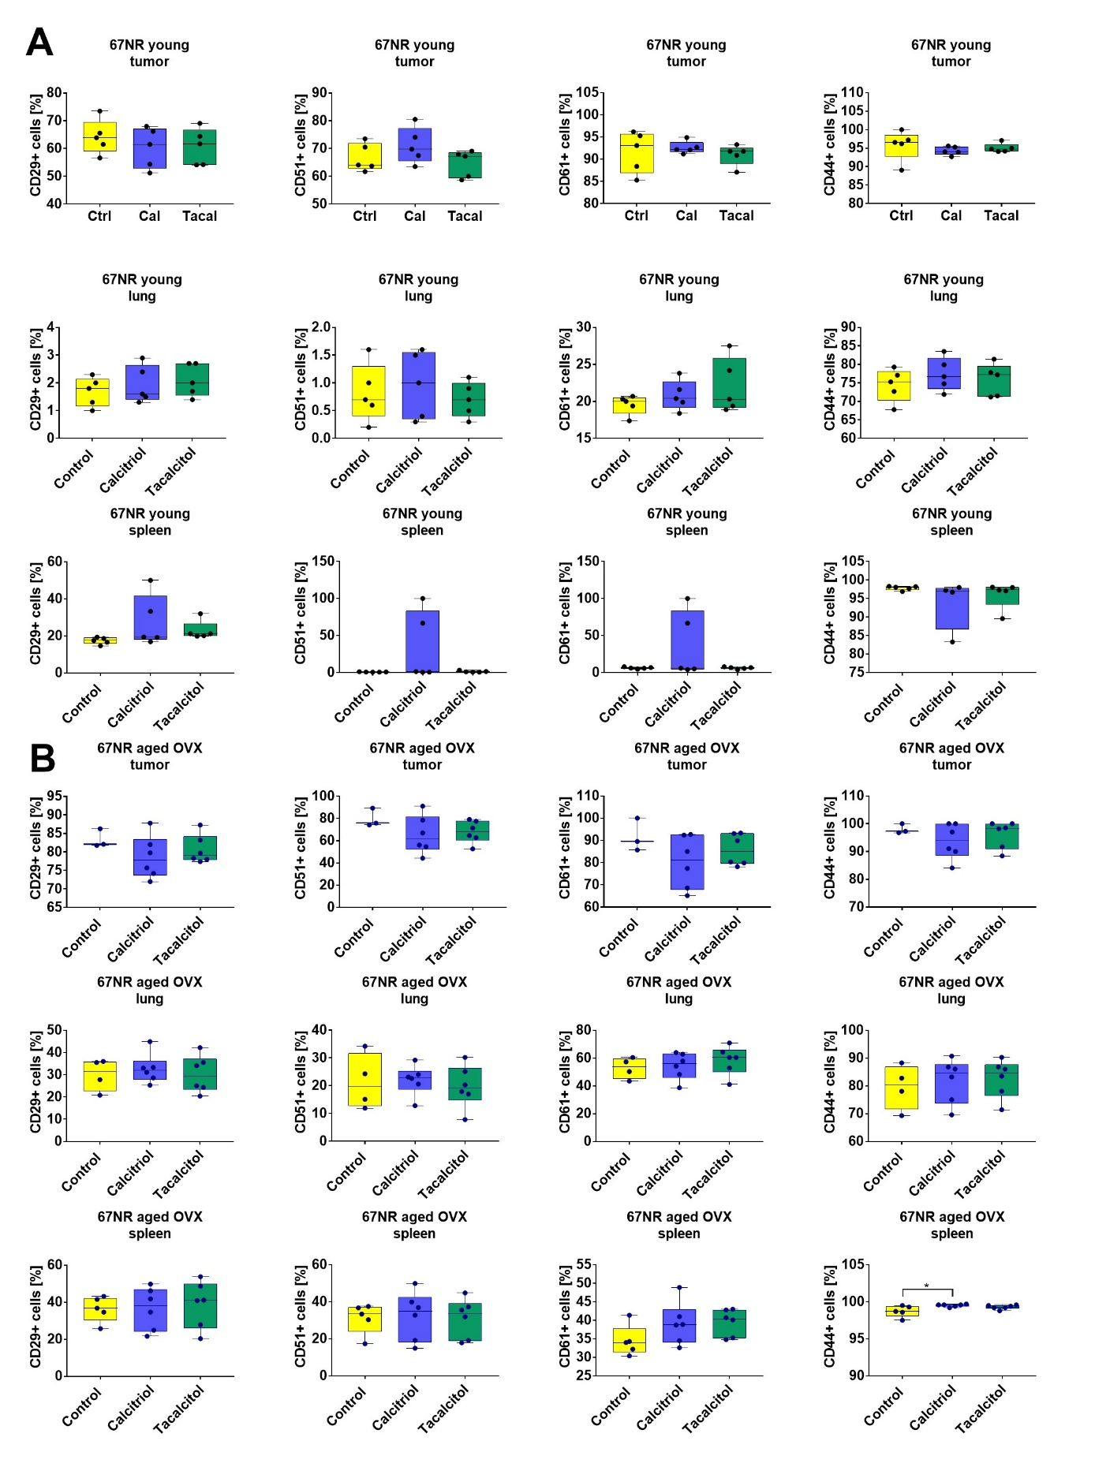Figure S7. The percentage of CD29⁺, CD51⁺, CD61⁺, and CD44⁺ among CD3⁺CD4⁺ lymphocytes in tissues (tumor, lung, spleen) harvested from 67NR tumor bearing mice. A young mice, B aged OVX mice. N=4-5. Statistical analysis: Sidak’s multiple comparison test; *p<0.05. Abbreviations: Ctrl – control, Cal – calcitriol, Tacal – tacalcitol, OVX – ovariectomized.

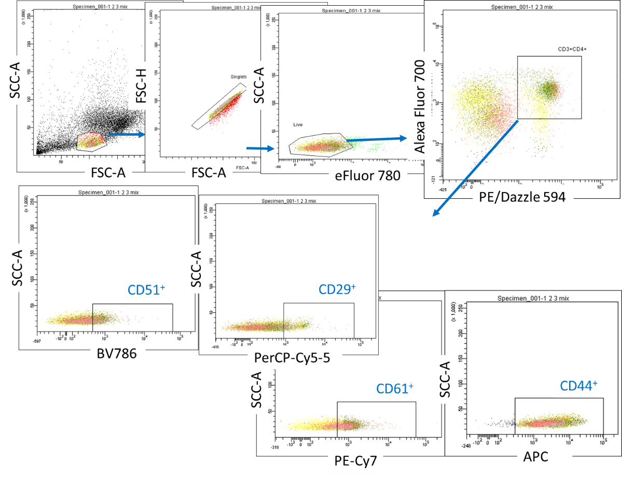
Figure S8. Gating strategy. Splenocytes from young 4T1 tumor-bearing mice.

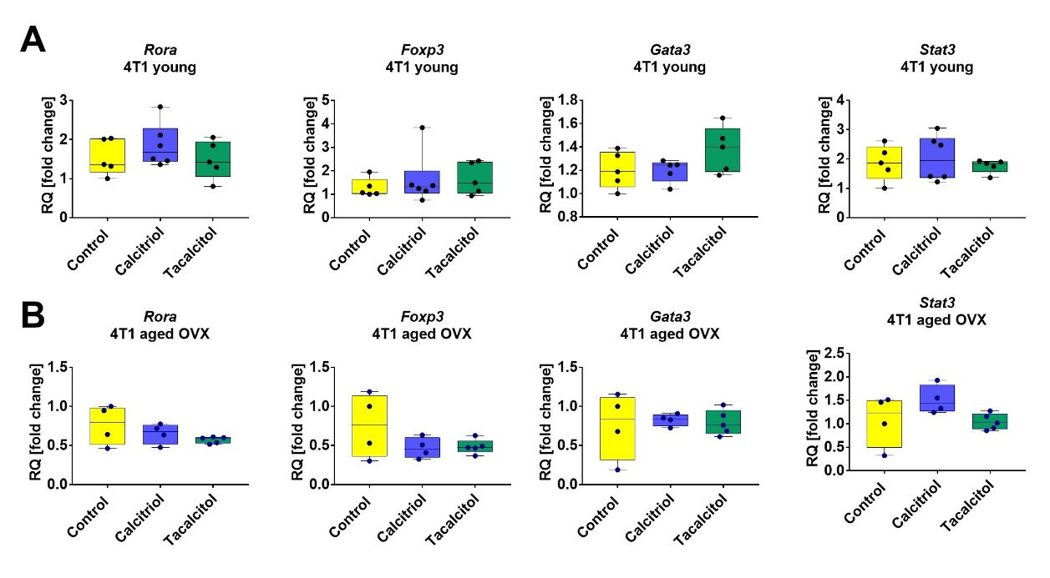
Figure S9. Selected genes expression in CD4⁺ T cells isolated from spleens of 4T1 tumor bearing young (A) and aged OVX (B) mice. Analysis of gene expression was performed using specially designed TaqMan Array 96-Well FAST Plate Mouse FoxP3 plates coated with probes for the analysis of specific genes. Endogenous controls (B2m, Actb, and Sdha) were selected and a comparative ΔΔCt analysis was performed. Samples from the group of control mice were selected as calibrators to obtain the RQ parameter. Analysis was performed using ExpressionSuite Software v1.3. Statistical analysis: Sidak’s multiple comparisons test; * p<0.05. Abbreviations: Rora – RAR related orphan receptor A, Gata3 – GATA binding protein 3, Foxp3 – forkhead box P3, Stat3 – signal transducer and activator of transcription 3, Ctrl – control, Cal – calcitriol, Tacal – tacalcitol, OVX – ovariectomized.

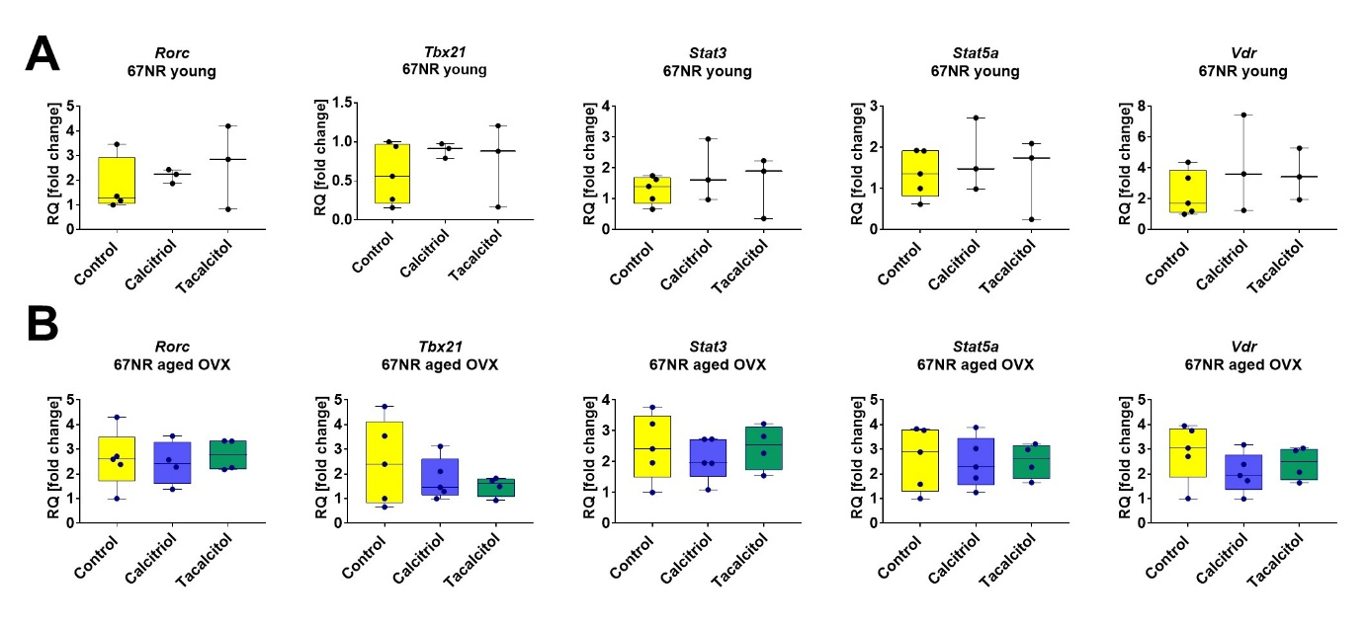
Figure S10. Selected genes expression in CD4⁺ T cells isolated from spleens of 67NR tumor bearing A young and B aged OVX mice. Analysis of gene expression was performed using specially designed TaqMan Array 96-Well FAST Plate Mouse FoxP3 plates coated with probes for the analysis of specific genes. Endogenous controls (B2m and Actb) were selected and a comparative ΔΔCt analysis was performed. Samples from the group of control mice were selected as calibrators to obtain the RQ parameter. Analysis was performed using ExpressionSuite Software v1.3. Statistical analysis: Sidak’s multiple comparisons test; * p<0.05. Abbreviations: Rorc – RAR-related orphan receptor C, Stat5a – signal transducer and activator of transcription 5a, Stat3 – signal transducer and activator of transcription 3, Tbx21 – T-Box Transcription Factor 21, Vdr – vitamin D receptor, Ctrl – control, Cal – calcitriol, Tacal – tacalcitol, OVX – ovariectomized.

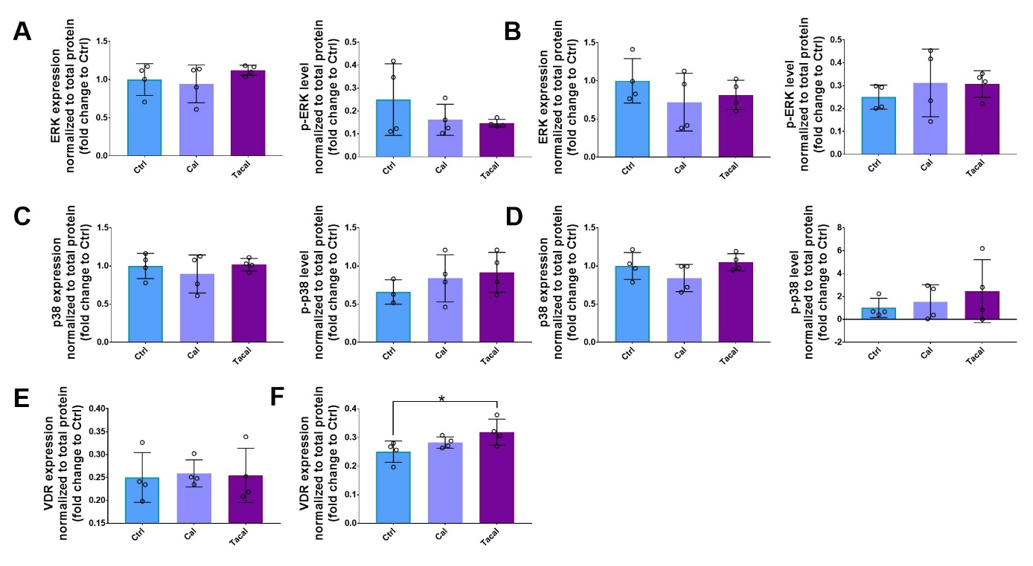
Figure S11. Selected proteins expression in CD4⁺ T cells isolated from spleens of 4T1 tumor bearing young and aged OVX mice. ERK and p-ERK expression in A young and B aged mice. p38 and p-p38 expression in C young and D aged mice. VDR expression in E young and F aged mice. The western blot analysis was performed in a Jess Simple Western System. The samples were normalized to total protein. Statistical analysis: Sidak’s multiple comparisons test; * p<0.05. Abbreviations: Ctrl – control, Cal – calcitriol, Tacal – tacalcitol, OVX – ovariectomized.

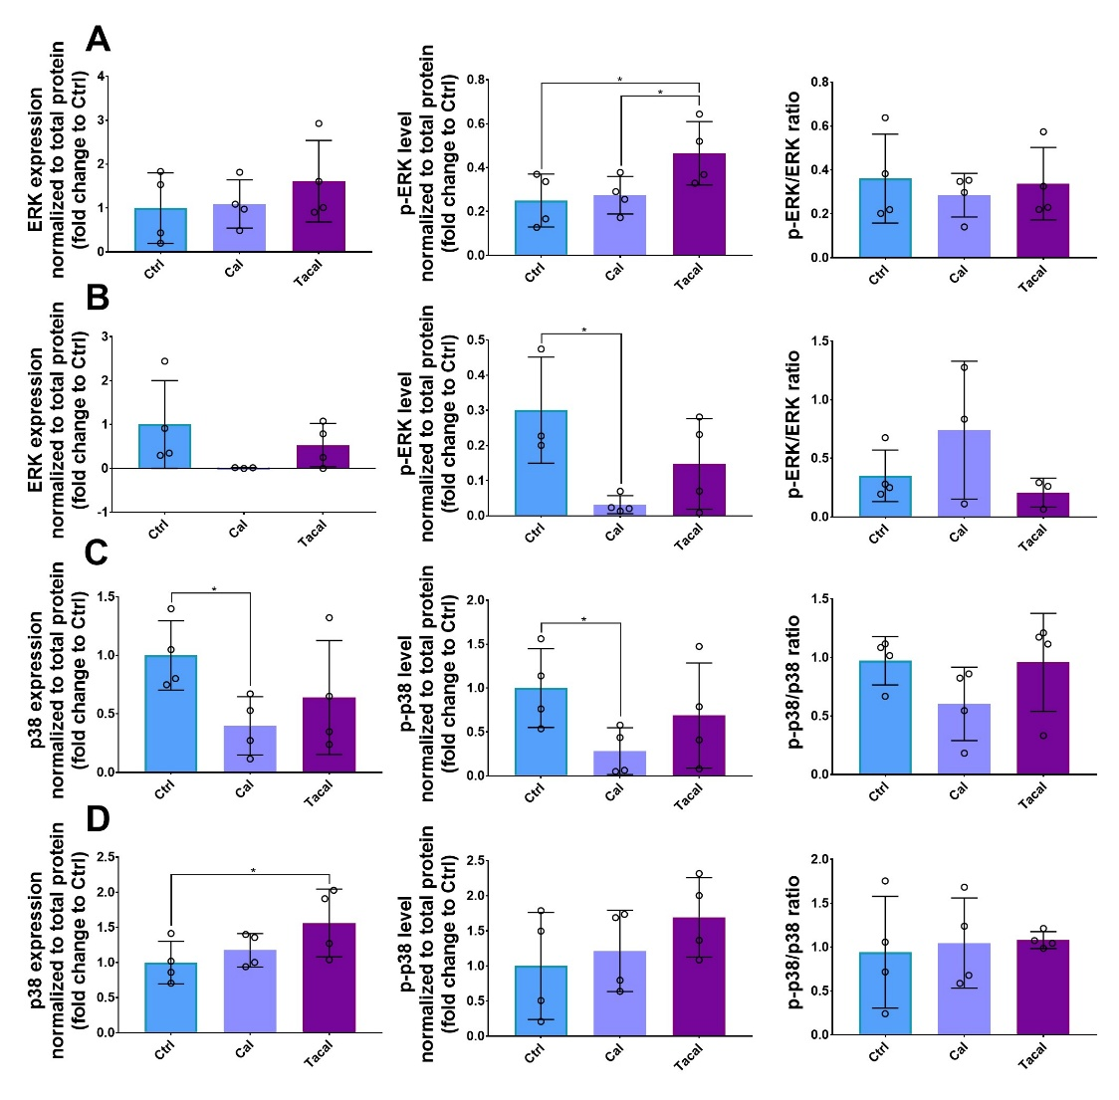
Figure S12. Selected proteins expression in CD4⁺ T cells isolated from spleens of 67NR tumor bearing young and aged OVX mice. ERK, p-ERK expression and p-ERK/ERK ratio in A young and B aged mice. p38, p-p38 expression and p-p38/p38 ratio in C young and D aged mice. The western blot analysis was performed in a Jess Simple Western System. The samples were normalized to total protein. Statistical analysis: Sidak’s multiple comparisons test; *p<0.05. Abbreviations: Ctrl – control, Cal – calcitriol, Tacal – tacalcitol, OVX – ovariectomized.
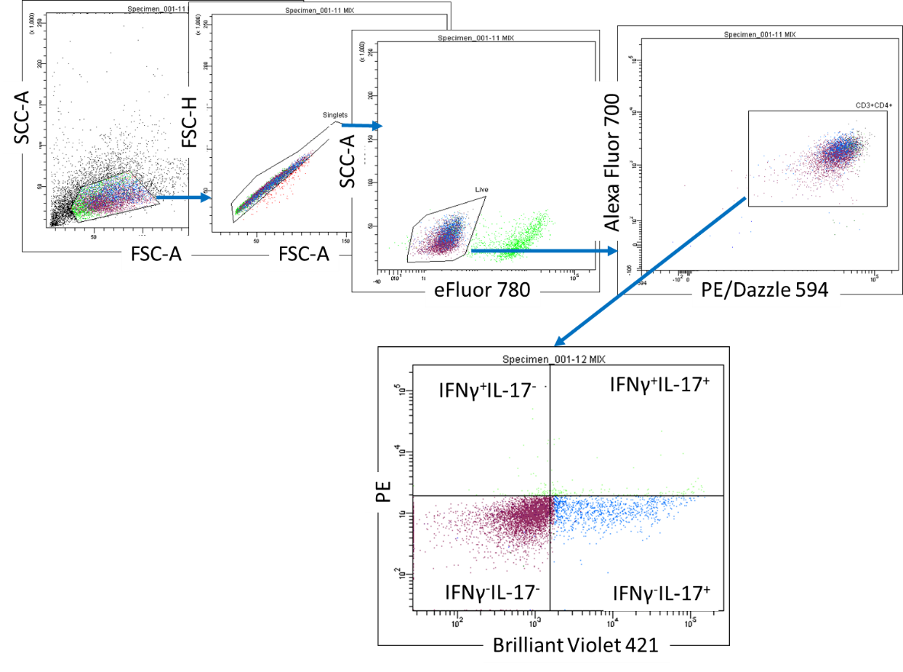
Figure S13. Gating for IL-17 and IFNγ analysis of splenocytes differentiated towards Th17.

