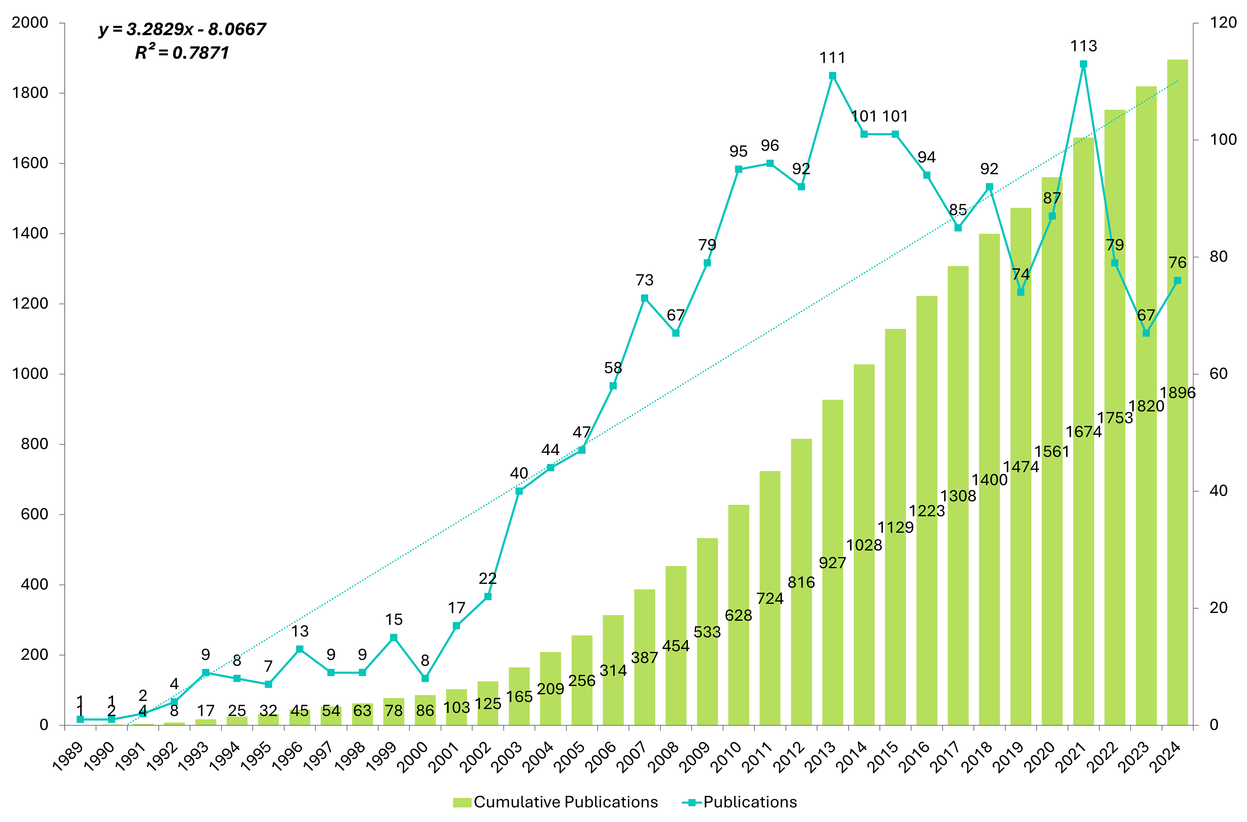Figure S1. Annual output of research from 1992 to 2024.
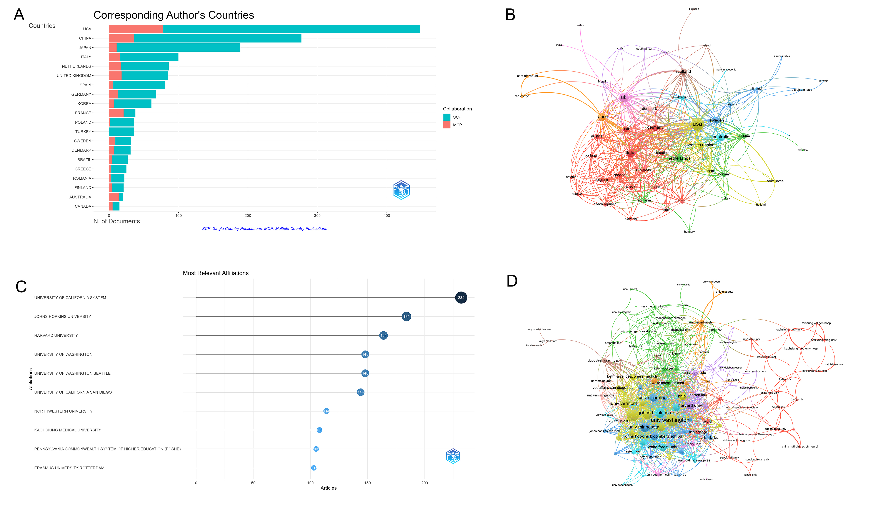Figure S2. Analysis of countries and institutions. (a) Distribution of responding author’s publications by country. (b) Visualization map depicting collaboration among different countries. (c) Bar chart of the top 10 most productive institutions ranked by article count. (d) Institutional collaboration network, where nodes represent institutions and links indicate co-authorship strength; colors denote different collaboration clusters.
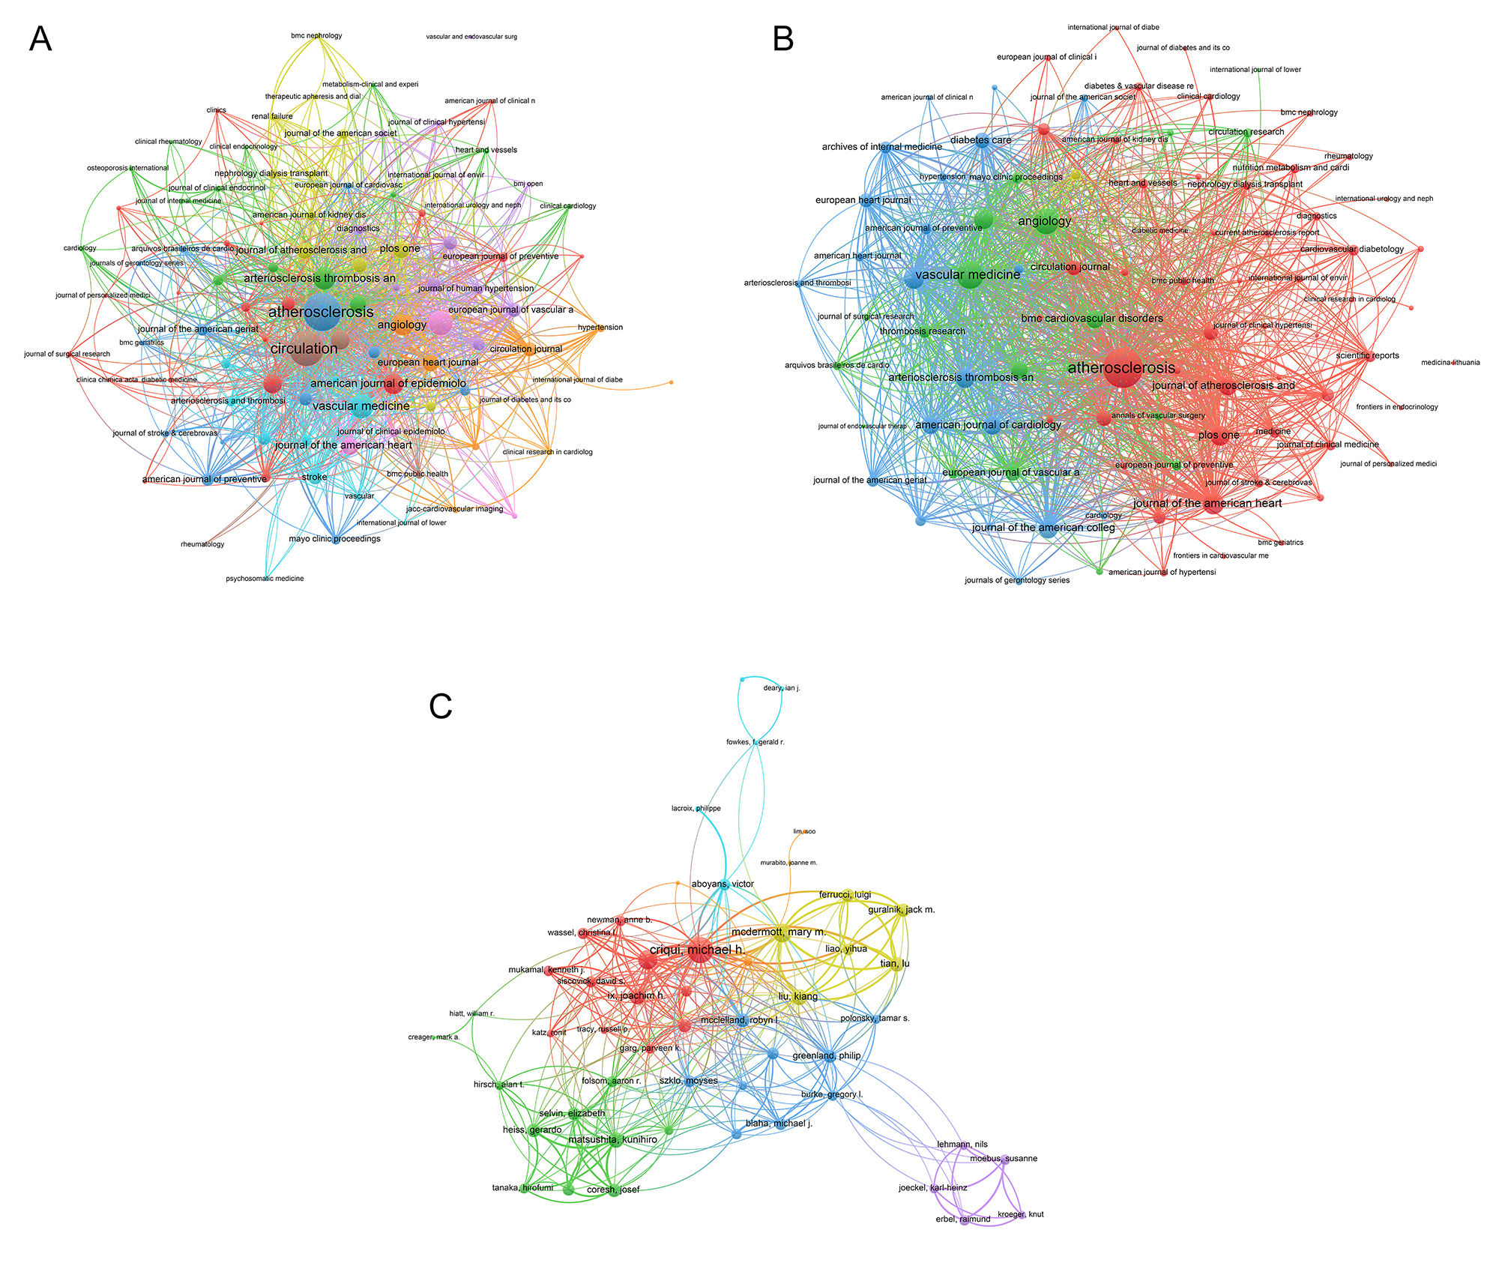Figure S3. Analysis of authors and journals. (a) Visualization map depicting collaboration among authors. (b) The co-occurrence networks of journals. (c) The coupling networks of journals.
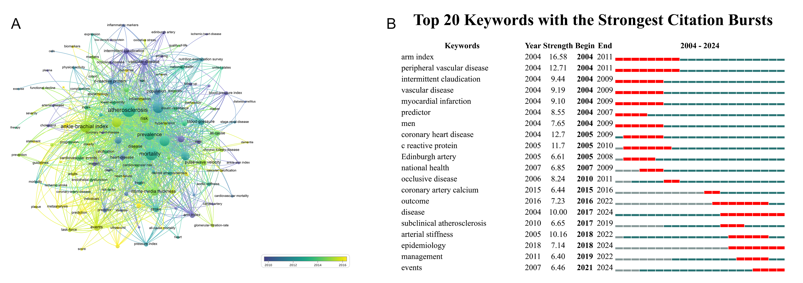Figure S4. Analysis of keywords. (A) Visual analysis of keyword co-occurrence network. (B) Top 20 keywords with the strongest citation bursts.

Table S1. The top 20 countries in terms of intensity of cooperation
Country | Articles | Freq | SCP | MCP | MCP-Ratio | TP | TP-rank | TC | TC-rank | Average Citations
USA | 448 | 23.6 | 370 | 78 | 0.174 | 2606 | 2 | 29980 | 1 | 66.9
CHINA | 277 | 14.6 | 241 | 36 | 0.130 | 1026 | 3 | 3648 | 5 | 13.2
JAPAN | 189 | 10 | 178 | 11 | 0.058 | 659 | 4 | 4367 | 4 | 23.1
ITALY | 100 | 5.3 | 84 | 16 | 0.160 | 378 | 7 | 2902 | 6 | 29
NETHERLANDS | 86 | 4.5 | 69 | 17 | 0.198 | 430 | 6 | 6349 | 3 | 73.8
UK | 85 | 4.5 | 67 | 18 | 0.212 | 304 | 9 | 7549 | 2 | 88.8
SPAIN | 81 | 4.3 | 75 | 6 | 0.074 | 436 | 5 | 1512 | 8 | 18.7
GERMANY | 68 | 3.6 | 55 | 13 | 0.191 | 340 | 8 | 2730 | 7 | 40.1
SOUTH KOREA | 61 | 3.2 | 54 | 7 | 0.115 | 218 | 10 | 1137 | 10 | 18.6
FRANCE | 38 | 2 | 17 | 21 | 0.553 | 172 | 12 | 1069 | 11 | 28.1
POLAND | 36 | 1.9 | 35 | 1 | 0.028 | 129 | 14 | 195 | 23 | 5.4
TURKEY | 36 | 1.9 | 36 | 0 | 0.000 | 120 | 15 | 331 | 19 | 9.2
SWEDEN | 32 | 1.7 | 23 | 9 | 0.281 | 181 | 11 | 892 | 12 | 27.9
DENMARK | 31 | 1.6 | 24 | 7 | 0.226 | 129 | 13 | 1429 | 9 | 46.1
BRAZIL | 27 | 1.4 | 23 | 4 | 0.148 | 79 | 20 | 412 | 18 | 15.3
GREECE | 25 | 1.3 | 22 | 3 | 0.120 | 66 | 21 | 506 | 17 | 20.2
ROMANIA | 22 | 1.2 | 19 | 3 | 0.136 | 107 | 16 | 182 | 24 | 8.3
FINLAND | 21 | 1.1 | 17 | 4 | 0.190 | 92 | 19 | 645 | 14 | 30.7
AUSTRALIA | 20 | 1.1 | 6 | 14 | 0.700 | 101 | 18 | 720 | 13 | 36
CANADA | 15 | 0.8 | 10 | 5 | 0.333 | 105 | 17 | 543 | 15 | 36.2
Note(s): Articles: Publications of Corresponding Authors only. Freq: Frequence of Total Publications. MCP-Ratio: Proportion of Multiple Country Publications. TP: Total Publications. TP-rank: Rank of Total Publications. TC: Total Citations. TC-rank: Rank of Total Citations. Average Citations: The average number of citations
Table S2. Bibliometric Indicators of High-Impact Journals
Journal | H-index | G-index | M-index | TP | TP rank | TC | TC rank | PY start | IF 2023 | JCR 2023
ATHEROSCLEROSIS | 40 | 57 | 1.212 | 136 | 1 | 2627 | 2 | 1993 | 4.9 | 1
CIRCULATION | 28 | 30 | 0.848 | 30 | 9 | 5913 | 1 | 1993 | 35.5 | 1
VASCULAR MEDICINE | 23 | 40 | 0.852 | 53 | 3 | 762 | 16 | 1999 | 3.0 | 2
ARTERIOSCLEROSIS THROMBOSIS AND VASCULAR BIOLOGY | 21 | 31 | 0.700 | 31 | 8 | 1515 | 7 | 1996 | 7.4 | 1
DIABETES CARE | 21 | 23 | 0.840 | 23 | 12 | 1391 | 8 | 2001 | 14.8 | 1
JOURNAL OF VASCULAR SURGERY | 21 | 34 | 0.568 | 34 | 6 | 1561 | 6 | 1989 | 3.9 | 1
JOURNAL OF THE AMERICAN COLLEGE OF CARDIOLOGY | 18 | 20 | 0.667 | 20 | 16 | 2272 | 3 | 1999 | 21.7 | 1
PLOS ONE | 18 | 28 | 1.059 | 45 | 4 | 524 | 20 | 2009 | 2.9 | 1
AMERICAN JOURNAL OF CARDIOLOGY | 17 | 27 | 0.654 | 27 | 10 | 1067 | 12 | 2000 | 2.3 | 2
AMERICAN JOURNAL OF EPIDEMIOLOGY | 17 | 18 | 0.500 | 18 | 18 | 971 | 13 | 1992 | 5.0 | 1
JOURNAL OF THE AMERICAN HEART ASSOCIATION | 17 | 26 | 1.214 | 32 | 7 | 341 | 35 | 2012 | 5.0 | 1
EUROPEAN JOURNAL OF VASCULAR AND ENDOVASCULAR SURGERY | 16 | 22 | 0.533 | 22 | 13 | 763 | 15 | 1996 | 5.7 | 1
ANGIOLOGY | 15 | 23 | 0.429 | 58 | 2 | 498 | 23 | 1991 | 2.6 | 2
JOURNAL OF ATHEROSCLEROSIS AND THROMBOSIS | 15 | 25 | 0.789 | 34 | 5 | 437 | 27 | 2007 | 3.0 | 2
CIRCULATION JOURNAL | 14 | 19 | 0.583 | 19 | 17 | 377 | 32 | 2002 | 3.1 | 2
CARDIOVASCULAR DIABETOLOGY | 13 | 20 | 0.619 | 20 | 15 | 246 | 45 | 2005 | 8.5 | 1
HYPERTENSION RESEARCH | 13 | 18 | 0.565 | 18 | 19 | 512 | 21 | 2003 | 4.3 | 1
BMC CARDIOVASCULAR DISORDERS | 12 | 20 | 0.667 | 27 | 11 | 113 | 82 | 2008 | 2.0 | 3
EUROPEAN HEART JOURNAL | 12 | 12 | 0.387 | 12 | 29 | 1141 | 11 | 1995 | 37.6 | 1
THROMBOSIS AND HAEMOSTASIS | 12 | 13 | 0.387 | 13 | 27 | 297 | 40 | 1995 | 5.0 | 1
Note(s): H-index: The h-index of the journal, which measures both the productivity and citation impact of the publications. IF: Impact Factor, indicating the average number of citations to recent articles published in the journal. JCR-Quartile: The quartile ranking of the journal in the Journal Citation Reports, indicating the journal's ranking relative to others in the same field (Q1: top 25%, Q2: 25%-50%, Q3: 50%-75%, Q4: bottom 25%). TP: Total Publications. TP-rank: Rank of Total Publications. TC: Total Citations. TC-rank: Rank of Total Citations. Average Citations: The average number of citations per publication. PY-start: Publication Year Start, indicating the year the journal started publication.
Table S3. Publication and Citation Profiles of High-Impact Authors
Author | h-index | g-index | m-index | PY-start | TP | TP-Frac | TP-rank | TC | TC-rank
CRIQUI MICHAEL H. | 30 | 65 | 1.50 | 2006 | 65 | 7.73 | 1 | 5848 | 1
FOWKES FGR | 23 | 26 | 0.68 | 1992 | 26 | 5.63 | 6 | 3149 | 6
ALLISON MATTHEW A. | 22 | 40 | 1.10 | 2006 | 40 | 5.02 | 2 | 2237 | 7
MCDERMOTT MARY M. | 21 | 31 | 1.05 | 2006 | 31 | 3.43 | 4 | 4115 | 2
LIU KIANG | 17 | 20 | 0.85 | 2006 | 20 | 1.81 | 9 | 1266 | 11
IX JOACHIM H. | 16 | 27 | 0.89 | 2008 | 27 | 3.54 | 5 | 1106 | 15
HOFMAN A | 15 | 15 | 0.47 | 1994 | 15 | 2.52 | 18 | 3983 | 3
LEE AJ | 15 | 16 | 0.48 | 1995 | 16 | 3.16 | 15 | 1905 | 10
MATSUSHITA KUNIHIRO | 15 | 31 | 1.25 | 2014 | 31 | 3.87 | 3 | 1151 | 14
FOLSOM AARON R. | 14 | 16 | 0.70 | 2006 | 16 | 1.94 | 14 | 1249 | 12
CUSHMAN MARY | 13 | 16 | 0.65 | 2006 | 16 | 1.73 | 12 | 560 | 19
FERRUCCI LUIGI | 13 | 16 | 0.68 | 2007 | 16 | 1.39 | 13 | 759 | 17
HEISS GERARDO | 13 | 20 | 0.68 | 2007 | 20 | 2.21 | 8 | 550 | 20
KULLER LH | 13 | 13 | 0.37 | 1991 | 13 | 2.36 | 24 | 1176 | 13
ABOYANS VICTOR | 12 | 23 | 0.63 | 2007 | 23 | 2.77 | 7 | 3528 | 4
HIRSCH ALAN T. | 12 | 12 | 0.63 | 2007 | 12 | 2.48 | 28 | 726 | 18
MCCLELLAND ROBYN L. | 12 | 17 | 0.60 | 2006 | 17 | 1.87 | 10 | 1955 | 9
WITTEMAN JCM | 12 | 12 | 0.50 | 2002 | 12 | 1.82 | 32 | 3398 | 5
BLAHA MICHAEL J. | 11 | 14 | 1.00 | 2015 | 14 | 1.05 | 21 | 1066 | 16
BURKE GREGORY L. | 11 | 11 | 0.61 | 2008 | 11 | 1.11 | 35 | 2212 | 8
Note(s): H-index: The h-index of the journal, which measures both the productivity and citation impact of the publications. g-index: The g-index of the journal, which gives more weight to highly-cited articles. m-index: The m-index of the journal, which is the h-index divided by the number of years since the first published paper. TP: Total Publications. TP-rank: Rank of Total Publications. TC: Total Citations. TC-rank: Rank of Total Citations. Average Citations: The average number of citations per publication. PY-start: Publication Year Start, indicating the year the journal started publication.

