Supplementary Material

Supplemental Figure S1

Figure S1. The expressions of inflammatory cytokines in models of self-limited and delayed-resolving inflammation in vitro. iBMDM cells were challenged with LPS at concentrations of 10 ng/ml and 1 µg/ml to establish the self-limited and delayed-resolving inflammation models, respectively. qPCR was employed to evaluate the mRNA expressions of inflammatory cytokines.

Supplemental Figure S2

Figure S2. The levels of glycolytic genes and lipid metabolism genes in the in vitro and in vivo inflammatory models. E. coli 10⁵ c.f.u. and LPS 10ng/ml were employed to establish inflammatory models in vivo and in vitro,respectively (a) (b). The expressions of genes were analyzed using quantitative real-time PCR (qPCR).

Supplemental Figure S3

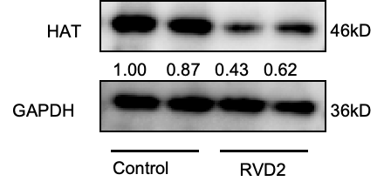
Figure S3. The protein levels of HAT in both the RvD2-treated and control groups for 24 hours were determined by Western blot analysis.

