Supplementary
In the figure S1, each numbered item corresponds to a key clinical feature or diagnostic clue within the image. These numbered items are systematically listed in the accompanying table below the figure, which provides a concise description and explains the clinical significance of each element. This integrated format is designed to help pre-medical students actively engage with image-based diagnostic interpretation by linking visual observations to underlying clinical reasoning and pathophysiology.

Figure S1 A CONFUSED PATIENT - Example for image-based interpretation exercises for pre-med students. Question – observe and identify the numbered items and interpret the observations.
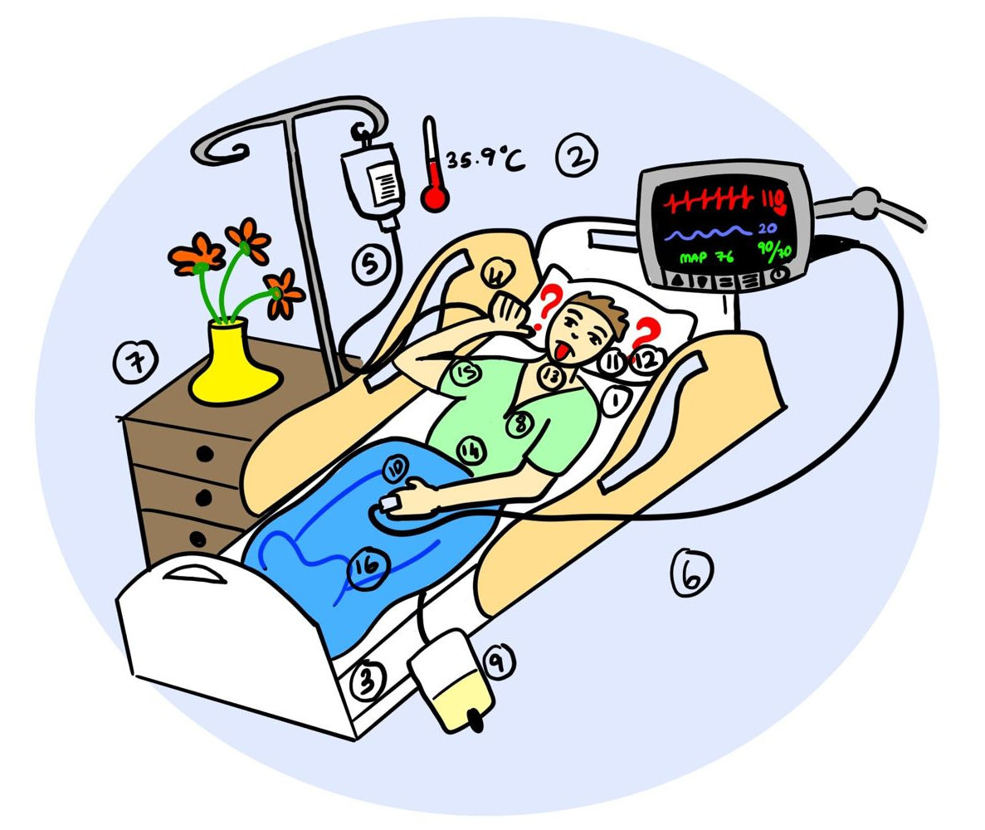

 | Observations | Interpretations
1 | Patient  Face grimacing  Patient seems to be confused  Slurred speech  Moving all 4 limbs  Staring blankly into space, eyes turned left, looking upwards, staring blankly  Gesturing that he wants to drink water | Confusion (alcohol withdrawal?)  Cerebellar involvement?  No paralysis  Possible hallucinations  Thirsty
2 | Connected to a monitor  Pulse  BP  Respiratory rate | Requires supervised treatment
 | Temperature | 37.4
 | Oxygen saturation | 95%
 | Heart rate – 110/min | Tachycardia
 | BP – 80/50 mmHg | Hypotension
 | MAP 60 | Reduced tissue perfusion
 | RR – 18/min | Normal
3 | Air bed | Prevention of DVT
4 | Iv line | Need for IV fluids
5 | No oxygen | No hypoxia – CHF, Pneumonia, exacerbation of asthma, COPD unlikely
6 | No bystanders | affect communication, consent, decision-making, and emotional support for the patient.
7 | No food or water on food tray + No NG tube | Intentional prevention of water intake – Possibly planning a surgical procedure
8 | ECG not connected | No arrhythmia (A fib)
9 | Urine catheter 30 ml in bag | Not in a position to go to the washroom; Need for accurate urine output assessment
10 | Refill time on finger – 4 seconds – Increased | Reduced tissue perfusion
11 | Eyes | Half open, confused
12 | Tongue  No facial asymmetry, No ophthalmoplegia, No nystagmus, Tongue movements normal | Cranial nerves may be normal
13 | Neck - Carotid pulsations and subclavian artery pulsations – normal | No blocks = Not likely ischemia of limbs or brain
14 | Chest and abdomen - Bilaterally symmetrical chest movement; No adventitious sounds | Not likely lobar fibrosis, pleural effusion, pneumothorax, consolidation, tumor, asthma, COPD
15 | Upper limb | Left arm with IV line  Right making sign for drinking water
16 | Lower limb  Left ankle joint - Warmth, tenderness, painful limitation of movements, yellow spot | Ankle swelling  Pus,  Septic arthritis left ankle

