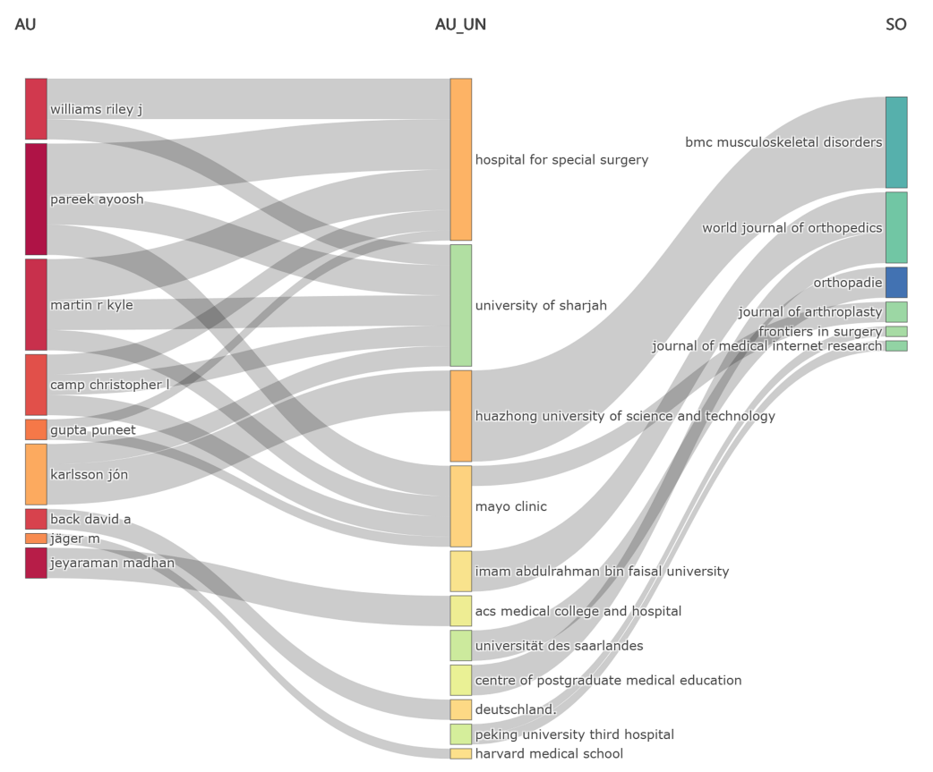
Supplementary Materials
Supplementary Fig. S1 From January 2010 to December 2024: Sankey Diagram of Interdisciplinary Literature on AI and Orthopedics (Fields: AU—AU_UN—SO).
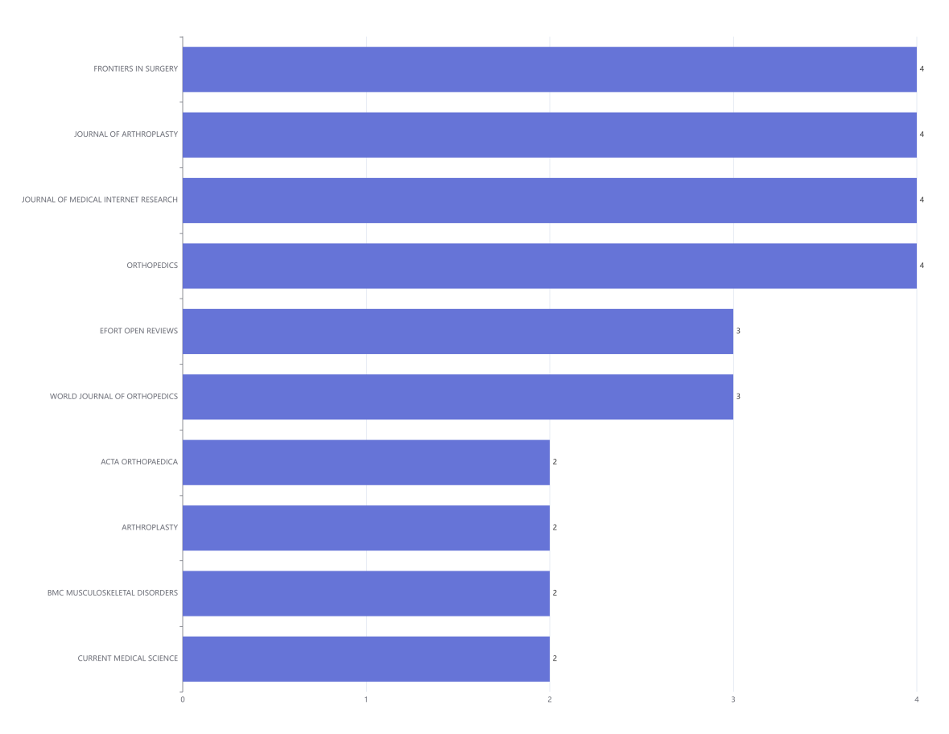
Supplementary Fig. S2 Bar Chart of Literature Sources in the Intersection of AI and Orthopedics from January 2010 to December 2024.
Supplementary Fig. S3 The cumulative publication statistics chart for literature in the interdisciplinary field of AI and orthopedics from January 2010 to December 2024, categorized by year of publication.
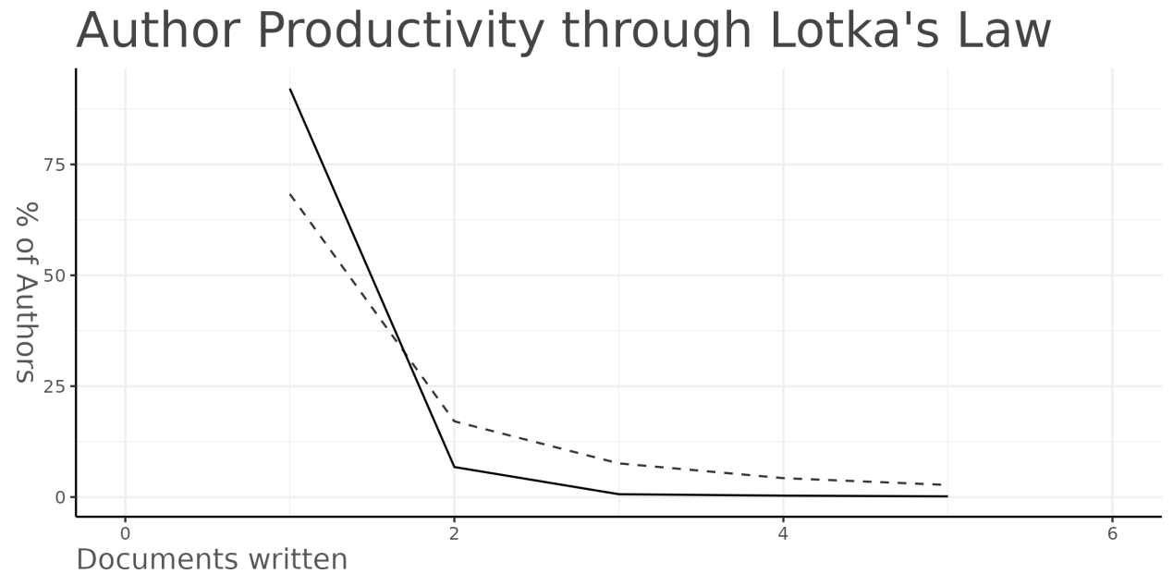
Supplementary Fig. S4 Evaluation of Author Productivity in the Intersection of AI and Orthopedics from January 2010 to December 2024 Based on Lotka's Law.

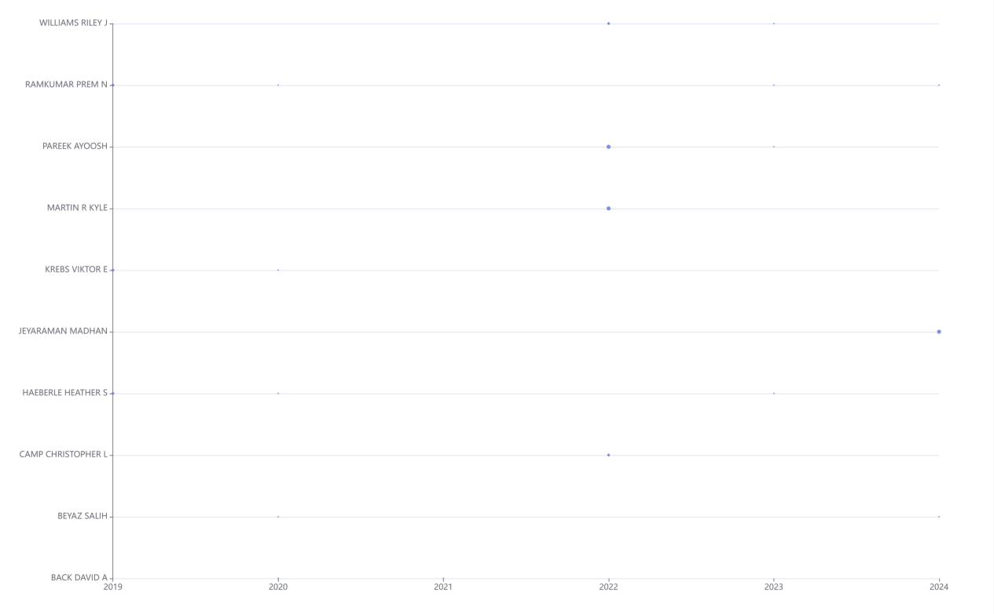
Supplementary Fig. S5 Publications by Authors in the Intersection of AI and Orthopedics from January 2010 to December 2024, Categorized by Year.

Supplementary Fig. S6 Timeline of Research Output from Institutions in the Intersection of AI and Orthopedics, January 2010 to December 2024.

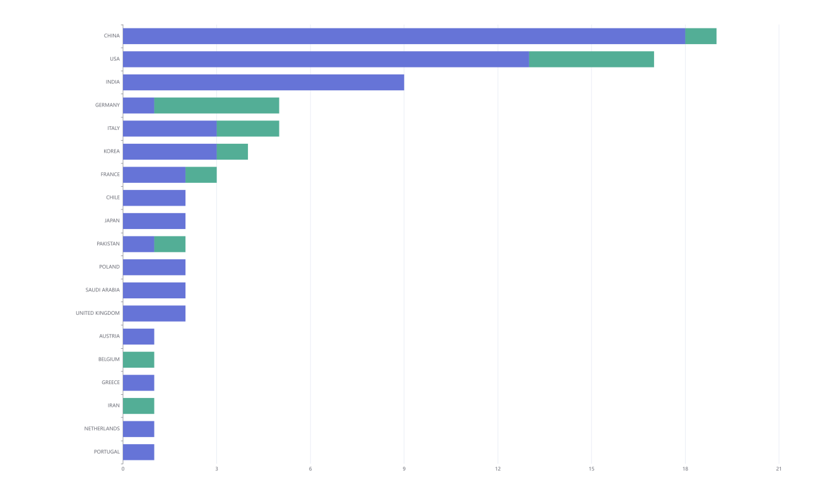
Supplementary Fig. S7 Ranking of Corresponding Authors' Countries and International Collaboration Ratios in the Field of AI and Orthopedics Cross-Disciplinary Research from January 2010 to December 2024.

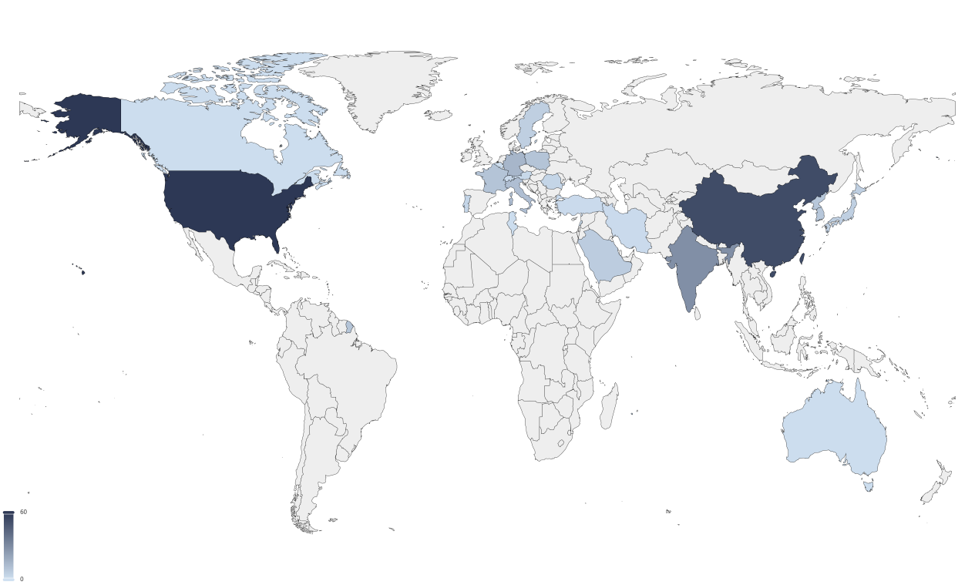
Supplementary Fig. S8 The regional distribution map of scientific output in the interdisciplinary field of AI and orthopedics across different countries from January 2010 to December 2024.

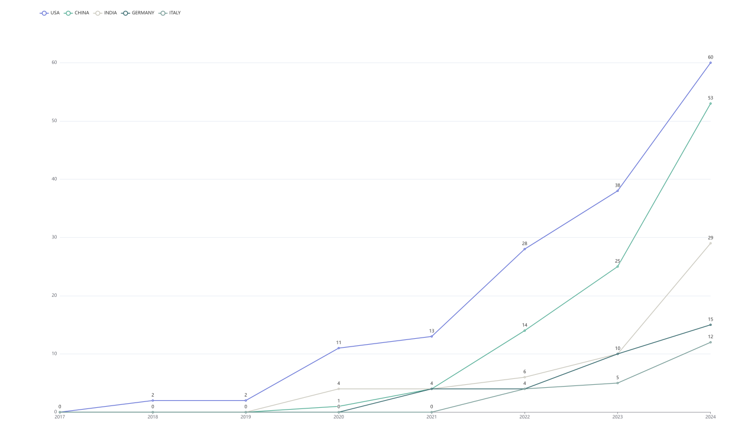
Supplementary Fig. S9 Chart of Output Over Time by Country in the Intersection of AI and Orthopedics from January 2010 to December 2024.

Supplementary Fig. S10 Citation Rankings of Different Countries in the Intersection of AI and Orthopedics from January 2010 to December 2024.

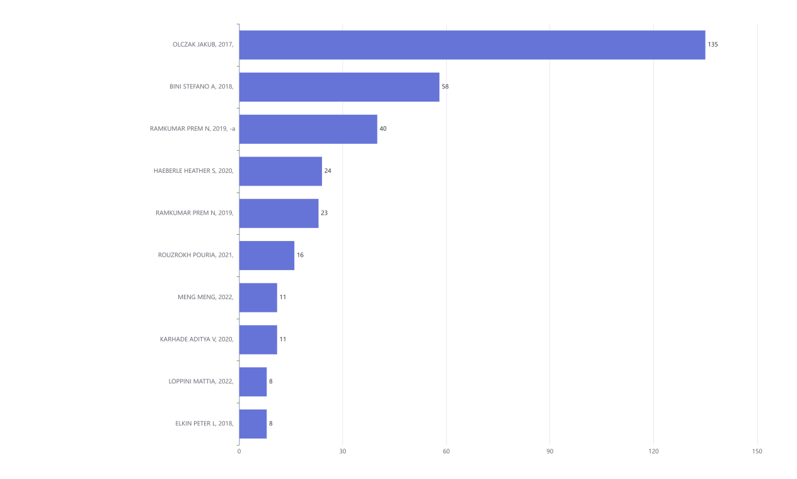
Supplementary Fig. S11 Ranking of Cited Literature in the Intersection of AI and Orthopedics from January 2010 to December 2024.

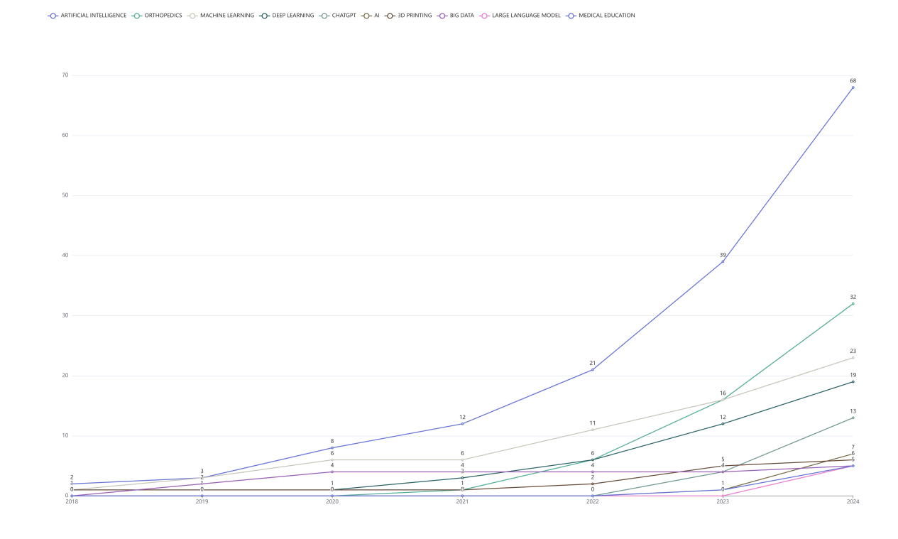
Supplementary Fig. S12 Frequency of Keywords in AI and Orthopedics Cross-Disciplinary Literature Over Time: January 2010 to December 2024.

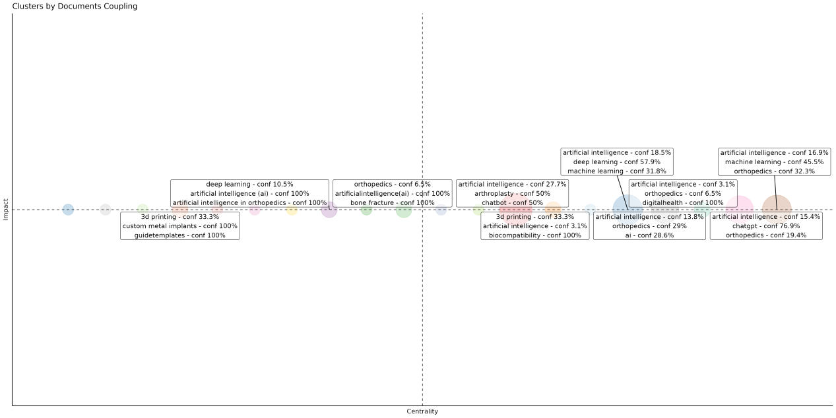
Supplementary Fig. S13 Literature Coupling Clustering in the Intersection of AI and Orthopedics from January 2010 to December 2024.

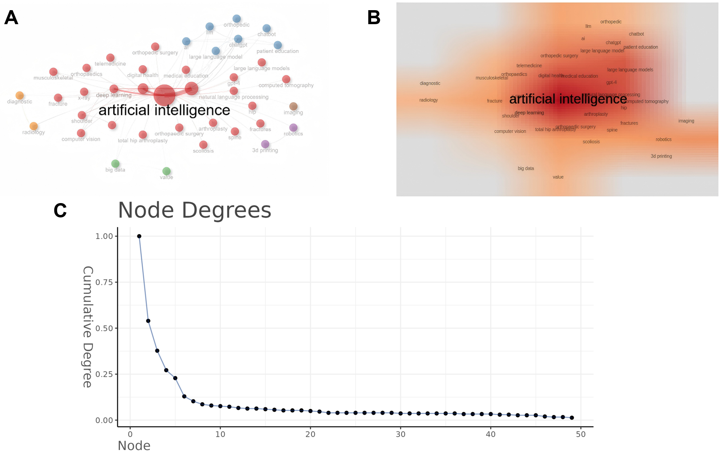
Supplementary Fig. S14 The co-occurrence network (A), density map (B), and degree distribution map (C) of keywords in the interdisciplinary field of AI and orthopedics from January 2010 to December 2024.

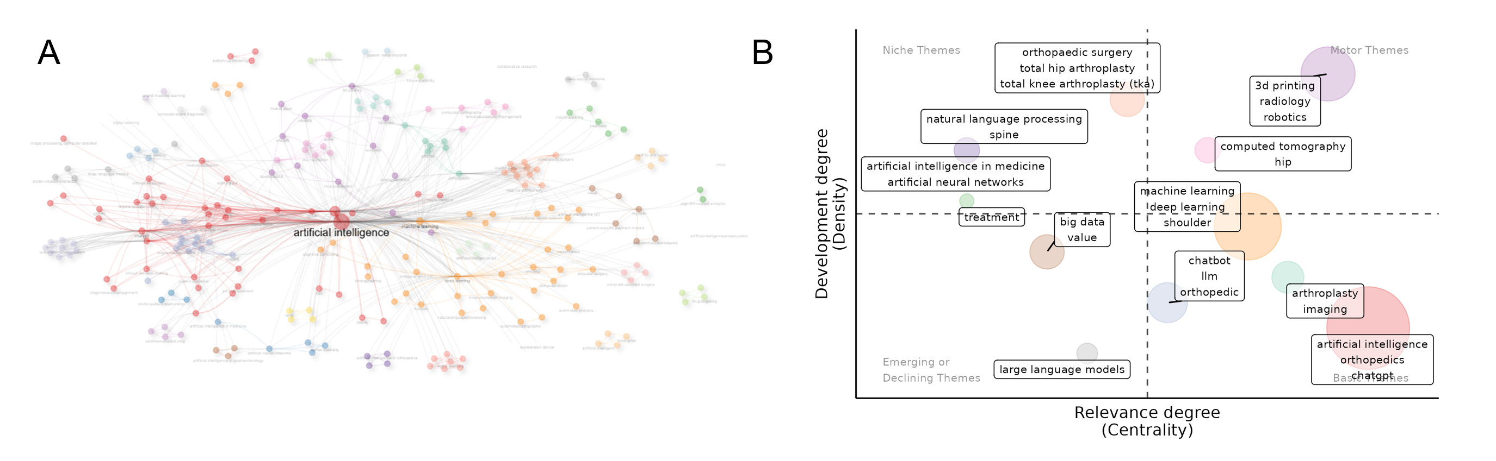
Supplementary Fig. S15 Thematic Map of AI and Orthopedics Intersection from January 2010 to December 2024. The cluster of Artificial Intelligence held a significant central position in the network (A), and main clusters, including 3D Printing, Machine Learning, Arthroplasty, and Chatbot, were shown (B).

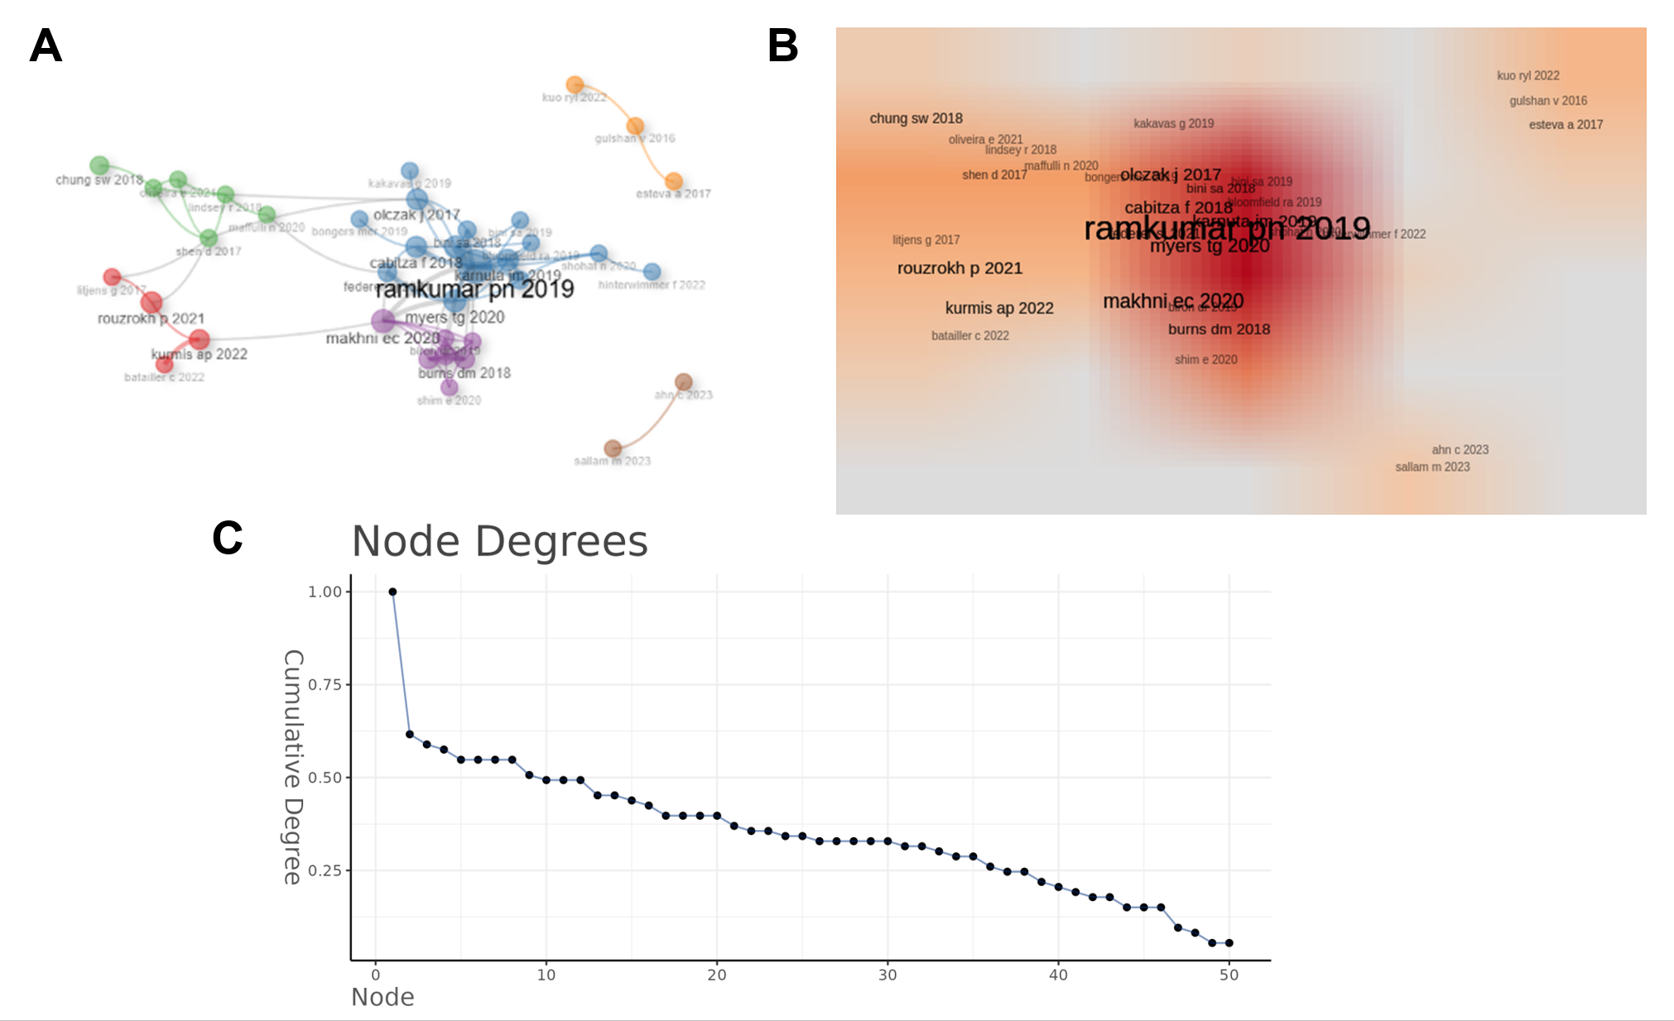
Supplementary Fig. S16 The co-citation network analysis in the interdisciplinary field of AI and orthopedics, spanning from January 2010 to December 2024, was constructed based on the frequency of simultaneous citations of literature. The study by Ramkumar PN (2019) stood out as the most influential paper (A), and other significant contributions included works by Olczak J (2017) and Makhni EC (2020), which also held considerable importance in the field (B). The degree plot illustrated the connectivity pattern of nodes within the network, representing the number of connections each node had. For instance, terms like " Ramkumar PN (2019)" and " Olczak J (2017)" were prominently highlighted in this visualization due to their high degree values (C).
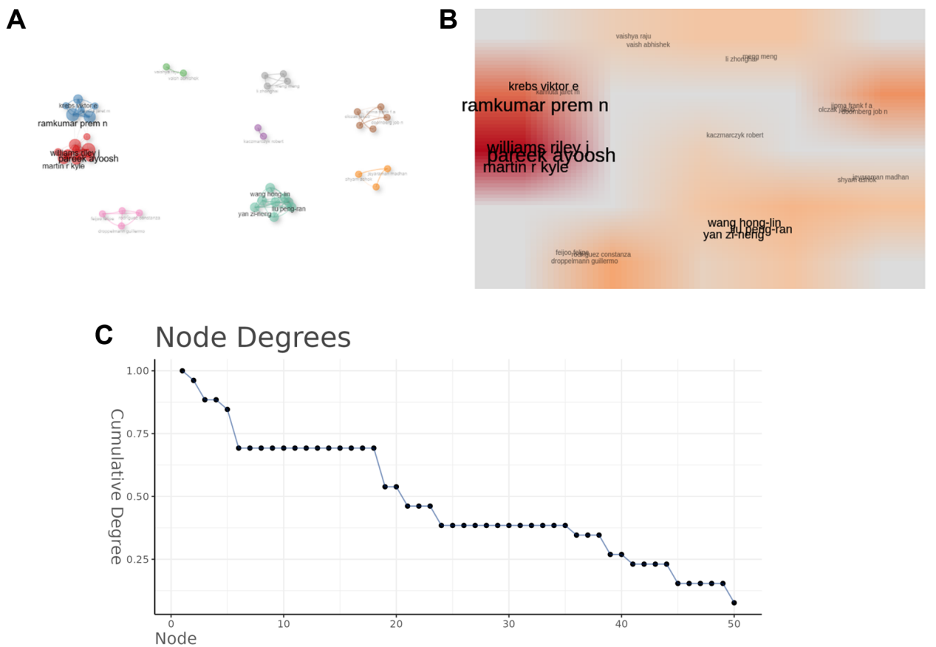
Supplementary Fig. S17 The collaborative network of literature in the interdisciplinary field of AI and orthopedics from January 2010 to December 2024 is analyzed based on joint research and publication activities among authors, institutions, or countries. Ramkumar P.N. stood out as the most influential researcher (A), and other researchers, such as Pareek ayoosh and Martin r kyle, also occupied significant positions in the network (B). Authors like Ramkumar P.N. and Pareek ayoosh were prominently highlighted in this visualization due to their high degree values (C).

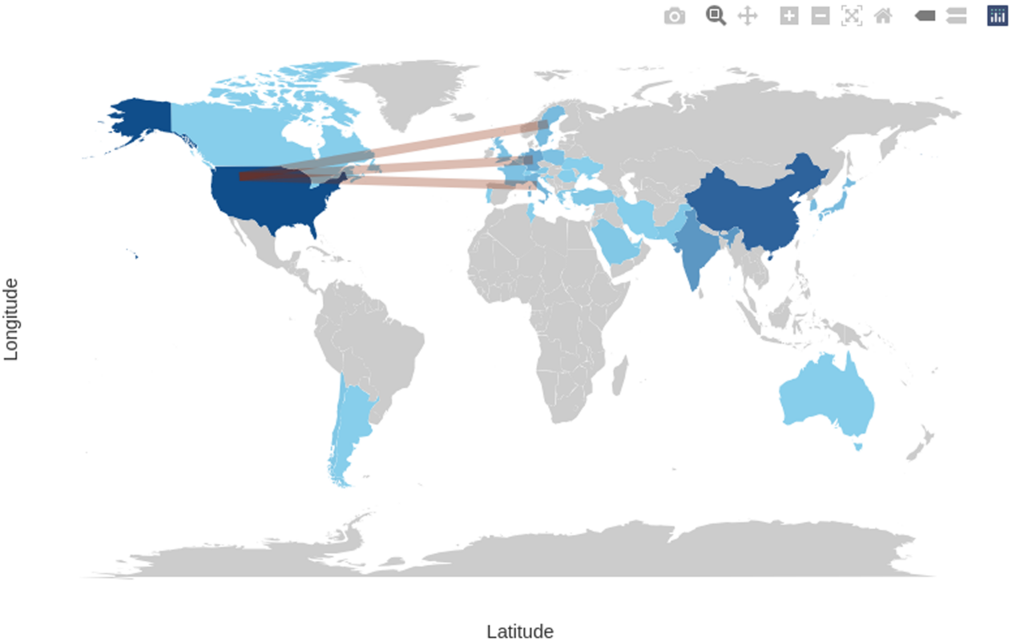
Supplementary Fig. S18 World Map of International Collaborations in the Intersection of AI and Orthopedics from January 2010 to December 2024.

