Supplementary materials
Biomimetic aggregation-induced emission luminogens mediated effective phototherapy and immune checkpoint blockade for the synergistic treatment of lung cancer
Authors: Langyu Yang ^{1, 2,} *, Minyan Wei ^{1, 2,} *, Xiaohua Deng ^{1, 2,} *, Linlong He ^{1, 2}, Yinshan Lin ^{1, 2}, Xufeng Lin ², Dazhi Zhou ², Ming Li ³, Aiping Qin ^{1, 2}, Lingmin Zhang ^{1, 2}, Zizhang Ouyang¹
Affiliations:
¹ The Affiliated Qingyuan Hospital (Qingyuan People's Hospital), Guangzhou Medical University, Qingyuan 511518, Guangdong, China
² The Affiliated Panyu Central Hospital, The Fifth Affiliated Hospital, Guangzhou Municipal and Guangdong Provincial Key Laboratory of Molecular Target & Clinical Pharmacology, the NMPA and State Key Laboratory of Respiratory Disease, AIE Pharmaceutical Biology Innovation Research Center, School of Pharmaceutical Sciences, Guangzhou Medical University, Guangzhou 511436, China
³ Medical Research Center, The Affiliated Guangdong Second Provincial General Hospital of Jinan University, Jinan University, Guangzhou, Guangdong, 510317,
China
* The authors contributed to the work equally.
E-mail: zhanglm@gzhmu.edu.cn (Lingmin Zhang); 2019695272@gzhmu.edu.cn (Zizhang Ouyang)

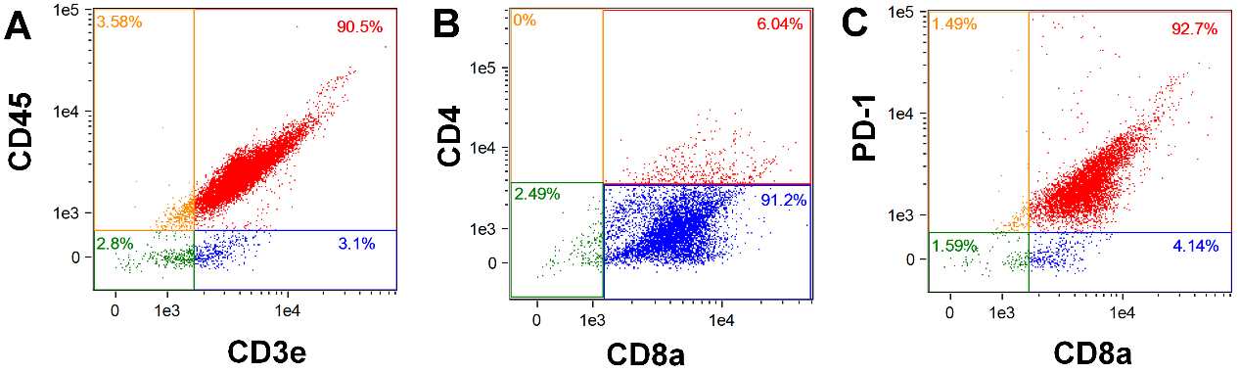
Figure S1 FACS analysis of the markers in different cells. (A) T cells. (B) CD8⁺ T cells. (C) CD8⁺ T cells overexpressed with PD-1. Flow cytometric plots to show the expression of CD4, CD8, PD-1, CD45, and CD3 on T cells harvested from mice.

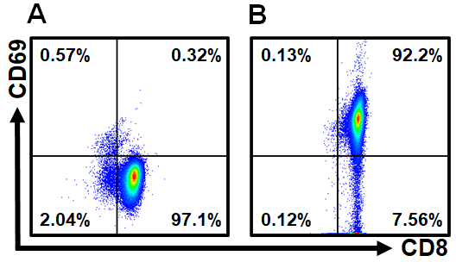
Figure S2 FACS analysis of the markers in CD8⁺ T cells. A) Wild type CD8⁺ T cells. B) PD-1 activated cells.

Figure S3 Photodynamic properties of different TB nanoparticles in solution detected by single-linear oxygen SOSG probe.

Figure S4 The infrared thermal imager observed the temperature changes of different components of BITT in the solution. The white arrow represents the location of the sample.

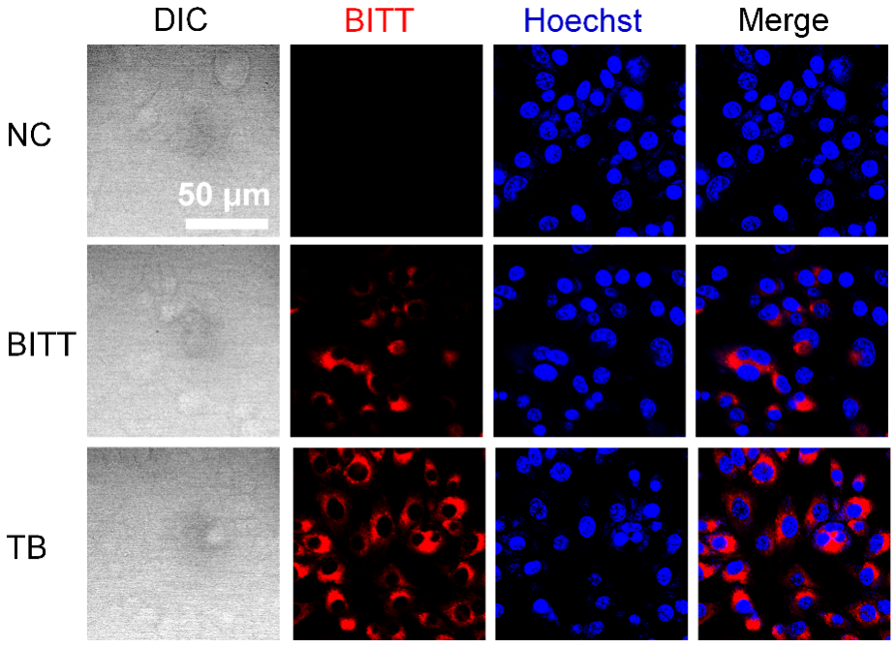
Figure S5 CLSM analysis of LLC cells treated with BITT-based nanoparticles for 9 h. Cell nuclei were stained with Hoechst (blue).

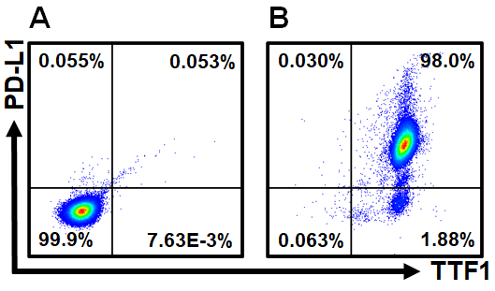
Figure S6 FACS analysis of the markers in LLC cells. (A) LLC cells without staining. (B) LLC cells labeled with PD-L1 and TTF1.

Figure S7 CLSM observed the effect of BMS-1 on the uptake of different BITT components by LLC cells.

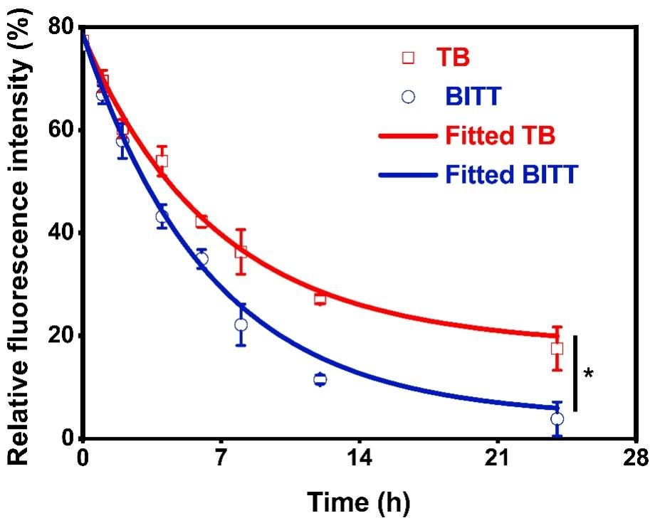
Figure S8 Pharmacokinetics of TB and BITT (BITT: 1 mg/kg) on LLC tumor-bearing mice after intravenous injection. * P<0.05.

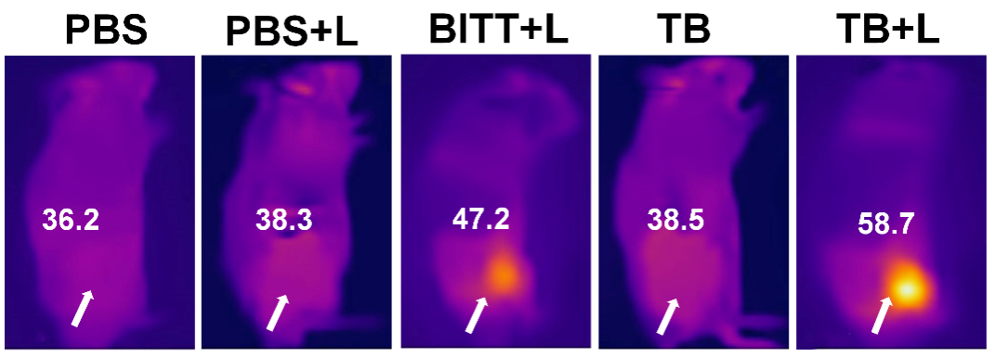
Figure S9 Thermal imaging on the tumor-bearing mice. The tumor-bearing mice were administrated with PBS, BITT, and TB (1 mg/kg BITT) via the intravenous injections, respectively. At 12 h after administration, the tumor sites were exposed to a laser irradiation (658 nm, 2 W∙cm⁻²) for 10 min. The white arrow represented the tumor site.

