Supplementary Material
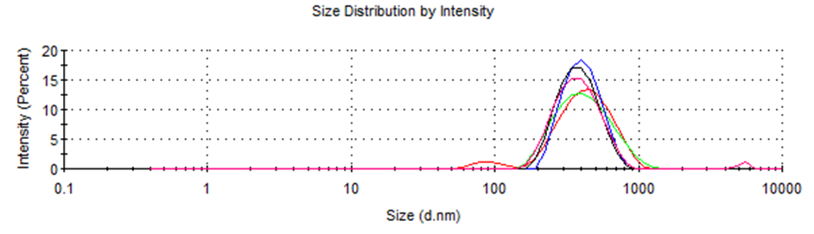
Supplementary Figure 1 Zetasizer dynamic light scattering (DLS) size measurement of KM encapsulated Pea Protein Nanoparticles by Berry Extract crosslinking (KM-PP-BE-NP)

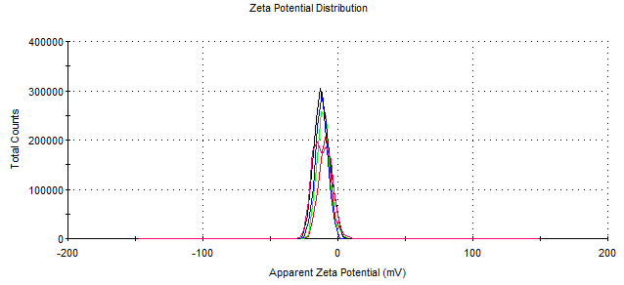
Supplementary Figure 2 Zetasizer dynamic light scattering (DLS) zeta potential (ZP) measurement of KM encapsulated Pea Protein Nanoparticles by Berry Extract crosslinking (KM-PP-BE-NP).

Stability study
The stability of KM encapsulated pea protein nanoparticles was monitored over a ~six-month period by measuring the hydrodynamic size and zeta potential of the nanoparticles. 600 mg/L of sodium benzoate and 350 mg/L of potassium sorbate, food grade preservatives were also added to the nano-formulations to extend shelf-life. The nanoparticles were refrigerated (5°C ± 3°C) in glass or plastic containers with a tight seal. Negligible change in size and zeta potential confirmed the stability of nanoparticles for long term storage. In the present study, stability of KM-encapsulated pea protein nanoparticles was assessed over a ~six-month period using both dynamic light scattering (DLS) measurements and gas chromatography–mass spectrometry (GC-MS). This enabled evaluation of temporal consistency in hydrodynamic size, zeta potential, and KM content throughout storage. The DLS size and ZP measurements over a ~six-month period for KM encapsulated Pea Protein Nanoparticles by Berry Extract crosslinking (KM-PP-BE-NP) is shown in Supplementary Table 1.

Supplementary Table 1 Stability study of KM encapsulated Pea Protein Nanoparticles Berry Extract crosslinking (KM-PP-BE-NP) by monitoring size and zeta potential (ZP).
Serial No. | Time  point | DLS Size (nm) | PDI | ZP (mV)
1 | 0 | 358 | 0.2 | -12
2 | 1 week | 301 | 0.2 | -13
3 | 2 weeks | 306 | 0.2 | -13
4 | 1 month | 372 | 0.2 | -8
5 | ~2 months | 314 | 0.2 | -14
6 | ~3 months | 307 | 0.2 | -13
7 | 8 months | 334 | 0,2 | -13

Gas chromatography–mass spectrometry (GC-MS) procedure: The neat Ketone Molecule (KM) was diluted 1,000 times by adding 1000 µL of pyridine. 200 μL of this solution was derivatized with 200 μL BSTFA [N,O-bis(trimethylsilyl)trifluoroacetamide] + 1% TMCS (chlorotrimethylsilane) reagent by incubating at 50 ℃ for an hour. The derivatized samples were then analyzed using a ThermoTRACE 1300 Gas Chromatograph coupled to a Thermo Trace GC/GCQ mass spectrometer with a scan range from 50 to 500 m/z (Thermo Scientific, Inc., Waltham, MA, USA). 1 μL of sample was injected into the GC column with a 35 min run time. Separation was achieved with a temperature program of 40 ℃ as the starting point, then ramped up to 10 ℃/min to 280 ℃ and held at 280 ℃ for 10 min, on a 30 m TG-5SILMS column (Thermo Scientific, 0.25 mm ID, 0.25 um file thickness) and a constant flow of 1 ml/min of helium gas. Using neat KM a calibration curve was generated to quantify KM in the nanoparticles and monitor changes during the stability study. For nanoparticle GC-MS sample preparation, 100 µL of the KM encapsulated Pea Protein Nanoparticles by Berry Extract crosslinking (KM-PP-BE-NP) was dried under nitrogen gas (to remove solvent) and mixed with 100 µL of pyridine. Then 1 μL of sample was injected into the GC column for KM quantification. There was negligible change in the amount of KM measured (~250 mg/ml) at the end of the study in comparison to the beginning, confirming the stability of nanoparticles for long term storage.

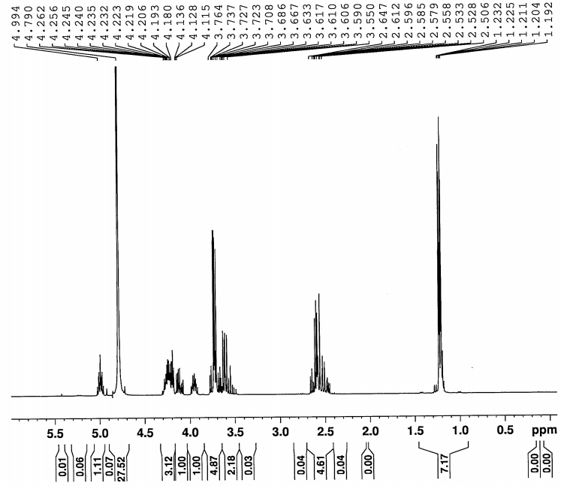
Supplementary Figure 3 ¹H NMR of Ketone Molecule (KM) in D₂O.

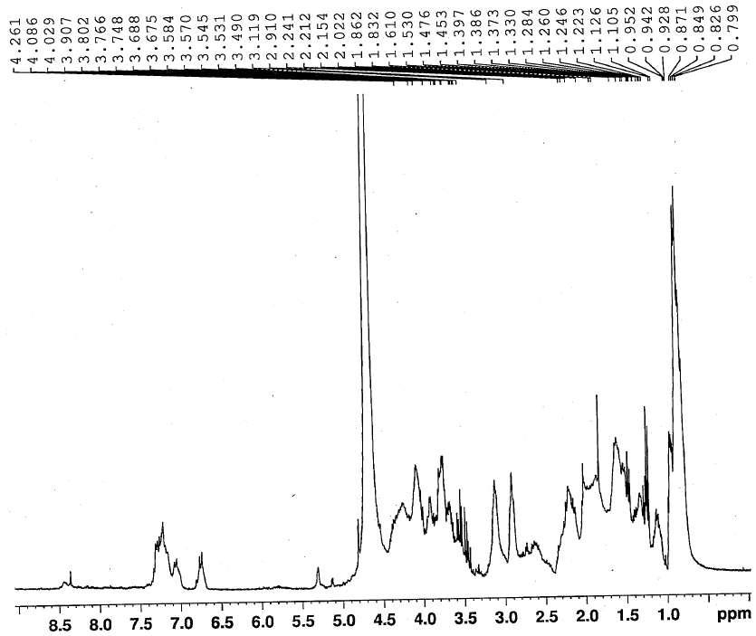
Supplementary Figure 4 ¹H NMR of water soluble Pea Protein (PP) in D₂O.

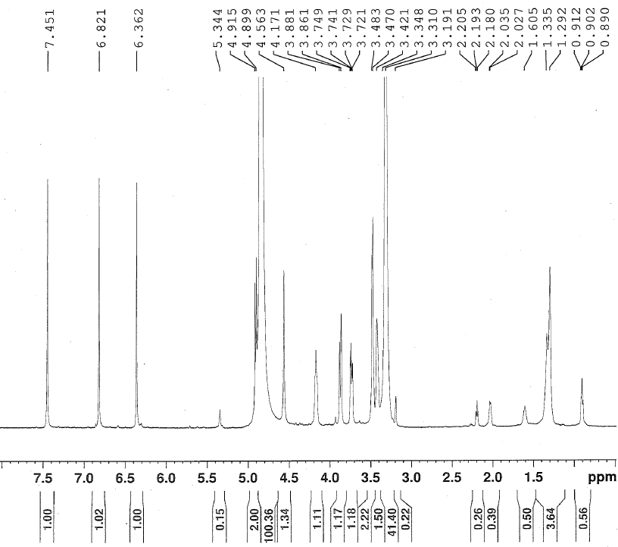
Supplementary Figure 5 ¹H NMR of mangiferin in CD₃OD.

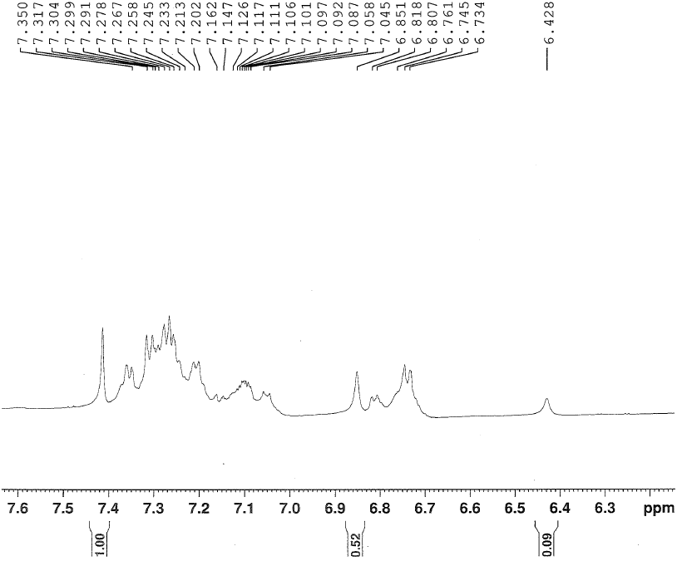
Supplementary Figure 6 ¹H NMR (expanded) of mangiferin and water soluble Pea Protein (PP) reaction mixture in CD₃OD/D₂O (arrows indicate change in the mangiferin protons).

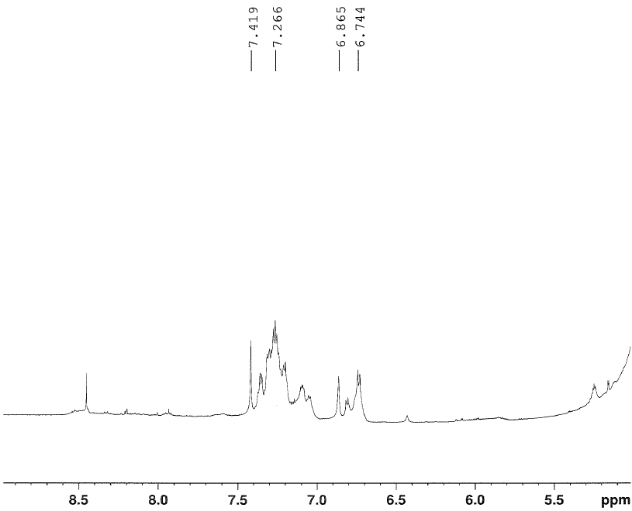
Supplementary Figure 7 ¹H NMR (expanded) of mangiferin, water soluble Pea Protein (PP) and KM reaction mixture in CD₃OD/D₂O.

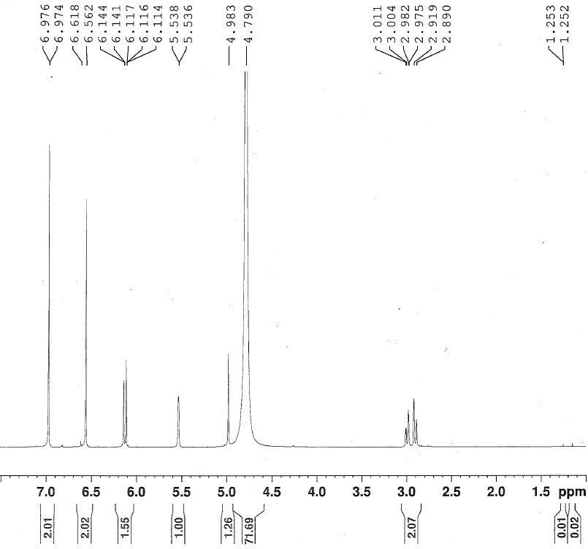
Supplementary Figure 8 ¹H NMR of epigallocatechin gallate (EGCG) in D₂O.

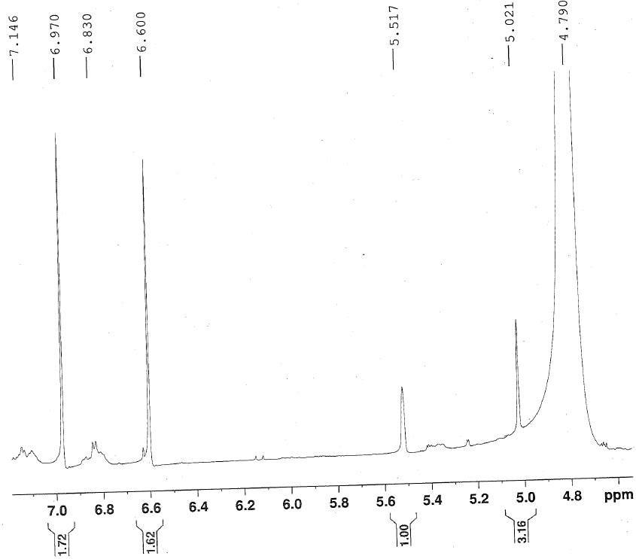
Supplementary Figure 9 ¹H NMR (expanded) of epigallocatechin gallate (EGCG) and water soluble Pea Protein (PP) reaction mixture in D₂O (arrow indicate change in EGCG proton).

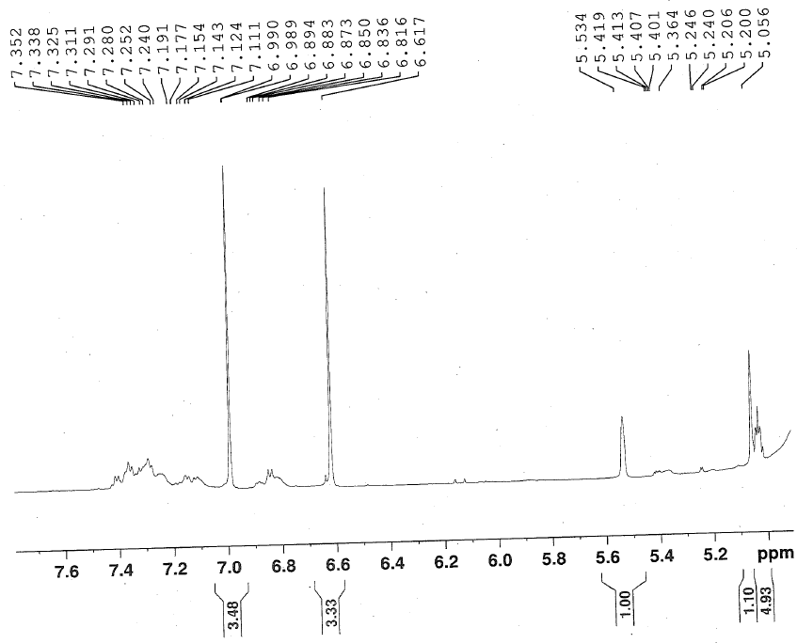
Supplementary Figure 10 ¹H NMR (expanded) of epigallocatechin gallate (EGCG), water soluble Pea Protein (PP) and KM reaction mixture in D₂O.

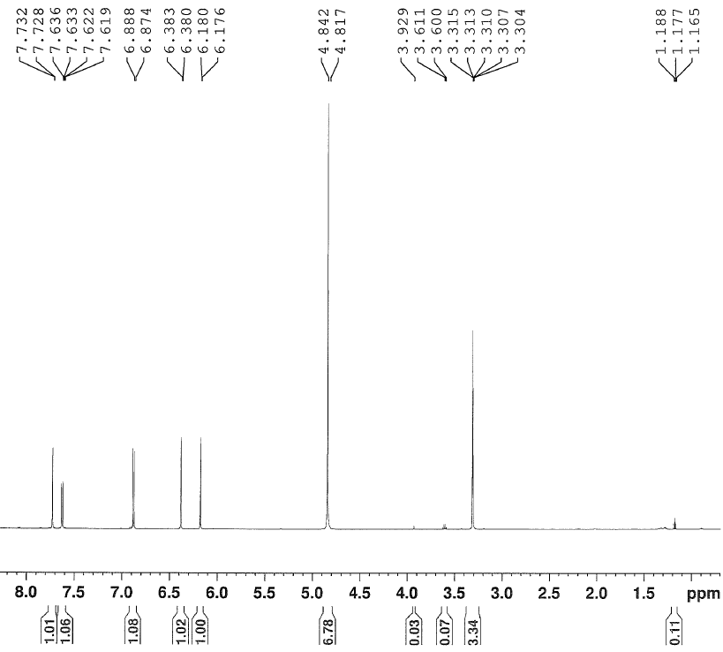
Supplementary Figure 11 ¹H NMR of quercetin in CD₃OD.

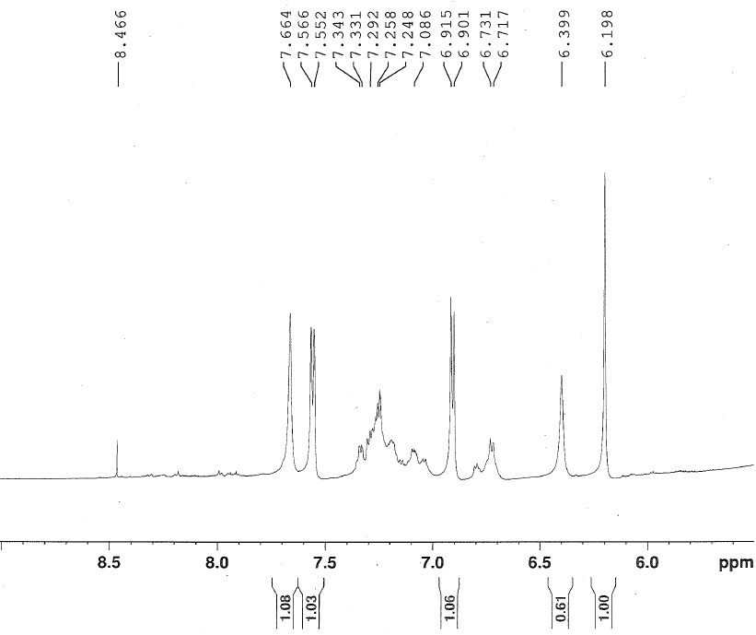
Supplementary Figure 12 ¹H NMR (expanded) of quercetin and water soluble Pea Protein (PP) reaction mixture in CD₃OD/D₂O (arrow indicate change in quercetin proton).

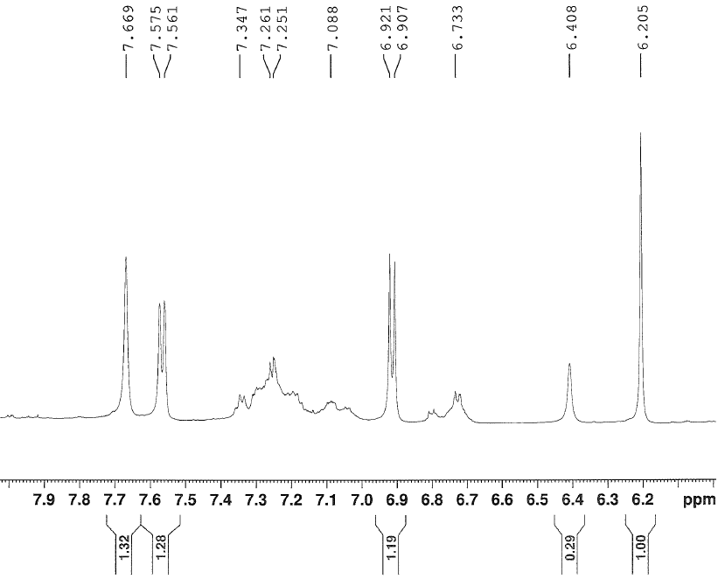
Supplementary Figure 13 ¹H NMR (expanded) of quercetin, water soluble Pea Protein (PP) and KM reaction mixture in CD₃OD/D₂O.

Supplementary Figure 14 Keonte Molecule (KM) hydrogen bonding with protein and phytochemical.

