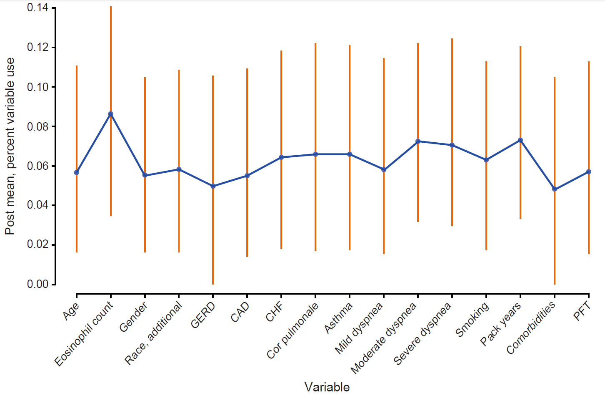

Supplementary Figure 1 Frequency of variable selection in a BART prediction model.

The frequency by which the BART algorithm is split on each variable is shown in the classification trees as a percentage.
BART, Bayesian Additive Regression Trees; CAD, coronary artery disease; CHF, congestive heart failure; GERD, gastroesophageal reflux disease; PFT, pulmonary function test.

