On-line Supplementary Materials
Title: Effect of Ciprofol on postoperative cognitive function in patients undergoing cardiac surgery with cardiopulmonary
bypass: A prospective, randomized, controlled trial.

Contents | Page
- Definition of intraoperative and postoperative complications. | 2
- The detail approach of multiple-imputation. | 4
- Supplementary Table S1. Intraoperative Data. | 5
- Supplementary Figure S1. The intraoperative sedative anesthesia induction and maintenance regimens for the two groups of patients. | 8
- Supplementary Figure S2. The occurrence of POD, relative risk and P-value for interaction in different subgroups. | 9

Definition of intraoperative and postoperative complications
1. Severe haemodynamic instability
During non cardiopulmonary bypass (CPB) mean arterial pressure (MAP) remains below 60 mmHg despite high-dose inotropic and vasoconstrictor support (inotrope score >10), or hemodynamic instability necessitating extracorporeal membrane oxygenation (ECMO) support.
2. Malignant arrhythmia
During non-CPB ventricular fibrillation (VF), sustained ventricular tachycardia (VT), torsades de pointes (Tdp), pulseless electrical activity (PEA), asystole, or other malignant arrhythmias causing significant hemodynamic compromise occurring during the off-pump period.
3. Postoperative pneumonia: meets the following criteria:
1) Sputum culture positive.
2) Respiratory infection. Patient has received antibiotics for a suspected respiratory infection and met one or more of the following criteria: new or changed sputum, new or changed lung opacities, fever, white blood cell count > 12×10⁹/L.
4. Postoperative pleural effusion
Chest radiograph demonstrating blunting of the costophrenic angle, loss of sharp silhouette of the ipsilateral hemidiaphragm in upright position, evidence of displacement of adjacent anatomical structures or (in supine position) a hazy opacity in one hemithorax with preserved vascular shadows.
5. Postoperative acute kidney injury (AKI): Defined using the creatinine component of the kidney disease: Improving Global Outcomes (KDIGO) criteria. Meets any of the following:
1) Increase in serum creatinine by ≥ 0.3 mg/dl (≥ 26.5 µmol/l) within 48 hours.
2) Increase in serum creatinine to ≥ 1.5 times baseline, which is known or presumed to have occurred within the prior 7 days.
3) Urine volume < 0.5 ml/kg/h for 6 hours.

The detail approach of multiple-imputation.
At 1 month postoperatively, a total of 5 patients (5/129, 3.88%) across both groups had missing T-MoCA assessment data, with 2 cases in the ciprofol group (2/64, 3.13%) and 3 cases in the propofol group (3/65, 4.62%). At 3 months postoperatively, 10 patients (10/129, 7.75%) had missing T-MoCA data, including 4 in the ciprofol group (4/64, 6.25%) and 6 in the propofol group (6/65, 9.23%).
Multiple imputation was performed for missing data using SPSS 27.0. Covariates incorporated into the imputation model included group allocation, age, sex, educational level, and preoperative MMSE score. A total of 20 imputed datasets were generated through 20 iterations of imputation for T-MoCA scores. The T-MoCA scores were then dichotomized into presence or absence of POCD (defined as POCD if T-MoCA score < 18). Chi-square tests were conducted to compare the incidence of POCD between the two groups in each imputed dataset, and the results of these tests were aggregated for final analysis.

Supplementary Table S1. Intraoperative data.
Characteristics | Total  (n = 129) | Group C  (n = 64) | Group P  (n = 65) | P value
Type of surgery, n (%) |  |  |  | 0.453
Valve | 97 (75.19) | 52 (81.25) | 45 (69.23)
CABG | 19 (14.73) | 7 (10.94) | 12 (18.46)
Valve + CABG | 7 (5.43) | 3 (4.69) | 4 (6.15)
Other | 6 (4.65) | 2 (3.13) | 4 (6.15)
CPB duration, min, median (IQR) | 131.00 (101.00, 180.00) | 127.00 (96.50, 168.75) | 144.00 (102.50, 186.50) | 0.364
CPB duration, n (%) |  |  |  | 0.801
< 2h | 53 (41.09) | 27 (57.81) | 26 (40.00)
≥ 2h | 76 (58.91) | 37 (57.81) | 39 (60.00)
Operation duration, min, median (IQR) | 270.00 (235.00, 325.00) | 265.00 (226.00, 318.75) | 290.00 (235.00, 330.00) | 0.242
Operation duration, n (%) |  |  |  | 0.517
< 4h | 35 (27.13) | 19 (70.31) | 16 (24.62)
≥ 4h | 94 (72.87) | 45 (70.31) | 49 (75.38)
Crystal solution, ml, median (IQR) | 2093.00 (1593.50, 2459.50) | 2144.50 (1746.00, 2494.50) | 1955.00 (1523.00, 2405.00) | 0.116
Autologous blood, ml, median (IQR) | 900.00 (700.00, 1000.00) | 900.00 (725.00, 1075.00) | 900.00 (700.00, 1000.00) | 0.575
Bleeding volume, ml, median (IQR) | 500.00 (400.00, 500.00) | 500.00 (400.00, 500.00) | 500.00 (450.00, 500.00) | 0.524
Urine volume, ml, median (IQR) | 1500.00 (1000.00, 2000.00) | 1500.00 (1200.00, 2000.00) | 1500.00 (950.00, 2000.00) | 0.520
Red cells suspension, n (%) | 15 (11.63) | 11 (17.19) | 4 (6.15) | 0.093
Plasma, n (%) | 34 (26.36) | 18 (28.13) | 16 (24.62) | 0.651
Platelet concentrate, n (%) | 12 (9.30) | 5 (7.81) | 7 (10.77) | 0.783
Cryoprecipitate, n (%) | 14 (10.85) | 7 (10.94) | 7 (10.77) | 0.975
Dosage of perioperative anaesthetic
drugs
Ciprofol/Propofol, mL, median (IQR) | 141.30 (115.22, 172.10) | 141.00 (118.20, 166.43) | 142.80 (121.23, 182.50) | 0.343
Midazolam, mg, median (IQR) | 7.00 (5.00, 9.00) | 7.50 (5.00, 9.00) | 7.00 (5.00, 9.50) | 0.962
Sufentanil, ug, median (IQR) | 412.50 (358.13, 479.38) | 401.88 (352.50, 464.69) | 422.50 (362.50, 490.00) | 0.414
Rocuronium, mg, median (IQR) | 80.00 (50.00, 100.00) | 80.00 (50.00, 100.00) | 80.00 (50.00, 100.00) | 0.796
Dexmedetomidine, ug, median (IQR) | 25.50 (20.63, 31.45) | 24.5.00 (20.56, 30.75) | 26.50 (20.42, 32.25) | 0.381
Drugs related to coagulation function
Heparin, mg, median (IQR) | 200.50 (170.00, 250.00) | 200.00 (162,50, 250.00) | 200.00 (175.00, 250.00) | 0.616
Protamine, mg, median (IQR) | 380.00 (320.00, 405.00) | 380.00 (330.00, 400.00) | 360.00 (320.00, 415.00) | 0.802
Dosage of cardiovascularactive drugs
Dopamine, mg, median (IQR) | 52.50 (27.30, 77.14) | 47.14 (24.97, 64.94) | 63.65 (29.17, 86.10) | 0.089
Dobutamine, mg, median (IQR) | 52.50 (20.97, 77.14) | 47.14 (21.97, 65.89) | 63.65 (19.53, 86.10) | 0.194
Adrenaline, mg, median (IQR) | 0.02 (0.00, 0.22) | 0.02 (0.00, 0.22) | 0.02 (0.01, 0.25) | 0.403
Norepinephrine, mg, median (IQR) | 0.00 (0.00, 0.20) | 0.00 (0.00, 0.21) | 0.00 (0.00, 0.12) | 0.434
Aramine, mg, median (IQR) | 0.00 (0.00, 0.30) | 0.05 (0.00, 0.30) | 0.00 (0.00, 0.30) | 0.152
Total number of additions of cardiovascularactive drugs ª,
time, median (IQR)
Positive b | 2 (1, 3) | 2 (1, 3) | 2 (1, 3) | 0.336
Negative c | 2 (1, 4) | 0 (0, 1) | 0 (0, 0) | 0.396
Notes: Data presented as n (%) or median (quartile 1, quartile 3), unless otherwise indicated.
ª Total number of additions of cardiovascularactive drugs indicates the total number of single additions of cardiovascular active drugs during non-cardiopulmonary bypass.
^{b} Positive cardiovascularactive drugs indicate Atropine, Ephedrine, Aramine, Isprenaline and Adrenaline.
^{c} Negative cardiovascularactive drug indicates Esmolol.
Abbreviations: CABG, Coronary artery bypass graft surgery; CPB, Cardiopulmonary bypass; IQR, Inter quartile range; COPD, Chronic Obstructive Pulmonary Disease.

Supplementary Figure S1. The intraoperative sedative anesthesia induction and maintenance regimens for the two groups of patients.

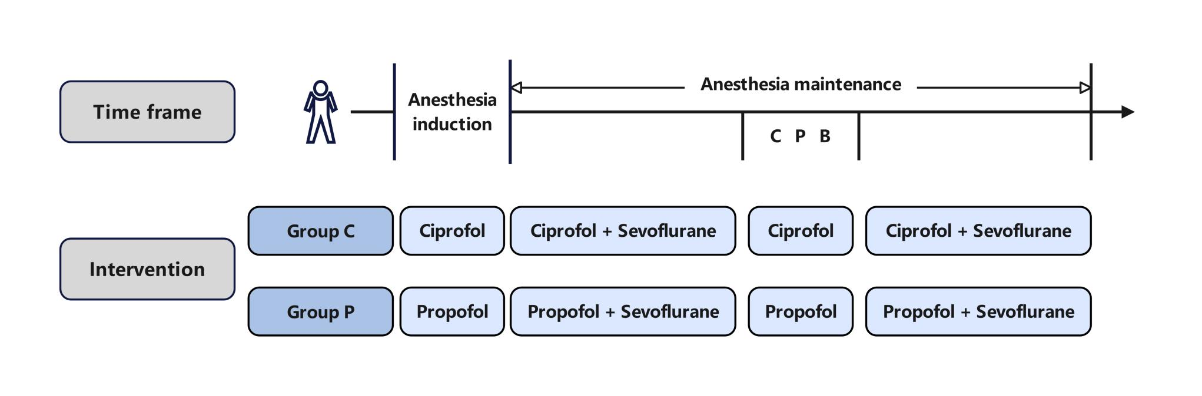
Abbreviations: CPB, Cardiopulmonary bypass.

Supplementary Figure S2. The occurrence of POD, relative risk and P-value for interaction in different subgroups.

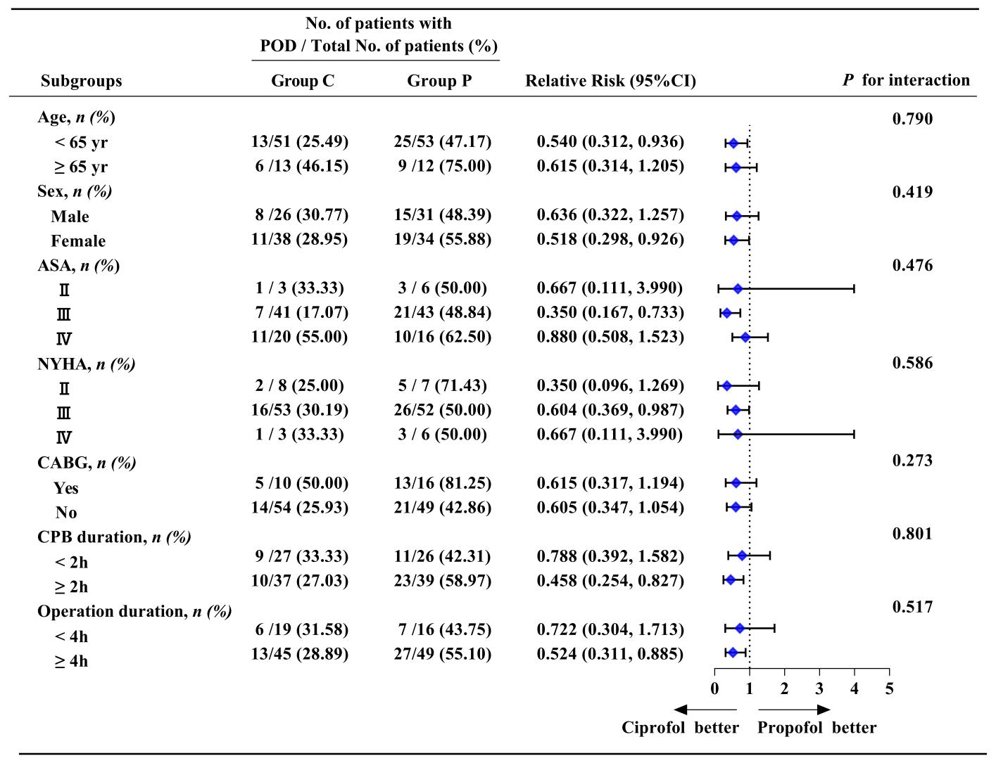
Abbreviations: POD, Postoperative delirium; ASA, American society anesthesiologists; NYHA, New York Heart Association Classiﬁcation; CABG, coronary artery bypass grafting; CPB, Cardiopulmonary bypass; CI, Cofident interval; P, P-value.

