Figure S1 Four integrated cohorts were created from 14 UC GEO datasets. (a, c, e, g) Samples from the different cohorts were distinctly separated before batch effect removal, whereas after batch effect removal and merging into Merge1-Cohort (b), Merge2-Cohort (d), Merge3-Cohort (f), and Merge4-Cohort (h), they were clearly mixed together.

Figure S2 The differences in the content of various immune cells between the control and UC. (a)EPIC algorithm. (b) MCPcounter algorithm. (c) ssGSEA algorithm. (d) CIBERSORT algorithm. (e) xCell algorithm. * indicates P < 0.05, ** indicates P < 0.01, *** indicates P < 0.001, and ns indicates no significance.

Figure S3 The differences in the content of various immune cells between cluster 1 and cluster 2. (a)EPIC algorithm. (b) MCPcounter algorithm. (c) ssGSEA algorithm. (d) CIBERSORT algorithm. (e) xCell algorithm. * indicates P < 0.05, ** indicates P < 0.01, *** indicates P < 0.001, and ns indicates no significance.

Table S1 The specific information of the 16 GEO cohorts included in this study.
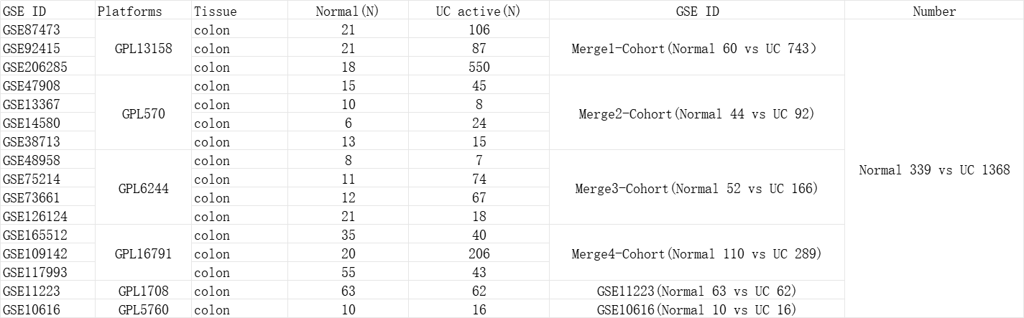

Table S2 The number and names of genes comprising the 13 cell death types.
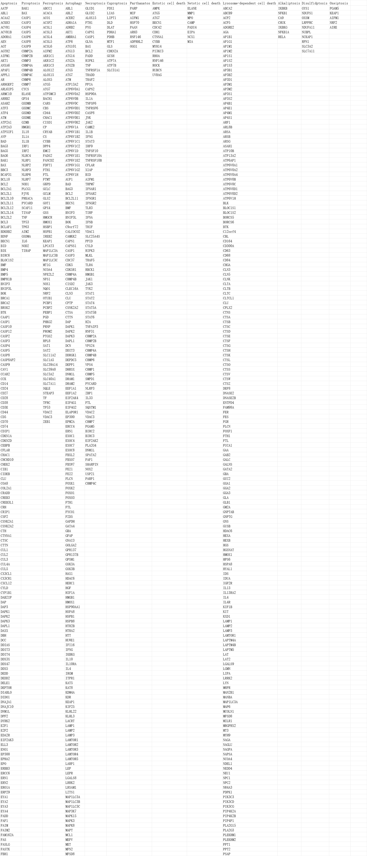

Table S3 Primer information for the seven genes involved in this study.
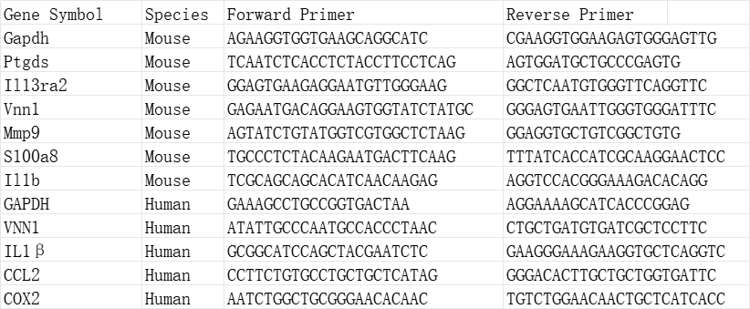

Table S4 Binding sites of mesalazine to six key cell death-related proteins. ΔGb(kcal/mol) represents the change in binding Gibbs free energy, measured in kilocalories per mole.
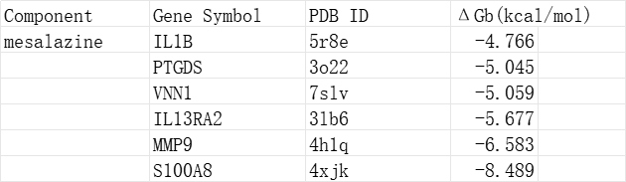

Table S5 Statistical information of PCR results of six key genes. △CT refers to the difference in CT values between the target gene and the reference gene. △△CT refers to the difference in △CT values between different treatment conditions. The formula 2^(-△△CT) is used to calculate the relative expression level (fold change) of the target gene.

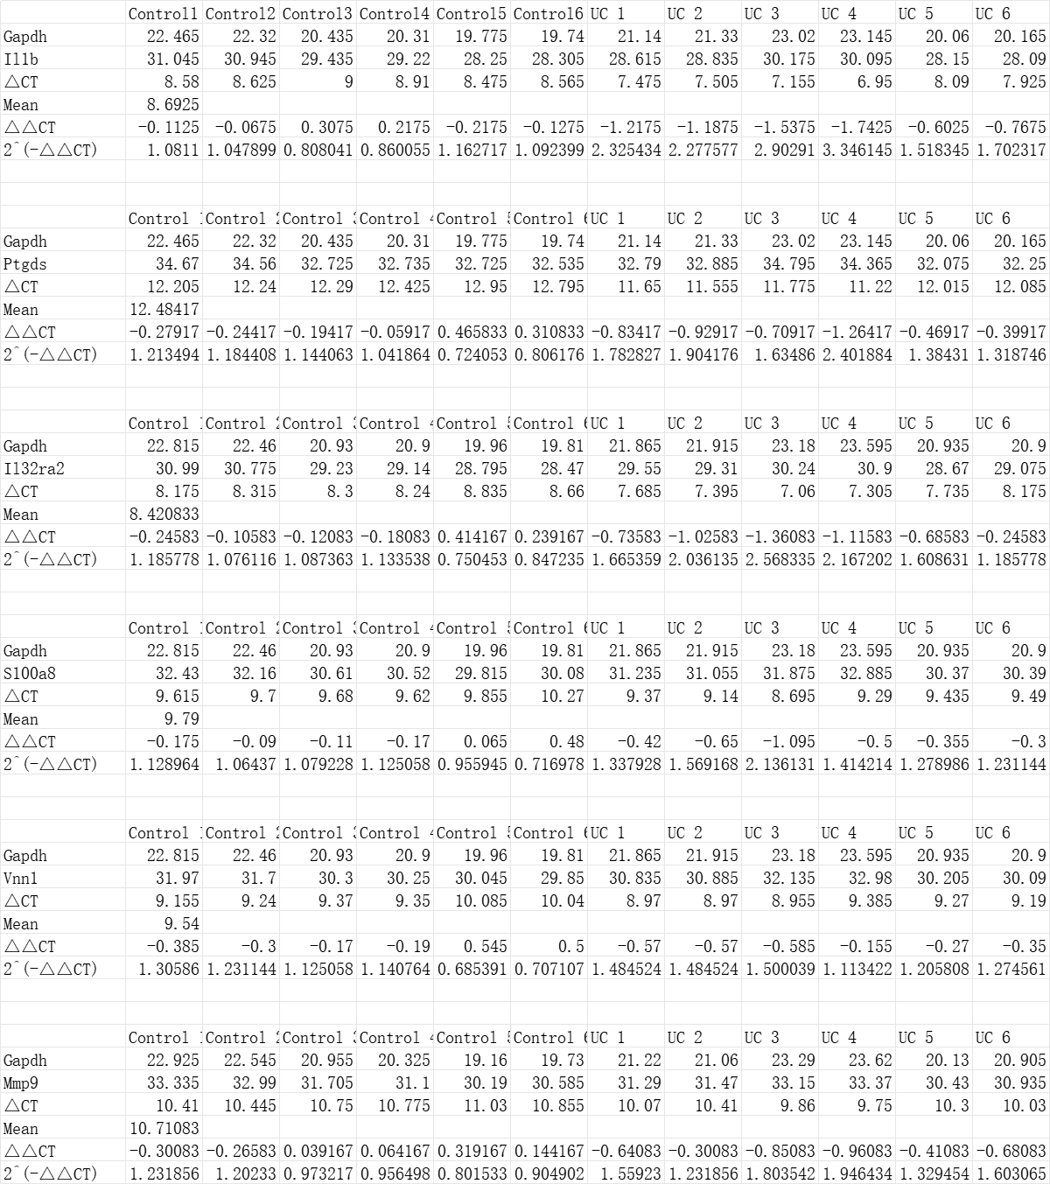

Table S6 PCR analysis of VNN1 knockdown efficiency. △CT refers to the difference in CT values between the target gene and the reference gene. △△CT refers to the difference in △CT values between different treatment conditions. The formula 2^(-△△CT) is used to calculate the relative expression level (fold change) of the target gene.
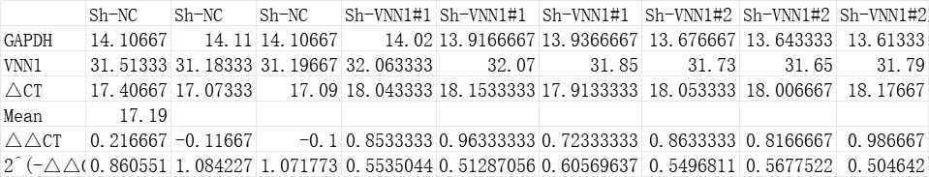

Table S7 PCR analysis of CCL2, COX2, and IL1B expression followingVNN1 knockdown. △CT refers to the difference in CT values between the target gene and the reference gene. △△CT refers to the difference in △CT values between different treatment conditions. The formula 2^(-△△CT) is used to calculate the relative expression level (fold change) of the target gene.
