Supporting information
FigureS1 Synergistic effects of enrofloxacin and colistin.
Figure S2 Bactericidal curves of single and compound combinations of enrofloxacin and colistin (Klebsiella pneumoniae WNX-1).
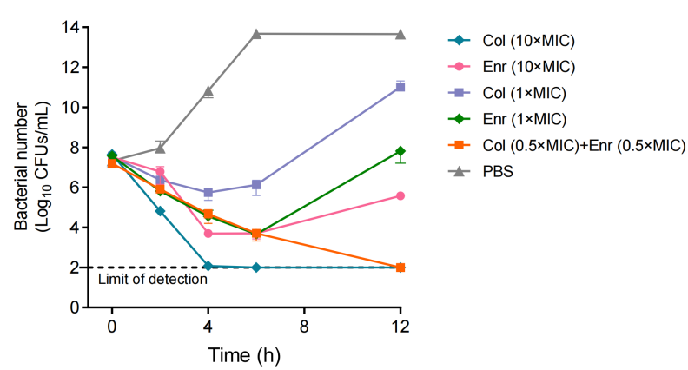
Figure S3 HPLC spectrum of enrofloxacin (A) and colistin (B).
HPLC method for the determination of colistin as below. The chromatographic separation was performed on a Waters XBridge Peptide BEH C18 column (300 Å, 5 µm, 4.6 mm × 250 mm) at 28°C. The mobile phase (78:22, v/v) comprised aqueous phase A (pH 3.0; 7.1 g sodium sulfite, 1.1 mL phosphoric acid, 2.3 mL acetic acid, 4.0 mL triethylamine in 1 L water) and acetonitrile (phase B), delivered isocratically at 1.0 mL/min. Colistin quantification utilized UV detection (206 nm) with 20 μL injections, validated for linearity (200–6000 ppm). Samples were diluted in mobile phase.

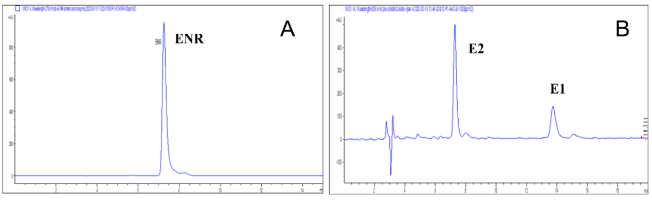

Table S1 UV-Vis Spectroscopy Conditions
Parameter | Condition
Solvent for enrofloxacin | Water
Solvent for enrofloxacin sodium | 40% 1,2-Propanediol
Final concentration | 10 μg/mL
Volume per well | 200 μL
Plate type | 96-well quartz plate
Wavelength range | 230–800 nm

Table S2 ¹H NMR Spectroscopy Parameters
Parameter | Setting
Instrument | JNM-ECZ400S NMR system (JEOL, Japan)
Temperature | 20 °C
Acquisition time | 2.1863 s
Relaxation delay | 5.0000 s
Number of scans | 8
Receiver gain | 26.0
Pulse width | 3.1250 μs
Spectral width | 5995.2 Hz
Minimum frequency | 998.6 Hz

Table S3 Computational Chemistry Parameters
Step / Method | Details
Conformation Search | Molclus + MOPAC v22.0.4, PM6-DH+ method
Geometry Optimization and Frequency Analysis | Gaussian 09, B3LYP-D3BJ, 6-31G* basis set
Binding Energy Calculations | Gaussian 09, M06-2X functional, ma-def2-TZVP basis set
Weak Interaction Analysis | IGMH analysis with Multiwfn 3.8
Visualization | VMD software

Table S4 Fractional inhibitory concentration index (FICI) of enrofloxacin and colistin.
Strains | MIC of ENR (µg/mL) |  | MIC of Col (µg/mL)
Strains | Alone | Combination | Alone | Combination | FICI
Klebsiella pneumoniae
WNX-1 | 256 | 16 | 1 | 0.06 | 0.1225
37-1 | 128 | 8 | 1 | 0.25 | 0.3125
29-1 | 128 | 8 | 2 | 0.25 | 0.1875
25-2 | 128 | 8 | 2 | 0.25 | 0.1875
Escherichia coli
OF B2 D19 | 1024 | 128 | 4 | 0.25 | 0.1875
OF 25922 D38 | 256 | 16 | 4 | 0.5 | 0.1875
Actinobacillus pleuropneumoniae
Hang 8 | 0.015 | 0.0009 | 1 | 0.5 | 0.56
Staphylococcus aureus
T144 | 4 | 2 | 512 | 128 | 0.75
Salmonella
80048 | 256 | 32 | 1 | 0.06 | 0.185
Pasteurella multocida
P32 D7 | 32 | 4 | 1 | 0.25 | 0.375

Table S5 Crystallization in accelerated stability test at 4℃
Group | 0d | 30d | 60d | 90d | 180d
1 | － | ＋＋ | ＋＋ | ＋＋＋ | ＋＋＋
2 | － | － | ＋ | ＋＋ | ＋＋＋
3 | － | ＋＋ | ＋＋＋ | ＋＋＋ | ＋＋＋
4 | － | ＋＋ | ＋＋ | ＋＋ | ＋＋＋
5 | － | － | － | ＋＋ | ＋＋＋
6 | － | － | － | － | －
7 | － | － | ＋ | ＋ | ＋＋
8 | － | － | ＋ | ＋ | ＋＋＋
9 | － | － | ＋ | ＋ | ＋＋
−: No crystal precipitation observed; +: Minor crystal precipitation; ++: Moderate crystal precipitation; +++: Significant crystal precipitation.

Table S6 content of colistin and enroxacin
Storage conditions |  | Content to labeling ratio
Time (month) | Temperature (℃) | E2 (IU/mL) | E1 (IU/mL) | ENR (μg/mL)
10 | 30 | 218355.97 ± 7481.75 (87.34%) | 225355.5 ± 118066.9 (90.14%) | 26.65 ± 1.72 (106.60%)
10 | 4 | 248544.61 ± 9102.77 (99.42%) | 241250.93 ± 1477.81 (96.50%) | 26.08 ± 0.63 (104.32%)

