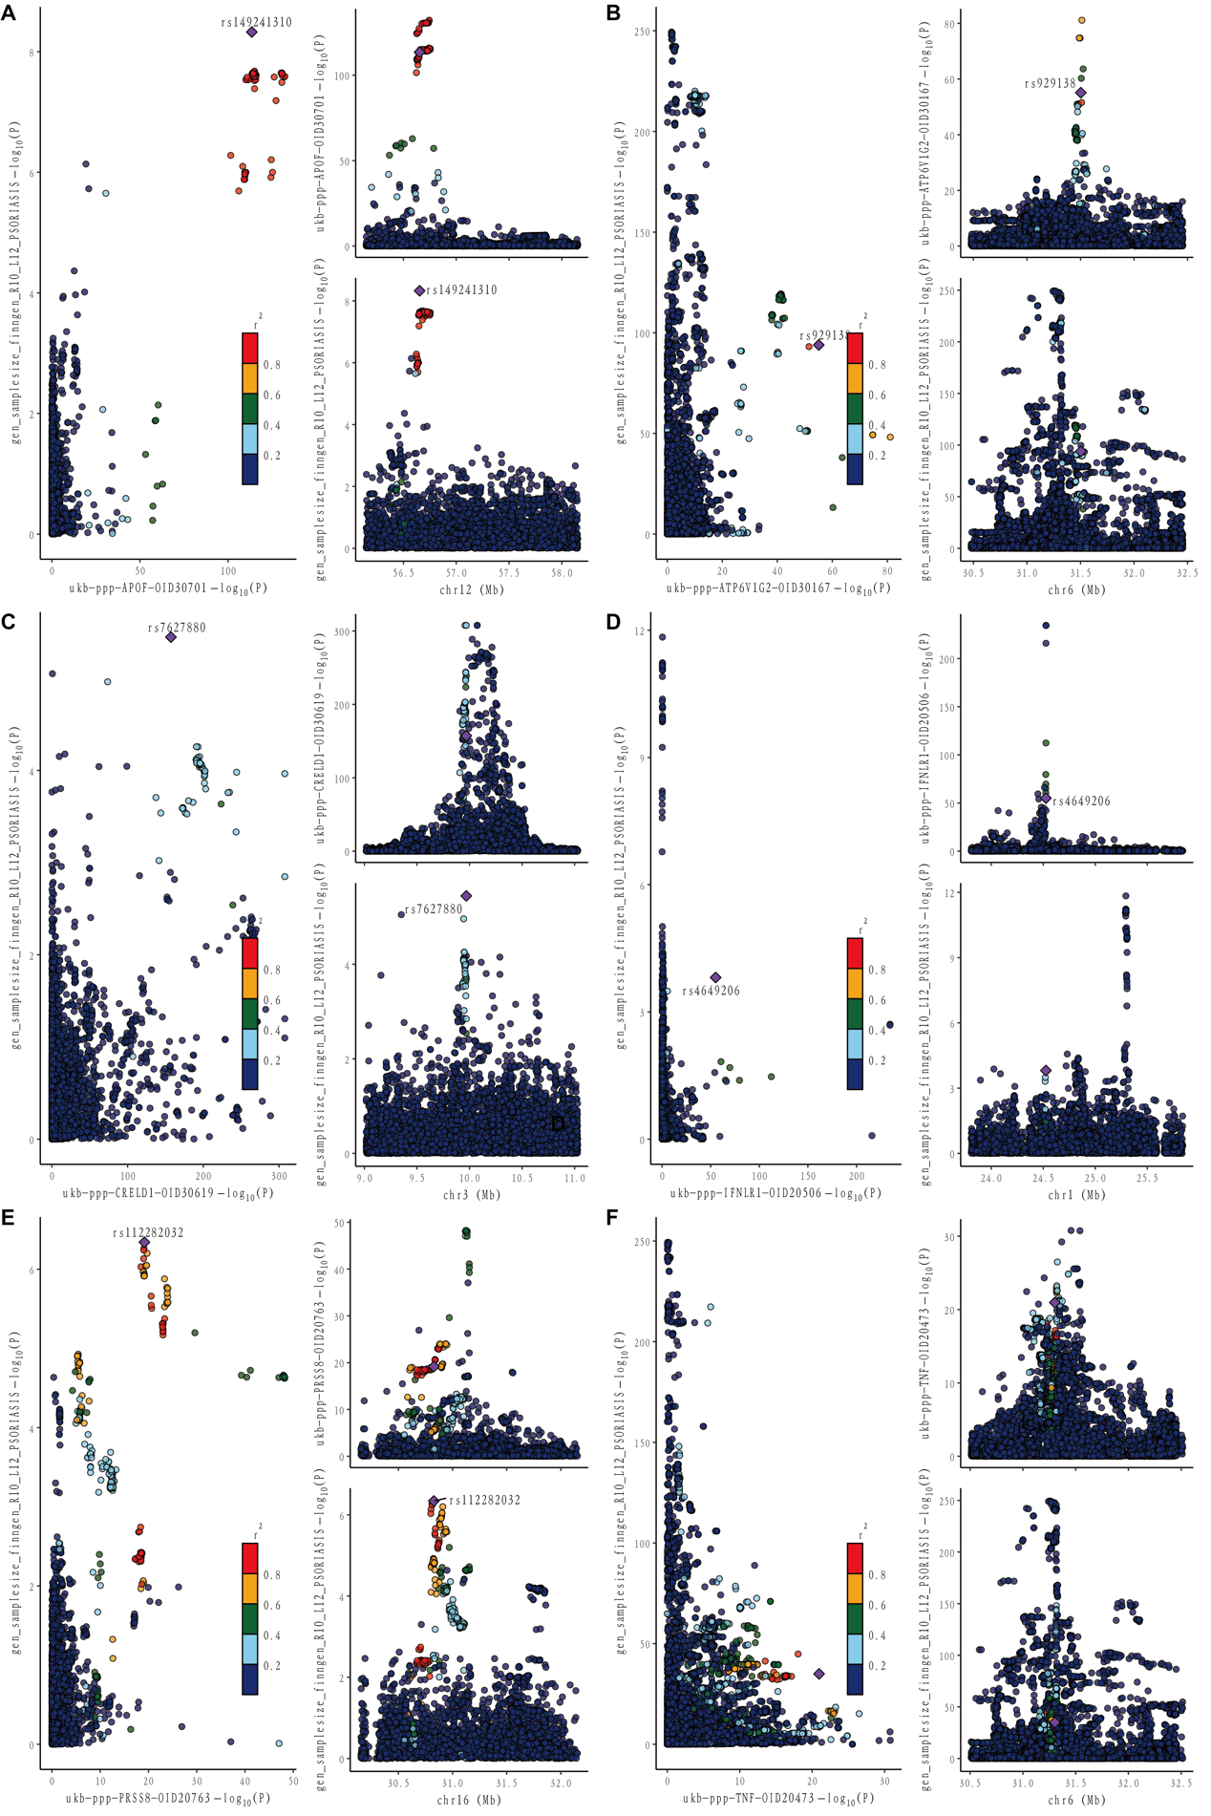

Figure S1. The colocalization map shows the relationship between six potential gene and the disease. (A) APOF with psoriasis. (B) ATP6V1G2 with psoriasis. (C) CRELD1 with psoriasis. (D) IFNLR1 with psoriasis. (E) PRSS8 with psoriasis. (F) TNF with psoriasis.
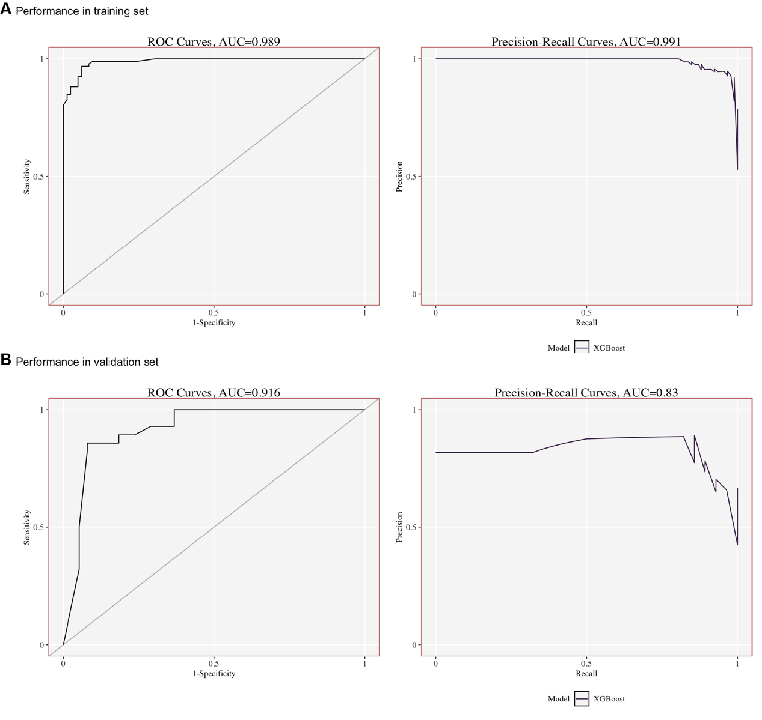

Figure S2. The ROC and PRC validation of the diagnostic model in psoriasis dataset. (A) The ROC and PRC validation of the diagnostic model in training dataset. (B) The ROC and PRC validation of the diagnostic model in testing dataset.

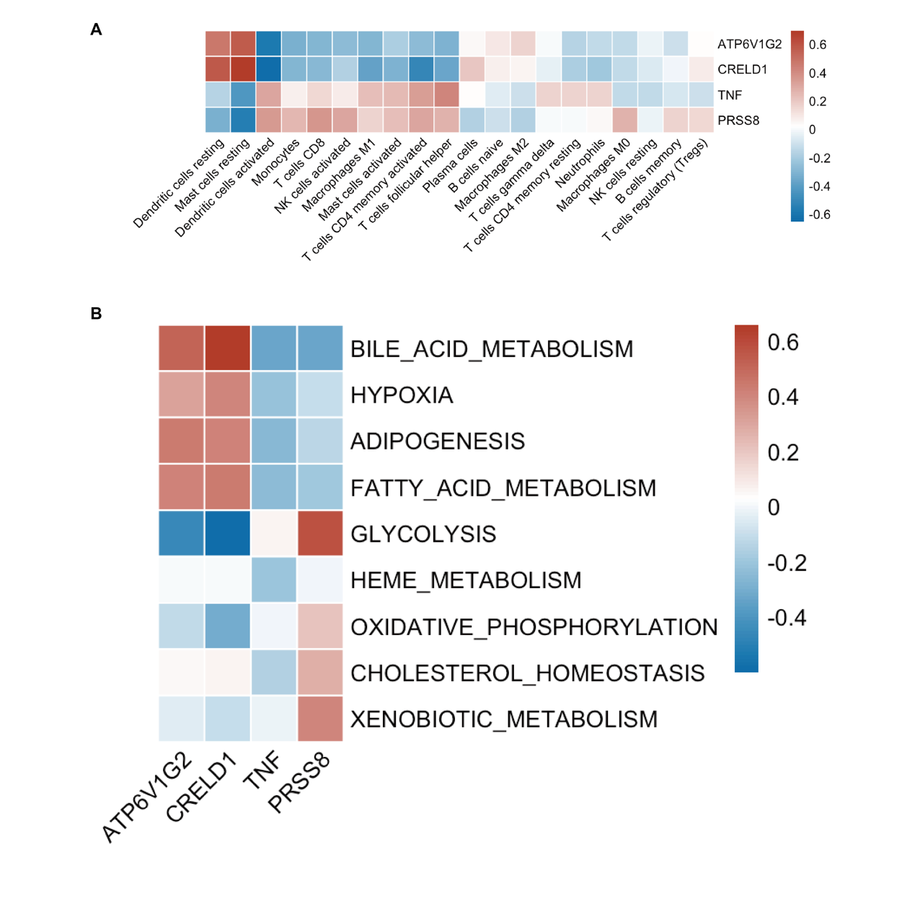
Figure S3. Analysis of Immune Infiltration and Metabolic Pathways in Psoriasis (A) This heatmap illustrates the relationships between key genes (referred to as "hub genes") and the presence of immune and inflammatory cells that have infiltrated the skin in psoriasis patients. (B) Similarly, this heatmap demonstrates the connections between the same set of hub genes and various metabolic pathways that are implicated in the disease process of psoriasis.

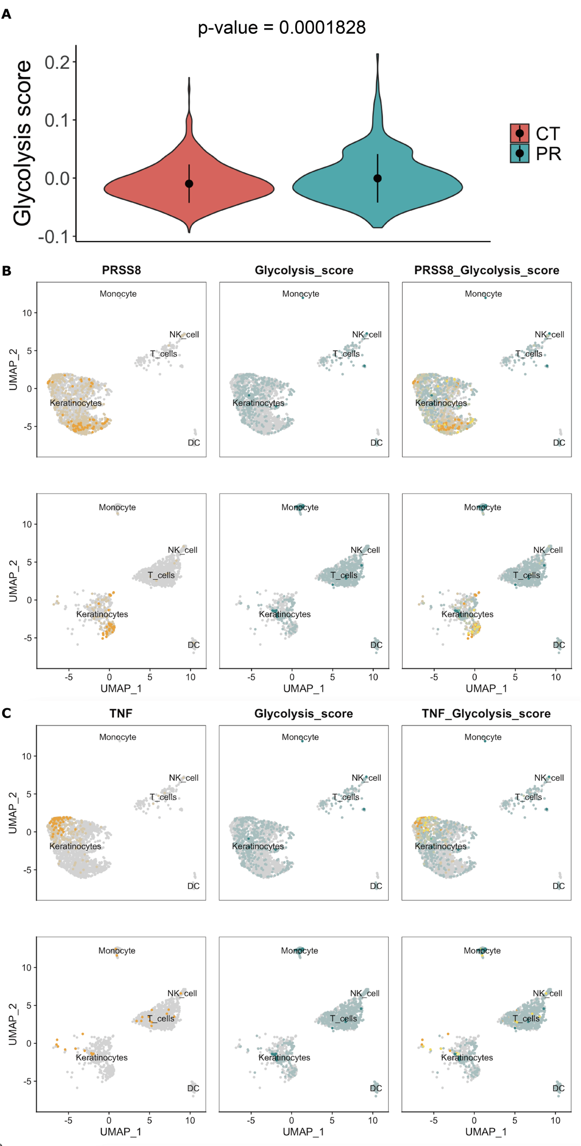
Figure S4. The glycolysis score comparison between MCAO mouse and sham mouse. (A) Violin plot shows the quantitative comparison of glycolysis score in keratinocytes between psoriasis and control group. (B) The co-expression of PRSS8 and glycolysis score on the uMAP. (C) The co-expression of TNF and glycolysis score on the uMAP.

Figure S5. The KEGG and drug-target result for druggable genes in psoriasis. (A) KEGG plot (B) The cnet plot show the potential drugs and targets.

Figure S6. The molecular docking between simvastatin and TNF-alpha with a binding score is around -10.0. (A) The structure of TNF-alpha. (B) The Vina score for binding between simvastatin and TNF-alpha. (C) The binding sites between simvastatin and TNF-alpha. (D) The enlarged binding site of C1, which has the biggest Vina score.

