Supplementary materials
- Supplementary Table 1. Definition and interpretation of the ABC pathway for integrated care – Page 2.
- Supplementary Table 2. Baseline characteristics of the patients with atrial fibrillation based on survival state at 12-month follow-up – Page 3-4.
- Supplementary Figure 1. Participation rates of patients and their family members in patient education and group discussions – Page 5.

Supplementary Table 1 Definition and interpretation of the ABC pathway for integrated care.
Criterion | Interpretation | Definitions
A - Avoid stroke | Guideline adherent OACs treatment | Patients with CHA₂DS₂-VASc score ≥ 1 if men or ≥ 2 if women receiving OACs and patients with CHA₂DS₂-VASc score = 0 if men or ≤ 1 if women not receiving OACs.  The use of appropriate non-vitamin K antagonist OACs or, alternatively, warfarin with a TTR of ≥65%.
B - Better symptoms control | Actual AF symptoms control | EHRA score of I or II
C - Cardiovascular risk and comorbidity optimization | Guideline adherent disease‑specific treatment of comorbidities | (i) rest blood pressure <140/90 mmHg for hypertension,  (ii) fasting blood glucose <7.0 mmol/L for diabetes mellitus,  (iii) BMI <30.0 kg/m² for obesity,  (iv) statins for arterial disease,  (v) statins for previous stroke/TIA, and  (vi) ACEI/ARB/ARNI for congestive heart failure, or  (vii) no management in case of no comorbidities.
ABC, atrial fibrillation better care; OACs, oral anticoagulants; TTR, time in therapeutic range; AF, atrial fibrillation; EHRA, European Heart Rhythm Association; BMI, body mass index; TIA, transient ischemic attacks, ACEI, angiotensin-converting enzyme inhibitors; ARB, angiotensin receptor blockers; ARNI, angiotensin receptor neprilysin inhibitors.

Supplementary Table 2 Baseline characteristics of the patients with atrial fibrillation based on survival state at 12-month.
Items | Total | Death | Survival | P value
No. | 810 | 41 | 769
Women | 416 (51.4) | 27 (65.9) | 389 (50.6) | 0.057
Age, years (mean, SD) | 76.1±5.9 | 78.0±5.6 | 76.1±5.9 | 0.045
≥75 years old | 477 (58.9) | 28 (68.3) | 449 (58.4) | 0.209
Systolic blood pressure, mmHg (mean, SD) | 138.8±21.6 | 140.5±22.7 | 138.7±21.6 | 0.687
Diastolic blood pressure, mmHg (mean, SD) | 84.1±14.0 | 84.5±11.7 | 84.0±14.1 | 0.887
Heart rate, beats/min (mean, SD) | 82.3±15.1 | 77.6±13.4 | 82.4±15.2 | 0.350
Fasting blood glucose, mmol/L (mean, SD) | 6.2±1.7 | 6.9±2.3 | 6.2±1.6 | 0.060
Body mass index, kg/m² (mean, SD) | 24.5±3.6 | 23.7±2.5 | 24.5±3.6 | 0.313
Known AF history | 402 (49.6) | 6 (14.6) | 396 (51.5) | <0.001
ABC pathway compliance | 14 (1.7) | 0(0) | 14 (1.8) | 1.000
Marital status |  |  |  | 0.125
Married/Remarried/Cohabitation | 525 (64.8) | 22 (53.7) | 503 (65.4)
Unmarried/Divorced/Widowed/Separated | 285 (35.2) | 19 (46.3) | 266 (34.6))
Living with adult children | 66 (8.1) | 2 (4.9) | 64 (8.3) | 0.767
Medical insurance |  |  |  | 1.000
Rural cooperative medical insurance | 795 (98.1) | 41 (100.0) | 754 (98.0)
Employee basic medical insurance | 15 (1.9) | 0 (0) | 15 (2.0)
Income |  |  |  | 0.337
No income | 381 (47.0) | 16 (39.0) | 365 (47.5)
Retirement pension/house renting/ government subsidy | 429 (53.0) | 25 (61.0) | 404 (52.5)
Use of smart phone |  |  |  | 0.205
No mobile phone | 361 (44.6) | 22 (53.7) | 339 (44.1)
Smartphone | 42 (5.2) | 0 (0) | 42 (5.5)
Non-smartphone | 407 (50.2) | 19 (46.3) | 388 (50.5)
Smartphone applications use | 21 (2.6) | 0 (0) | 21 (2.7) | 0.619
Education level |  |  |  | 0.458
Below primary school | 417 (51.5) | 25 (61.0) | 392 (51.0)
Primary school | 321 (39.6) | 13 (31.7) | 308 (40.1)
Middle and High school | 62 (7.7) | 3 (7.3) | 69 (7.9)
Comorbidities
Hypertension | 575 (71.0) | 24 (58.5) | 551 (71.7) | 0.071
Diabetes mellitus | 195 (24.1) | 10 (24.4) | 185 (24.1) | 0.961
Stroke or TIA | 34 (4.2) | 2 (4.9) | 32 (4.2) | 0.688
Continued…
Items | Total | Death | Survival | P value
CAD or PAD | 100 (12.3) | 6 (14.6) | 94 (12.2) | 0.648
Congestive heart failure | 14 (1.7) | 0 (0) | 14 (1.8) | 1.000
CHA₂DS₂-VASc score (mean, SD) | 3.3±1.1 | 3.4±1.2 | 3.3±1.1 | 0.415
≥3 in women or ≥2 in men | 744 (91.9) | 36 (87.8) | 708 (92.1) | 0.331
Data are number (%), unless otherwise mentioned.
ABC, atrial fibrillation better care; TIA, transient ischemic attacks; CAD, coronary artery disease; PAD, peripheral artery disease.

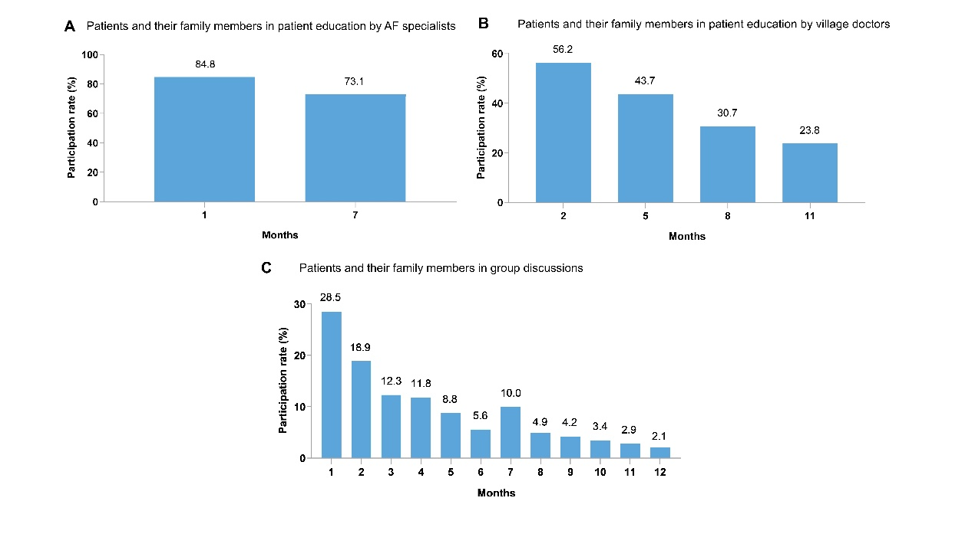
Supplementary Figure 1 Participation rates of patients and their family members in patient education and group discussions. (A) Patients and their family members in patient education by AF specialists; (B) Patients and their family members in patient education by village doctors; (C) Patients and their family members in group discussions. AF, atrial fibrillation.

