Supplementary Table S1 Instruments and reagents for in vivo experiments.
Name | Company | Catalog Number
Sprague Dawley (SD) male rats | Beijing Vital River Laboratory Animal Technology Co., Ltd, China | SCxK (Jing) 2021–0006
Papain | Beijing Soleibao Biotechnology Co., LTD, China | G8430
L-cysteine | Beijing Soleibao Biotechnology Co., LTD, China | C0012
Sodium pentobarbital | Sigma-Aldrich Corporation, USA | P3761
 | Stolting lnc, USA | ALMEMO 2450
Dehydrator | Wuhan Junjie Electronics Co., LTD, China | JJ-12J
Embedding machine | Wuhan Junjie Electronics Co., LTD, China | JB-P5
Pathological microtome | Shanghai Leica Instrument Co., LTD, China | RM2016
Frozen table | Wuhan Junjie Electronics Co., LTD, China | JB-L5
Oven | Shanghai Huitai Instrument Manufacturing Co., LTD, China | DHG-9140A
Microwave oven | Galanz microwave electric appliance Co., LTD, China | P70D20TL-P4
Decolorizing shaker | SCILOGEX, USA | CF1524R
Anhydrous ethanol | Sinopharm Group Chemical reagent Co., LTD, China | 100092683
Xylene | Sinopharm Group Chemical reagent Co., LTD, China | 10023418
Neutral gum | Sinopharm Group Chemical reagent Co., LTD, China | 10004160
Positive fluorescence microscope | Nikon, Japan | ECLIPSE
Imaging system | Nikon, Japan | DS-U3
Dewaxing solution | Wuhan Servicebio Biotechnology Co., LTD, China | G1128
Slide | Jiangsu Shitai experimental equipment Co., LTD, China | 188105
Coverslip | Jiangsu Shitai experimental equipment Co., LTD, China | 10212432C
Electron microscope fixative | Wuhan Xavier Biotechnology Co., LTD, China | G1102
Transmission electron microscope | Hitachi, Japan | HT7800
Transmission electron microscope imaging system | Hitachi, Japan | Hitachi TEM system
Ultra microtome | Leica, Germany | Leica UC7
4℃ centrifuge | Quzhou Xinzhi Biotechnology Co., LTD, China | CF1524R
Ultra-clean table | Suzhou purification Equipment Co., LTD, China | SW-CJ-2D
Diamond slicing knife | Daitome, Japan | Ultra 45°
Osmic acid | Beijing Bole Biological Technology Co., LTD, China | 18456
Microcoder | Thermo Fisher Scientific, USA | Multiskan FC
Pipette | Shanghai Baoyu De Scientific Instrument Co., LTD, China | Genex Beta
GraphPad Prism 8.0.2 | GraphPad Software | -

Supplementary Table S2 The results of Cochran’ s Q test, MR-Egger intercept, MR-PRESSO and Steiger test
Exposure | Outcome | Cochran’s Q test (Q value /P value) |  | MR-Egger intercept (P value) | MR-PRESSO  (P value) | Steiger test  (P value)
IFN-γ | Knee osteoarthritis | 25.299 | 0.710 | 0.942 | 0.745 | 0.000
IL-1β | Knee osteoarthritis | 9.032 | 0.700 | 0.218 | 0.619 | 6.30e⁻¹⁰²
IL-17 | Knee osteoarthritis | 1.792 | 0.773 | 0.524 | 0.777 | 1.96e⁻²⁷
TGF-β1 | Knee osteoarthritis | 9.800 | 0.279 | 0.102 | 0.310 | 0.000
MMP-3 | Knee osteoarthritis | 51.214 | 0.386 | 0.323 | 0.364 | 0.000
MMP-10 | Knee osteoarthritis | 36.903 | 0.731 | 0.227 | 0.756 | 0.000
OCN | Knee osteoarthritis | 17.664 | 0.856 | 0.836 | 0.184 | 0.000
PTH | Knee osteoarthritis | 23.967 | 0.521 | 0.407 | 0.518 | 9.49e⁻¹⁴⁹

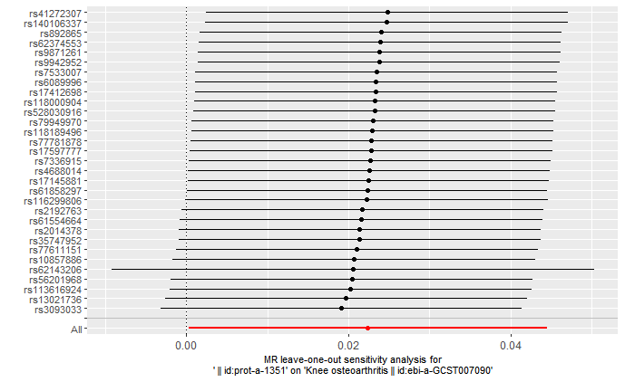
Supplementary Figure S1 The resulis of LOO analysis for IFN-γ on KOA.

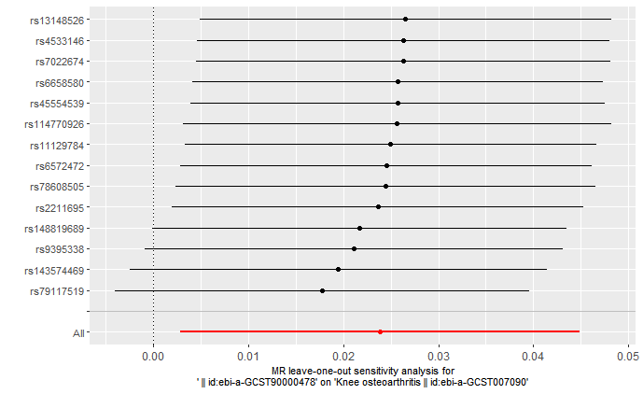
Supplementary Figure S2 The resulis of LOO analysis for IL-1β on KOA.

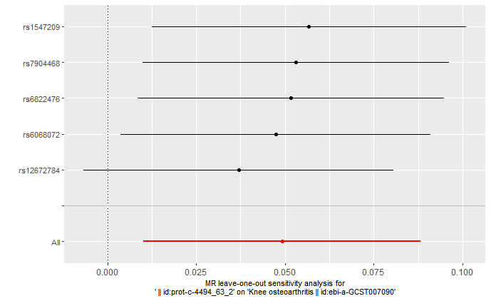
Supplementary Figure S3 The resulis of LOO analysis for IL-17 on KOA.

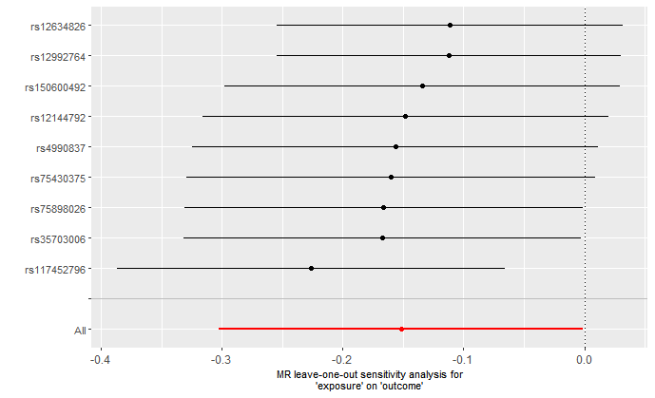
Supplementary Figure S4 The resulis of LOO analysis for TGF-β1 on KOA.

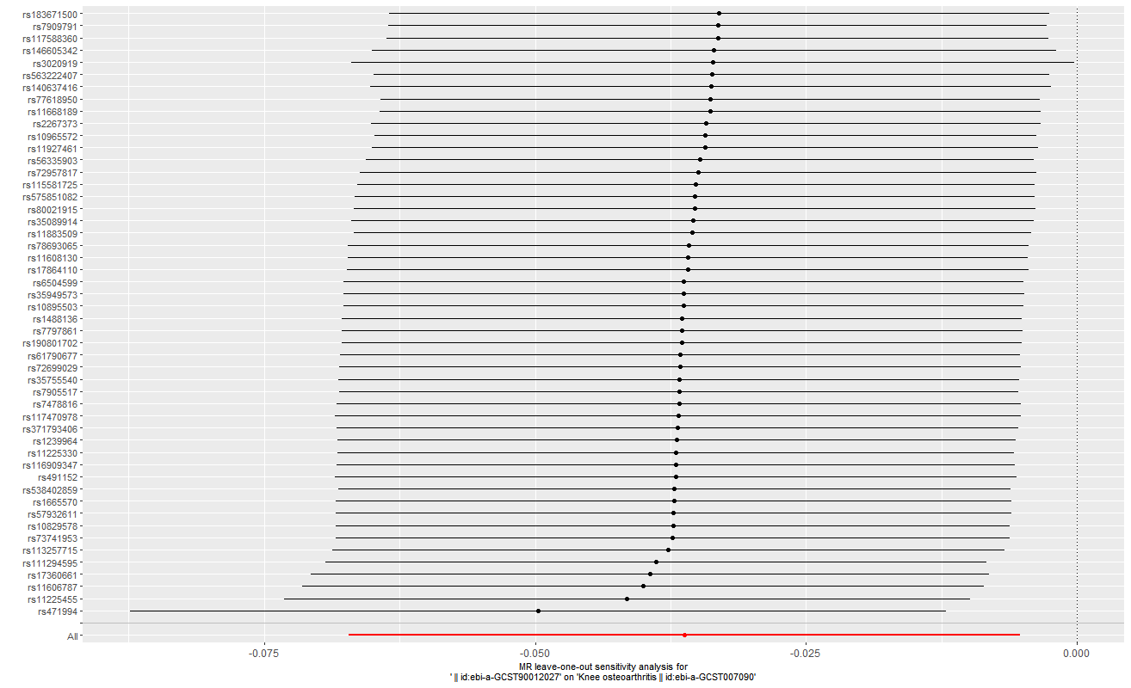
Supplementary Figure S5 The resulis of LOO analysis for MMP-3 on KOA.

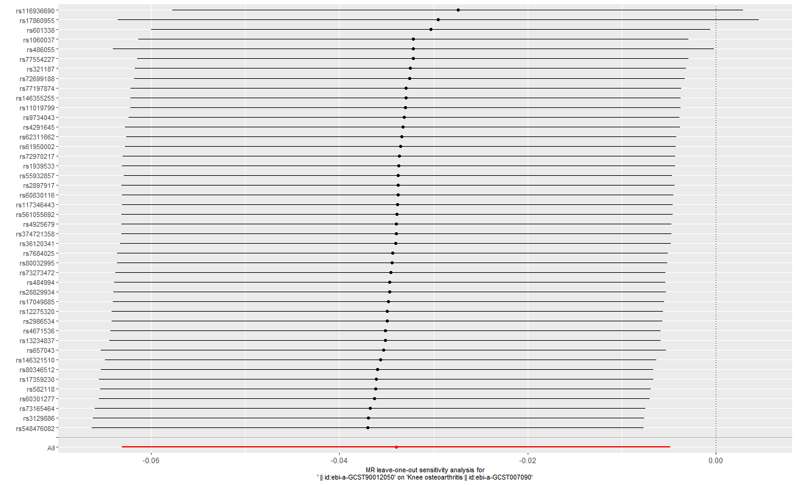
Supplementary Figure S6 The resulis of LOO analysis for MMP-10 on KOA.

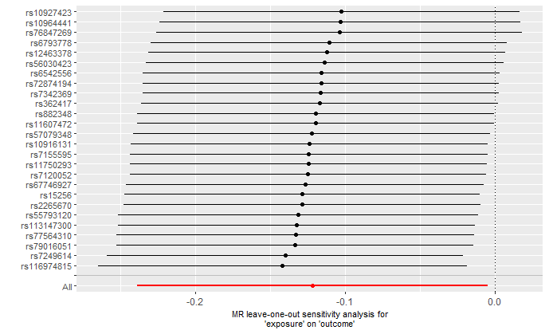
Supplementary Figure S7 The resulis of LOO analysis for OCN on KOA.

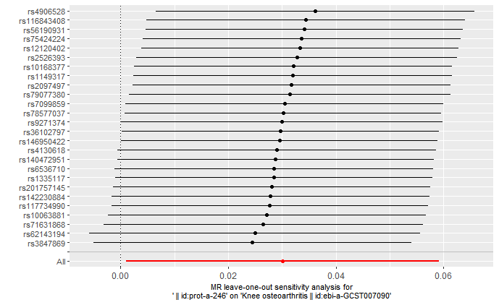
Supplementary Figure S8 The resulis of LOO analysis for PTH on KOA.

