SUPPLEMENTARY MATERIALS

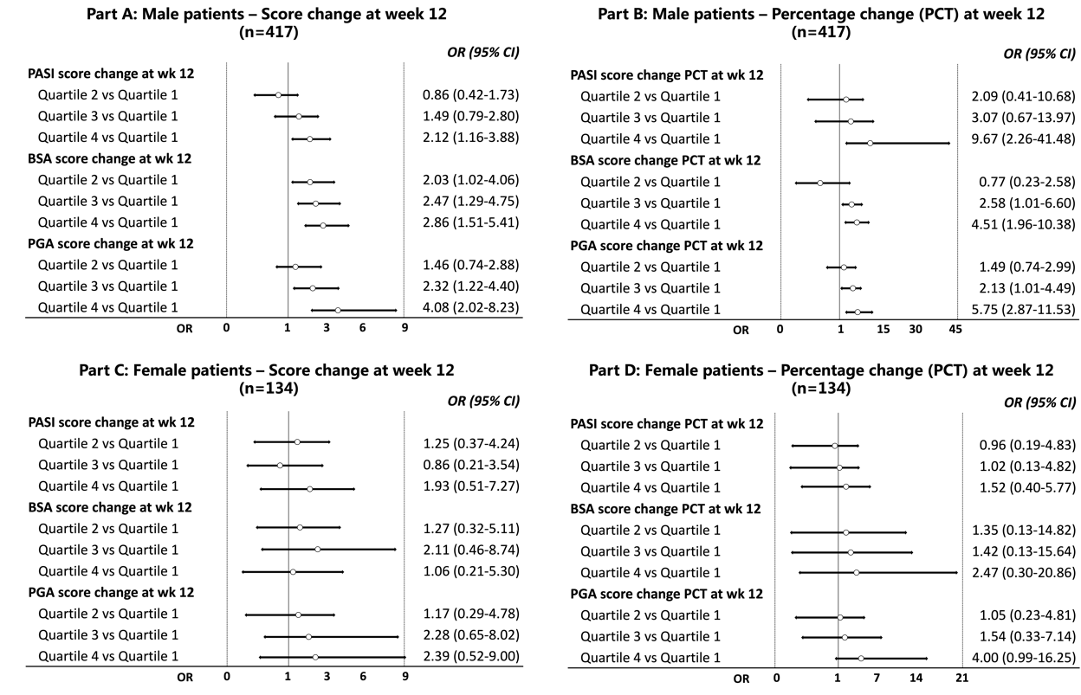
Figure S1 Sex-Stratified Forest Plots of Quartile Changes in PASI, BSA, and PGA for Achieving a ≥90% Reduction in DLQI
(A) Male patients – score change; (B) Male patients – percentage change; (C) Female patients – score change; (D) Female patients – percentage change.
OR, odds ratio; CI, confidence interval; PASI, psoriasis area and severity index; BSA, body surface area; PGA, Physician's Global Assessment; PCT, percentage; wk, week; Quartile 1 (P0-P25); Quartile 2 (P25-P50); Quartile3 (P50-P75); Quartile 4 (P75-P100)

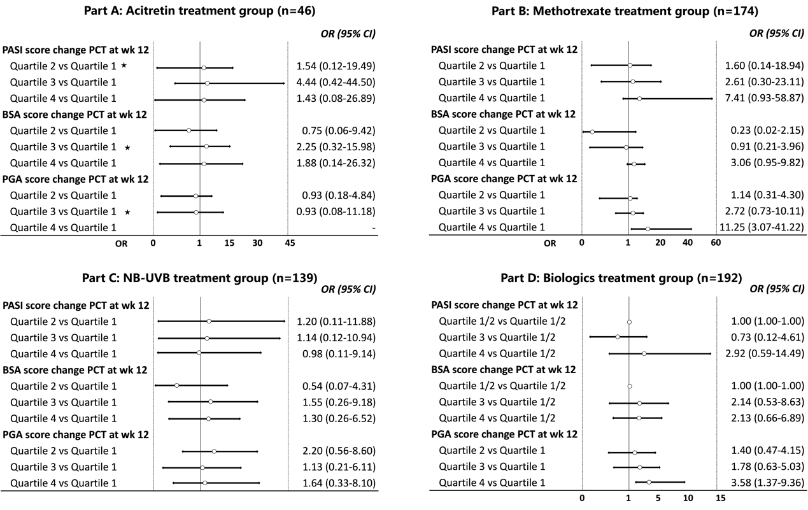
Figure S2 Forest Plots by Treatment Modality for Score Changes in PASI, BSA, and PGA in Achieving a ≥90% Reduction in DLQI
(A) Acitretin treatment group; (B) Methotrexate treatment group; (C) NB-UVB treatment group; (D) Biologics treatment group.
OR, odds ratio; CI, confidence interval; PASI, psoriasis area and severity index; BSA, body surface area; PGA, Physician's Global Assessment; NB-UVB, narrow band ultraviolet; Quartile 1 (P0-P25); Quartile 2 (P25-P50); Quartile3 (P50-P75); Quartile 4 (P75-P100). ★: number of patients in the quartile was 0, the OR could not be calculated.

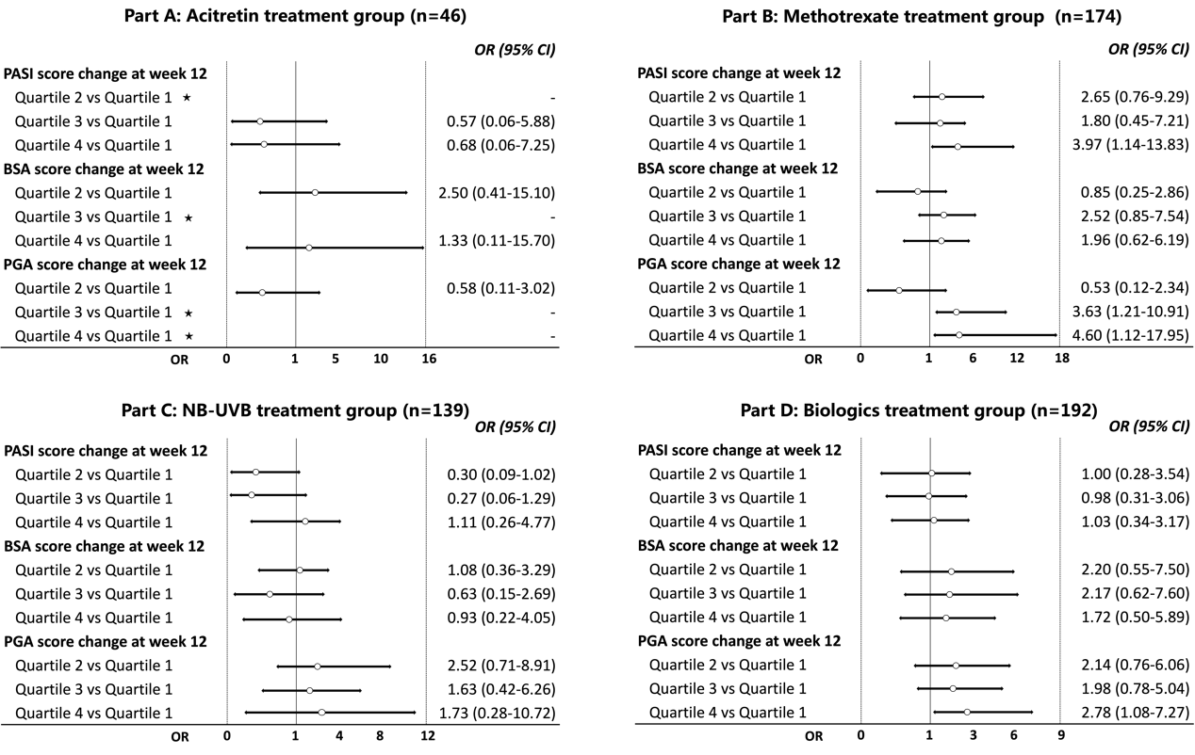
Figure S3 Forest Plots by Treatment Modality for Score Percentage Changes in PASI, BSA, and PGA in Achieving a ≥90% Reduction in DLQI
(A) Acitretin treatment group; (B) Methotrexate treatment group; (C) NB-UVB treatment group; (D) Biologics treatment group.
OR, odds ratio; CI, confidence interval; PASI, psoriasis area and severity index; BSA, body surface area; PGA, Physician's Global Assessment; PCT, percentage; NB-UVB, narrow band ultraviolet; Quartile 1 (P0-P25); Quartile 2 (P25-P50); Quartile3 (P50-P75); Quartile 4 (P75-P100). ★: number of patients in the quartile was 0, the OR could not be calculated.

Figure S4 Comparison of DLQI Improvement Across Treatment Modalities
(A) Mean change in Dermatology Life Quality Index (DLQI) score from baseline to week 12 across four treatment modalities: acitretin, methotrexate, narrowband ultraviolet B (NB-UVB), and biologics. Error bars represent standard deviations. Significant between-group differences were observed, with biologics showing the greatest DLQI improvement (P < 0.05 for all comparisons with biologics).
(B) Distribution of DLQI improvement at week 12 stratified by treatment group and expressed as percentage change quartiles: 0%–25%, 26%–50%, 51%–75%, and 76%–100%.

