Supplementary Material
Supplementary Table 1
Table 1 Clinicopathological features of 25 HCC patients
Clinicopathological features |  | Number of cases (n)
Sex | Male | 22
Sex | Female | 3
Age | ≤ 55 years old | 9
Age | > 55 years old | 16
HBV infection | Positive | 22
HBV infection | Negative | 3
Tumor number | Single | 22
Tumor number | Multiple (≥2) | 3
Tumor size | ≤ 5 cm | 17
Tumor size | > 5 cm | 8
TNM staging | I-II | 17
TNM staging | III-IV | 8
Note: HBV, hepatitis B virus.

Supplementary Figure 1
Supplementary Figure 1. Analysis of the correlation between PD-L1 and ITGB4 in the Linked Omics database (https://www.linkedomics.org/login.php).
Supplementary Figure 2
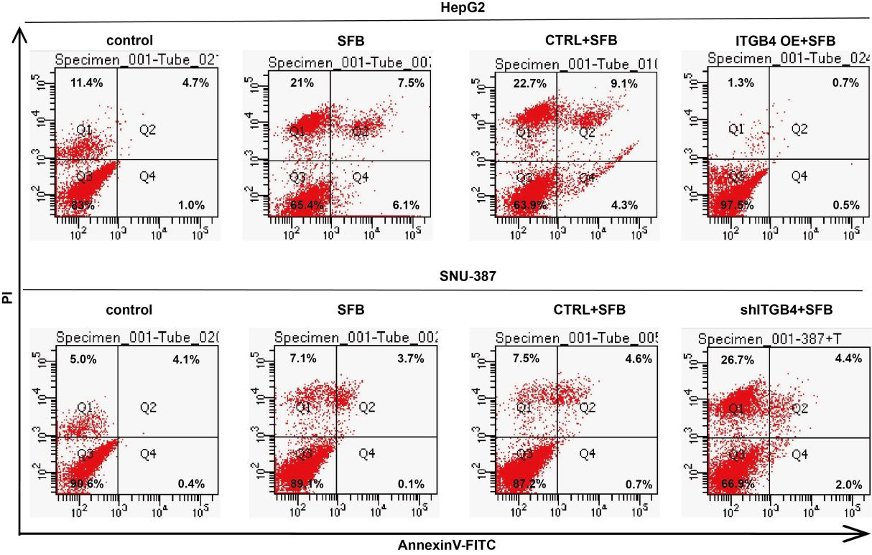
Supplementary Figure 2. Flow cytometry assessment of apoptotic ability of different cell groups post sorafenib treatment.

Supplementary Figure 3
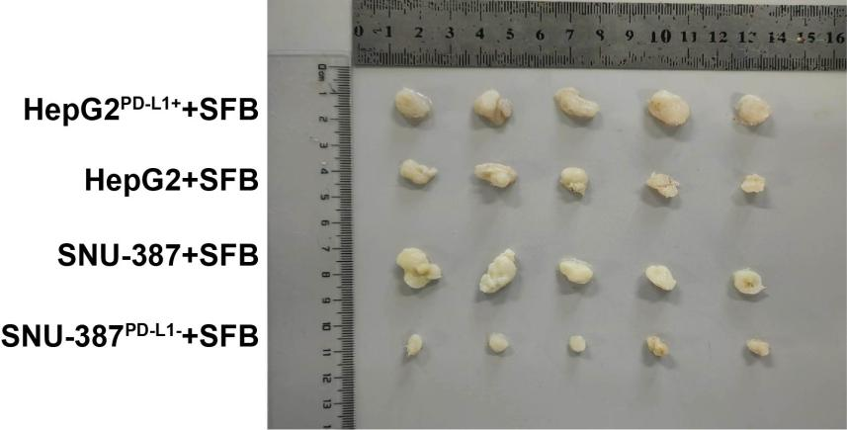
Supplementary Figure 3. HepG2, HepG2^{PD-L1+}, SNU-387, and SNU-387^{PD-L1-} terminal tumor solid image.

