Supplementary File 1

FUS activated spleen immunological function to suppress proliferation of the subcutaneous 4T1 breast tumor
To further verify the universality of FUS sti. spleen as a non-specific strategy for modulating splenic immune function to suppress tumor progression, another model of subcutaneous 4T1 breast tumor was also used to confirm the anti-cancer effect of FUS sti. spleen. The subcutaneous 4T1 tumor mice were subjected to FUS sti. spleen also from day 0 after cancer cell implantation and once every two days as described in main text, except that the experimental period was set to 34 days. Next, twelve subcutaneous 4T1 breast tumor mice were randomly divided into two groups: the P1 group was used as the control group, and the P2 group was subjected to FUS sti. spleen.
The results of visual observation, tumor volume and tumor weight demonstrated that FUS sti spleen significantly suppressed the proliferation of 4T1 breast tumor, with a ~70% of tumor inhibition rate (P2 vs. P1, p＜0.001; Figure 1 A-C). Moreover, a significant pathological change in the lungs of the P1 group was observed, but the degree of pulmonary lesions in the P2 group was significantly reduced (p＜0.01; Figure 1 D). During the experimental period, the P1 group showed a decrease in body weight, while that of the P2 group slightly increased without significant difference compared to the P1 group (Figure 1 E), which was most likely due to the poor health status caused by the metastasis of 4T1 cancer cells to the lungs. Notably, the spleen weight and splenic index in the P2 group showed that FUS sti spleen significantly reduced splenomegaly compared to the P1 group (p＜0.01; Figure 1 F-G). Importantly, the survival time of subcutaneous 4T1 breast tumor mice in the P2 group was significantly longer than that in the P1 group (Figure 1 H).
FCM results showed that the change of various immune cell proportion was basically consistent with that in the orthotopic HCC mice experiment. In detail, the proportion of NK cells and CD8 T cells in the P2 group was significantly increased in the spleen, blood, tumor, and lung as compared with the P1 group, and PMN-MDSCs was decreased except in the tumor (Table 1; Figure 2-5). Moreover, the number of other tumor suppressor related immune cells was significantly increased in the spleen, blood, tumor or lung of the P2 group compared to that in the P1 group (such as Mφ (Mφ1/2) and DC1 in the spleen and blood; Mφ (Mφ2) and DCs in the tumor; and Mφ (Mφ1) and DC1 in the lung (Table 1; Figure 2-5). These results further confirmed that FUS sti. spleen universally activated spleen immunological function by upregulating tumor suppressor-related immune cells and inhibiting negative immune cells, especially in the significant modulation of NK cells and CD8 T cells, to suppress the proliferation of various tumors. While FCM confirmed the proliferation of NK cells and CD8 T cells in the spleen following FUS stimulation, immunohistochemical staining of Ki67, NK1.1, and CD8a also indicated enhanced cell proliferation and especially an increase in the number of NK cells and CD8 T cells (Figure 1 I).
Figure 1 FUS sti. spleen suppressed the proliferation of the subcutaneous 4T1 breast tumor. A, images of spleen and 4T1 tumor. B-C, tumor growth curves and tumor weight, respectively. D, pulmonary variation score to evaluate lung metastasis of 4T1 cancer cells, where the color area of the lung tissue was scored from 0 to 10; the larger the black-brown area, the higher the score. E-F, Mouse weight and spleen weight, respectively. G, splenic index calculated by the ratio of spleen weight to mouse weight. H, survival curves. (n = 6; **p ≤ 0.01; ***p ≤ 0.001; mean ± SEM). I, immunohistochemical staining of Ki67, NK1.1, and CD8a, and the corresponded statistical diagrams. (n = 5; **p ≤ 0.01; ***p ≤ 0.001; mean ± SEM). P1, control group of subcutaneous 4T1 breast tumor; P2, FUS sti. spleen on day 2 after 4T1 cancer cell implantation.
Figure 2 Representative FCM plots and statistical diagram of immune cell proportion in spleen. A, representative FCM plot of NK cells (CD3⁻ NK1.1⁺ gated on CD45⁺), and corresponded quantification. B, representative FCM plot of CD8 T cells (CD3⁺ CD8⁺ gated on CD45⁺), and corresponded quantification. C, representative FCM plot of Treg cells (CD25⁺ Foxp3⁺ gated on CD3⁺ CD4⁺ CD45⁺), and corresponded quantification. D, representative FCM plot of Mφ (CD11b⁺ F4/80⁺ gated on CD45⁺), and corresponded quantification. E, representative FCM plot of Mφ1 (CD11c⁺ CD206⁻ gated on CD11b⁺ F4/80⁺ CD45⁺) and Mφ2 (CD11c⁻ CD206⁺ gated on CD11b⁺ F4/80⁺ CD45⁺), and corresponded quantification. F, representative FCM plot of DC1 (CD8⁺ CD11b⁻ gated on total cells) and DC2 (CD8⁻ CD11b⁺CD8⁻ gated on total cells), and corresponded quantification. G, representative FCM plot of M-MDSCs (LY6G⁻ LY6C⁺ gated on CD45⁺ CD11b⁺) and PMN⁻MDSCs (LY6G⁺ LY6C⁻ gated on CD45⁺ CD11b⁺), and corresponded quantification. (n = 5; * p ≤ 0.05; **p ≤ 0.01; ***p ≤ 0.001; mean ± SEM). P1, the control group of subcutaneous 4T1 breast tumor; P2, FUS sti. spleen to suppress 4T1 breast tumor proliferation.
Figure 3 Representative FCM plots and statistical diagram of immune cell proportion in blood. A, representative FCM plot of NK cells (CD3⁻ NK1.1⁺ gated on CD45⁺), and corresponded quantification. B, representative FCM plot of CD8 T cells (CD3⁺ CD8⁺ gated on CD45⁺), and corresponded quantification. C, representative FCM plot of Treg cells (CD25⁺ Foxp3⁺ gated on CD3⁺ CD4⁺ CD45⁺), and corresponded quantification. D, representative FCM plot of Mφ (CD11b⁺ F4/80⁺ gated on CD45⁺), and corresponded quantification. E, representative FCM plot of Mφ1 (CD11c⁺ CD206⁻ gated on CD11b⁺ F4/80⁺ CD45⁺) and Mφ2 (CD11c⁻ CD206⁺ gated on CD11b⁺ F4/80⁺ CD45⁺), and corresponded quantification. F, representative FCM plot of DC1 (CD8⁺ CD11b⁻ gated on total cells) and DC2 (CD8⁻ CD11b⁺ gated on total cells), and corresponded quantification. G, representative FCM plot of M-MDSCs (LY6G⁻ LY6C⁺ gated on CD45⁺ CD11b⁺) and PMN-MDSCs (LY6G⁺ LY6C⁻ gated on CD45⁺ CD11b⁺), and corresponded quantification. (n = 5; * p ≤ 0.05; **p ≤ 0.01; mean ± SEM). P1, the control group of subcutaneous 4T1 breast tumor; P2, FUS sti. spleen to suppress 4T1 breast tumor proliferation.
Figure 4 Representative FCM plots and statistical diagram of immune cell proportion in tumor. A, representative FCM plot of NK cells (CD3⁻ NK1.1⁺ gated on CD45⁺), and corresponded quantification. B, representative FCM plot of CD8 T cells (CD3⁺ CD8⁺ gated on CD45⁺), and corresponded quantification. C, representative FCM plot of Treg cells (CD25⁺ Foxp3⁺ gated on CD3⁺ CD4⁺ CD45⁺), and corresponded quantification. D, representative FCM plot of Mφ (CD11b⁺ F4/80⁺ gated on CD45⁺), and corresponded quantification. E, representative FCM plot of Mφ1 (CD11c⁺ CD206⁻ gated on CD11b⁺ F4/80⁺ CD45⁺) and Mφ2 (CD11c⁻ CD206⁺ gated on CD11b⁺ F4/80⁺ CD45⁺), and corresponded quantification. F, representative FCM plot of DC1 (CD8⁺ CD11b⁻ gated on total cells) and DC2 (CD8⁻ CD11b⁺ gated on total cells), and corresponded quantification. G, representative FCM plot of M-MDSCs (LY6G⁻ LY6C⁺ gated on CD45⁺ CD11b⁺) and PMN-MDSCs (LY6G⁺ LY6C⁻ gated on CD45⁺ CD11b⁺), and corresponded quantification. (n = 5; * p ≤ 0.05; **p ≤ 0.01; mean ± SEM). P1, the control group of subcutaneous 4T1 breast tumor; P2, FUS sti. spleen to suppress 4T1 breast tumor proliferation.
Figure 5 Representative FCM plots and statistical diagram of immune cell proportion in lung. A, representative FCM plot of NK cells (CD3⁻ NK1.1⁺ gated on CD45⁺), and corresponded quantification. B, representative FCM plot of CD8 T cells (CD3⁺ CD8⁺ gated on CD45⁺), and corresponded quantification. C, representative FCM plot of Treg cells (CD25⁺ Foxp3⁺ gated on CD3⁺ CD4⁺ CD45⁺), and corresponded quantification. D, representative FCM plot of Mφ (CD11b⁺ F4/80⁺ gated on CD45⁺), and corresponded quantification. E, representative FCM plot of Mφ1 (CD11c⁺ CD206⁻ gated on CD11b⁺ F4/80⁺ CD45⁺) and Mφ2 (CD11c⁻ CD206⁺ gated on CD11b⁺ F4/80⁺ CD45⁺), and corresponded quantification. F, representative FCM plot of DC1 (CD8⁺ CD11b⁻ gated on total cells) and DC2 (CD8⁻ CD11b⁺ gated on total cells), and corresponded quantification. G, representative FCM plot of M-MDSCs (LY6G⁻ LY6C⁺ gated on CD45⁺ CD11b⁺) and PMN-MDSCs (LY6G⁺ LY6C⁻ gated on CD45⁺ CD11b⁺), and corresponded quantification. (n = 5; * p ≤ 0.05; **p ≤ 0.01; mean ± SEM). P1, the control group of subcutaneous 4T1 breast tumor; P2, FUS sti. spleen to suppress 4T1 breast tumor proliferation.

Table 1 FCM results of various immune cells in the spleen, blood, tumor, and lung tissues from subcutaneous 4T1 tumor-bearing mice subjected to FUS sti. spleen or non-treated mice.
Analysis | NK  cells | CD8  T cells | Mφ | Mφ1 | Mφ2 | DC1 | DC2 | Tregcells | M-  MDSCs | PMN-MDSCs
Spleen P2 vs. P1 | * | *** | ** | *** | ** | *** | * | — | — | **
Blood P2 vs. P1 | ** | * | * | * | ** | ** | * | * | — | *
Tumor P2 vs. P1 | ** | * | ** | — | * | * | ** | — | — | —
Lung P2 vs. P1 | ** | * | ** | ** | — | — | — | — | — | **
Notes: P1, control group of subcutaneous 4T1 breast tumor; P2, FUS sti. spleen on day 2 after 4T1 cancer cell subcutaneous implantation. (n = 5; * p ≤ 0.05; **p ≤ 0.01; ***p ≤ 0.001). The red asterisk indicates a significant increase in the proportion of immune cells; the blue asterisk indicates a significant decrease in the proportion of immune cells; and the dash represents no significant difference. The representative FCM plots and statistical diagram of immune cells in the P1 and P2 group are shown in Figure 2-5.

Supplementary Figures

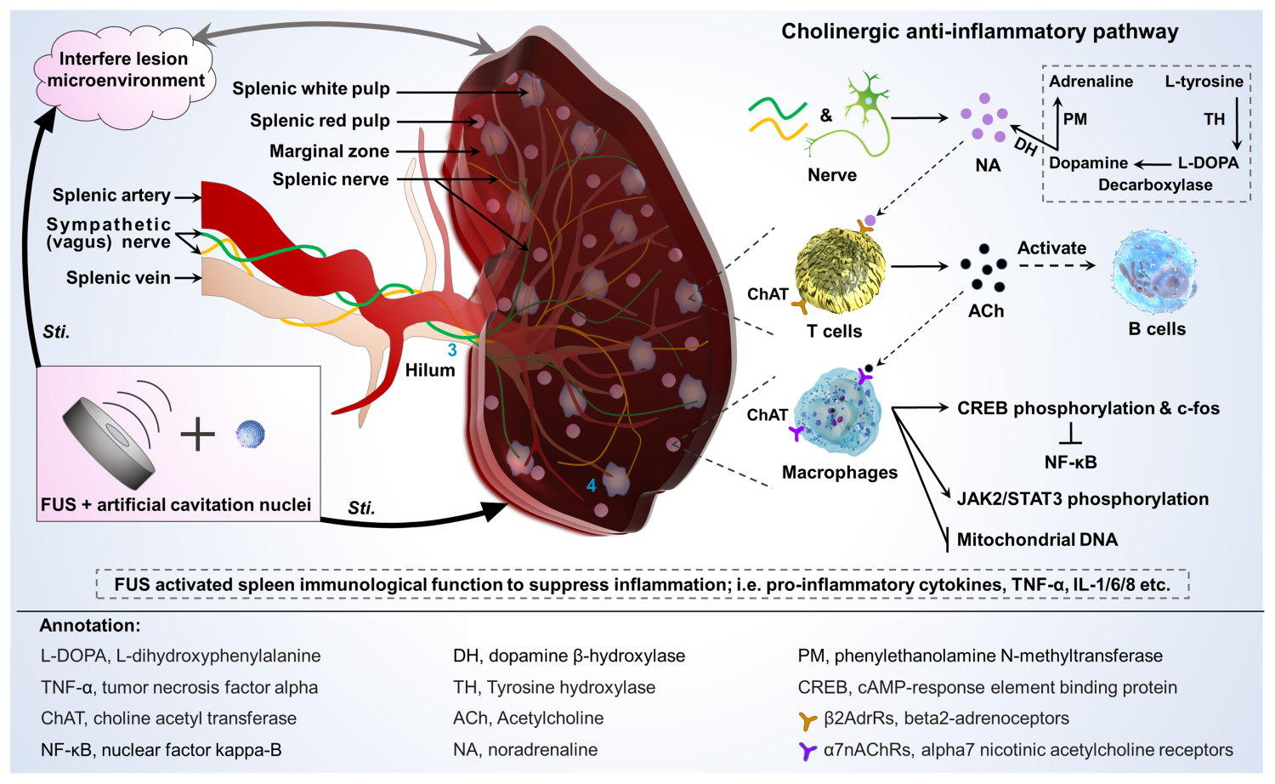
Supplementary Figure 1 Diagram of spleen structure and cholinergic signaling pathway.

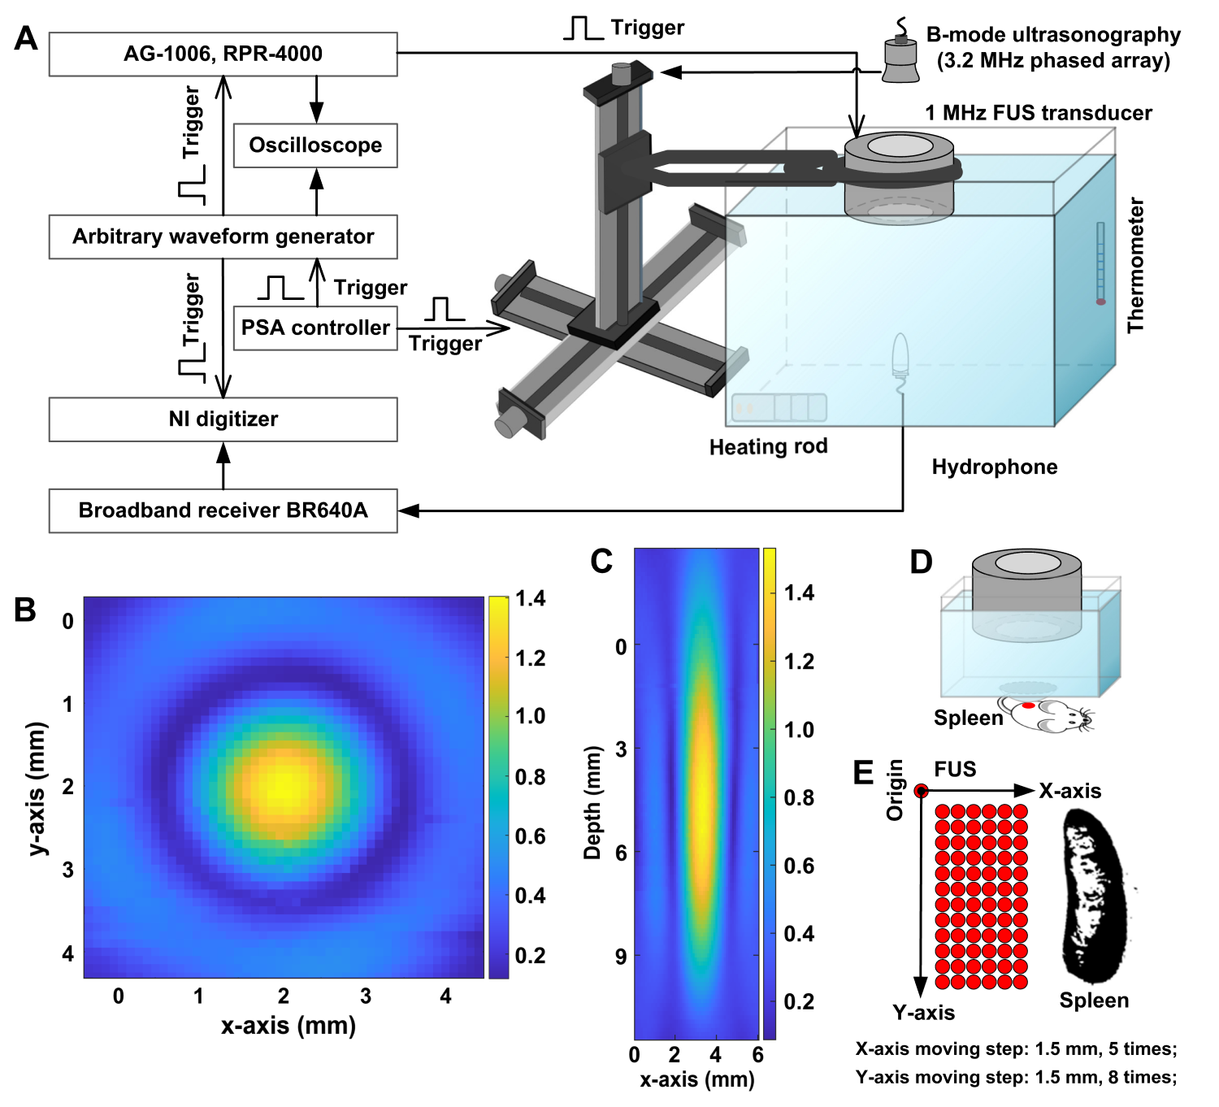
Supplementary Figure 2 The ultrasound platform applied for FUS sti. spleen to treat tumor. A, experimental setup used for acoustic field calibration. B-C, the xy and xz profile of the ultrasound focal region, respectively. D, experimental platform of FUS sti. spleen based on the device shown in figure A, except that the tank was replaced with a capsule covered with a sound permeable film at the bottom. E, motion scheme of FUS irradiation on spleen displaced by a computer-controlled XYZ motorized positioning stage.
Supplementary Figure 3 Representative FCM plots and statistical diagram of immune cell proportion in spleen. A, representative FCM plot of CD4 T cells (CD3⁺ CD4⁺ gated on CD45⁺), and corresponded quantification. B, representative FCM plot of Th1 cells (IFN-γ⁺ gated on CD3⁺ CD4⁺ CD45⁺), and corresponded quantification. C, representative FCM plot of Th2 cells (IL-4⁺ gated on CD3⁺ CD4⁺ CD45⁺), and corresponded quantification. D, representative FCM plot of Th17 cells (IL-17⁺ gated on CD3⁺ CD4⁺ CD45⁺), and corresponded quantification. E, representative FCM plot of B cells (CD19⁺ B220⁺ gated on CD3⁺ CD4⁺ CD45⁺), and corresponded quantification. F, representative FCM plot of NK cells (CD3⁻ NK1.1⁺ gated on CD45⁺), and corresponded quantification. G, representative FCM plot of CD8 T cells (CD3⁺ CD8⁺ gated on CD45⁺), and corresponded quantification. H, representative FCM plot of Mφ (CD11b⁺ F4/80⁺ gated on CD45⁺), and corresponded quantification. I, representative FCM plot of Mφ1 (CD11c⁺ CD206⁻ gated on CD11b⁺ F4/80⁺ CD45⁺) and Mφ2 (CD11c⁻ CD206⁺ gated on CD11b⁺ F4/80⁺ CD45⁺), and corresponded quantification. J, representative FCM plot of DC1 (CD8⁺ CD11b⁻ gated on total cells) and DC2 (CD8⁻ CD11b⁺ gated on total cells), and corresponded quantification. K, representative FCM plot of Treg cells (CD25⁺ Foxp3⁺ gated on CD3⁺ CD4⁺ CD45⁺), and corresponded quantification. L, representative FCM plot of M-MDSCs (LY6G⁻ LY6C⁺ gated on CD45⁺ CD11b⁺) and PMN-MDSCs (LY6G⁺ LY6C⁻ gated on CD45⁺ CD11b⁺), and corresponded quantification. (n = 6; * p ≤ 0.05; **p ≤ 0.01; ***p ≤ 0.001; mean ± SEM). S1, the control group of xenograft H22 HCC in situ; S2, FUS sti. spleen to treat orthotopic H22 HCC.

Supplementary Figure 4 Representative FCM plots and statistical diagram of immune cell proportion in blood. A, representative FCM plot of CD4 T cells (CD3⁺ CD4⁺ gated on CD45⁺), and corresponded quantification. B, representative FCM plot of Th1 cells (IFN-γ⁺ gated on CD3⁺ CD4⁺ CD45⁺), and corresponded quantification. C, representative FCM plot of Th2 cells (IL-4⁺ gated on CD3⁺ CD4⁺ CD45⁺), and corresponded quantification. D, representative FCM plot of Th17 cells (IL-17⁺ gated on CD3⁺ CD4⁺ CD45⁺), and corresponded quantification. E, representative FCM plot of B cells (CD19⁺ B220⁺ gated on CD3⁺ CD4⁺ CD45⁺), and corresponded quantification. F, representative FCM plot of NK cells (CD3⁻ NK1.1⁺ gated on CD45⁺), and corresponded quantification. G, representative FCM plot of CD8 T cells (CD3⁺ CD8⁺ gated on CD45⁺), and corresponded quantification. H, representative FCM plot of Mφ (CD11b⁺ F4/80⁺ gated on CD45⁺), and corresponded quantification. I, representative FCM plot of Mφ1 (CD11c⁺ CD206⁻ gated on CD11b⁺ F4/80⁺ CD45⁺) and Mφ2 (CD11c⁻ CD206⁺ gated on CD11b⁺ F4/80⁺ CD45⁺), and corresponded quantification. J, representative FCM plot of DC1 (CD8⁺ CD11b⁻ gated on total cells) and DC2 (CD8⁻ CD11b⁺ gated on total cells), and corresponded quantification. K, representative FCM plot of Treg cells (CD25⁺ Foxp3⁺ gated on CD3⁺ CD4⁺ CD45⁺), and corresponded quantification. L, representative FCM plot of M-MDSCs (LY6G⁻ LY6C⁺ gated on CD45⁺ CD11b⁺) and PMN-MDSCs (LY6G⁺ LY6C⁻ gated on CD45⁺ CD11b⁺), and corresponded quantification. (n = 6; * p ≤ 0.05; **p ≤ 0.01; mean ± SEM). S1, the control group of xenograft H22 HCC in situ; S2, FUS sti. spleen to treat orthotopic H22 HCC.

Supplementary Figure 5 Representative FCM plots and statistical diagram of immune cell proportion in tumor. A, representative FCM plot of CD4 T cells (CD3⁺ CD4⁺ gated on CD45⁺), and corresponded quantification. B, representative FCM plot of Th1 cells (IFN-γ⁺ gated on CD3⁺ CD4⁺ CD45⁺), and corresponded quantification. C, representative FCM plot of Th2 cells (IL-4⁺ gated on CD3⁺ CD4⁺ CD45⁺), and corresponded quantification. D, representative FCM plot of Th17 cells (IL-17⁺ gated on CD3⁺ CD4⁺ CD45⁺), and corresponded quantification. E, representative FCM plot of B cells (CD19⁺ B220⁺ gated on CD3⁺ CD4⁺ CD45⁺), and corresponded quantification. F, representative FCM plot of NK cells (CD3⁻ NK1.1⁺ gated on CD45⁺), and corresponded quantification. G, representative FCM plot of CD8 T cells (CD3⁺ CD8⁺ gated on CD45⁺), and corresponded quantification. H, representative FCM plot of Mφ (CD11b⁺ F4/80⁺ gated on CD45⁺), and corresponded quantification. I, representative FCM plot of Mφ1 (CD11c⁺ CD206⁻ gated on CD11b⁺ F4/80⁺ CD45⁺) and Mφ2 (CD11c⁻ CD206⁺ gated on CD11b⁺ F4/80⁺ CD45⁺), and corresponded quantification. J, representative FCM plot of DC1 (CD8⁺ CD11b⁻ gated on total cells) and DC2 (CD8⁻ CD11b⁺ gated on total cells), and corresponded quantification. K, representative FCM plot of Treg cells (CD25⁺ Foxp3⁺ gated on CD3⁺ CD4⁺ CD45⁺), and corresponded quantification. L, representative FCM plot of M-MDSCs (LY6G⁻ LY6C⁺ gated on CD45⁺ CD11b⁺) and PMN-MDSCs (LY6G⁺ LY6C⁻ gated on CD11b⁺ CD45⁺), and corresponded quantification. (n = 6; * p ≤ 0.05; **p ≤ 0.01; mean ± SEM). S1, the control group of xenograft H22 HCC in situ; S2, FUS sti. spleen to treat orthotopic H22 HCC.

Supplementary Figure 6 Representative FCM plots and statistical diagram of immune cell proportion in para-carcinoma tissue. A, representative FCM plot of CD4 T cells (CD3⁺ CD4⁺ gated on CD45⁺), and corresponded quantification. B, representative FCM plot of Th1 cells (IFN-γ⁺ gated on CD3⁺ CD4⁺ CD45⁺), and corresponded quantification. C, representative FCM plot of Th2 cells (IL-4⁺ gated on CD3⁺ CD4⁺ CD45⁺), and corresponded quantification. D, representative FCM plot of Th17 cells (IL-17⁺ gated on CD3⁺ CD4⁺ CD45⁺), and corresponded quantification. E, representative FCM plot of B cells (CD19⁺ B220⁺ gated on CD3⁺ CD4⁺ CD45⁺), and corresponded quantification. F, representative FCM plot of NK cells (CD3⁻ NK1.1⁺ gated on CD45⁺), and corresponded quantification. G, representative FCM plot of CD8 T cells (CD3⁺ CD8⁺ gated on CD45⁺), and corresponded quantification. H, representative FCM plot of Mφ (CD11b⁺ F4/80⁺ gated on CD45⁺), and corresponded quantification. I, representative FCM plot of Mφ1 (CD11c⁺ CD206⁻ gated on CD11b⁺ F4/80⁺ CD45⁺) and Mφ2 (CD11c⁻ CD206⁺ gated on CD11b⁺ F4/80⁺ CD45⁺), and corresponded quantification. J, representative FCM plot of DC1 (CD8⁺ CD11b⁻ gated on total cells) and DC2 (CD8⁻ CD11b⁺ gated on total cells), and corresponded quantification. K, representative FCM plot of Treg cells (CD25⁺ Foxp3⁺ gated on CD3⁺ CD4⁺ CD45⁺), and corresponded quantification. L, representative FCM plot of M-MDSCs (LY6G⁻ LY6C⁺ gated on CD45⁺ CD11b⁺) and PMN-MDSCs (LY6G⁺ LY6C⁻ gated on CD45⁺ CD11b⁺), and corresponded quantification. (n = 6; * p ≤ 0.05; **p ≤ 0.01; ***p ≤ 0.001; mean ± SEM). S1, the control group of xenograft H22 HCC in situ; S2, FUS sti. spleen to treat orthotopic H22 HCC.

Supplementary Figure 7 Representative FCM plots and statistical diagram of immune cell proportion in spleen. A, FCM plot of CD4 T cells (CD3⁺ CD4⁺ gated on CD45⁺), and corresponded quantification. B, FCM plot of Th1 cells (IFN-γ⁺ gated on CD3⁺ CD4⁺ CD45⁺), and corresponded quantification. C, FCM plot of Th2 cells (IL-4⁺ gated on CD3⁺ CD4⁺ CD45⁺), and corresponded quantification. D, FCM plot of Th17 cells (IL-17⁺ gated on CD3⁺ CD4⁺ CD45⁺), and corresponded quantification. E, FCM plot of B cells (CD19⁺ B220⁺ gated on CD3⁺ CD4⁺ CD45⁺), and corresponded quantification. F, FCM plot of NK cells (CD3⁻ NK1.1⁺ gated on CD45⁺), and corresponded quantification. G, FCM plot of CD8 T cells (CD3⁺ CD8⁺ gated on CD45⁺), and corresponded quantification. H, FCM plot of Mφ (CD11b⁺ F4/80⁺ gated on CD45⁺), and corresponded quantification. I, FCM plot of Mφ1 (CD11c⁺ CD206- gated on CD11b⁺ F4/80⁺ CD45⁺) and Mφ2 (CD11c⁻ CD206⁺ gated on CD11b⁺ F4/80⁺ CD45⁺), and corresponded quantification. J, representative FCM plot of DC1 (CD8⁺ CD11b⁻ gated on total cells) and DC2 (CD8⁻ CD11b⁺ gated on total cells), and corresponded quantification. K, representative FCM plot of Treg cells (CD25⁺ Foxp3⁺ gated on CD3⁺ CD4⁺ CD45⁺), and corresponded quantification. L, representative FCM plot of M-MDSCs (LY6G⁻ LY6C⁺ gated on CD45⁺ CD11b⁺) and PMN-MDSCs (LY6G⁺ LY6C⁻ gated on CD45⁺ CD11b⁺), and corresponded quantification. (n = 4; * p ≤ 0.05; **p ≤ 0.01; ***p ≤ 0.001; mean ± SEM). L1, the control group of xenograft Hepa1-6 HCC in situ; L2, FUS sti. spleen to treat orthotopic Hepa1-6 HCC.

Supplementary Figure 8 Representative FCM plots and statistical diagram of immune cell proportion in blood. A, FCM plot of CD4 T cells (CD3⁺ CD4⁺ gated on CD45⁺), and corresponded quantification. B, FCM plot of Th1 cells (IFN-γ⁺ gated on CD3⁺ CD4⁺ CD45⁺), and corresponded quantification. C, FCM plot of Th2 cells (IL-4⁺ gated on CD3⁺ CD4⁺ CD45⁺), and corresponded quantification. D, FCM plot of Th17 cells (IL-17⁺ gated on CD3⁺ CD4⁺ CD45⁺), and corresponded quantification. E, FCM plot of B cells (CD19⁺ B220⁺ gated on CD3⁺ CD4⁺ CD45⁺), and corresponded quantification. F, FCM plot of NK cells (CD3⁻ NK1.1⁺ gated on CD45⁺), and corresponded quantification. G, FCM plot of CD8 T cells (CD3⁺ CD8⁺ gated on CD45⁺), and corresponded quantification. H, FCM plot of Mφ (CD11b⁺ F4/80⁺ gated on CD45⁺), and corresponded quantification. I, FCM plot of Mφ1 (CD11c⁺ CD206⁻ gated on CD11b⁺ F4/80⁺ CD45⁺) and Mφ2 (CD11c⁻ CD206⁺ gated on CD11b⁺ F4/80⁺ CD45⁺), and corresponded quantification. J, representative FCM plot of DC1 (CD8⁺ CD11b⁻ gated on total cells) and DC2 (CD8⁻ CD11b⁺ gated on total cells), and corresponded quantification. K, representative FCM plot of Treg cells (CD25⁺ Foxp3⁺ gated on CD3⁺ CD4⁺ CD45⁺), and corresponded quantification. L, representative FCM plot of M-MDSCs (LY6G⁻ LY6C⁺ gated on CD45⁺ CD11b⁺) and PMN-MDSCs (LY6G⁺ LY6C⁻ gated on CD45⁺ CD11b⁺), and corresponded quantification. (n = 4; * p ≤ 0.05; **p ≤ 0.01; mean ± SEM) L1, the control group of xenograft Hepa1-6 HCC in situ; L2, FUS sti. spleen to treat orthotopic Hepa1-6 HCC.

Supplementary Figure 9 Representative FCM plots and statistical diagram of immune cell proportion in tumor. A, FCM plot of CD4 T cells (CD3⁺ CD4⁺ gated on CD45⁺), and corresponded quantification. B, FCM plot of Th1 cells (IFN-γ⁺ gated on CD3⁺ CD4⁺ CD45⁺), and corresponded quantification. C, FCM plot of Th2 cells (IL-4⁺ gated on CD3⁺ CD4⁺ CD45⁺), and corresponded quantification. D, FCM plot of Th17 cells (IL-17⁺ gated on CD3⁺ CD4⁺ CD45⁺), and corresponded quantification. E, FCM plot of B cells (CD19⁺ B220⁺ gated on CD3⁺ CD4⁺ CD45⁺), and corresponded quantification. F, FCM plot of NK cells (CD3⁻ NK1.1⁺ gated on CD45⁺), and corresponded quantification. G, FCM plot of CD8 T cells (CD3⁺ CD8⁺ gated on CD45⁺), and corresponded quantification. H, FCM plot of Mφ (CD11b⁺ F4/80⁺ gated on CD45⁺), and corresponded quantification. I, FCM plot of Mφ1 (CD11c⁺ CD206⁻ gated on CD11b⁺ F4/80⁺ CD45⁺) and Mφ2 (CD11c⁻ CD206⁺ gated on CD11b⁺ F4/80⁺ CD45⁺), and corresponded quantification. J, representative FCM plot of DC1 (CD8⁺ CD11b⁻ gated on total cells) and DC2 (CD8⁻ CD11b⁺ gated on total cells), and corresponded quantification. K, representative FCM plot of Treg cells (CD25⁺ Foxp3⁺ gated on CD3⁺ CD4⁺ CD45⁺), and corresponded quantification. L, representative FCM plot of M-MDSCs (LY6G⁻ LY6C⁺ gated on CD45⁺ CD11b⁺) and PMN-MDSCs (LY6G⁺ LY6C⁻ gated on CD45⁺ CD11b⁺), and corresponded quantification. (n = 4; * p ≤ 0.05; **p ≤ 0.01; mean ± SEM). L1, the control group of xenograft Hepa1-6 HCC in situ; L2, FUS sti. spleen to treat orthotopic Hepa1-6 HCC.

Supplementary Figure 10 Representative FCM plots and statistical diagram of immune cell proportion in para-carcinoma tissue. A, FCM plot of CD4 T cells (CD3⁺ CD4⁺ gated on CD45⁺), and corresponded quantification. B, FCM plot of Th1 cells (IFN-γ⁺ gated on CD3⁺ CD4⁺ CD45⁺), and corresponded quantification. C, FCM plot of Th2 cells (IL-4⁺ gated on CD3⁺ CD4⁺ CD45⁺), and corresponded quantification. D, FCM plot of Th17 cells (IL-17⁺ gated on CD3⁺ CD4⁺ CD45⁺), and corresponded quantification. E, FCM plot of B cells (CD19⁺B220⁺ gated on CD3⁺ CD4⁺ CD45⁺), and corresponded quantification. F, FCM plot of NK cells (CD3⁻ NK1.1⁺ gated on CD45⁺), and corresponded quantification. G, FCM plot of CD8 T cells (CD3⁺ CD8⁺ gated on CD45⁺), and corresponded quantification. H, FCM plot of Mφ (CD11b⁺ F4/80⁺ gated on CD45⁺), and corresponded quantification. I, FCM plot of Mφ1 (CD11c⁺ CD206⁻ gated on CD11b⁺ F4/80⁺ CD45⁺) and Mφ2 (CD11c⁻ CD206⁺ gated on CD11b⁺ F4/80⁺ CD45⁺), and corresponded quantification. J, representative FCM plot of DC1 (CD8⁺ CD11b⁻ gated on total cells) and DC2 (CD8⁻ CD11b⁺ gated on total cells), and corresponded quantification. K, representative FCM plot of Treg cells (CD25⁺ Foxp3⁺ gated on CD3⁺ CD4⁺ CD45⁺), and corresponded quantification. L, representative FCM plot of M-MDSCs (LY6G⁻ LY6C⁺ gated on CD45⁺ CD11b⁺) and PMN-MDSCs (LY6G⁺ LY6C⁻ gated on CD45⁺ CD11b⁺), and corresponded quantification. (n = 4; * p ≤ 0.05; **p ≤ 0.01; mean ± SEM). L1, the control group of xenograft Hepa1-6 HCC in situ; L2, FUS sti. spleen to treat orthotopic Hepa1-6 HCC.
Supplementary Figure 11 Representative FCM plots and statistical diagram of immune cell proportion in spleen. A, representative FCM plot of NK cells (CD3⁻ NK1.1⁺ gated on CD45⁺), and corresponded quantification. B, representative FCM plot of CD8 T cells (CD3⁺ CD8⁺ gated on CD45⁺), and corresponded quantification. C, representative FCM plot of Treg cells (CD25⁺ Foxp3⁺ gated on CD3⁺ CD4⁺ CD45⁺), and corresponded quantification. D, representative FCM plot of Mφ (CD11b⁺ F4/80⁺ gated on CD45⁺), and corresponded quantification. E, representative FCM plot of Mφ1 (CD11c⁺ CD206⁻ gated on CD11b⁺ F4/80⁺ CD45⁺) and Mφ2 (CD11c⁻ CD206⁺ gated on CD11b⁺ F4/80⁺ CD45⁺), and corresponded quantification. F, representative FCM plot of DC1 (CD8⁺ CD11b⁻ gated on total cells) and DC2 (CD8⁻ CD11b⁺ gated on total cells), and corresponded quantification. G, representative FCM plot of M-MDSCs (LY6G⁻ LY6C⁺ gated on CD45⁺ CD11b⁺) and PMN-MDSCs (LY6G⁺ LY6C⁻ gated on CD45⁺ CD11b⁺), and corresponded quantification. (n = 4; * p ≤ 0.05; **p ≤ 0.01; ***p ≤ 0.001; mean ± SEM). Q1, the control group of xenograft H22 HCC in situ; Q2, FUS sti. spleen; Q3, injection of propranolol hydrochloride to block CAP; Q4, FUS sti. spleen after injection of propranolol hydrochloride; Q5, NK cell clearance; Q6, FUS sti. spleen after NK cell depletion; Q7, CD8 T cell clearance; Q8, FUS sti. spleen after CD8 T cell depletion.

Supplementary Figure 12 Representative FCM plots and statistical diagram of immune cell proportion in blood. A, representative FCM plot of NK cells (CD3⁻ NK1.1⁺ gated on CD45⁺), and corresponded quantification. B, representative FCM plot of CD8 T cells (CD3⁺ CD8⁺ gated on CD45⁺), and corresponded quantification. C, representative FCM plot of Treg cells (CD25⁺ Foxp3⁺ gated on CD3⁺ CD4⁺ CD45⁺), and corresponded quantification. D, representative FCM plot of Mφ (CD11b⁺ F4/80⁺ gated on CD45⁺), and corresponded quantification. E, representative FCM plot of Mφ1 (CD11c⁺ CD206⁻ gated on CD11b⁺ F4/80⁺ CD45⁺) and Mφ2 (CD11c⁻ CD206⁺ gated on CD11b⁺ F4/80⁺ CD45⁺), and corresponded quantification. F, representative FCM plot of DC1 (CD8⁺ CD11b⁻ gated on total cells) and DC2 (CD8⁻ CD11b⁺ gated on total cells), and corresponded quantification. G, representative FCM plot of M-MDSCs (LY6G⁻ LY6C⁺ gated on CD45⁺ CD11b⁺) and PMN-MDSCs (LY6G⁺ LY6C⁻ gated on CD45⁺ CD11b⁺), and corresponded quantification. (n = 4; * p ≤ 0.05; **p ≤ 0.01; ***p ≤ 0.001; mean ± SEM). Q1, the control group of xenograft H22 HCC in situ; Q2, FUS sti. spleen; Q3, injection of propranolol hydrochloride to block CAP; Q4, FUS sti. spleen after injection of propranolol hydrochloride; Q5, NK cell clearance; Q6, FUS sti. spleen after NK cell depletion; Q7, CD8 T cell clearance; Q8, FUS sti. spleen after CD8 T cell depletion.

Supplementary Figure 13 Representative FCM plots and statistical diagram of immune cell proportion in tumor. A, representative FCM plot of NK cells (CD3⁻ NK1.1⁺ gated on CD45⁺), and corresponded quantification. B, representative FCM plot of CD8 T cells (CD3⁺ CD8⁺ gated on CD45⁺), and corresponded quantification. C, representative FCM plot of Treg cells (CD25⁺ Foxp3⁺ gated on CD3⁺ CD4⁺ CD45⁺), and corresponded quantification. D, representative FCM plot of Mφ (CD11b⁺ F4/80⁺ gated on CD45⁺), and corresponded quantification. E, representative FCM plot of Mφ1 (CD11c⁺ CD206⁻ gated on CD11b⁺ F4/80⁺ CD45⁺) and Mφ2 (CD11c⁻ CD206⁺ gated on CD11b⁺ F4/80⁺ CD45⁺), and corresponded quantification. F, representative FCM plot of DC1 (CD8⁺ CD11b⁻ gated on total cells) and DC2 (CD8⁻ CD11b⁺ gated on total cells), and corresponded quantification. G, representative FCM plot of M-MDSCs (LY6G⁻ LY6C⁺ gated on CD45⁺ CD11b⁺) and PMN-MDSCs (LY6G⁺ LY6C⁻ gated on CD45⁺ CD11b⁺), and corresponded quantification. (n = 4; * p ≤ 0.05; **p ≤ 0.01; ***p ≤ 0.001; mean ± SEM). Q1, the control group of xenograft H22 HCC in situ; Q2, FUS sti. spleen; Q3, injection of propranolol hydrochloride to block CAP; Q4, FUS sti. spleen after injection of propranolol hydrochloride; Q5, NK cell clearance; Q6, FUS sti. spleen after NK cell depletion; Q7, CD8 T cell clearance; Q8, FUS sti. spleen after CD8 T cell depletion.

Supplementary Figure 14 Representative FCM plots and statistical diagram of immune cell proportion in para-carcinoma tissue. A, representative FCM plot of NK cells (CD3⁻ NK1.1⁺ gated on CD45⁺), and corresponded quantification. B, representative FCM plot of CD8 T cells (CD3⁺ CD8⁺ gated on CD45⁺), and corresponded quantification. C, representative FCM plot of Treg cells (CD25⁺ Foxp3⁺ gated on CD3⁺ CD4⁺ CD45⁺), and corresponded quantification. D, representative FCM plot of Mφ (CD11b⁺ F4/80⁺ gated on CD45⁺), and corresponded quantification. E, representative FCM plot of Mφ1 (CD11c⁺ CD206⁻ gated on CD11b⁺ F4/80⁺ CD45⁺) and Mφ2 (CD11c⁻ CD206⁺ gated on CD11b⁺ F4/80⁺ CD45⁺), and corresponded quantification. F, representative FCM plot of DC1 (CD8⁺ CD11b⁻ gated on total cells) and DC2 (CD8⁻ CD11b⁺ gated on total cells), and corresponded quantification. G, representative FCM plot of M-MDSCs (LY6G⁻ LY6C⁺ gated on CD45⁺ CD11b⁺) and PMN-MDSCs (LY6G⁺ LY6C⁻ gated on CD45⁺ CD11b⁺), and corresponded quantification. (n = 4; * p ≤ 0.05; **p ≤ 0.01; ***p ≤ 0.001; mean ± SEM). Q1, the control group of xenograft H22 HCC in situ; Q2, FUS sti. spleen; Q3, injection of propranolol hydrochloride to block CAP; Q4, FUS sti. spleen after injection of propranolol hydrochloride; Q5, NK cell clearance; Q6, FUS sti. spleen after NK cell depletion; Q7, CD8 T cell clearance; Q8, FUS sti. spleen after CD8 T cell depletion.

Supplementary Figure 15 Representative FCM plots and statistical diagram of immune cell proportion in spleen. A, representative FCM plot of NK cells (CD3⁻ NK1.1⁺ gated on CD45⁺), and corresponded quantification. B, representative FCM plot of CD8 T cells (CD3⁺ CD8⁺ gated on CD45⁺), and corresponded quantification. C, representative FCM plot of Treg cells (CD25⁺ Foxp3⁺ gated on CD3⁺ CD4⁺ CD45⁺), and corresponded quantification. D, representative FCM plot of Mφ (CD11b⁺ F4/80⁺ gated on CD45⁺), and corresponded quantification. E, representative FCM plot of Mφ1 (CD11c⁺ CD206⁻ gated on CD11b⁺ F4/80⁺ CD45⁺) and Mφ2 (CD11c⁻ CD206⁺ gated on CD11b⁺ F4/80⁺ CD45⁺), and corresponded quantification. F, representative FCM plot of DC1 (⁻CD8⁺ CD11b⁻ gated on total cells) and DC2 (CD8⁻ CD11b⁺ gated on total cells), and corresponded quantification. G, representative FCM plot of M-MDSCs (LY6G⁻ LY6C⁺ gated on CD45⁺ CD11b⁺) and PMN-MDSCs (LY6G⁺ LY6C⁻ gated on CD45⁺ CD11b⁺), and corresponded quantification. (n = 4; * p ≤ 0.05; **p ≤ 0.01; mean ± SEM). H1, the control group of xenograft H22 HCC in situ; H2, FUS sti. spleen; H3, splenic nerve denervation by absolute ethanol; H4, FUS sti. spleen after splenic nerve denervation.
Supplementary Figure 16 Representative FCM plots and statistical diagram of immune cell proportion in blood. A, representative FCM plot of NK cells (CD3⁻ NK1.1⁺ gated on CD45⁺), and corresponded quantification. B, representative FCM plot of CD8 T cells (CD3⁺ CD8⁺ gated on CD45⁺), and corresponded quantification. C, representative FCM plot of Treg cells (CD25⁺ Foxp3⁺ gated on CD3⁺ CD4⁺ CD45⁺), and corresponded quantification. D, representative FCM plot of Mφ (CD11b⁺ F4/80⁺ gated on CD45⁺), and corresponded quantification. E, representative FCM plot of Mφ1 (CD11c⁺ CD206⁻ gated on CD11b⁺ F4/80⁺ CD45⁺) and Mφ2 (CD11c⁻ CD206⁺ gated on CD11b⁺ F4/80⁺ CD45⁺), and corresponded quantification. F, representative FCM plot of DC1 (⁻CD8⁺ CD11b⁻ gated on total cells) and DC2 (CD8⁻ CD11b⁺ gated on total cells), and corresponded quantification. G, representative FCM plot of M-MDSCs (LY6G⁻ LY6C⁺ gated on CD45⁺ CD11b⁺) and PMN-MDSCs (LY6G⁺ LY6C⁻ gated on CD45⁺ CD11b⁺), and corresponded quantification. (n = 4; * p ≤ 0.05; **p ≤ 0.01; ***p ≤ 0.001; mean ± SEM). H1, the control group of xenograft H22 HCC in situ; H2, FUS sti. spleen; H3, splenic nerve denervation by absolute ethanol; H4, FUS sti. spleen after splenic nerve denervation. H5, removal of the spleen; H6, FUS stimulated the splenic position after splenectomy.
Supplementary Figure 17 Representative FCM plots and statistical diagram of immune cell proportion in tumor. A, representative FCM plot of NK cells (CD3⁻ NK1.1⁺ gated on CD45⁺), and corresponded quantification. B, representative FCM plot of CD8 T cells (CD3⁺ CD8⁺ gated on CD45⁺), and corresponded quantification. C, representative FCM plot of Treg cells (CD25⁺ Foxp3⁺ gated on CD3⁺ CD4⁺ CD45⁺), and corresponded quantification. D, representative FCM plot of Mφ (CD11b⁺ F4/80⁺ gated on CD45⁺), and corresponded quantification. E, representative FCM plot of Mφ1 (CD11c⁺ CD206⁻ gated on CD11b⁺ F4/80⁺ CD45⁺) and Mφ2 (CD11c⁻ CD206⁺ gated on CD11b⁺ F4/80⁺ CD45⁺), and corresponded quantification. F, representative FCM plot of DC1 (⁻CD8⁺ CD11b⁻ gated on total cells) and DC2 (CD8⁻ CD11b⁺ gated on total cells), and corresponded quantification. G, representative FCM plot of M-MDSCs (LY6G⁻ LY6C⁺ gated on CD45⁺ CD11b⁺) and PMN-MDSCs (LY6G⁺ LY6C⁻ gated on CD45⁺ CD11b⁺), and corresponded quantification. (n = 4; * p ≤ 0.05; **p ≤ 0.01; ***p ≤ 0.001; mean ± SEM). H1, the control group of xenograft H22 HCC in situ; H2, FUS sti. spleen; H3, splenic nerve denervation by absolute ethanol; H4, FUS sti. spleen after splenic nerve denervation. H5, removal of the spleen; H6, FUS stimulated the splenic position after splenectomy.
Supplementary Figure 18 Representative FCM plots and statistical diagram of immune cell proportion in para-carcinoma tissue. A, representative FCM plot of NK cells (CD3⁻ NK1.1⁺ gated on CD45⁺), and corresponded quantification. B, representative FCM plot of CD8 T cells (CD3⁺ CD8⁺ gated on CD45⁺), and corresponded quantification. C, representative FCM plot of Treg cells (CD25⁺ Foxp3⁺ gated on CD3⁺ CD4⁺ CD45⁺), and corresponded quantification. D, representative FCM plot of Mφ (CD11b⁺ F4/80⁺ gated on CD45⁺), and corresponded quantification. E, representative FCM plot of Mφ1 (CD11c⁺ CD206⁻ gated on CD11b⁺ F4/80⁺ CD45⁺) and Mφ2 (CD11c⁻ CD206⁺ gated on CD11b⁺ F4/80⁺ CD45⁺), and corresponded quantification. F, representative FCM plot of DC1 (⁻CD8⁺ CD11b⁻ gated on total cells) and DC2 (CD8⁻ CD11b⁺ gated on total cells), and corresponded quantification. G, representative FCM plot of M-MDSCs (LY6G⁻ LY6C⁺ gated on CD45⁺ CD11b⁺) and PMN-MDSCs (LY6G⁺ LY6C⁻ gated on CD45⁺ CD11b⁺), and corresponded quantification. (n = 4; * p ≤ 0.05; **p ≤ 0.01; ***p ≤ 0.001; mean ± SEM). H1, the control group of xenograft H22 HCC in situ; H2, FUS sti. spleen; H3, splenic nerve denervation by absolute ethanol; H4, FUS sti. spleen after splenic nerve denervation. H5, removal of the spleen; H6, FUS stimulated the splenic position after splenectomy.
Supplementary Figure 19 FUS sti. spleen for tumor suppression after depleting PMN-MDSCs. A, images of spleen and orthotopic H22 tumor. B, tumor volume. C, tumor weight. D, liver weight. E, mice weight. F, spleen weight. G, splenic index. (n = 10; * p ≤ 0.05; **p ≤ 0.01; ***p ≤ 0.001; mean ± SEM). H, FCM results of PMN-MDSCs, NK cells, CD8 T cells, Mφ and Mφ2 in the spleen; I, FCM results of PMN-MDSCs, NK cells, CD8 T cells, Mφ and Mφ2 in the blood; J, FCM results of PMN-MDSCs, NK cells, CD8 T cells, Mφ and Mφ2 in the tumor; K, FCM results of PMN-MDSCs, NK cells, CD8 T cells, Mφ and Mφ2 in para-carcinoma tissue. (n = 6; * p ≤ 0.05; **p ≤ 0.01; ***p ≤ 0.001; mean ± SEM). R1, control group of xenograft H22 carcinoma in situ; R2, group subjected to FUS sti. spleen; R3, group subjected to PMN-MDSCs depletion; R4, group subjected to FUS sti. spleen after PMN-MDSCs clearance. Representative FCM plots and statistical diagram of immune cells in the R1-4 groups are shown in Supplementary Figure 25-28.

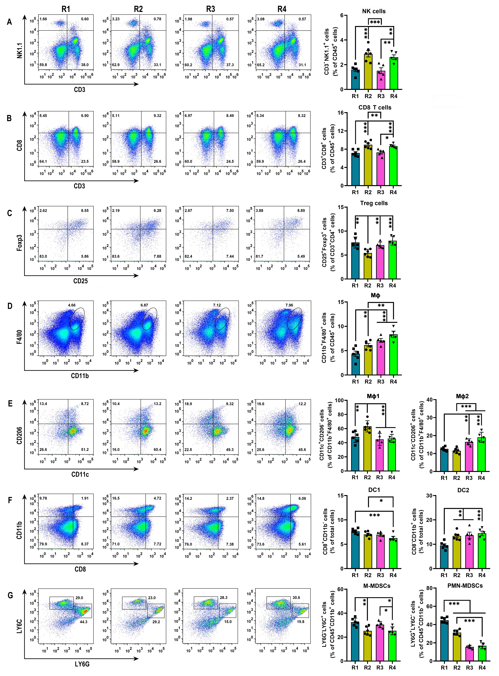
Supplementary Figure 20 Representative FCM plots and statistical diagram of immune cell proportion in spleen. A, representative FCM plot of NK cells (CD3⁻ NK1.1⁺ gated on CD45⁺), and corresponded quantification. B, representative FCM plot of CD8 T cells (CD3⁺ CD8⁺ gated on CD45⁺), and corresponded quantification. C, representative FCM plot of Treg cells (CD25⁺ Foxp3⁺ gated on CD3⁺ CD4⁺ CD45⁺), and corresponded quantification. D, representative FCM plot of Mφ (CD11b⁺ F4/80⁺ gated on CD45⁺), and corresponded quantification. E, representative FCM plot of Mφ1 (CD11c⁺ CD206⁻ gated on CD11b⁺ F4/80⁺ CD45⁺) and Mφ2 (CD11c⁻ CD206⁺ gated on CD11b⁺ F4/80⁺ CD45⁺), and corresponded quantification. F, representative FCM plot of DC1 (⁻CD8⁺ CD11b⁻ gated on total cells) and DC2 (CD8⁻ CD11b⁺ gated on total cells), and corresponded quantification. G, representative FCM plot of M-MDSCs (LY6G⁻ LY6C⁺ gated on CD45⁺ CD11b⁺) and PMN-MDSCs (LY6G⁺ LY6C⁻ gated on CD45⁺ CD11b⁺), and corresponded quantification. (n = 5; * p ≤ 0.05; **p ≤ 0.01; ***p ≤ 0.001; mean ± SEM). R1, the control group of xenograft H22 carcinoma in situ; R2, the group subjected to FUS sti. spleen; R3, the group administered to PMN-MDSCs depletion; R4, the group performed with FUS sti. spleen after PMN-MDSCs clearance.
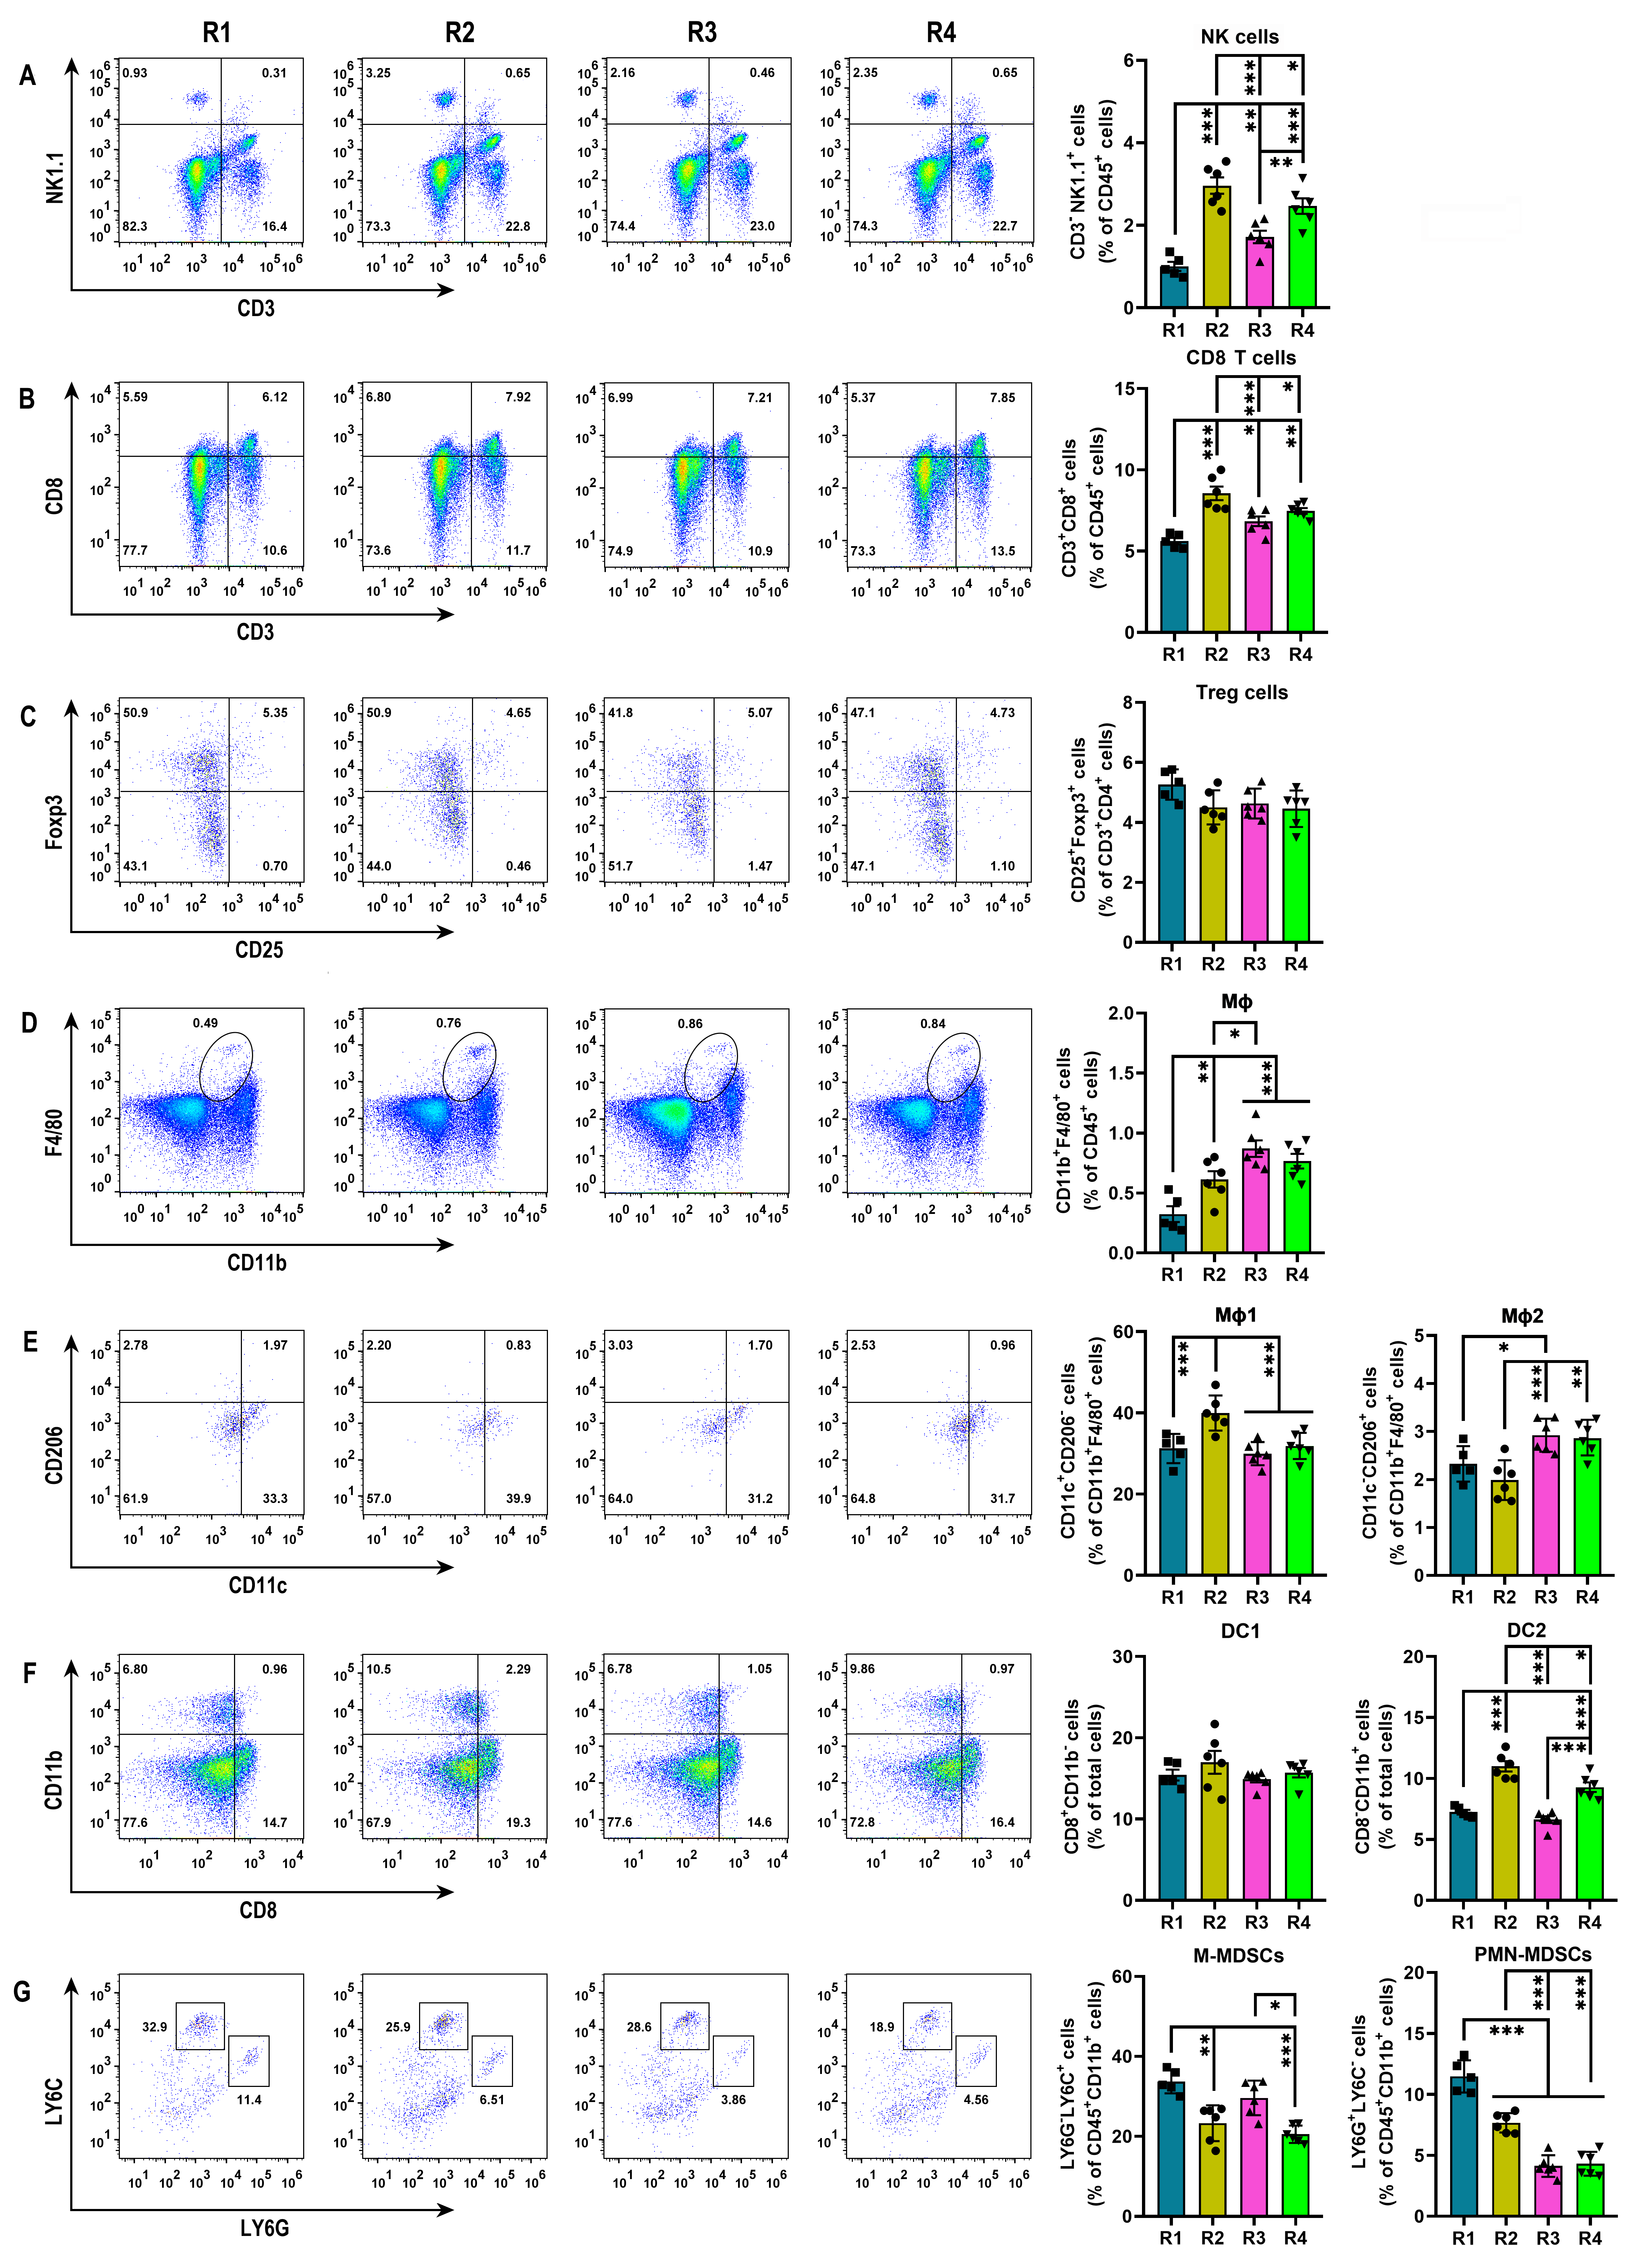
Supplementary Figure 21 Representative FCM plots and statistical diagram of immune cell proportion in blood. A, representative FCM plot of NK cells (CD3⁻ NK1.1⁺ gated on CD45⁺), and corresponded quantification. B, representative FCM plot of CD8 T cells (CD3⁺ CD8⁺ gated on CD45⁺), and corresponded quantification. C, representative FCM plot of Treg cells (CD25⁺ Foxp3⁺ gated on CD3⁺ CD4⁺ CD45⁺), and corresponded quantification. D, representative FCM plot of Mφ (CD11b⁺ F4/80⁺ gated on CD45⁺), and corresponded quantification. E, representative FCM plot of Mφ1 (CD11c⁺ CD206⁻ gated on CD11b⁺ F4/80⁺ CD45⁺) and Mφ2 (CD11c⁻ CD206⁺ gated on CD11b⁺ F4/80⁺ CD45⁺), and corresponded quantification. F, representative FCM plot of DC1 (⁻CD8⁺ CD11b⁻ gated on total cells) and DC2 (CD8⁻ CD11b⁺ gated on total cells), and corresponded quantification. G, representative FCM plot of M-MDSCs (LY6G⁻ LY6C⁺ gated on CD45⁺ CD11b⁺) and PMN-MDSCs (LY6G⁺ LY6C⁻ gated on CD45⁺ CD11b⁺), and corresponded quantification. (n = 5; * p ≤ 0.05; **p ≤ 0.01; ***p ≤ 0.001; mean ± SEM). R1, the control group of xenograft H22 carcinoma in situ; R2, the group subjected to FUS sti. spleen; R3, the group administered to PMN-MDSCs depletion; R4, the group performed with FUS sti. spleen after PMN-MDSCs clearance.
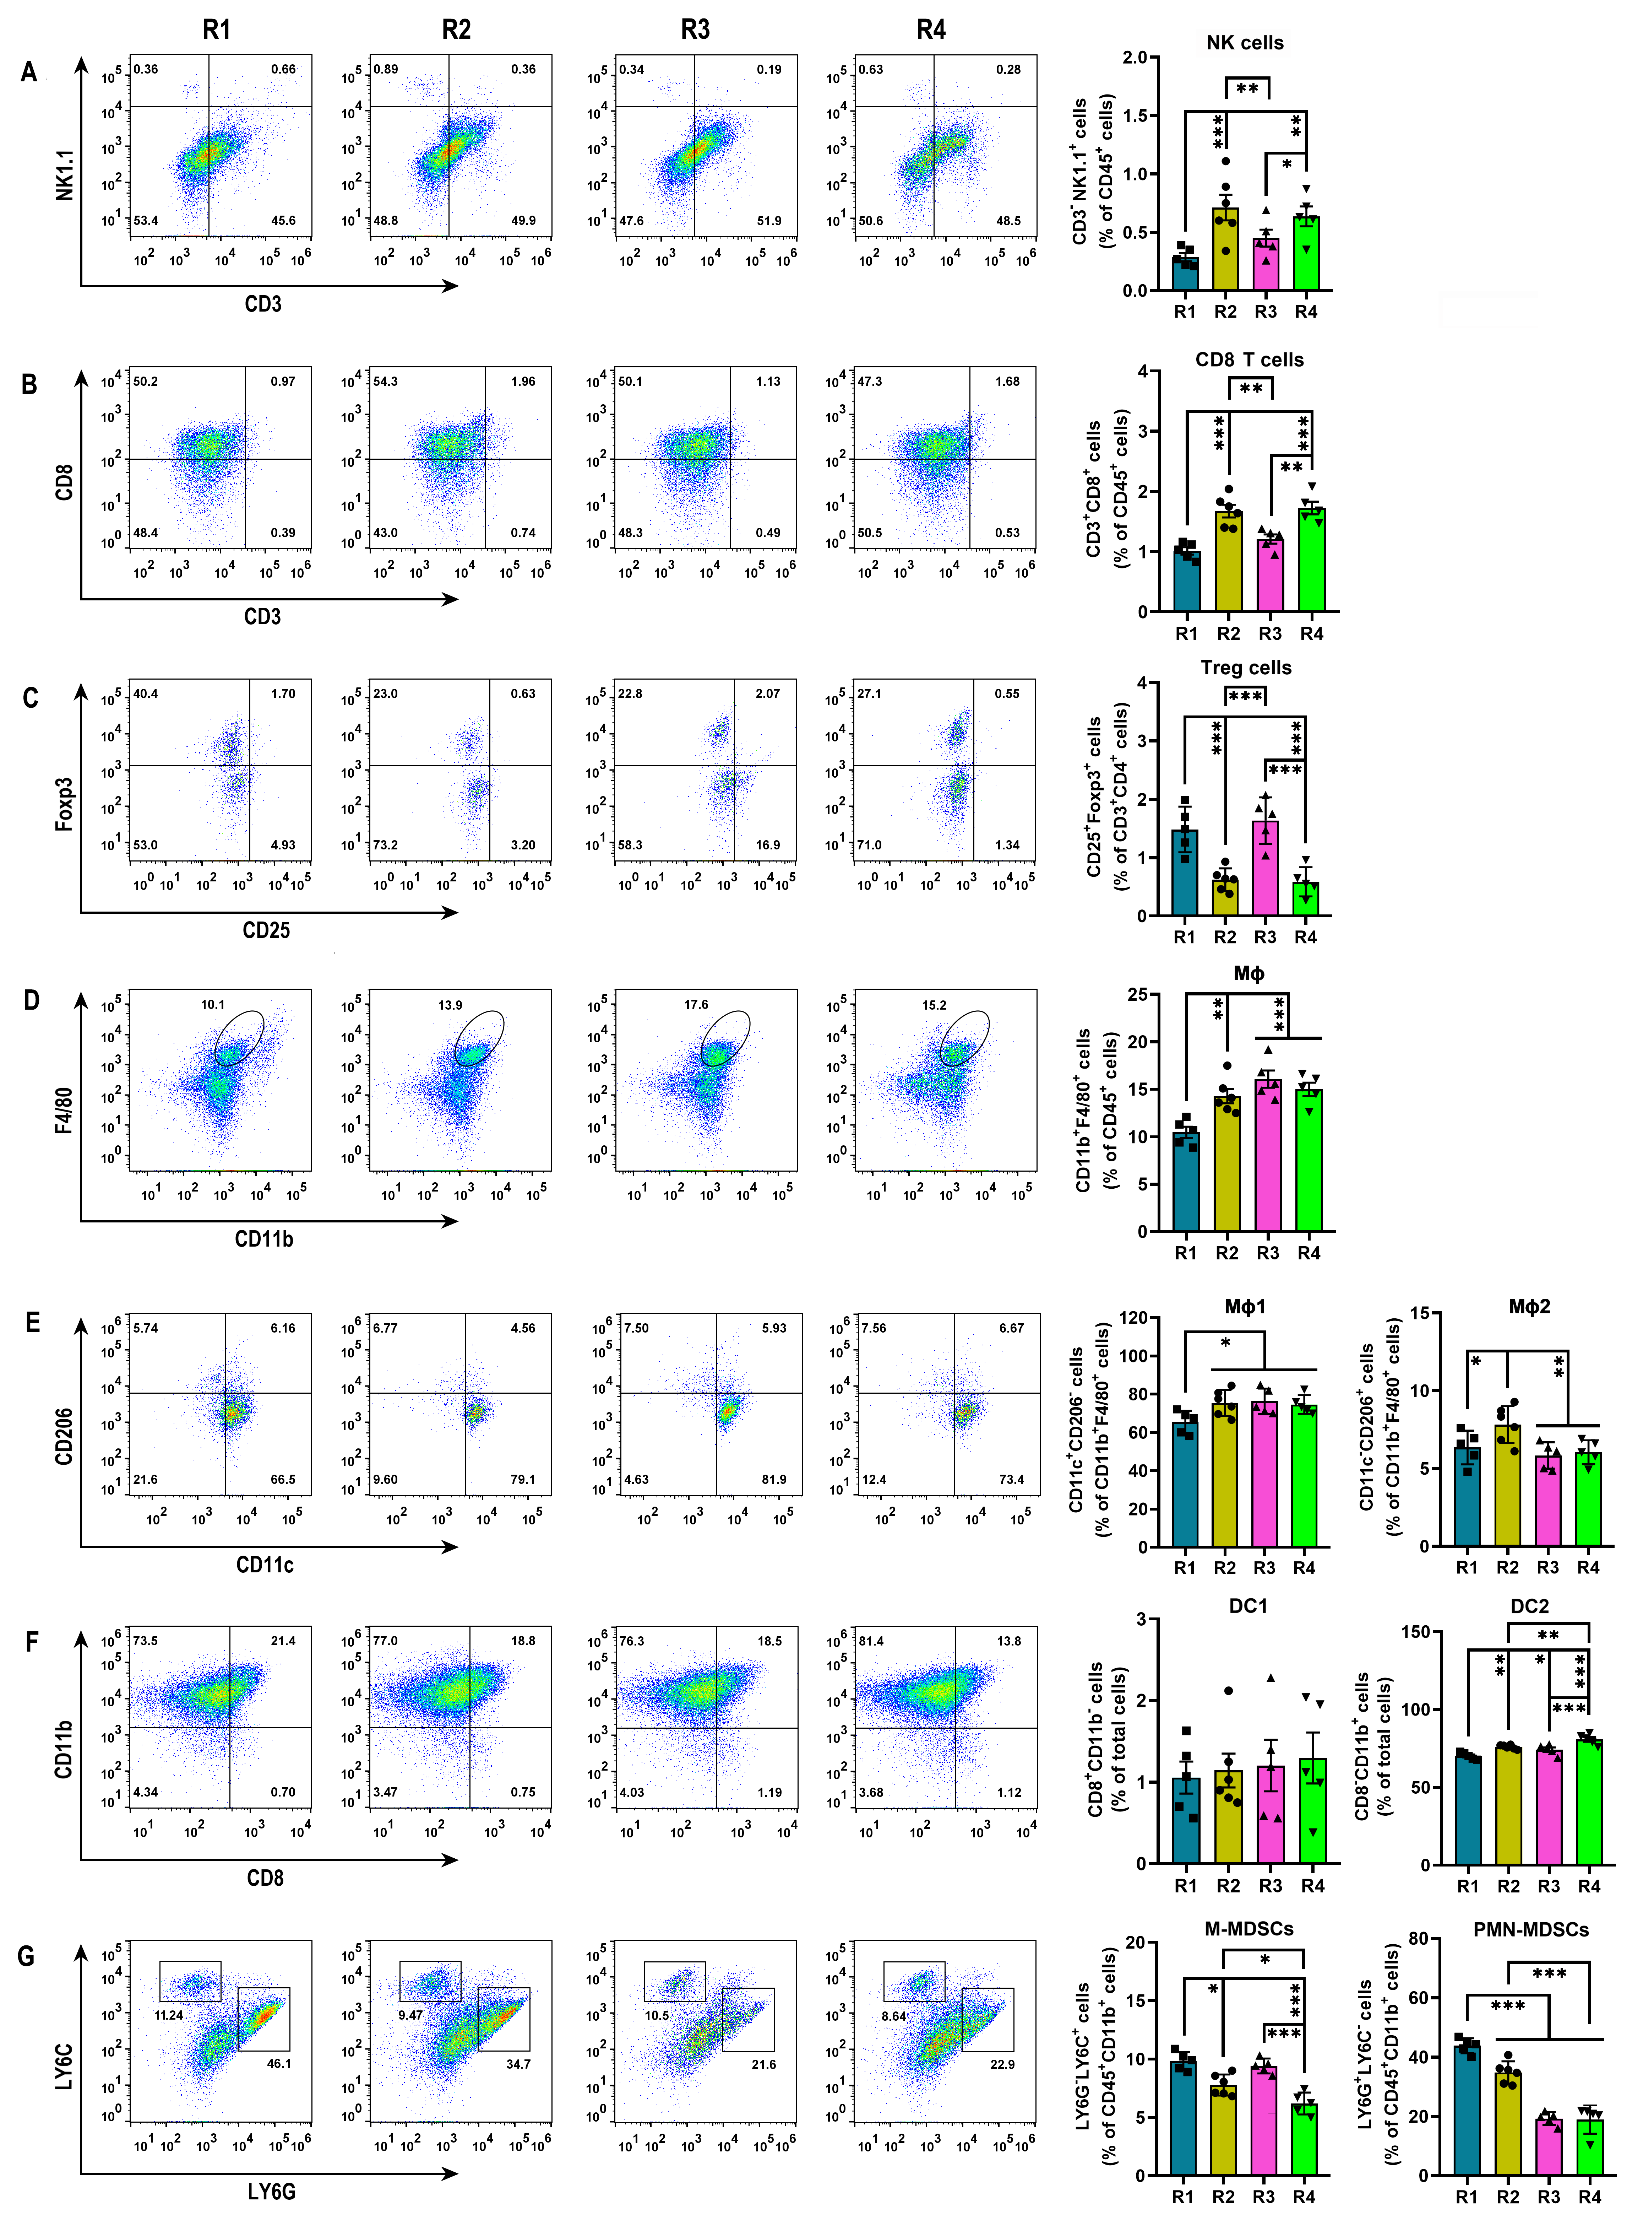
Supplementary Figure 22 Representative FCM plots and statistical diagram of immune cell proportion in tumor. A, representative FCM plot of NK cells (CD3⁻ NK1.1⁺ gated on CD45⁺), and corresponded quantification. B, representative FCM plot of CD8 T cells (CD3⁺ CD8⁺ gated on CD45⁺), and corresponded quantification. C, representative FCM plot of Treg cells (CD25⁺ Foxp3⁺ gated on CD3⁺ CD4⁺ CD45⁺), and corresponded quantification. D, representative FCM plot of Mφ (CD11b⁺ F4/80⁺ gated on CD45⁺), and corresponded quantification. E, representative FCM plot of Mφ1 (CD11c⁺ CD206⁻ gated on CD11b⁺ F4/80⁺ CD45⁺) and Mφ2 (CD11c⁻ CD206⁺ gated on CD11b⁺ F4/80⁺ CD45⁺), and corresponded quantification. F, representative FCM plot of DC1 (⁻CD8⁺ CD11b⁻ gated on total cells) and DC2 (CD8⁻ CD11b⁺ gated on total cells), and corresponded quantification. G, representative FCM plot of M-MDSCs (LY6G⁻ LY6C⁺ gated on CD45⁺ CD11b⁺) and PMN-MDSCs (LY6G⁺ LY6C⁻ gated on CD45⁺ CD11b⁺), and corresponded quantification. (n = 5; * p ≤ 0.05; **p ≤ 0.01; ***p ≤ 0.001; mean ± SEM). R1, the control group of xenograft H22 carcinoma in situ; R2, the group subjected to FUS sti. spleen; R3, the group administered to PMN-MDSCs depletion; R4, the group performed with FUS sti. spleen after PMN-MDSCs clearance.
Supplementary Figure 23 Representative FCM plots and statistical diagram of immune cell proportion in para-carcinoma tissue. A, representative FCM plot of NK cells (CD3⁻ NK1.1⁺ gated on CD45⁺), and corresponded quantification. B, representative FCM plot of CD8 T cells (CD3⁺ CD8⁺ gated on CD45⁺), and corresponded quantification. C, representative FCM plot of Treg cells (CD25⁺ Foxp3⁺ gated on CD3⁺ CD4⁺ CD45⁺), and corresponded quantification. D, representative FCM plot of Mφ (CD11b⁺ F4/80⁺ gated on CD45⁺), and corresponded quantification. E, representative FCM plot of Mφ1 (CD11c⁺ CD206⁻ gated on CD11b⁺ F4/80⁺ CD45⁺) and Mφ2 (CD11c⁻ CD206⁺ gated on CD11b⁺ F4/80⁺ CD45⁺), and corresponded quantification. F, representative FCM plot of DC1 (⁻CD8⁺ CD11b⁻ gated on total cells) and DC2 (CD8⁻ CD11b⁺ gated on total cells), and corresponded quantification. G, representative FCM plot of M-MDSCs (LY6G⁻ LY6C⁺ gated on CD45⁺ CD11b⁺) and PMN-MDSCs (LY6G⁺ LY6C⁻ gated on CD45⁺ CD11b⁺), and corresponded quantification. (n = 5; * p ≤ 0.05; **p ≤ 0.01; ***p ≤ 0.001; mean ± SEM). R1, the control group of xenograft H22 carcinoma in situ; R2, the group subjected to FUS sti. spleen; R3, the group administered to PMN-MDSCs depletion; R4, the group performed with FUS sti. spleen after PMN-MDSCs clearance.

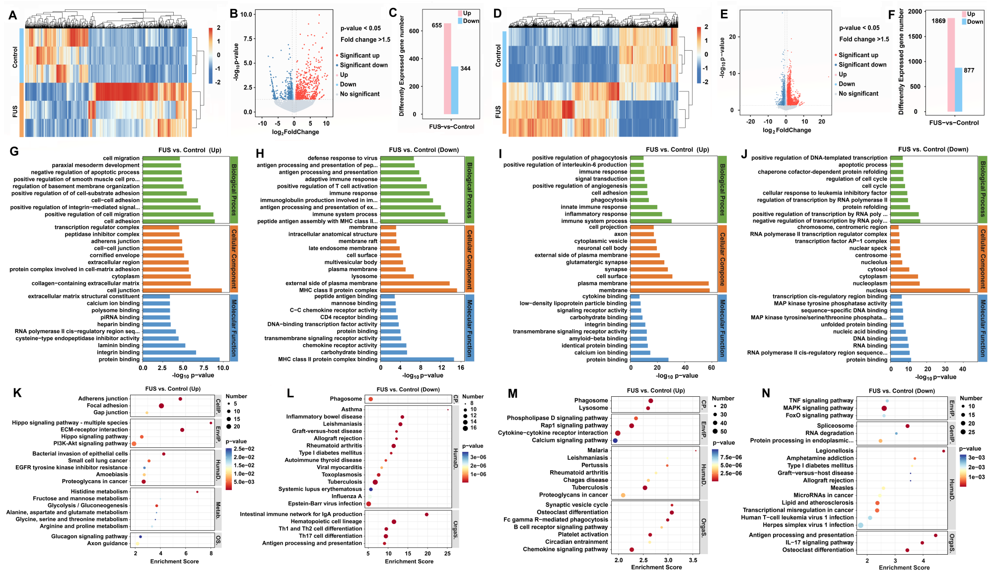
Supplementary Figure 24 RNA-seq analysis of the NK cells and CD8 T cells sorted from spleen after FUS stimulation. A-C, heatmap diagram, volcano plot and number statistics of differentially expressed genes in NK cells, respectively. D-F, heatmap diagram, volcano plot and number statistics of differentially expressed genes in CD8 T cells, respectively. G-H, GO pathway enrichment of the upregulated genes and downregulated genes in NK cells, respectively. I-J, GO pathway enrichment of the upregulated genes and downregulated genes in CD8 T cells, respectively. K-L, KEGG pathway enrichment of the upregulated genes and downregulated genes in NK cells, respectively. M-N, KEGG pathway enrichment of the upregulated genes and downregulated genes in CD8 T cells, respectively. (n = 3).
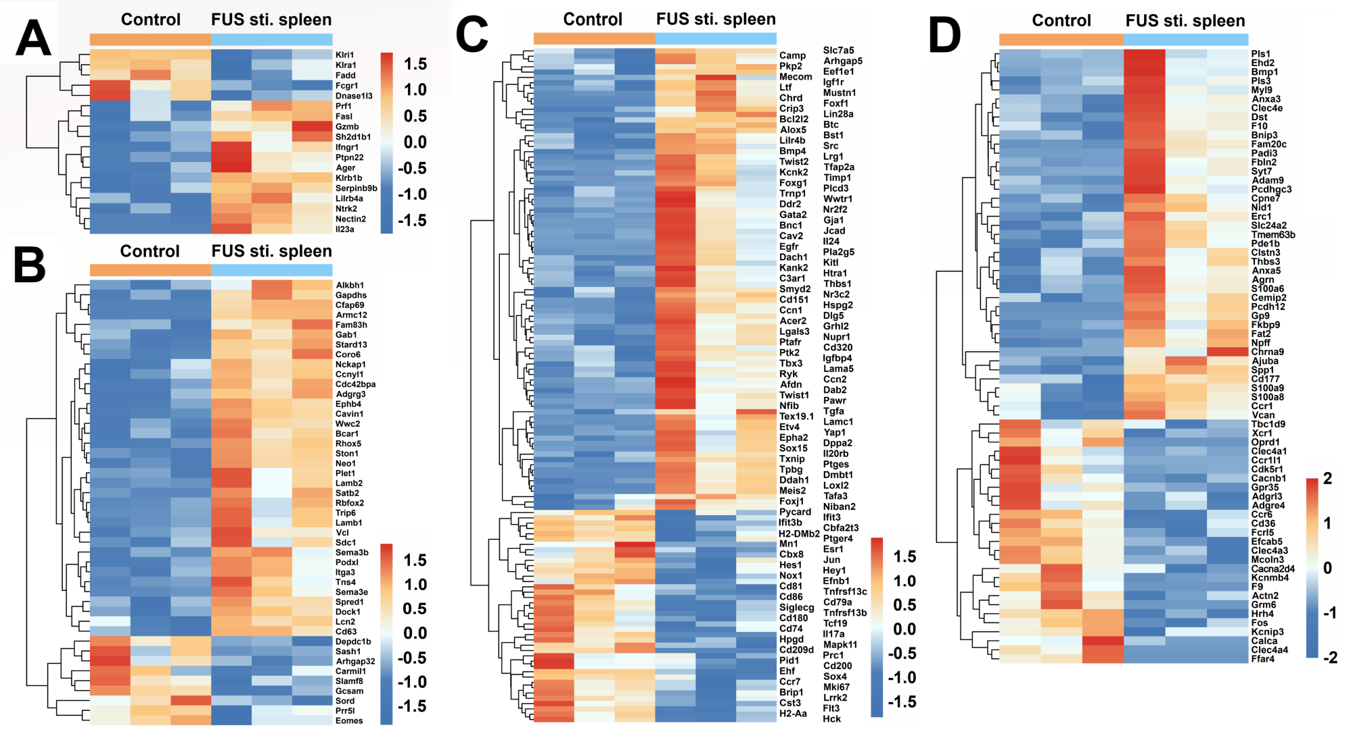
Supplementary Figure 25 Bioinformatic analysis of the DEGs related to NK cell activation, migration, and proliferation, and involved in calcium-related signaling pathways. A-D, heatmap diagram of the DEGs related to NK cell activation, migration, and proliferation, and involved in calcium-related signaling pathways, respectively. (n = 3).
Supplementary Figure 26 Bioinformatic analysis of the DEGs related to NK cell activation, migration, and proliferation, and involved in calcium-related signaling pathways. A-B, GO pathway enrichment analysis of the upregulated and downregulated genes in Supplementary Figure 30 A-D. C-D, KEGG pathway enrichment analysis of the upregulated and downregulated genes in Supplementary Figure 30 A-D. E, protein-protein network analysis of the DEGs in Supplementary Figure 30 A-D based on STRING database. F, GSEA snapshots of KEGG pathway enrichment analysis: ECM-receptor interaction, PI3K-AKT signaling pathway, Hippo signaling pathway and calcium signaling pathways. (n = 3).
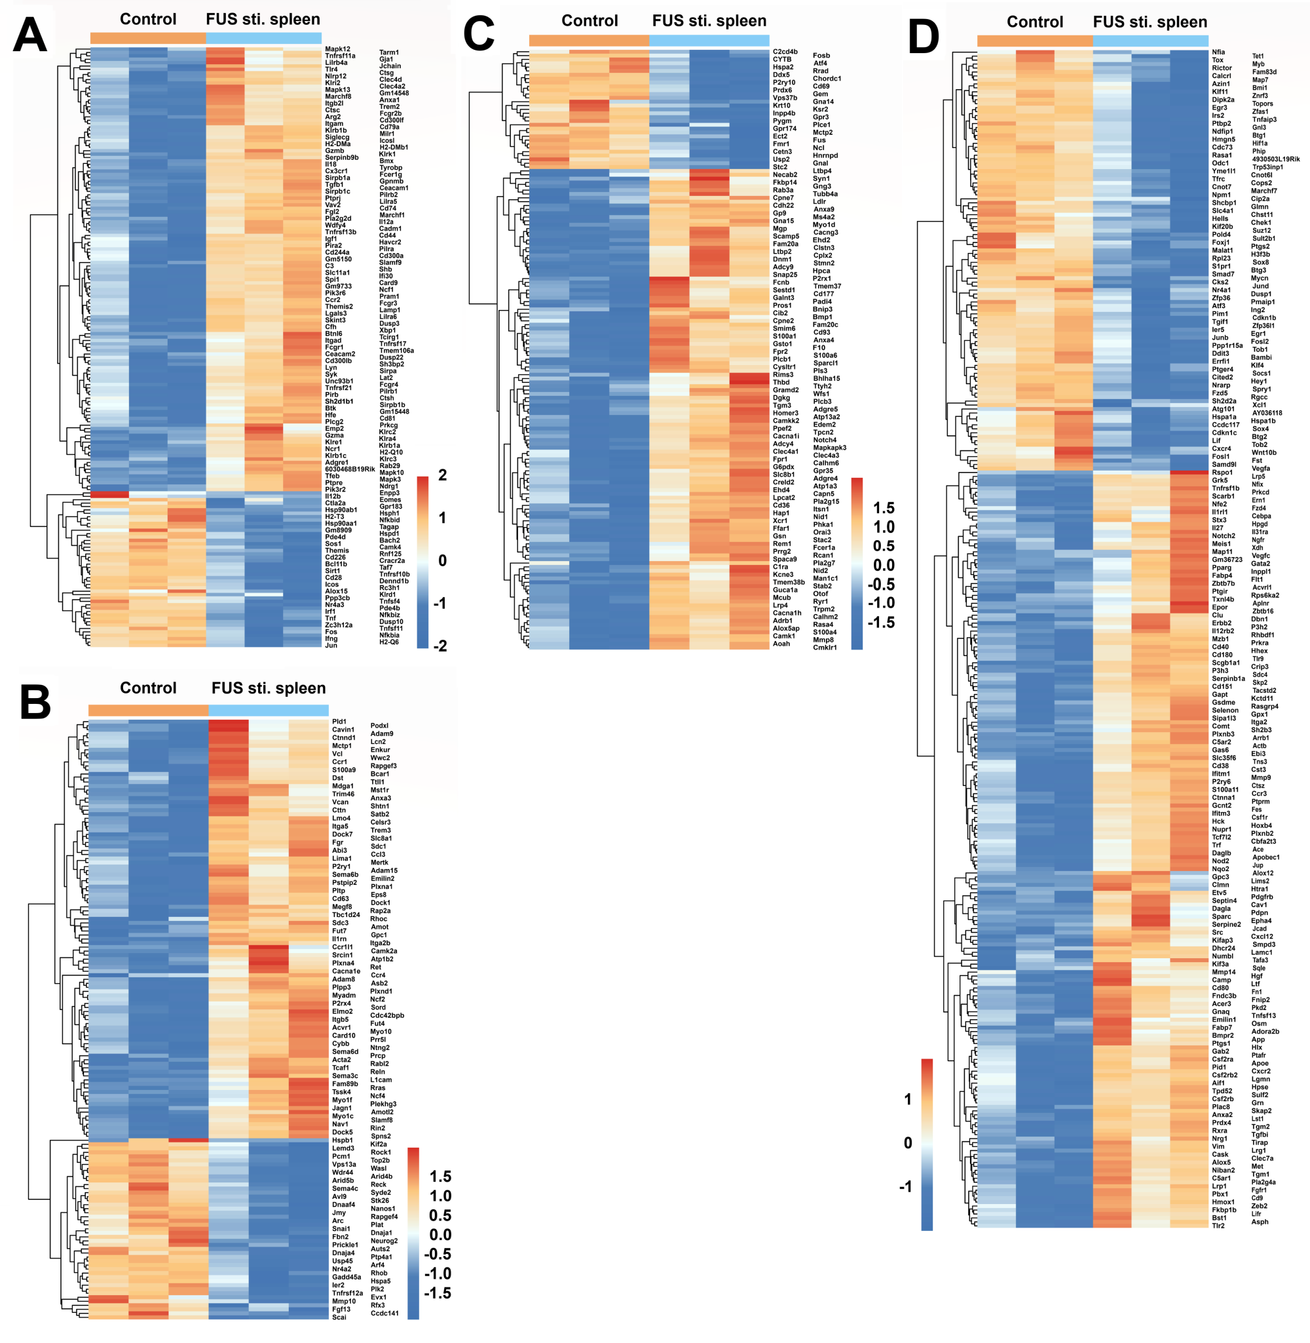
Supplementary Figure 27 Bioinformatic analysis of the DEGs related to CD8 T cell activation, migration, and proliferation, and involved in calcium-related signaling pathways. A-D, heatmap diagram of the DEGs related to CD8 T cell activation, proliferation, and migration, and involved in calcium-related signaling pathways, respectively. (n = 3).
Supplementary Figure 28 Bioinformatic analysis of DEGs related to CD8 T cells activation, proliferation, and migration, and involved in calcium-related signaling pathways. A-B, GO pathway enrichment of the upregulated genes and downregulated genes in Supplementary Figure 32 A-D, respectively. C-D, KEGG pathway enrichment analysis of the upregulated genes and downregulated genes in Supplementary Figure 32 A-D, respectively. E, protein-protein network analysis of the DEGs in Supplementary Figure 32 A-D based on STRING database. F, GSEA snapshots of KEGG pathway enrichment analysis: calcium signaling pathways, Rap1 signaling pathway, PI3K-AKT signaling pathway and ECM-receptor interaction. G, GSEA snapshots of KEGG pathway enrichment analysis: MAPK signaling pathways and TNF signaling pathway. (n = 3).
Supplementary Figure 29 Representative FCM plots and statistical diagram of immune cell proportion in spleen. A, representative FCM plot of NK cells (CD3⁻ NK1.1⁺ gated on CD45⁺), and corresponded quantification. B, representative FCM plot of CD8 T cells (CD3⁺ CD8⁺ gated on CD45⁺), and corresponded quantification. C, representative FCM plot of Treg cells (CD25⁺ Foxp3⁺ gated on CD3⁺ CD4⁺ CD45⁺), and corresponded quantification. D, representative FCM plot of Mφ (CD11b⁺ F4/80⁺ gated on CD45⁺), and corresponded quantification. E, representative FCM plot of Mφ1 (CD11c⁺ CD206⁻ gated on CD11b⁺ F4/80⁺ CD45⁺) and Mφ2 (CD11c⁻ CD206⁺ gated on CD11b⁺ F4/80⁺ CD45⁺), and corresponded quantification. F, representative FCM plot of DC1 (CD11b⁻ CD8⁺ gated on total cells) and DC2 (CD11b⁺ CD8⁻ gated on total cells), and corresponded quantification. G, representative FCM plot of M-MDSCs (LY6G⁻ LY6C⁺ gated on CD45⁺ CD11b⁺) and PMN-MDSCs (LY6G⁺ LY6C⁻ gated on CD45⁺ CD11b⁺), and corresponded quantification. (n = 4; * p ≤ 0.05; **p ≤ 0.01; ***p ≤ 0.001; mean ± SEM). K1, the control group of xenograft H22 HCC in situ; K2-K4, FUS sti. spleen on day 0, 4 and 8 respectively after H22 cancer cell implantation.
Supplementary Figure 30 Representative FCM plots and statistical diagram of immune cell proportion in blood. A, representative FCM plot of NK cells (CD3⁻ NK1.1⁺ gated on CD45⁺), and corresponded quantification. B, representative FCM plot of CD8 T cells (CD3⁺ CD8⁺ gated on CD45⁺), and corresponded quantification. C, representative FCM plot of Treg cells (CD25⁺ Foxp3⁺ gated on CD3⁺ CD4⁺ CD45⁺), and corresponded quantification. D, representative FCM plot of Mφ (CD11b⁺ F4/80⁺ gated on CD45⁺), and corresponded quantification. E, representative FCM plot of Mφ1 (CD11c⁺ CD206⁻ gated on CD11b⁺ F4/80⁺ CD45⁺) and Mφ2 (CD11c⁻ CD206⁺ gated on CD11b⁺ F4/80⁺ CD45⁺), and corresponded quantification. F, representative FCM plot of DC1 (CD11b⁻ CD8⁺ gated on total cells) and DC2 (CD11b⁺ CD8⁻ gated on total cells), and corresponded quantification. G, representative FCM plot of M-MDSCs (LY6G⁻ LY6C⁺ gated on CD45⁺ CD11b⁺) and PMN-MDSCs (LY6G⁺ LY6C⁻ gated on CD45⁺ CD11b⁺), and corresponded quantification. (n = 4; * p ≤ 0.05; **p ≤ 0.01; mean ± SEM). K1, the control group of xenograft H22 HCC in situ; K2-K4, FUS sti. spleen on day 0, 4 and 8 respectively after H22 cancer cell implantation.

Supplementary Figure 31 Representative FCM plots and statistical diagram of immune cell proportion in tumor. A, representative FCM plot of NK cells (CD3⁻ NK1.1⁺ gated on CD45⁺), and corresponded quantification. B, representative FCM plot of CD8 T cells (CD3⁺ CD8⁺ gated on CD45⁺), and corresponded quantification. C, representative FCM plot of Treg cells (CD25⁺ Foxp3⁺ gated on CD3⁺ CD4⁺ CD45⁺), and corresponded quantification. D, representative FCM plot of Mφ (CD11b⁺ F4/80⁺ gated on CD45⁺), and corresponded quantification. E, representative FCM plot of Mφ1 (CD11c⁺ CD206⁻ gated on CD11b⁺ F4/80⁺ CD45⁺) and Mφ2 (CD11c⁻ CD206⁺ gated on CD11b⁺ F4/80⁺ CD45⁺), and corresponded quantification. F, representative FCM plot of DC1 (CD11b⁻ CD8⁺ gated on total cells) and DC2 (CD11b⁺ CD8⁻ gated on total cells), and corresponded quantification. G, representative FCM plot of M-MDSCs (LY6G⁻ LY6C⁺ gated on CD45⁺ CD11b⁺) and PMN-MDSCs (LY6G⁺ LY6C⁻ gated on CD45⁺ CD11b⁺), and corresponded quantification. (n = 4; * p ≤ 0.05; **p ≤ 0.01; ***p ≤ 0.001; mean ± SEM). K1, the control group of xenograft H22 HCC in situ; K2-K4, FUS sti. spleen on day 0, 4 and 8 respectively after H22 cancer cell implantation.
Supplementary Figure 32 Representative FCM plots and statistical diagram of immune cell proportion in para-carcinoma tissue. A, representative FCM plot of NK cells (CD3⁻ NK1.1⁺ gated on CD45⁺), and corresponded quantification. B, representative FCM plot of CD8 T cells (CD3⁺ CD8⁺ gated on CD45⁺), and corresponded quantification. C, representative FCM plot of Treg cells (CD25⁺ Foxp3⁺ gated on CD3⁺ CD4⁺ CD45⁺), and corresponded quantification. D, representative FCM plot of Mφ (CD11b⁺ F4/80⁺ gated on CD45⁺), and corresponded quantification. E, representative FCM plot of Mφ1 (CD11c⁺ CD206⁻ gated on CD11b⁺ F4/80⁺ CD45⁺) and Mφ2 (CD11c⁻ CD206⁺ gated on CD11b⁺ F4/80⁺ CD45⁺), and corresponded quantification. F, representative FCM plot of DC1 (CD11b⁻ CD8⁺ gated on total cells) and DC2 (CD11b⁺ CD8⁻ gated on total cells), and corresponded quantification. G, representative FCM plot of M-MDSCs (LY6G⁻ LY6C⁺ gated on CD45⁺ CD11b⁺) and PMN-MDSCs (LY6G⁺ LY6C⁻ gated on CD45⁺ CD11b⁺), and corresponded quantification. (n = 4; * p ≤ 0.05; **p ≤ 0.01; mean ± SEM). K1, the control group of xenograft H22 HCC in situ; K2-K4, FUS sti. spleen on day 0, 4 and 8 respectively after H22 cancer cell implantation.

Supplementary Figure 33 Representative FCM plots and statistical diagram of immune cell proportion in spleen. A, representative FCM plot of CD4 T cells (CD3⁺ CD4⁺ gated on CD45⁺), and corresponded quantification. B, representative FCM plot of Th1 cells (IFN-γ⁺ gated on CD3⁺ CD4⁺ CD45⁺), and corresponded quantification. C, representative FCM plot of Th2 cells (IL-4⁺ gated on CD3⁺ CD4⁺ CD45⁺), and corresponded quantification. D, representative FCM plot of Th17 cells (IL-17⁺ gated on CD3⁺ CD4⁺ CD45⁺), and corresponded quantification. E, representative FCM plot of B cells (CD19⁺ B220⁺ gated on CD3⁺ CD4⁺ CD45⁺), and corresponded quantification. F, representative FCM plot of NK cells (CD3⁻ NK1.1⁺ gated on CD45⁺), and corresponded quantification. G, representative FCM plot of CD8 T cells (CD3⁺ CD8⁺ gated on CD45⁺), and corresponded quantification. H, representative FCM plot of Mφ (CD11b⁺ F4/80⁺ gated on CD45⁺), and corresponded quantification. I, representative FCM plot of Mφ1 (CD11c⁺ CD206⁻ gated on CD11b⁺ F4/80⁺ CD45⁺) and Mφ2 (CD11c⁻ CD206⁺ gated on CD11b⁺ F4/80⁺ CD45⁺), and corresponded quantification. J, representative FCM plot of DC1 (CD8⁺ CD11b⁻ gated on total cells) and DC2 (CD8⁻ CD11b⁺ gated on total cells), and corresponded quantification. K, representative FCM plot of Treg cells (CD25⁺ Foxp3⁺ gated on CD3⁺ CD4⁺ CD45⁺), and corresponded quantification. L, representative FCM plot of M-MDSCs (LY6G⁻ LY6C⁺ gated on CD45⁺ CD11b⁺) and PMN-MDSCs (LY6G⁺ LY6C⁻ gated on CD45⁺ CD11b⁺), and corresponded quantification. (n = 4; * p ≤ 0.05; **p ≤ 0.01; ***p ≤ 0.001; mean ± SEM). #1, the normal mice group; #2, the control group of subcutaneous H22 tumor mice; #3, FUS sti. spleen; #4, FUS int. tumor; #5, FUS sti. spleen and FUS int. tumor synergistically.

Supplementary Figure 34 Representative FCM plots and statistical diagram of immune cell proportion in blood. A, representative FCM plot of CD4 T cells (CD3⁺ CD4⁺ gated on CD45⁺), and corresponded quantification. B, representative FCM plot of Th1 cells (IFN-γ⁺ gated on CD3⁺ CD4⁺ CD45⁺), and corresponded quantification. C, representative FCM plot of Th2 cells (IL-4⁺ gated on CD3⁺ CD4⁺ CD45⁺), and corresponded quantification. D, representative FCM plot of Th17 cells (IL-17⁺ gated on CD3⁺ CD4⁺ CD45⁺), and corresponded quantification. E, representative FCM plot of B cells (CD19⁺ B220⁺ gated on CD3⁺ CD4⁺ CD45⁺), and corresponded quantification. F, representative FCM plot of NK cells (CD3⁻ NK1.1⁺ gated on CD45⁺), and corresponded quantification. G, representative FCM plot of CD8 T cells (CD3⁺ CD8⁺ gated on CD45⁺), and corresponded quantification. H, representative FCM plot of Mφ (CD11b⁺ F4/80⁺ gated on CD45⁺), and corresponded quantification. I, representative FCM plot of Mφ1 (CD11c⁺ CD206⁻ gated on CD11b⁺ F4/80⁺ CD45⁺) and Mφ2 (CD11c⁻ CD206⁺ gated on CD11b⁺ F4/80⁺ CD45⁺), and corresponded quantification. J, representative FCM plot of DC1 (CD8⁺ CD11b⁻ gated on total cells) and DC2 (CD8⁻ CD11b⁺ gated on total cells), and corresponded quantification. K, representative FCM plot of Treg cells (CD25⁺ Foxp3⁺ gated on CD3⁺ CD4⁺ CD45⁺), and corresponded quantification. L, representative FCM plot of M-MDSCs (LY6G⁻ LY6C⁺ gated on CD45⁺ CD11b⁺) and PMN-MDSCs (LY6G⁺ LY6C⁻ gated on CD45⁺ CD11b⁺), and corresponded quantification. (n = 4; * p ≤ 0.05; **p ≤ 0.01; ***p ≤ 0.001; mean ± SEM). #1, the normal mice group; #2, the control group of subcutaneous H22 tumor mice; #3, FUS sti. spleen; #4, FUS int. tumor; #5, FUS sti. spleen and FUS int. tumor synergistically.

Supplementary Figure 35 Representative FCM plots and statistical diagram of immune cell proportion in tumor. A, representative FCM plot of CD4 T cells (CD3⁺ CD4⁺ gated on CD45⁺), and corresponded quantification. B, representative FCM plot of Th1 cells (IFN-γ⁺ gated on CD3⁺ CD4⁺ CD45⁺), and corresponded quantification. C, representative FCM plot of Th2 cells (IL-4⁺ gated on CD3⁺ CD4⁺ CD45⁺), and corresponded quantification. D, representative FCM plot of Th17 cells (IL-17⁺ gated on CD3⁺ CD4⁺ CD45⁺), and corresponded quantification. E, representative FCM plot of B cells (CD19⁺ B220⁺ gated on CD3⁺ CD4⁺ CD45⁺), and corresponded quantification. F, representative FCM plot of NK cells (CD3⁻ NK1.1⁺ gated on CD45⁺), and corresponded quantification. G, representative FCM plot of CD8 T cells (CD3⁺ CD8⁺ gated on CD45⁺), and corresponded quantification. H, representative FCM plot of Mφ (CD11b⁺ F4/80⁺ gated on CD45⁺), and corresponded quantification. I, representative FCM plot of Mφ1 (CD11c⁺ CD206⁻ gated on CD11b⁺ F4/80⁺ CD45⁺) and Mφ2 (CD11c⁻ CD206⁺ gated on CD11b⁺ F4/80⁺ CD45⁺), and corresponded quantification. J, representative FCM plot of DC1 (CD8⁺ CD11b⁻ gated on total cells) and DC2 (CD8⁻ CD11b⁺ gated on total cells), and corresponded quantification. K, representative FCM plot of Treg cells (CD25⁺ Foxp3⁺ gated on CD3⁺ CD4⁺ CD45⁺), and corresponded quantification. L, representative FCM plot of M-MDSCs (LY6G⁻ LY6C⁺ gated on CD45⁺ CD11b⁺) and PMN-MDSCs (LY6G⁺ LY6C⁻ gated on CD45⁺ CD11b⁺), and corresponded quantification. (n = 4; * p ≤ 0.05; **p ≤ 0.01; ***p ≤ 0.001; mean ± SEM). #1, the normal mice group; #2, the control group of subcutaneous H22 tumor mice; #3, FUS sti. spleen; #4, FUS int. tumor; #5, FUS sti. spleen and FUS int. tumor synergistically.

Supplementary Tables

Supplementary Table 1 The antibodies used in flow cytometry.
Antibody | Conjugate | Clone | Isotype | Manufacturer
Anti- mouse CD45 | PE/Cyanine 7 | 30-F11 | Rat IgG2b,κ | Biolegend, Cat. No. 103114
Anti- mouse/ human CD11b | FITC | M1/70 | Rat IgG2b,κ | Biolegend, Cat. No. 101205
Anti- mouse F4/80 | PE | BM8 | Rat IgG2b,κ | Biolegend, Cat. No. 123110
Anti-mouse CD11c | PerCP/Cyanine5.5 | N418 | Armenian Hamster IgG | Biolegend, Cat. No. 117327
Anti-mouse CD206 (MMR) | APC | C068C2 | Rat IgG2b,κ | Biolegend, Cat. No. 141707
Anti-mouse CD3 | FITC | 17A2 | Rat IgG2b,κ | Biolegend, Cat. No. 100204
Anti-mouse CD4 | PerCP/Cyanine5.5 | RM4-5 | Rat IgG2a,κ | Biolegend, Cat. No. 100540
Anti-mouse CD8α | APC/Cyanine7 | 53-6.7 | Rat IgG2a,κ | Biolegend, Cat. No. 100714
Anti-mouse NK1.1 | APC | S17016D | Mouse IgG2a, κ | Biolegend, Cat. No. 156506
Anti-mouse CD19 | Brilliant Violet 510™ | 6D5 | Rat IgG2a,κ | Biolegend, Cat. No. 115546
Anti-mouse/ human B220 | FITC | RA3-6B2 | Rat IgG2a, κ | Biolegend, Cat. No. 103205
Anti-mouse Ly6C | PE | HK1.4 | Rat IgG2c, κ | Biolegend, Cat. No. 128007
Anti-mouse Ly6G | APC | 1A8 | Rat IgG2a, κ | Biolegend, Cat. No. 127613
Anti-mouse IL4 | PE | 11B11 | Rat IgG1, κ | Biolegend, Cat. No.504104
Anti-mouse IFN-γ | APC | XMG1.2 | Rat IgG1, κ | Biolegend, Cat. No. 505810
Anti-mouse FOXP3 | PE | 150D | Mouse IgG1, κ | Biolegend, Cat. No. 320008
Anti-mouse CD25 | APC | PC61 | Rat IgG1, λ | Biolegend, Cat. No. 102012
Anti-mouse IL17A | Brilliant Violet 421™ | TC11-18H10.1 | Rat IgG1, κ | Biolegend, Cat. No. 506926

Supplementary Table 2 Summary of flow cytometric markers for immune cells.
Cell type | Markers
CD4 T cell | CD45⁺ CD3⁺ CD4⁺
Th1 cell | CD45⁺ CD3⁺ CD4⁺ IFN-γ⁺
Th2 cell | CD45⁺ CD3⁺ CD4⁺ IL-4⁺
Th17 cell | CD45⁺ CD3⁺ CD4⁺ IL-17⁺
CD8 T cell | CD45⁺ CD3⁺ CD8a⁺
B cell | CD45⁺ CD19⁺ B220⁺
NK cell | CD45⁺ CD3⁻ NK1.1⁺
Mφ | CD45⁺ CD11b⁺ F4/80⁺
Mφ | Mφ1: CD45⁺ CD11b⁺ F4/80⁺ CD11C⁺ CD206⁻
Mφ | Mφ2: CD45⁺ CD11b⁺ F4/80⁺ CD11C⁻ CD206⁺
DC | DC1: CD45⁺ CD11b⁻ CD8a⁺
DC | DC2: CD45⁺ CD11b⁺ CD8a⁻
Treg | CD45⁺ CD3⁺ CD4⁺ CD25⁺ Foxp3⁺
MDSC | M-MDSC: CD45⁺ CD11b⁺ Ly6G⁻ Ly6C⁺
MDSC | PMN-MDSC: CD45⁺ CD11b⁺ Ly6G⁺ Ly6C⁻

Supplementary Table 3 Summary of the literature related to splenic ultrasound stimulation for modulating immunotherapy on various diseases.
No. | Summary of the Experimental Content | Ultrasonic parameters | Therapeutic effect and mechanism | Reference
1 | Acute colitis was induced by 2% Dextran Sulphate Sodium (DSS) in drinking water for 7 days, and therapeutic ultrasound was performed to the abdominal area. | A 5 cm² transducer (Mettler 740×; Anaheim, CA), 1 MHz, at 10% duty cycle and intensity of 2 w/cm2 for 7 min at day 4–10. | Ultrasound improves DSS-induced colitis through the stimulation of the splenic nerve along with the contribution by CAP activation to decrease the levels of colonic F4/80+α7nAChR+ Mφ. | [1]
2 | Autoimmune myocarditis was established by a cardiac-specific peptide, and low-intensity pulsed ultrasound stimulated the splenic nerve. | A concave transducer (OLYMPUS V302), 1 MHz, at 0.1 MPa, 0.35 MPa, 0.473 MPa, and 1 s on/5 s off bursts for 6 min or 12 min stimulation during day 0 to 21 or day 7 to 21. | Splenic ultrasound reduces heart inflammatory injury and improves cardiac remodeling by alleviating the immune response, as well as regulating the proportion and function of CD4+Treg and Mφ by activating CAP. | [2]
3 | A pneumonia model was induced by lung instillation of 10⁵ CFU of Streptococcus pneumoniae, and splenic ultrasound stimulation was performed at 4-, 16-, or 48-hours after bacteria inoculation. | A transducer (Sonic Concept H106), 1.1 MHz, at 200 mVpp, burst cycles of 150, and a burst period of 200 ms. | Non-invasive ultrasound stimulation targeted to the spleen demonstrates a time-dependent effect of CAP activation on the cytokine response during infection progression. | [3]
4 | Full thickness cutaneous excisional wounds were made on a rodent model of type II diabetes, and FUS pulses were used externally to the spleen area for 3 min over the course of 15 days. | A transducer (Sonic Concept H106), 1.1 MHz, at 300 mVpp, and a pulse repetition period of 0.5 ms. | Non-invasive splenic pFUS accelerates wound closure in type II diabetes rodents by up to 4.5 days vs. sham controls. | [4]
5 | Acute inflammation and metabolic dysfunction were induced by LPS injection, and FUS was used for splenic nerve stimulation. | A transducer (Sonic Concept H106), 1.1 MHz, at 0.27 duty cycle, 136.36 us pulse length, 0.83 MPa peak positive pressure, and a single stimulus not surpassing a single 1 min pulse. | Ultrasound applied to spleen reduces cytokine response to endotoxin to the same levels as implant-based vagus nerve stimulation by modulating the CAP. | [5]
6 | Inflammatory arthritis was induced through arthritogenic donor serum, and the spleen was irradiated by ultrasound one day prior to serum transfer. | A single element ultrasound transducer, 1 MHz, at 350 kPa, 1 s on/5 s off pulse pattern, and 2 min per day for 7 consecutive days. | Ultrasound stimulation targeting the spleen significantly reduces disease severity in a mouse model of inflammatory arthritis mainly attributed to splenic T and B cells playing an anti-inflammatory effect. | [6]
7 | Bilateral renal ischemia-reperfusion injury (IRI) was performed by flank incisions by clamping the renal pedicle for 26 minutes, and ultrasound was applied 3–7 days before IRI. | A Sequoia 512 US machine with a small-animal 15L8w transducer (Acuson, Malvern, PA), 7 MHz. mechanical index of 1.2, duration of 1 second to destroy microbubbles, and once every 6 seconds for 2 minutes. | Ultrasound prevents renal ischemia-reperfusion injury by stimulating the splenic cholinergic anti-inflammatory pathway. | [7]
8 | RA was induced by type II collagen, and FUS irradiation on the spleen was performed one day prior to collagen injection. | A FUS concave transducer (Panametrics-NDT, Waltham, MA, USA), 1 MHz, at 350 kPa, 1 s on/5 s off bursts, and 12 min per day. | Spleen­targeted low­frequency pulsed FUS effectively improved the severity of arthritis by regulating various cell subpopulations, especially CD8+ T cell subsets. | [8]

Reference
[1] N.S. Nunes, P. Chandran, M. Sundby, F. Visioli, F. da Costa Gonçalves, S.R. Burks, A.H. Paz, J.A. Frank, Therapeutic ultrasound attenuates DSS-induced colitis through the cholinergic anti-inflammatory pathway, EBioMedicine 45 (2019) 495-510.
[2] T. Liu, Y. Fu, J. Shi, S. He, D. Chen, W. Li, Y. Chen, L. Zhang, Q. Lv, Y. Yang, Q. Jin, J. Wang, M. Xie, Noninvasive ultrasound stimulation to treat myocarditis through splenic neuro-immune regulation, J Neuroinflammation 20(1) (2023) 94.
[3] U. Ahmed, J.F. Graf, A. Daytz, O. Yaipen, I. Mughrabi, N. Jayaprakash, V. Cotero, C. Morton, C.S. Deutschman, S. Zanos, C. Puleo, Ultrasound Neuromodulation of the Spleen Has Time-Dependent Anti-Inflammatory Effect in a Pneumonia Model, Front Immunol 13 (2022) 892086.
[4] C. Morton, V. Cotero, J. Ashe, F. Ginty, C. Puleo, Accelerating cutaneous healing in a rodent model of type II diabetes utilizing non-invasive focused ultrasound targeted at the spleen, Front Neurosci 16 (2022) 1039960.
[5] V. Cotero, Y. Fan, T. Tsaava, A.M. Kressel, I. Hancu, P. Fitzgerald, K. Wallace, S. Kaanumalle, J. Graf, W. Rigby, T.J. Kao, J. Roberts, C. Bhushan, S. Joel, T.R. Coleman, S. Zanos, K.J. Tracey, J. Ashe, S.S. Chavan, C. Puleo, Noninvasive sub-organ ultrasound stimulation for targeted neuromodulation, Nat Commun 10(1) (2019) 952.
[6] D.P. Zachs, S.J. Offutt, R.S. Graham, Y. Kim, J. Mueller, J.L. Auger, N.J. Schuldt, C.R.W. Kaiser, A.P. Heiller, R. Dutta, H. Guo, J.K. Alford, B.A. Binstadt, H.H. Lim, Noninvasive ultrasound stimulation of the spleen to treat inflammatory arthritis, Nat Commun 10(1) (2019) 951.
[7] J.C. Gigliotti, L. Huang, H. Ye, A. Bajwa, K. Chattrabhuti, S. Lee, A.L. Klibanov, K. Kalantari, D.L. Rosin, M.D. Okusa, Ultrasound prevents renal ischemia-reperfusion injury by stimulating the splenic cholinergic anti-inflammatory pathway, J Am Soc Nephrol 24(9) (2013) 1451-60.
[8] X. Hu, F. Li, J. Zeng, Z. Zhou, Z. Wang, J. Chen, D. Cao, Y. Hong, L. Huang, Y. Chen, J. Xu, F. Dong, R. Yu, H. Zheng, Noninvasive Low-Frequency Pulsed Focused Ultrasound Therapy for Rheumatoid Arthritis in Mice, Research 2022 (2022) 0013.

