Table S1. The risk of vaginal intraepithelial neoplasia in previous studies
Reference | Author | Year | Surgery" | Incidence rate | Risk factors
1. [3] | Lu M et a | 2017-2021 | - | 8.47% | older age
2. [4] | Xu M et a | 2019-2023 | - | - | older age， multiple HPV infections 、cytological abnormalities
3. [5] | Ao M et a | 2014-2020 | - | - | HPV 16 positive
4. [6] | Iacobone AD, et a | 2000-2022 | - | - | Smoking
5. [9] | Kim JH, et al | 2001-2019 | hysterectomy | 9.6% | Age>50
6. [10] | Bruno MT, et al | 2019-2022 | hysterectomy | 4.7% | HPV persistence,
7. [11] | Lu M,et al | 2006 -2017 | hysterectomy | 0.9% | HPV positive persistence,
8 [12] | Piedimonte S，et al | 2005-2015 | hysterectomy | 1.9% | HSIL at time of hysterectomy
Abbreviations: HPV: human papillomavirus; HSIL: high-grade squamous intraepithelial lesions

Figure S1. Y score in the equation of the prediction model for the risk of VaIN.
.
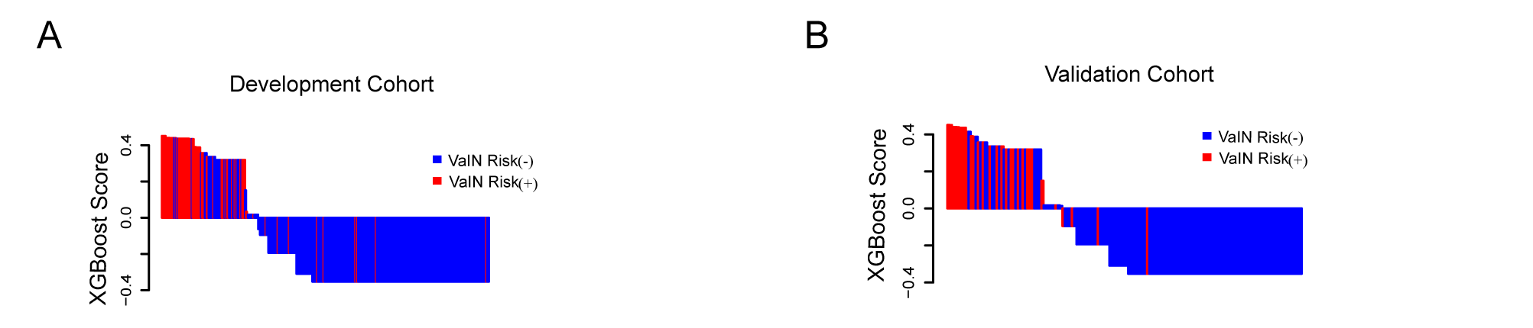
Figure S1. Y score of the development cohorts (A) and validation cohorts(B)

Figure S2. Calibration curves of the prediction model .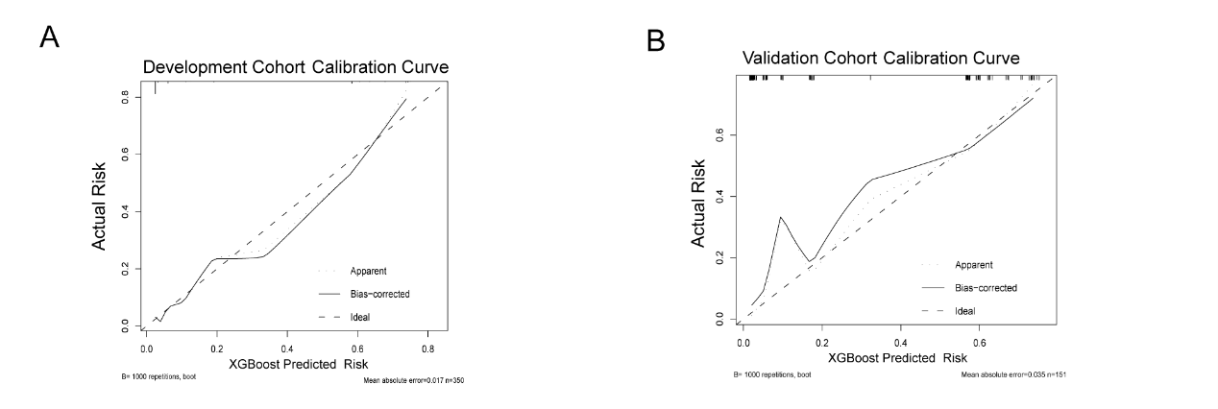
Figure S2 Calibration curves of the prediction model in the development (A) and validation (B)

