Supplementary Table S1. Description of GAWS information.
 | Traits | Data source | GWAS ID | Case/Control | SNPs
Exposures | MMP-1 | GWAS Catalog | GCST90012033 | 21758 | 12,705,782
 | MMP-2 | GWAS Catalog | GCST90010238 | 1,323 | 18,221,903
 | MMP-3 | GWAS Catalog | GCST90012027 | 21758 | 12,705,782
 | MMP-7 | GWAS Catalog | GCST90012056 | 21758 | 12,705,782
 | MMP-9 | GWAS Catalog | GCST90010240 | 1,323 | 18,221,903
 | MMP-10 | GWAS Catalog | GCST90012050 | 21758 | 12,705,782
 | MMP-12 | GWAS Catalog | GCST90012070 | 21758 | 12,705,782
 | MMP-14 | GWAS Catalog | GCST90241890 | 3301 | 10,572,788
 | MMP-16 | GWAS Catalog | GCST90241892 | 3,301 | NA
 | MMP-17 | GWAS Catalog | GCST90241893 | 3301 | 10,572,788
Outcomes | Cervical inflammation | FINNGen | finn-b-N14_INFCERVIX | 2195/ 226439 | NA
 | Cervical erosion and ectropion | FINNGen | finn-b-N14_EROSECTROPUT | 980/119468 | NA
 | Cervical precancerous lesions | UKB | ukb-b-17507 | 1,604/461,329 | 9,851,867
 | Cervical cancer | FINNGen | finn-b-C3_CERVIX_UTERI | 490/201494 | NA
GWAS, genome-wide association studies; SNPs, single nucleotide polymorphism; MMPs, matrix metalloproteinases; UKB, UK Biobank.

Supplementary Table S2. Detailed information of SNPs of MMPs.
Chr, chromosome; Eaf, Effect allele frequency; SE, standard error; SNP, single nucleotide polymorphisms; MMPs, matrix metalloproteinases.
Exposure | SNP | Chr | Pos | Beta | SE | P-value | Sample size | ID | Effect/allele | Other/allele | Eaf | MR/keep | Pval/origin | Data source
MMP-1 | rs75252943 | 1 | 14768859 | 0,2314 | 0,0494 | 2,81E-06 | 21758 | ebi-a-GCST90012033 | A | G | 0,0176 | VRAI | reported | igd
 | rs137969831 | 1 | 23311697 | -0,313 | 0,0684 | 4,80E-06 | 21758 | ebi-a-GCST90012033 | T | C | 0,0132 | VRAI | reported | igd
 | rs12141791 | 1 | 156419786 | 0,0829 | 0,0134 | 6,36E-10 | 21758 | ebi-a-GCST90012033 | A | G | 0,6953 | VRAI | reported | igd
 | rs9809116 | 3 | 72397279 | 0,0559 | 0,0118 | 2,30E-06 | 21758 | ebi-a-GCST90012033 | G | A | 0,4049 | VRAI | reported | igd
 | rs77237249 | 3 | 171051373 | -0,0939 | 0,0195 | 1,54E-06 | 21758 | ebi-a-GCST90012033 | A | G | 0,4364 | VRAI | reported | igd
 | rs17186760 | 4 | 91713549 | 0,0548 | 0,0117 | 3,07E-06 | 21758 | ebi-a-GCST90012033 | C | T | 0,5084 | VRAI | reported | igd
 | rs74708434 | 4 | 158692442 | 0,0844 | 0,0168 | 5,41E-07 | 21758 | ebi-a-GCST90012033 | A | G | 0,4333 | VRAI | reported | igd
 | rs9389269 | 6 | 135427159 | 0,0654 | 0,0127 | 2,46E-07 | 21758 | ebi-a-GCST90012033 | C | T | 0,2675 | VRAI | reported | igd
 | rs6993770 | 8 | 106581528 | -0,1235 | 0,0125 | 4,63E-23 | 21758 | ebi-a-GCST90012033 | T | A | 0,2681 | VRAI | reported | igd
 | rs55665228 | 9 | 99234329 | 0,0843 | 0,0165 | 3,02E-07 | 21758 | ebi-a-GCST90012033 | T | C | 0,1849 | VRAI | reported | igd
 | rs2509013 | 11 | 102584607 | -0,1307 | 0,0116 | 2,41E-29 | 21758 | ebi-a-GCST90012033 | C | T | 0,5995 | VRAI | reported | igd
 | rs471994 | 11 | 102697731 | -0,3575 | 0,0111 | 1,00E-200 | 21758 | ebi-a-GCST90012033 | A | G | 0,3679 | VRAI | reported | igd
 | rs111517401 | 11 | 102982515 | -0,2224 | 0,0297 | 6,39E-14 | 21758 | ebi-a-GCST90012033 | C | G | 0,0534 | VRAI | reported | igd
 | rs141699001 | 11 | 103331867 | 0,2997 | 0,0494 | 1,31E-09 | 21758 | ebi-a-GCST90012033 | T | G | 0,0206 | VRAI | reported | igd
 | rs10876549 | 12 | 54701896 | 0,0657 | 0,0126 | 2,04E-07 | 21758 | ebi-a-GCST90012033 | G | A | 0,3766 | VRAI | reported | igd
 | rs2958130 | 12 | 57140506 | 0,0761 | 0,0116 | 4,59E-11 | 21758 | ebi-a-GCST90012033 | A | G | 0,6534 | VRAI | reported | igd
 | rs67605787 | 13 | 34837974 | 0,127 | 0,0269 | 2,47E-06 | 21758 | ebi-a-GCST90012033 | C | A | 0,0512 | VRAI | reported | igd
 | rs34226397 | 19 | 14758168 | -0,0612 | 0,0133 | 4,26E-06 | 21758 | ebi-a-GCST90012033 | A | G | 0,2953 | VRAI | reported | igd
 | rs113965694 | 20 | 9899255 | 0,1748 | 0,0383 | 4,96E-06 | 21758 | ebi-a-GCST90012033 | T | A | 0,034 | VRAI | reported | igd
 | rs113140218 | 20 | 60752803 | 0,137 | 0,0288 | 1,88E-06 | 21758 | ebi-a-GCST90012033 | A | G | 0,0517 | VRAI | reported | igd
MMP-2 | rs72791401 | 2 | 41411001 | -0,423743 | 0,0881512 | 2,23E-06 | 1323 | ebi-a-GCST90010238 | A | G | 0,053 | VRAI | reported | igd
 | rs3852053 | 3 | 186937200 | 0,187577 | 0,0405624 | 4,95E-06 | 1323 | ebi-a-GCST90010238 | G | T | 0,495 | VRAI | reported | igd
 | rs1223398 | 6 | 13271082 | 0,229039 | 0,0484765 | 4,14E-06 | 1323 | ebi-a-GCST90010238 | C | T | 0,791 | VRAI | reported | igd
 | rs10809913 | 9 | 13181898 | 0,228237 | 0,046209 | 1,32E-06 | 1323 | ebi-a-GCST90010238 | A | G | 0,257 | VRAI | reported | igd
 | rs672304 | 12 | 4074906 | -0,198489 | 0,0425902 | 4,74E-06 | 1323 | ebi-a-GCST90010238 | C | A | 0,679 | VRAI | reported | igd
 | rs71434787 | 13 | 30922081 | -0,891801 | 0,188188 | 2,84E-06 | 1323 | ebi-a-GCST90010238 | A | G | 0,011 | VRAI | reported | igd
 | rs71391564 | 16 | 24455987 | 0,369756 | 0,0777546 | 2,76E-06 | 1323 | ebi-a-GCST90010238 | G | A | 0,073 | VRAI | reported | igd
MMP-3 | rs72699029 | 1 | 113016701 | -0,0734 | 0,0158 | 3,50E-06 | 21758 | ebi-a-GCST90012027 | G | A | 0,6348 | VRAI | reported | igd
 | rs11883509 | 2 | 181947163 | 0,1146 | 0,0241 | 2,02E-06 | 21758 | ebi-a-GCST90012027 | T | C | 0,0519 | VRAI | reported | igd
 | rs11927461 | 3 | 168608422 | -0,0541 | 0,011 | 9,00E-07 | 21758 | ebi-a-GCST90012027 | G | A | 0,2754 | VRAI | reported | igd
 | rs80021915 | 6 | 147494132 | -0,3644 | 0,0701 | 2,05E-07 | 21758 | ebi-a-GCST90012027 | G | A | 0,011 | VRAI | reported | igd
 | rs7797861 | 7 | 36752594 | -0,0578 | 0,012 | 1,36E-06 | 21758 | ebi-a-GCST90012027 | T | C | 0,6177 | VRAI | reported | igd
 | rs7909791 | 10 | 105613178 | -0,0499 | 0,0103 | 1,15E-06 | 21758 | ebi-a-GCST90012027 | A | C | 0,334 | VRAI | reported | igd
 | rs11225074 | 11 | 101808815 | 0,1155 | 0,0252 | 4,58E-06 | 21758 | ebi-a-GCST90012027 | A | C | 0,0533 | VRAI | reported | igd
 | rs495041 | 11 | 102390188 | 0,0722 | 0,0131 | 3,65E-08 | 21758 | ebi-a-GCST90012027 | T | C | 0,1749 | VRAI | reported | igd
 | rs72971614 | 11 | 102489621 | 0,1121 | 0,0141 | 1,61E-15 | 21758 | ebi-a-GCST90012027 | G | T | 0,1331 | VRAI | reported | igd
 | rs471994 | 11 | 102697731 | 0,3597 | 0,0094 | 1,00E-200 | 21758 | ebi-a-GCST90012027 | A | G | 0,3582 | VRAI | reported | igd
 | rs3020919 | 11 | 102713046 | 0,2572 | 0,0106 | 3,68E-130 | 21758 | ebi-a-GCST90012027 | T | C | 0,2409 | VRAI | reported | igd
 | rs2186789 | 11 | 102911494 | 0,1337 | 0,011 | 4,34E-34 | 21758 | ebi-a-GCST90012027 | C | A | 0,232 | VRAI | reported | igd
 | rs575851082 | 17 | 36274683 | -0,2511 | 0,0549 | 4,86E-06 | 21758 | ebi-a-GCST90012027 | T | C | 0,0395 | VRAI | reported | igd
 | rs1239964 | 18 | 56928652 | 0,0522 | 0,0107 | 1,15E-06 | 21758 | ebi-a-GCST90012027 | C | A | 0,5283 | VRAI | reported | igd
 | rs11668189 | 19 | 54754103 | -0,0557 | 0,01 | 2,66E-08 | 21758 | ebi-a-GCST90012027 | A | C | 0,3586 | VRAI | reported | igd
 | rs2267373 | 22 | 38600542 | 0,057 | 0,0096 | 3,02E-09 | 21758 | ebi-a-GCST90012027 | T | C | 0,5813 | VRAI | reported | igd
MMP-7 | rs9427716 | 1 | 202012252 | 0,0866 | 0,0123 | 1,99E-12 | 21758 | ebi-a-GCST90012056 | T | C | 0,4615 | VRAI | reported | igd
 | rs668586 | 2 | 72663316 | -0,0595 | 0,0127 | 2,91E-06 | 21758 | ebi-a-GCST90012056 | G | A | 0,2234 | VRAI | reported | igd
 | rs905880 | 2 | 213188777 | -0,1213 | 0,0265 | 4,62E-06 | 21758 | ebi-a-GCST90012056 | T | C | 0,9164 | VRAI | reported | igd
 | rs4836041 | 5 | 121884745 | -0,0748 | 0,0141 | 1,23E-07 | 21758 | ebi-a-GCST90012056 | C | T | 0,8179 | VRAI | reported | igd
 | rs11752320 | 6 | 165475051 | 0,0564 | 0,0123 | 4,71E-06 | 21758 | ebi-a-GCST90012056 | T | C | 0,3401 | VRAI | reported | igd
 | rs9355583 | 6 | 166874083 | -0,0533 | 0,0116 | 4,34E-06 | 21758 | ebi-a-GCST90012056 | T | C | 0,4075 | VRAI | reported | igd
 | rs117667600 | 8 | 61792438 | 0,1117 | 0,0231 | 1,34E-06 | 21758 | ebi-a-GCST90012056 | A | G | 0,0685 | VRAI | reported | igd
 | rs12350534 | 9 | 89558064 | 0,1015 | 0,0205 | 7,27E-07 | 21758 | ebi-a-GCST90012056 | T | C | 0,0754 | VRAI | reported | igd
 | rs7077594 | 10 | 125703247 | -0,066 | 0,0127 | 1,95E-07 | 21758 | ebi-a-GCST90012056 | C | T | 0,2721 | VRAI | reported | igd
 | rs11568819 | 11 | 102401633 | 0,5584 | 0,0244 | 9,51E-116 | 21758 | ebi-a-GCST90012056 | A | G | 0,0625 | VRAI | reported | igd
 | rs12796179 | 11 | 102430209 | -0,123 | 0,0138 | 5,45E-19 | 21758 | ebi-a-GCST90012056 | C | T | 0,2249 | VRAI | reported | igd
 | rs149971537 | 12 | 84364916 | -0,3043 | 0,0665 | 4,69E-06 | 21758 | ebi-a-GCST90012056 | T | A | 0,0137 | VRAI | reported | igd
 | rs73339017 | 14 | 44740020 | 0,2982 | 0,0648 | 4,25E-06 | 21758 | ebi-a-GCST90012056 | C | A | 0,0165 | VRAI | reported | igd
 | rs79516461 | 16 | 19264757 | -0,2463 | 0,0536 | 4,36E-06 | 21758 | ebi-a-GCST90012056 | A | G | 0,026 | VRAI | reported | igd
 | rs8082122 | 17 | 62534459 | -0,0905 | 0,0187 | 1,31E-06 | 21758 | ebi-a-GCST90012056 | C | T | 0,1133 | VRAI | reported | igd
 | rs62133135 | 19 | 54753202 | -0,0652 | 0,0114 | 9,26E-09 | 21758 | ebi-a-GCST90012056 | C | T | 0,3853 | VRAI | reported | igd
MMP-9 | rs112016221 | 2 | 43104586 | -0,263048 | 0,0533326 | 1,13E-06 | 1323 | ebi-a-GCST90010240 | T | G | 0,169 | VRAI | reported | igd
 | rs17363675 | 4 | 184880036 | -0,762863 | 0,154297 | 1,06E-06 | 1323 | ebi-a-GCST90010240 | T | C | 0,017 | VRAI | reported | igd
 | rs6881516 | 5 | 11347020 | 0,392658 | 0,0710655 | 6,42E-08 | 1323 | ebi-a-GCST90010240 | G | A | 0,083 | VRAI | reported | igd
 | rs72821475 | 5 | 165870095 | -0,895316 | 0,187235 | 2,84E-06 | 1323 | ebi-a-GCST90010240 | T | G | 0,012 | VRAI | reported | igd
 | rs150755111 | 6 | 37934825 | -0,986524 | 0,197162 | 8,50E-07 | 1323 | ebi-a-GCST90010240 | A | G | 0,011 | VRAI | reported | igd
 | rs148608708 | 6 | 43429666 | -0,990032 | 0,187041 | 1,85E-07 | 1323 | ebi-a-GCST90010240 | C | G | 0,012 | VRAI | reported | igd
 | rs9480646 | 6 | 106600243 | 0,263715 | 0,0562026 | 3,68E-06 | 1323 | ebi-a-GCST90010240 | A | G | 0,153 | VRAI | reported | igd
 | rs78720213 | 8 | 136037060 | -0,431676 | 0,0850929 | 5,70E-07 | 1323 | ebi-a-GCST90010240 | C | A | 0,059 | VRAI | reported | igd
 | rs117418264 | 10 | 9076156 | -0,484165 | 0,0994245 | 1,53E-06 | 1323 | ebi-a-GCST90010240 | C | T | 0,041 | VRAI | reported | igd
 | rs77592306 | 19 | 34744263 | -0,716741 | 0,151443 | 2,93E-06 | 1323 | ebi-a-GCST90010240 | G | A | 0,018 | VRAI | reported | igd
MMP-10 | rs146355255 | 1 | 85559440 | 0,3622 | 0,0716 | 4,26E-07 | 21758 | ebi-a-GCST90012050 | A | T | 0,0102 | VRAI | reported | igd
 | rs60830116 | 2 | 34889369 | 0,122 | 0,0249 | 9,89E-07 | 21758 | ebi-a-GCST90012050 | T | G | 0,0889 | VRAI | reported | igd
 | rs77197874 | 4 | 143088710 | 0,0899 | 0,0195 | 4,12E-06 | 21758 | ebi-a-GCST90012050 | T | A | 0,1119 | VRAI | reported | igd
 | rs7684025 | 4 | 187116227 | 0,058 | 0,0123 | 2,48E-06 | 21758 | ebi-a-GCST90012050 | A | G | 0,4381 | VRAI | reported | igd
 | rs80346512 | 5 | 668045 | 0,4345 | 0,0824 | 1,34E-07 | 21758 | ebi-a-GCST90012050 | G | A | 0,0191 | VRAI | reported | igd
 | rs77554227 | 5 | 153908841 | 0,0763 | 0,015 | 3,78E-07 | 21758 | ebi-a-GCST90012050 | G | C | 0,1931 | VRAI | reported | igd
 | rs561055692 | 6 | 30704994 | -0,2681 | 0,0527 | 3,59E-07 | 21758 | ebi-a-GCST90012050 | T | C | 0,0281 | VRAI | reported | igd
 | rs3129886 | 6 | 32410576 | 0,0707 | 0,0129 | 4,39E-08 | 21758 | ebi-a-GCST90012050 | C | T | 0,7474 | VRAI | reported | igd
 | rs484994 | 6 | 151327735 | -0,1253 | 0,027 | 3,63E-06 | 21758 | ebi-a-GCST90012050 | G | T | 0,0608 | VRAI | reported | igd
 | rs13234837 | 7 | 615892 | 0,231 | 0,0501 | 3,93E-06 | 21758 | ebi-a-GCST90012050 | A | G | 0,0313 | VRAI | reported | igd
 | rs6961848 | 7 | 25898723 | -0,0507 | 0,0109 | 3,58E-06 | 21758 | ebi-a-GCST90012050 | A | T | 0,4945 | VRAI | reported | igd
 | rs321187 | 7 | 137070042 | -0,1264 | 0,0258 | 9,83E-07 | 21758 | ebi-a-GCST90012050 | T | A | 0,0781 | VRAI | reported | igd
 | rs72699188 | 9 | 6176871 | 0,0816 | 0,0161 | 4,05E-07 | 21758 | ebi-a-GCST90012050 | G | C | 0,1529 | VRAI | reported | igd
 | rs582118 | 9 | 136145471 | 0,0598 | 0,0125 | 1,65E-06 | 21758 | ebi-a-GCST90012050 | G | A | 0,3712 | VRAI | reported | igd
 | rs11225354 | 11 | 102510046 | -0,3141 | 0,0174 | 1,86E-72 | 21758 | ebi-a-GCST90012050 | C | T | 0,1205 | VRAI | reported | igd
 | rs139775779 | 11 | 102610160 | 0,2541 | 0,055 | 3,79E-06 | 21758 | ebi-a-GCST90012050 | G | A | 0,0214 | VRAI | reported | igd
 | rs17860955 | 11 | 102649482 | -1,1276 | 0,0443 | 6,44E-143 | 21758 | ebi-a-GCST90012050 | C | T | 0,0168 | VRAI | reported | igd
 | rs17099622 | 11 | 102700352 | 0,2437 | 0,0226 | 3,97E-27 | 21758 | ebi-a-GCST90012050 | G | A | 0,0701 | VRAI | reported | igd
 | rs142915220 | 11 | 102881952 | 0,3397 | 0,0491 | 4,62E-12 | 21758 | ebi-a-GCST90012050 | G | A | 0,0223 | VRAI | reported | igd
 | rs73273472 | 14 | 33036081 | -0,1031 | 0,0223 | 3,83E-06 | 21758 | ebi-a-GCST90012050 | C | T | 0,1032 | VRAI | reported | igd
 | rs60301277 | 17 | 9893773 | -0,0649 | 0,0137 | 2,32E-06 | 21758 | ebi-a-GCST90012050 | G | A | 0,2838 | VRAI | reported | igd
 | rs34783010 | 19 | 46180414 | -0,0623 | 0,0133 | 3,03E-06 | 21758 | ebi-a-GCST90012050 | T | G | 0,2097 | VRAI | reported | igd
 | rs601338 | 19 | 49206674 | 0,1227 | 0,0112 | 6,34E-28 | 21758 | ebi-a-GCST90012050 | A | G | 0,4498 | VRAI | reported | igd
MMP-12 | rs77664135 | 1 | 88031792 | 0,1795 | 0,0372 | 1,44E-06 | 21758 | ebi-a-GCST90012070 | A | G | 0,0277 | VRAI | reported | igd
 | rs111679476 | 2 | 132113292 | 0,3645 | 0,071 | 2,86E-07 | 21758 | ebi-a-GCST90012070 | A | G | 0,0112 | VRAI | reported | igd
 | rs7576202 | 2 | 142582439 | 0,079 | 0,0155 | 3,79E-07 | 21758 | ebi-a-GCST90012070 | A | G | 0,1433 | VRAI | reported | igd
 | rs116099385 | 2 | 241035359 | 0,1333 | 0,0286 | 3,09E-06 | 21758 | ebi-a-GCST90012070 | G | A | 0,0524 | VRAI | reported | igd
 | rs6798734 | 3 | 158790222 | -0,0547 | 0,0119 | 4,57E-06 | 21758 | ebi-a-GCST90012070 | A | G | 0,7378 | VRAI | reported | igd
 | rs1265181 | 6 | 31155785 | 0,0587 | 0,0128 | 4,76E-06 | 21758 | ebi-a-GCST90012070 | C | G | 0,1981 | VRAI | reported | igd
 | rs6466339 | 7 | 110136997 | 0,0535 | 0,0116 | 4,29E-06 | 21758 | ebi-a-GCST90012070 | C | T | 0,2882 | VRAI | reported | igd
 | rs117447137 | 8 | 61633079 | 0,3277 | 0,0614 | 9,39E-08 | 21758 | ebi-a-GCST90012070 | A | G | 0,011 | VRAI | reported | igd
 | rs376343633 | 10 | 115408224 | 0,2028 | 0,0422 | 1,53E-06 | 21758 | ebi-a-GCST90012070 | A | C | 0,0534 | VRAI | reported | igd
 | rs148424769 | 11 | 102074124 | -0,2446 | 0,0419 | 5,16E-09 | 21758 | ebi-a-GCST90012070 | A | T | 0,0245 | VRAI | reported | igd
 | rs529381 | 11 | 102680837 | 0,1558 | 0,0113 | 1,28E-43 | 21758 | ebi-a-GCST90012070 | T | C | 0,295 | VRAI | reported | igd
 | rs626750 | 11 | 102720945 | -0,4744 | 0,0127 | 1,00E-200 | 21758 | ebi-a-GCST90012070 | A | G | 0,1898 | VRAI | reported | igd
 | rs12288698 | 11 | 102787451 | 0,2802 | 0,0139 | 2,18E-90 | 21758 | ebi-a-GCST90012070 | C | T | 0,1737 | VRAI | reported | igd
 | rs7126430 | 11 | 102839201 | 0,1096 | 0,0161 | 1,00E-11 | 21758 | ebi-a-GCST90012070 | A | G | 0,1256 | VRAI | reported | igd
 | rs117953762 | 13 | 72450627 | 0,2541 | 0,0461 | 3,42E-08 | 21758 | ebi-a-GCST90012070 | C | T | 0,0192 | VRAI | reported | igd
 | rs4551939 | 14 | 106900355 | -0,0903 | 0,019 | 1,95E-06 | 21758 | ebi-a-GCST90012070 | A | C | 0,4041 | VRAI | reported | igd
 | rs12437834 | 15 | 63705044 | 0,1079 | 0,0226 | 1,82E-06 | 21758 | ebi-a-GCST90012070 | T | C | 0,0598 | VRAI | reported | igd
 | rs2582597 | 16 | 60125785 | 0,0487 | 0,0107 | 4,98E-06 | 21758 | ebi-a-GCST90012070 | A | G | 0,4695 | VRAI | reported | igd
 | rs55740617 | 18 | 25043161 | -0,1217 | 0,0253 | 1,44E-06 | 21758 | ebi-a-GCST90012070 | T | C | 0,0554 | VRAI | reported | igd
 | rs376118478 | 19 | 9105908 | 0,0948 | 0,0192 | 7,77E-07 | 21758 | ebi-a-GCST90012070 | T | G | 0,3343 | VRAI | reported | igd
 | rs9676842 | 19 | 21006321 | -0,0608 | 0,0131 | 3,71E-06 | 21758 | ebi-a-GCST90012070 | A | G | 0,6219 | VRAI | reported | igd
 | rs12975366 | 19 | 54759361 | -0,0804 | 0,0106 | 3,72E-14 | 21758 | ebi-a-GCST90012070 | C | T | 0,3984 | VRAI | reported | igd
 | rs41280266 | 20 | 44108475 | 0,2667 | 0,0538 | 7,08E-07 | 21758 | ebi-a-GCST90012070 | T | C | 0,0168 | VRAI | reported | igd
MMP-14 | rs3107867 | 2 | 196160419 | 0,3568 | 0,0768 | 3,39E-06 | 3301 | LlHp9C | C | G | 0,04426 | VRAI | reported
 | rs139003267 | 3 | 76265114 | 0,7335 | 0,1576 | 3,24E-06 | 3301 | LlHp9C | C | G | 0,9819 | VRAI | reported
 | rs141516598 | 4 | 146334399 | -0,7801 | 0,167 | 2,95E-06 | 3301 | LlHp9C | A | T | 0,9972 | VRAI | reported
 | rs62361678 | 5 | 41927601 | -0,2019 | 0,0428 | 2,40E-06 | 3301 | LlHp9C | A | C | 0,9175 | VRAI | reported
 | rs308210 | 5 | 93723468 | -0,6927 | 0,1482 | 2,95E-06 | 3301 | LlHp9C | A | C | 0,9939 | VRAI | reported
 | rs9388756 | 6 | 99269120 | -0,1396 | 0,0293 | 1,86E-06 | 3301 | LlHp9C | T | G | 0,1738 | VRAI | reported
 | rs188859278 | 7 | 88968663 | 0,7211 | 0,1542 | 2,88E-06 | 3301 | LlHp9C | A | G | 0,9943 | VRAI | reported
 | rs4644164 | 7 | 131782596 | -0,1544 | 0,0325 | 2,09E-06 | 3301 | LlHp9C | A | G | 0,7543 | VRAI | reported
 | rs16882774 | 7 | 145194015 | 0,5114 | 0,1064 | 1,55E-06 | 3301 | LlHp9C | A | C | 0,07983 | VRAI | reported
 | rs117543984 | 8 | 11288877 | 0,4868 | 0,1016 | 1,66E-06 | 3301 | LlHp9C | A | T | 0,9966 | VRAI | reported
 | rs138537143 | 8 | 62739795 | -0,5557 | 0,1118 | 6,76E-07 | 3301 | LlHp9C | A | G | 0,01048 | VRAI | reported
 | rs7973793 | 12 | 131769409 | -0,1511 | 0,0329 | 4,27E-06 | 3301 | LlHp9C | T | C | 0,1703 | VRAI | reported
 | rs77044550 | 13 | 50379725 | -0,286 | 0,0619 | 3,89E-06 | 3301 | LlHp9C | A | G | 0,9733 | VRAI | reported
 | rs7328458 | 13 | 85163594 | -0,1569 | 0,0334 | 2,57E-06 | 3301 | LlHp9C | A | G | 0,1591 | VRAI | reported
 | rs2736885 | 14 | 94815476 | -0,1424 | 0,0296 | 1,51E-06 | 3301 | LlHp9C | A | T | 0,7314 | VRAI | reported
 | rs79211393 | 15 | 61837407 | -0,8614 | 0,1739 | 7,24E-07 | 3301 | LlHp9C | A | G | 0,9973 | VRAI | reported
 | rs117827992 | 21 | 31226070 | -0,6066 | 0,1307 | 3,47E-06 | 3301 | LlHp9C | A | T | 0,9968 | VRAI | reported
 | rs2304533 | 22 | 23055752 | -0,1211 | 0,0259 | 3,02E-06 | 3301 | LlHp9C | T | C | 0,5844 | VRAI | reported
 | rs2413207 | 22 | 34281940 | -0,1178 | 0,025 | 2,51E-06 | 3301 | LlHp9C | A | C | 0,3097 | VRAI | reported
MMP-16 | rs6662887 | 1 | 92174914 | 0,1235 | 0,0267 | 3,80E-06 | 3301 | OweYGW | T | C | 0,3105 | VRAI | reported
 | rs79041939 | 1 | 99947428 | -0,2212 | 0,048 | 3,98E-06 | 3301 | OweYGW | T | C | 0,9327 | VRAI | reported
 | rs1863142 | 2 | 67074244 | -0,1581 | 0,0342 | 3,80E-06 | 3301 | OweYGW | T | C | 0,1388 | VRAI | reported
 | rs149042482 | 4 | 109027473 | -0,84 | 0,1822 | 3,98E-06 | 3301 | OweYGW | A | T | 0,9967 | VRAI | reported
 | rs12204666 | 6 | 10837668 | -0,1445 | 0,0315 | 4,37E-06 | 3301 | OweYGW | A | T | 0,1088 | VRAI | reported
 | rs75258025 | 6 | 44582440 | -0,5058 | 0,1095 | 3,80E-06 | 3301 | OweYGW | T | C | 0,01069 | VRAI | reported
 | rs12823958 | 12 | 19405901 | -0,2013 | 0,0433 | 3,31E-06 | 3301 | OweYGW | A | G | 0,8992 | VRAI | reported
 | rs12099491 | 12 | 96167685 | 0,3525 | 0,0734 | 1,55E-06 | 3301 | OweYGW | T | C | 0,02374 | VRAI | reported
 | rs11068010 | 12 | 116809924 | 0,1359 | 0,0289 | 2,57E-06 | 3301 | OweYGW | T | C | 0,7251 | VRAI | reported
 | rs183779183 | 13 | 72925978 | 0,5359 | 0,112 | 1,74E-06 | 3301 | OweYGW | A | T | 0,9909 | VRAI | reported
 | rs28761328 | 18 | 4746271 | 0,2167 | 0,0375 | 7,24E-09 | 3301 | OweYGW | A | T | 0,1472 | VRAI | reported
 | rs78837219 | 19 | 57408835 | -0,3022 | 0,0658 | 4,27E-06 | 3301 | OweYGW | A | T | 0,03213 | VRAI | reported
 | rs2296241 | 20 | 52786219 | 0,1223 | 0,0246 | 7,08E-07 | 3301 | OweYGW | A | G | 0,53 | VRAI | reported
 | rs2015585 | 21 | 41932452 | -0,2005 | 0,0426 | 2,51E-06 | 3301 | OweYGW | T | C | 0,896 | VRAI | reported
MMP-17 | rs12136128 | 1 | 77582280 | -0,1381 | 0,0299 | 3,89E-06 | 3301 | z21LX0 | T | C | 0,7442 | VRAI | reported
 | rs143096885 | 1 | 179968110 | 0,5174 | 0,1006 | 2,69E-07 | 3301 | z21LX0 | T | C | 0,01751 | VRAI | reported
 | rs10801557 | 1 | 196669581 | -0,1368 | 0,0254 | 7,08E-08 | 3301 | z21LX0 | T | C | 0,6242 | VRAI | reported
 | rs78601274 | 3 | 140763192 | 0,2229 | 0,0438 | 3,55E-07 | 3301 | z21LX0 | A | G | 0,07109 | VRAI | reported
 | rs74480769 | 5 | 40972211 | 0,4224 | 0,0734 | 8,51E-09 | 3301 | z21LX0 | A | G | 0,9597 | VRAI | reported
 | rs13209980 | 6 | 144639010 | -0,397 | 0,0718 | 3,24E-08 | 3301 | z21LX0 | A | T | 0,02192 | VRAI | reported
 | rs12201610 | 6 | 150500108 | -0,162 | 0,035 | 3,72E-06 | 3301 | z21LX0 | A | C | 0,9249 | VRAI | reported
 | rs143643633 | 7 | 3535519 | 0,8356 | 0,169 | 7,59E-07 | 3301 | z21LX0 | C | G | 0,9986 | VRAI | reported
 | rs7117679 | 11 | 21262344 | 0,1387 | 0,0299 | 3,55E-06 | 3301 | z21LX0 | A | G | 0,2352 | VRAI | reported
 | rs530016 | 12 | 79115954 | -0,2407 | 0,0499 | 1,45E-06 | 3301 | z21LX0 | A | G | 0,9412 | VRAI | reported
 | rs2005615 | 16 | 21725625 | 0,1676 | 0,0344 | 1,07E-06 | 3301 | z21LX0 | T | C | 0,1082 | VRAI | reported
 | rs546057164 | 16 | 87907639 | 0,3102 | 0,0649 | 1,78E-06 | 3301 | z21LX0 | A | G | 0,9563 | VRAI | reported
 | rs6510328 | 19 | 33516441 | -0,1353 | 0,0281 | 1,51E-06 | 3301 | z21LX0 | T | C | 0,7765 | VRAI | reported
 | rs62143196 | 19 | 54320636 | 0,1849 | 0,0302 | 9,77E-10 | 3301 | z21LX0 | A | G | 0,8635 | VRAI | reported

Supplementary Table S3. Detailed information of absent and palindromic SNPs.
SNP, single nucleotide polymorphisms; MMPs, matrix metalloproteinases.
Exposure | Outcomes | Number of SNPs | Absent SNPs without proxies | Palindrome structure
MMP-1 | Cervical inflammation | 20 | rs77237249
 | Cervical erosion and ectropion | 20 | rs77237249
 | Cervical precancerous lesions | 10
 | Cervical cancer | 20 | rs77237249
MMP-2 | Cervical inflammation | 7
 | Cervical erosion and ectropion | 7
 | Cervical precancerous lesions | 4
 | Cervical cancer | 7
MMP-3 | Cervical inflammation | 16 | rs11225074, rs575851082, rs1239964
 | Cervical erosion and ectropion | 16 | rs11225074, rs575851082, rs1239964
 | Cervical precancerous lesions | 8
 | Cervical cancer | 16 | rs11225074, rs575851082, rs1239964
MMP-7 | Cervical inflammation | 16 | rs905880
 | Cervical erosion and ectropion | 16 | rs905880
 | Cervical precancerous lesions | 7
 | Cervical cancer | 16 | rs905880
MMP-9 | Cervical inflammation | 10
 | Cervical erosion and ectropion | 10
 | Cervical cancer | 10
MMP-10 | Cervical inflammation | 23 | rs80346512, rs561055692, rs582118 | rs6961848
 | Cervical erosion and ectropion | 23 | rs80346512, rs561055692, rs582118 | rs6961848
 | Cervical precancerous lesions | 6
 | Cervical cancer | 23 | rs80346512, rs561055692, rs582118 | rs6961848
MMP-12 | Cervical inflammation | 23 | rs376343633, rs4551939, rs376118478, rs9676842
 | Cervical erosion and ectropion | 23 | rs376343633, rs4551939, rs376118478, rs9676842
 | Cervical precancerous lesions | 7
 | Cervical cancer | 23 | rs376343633, rs4551939, rs376118478, rs9676842 | rs9388756
MMP-14 | Cervical inflammation | 19 |  | rs9388756
 | Cervical erosion and ectropion | 19
 | Cervical precancerous lesions | 4 |  | rs9388756
 | Cervical cancer | 19
MMP-16 | Cervical inflammation | 14
 | Cervical erosion and ectropion | 14
 | Cervical precancerous lesions | 3
 | Cervical cancer | 14
MMP-17 | Cervical inflammation | 14 | rs12136128, rs2005615
 | Cervical erosion and ectropion | 14 | rs12136128, rs2005615
 | Cervical precancerous lesions | 4
 | Cervical cancer | 14 | rs12136128, rs2005615

Supplementary Figure S1. Scatter plot (A), forest plot (B), leave-one-out plot (C), and funnel plot (D) of the MR analysis of the causal association of MMP-3 on cervical precancerous lesions. MR, Mendelian randomization; SNP, single nucleotide polymorphism; MMPs, matrix metalloproteinases.
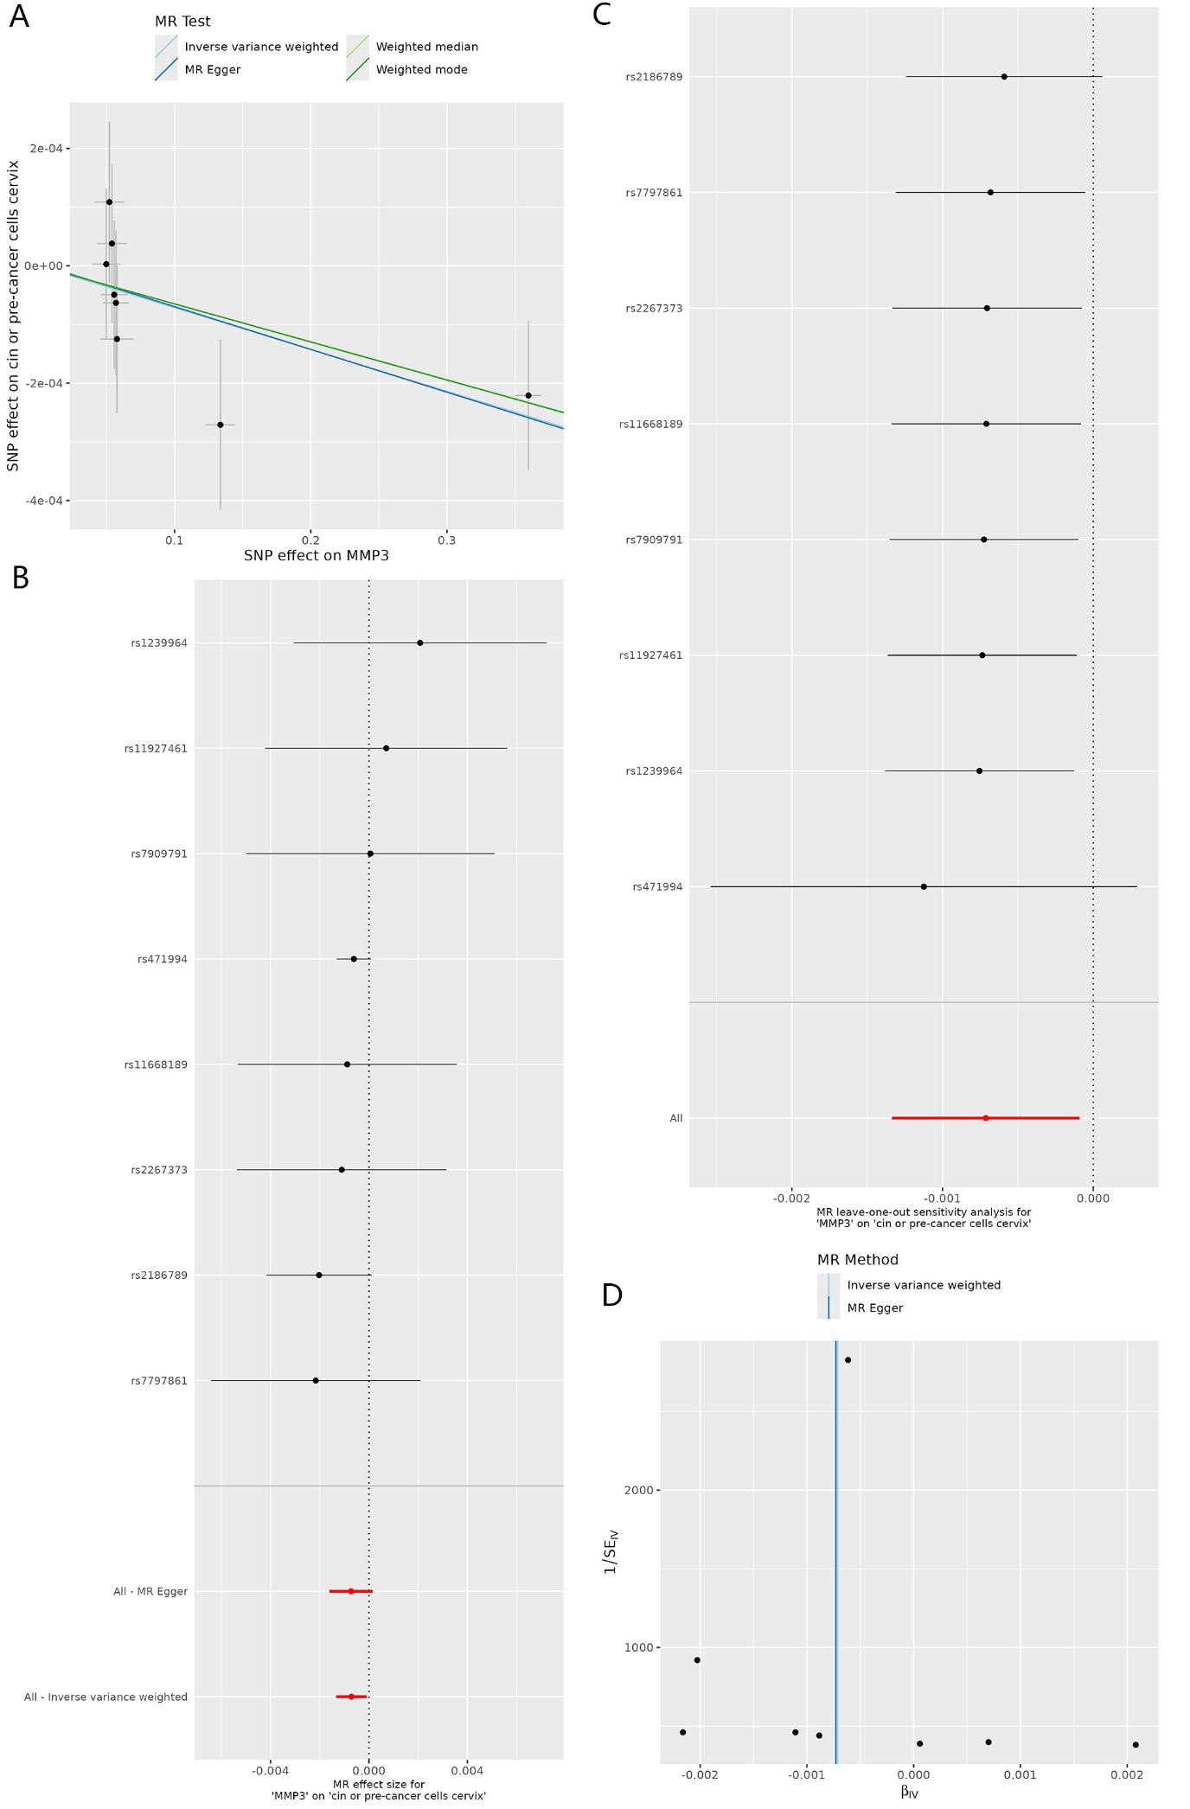
Supplementary Figure S2. Scatter plot (A), forest plot (B), leave-one-out plot (C), and funnel plot (D) of the MR analysis of the causal association of MMP-7 on cervical cancer. MR, Mendelian randomization; SNP, single nucleotide polymorphism; MMPs, matrix metalloproteinases.
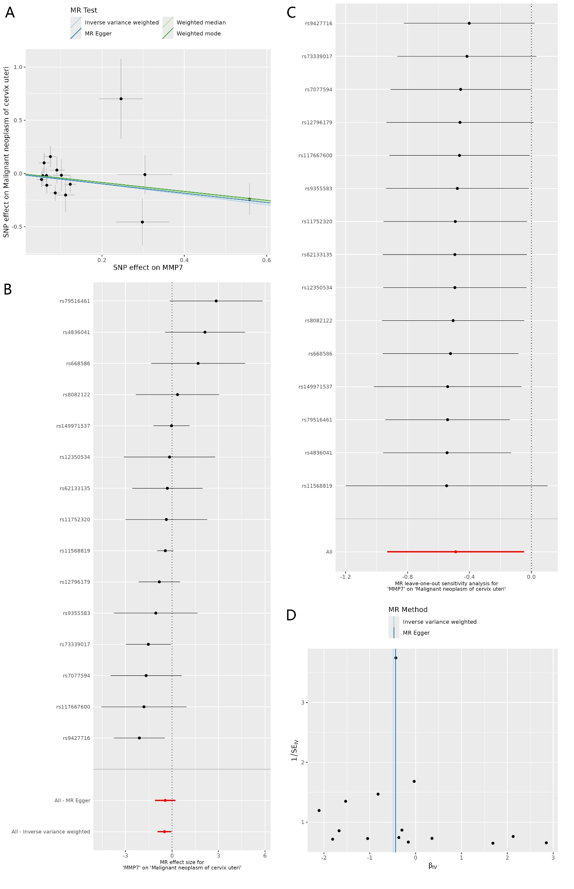
Supplementary Figure S3. Scatter plot (A), forest plot (B), leave-one-out plot (C), and funnel plot (D) of the MR analysis of the causal association of MMP-9 on cervical inflammation. MR, Mendelian randomization; SNP, single nucleotide polymorphism; MMPs, matrix metalloproteinases.
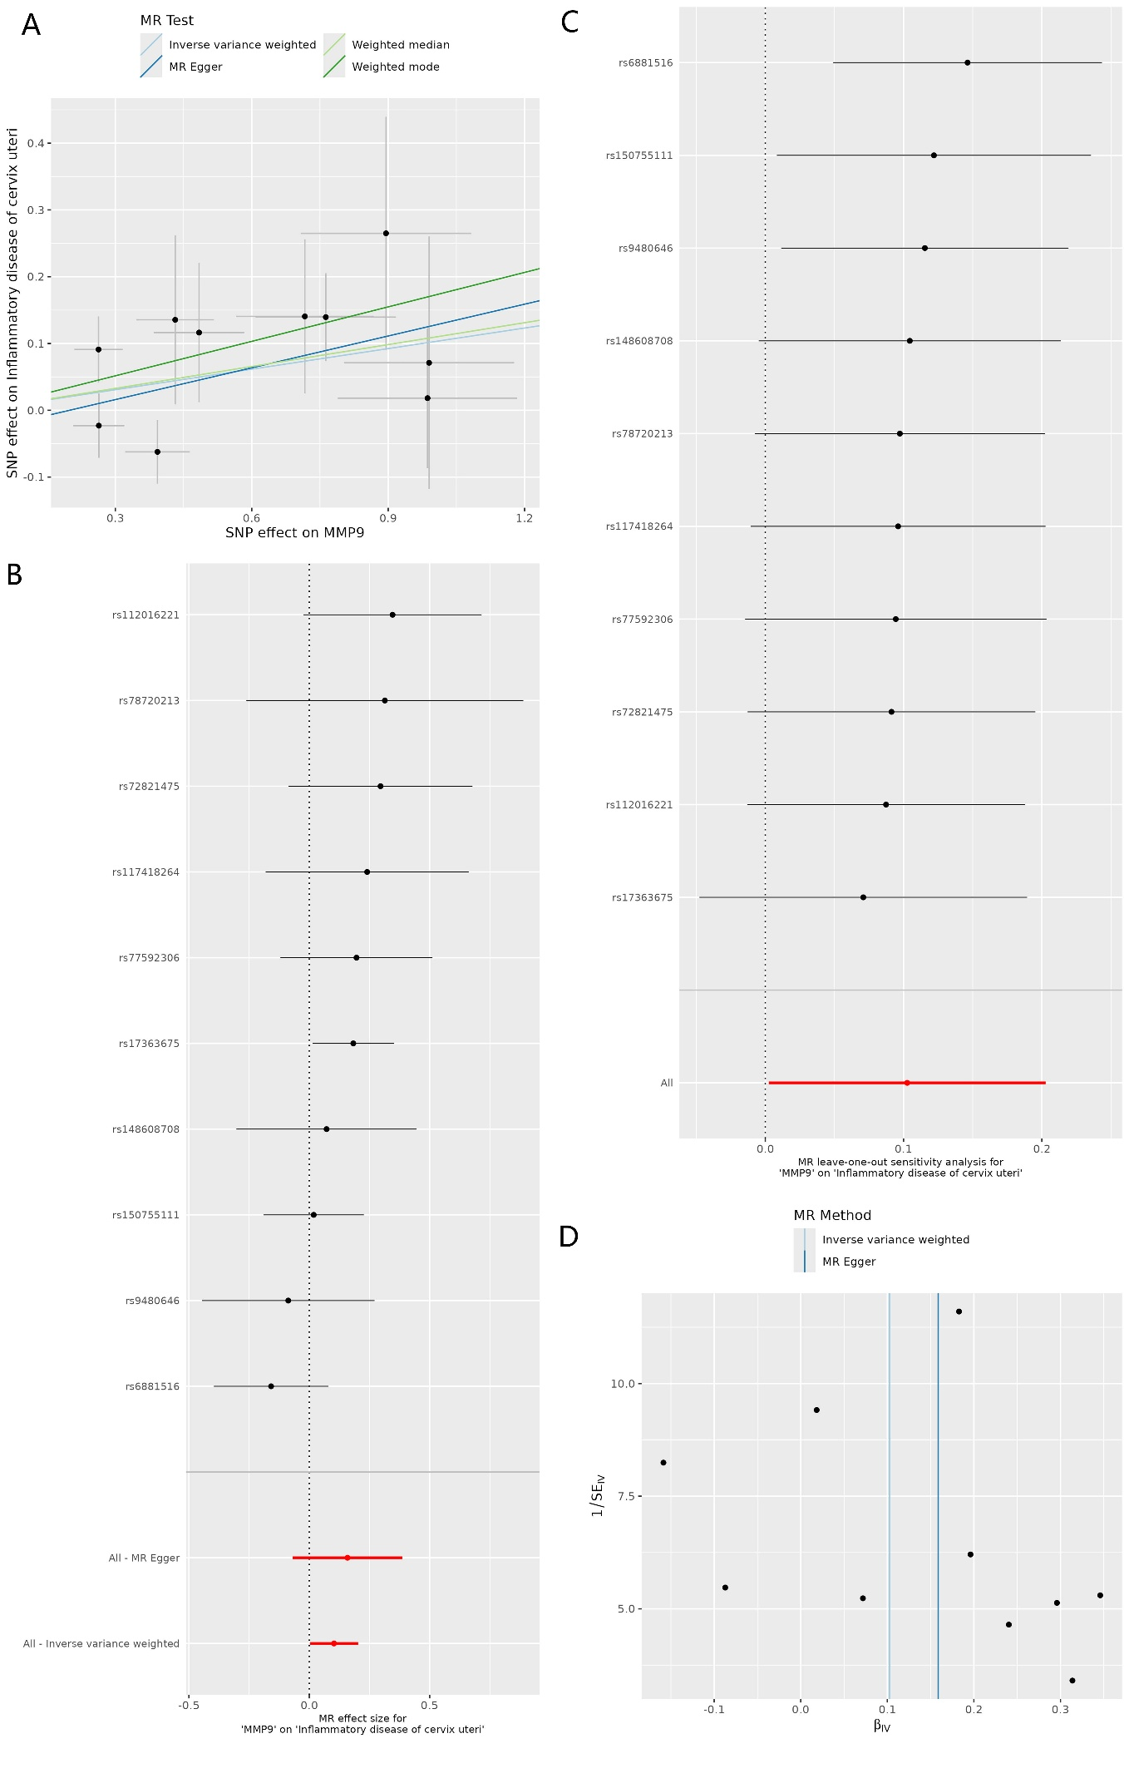
Supplementary Figure S4. Scatter plot (A), forest plot (B), leave-one-out plot (C), and funnel plot (D) of the MR analysis of the causal association of MMP-12 on cervical erosion and ectropion. MR, Mendelian randomization; SNP, single nucleotide polymorphism; MMPs, matrix metalloproteinases.
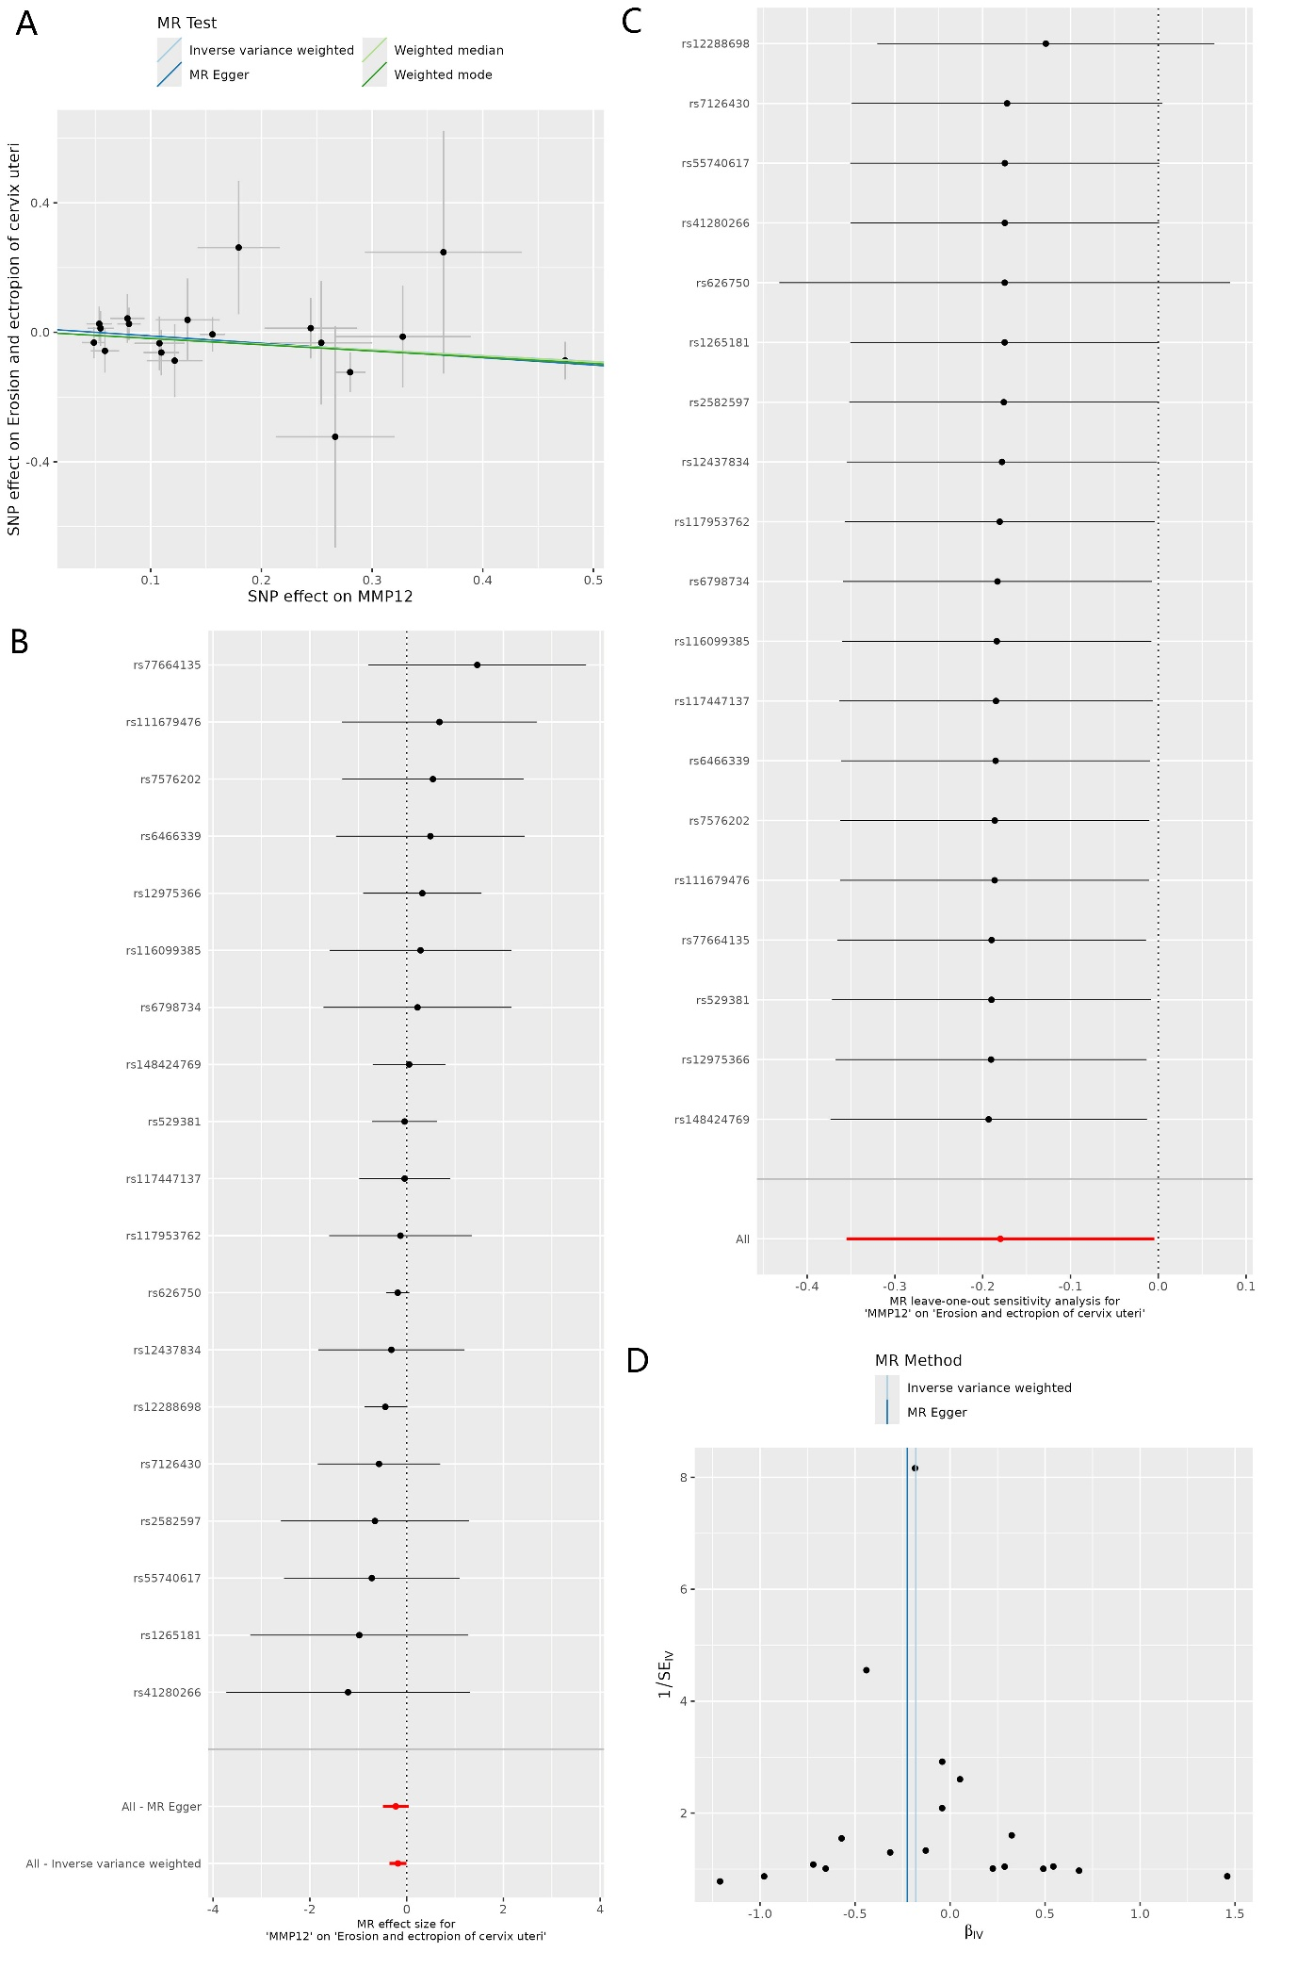
Supplementary Figure S5. Scatter plot (A), forest plot (B), leave-one-out plot (C), and funnel plot (D) of the MR analysis of the causal association of MMP-12 on cervical cancer. MR, Mendelian randomization; SNP, single nucleotide polymorphism; MMPs, matrix metalloproteinases.
