Supporting information:

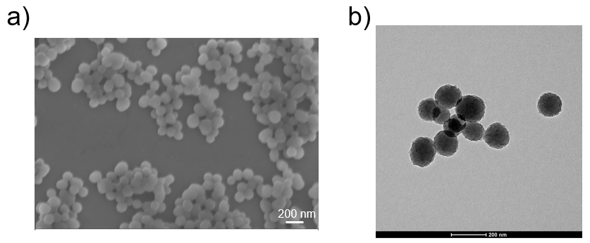
Figure S1. a) SEM and b) TEM images of PDA.

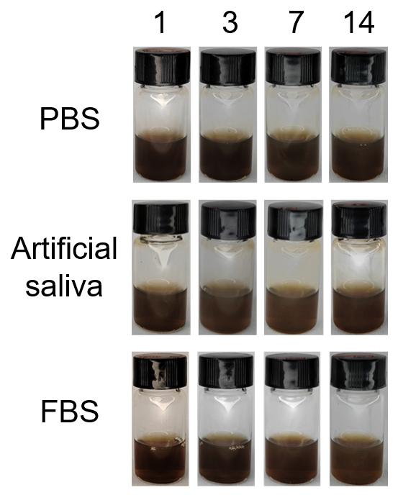
Figure S2. The photographs of PDA dispersed at PBS, artificial saliva and FBS for 14 days to observe stability.

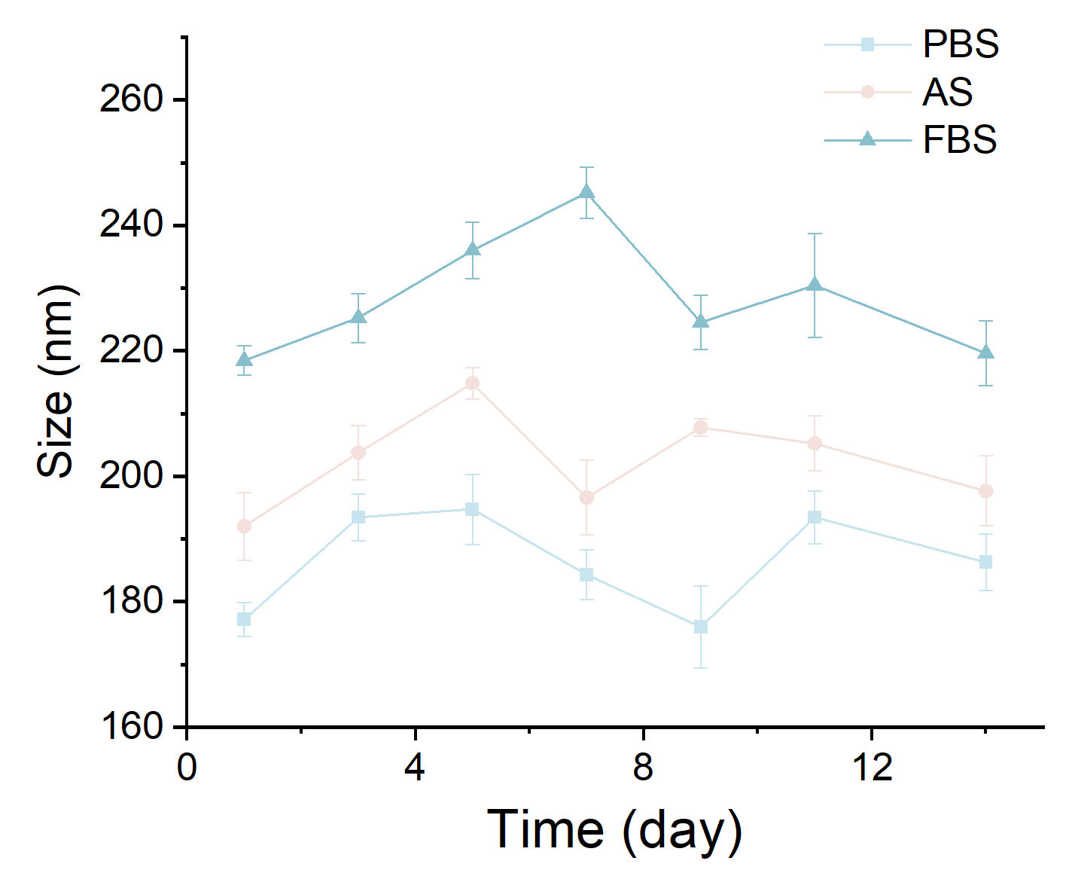
Figure S3. The size changes of PDA dispersed at PBS, artificial saliva and FBS for 14 days.

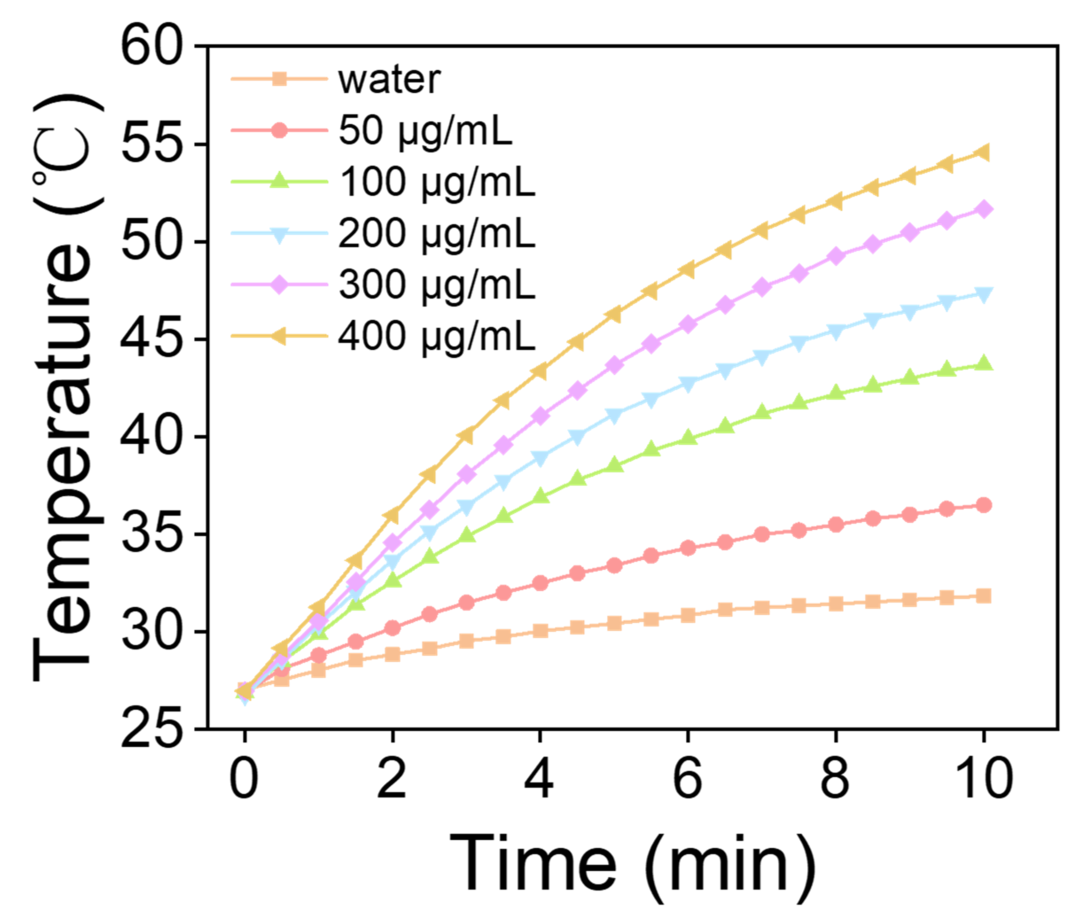
Figure S4. The temperature variation of PDA with different concentration at the irradiation of 808-nm laser with 1.5 W cm⁻¹ for 10 min.

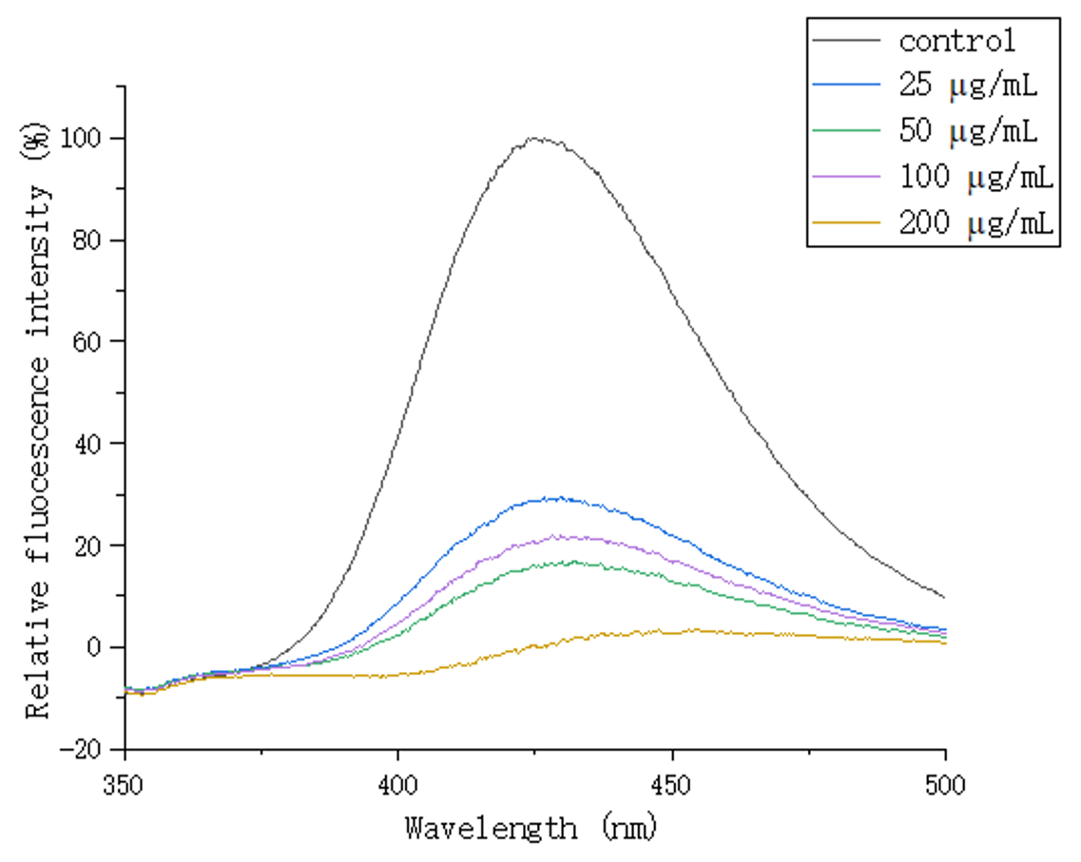
Figure S5.·The relative fluorescence spectrum of oxTA after eliminating ·OH by PDA at various concentration.

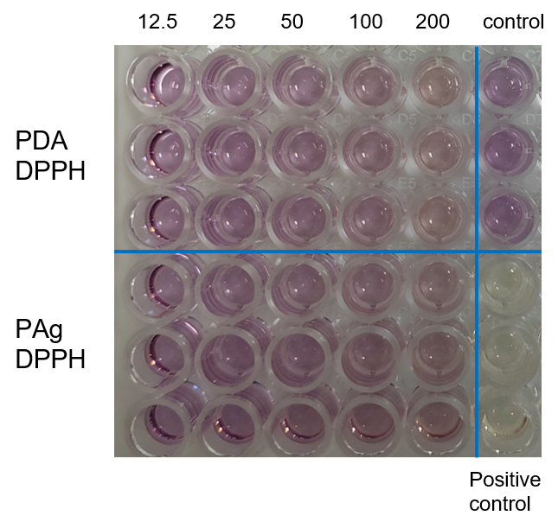
Figure S6. The photograph showing the color of the reaction for 30 min with PDA and PAg at various concentration.

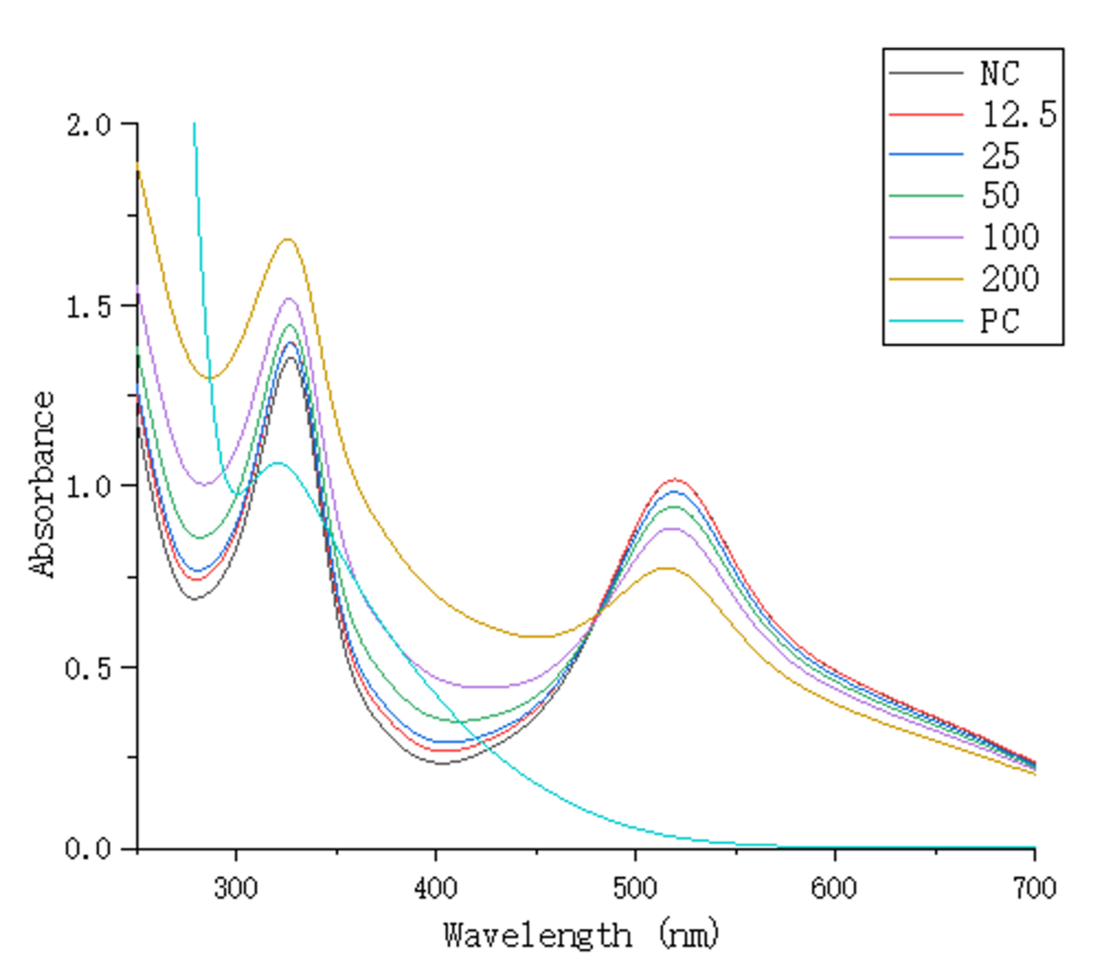
Figure S7. The absorbance spectrum of DPPH after treating with PDA at various concentration.

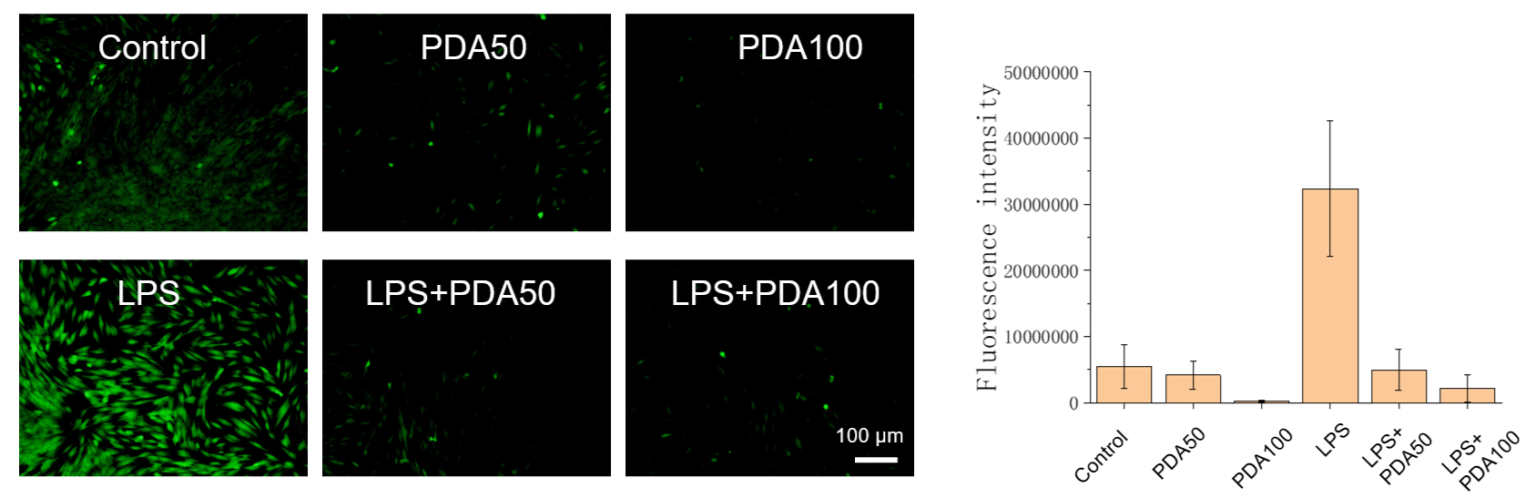
Figure S8. The fluorescence images and intensity of HPLCs after different treatments.

Figure S9. The body weight variation of rats in the course of treatments.

