Supplementary methods:
Computational fluid dynamics analysis
The hemodynamic parameters extracted in this study include: TAWSS (Time-averaged Wall Shear Stress, the average value of wall shear stress over a cardiac cycle), NWSS (Oscillatory Shear Index, indicating the degree of WSS direction changes during a cardiac cycle), TAWSSV (Time-averaged Wall Shear Stress Vector, the time-averaged value of instantaneous wall shear stress vectors over a cardiac cycle), WSSMAX (Maximum Wall Shear Stress, the peak shear stress on the vessel wall during a cardiac cycle), WSSMIN (Minimum Wall Shear Stress, the lowest shear stress on the vessel wall during a cardiac cycle), HSA (High Shear Area, regions where WSS exceeds the mean), LSA (Low Shear Area, regions where WSS is below the mean), OSI (Oscillatory Shear Index, representing the oscillatory nature of blood flow), OSIMAX (Maximum Oscillatory Shear Index, the maximum OSI value in a region), WSSG (Wall Shear Stress Gradient, the rate of spatial change in WSS), GON (Geometric Orientation Number, indicating the directional variation of WSS vectors), and RRT (Residence Time, the time blood stays within the aneurysm sac).
Morphological parameters measurement
- S refers to the surface area above the aneurysm neck plane[1].(2) V refers to the volume above the aneurysm neck plane[1].(3) UI is defined as UI = 1 - (V/Vch), where Vch represents the smallest volume that fully encloses the aneurysm starting from the neck and is convex at all points[1,2].(4) EI measures the deviation of Vch from a perfect sphere[8,9].Sch represents the surface area of the smallest convex region, starting from the neck, that fully encloses the aneurysm.(5) NSI describes the deviation of the aneurysm's volume and surface area from those of a perfect hemisphere[1,2].Other parameters were described in previous studies by Zheng et al[3].Detailed information can be found in Supplementary Figure 1.A daughter sac is an irregular protrusion of the aneurysm wall.

Construction and validation of machine learning model
Ten-fold cross-validation and the LASSO algorithm were applied to the training dataset. A lambda value of 0.028 was selected, resulting in the optimal model fit, avoiding both overfitting and underfitting. Nine variables were initially selected: hypertension, diabetes, irregular shape, Inflow, UI, SR, EI, NSI, and WSSmin. Collinearity of variables was calculated in each dataset, as follows: Training set: hypertension (1.86), diabetes (1.12), irregular shape (1.66), Inflow (1.11), UI (2.52), SR (1.95), EI (2.07), NSI (4.78), WSSmin (1.23).Internal validation set: hypertension (2.29), diabetes (1.26), irregular shape (2.77), Inflow (1.08), UI (8.28), SR (1.87), EI (31.34), NSI (51.00), WSSmin (1.31).External validation set: hypertension (2.75), diabetes (3.64), irregular shape (1.69), Inflow (1.15), UI (22.9), SR (1.74), EI (15.27), NSI (20.42), WSSmin (9.54).UI, EI, and NSI were highly correlated. Literature review revealed that a study [4] analyzed the correlation of these three variables with aneurysm rupture and found that NSI was the most important factor affecting intracranial aneurysm rupture, thus UI and EI were excluded.The final modeling variables were: hypertension, diabetes, irregular shape, Inflow, SR, NSI, and WSSmin.

Statistical analysis
The hyperparameters of the five base models are shown in Supplementary Table 1.
The hyperparameters of the Superlearner model are shown in Supplementary Table 2.

Supplementary Table 1. The construction methods of five foundational models.
Model | Hyperparameter(s) | Tuning Method | Search Range | Selected Value(s) | Notes
Decision Tree | Complexity parameter (cp) | 5-fold CV, grid search | 0.01 to 0.1 (step = 0.01) | 0.03 | Controls tree pruning to avoid overfitting
Random Forest | mtry (No. of variables per split) | 5-fold CV, grid search | 2, 3, 4, 5 | 3 | Balances bias and variance
SVM (RBF) | Cost (C), Gamma (σ) | 5-fold CV, grid search | C: 0.1, 1, 10; Gamma: 0.001, 0.01, 0.1 | C = 1, γ = 0.142857 | RBF kernel (Gaussian); gamma automatically computed by caret
KNN | Number of neighbors (k) | 5-fold CV, grid search | 1 to 20 (step = 2) | 15 | k optimized based on minimum CV error
XGBoost | nrounds, objective | Manual tuning | nrounds = 100; objective = "binary:logistic" | nrounds = 100 | Default learning rate and depth used for simplicity

Supplementary Table 2. Contribution of five base models in Super Learner.
Model | Risk | Coef
SL_rpart | 0.116 | 0.076
SL_knn | 0.182 | 0.000
SL_xgboost | 0.164 | 0.000
SL_randomforest | 0.070 | 0.0924
SL_svm | 0.201 | 0.000

Supplementary figure 1. Definitions of morphological parameters.

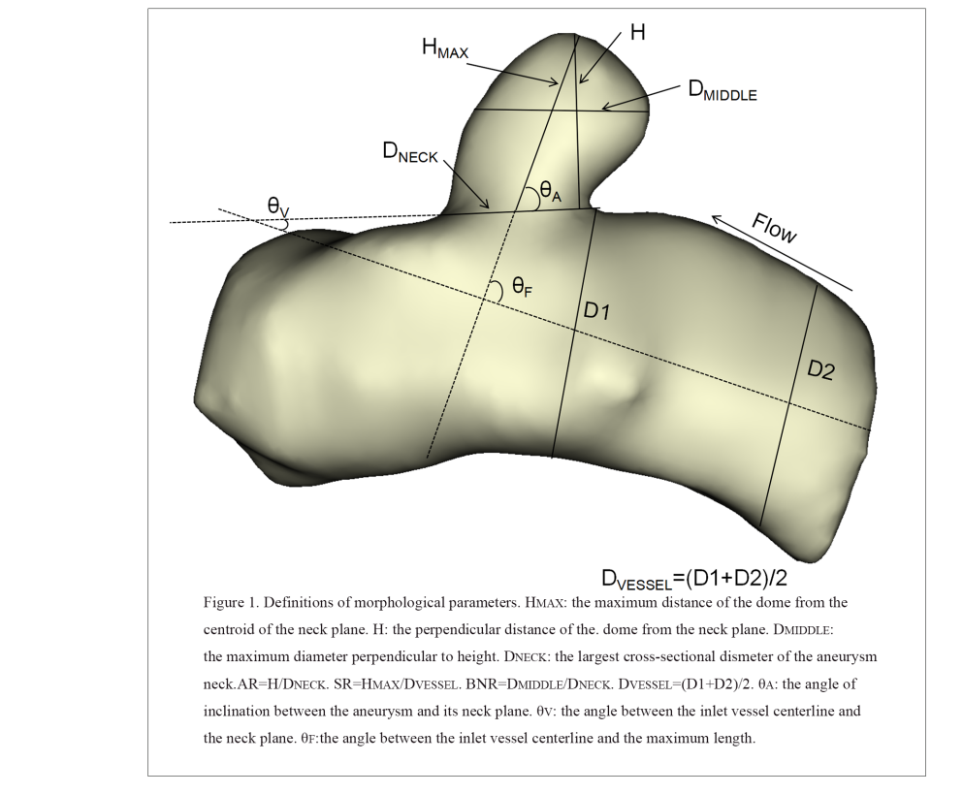
References
[1] Raghavan ML, Ma B, Harbaugh RE. Quantified aneurysm shape and rupture risk. J Neurosurg. 2005;102(2):355-362.
[2] Dhar S, Tremmel M, Mocco J, et al. Morphology parameters for intracranial aneurysm rupture risk assessment. Neurosurgery. 2008;63(2):185-197.
[3] Zheng Y, Xu F, Ren J, et al. Assessment of intracranial aneurysm rupture based on morphology parameters and anatomical locations. J Neurointerv Surg. 2016;8(12):1240-1246.
[4] Detmer FJ, Hadad S, Chung BJ, Mut F, Slawski M, Juchler N, Kurtcuoglu V, Hirsch S, Bijlenga P, Uchiyama Y, Fujimura S, Yamamoto M, Murayama Y, Takao H, Koivisto T, Frösen J, Cebral JR. Extending statistical learning for aneurysm rupture assessment to Finnish and Japanese populations using morphology, hemodynamics, and patient characteristics. Neurosurg Focus. 2019 Jul 1;47(1):E16.

