Supplementary Figure 1: The TCRPs of several Traditional Chinese Medicinal screening based on the FAK-TCRPs. (A) The TCRPs of EGF induction models were recorded by xCELLigence system. (B-K) Pogostemon cablin (Blanco) Benth., Adenophora tetraphylla (Thunb.)Fisch., Salvia miltiorrhiza Bunge, Belamcanda chinensis (L.) Redouté), Achyranthes bidentata Blume, F.A. Sophora flavescens Aiton, Polygala tenuifolia Willd., Wolfiporia cocos (F.A. Wolf) Ryvarden & Gilb., Armeniacae Amarum Semen, Moutan cortex radicis’s TRCP were recorded by xCELLigence system in FAK-TCRPs model. A red dashed box highlights Moutan cortex radicis’s TRCP.

Supplementary Material 1：Analysis injection list
Component name: (Z)-(1S,5R)-β-Pinen-10-yl-β-vicianoside
Channel name: (Z)-(1S,5R)-β-Pinen-10-yl-β-vicianoside [-H] : (10.00mDa)445.2078

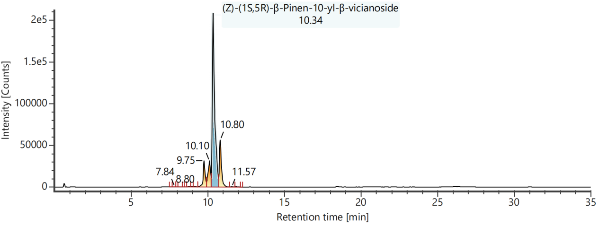
Channel name: Low energy : Time 10.3524 +/- 0.0740 minutes

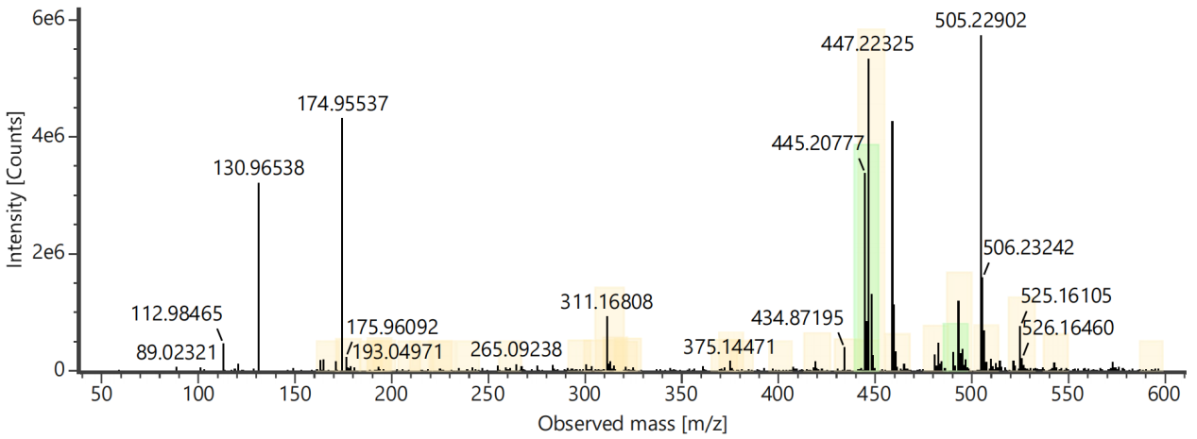
Channel name: High energy : Time 10.3524 +/- 0.0740 minutes
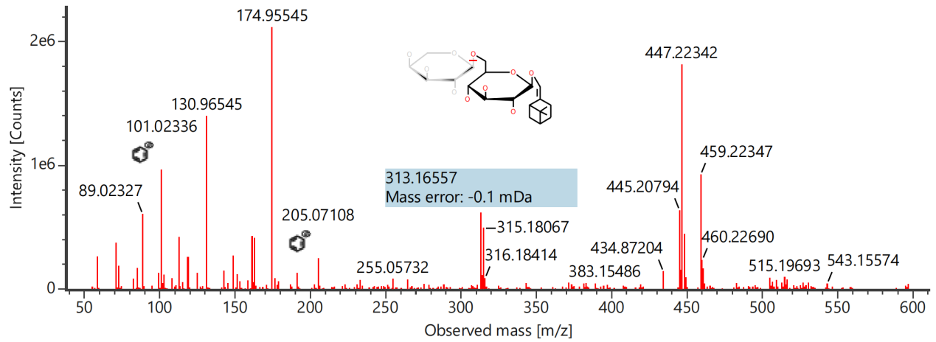

Component name: 10-O-Acetylgeniposidic acid
Channel name: 10-O-Acetylgeniposidic acid [+HCOO] : (10.00 mDa) 461.1300
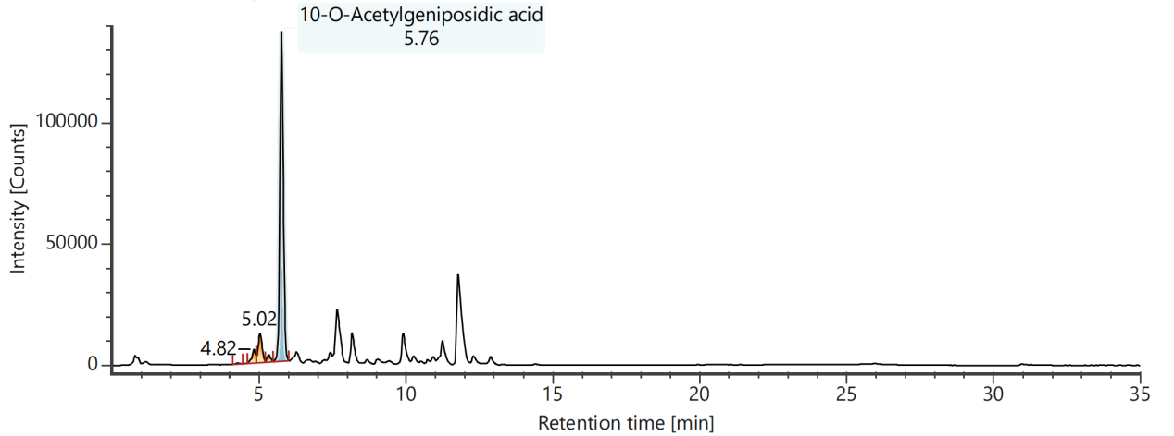
Channel name: Low energy : Time 5.7624 +/- 0.0740 minutes
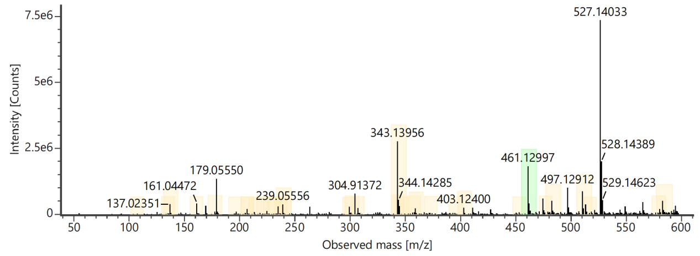
Channel name: High energy : Time 5.7624 +/- 0.0740 minutes
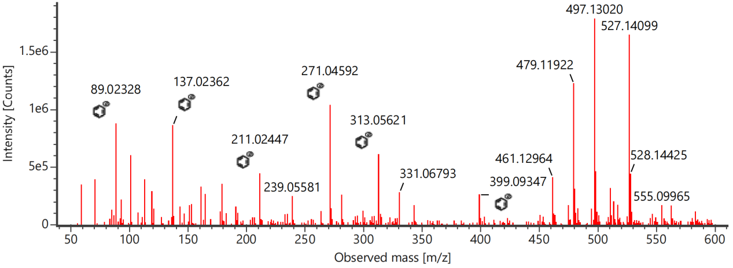

Component name: 1-Galloyl-β-D-glucose
Channel name: 1-Galloyl-β-D-glucose [-H] : (10.00 mDa) 331.0670
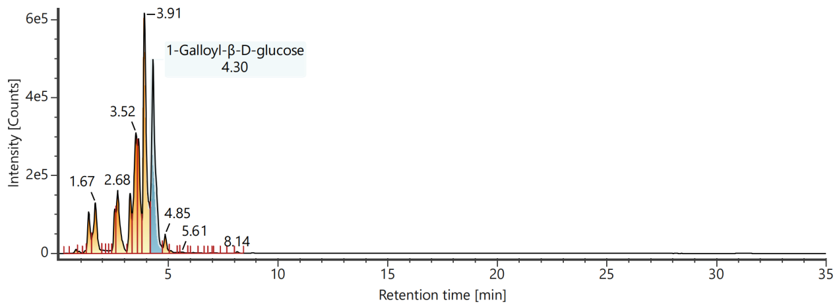
Channel name: Low energy : Time 4.3044 +/- 0.0740 minutes
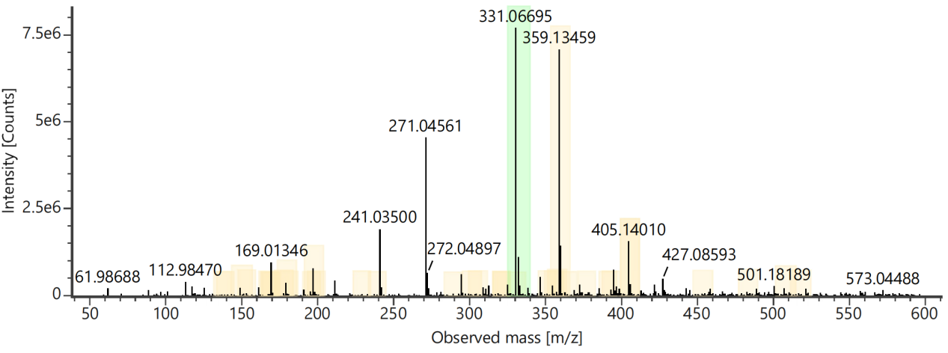
Channel name: High energy : Time 4.3044 +/- 0.0740 minutes
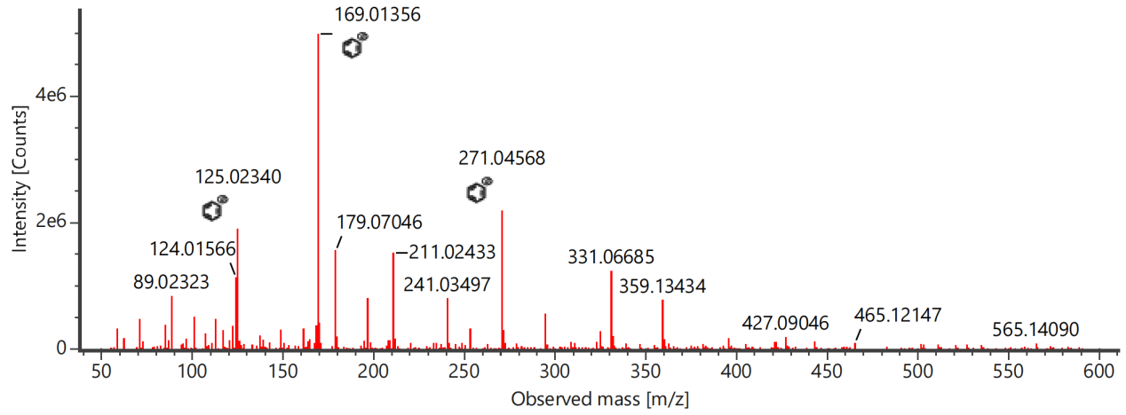

Component name: 1-O-β-D-Glucopyranosylpaeonisuffrone
Channel name: 1-O-β-D-Glucopyranosylpaeonisuffrone [-H] : (10.00 mDa) 359.1346
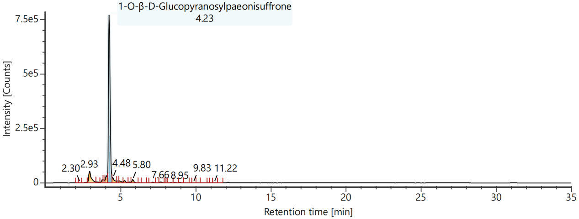
Channel name: Low energy : Time 4.2395 +/- 0.0740 minutes
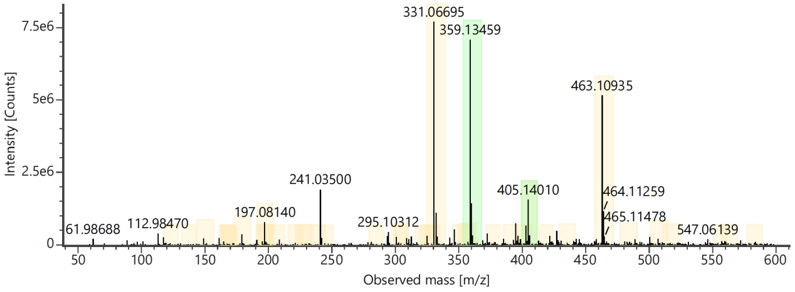
Channel name: High energy : Time 4.2395 +/- 0.0740 minutes
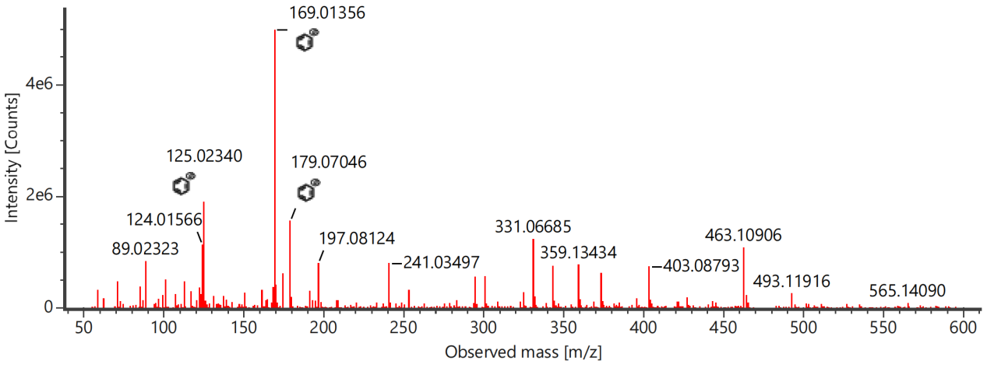

Component name: 2,4,6-Trihydroxyacetophenone-2,4-di-O-β-D-glucopyranoside
Channel name: 2,4,6-Trihydroxyacetophenone-2,4-di-O-β-D-glucopyranoside [-H] : (10.00 mDa) 491.1404
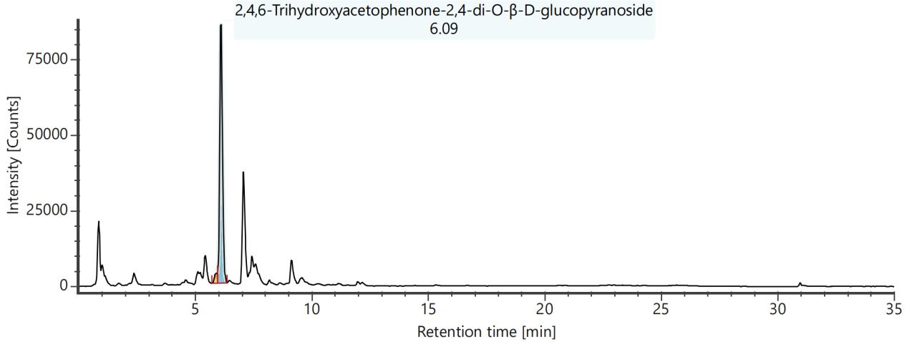
Channel name: Low energy : Time 6.0985 +/- 0.0740 minutes
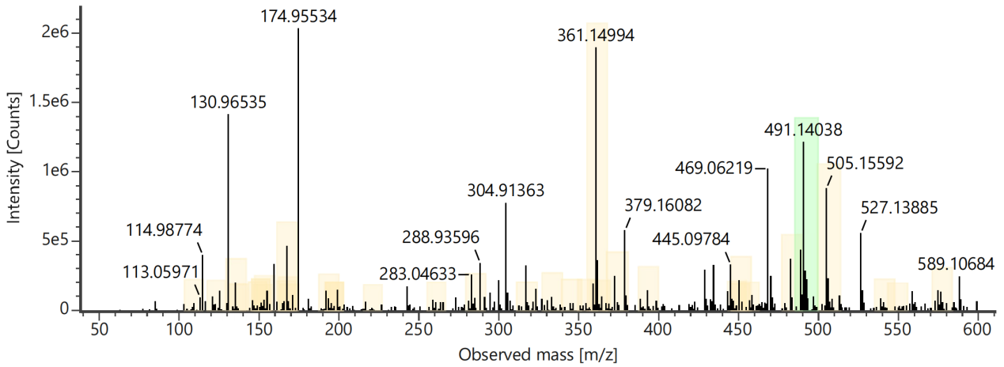
Channel name: High energy : Time 6.0985 +/- 0.0740 minutes
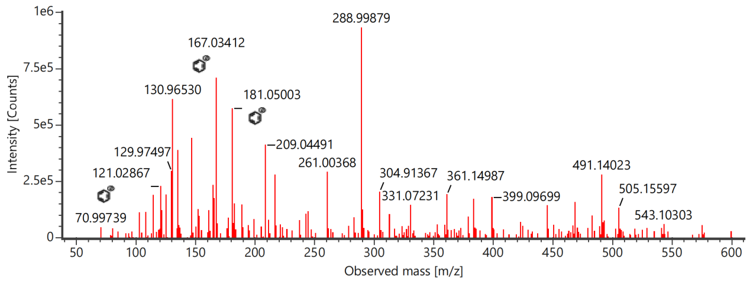

Component name: 2′-Hydroxy-3′,4′-dimethoxy-isoflavan-7-O-β-D-glucoside
Channel name: 2′-Hydroxy-3′,4′-dimethoxy-isoflavan-7-O-β-D-glucoside [+HCOO] : (10.00 mDa) 509.1663

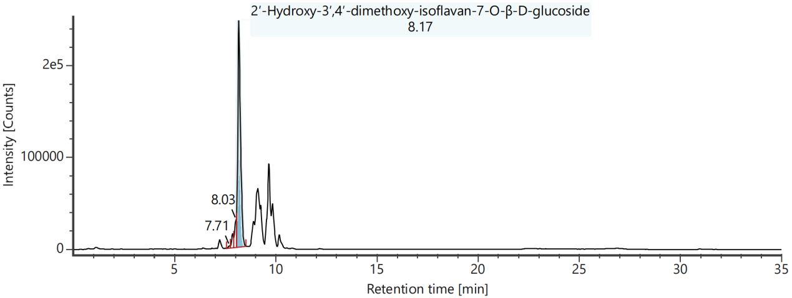
Channel name: Low energy : Time 8.1903 +/- 0.0740 minutes
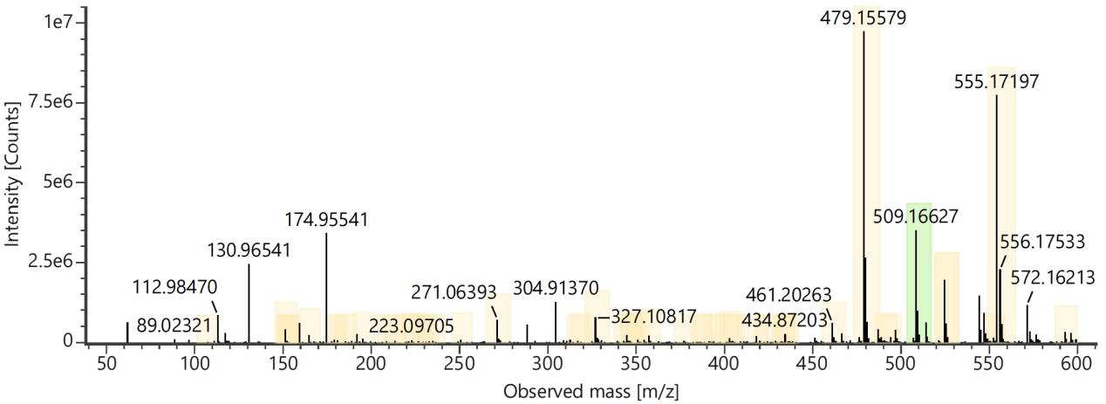
Channel name: High energy : Time 8.1903 +/- 0.0740 minutes
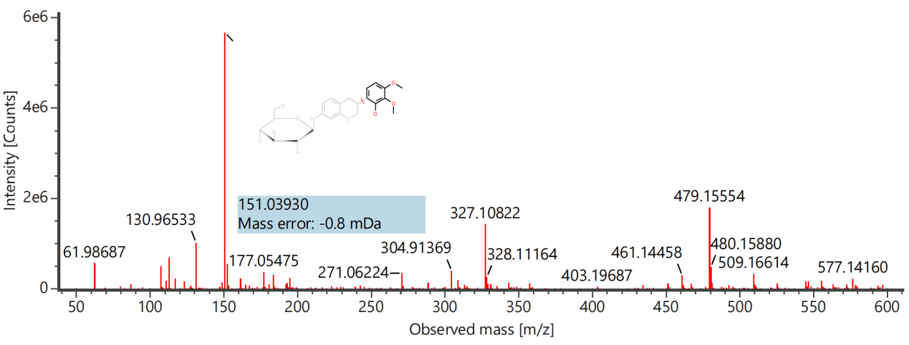

Component name: 3,5,6,7,8,3',4'-Heptemethoxyflavone
Channel name: 3,5,6,7,8,3',4'-Heptemethoxyflavone [-H] : (10.00 mDa) 431.1351
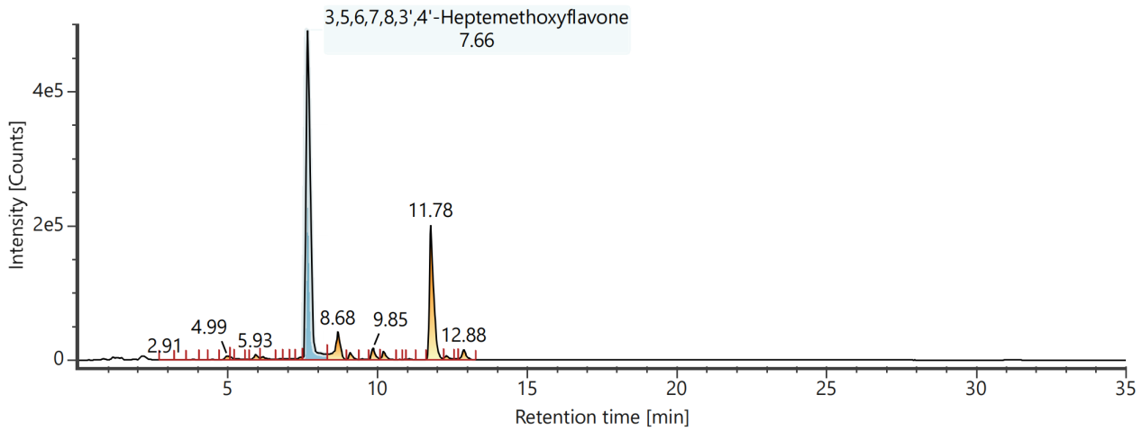
Channel name: Low energy : Time 7.6783 +/- 0.0740 minutes
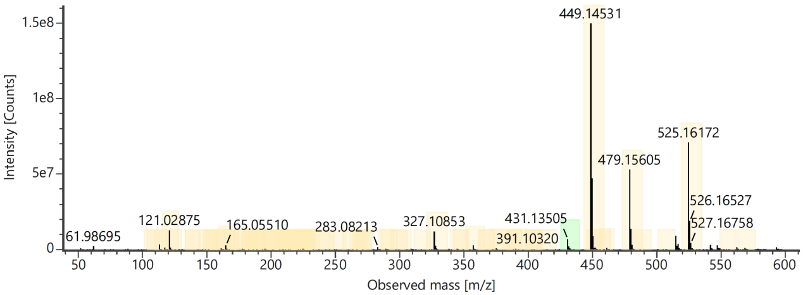
Channel name: High energy : Time 7.6783 +/- 0.0740 minutes
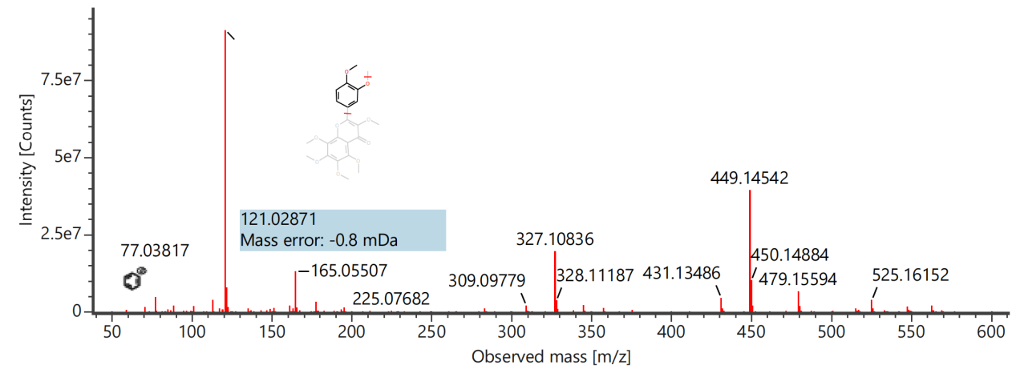

Component name: 6-O-β-D-Glucopyranosyllactinolide
Channel name: 6-O-β-D-Glucopyranosyllactinolide [-H] : (10.00 mDa) 361.1502
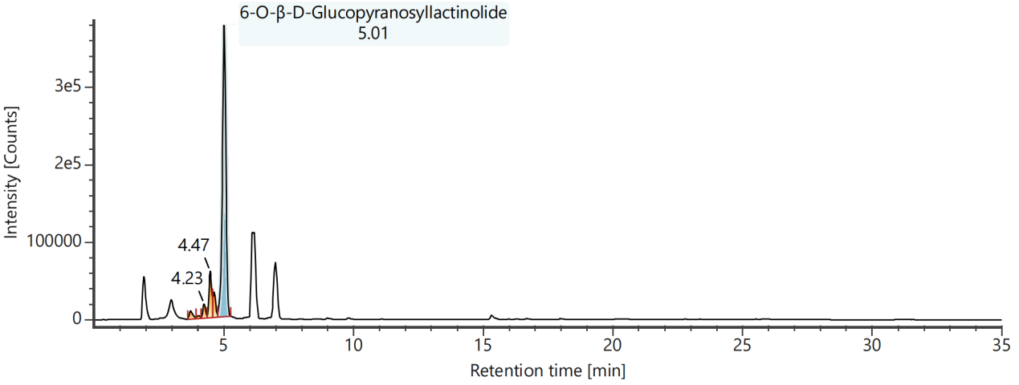
Channel name: Low energy : Time 5.0092 +/- 0.0740 minutes
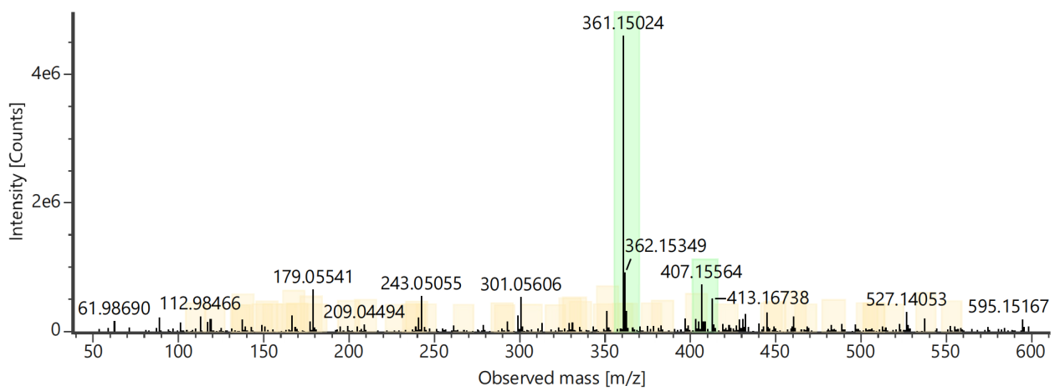
Channel name: High energy : Time 5.0092 +/- 0.0740 minutes
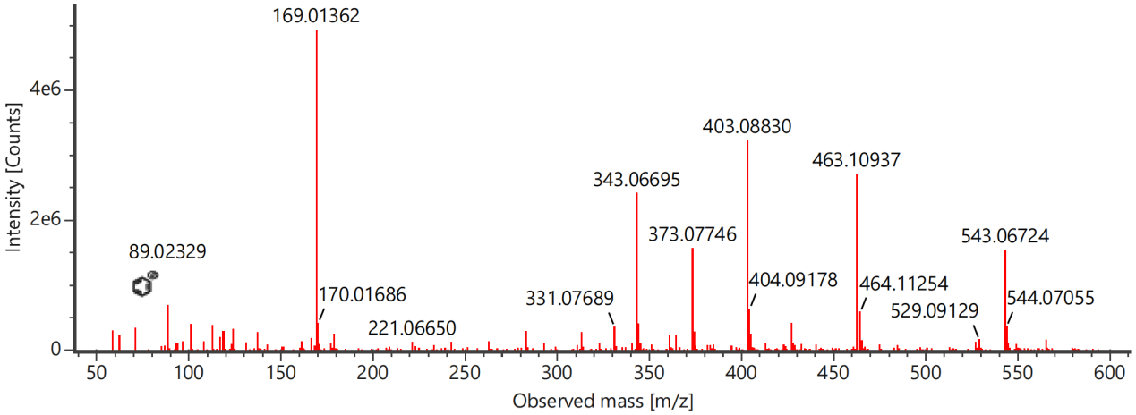

Component name: 7,4′,7′′,4′′′-Tetra-O-amentoflavone
Channel name: 7,4′,7′′,4′′′-Tetra-O-amentoflavone [-H] : (10.00 mDa) 593.1444
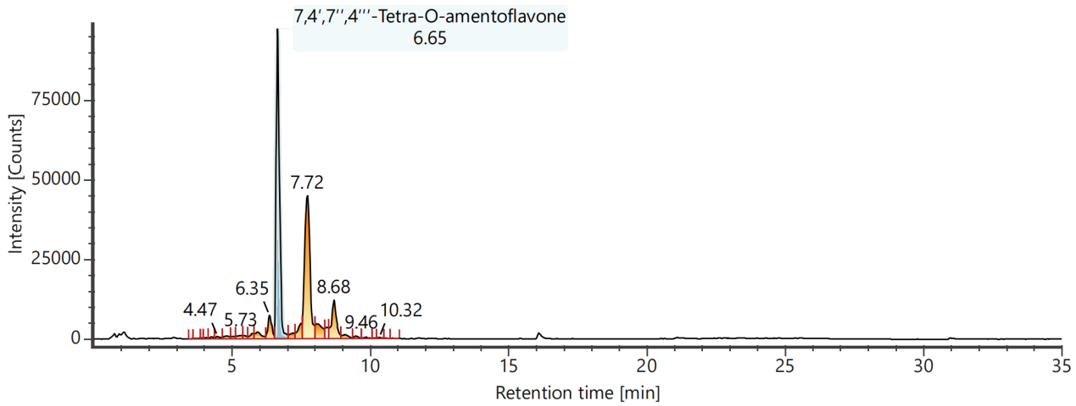
Channel name: Low energy : Time 6.6567 +/- 0.0740 minutes
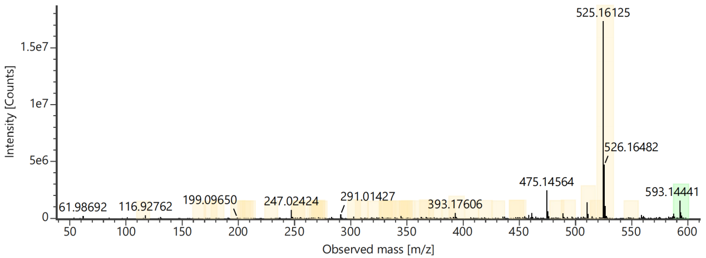
Channel name: High energy : Time 6.6567 +/- 0.0740 minutes
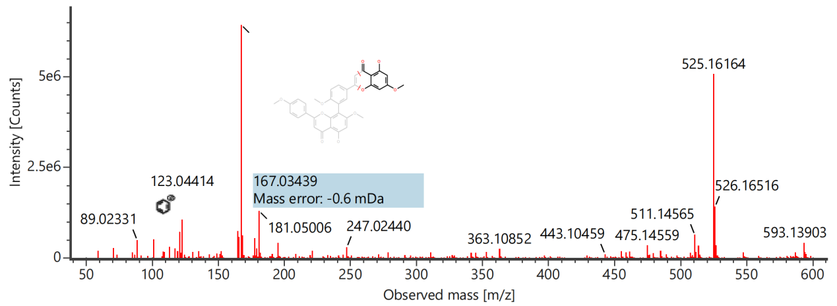

Component name: Acetylharpagide
Channel name: Acetylharpagide [-H] : (10.00 mDa) 405.1401
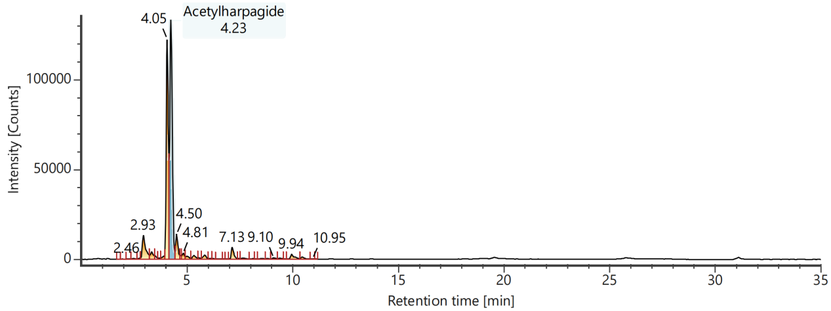
Channel name: Low energy : Time 4.2370 +/- 0.0740 minutes
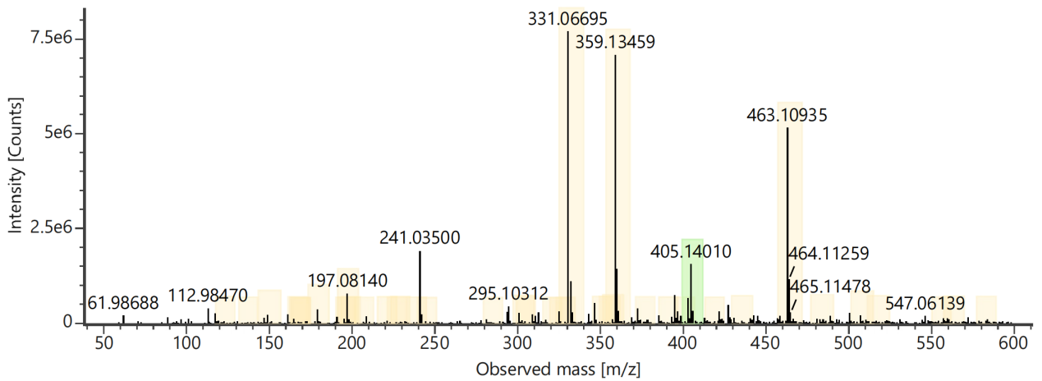
Channel name: High energy : Time 4.2370 +/- 0.0740 minutes
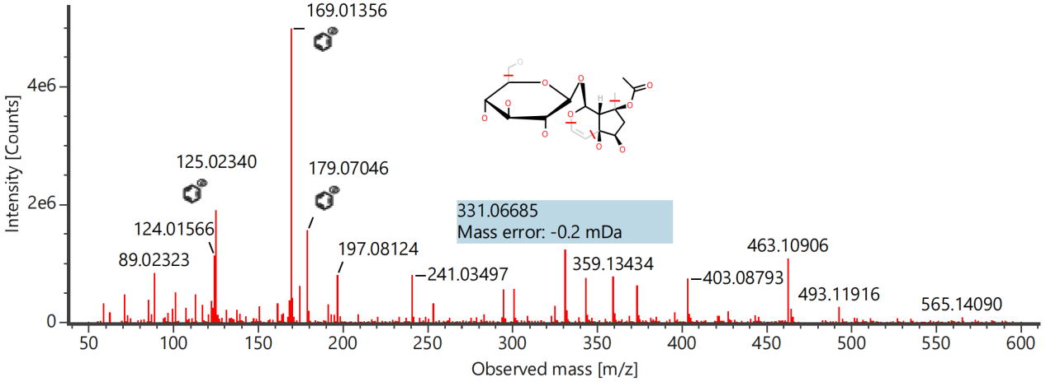

Component name: Albiflorin
Channel name: Albiflorin [-H] : (10.00 mDa) 479.1557
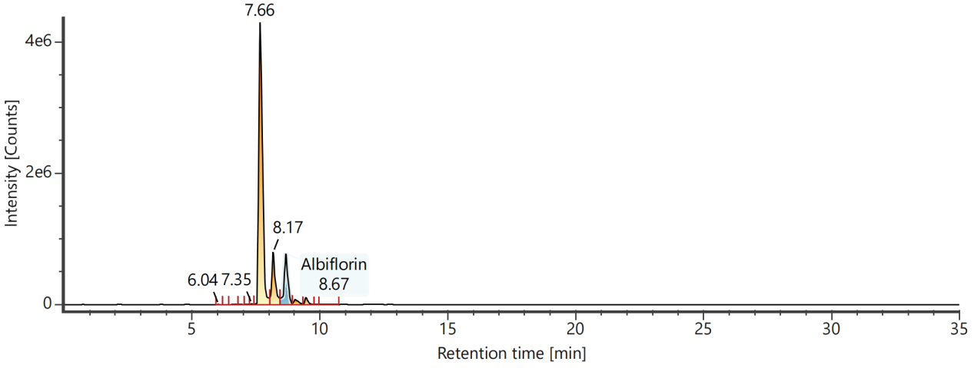
Channel name: Low energy : Time 8.6813 +/- 0.0740 minutes
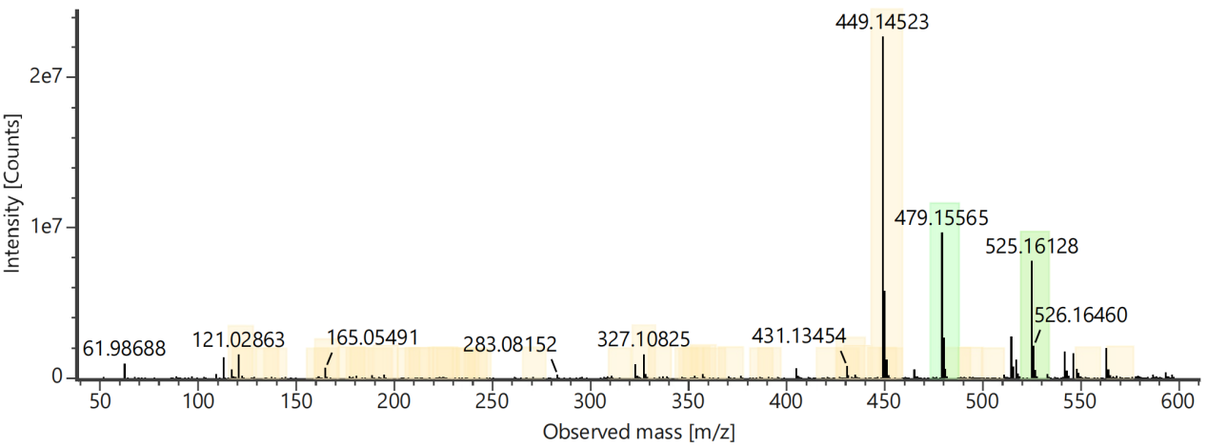
Channel name: High energy : Time 8.6813 +/- 0.0740 minutes

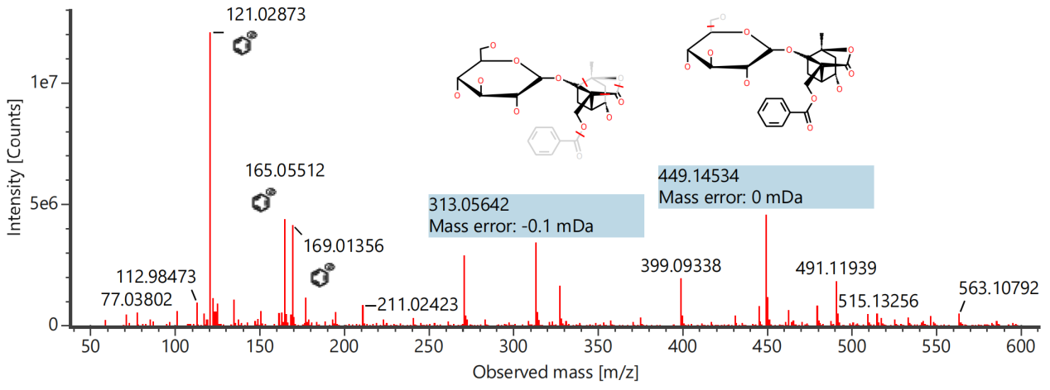

Component name: Albiflorin R1
Channel name: Albiflorin R1 [-H] : (10.00 mDa) 479.1558
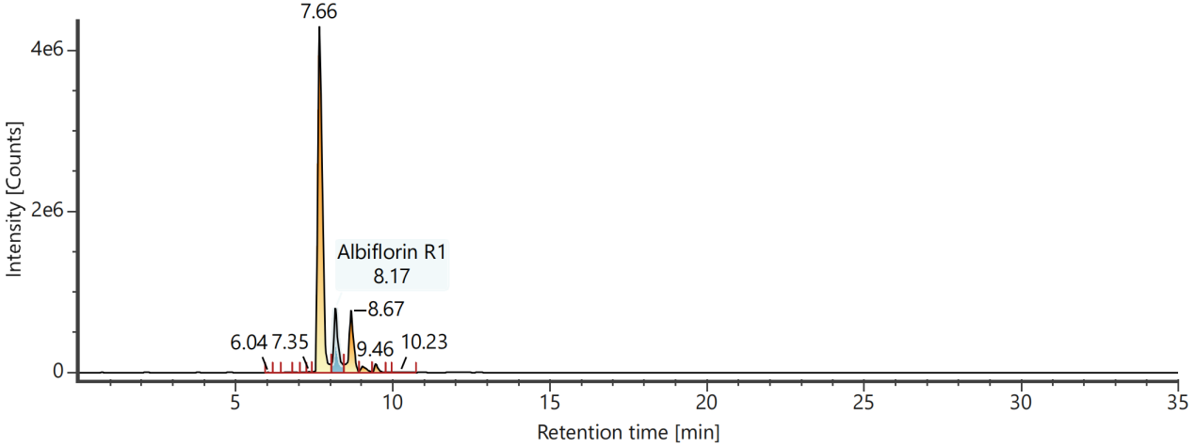
Channel name: Low energy : Time 8.1871 +/- 0.0740 minutes
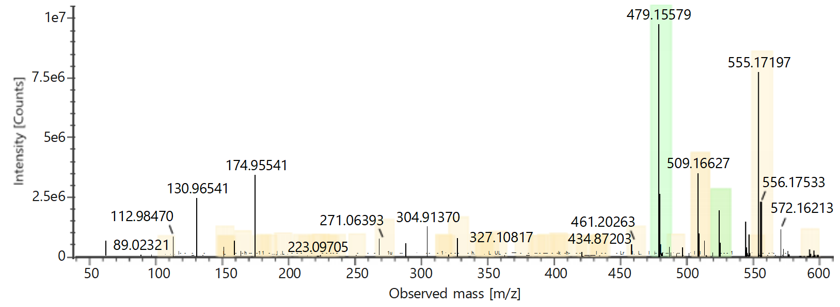
Channel name: High energy : Time 8.1871 +/- 0.0740 minutes
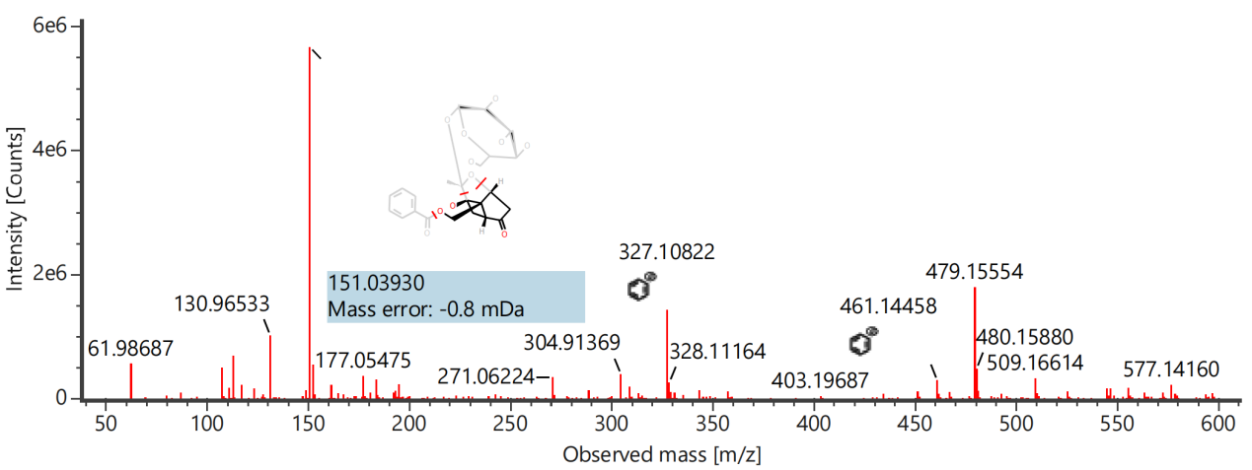

Component name: Apiopaeonoside
Channel name: Apiopaeonoside [-H] : (10.00 mDa) 459.1504
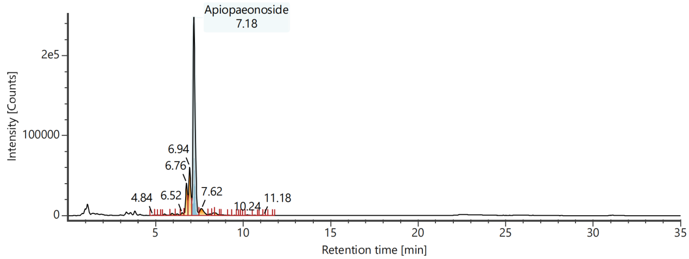
Channel name: Low energy : Time 7.1994 +/- 0.0740 minutes
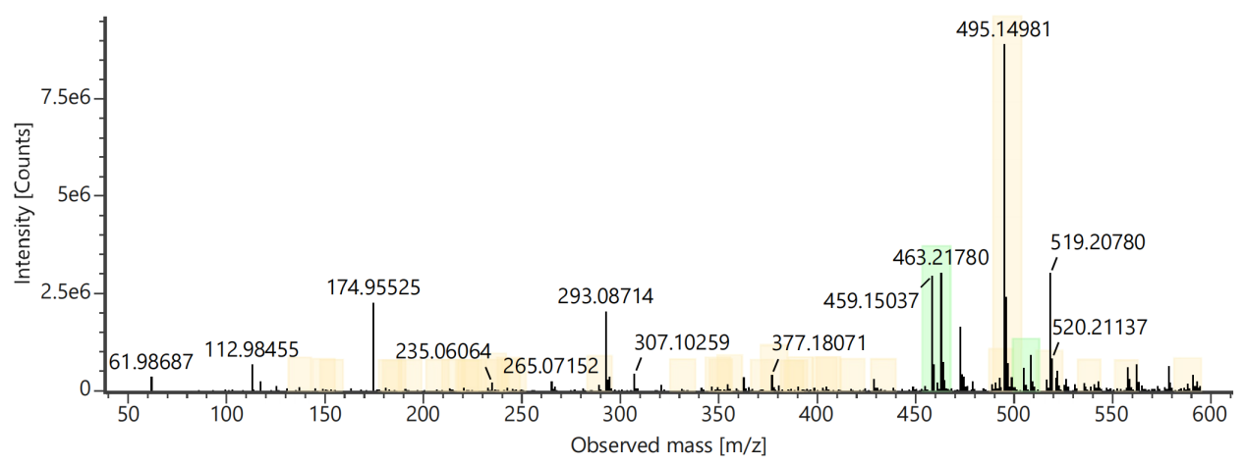
Channel name: High energy : Time 7.1994 +/- 0.0740 minutes
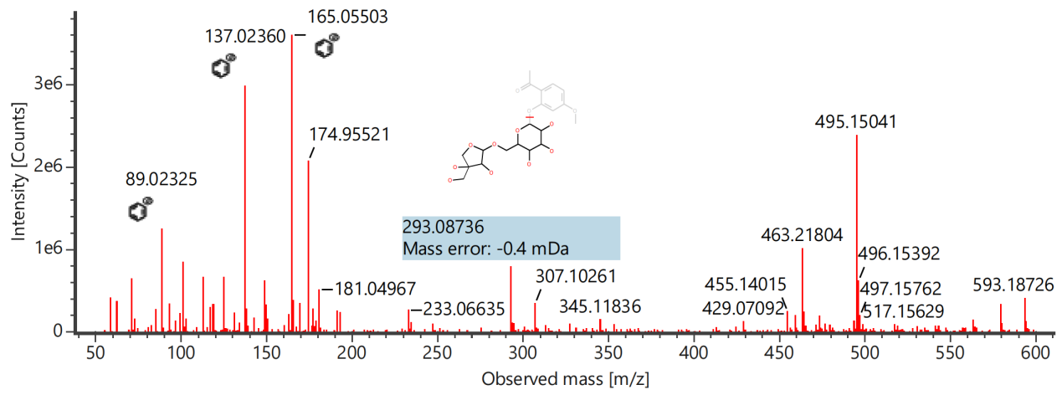

Component name: Aucubin
Channel name: Aucubin [-H] : (10.00 mDa) 345.1187

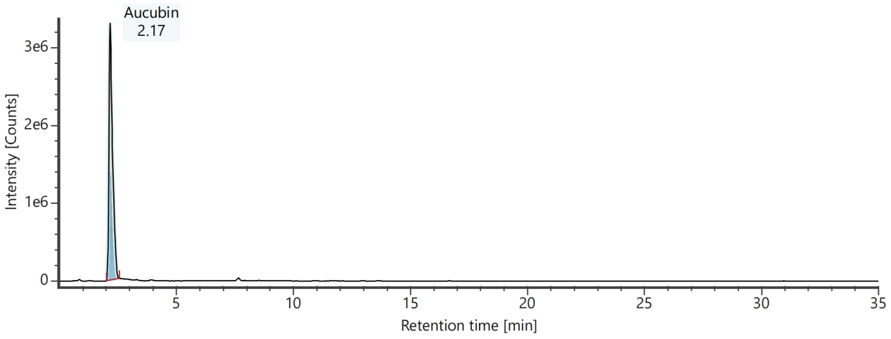
Channel name: Low energy : Time 2.1905 +/- 0.0740 minutes
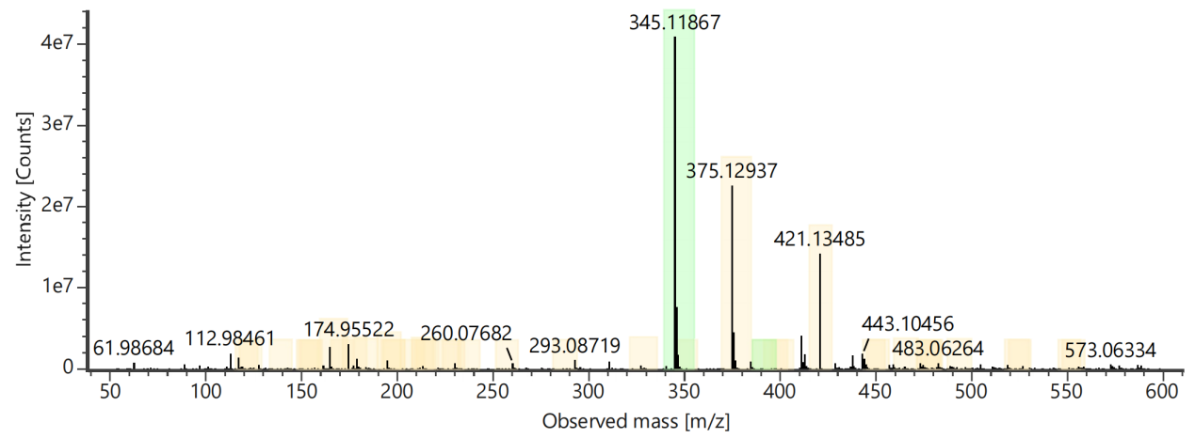
Channel name: Low energy : Time 2.1905 +/- 0.0740 minutes
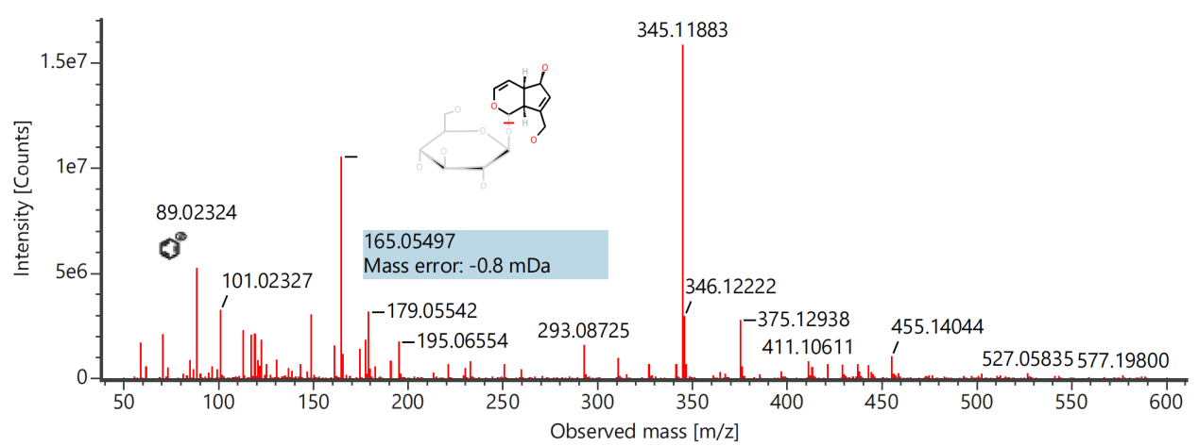

Component name: Benzoyl-oxypaeoniflorin
Channel name: Benzoyl-oxypaeoniflorin [-H] : (10.00 mDa) 599.1778
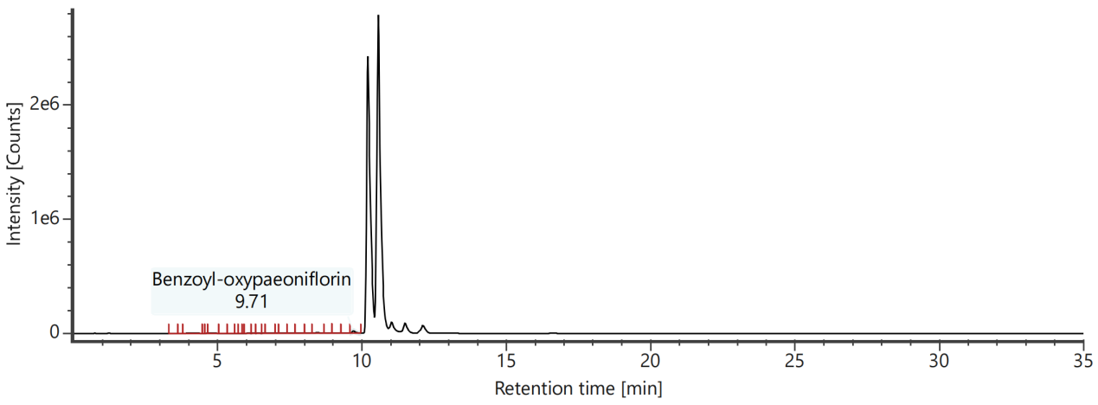
Channel name: Low energy : Time 9.7261 +/- 0.0740 minutes
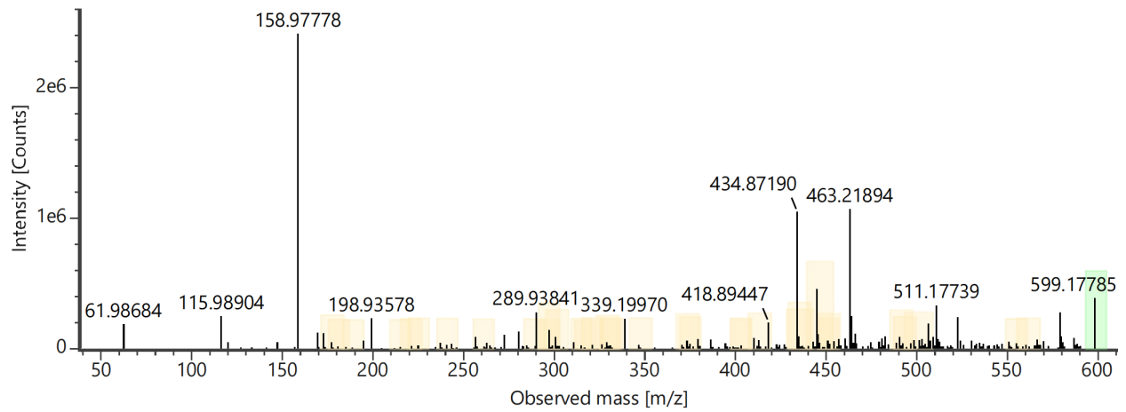
Channel name: High energy : Time 9.7261 +/- 0.0740 minutes
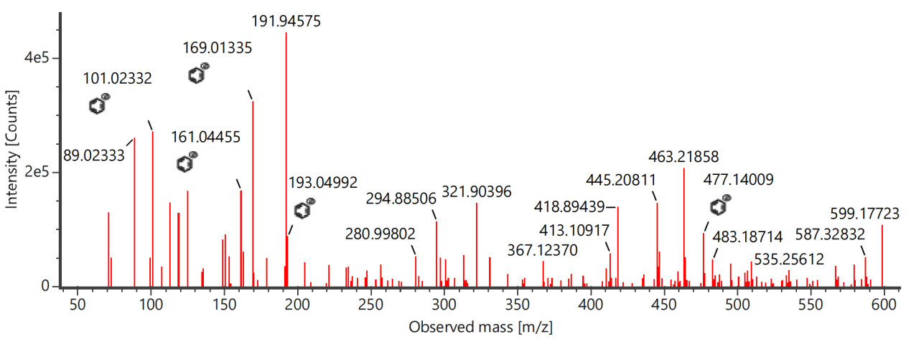

Component name: Benzoylpaeoniflorin
Channel name: Benzoylpaeoniflorin [-H] : (10.00 mDa) 583.1822
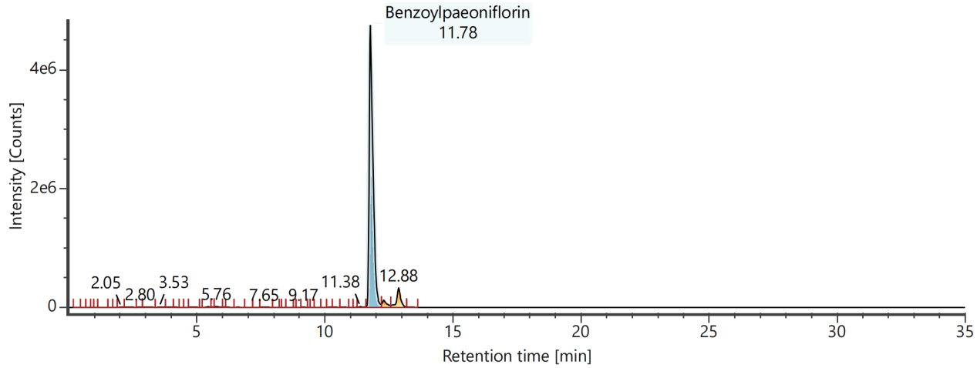
Channel name: Low energy : Time 11.7986 +/- 0.0740 minutes
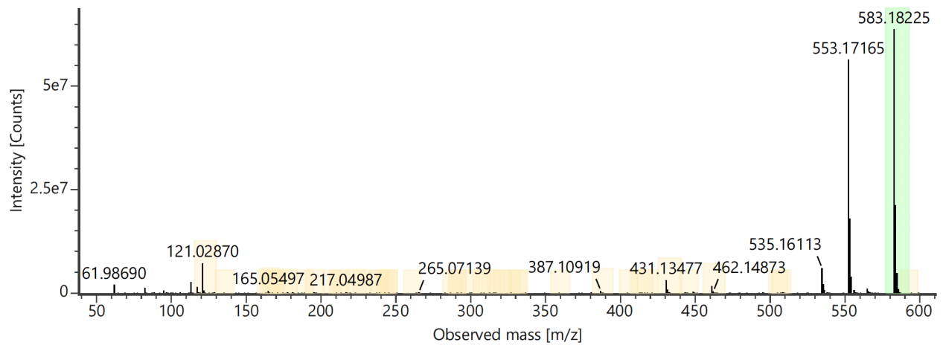
Channel name: High energy : Time 11.7986 +/- 0.0740 minutes
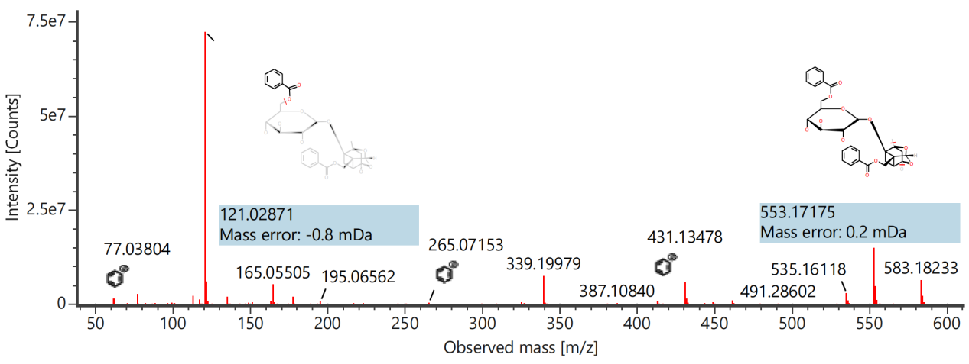

Component name: beta-D-Apiose
Channel name: beta-D-Apiose [+HCOO] : (10.00 mDa) 195.0504
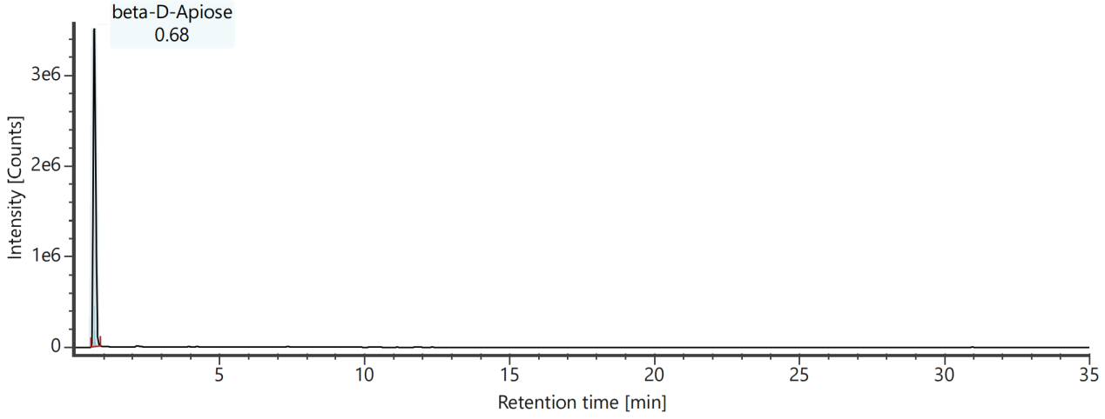
Channel name: Low energy : Time 0.6889 +/- 0.0740 minutes
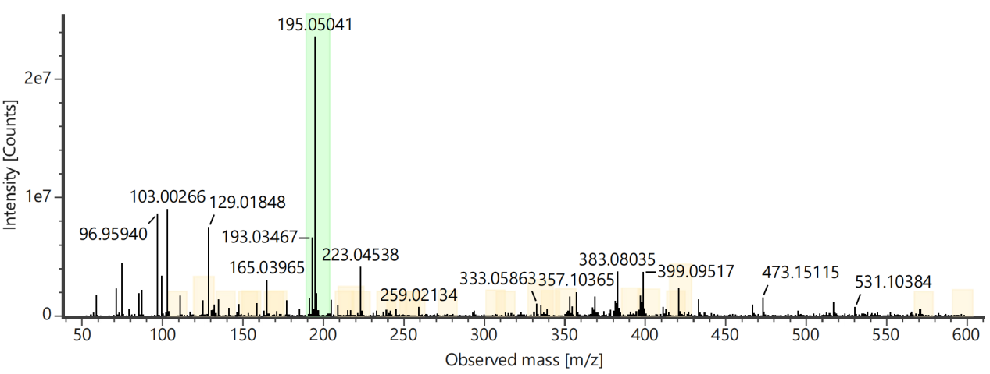
Channel name: High energy : Time 0.6889 +/- 0.0740 minutes
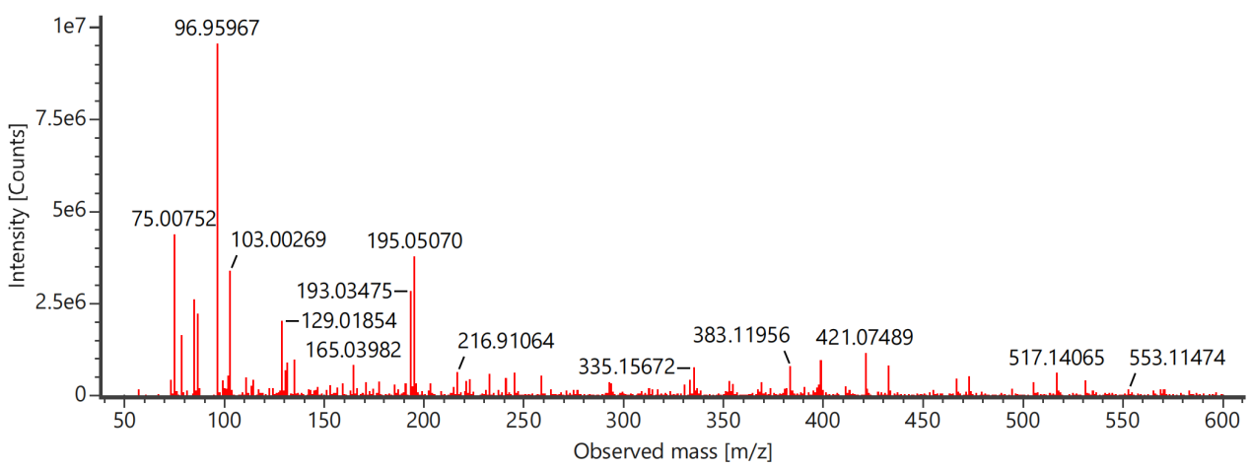

Component name: Blestrianol D
Channel name: Blestrianol D [+HCOO] : (10.00 mDa) 497.1626
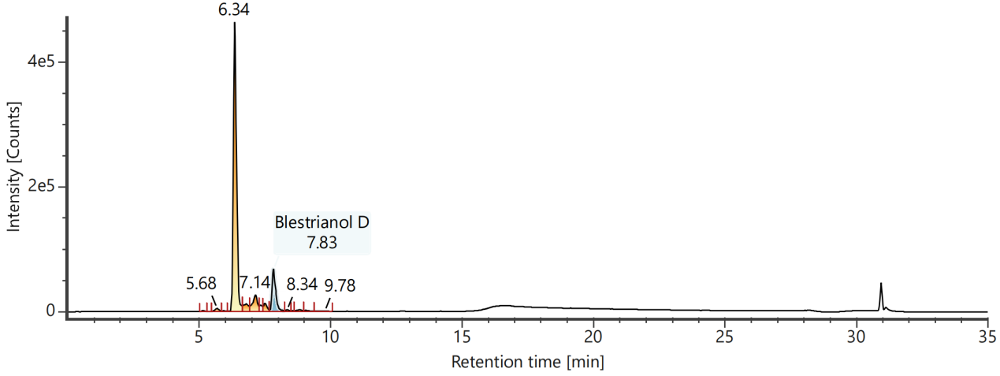
Channel name: Low energy : Time 7.8409 +/- 0.0740 minutes
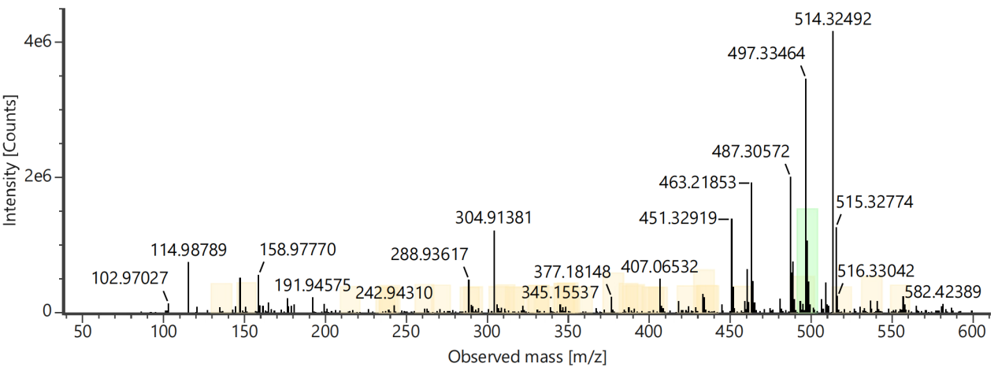
Channel name: High energy : Time 7.8409 +/- 0.0740 minutes
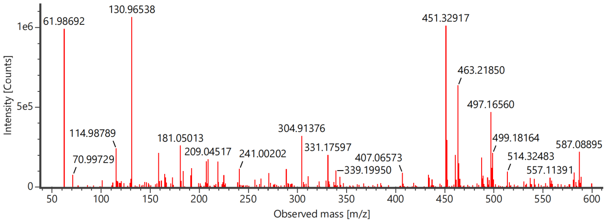

Component name: Ciwujiatone
Channel name: Ciwujiatone [+HCOO] : (10.00 mDa) 479.1561
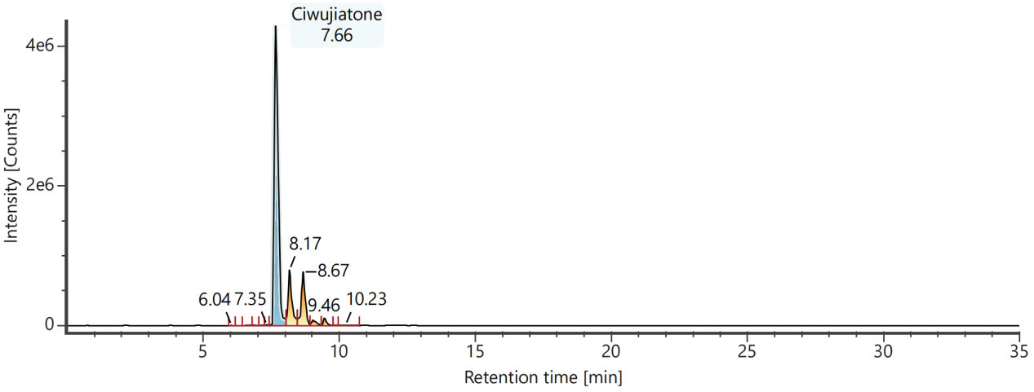
Channel name: Low energy : Time 7.6809 +/- 0.0740 minutes
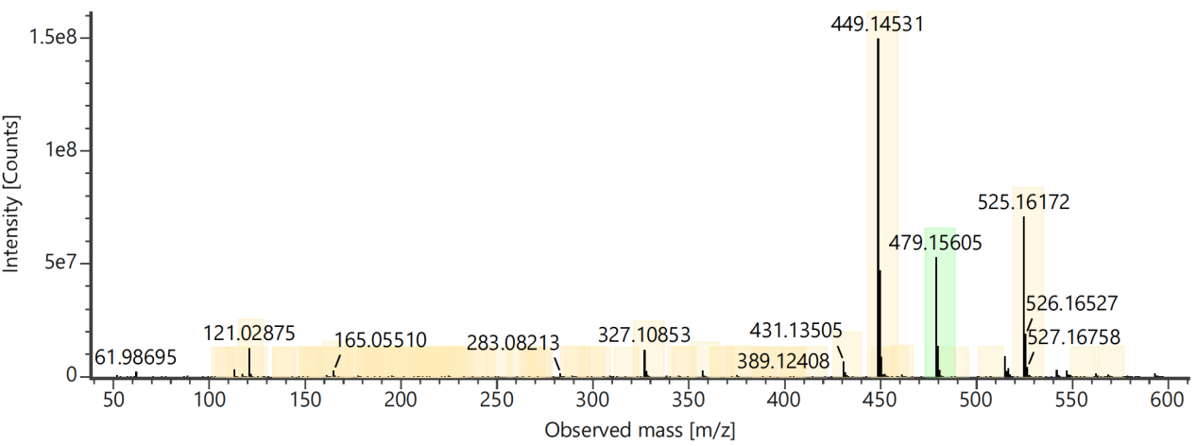
Channel name: High energy : Time 7.6809 +/- 0.0740 minutes
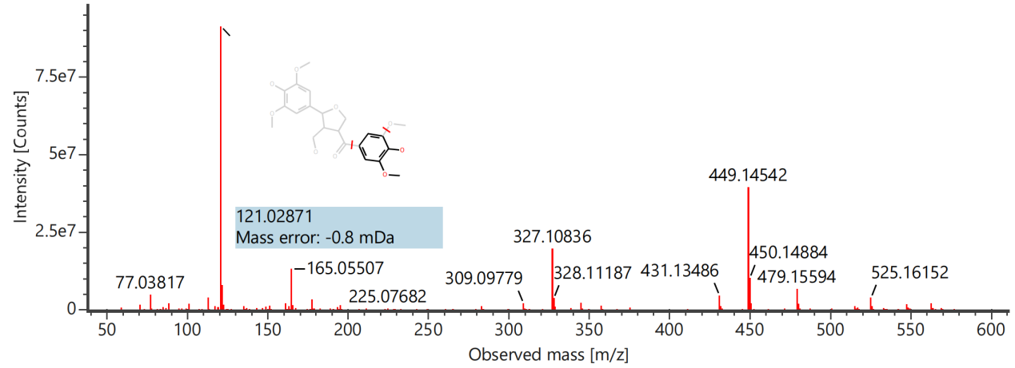

Component name: Dendrocandin C
Channel name: Dendrocandin C [+HCOO] : (10.00 mDa) 335.1133
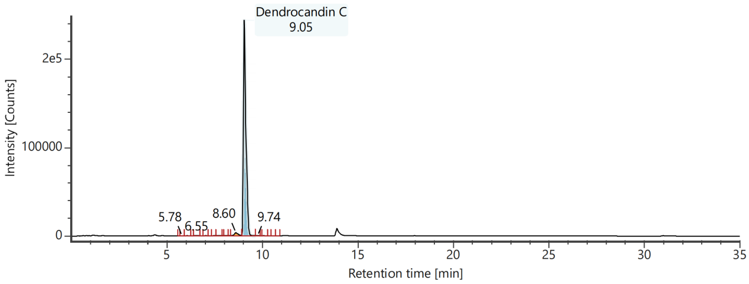
Channel name: Low energy : Time 9.0661 +/- 0.0740 minutes
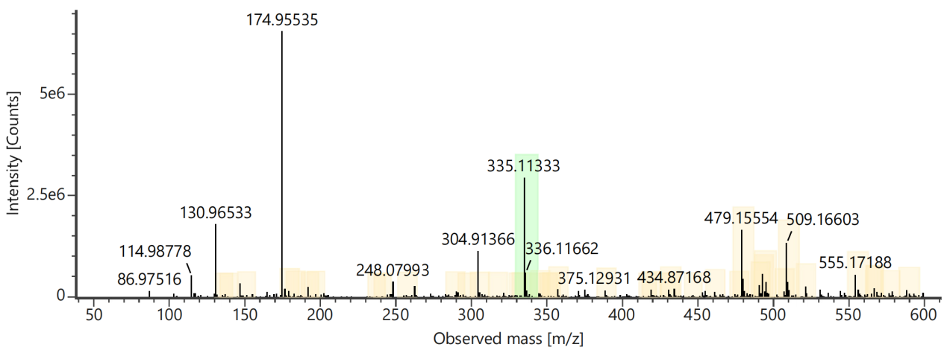
Channel name: High energy : Time 9.0661 +/- 0.0740 minutes
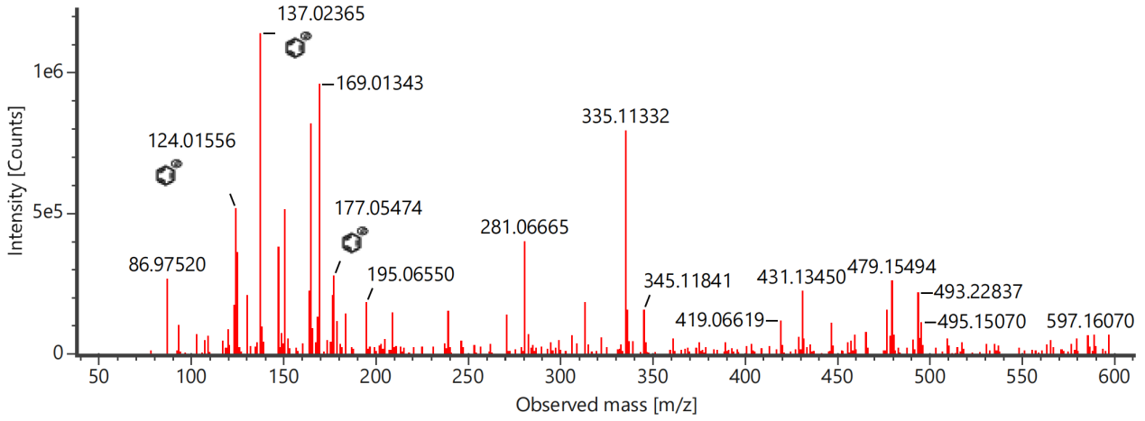

Component name: Kushenol A
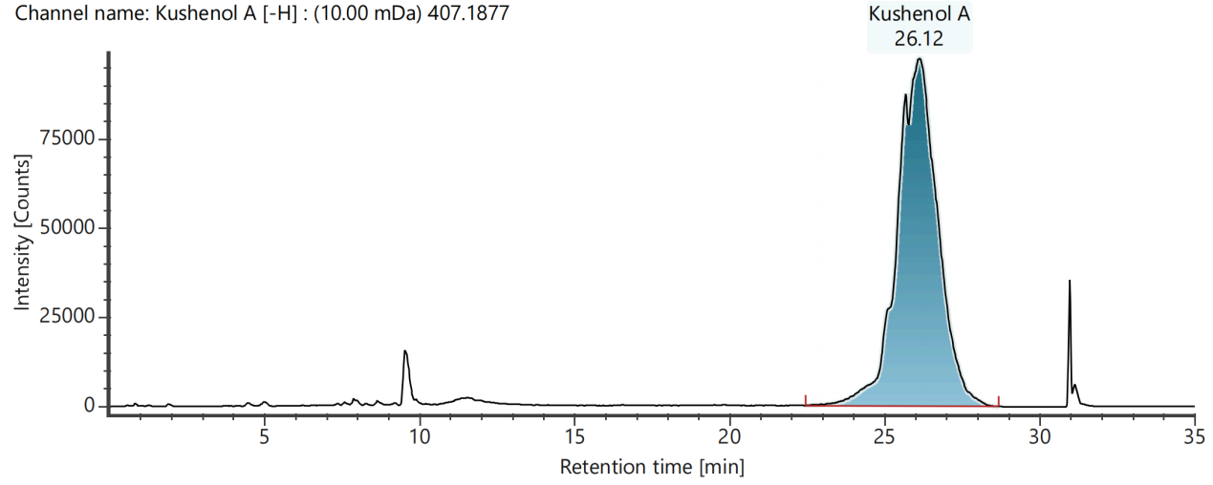
Channel name: Low energy : Time 26.1319 +/- 0.0740 minutes
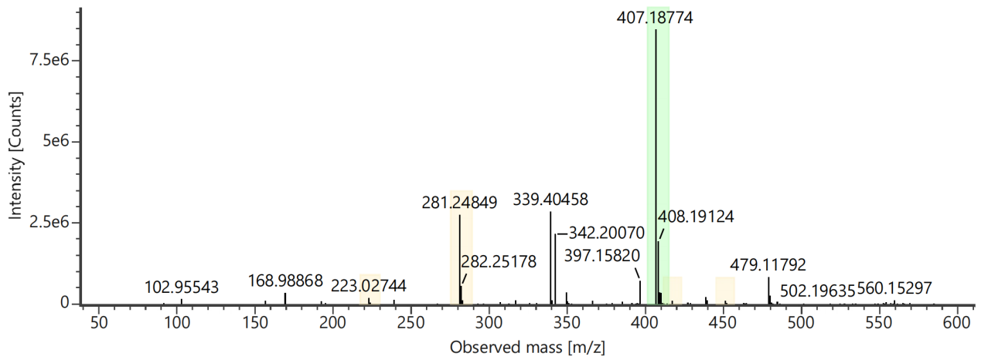
Channel name: High energy : Time 26.1319 +/- 0.0740 minutes
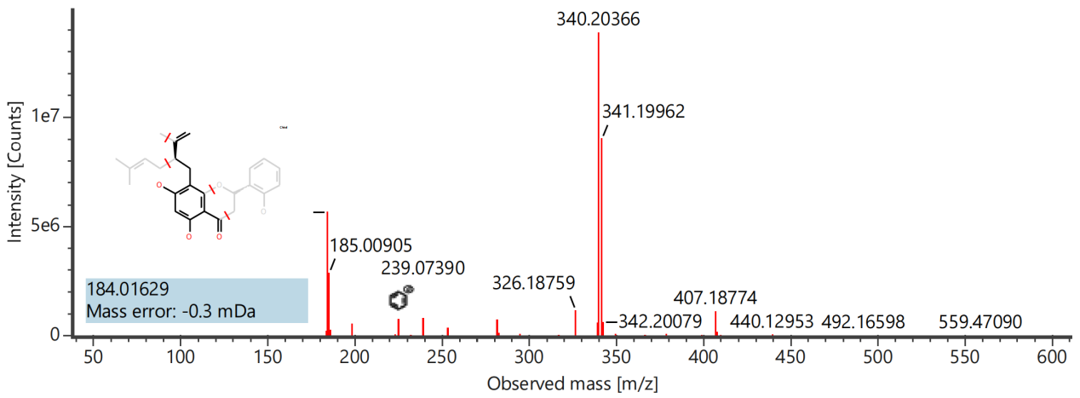

Component name: Lactiflorin
Channel name: Lactiflorin [-H] : (10.00 mDa) 461.1451
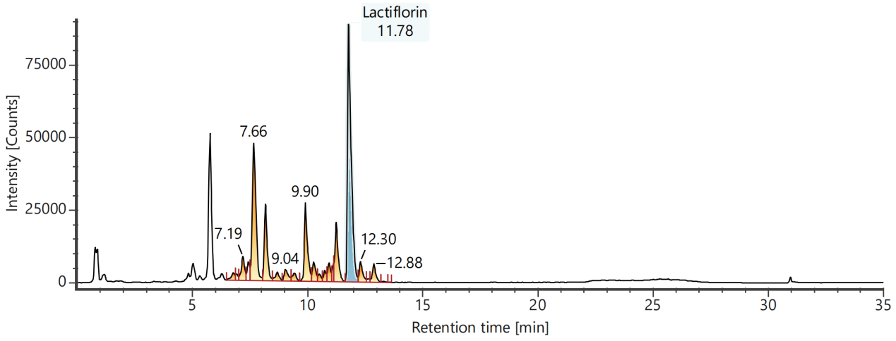
Channel name: Low energy : Time 11.7974 +/- 0.0740 minutes
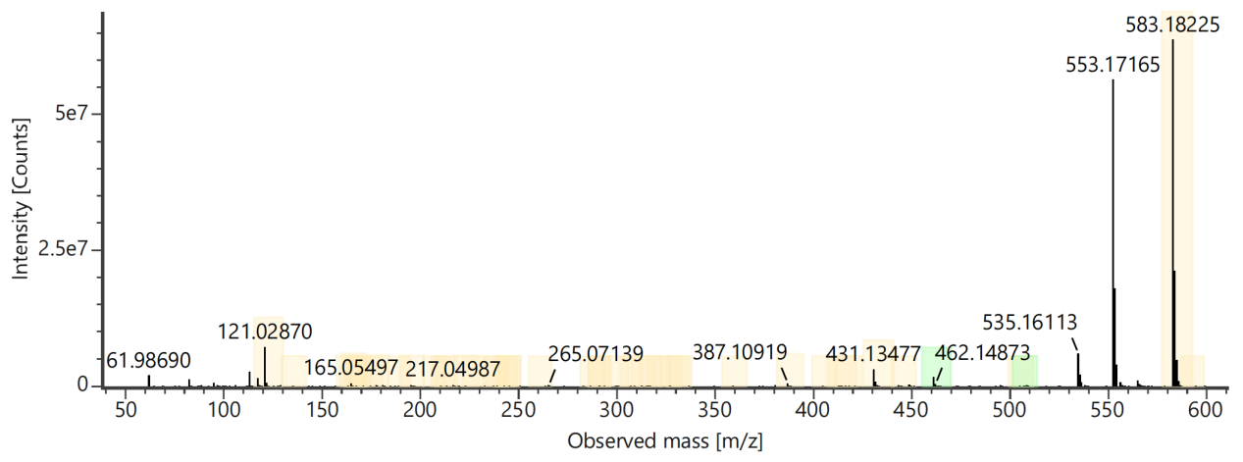
Channel name: High energy : Time 11.7974 +/- 0.0740 minutes
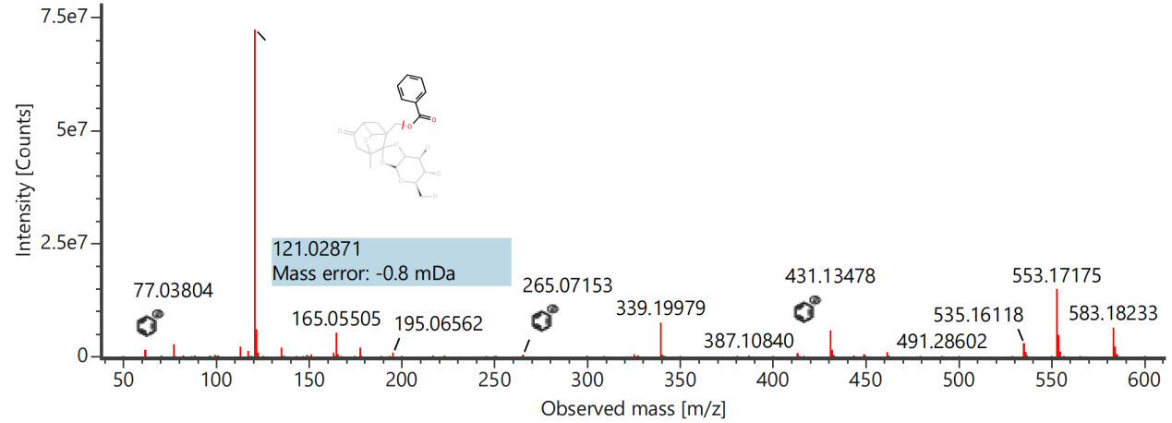

Component name: Logaric acid (Loganic acid)
Channel name: Logaric acid (Loganic acid) [-H] : (10.00 mDa) 375.1294
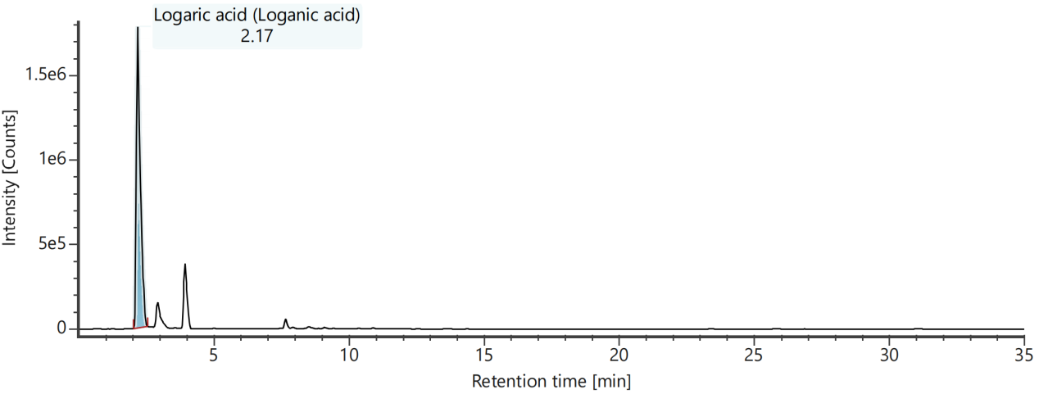
Channel name: Low energy : Time 2.1902 +/- 0.0740 minutes
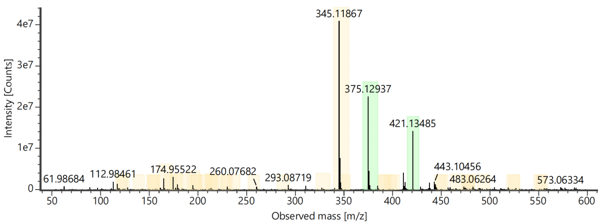
Channel name: High energy : Time 2.1902 +/- 0.0740 minutes
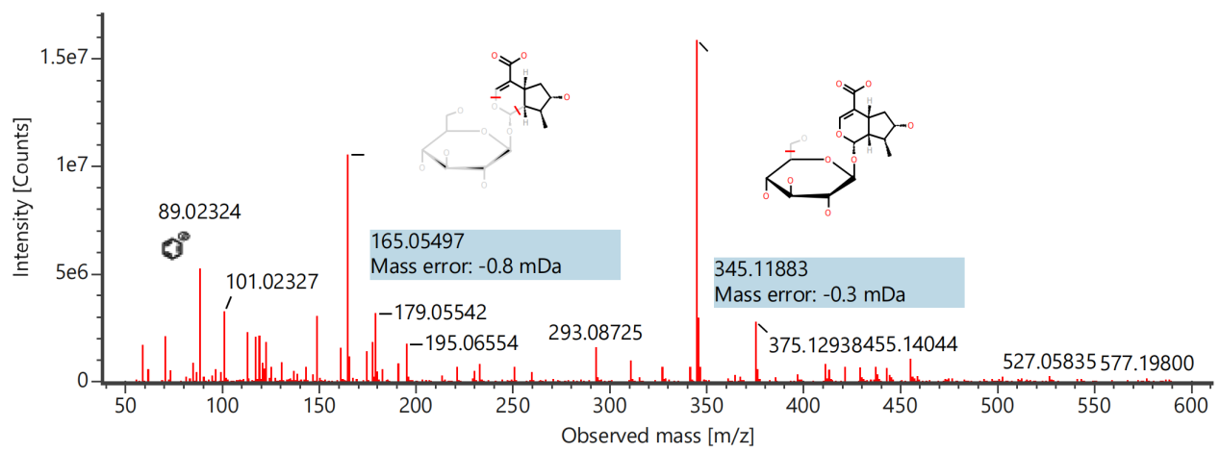

Component name: Mahuannin G
Channel name: Mahuannin G [+HCOO] : (10.00 mDa) 587.1171
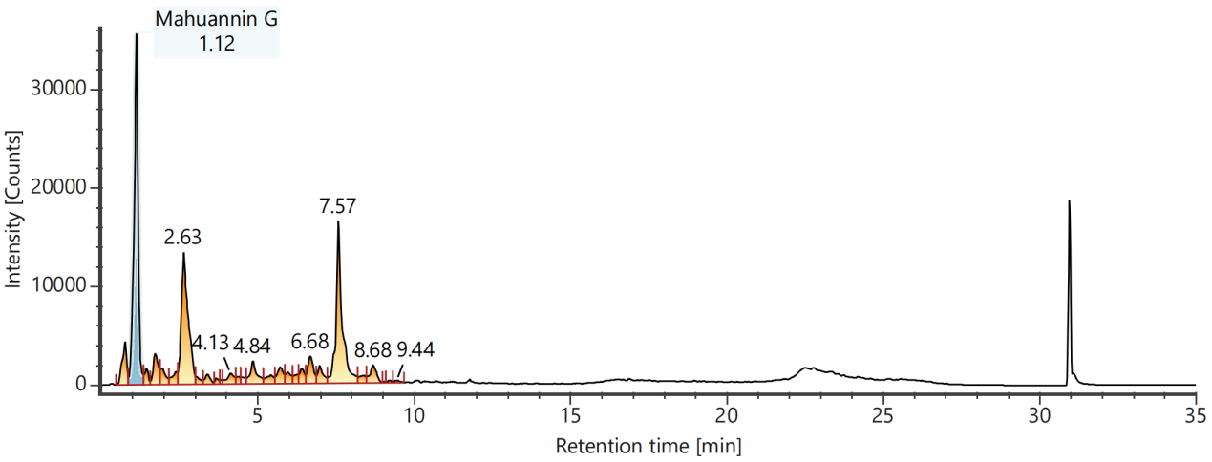
Channel name: Low energy : Time 1.1102 +/- 0.0740 minutes
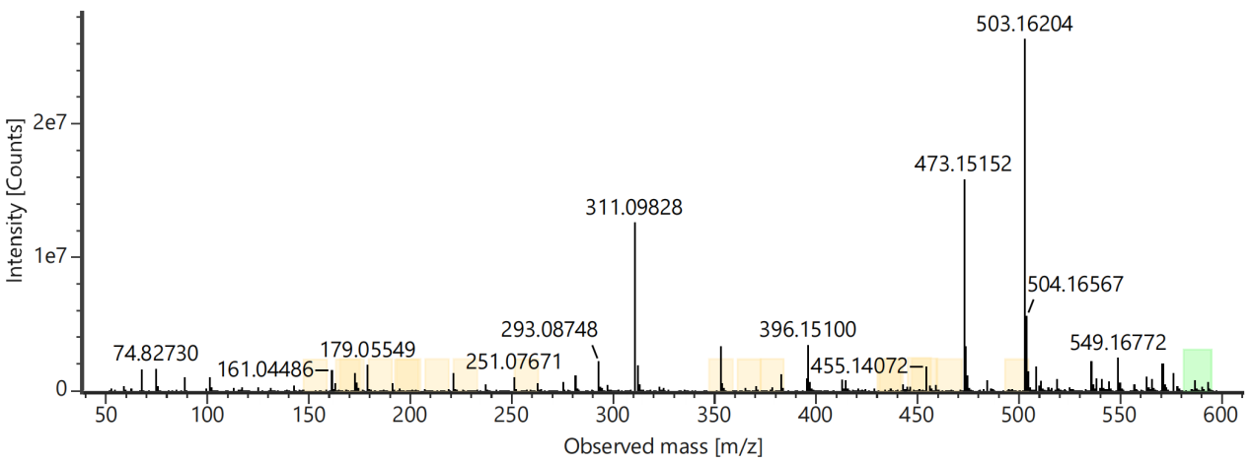
Channel name: High energy : Time 1.1102 +/- 0.0740 minutes
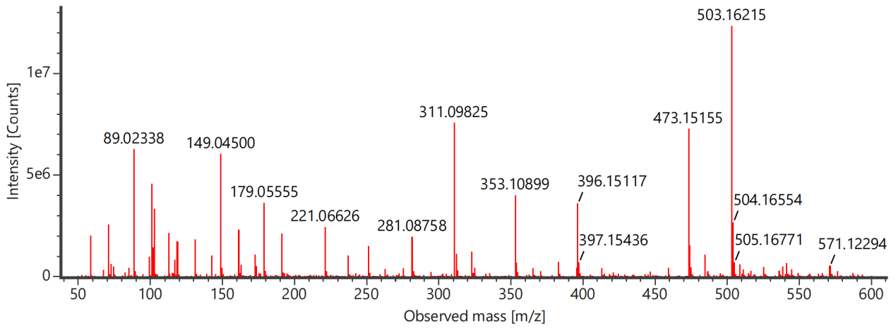

Component name: Meliadanoside B
Channel name: Meliadanoside B [-H] : (10.00 mDa) 327.1085
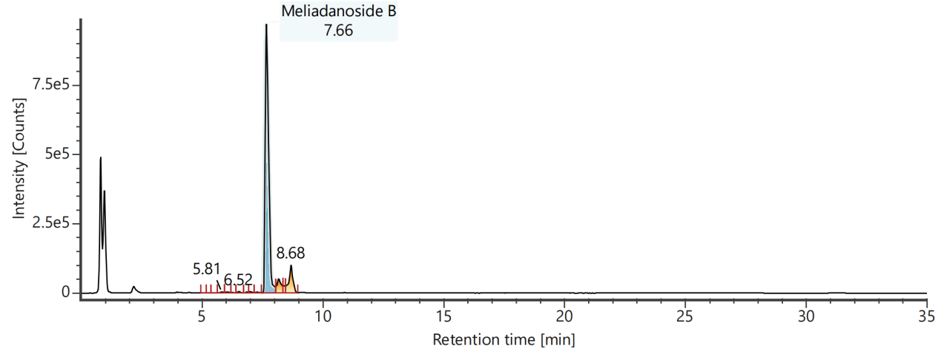
Channel name: Low energy : Time 7.6775 +/- 0.0740 minutes

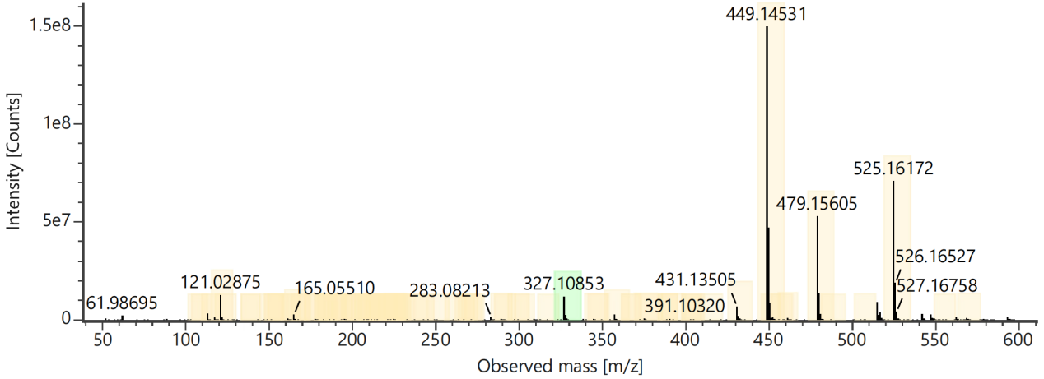
Channel name: High energy : Time 7.6775 +/- 0.0740 minutes
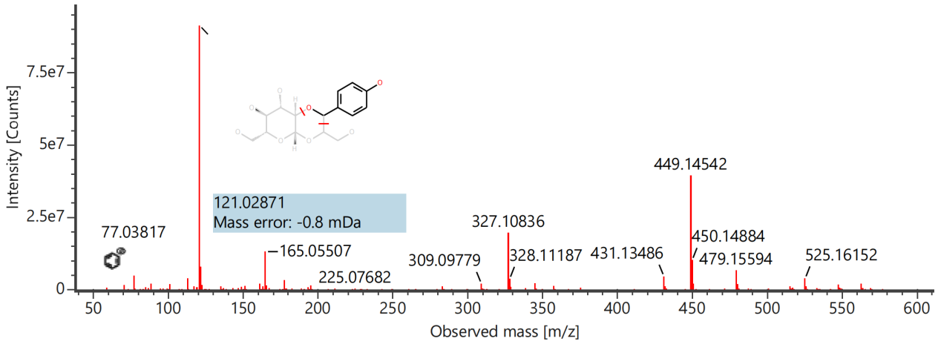

Component name: Mudanoside B
Channel name: Mudanoside B [-H] : (10.00 mDa) 463.1096
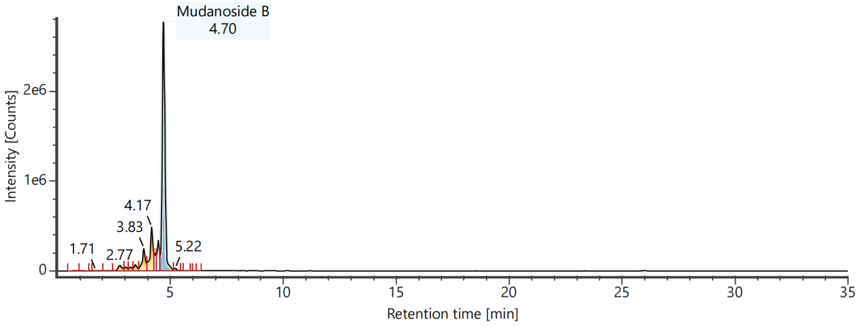
Channel name: Low energy : Time 4.7087 +/- 0.0740 minutes
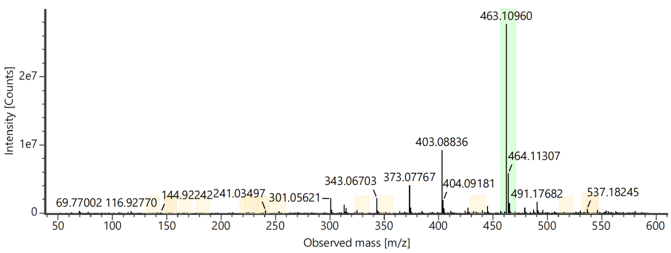
Channel name: High energy : Time 4.7087 +/- 0.0740 minutes
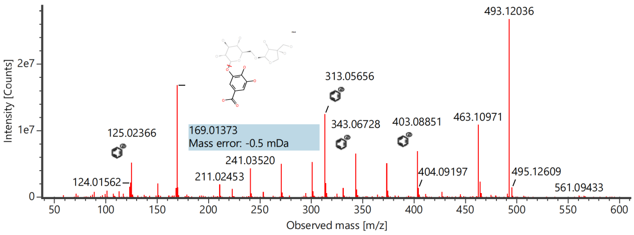

Component name: Mudanpioside D
Channel name: Mudanpioside D [+HCOO] : (10.00 mDa) 555.1720
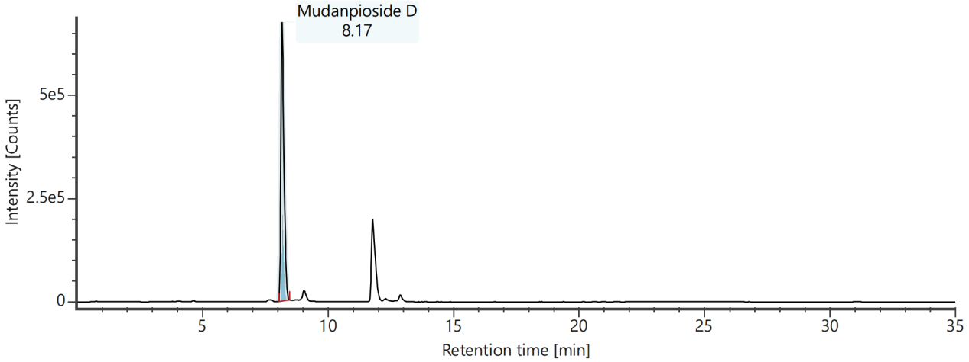
Channel name: Low energy : Time 8.1870 +/- 0.0740 minutes
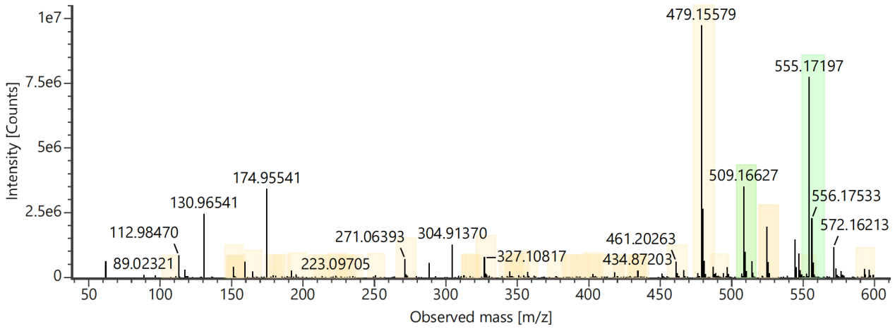
Channel name: High energy : Time 8.1870 +/- 0.0740 minutes
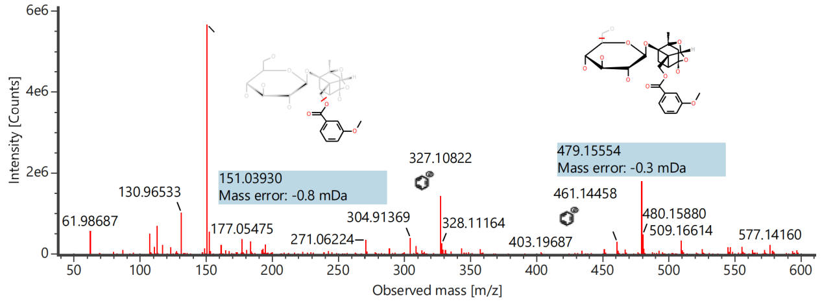

Component name: Mudanpioside E
Channel name: Mudanpioside E [-H] : (10.00 mDa) 525.1617
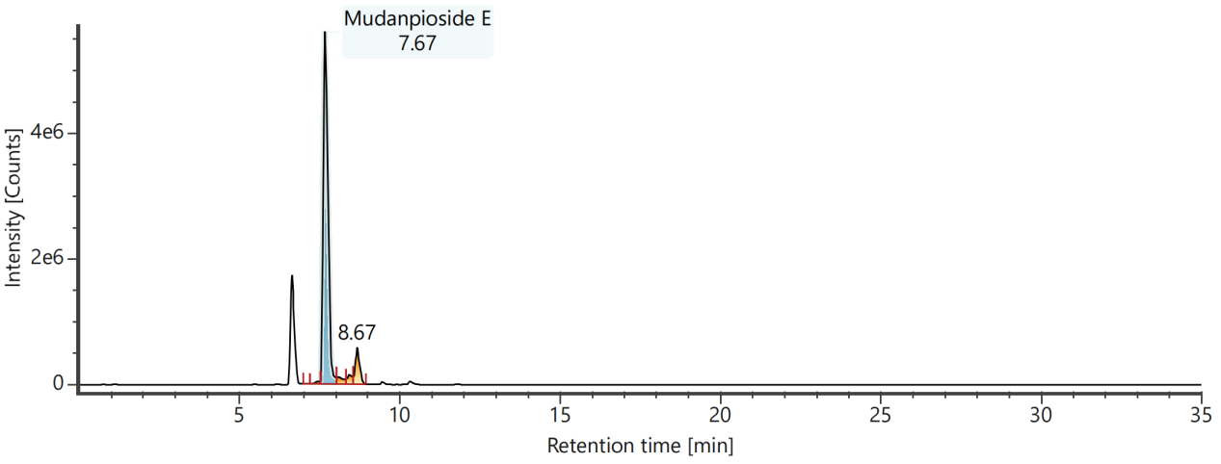
Channel name: Low energy : Time 7.6822 +/- 0.0740 minutes
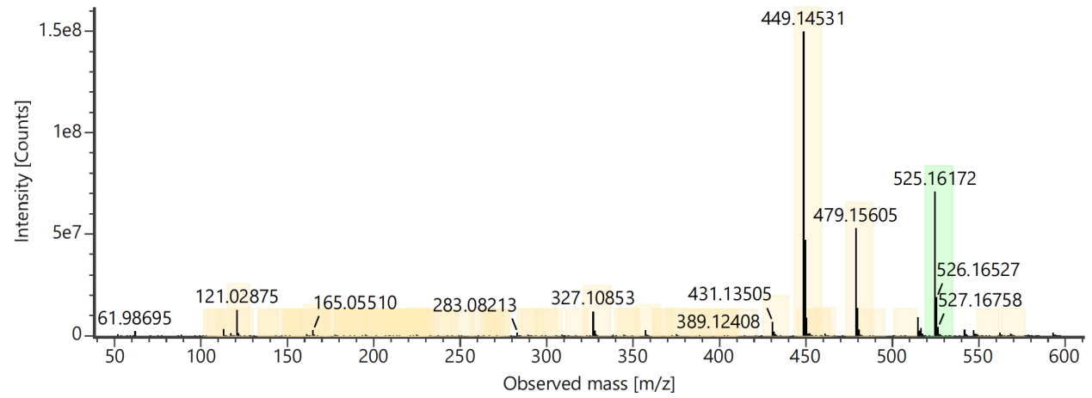
Channel name: High energy : Time 7.6822 +/- 0.0740 minutes
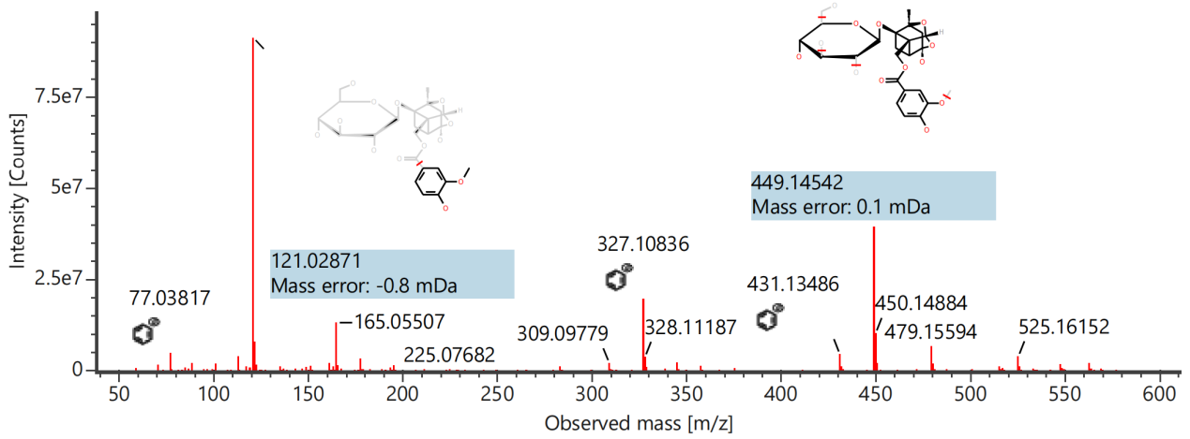

Component name: Mudanpioside F
Channel name: Mudanpioside F [-H] : (10.00 mDa) 343.1396
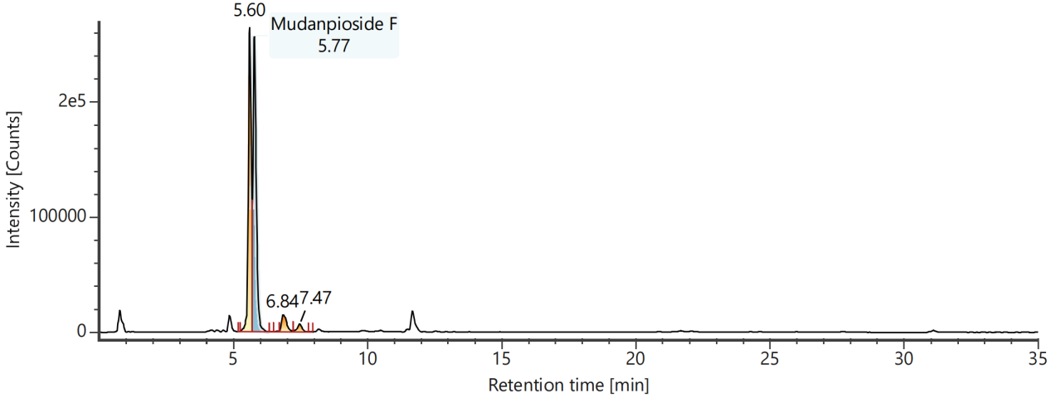
Channel name: Low energy : Time 5.7873 +/- 0.0740 minutes
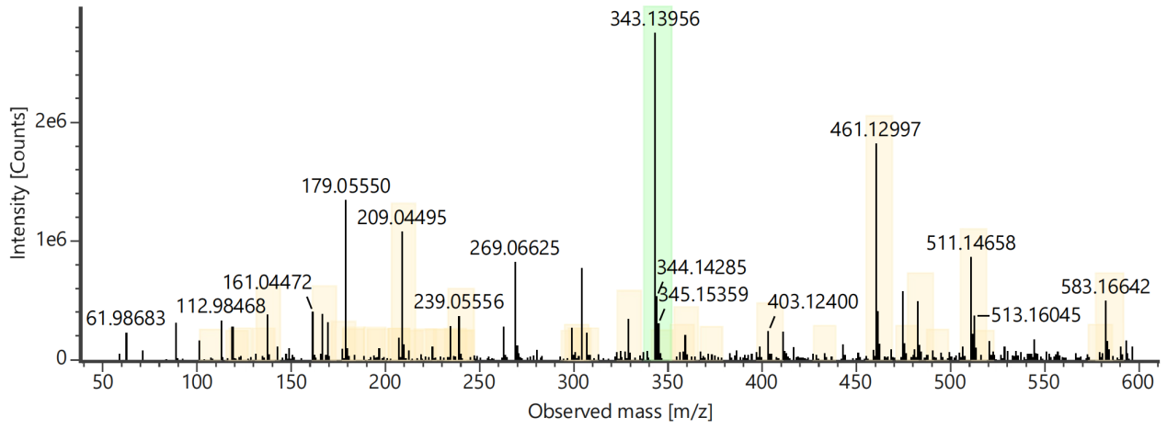
Channel name: High energy : Time 5.7873 +/- 0.0740 minutes
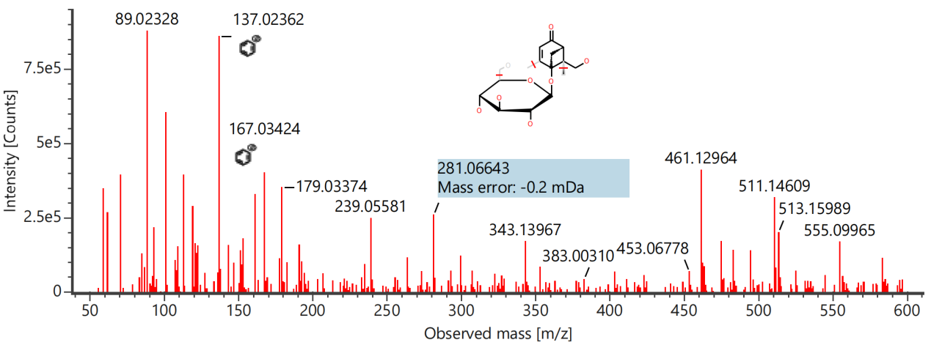

Component name: Oleic acid
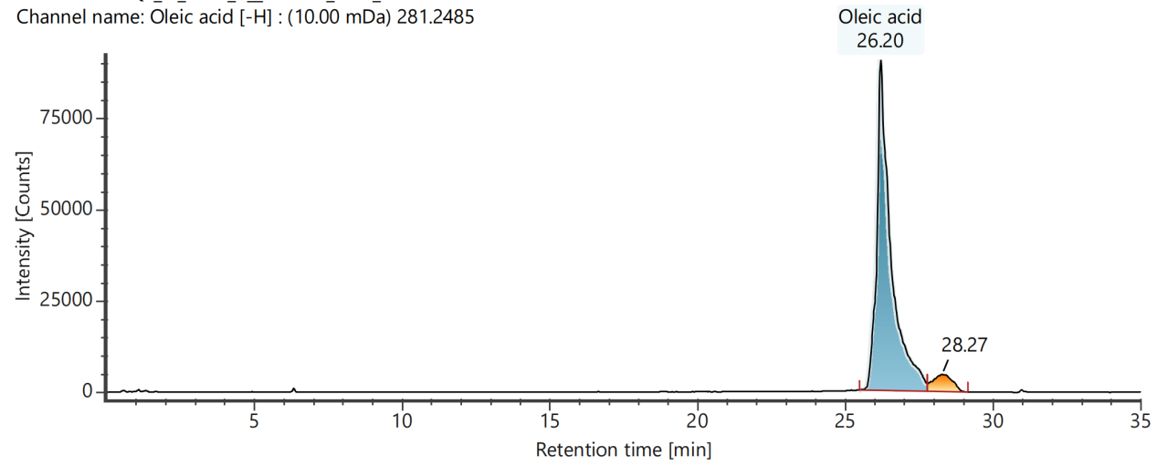
Channel name: Low energy : Time 26.1950 +/- 0.0740 minutes
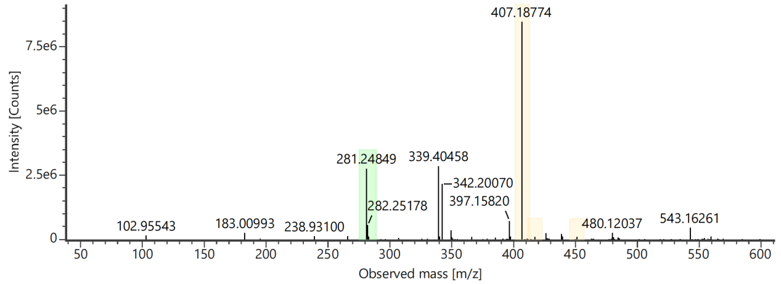
Channel name: High energy : Time 26.1950 +/- 0.0740 minutes
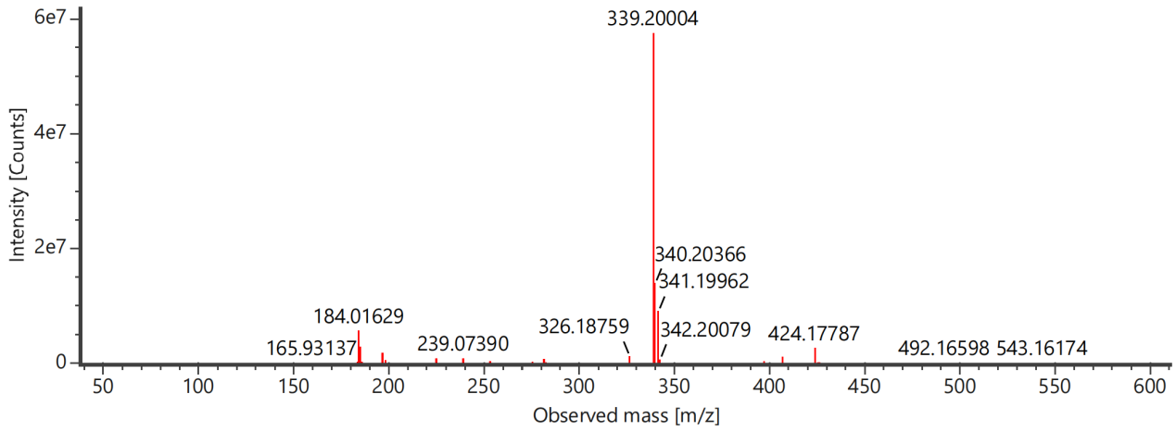

Component name: Oxybenzoyl paeoniflorin
Channel name: Oxybenzoyl paeoniflorin [-H] : (10.00 mDa) 599.1771
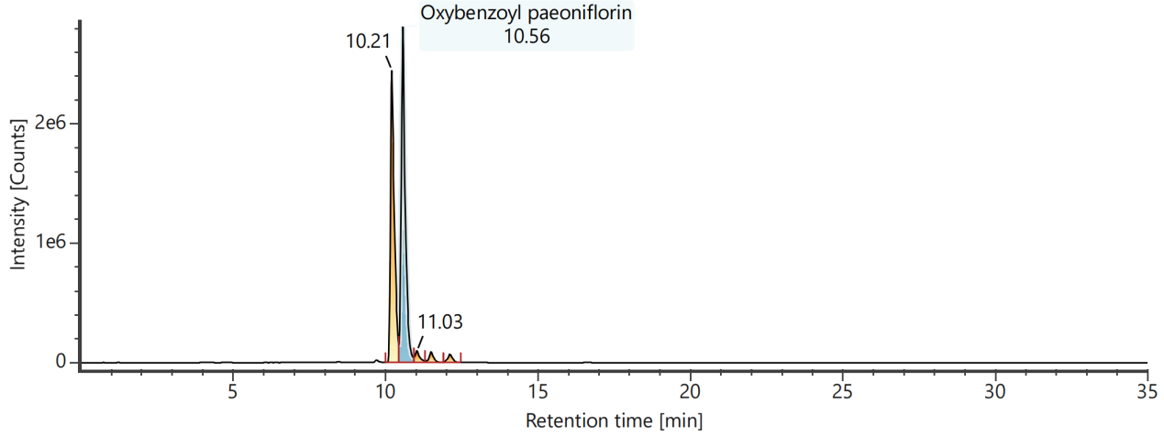
Channel name: Low energy : Time 10.5831 +/- 0.0740 minutes
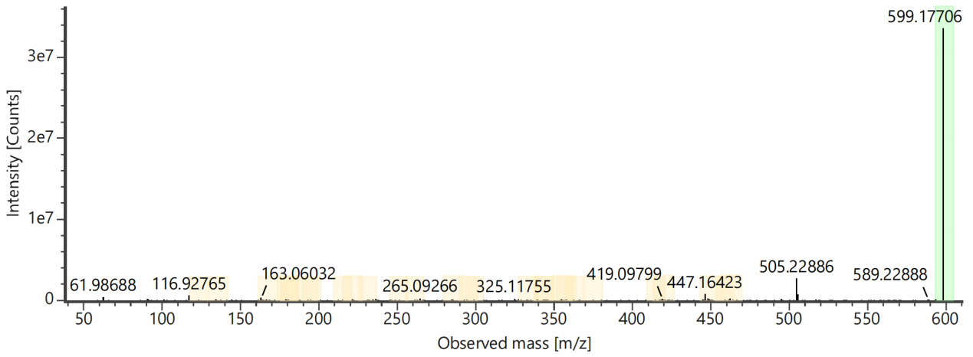
Channel name: High energy : Time 10.5831 +/- 0.0740 minutes
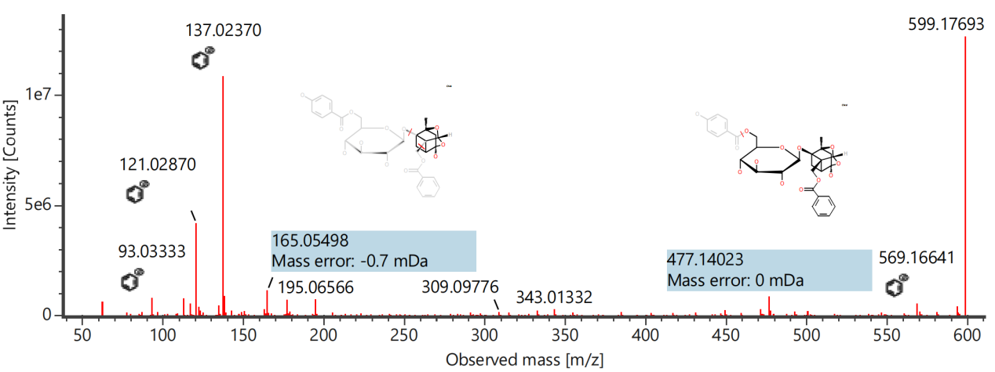

Component name: Oxypaeoniflorin
Channel name: Oxypaeoniflorin [-H] : (10.00 mDa) 495.1507
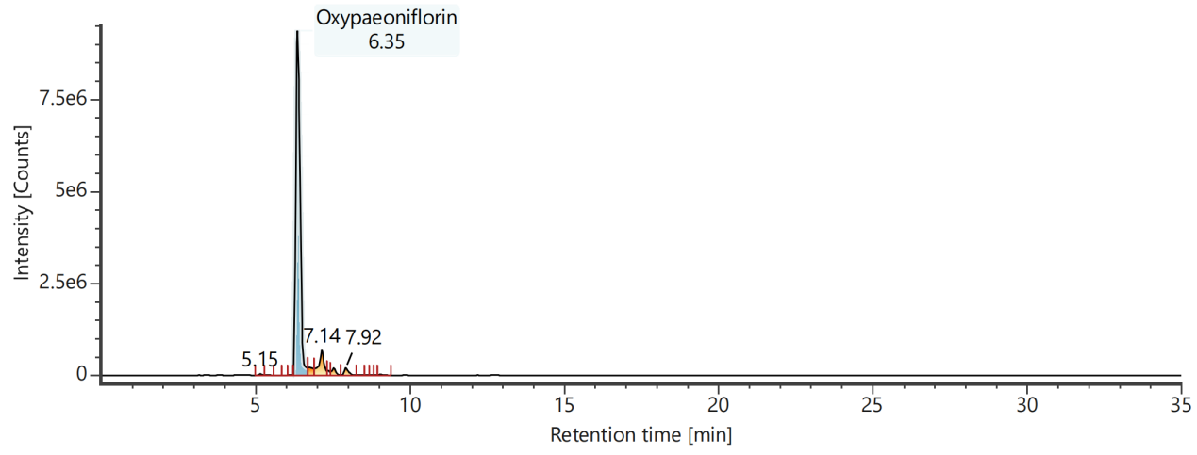
Channel name: Low energy : Time 6.3659 +/- 0.2220 minutes
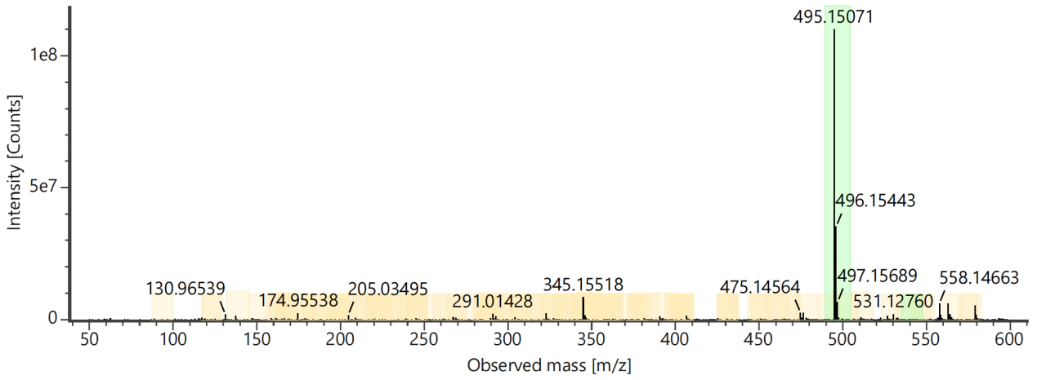
Channel name: High energy : Time 6.3659 +/- 0.2220 minutes
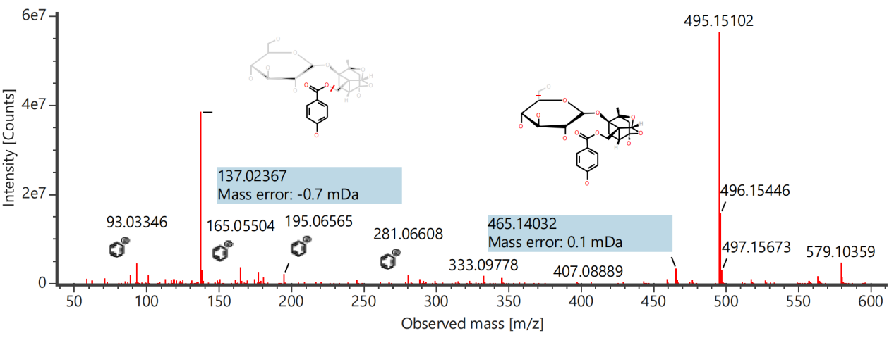

Component name: Paeonol
Channel name: Paeonol [-H] : (10.00 mDa) 165.0551
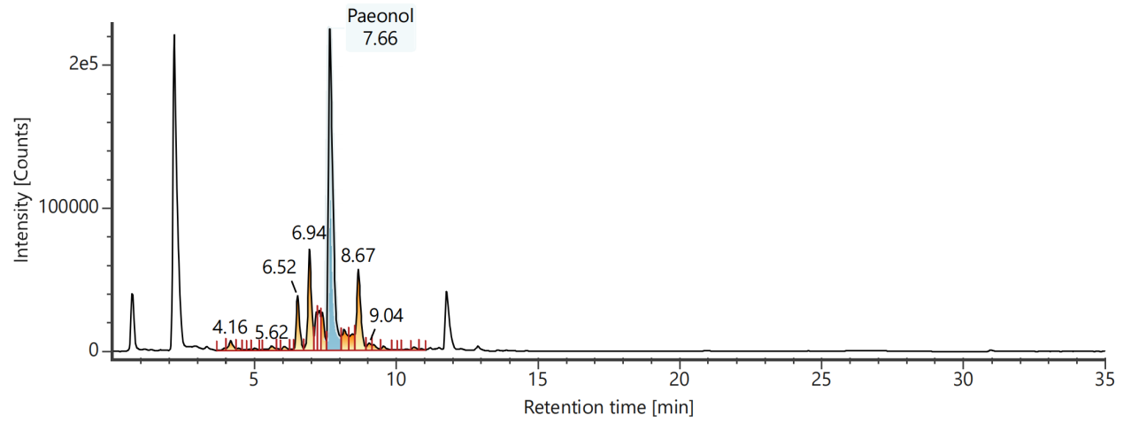
Channel name: Low energy : Time 7.6781 +/- 0.0740 minutes
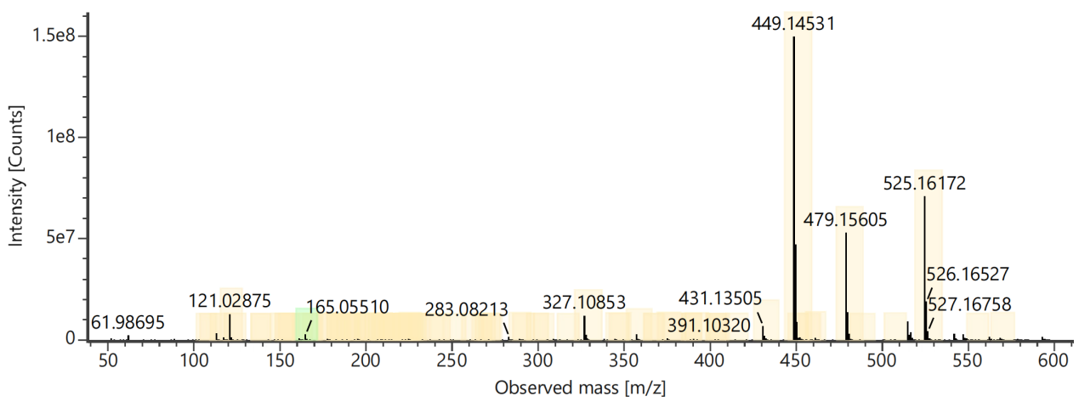
Channel name: High energy : Time 7.6781 +/- 0.0740 minutes
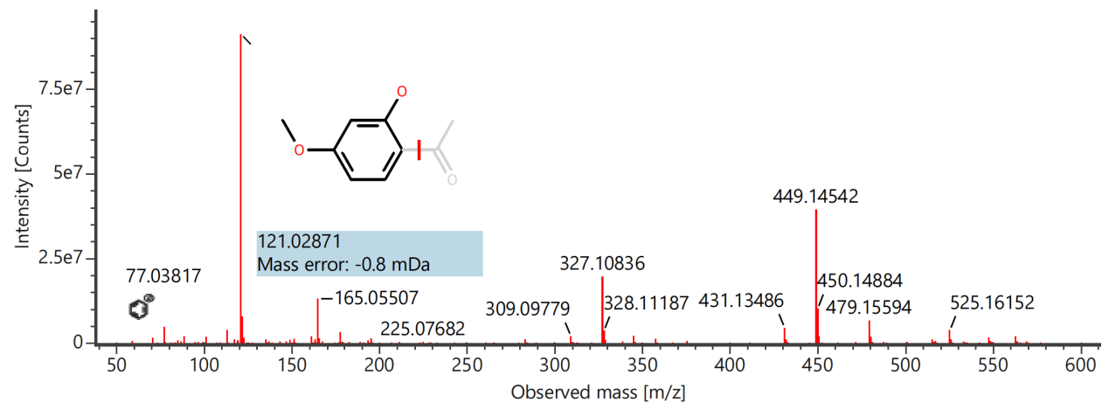

Component name: Paeonolide
Channel name: Paeonolide [+HCOO] : (10.00 mDa) 505.1564
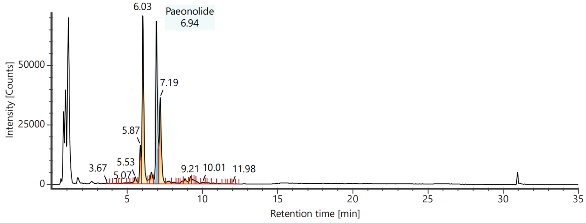
Channel name: Low energy : Time 6.9471 +/- 0.0740 minutes
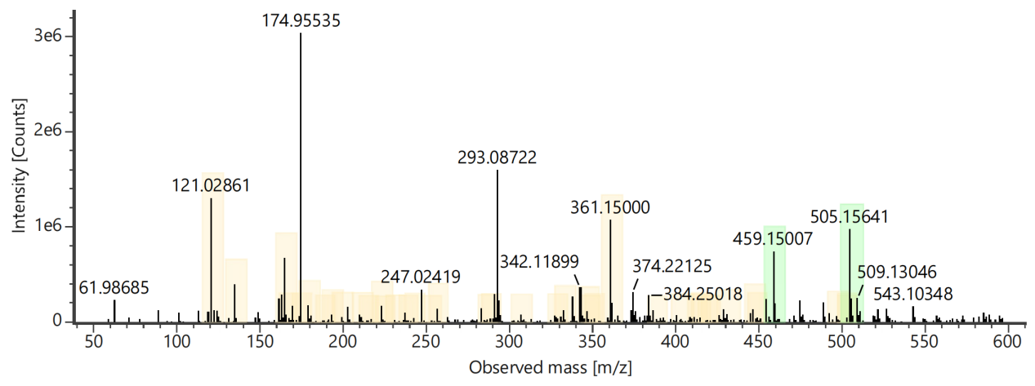
Channel name: High energy : Time 6.9471 +/- 0.0740 minutes
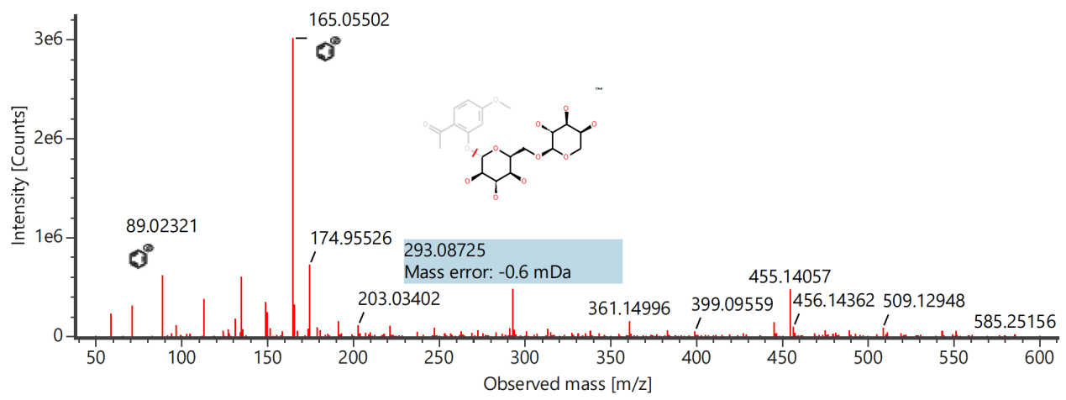

Component name: Penstemoside
Channel name: Penstemoside [-H] : (10.00 mDa) 405.1400
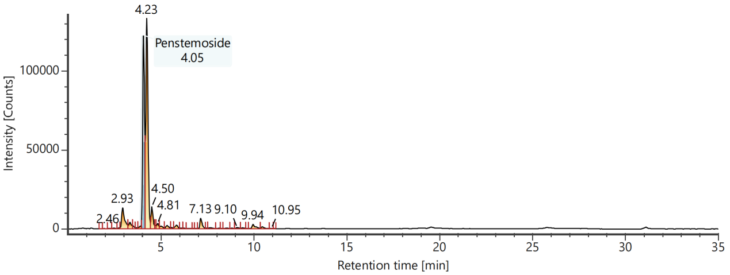
Channel name: Low energy : Time 4.0611 +/- 0.0740 minutes
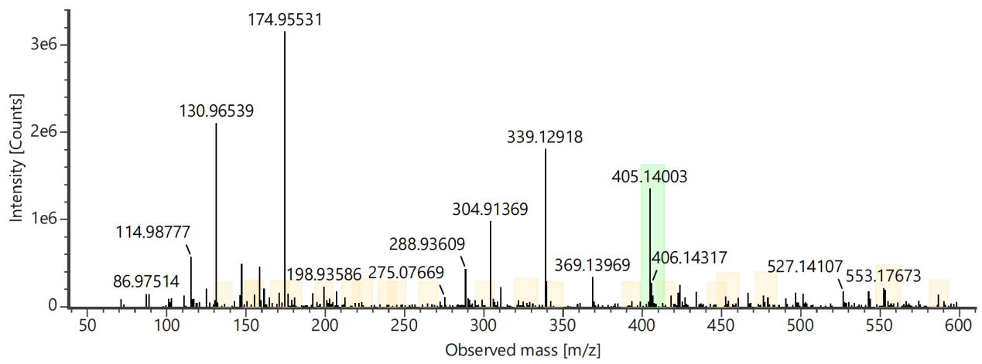
Channel name: High energy : Time 4.0611 +/- 0.0740 minutes
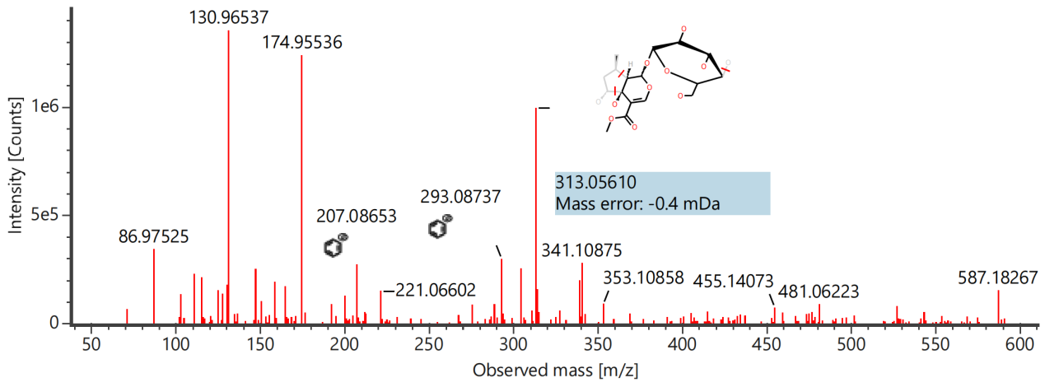

Component name: Picroside Ⅱ
Channel name: Picroside Ⅱ [-H] : (10.00 mDa) 511.1456
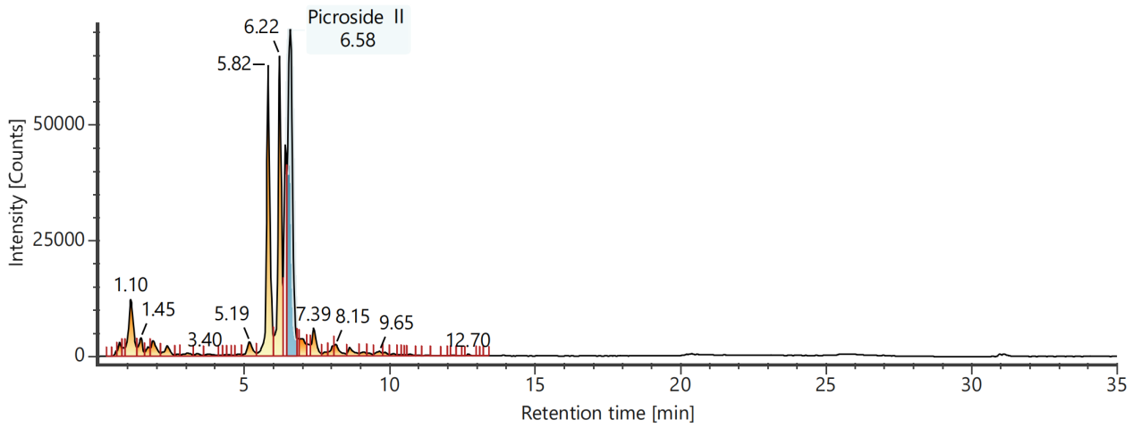
Channel name: Low energy : Time 6.5889 +/- 0.0740 minutes
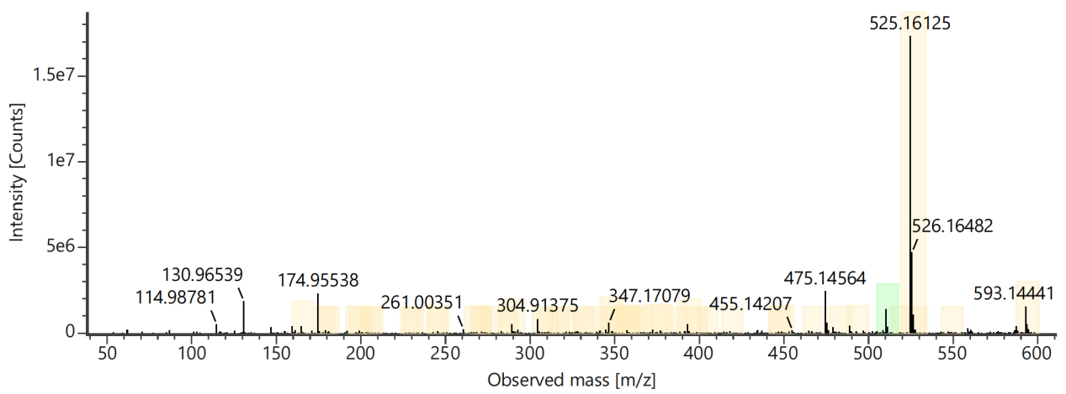
Channel name: High energy : Time 6.5889 +/- 0.0740 minutes
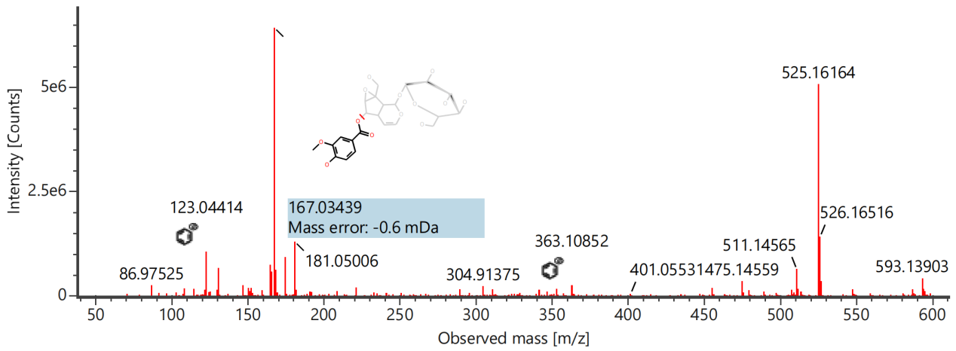

Component name: Picroside Ⅲ
Channel name: Picroside Ⅲ [-H] : (10.00 mDa) 537.1607
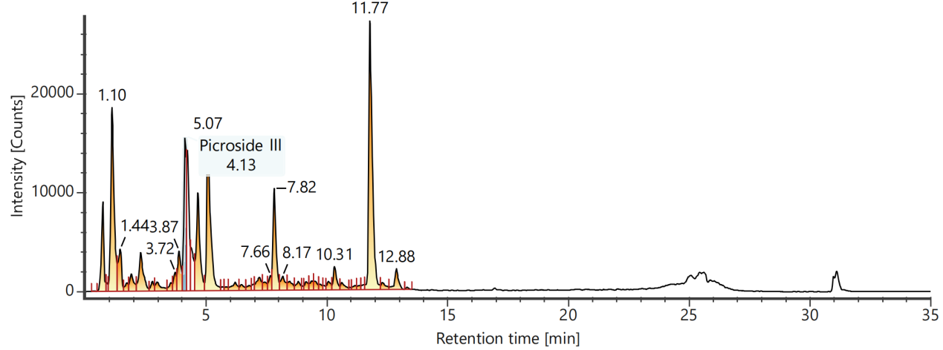
Channel name: Low energy : Time 4.1378 +/- 0.0740 minutes
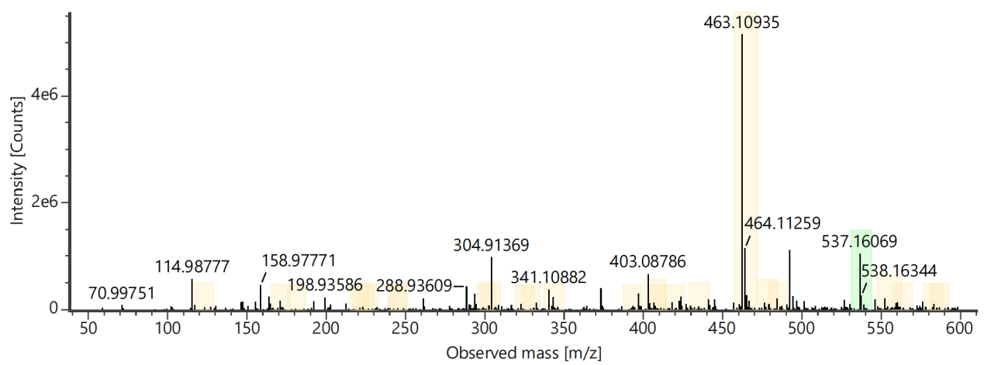
Channel name: High energy : Time 4.1378 +/- 0.0740 minutes
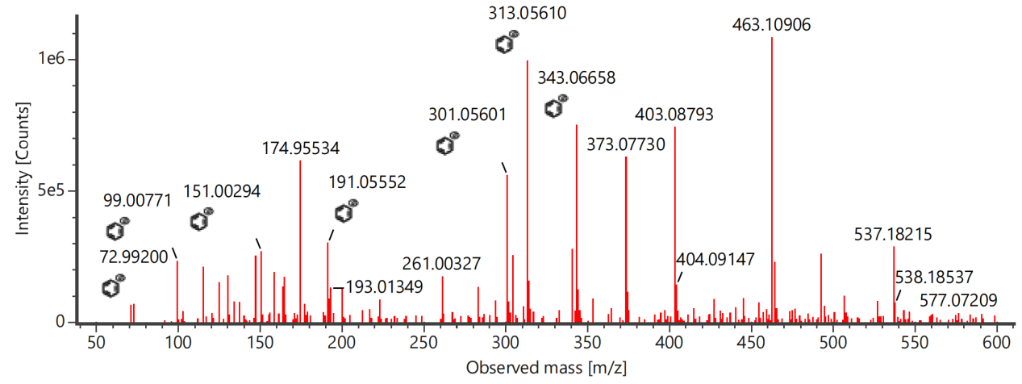

Component name: Shionoside A
Channel name: Shionoside A [-H] : (10.00 mDa) 447.2235
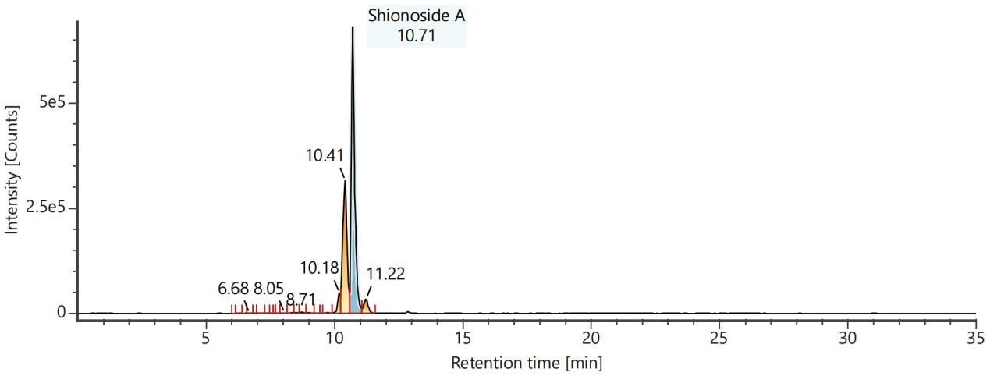
Channel name: Low energy : Time 10.7215 +/- 0.0740 minutes
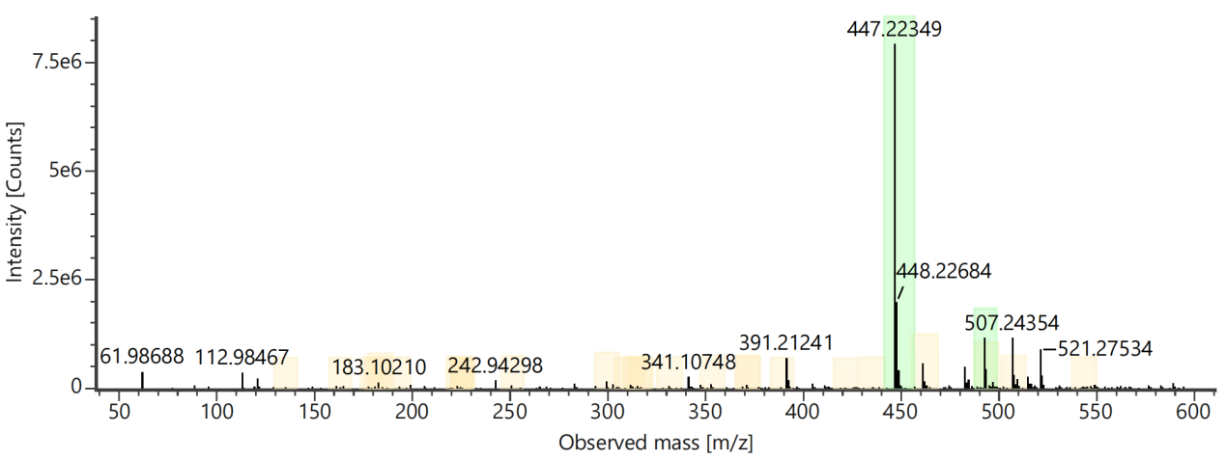
Channel name: High energy : Time 10.7215 +/- 0.0740 minutes
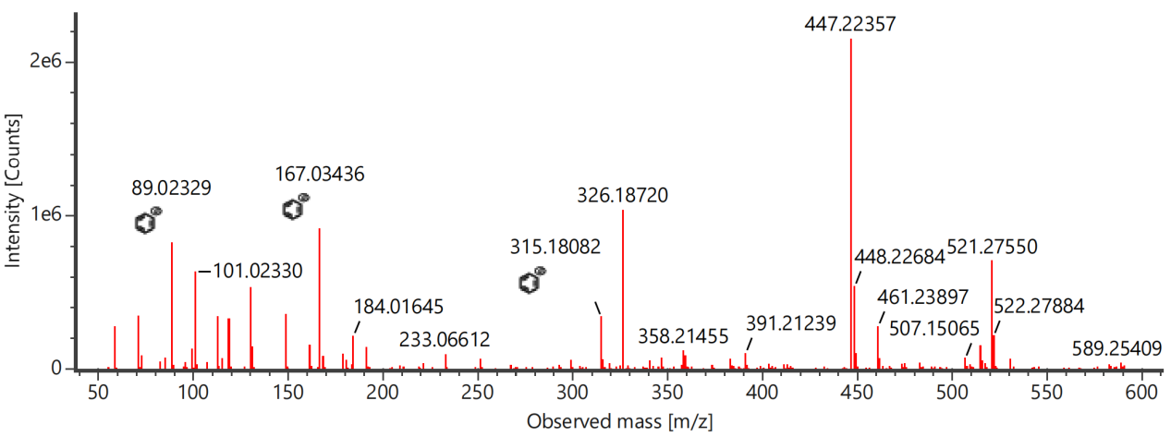

Component name: Shionoside B
Channel name: Shionoside B [+HCOO] : (10.00 mDa) 507.2444
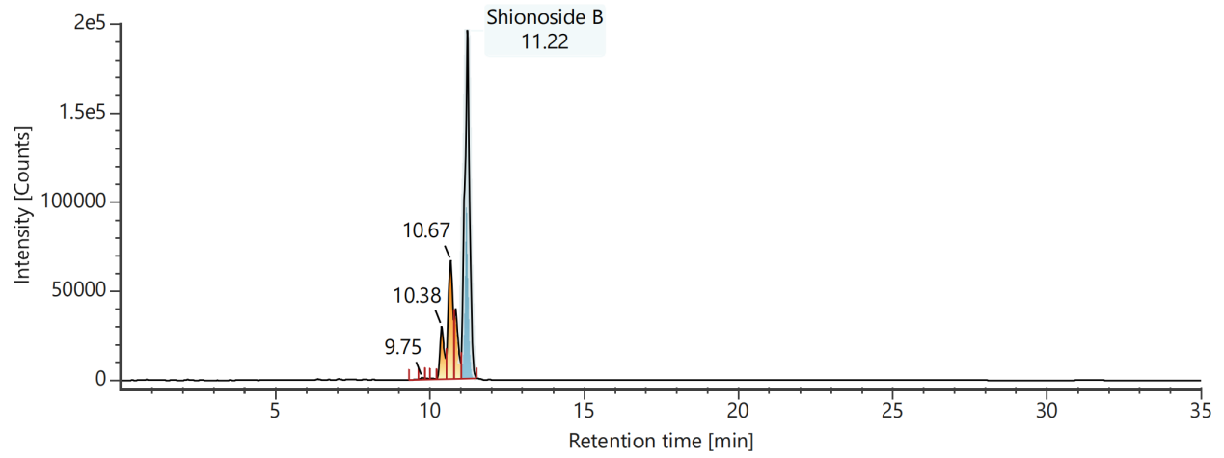
Channel name: Low energy : Time 11.2136 +/- 0.0740 minutes
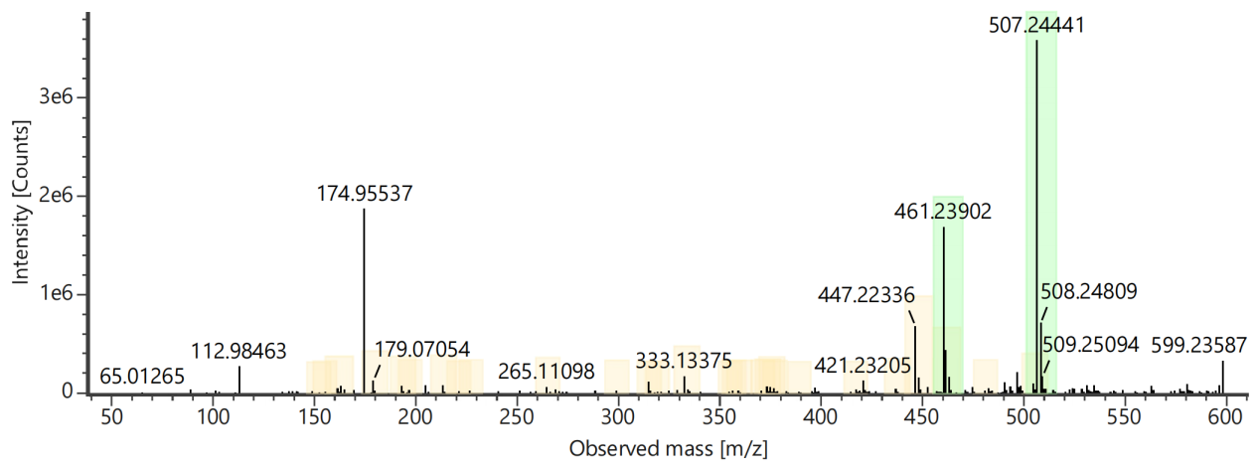
Channel name: High energy : Time 11.2136 +/- 0.0740 minutes
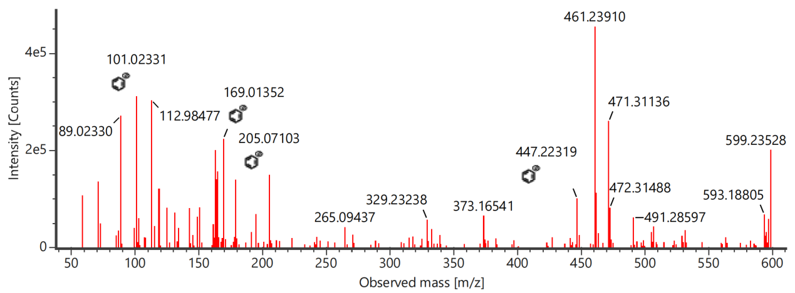

Component name: Shionoside C
Channel name: Shionoside C [+HCOO] : (10.00 mDa) 533.2601
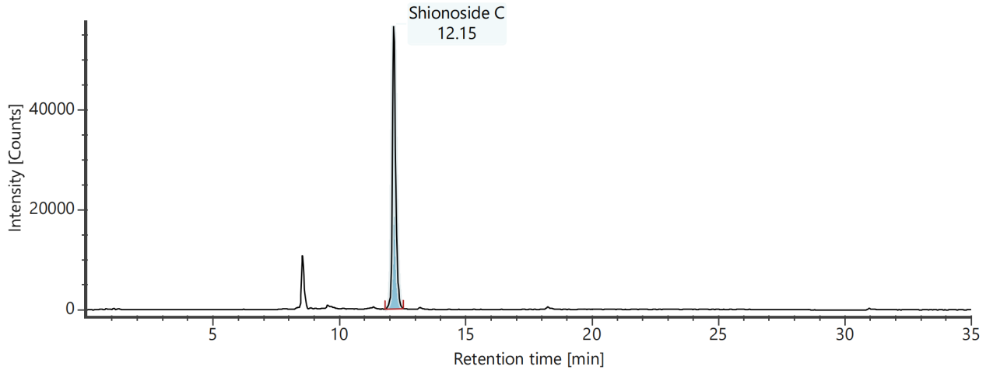
Channel name: Low energy : Time 12.1618 +/- 0.0740 minutes
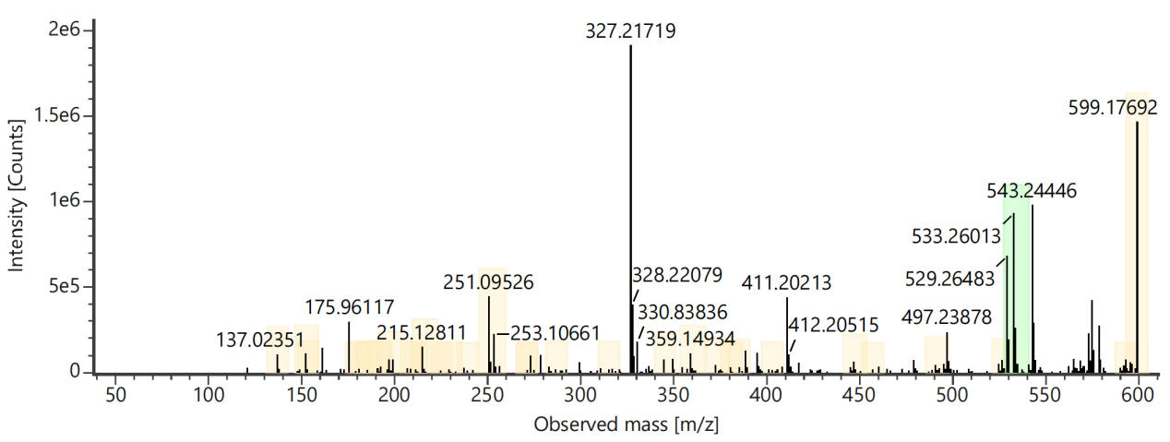
Channel name: High energy : Time 12.1618 +/- 0.0740 minutes
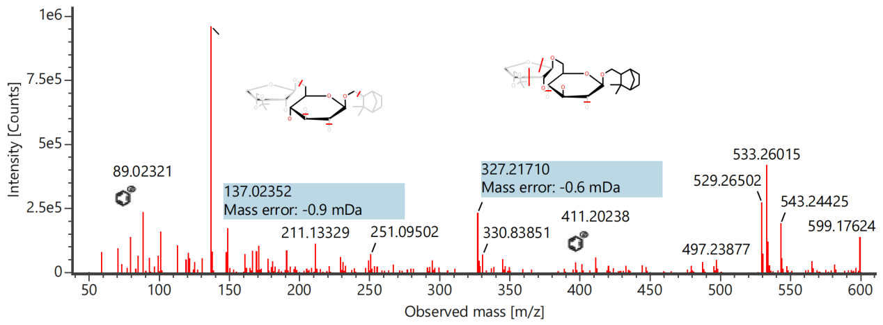

Component name: Sweroside
Channel name: Sweroside [-H] : (10.00 mDa) 357.1190
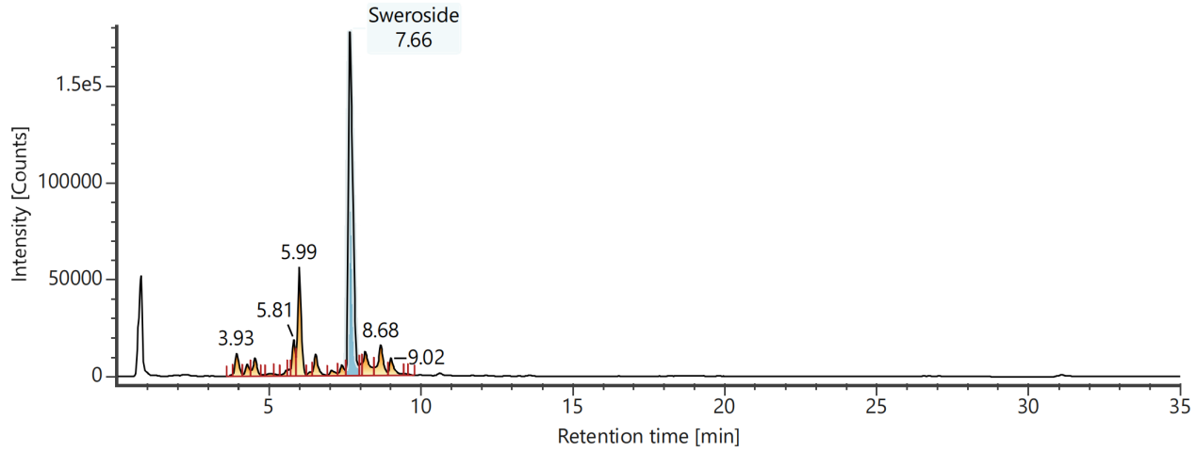
Channel name: Low energy : Time 7.6781 +/- 0.0740 minutes
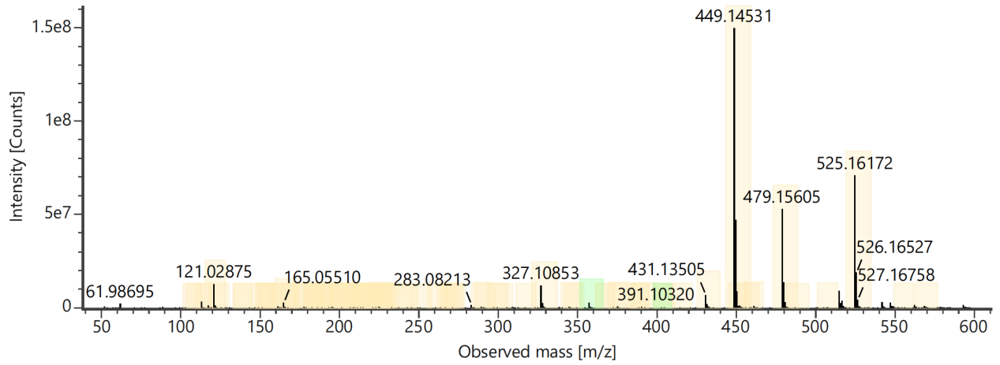
Channel name: High energy : Time 7.6781 +/- 0.0740 minutes
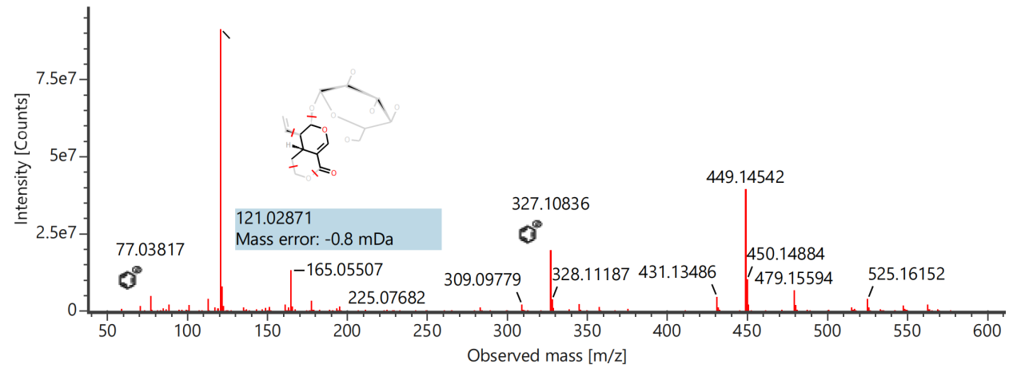

Component name: Syringylethanone
Channel name: Syringylethanone [+HCOO] : (10.00 mDa) 241.0714
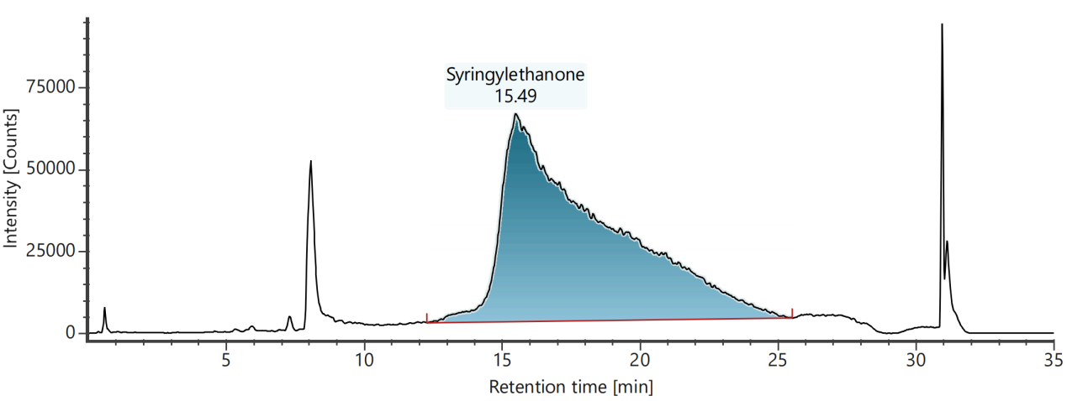
Channel name: Low energy : Time 15.5174 +/- 0.0740 minutes
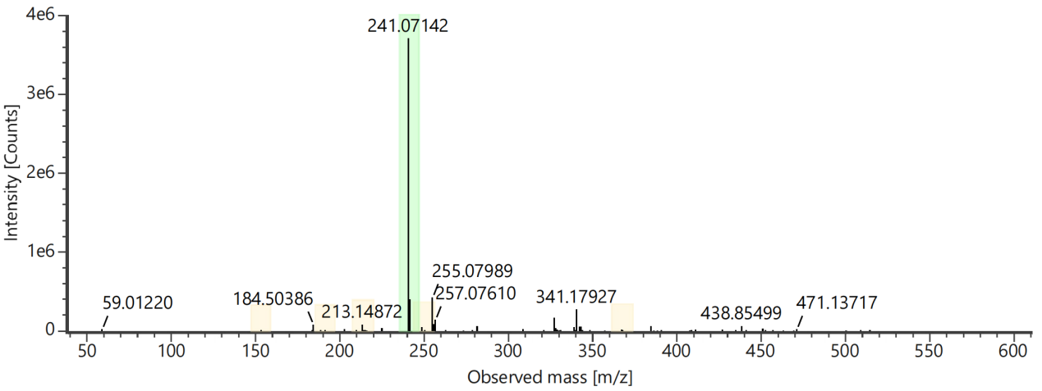
Channel name: High energy : Time 15.5174 +/- 0.0740 minutes
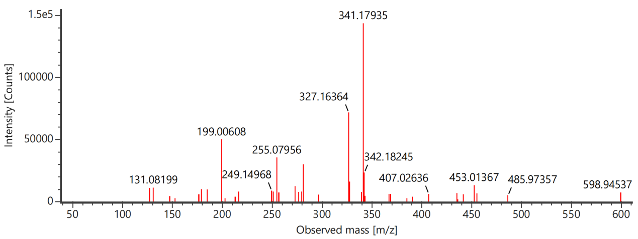

Component name: Uralenneoside
Channel name: Uralenneoside [+HCOO] : (10.00 mDa) 331.0667
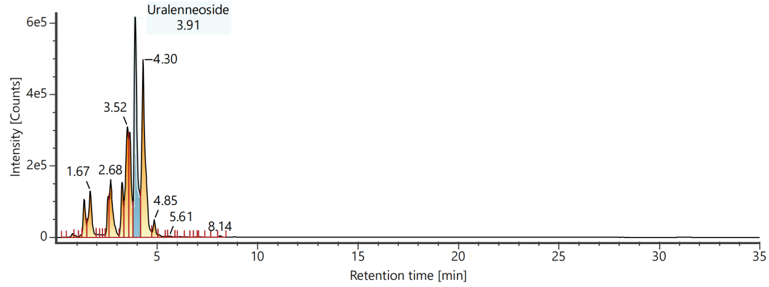
Channel name: Low energy : Time 3.9185 +/- 0.0740 minutes
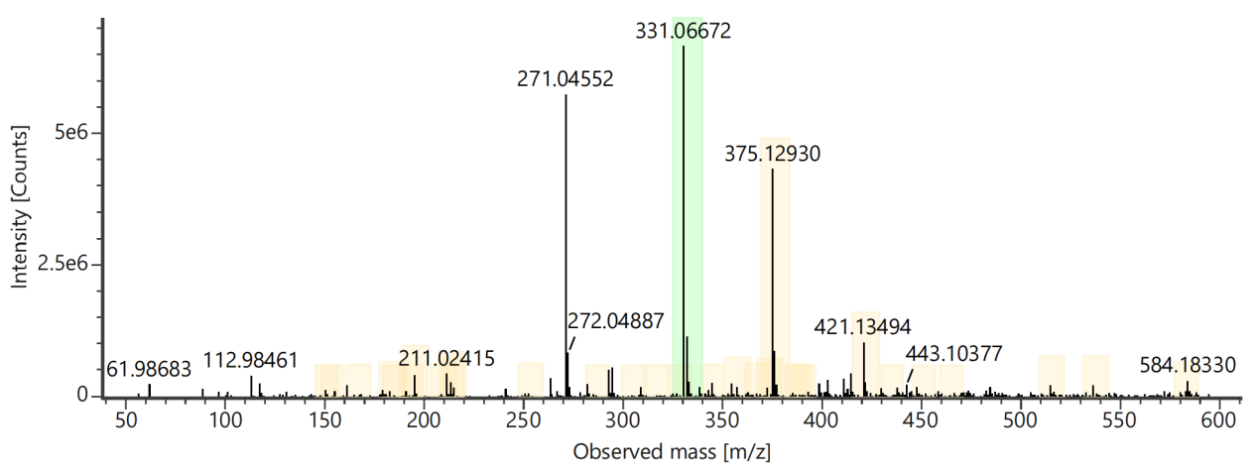
Channel name: High energy : Time 3.9185 +/- 0.0740 minutes
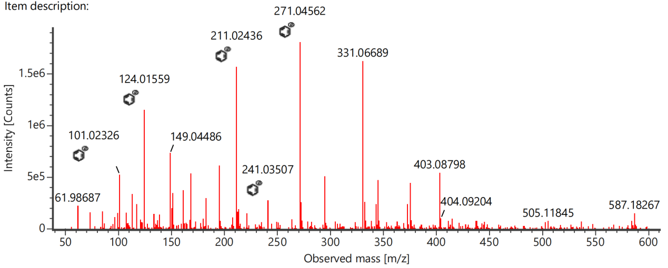

Component name: Veronicoside
Channel name: Veronicoside [-H] : (10.00 mDa) 465.1396
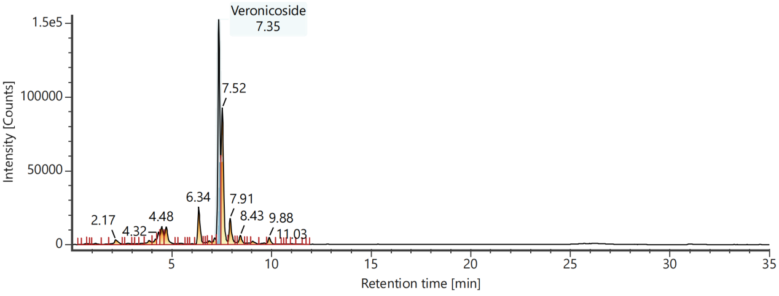
Channel name: Low energy : Time 7.3595 +/- 0.0740 minutes
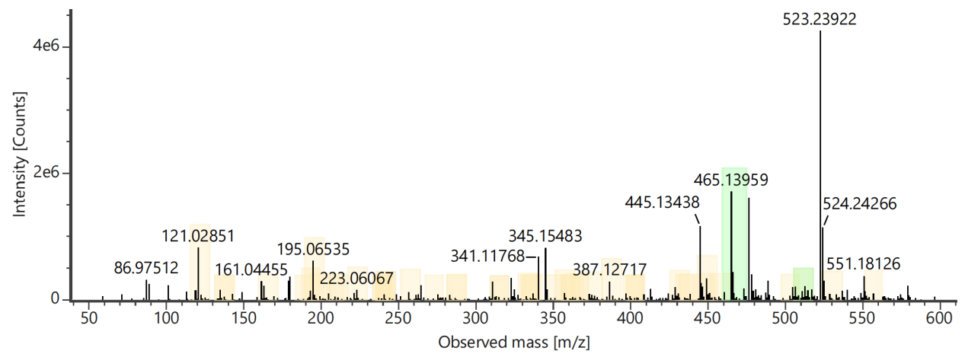
Channel name: High energy : Time 7.3595 +/- 0.0740 minutes
