Supplementary

Table S1: Instrumental variants (n=15) of labor epidural analgesia
SNPs | Effect_allele | Other_allele | Eaf | Beta | Se | Pval | F
rs139441007 | T | C | 0.0123 | 0.2323 | 0.0517 | 7.32E-06 | 5.19
rs966498 | T | C | 0.1673 | -0.0702 | 0.0155 | 6.07E-06 | 5.45
rs76264326 | G | A | 0.0137 | 0.2388 | 0.0514 | 3.47E-06 | 6.09
rs149027603 | G | C | 0.0216 | 0.2146 | 0.0410 | 1.72E-07 | 7.73
rs78507448 | A | G | 0.0196 | 0.1897 | 0.0417 | 5.50E-06 | 5.48
rs76499851 | G | A | 0.0658 | 0.1137 | 0.0237 | 1.73E-06 | 6.30
rs2393805 | A | T | 0.1198 | 0.1014 | 0.0178 | 1.36E-08 | 8.61
rs184695056 | T | C | 0.0435 | -0.1456 | 0.0306 | 2.10E-06 | 7.00
rs115165446 | T | G | 0.0251 | -0.1654 | 0.0370 | 8.25E-06 | 5.31
rs117046806 | G | A | 0.0711 | 0.1030 | 0.0233 | 9.85E-06 | 5.56
rs75402832 | A | G | 0.0549 | 0.1397 | 0.0256 | 5.38E-08 | 8.04
rs72481178 | C | T | 0.0380 | 0.1554 | 0.0316 | 8.95E-07 | 6.99
rs4375412 | A | G | 0.2649 | 0.0585 | 0.0132 | 9.24E-06 | 5.28
rs117498036 | G | A | 0.0321 | 0.1457 | 0.0326 | 8.28E-06 | 5.24
rs141460853 | A | G | 0.0125 | 0.2390 | 0.0539 | 9.62E-06 | 5.60
Note: GWAS significance, P<1×10⁻⁵, R²<0.001 and distance greater than 1000kb

Table S2: Instrumental variants (n=23) of spinal epidural analgesia in MR analysis
SNPs | Effect_allele | Other_allele | Eaf | Beta | Se | Pval | F
rs115803945 | T | C | 0.0116 | 0.2517 | 0.0490 | 2.89E-07 | 5.48
rs72936729 | T | C | 0.1083 | 0.0876 | 0.0173 | 4.24E-07 | 5.61
rs79070408 | A | G | 0.0160 | 0.2060 | 0.0415 | 7.17E-07 | 5.05
rs11125130 | G | T | 0.2694 | -0.0547 | 0.0120 | 5.22E-06 | 4.46
rs141356143 | G | A | 0.0301 | 0.1478 | 0.0327 | 6.57E-06 | 4.81
rs72783076 | C | T | 0.0627 | 0.1005 | 0.0223 | 6.58E-06 | 4.49
rs114158414 | T | C | 0.0173 | 0.1873 | 0.0402 | 3.37E-06 | 4.52
rs72664594 | A | C | 0.0775 | 0.0906 | 0.0200 | 6.32E-06 | 4.44
rs141823625 | A | G | 0.0196 | 0.1865 | 0.0401 | 3.36E-06 | 5.07
rs147325029 | T | C | 0.0183 | 0.1863 | 0.0408 | 5.14E-06 | 4.72
rs187890992 | T | C | 0.0119 | 0.2392 | 0.0505 | 2.28E-06 | 5.10
rs7310784 | T | C | 0.0539 | 0.1140 | 0.0237 | 1.53E-06 | 5.01
rs117179567 | T | C | 0.0117 | 0.2278 | 0.0512 | 8.76E-06 | 4.52
rs79093681 | C | T | 0.0625 | 0.0997 | 0.0217 | 4.58E-06 | 4.40
rs73183682 | C | T | 0.0131 | 0.2138 | 0.0464 | 4.28E-06 | 4.46
rs61912216 | A | G | 0.1675 | 0.0671 | 0.0151 | 8.62E-06 | 4.75
rs17100062 | T | C | 0.1123 | 0.0832 | 0.0185 | 6.80E-06 | 5.22
rs141851998 | A | C | 0.0114 | 0.2414 | 0.0529 | 5.30E-06 | 4.97
rs66506808 | G | C | 0.1600 | -0.0653 | 0.0145 | 6.88E-06 | 4.33
rs80026974 | A | G | 0.0732 | -0.0894 | 0.0200 | 8.22E-06 | 4.11
rs143712255 | A | C | 0.0201 | 0.1712 | 0.0385 | 9.09E-06 | 4.37
rs2138181 | T | C | 0.0522 | 0.1064 | 0.0238 | 8.30E-06 | 4.24
rs7339690 | C | T | 0.0272 | 0.1514 | 0.0329 | 4.48E-06 | 4.59

Note: GWAS significance, P<1×10⁻⁵, R²<0.001 and distance greater than 1000kb

Figure S1. The flowchart of the observational study
Assessed for eligibility (n = 177)

Stratified (n = 146)
Excluded (n = 31)
●  Decline to participate (n = 6)
 Prepartum depression (n = 5)
 Previous diseases of the uterus (n = 7)
 History of psychiatric diseases (n = 2)
 Intrapartum cesarean section (n = 11)

Treatment group (n = 73)
  Receiving labor epidural analgesia

Control group (n = 73)
●  Routine childbirth care
Lost to follow-up (n =0)

Lost to follow-up (n = 0)
Allocation
Follow-up
Included in analysis (n = 73)
Included in analysis (n = 73)

Analysis

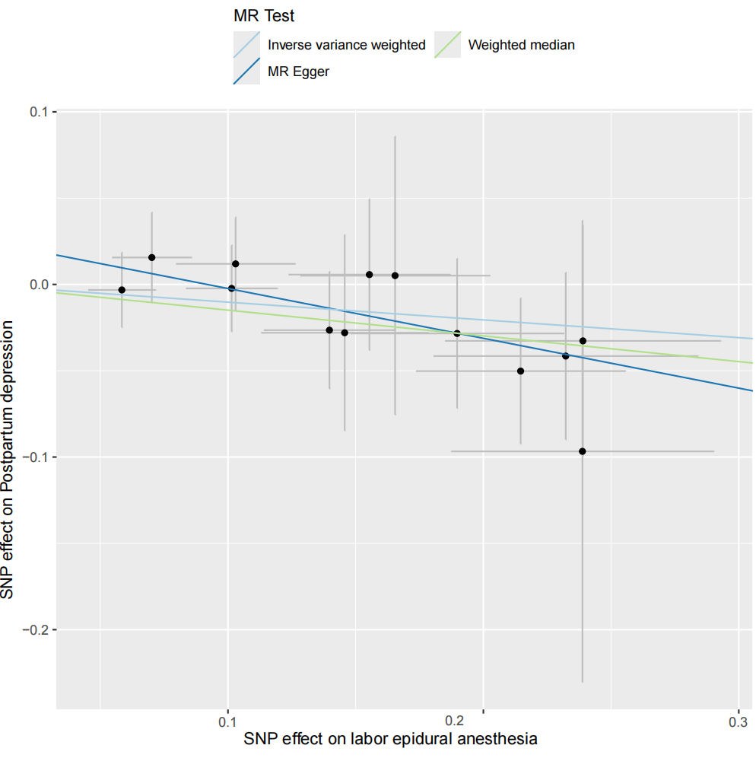
Figure S2. The scatter plot for the association between labor epidural anesthesia and postpartum depression
Note: The plot presents the effect size and confidence intervals for each SNP included in the model on
labor epidural anesthesia (exposure) and postpartum depression (outcome). The slope of the plotted lines represents the Mendelian randomization associations with different methods.

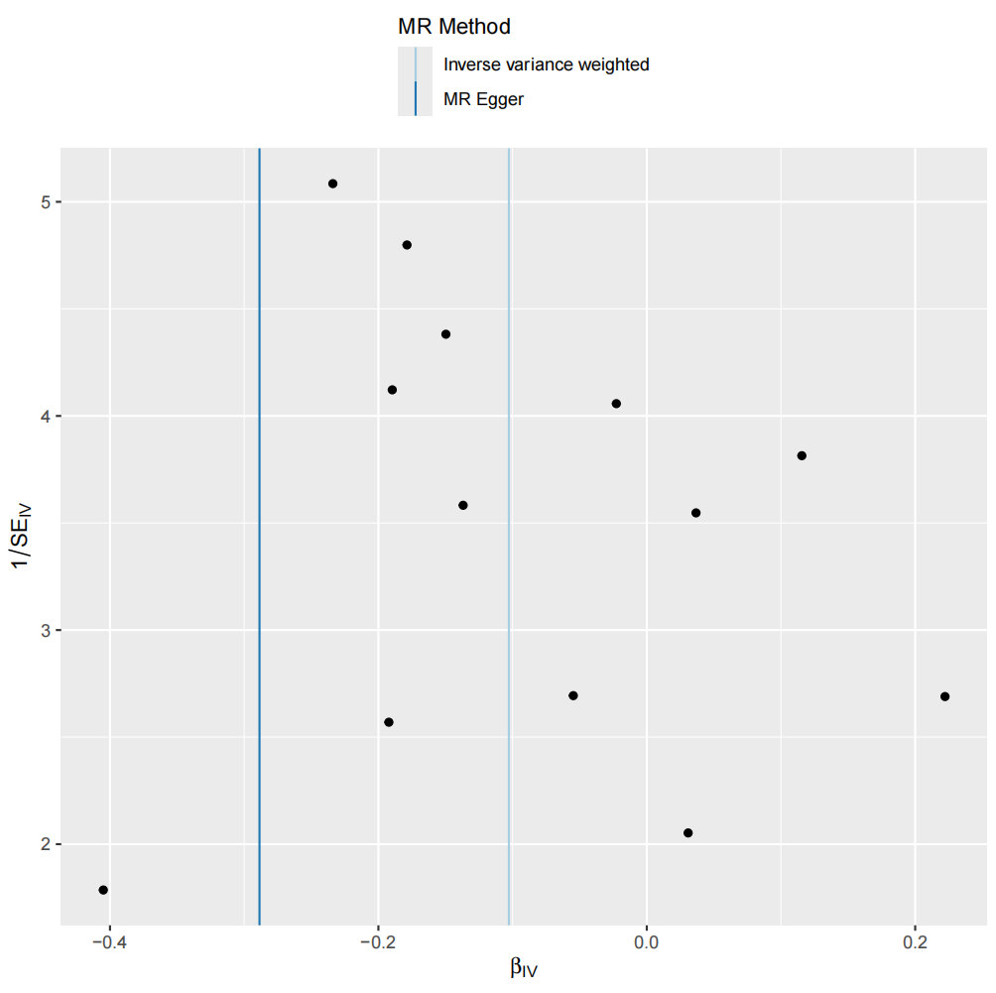
Figure S3. The funnel plot for the association between labor epidural anesthesia and postpartum depression

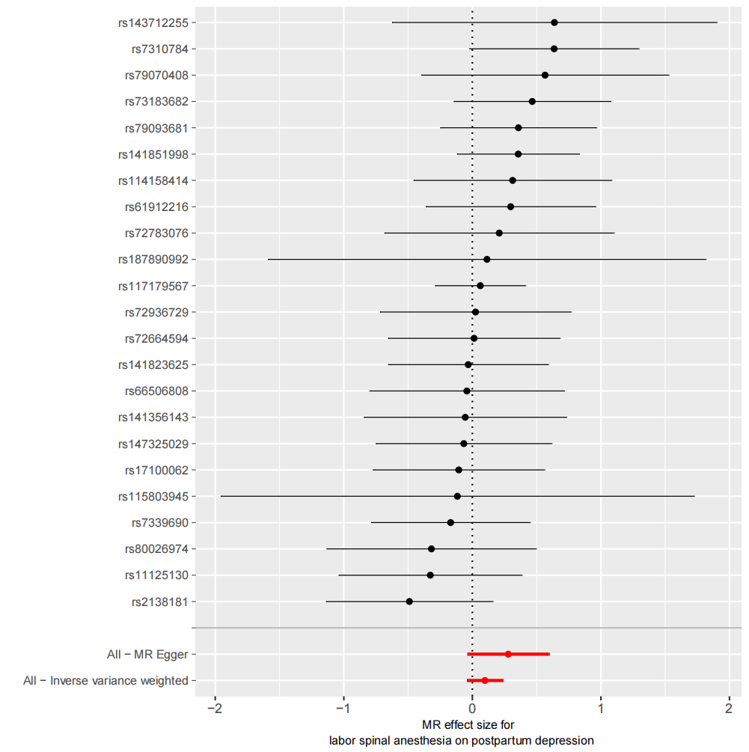
Figure S4. The forest plot for the association between labor spinal anesthesia and postpartum depression

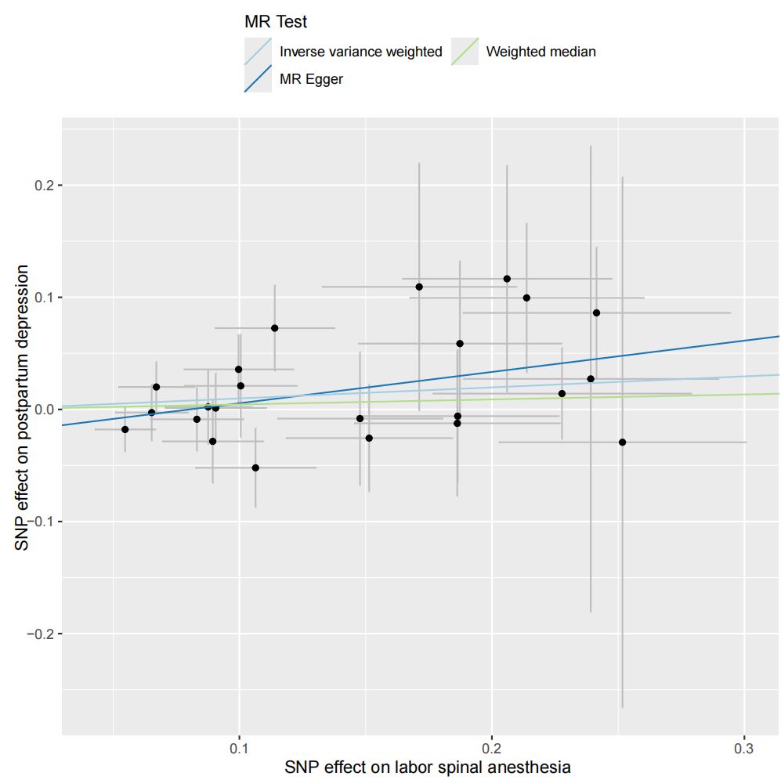

Figure S5. The scatter plot for the association between labor spinal anesthesia and postpartum depression
Note: The plot presents the effect size and confidence intervals for each SNP included in the model on
labor spinal anesthesia (exposure) and postpartum depression (outcome). The slope of the plotted lines represents the Mendelian randomization associations with different methods.

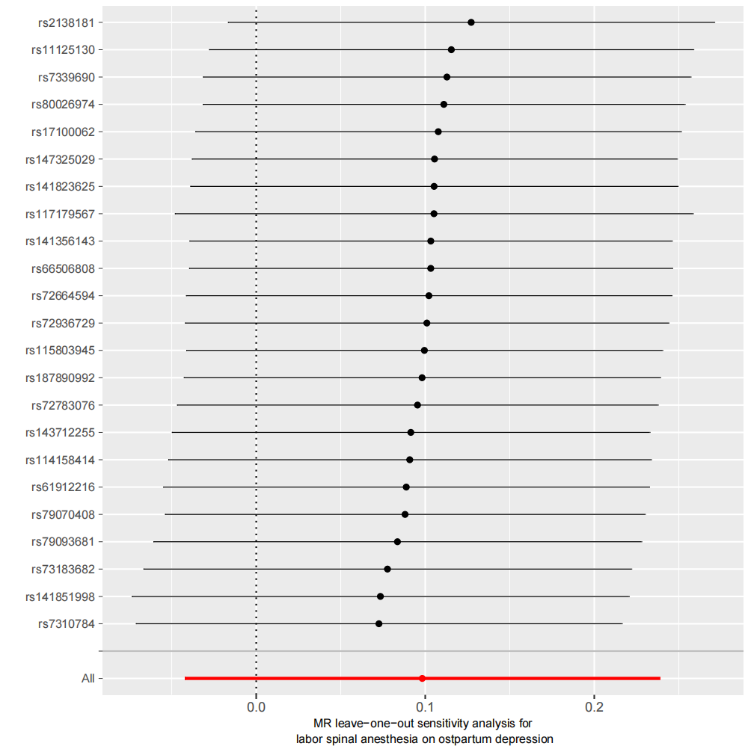
Figure S6. The leave-one-out analysis for the association between labor spinal anesthesia and postpartum depression

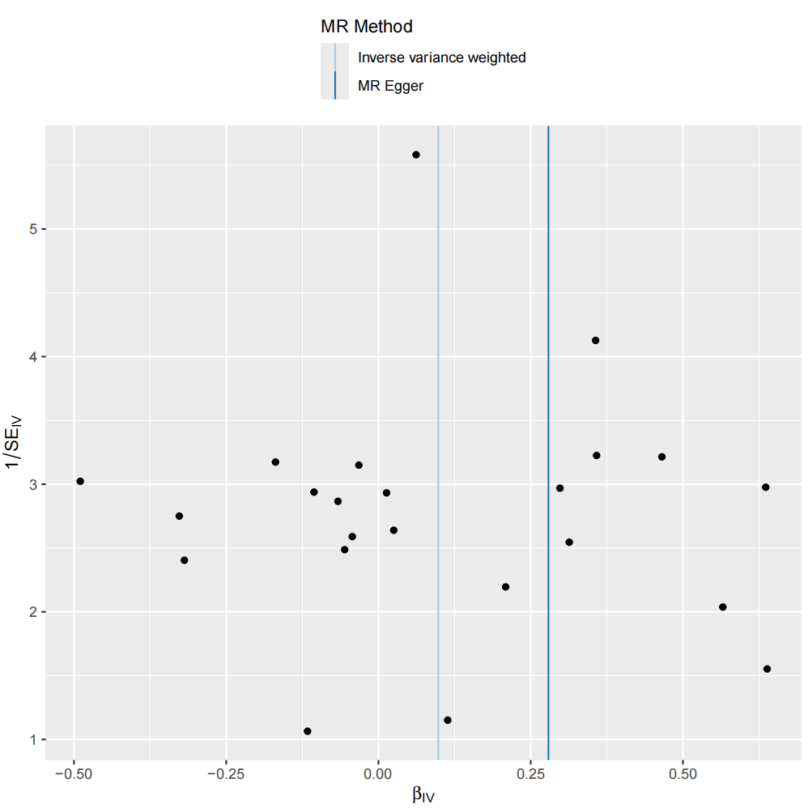
Figure S7. The funnel plot for the association between labor spinal anesthesia and postpartum depression

