Supplemental Figures

Assessed for eligibility (n=127)
Excluded (n= 15)
♦ Bleeding or nerve trauma (n=8)
♦ Postoperative infection (n=5)
♦ Other reasons (n=2)
Analysed (n=72 )
♦ Excluded from analysis (n=0)
Lost to follow-up (n=0)

Allocated to Group plantar incision (n=72 )
Lost to follow-up (n=0)

Allocated to Group SNI (n= 40)

Analysed (n= 40 )
♦ Excluded from analysis (n=0)

Allocation

Analysis

Follow-Up
Randomized (n=112)

Enrollment

Figure S1. Flow diagram of animal inclusion, exclusion, and allocation.

Figure S2. Relationship between ropivacaine concentration and UV-Vis absorption intensity at 263 nm (black line). Red line is the linear fitting line.
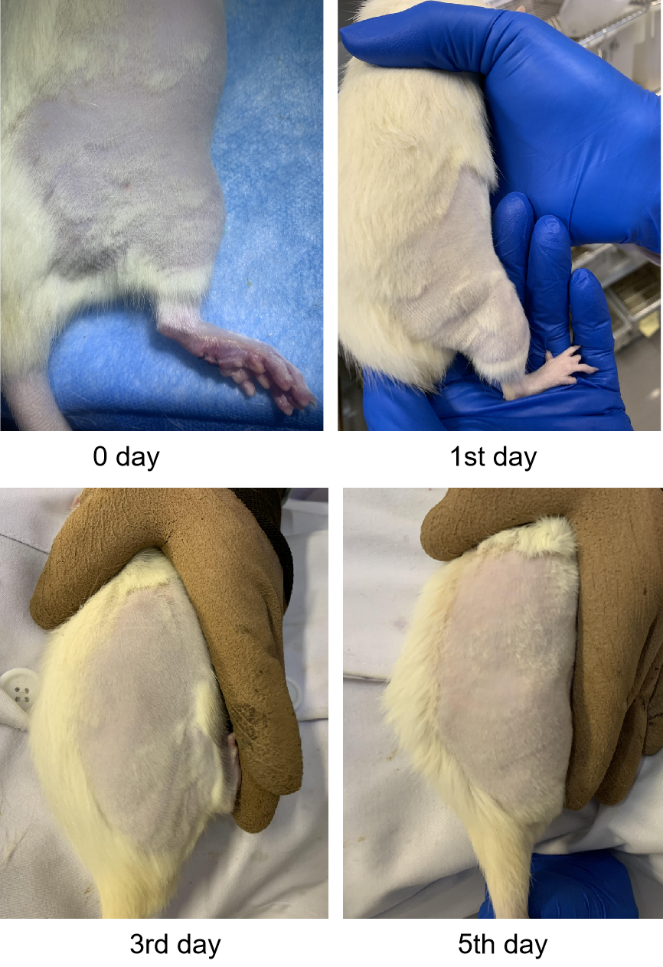
Figure S3. Photograph of the injected site after the perisciatic nerve injection of APRMs.

Figure S4. Photograph of the sciatic nerve after the perisciatic nerve injection of vehicle, PRMs, and APRMs. The dotted white marked area indicates the sciatic nerve at the site of injection.

